Supplementary Information (SI)

Figure S1: Addressing missingness patterns in dietary diversity score (DDS), missing in n = 113,645 children who were omitted for the main analyses
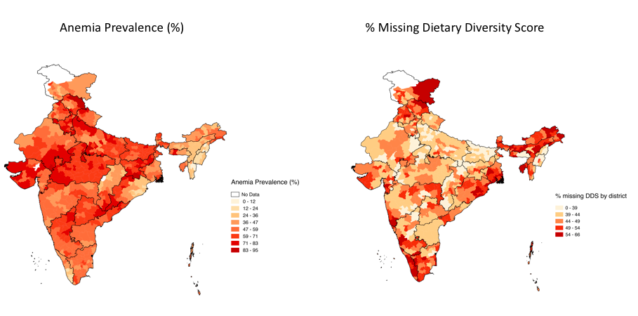Figure S1 (L) Prevalence of anemia by district within each state in India; children considered anemic if Hb < 11 g/dL. (R) % children missing dietary diversity score (DDS) by district. Missingness across all districts is between about 31% and 66%. Visually, we can see that there does not seem to be a pattern connection % children missing DDS by district and anemia prevalence by district. Most of the omissions in observations were due to lack of data about food consumption, which was used to calculate DDS (113,645 observations). Because the missingness appears to be non-differential, any bias introduced would push effect estimates towards the null.

Table S1: Characteristics of 98,557 children under the age of five years across India included in analysis from NFHS-4 by state/union territory.

State | Children per state (N) | Hemoglobin (g/dL) | PM_{2.5} exposure (μg/m³) | DDS (range 0-6) | Anemia prevalence (%)^{a,b}
Andaman and Nicobar Islands | 238 | 10.85 (1.43) | 9.73 (1.64) | 2.32 (1.79) | 49.0
Andhra Pradesh | 970 | 10.34 (1.57) | 31.26 (4.91) | 1.77 (1.61) | 58.6
Arunachal Pradesh | 1363 | 10.58 (1.48) | 17.60 (3.33) | 2.38 (2.04) | 54.2
Assam | 3261 | 11.17 (1.41) | 34.70 (8.87) | 2.08 (1.72) | 35.7
Bihar | 11,412 | 10.27 (1.41) | 75.15 (8.34) | 1.48 (1.64) | 63.5
Chandigarh | 68 | 9.44 (1.67) | 62.39 (1.11) | 1.03 (1.11) | 73.1
Chhattisgarh | 3412 | 10.89 (1.44) | 41.69 (7.32) | 1.85 (1.51) | 41.6
Dadra and Nagar Haveli | 115 | 9.66 (1.27) | 43.93 (2.99) | 0.88 (1.03) | 84.6
Daman and Diu | 49 | 10.27 (0.95) | 58.26 (3.81) | 1.92 (1.84) | 73.8
Goa | 143 | 10.64 (1.30) | 29.33 (0.79) | 1.69 (1.82) | 48.3
Gujarat | 2648 | 10.22 (1.45) | 47.14 (5.67) | 1.41 (1.25) | 62.6
Haryana | 3158 | 9.83 (1.52) | 84.90 (9.35) | 1.27 (1.39) | 71.7
Himachal Pradesh | 982 | 10.24 (1.96) | 44.51 (9.74) | 1.77 (1.31) | 53.7
Jammu and Kashmir | 3097 | 10.23 (1.83) | 31.56 (6.63) | 2.45 (1.95) | 54.5
Jharkhand | 4720 | 10.05 (1.33) | 61.91 (11.21) | 1.72 (1.55) | 69.9
Karnataka | 2691 | 10.34 (1.40) | 28.87 (6.29) | 1.63 (1.71) | 60.9
Kerala | 754 | 10.97 (1.36) | 23.54 (4.09) | 2.40 (1.77) | 35.7
Lakshadweep | 99 | 10.20 (1.49) | 27.93 (2.14) | 2.04 (1.62) | 53.6
Madhya Pradesh | 9768 | 9.99 (1.47) | 44.27 (8.88) | 1.43 (1.47) | 68.9
Maharashtra | 3371 | 10.60 (1.45) | 38.23 (4.94) | 1.60 (1.58) | 53.8
Manipur | 2352 | 11.39 (1.28) | 16.89 (1.52) | 2.51 (1.85) | 23.9
Meghalaya | 1857 | 10.95 (1.32) | 24.65 (4.94) | 2.86 (2.11) | 48.0
Mizoram | 2002 | 11.56 (1.52) | 16.48 (3.99) | 2.69 (2.11) | 19.3
Nagaland | 1933 | 11.50 (1.51) | 21.11 (3.69) | 2.45 (2.06) | 26.4
Delhi | 313 | 9.64 (1.79) | 63.72 (32.21) | 1.96 (1.57) | 59.7
Odisha | 3854 | 10.69 (1.48) | 43.67 (10.69) | 2.10 (1.57) | 44.6
Puducherry | 250 | 10.88 (1.23) | 27.76 (3.09) | 3.19 (2.12) | 44.9
Punjab | 1957 | 10.35 (1.54) | 79.83 (8.90) | 1.47 (1.36) | 56.6
Rajasthan | 6626 | 10.27 (1.56) | 61.33 (11.41) | 1.06 (1.18) | 60.3
Sikkim | 330 | 10.48 (1.42) | 33.25 (10.52) | 2.82 (2.11) | 55.1
Tamil Nadu | 2861 | 10.63 (1.43) | 27.08 (4.20) | 3.15 (2.13) | 50.7
Tripura | 376 | 10.60 (1.21) | 27.90 (3.77) | 1.39 (1.72) | 48.3
Uttar Pradesh | 16,657 | 10.15 (1.61) | 79.11 (13.20) | 1.33 (1.33) | 63.2
Uttarakhand | 2225 | 10.22 (1.62) | 43.95 (14.09) | 1.56 (1.44) | 59.8
West Bengal | 1806 | 10.50 (1.37) | 62.29 (7.31) | 2.38 (1.85) | 54.2
Telangana | 839 | 9.98 (1.67) | 38.51 (2.91) | 1.83 (1.65) | 60.7
ª Hemoglobin < 11 g/dL, coded yes/no
^{b} Statewide prevalence estimates from NHFS-4 2015-2016

Table S2: Comparing characteristics of 98,815 children under the age of five years across India included in analysis from NFHS-4 to observations omitted from analysis due to missing data values.

Variables | Included Values (n = 98,557) | Omitted Values  (n = 160,070)
Hemoglobin (g/dL) | 10.39 (1.56) | 10.75 (1.50)
Household Cooking Fuel
Clean Fuel | 26.3% | 31.5%
Kerosene | 0.73% | 0.8%
Biomass | 73.0% | 67.7%
BMI (Z-Score)
-2 SD | -365.8 | -364.10
Median | -75 | -83
+2 SD | 216.8 | 198.10
Secondhand Smoke
Yes | 57.6% | 56.2%
No | 42.4% | 43.8%
Residence Type
Urban | 21.6% | 24.9%
Rural | 78.4% | 75.1%
Maternal Anemia
Yes | 58.1% | 54.8%
No | 41.9% | 45.2%
Wealth Index
Poorest | 28.3% | 25.3%
Poorer | 24.3% | 23.3%
Middle | 20.1% | 19.8%
Richer | 15.6% | 17.1%
Richest | 11.6% | 14.5%

Figure S2: Addressing sub-district and temporal variability of PM_{2.5} exposure levels across India

We acknowledge that there might be substantial variability of PM_{2.5} within a district, please find Figure S2, which indicates the standard deviation of PM_{2.5} among the grids that lie within a district boundary (included below to address sub-district and temporal variability). It can be seen that the standard deviation rarely exceeds 10 μg m⁻³ for a district, but is relatively high for districts with large areas. Also included in Figure RC1 is the standard deviation of annual PM_{2.5} within a district over the time period 2010-2015. However, we note that the satellite data we used is at 50x50km and does not allow us to quantify the rural-urban variability of PM_{2.5}.

Figure S2 (L) Standard deviation of PM_{2.5} among grids that lie within a district boundary (R) Standard deviation of annual PM_{2.5} level within a district over time period 2010-2015

