Table 1: Total deaths across the study period and in different categories

Year | Overall | >=60 Yrs | 40-59 Yrs | <40 Yrs | Male* | Female*
2010 (Jun-Dec) | 53,726 | 24,341 | 14,274 | 15,030 | 27,968 | 17,253
2011 | 93,058 | 44,945 | 24,141 | 23,930 | 49,154 | 31,122
2012 | 97,491 | 48,444 | 25,315 | 23,647 | 51,372 | 32,706
2013 | 106,002 | 52,810 | 27,665 | 25,402 | 56,945 | 36,137
2014 | 109,399 | 55,472 | 28,694 | 25,192 | 59,053 | 37,526
2015 | 114,753 | 57,764 | 30,433 | 26,475 | 61,195 | 39,809
2016 | 126,083 | 65,697 | 32,674 | 27,406 | 68,296 | 39,809
Total | 700,512 | 349,473 | 183,196 | 167,082 | 373,983 | 234,362
*Numbers restricted to East, North and South Delhi Municipal Corporations

Table 2: Relative risk of mortality associated with a 25 µg/m³ increase in PM_{2.5} exposure for the whole population (including under-40s age group)

Group | Relative Risk (95% CI)
Overall | 1.009 (1.004, 1.013)
Age Strata
>60 | 1.026 (1.019, 1.032)
40-59 | 1.007 (1.001, 1.014)
<40 | 0.974 (0.967, 0.981)
Sex*
Male | 1.009 (1.003, 1.015)
Female | 1.006 (1.004, 1.008)
*Analyses restricted to East, North and South Delhi Municipal Corporations

Figure 1: Exposure-Response curves for the relationship between daily PM_{2.5} exposure and relative risk of daily mortality of different strata

1a: Exposure-response relationship for those under the age of 40 for the complete exposure range (left) and days under the median exposure of 91.1 µg/m³ (right).

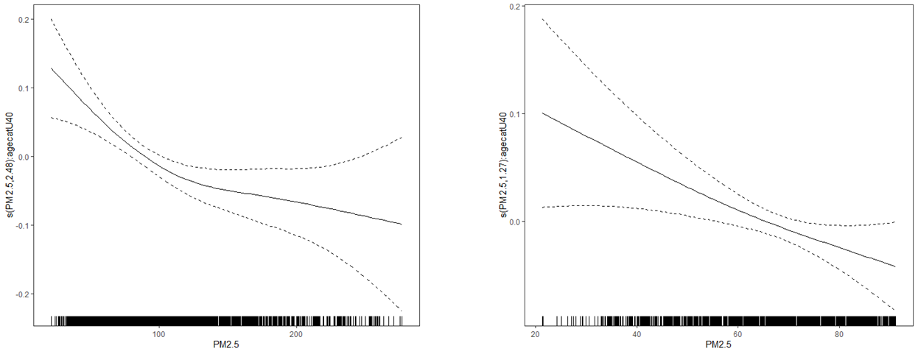

1b: : Exposure-response relationship by season of death for complete exposure range (From top left to bottom middle: Winter, Spring, Summer, Monsoon, Autumn).

