Supplemental Figure 1. Untargeted metabolomics workflow

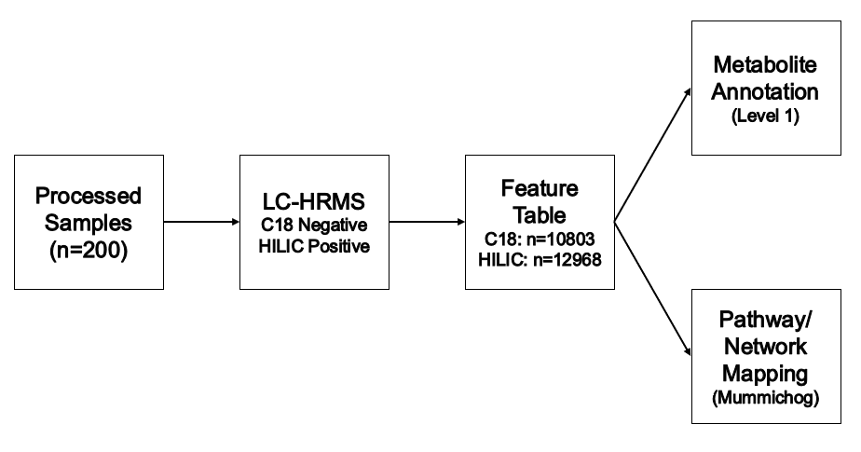

Supplemental Table 1. Descriptive characteristics of the eligible women (n=345) enrolled in the EARTH Study who were included in the metabolomics sub-study (n=200) from 2005 to 2015 in the Northeast United States.
 | All eligible  women  (n=345) | Included in metabolomics study (n=200)
Demographics¹
Age, years | 35.0 ± 3.9 | 34.8 ± 3.9
BMI, kg/m² | 24.3 ± 4.4 | 23.9 ± 4.6
Race, n (%)
White | 294 (85%) | 171 (86%)
African-American | 8 (2%) | 3 (2%)
Asian | 31 (9%) | 19 (10%)
Other | 12 (3%) | 7 (4%)
Smoking Status, n (%)
Never | 248 (72%) | 147 (74%)
Ever | 97 (28%) | 53 (27%)
Education Level, n (%)
<College | 30 (9%) | 17 (8%)
College Graduate | 112 (32%) | 62 (31%)
Graduate Degree | 203 (59%) | 121 (61%)
Census-Tract Median Income, $ | 105,401 ± 43,244 | 104,382 ± 43,205
ART Cycle Characteristics¹
Year of Cycle Start, n (%)
2005-2008 | 100 (29%) | 41 (21%)
2009-2012 | 176 (51%) | 109 (55%)
2013-2015 | 69 (20%) | 50 (25%)
Season of Cycle Start, n (%)
Jan-Mar | 87 (25%) | 51 (26%)
Apr-Jun | 109 (32%) | 62 (31%)
Jul-Sep | 82 (24%) | 53 (27%)
Oct-Dec | 67 (19%) | 34 (17%)
Initial Infertility Diagnosis, n (%)
Male | 113 (33%) | 55 (28%)
Female | 107 (31%) | 66 (33%)
Unexplained | 125 (36%) | 79 (40%)
Treatment protocol, n (%)
Luteal phase agonist | 262 (76%) | 150 (75%)
Flare or antagonist | 83 (24%) | 50 (25%)
Day of Serum Sample, n (%)
Day 3 | - | 139 (70%)
Monitoring Phase | - | 50 (25%)
Oocyte Retrieval | - | 11 (6%)
¹ Data presented as average ± standard deviation unless otherwise stated.

Supplemental Table 2. Correlation matrix of PM_{2.5} Exposure windows among 200 women in the EARTH study from 2005 to 2015 in the Northeast United States
Exposure | Average ± SD¹ | Correlation Coefficients
 |  | 1 Day | 2 Days | 3 Days | 2 Weeks | 3 Months
1-Day Average | 8.7 ± 4.0 | 1.00
2-Day Average | 8.8 ± 3.6 | 0.89 | 1.00
3-Day Average | 9.0 ± 3.4 | 0.77 | 0.94 | 1.00
2-Week Average | 8.8 ± 2.3 | 0.58 | 0.66 | 0.73 | 1.00
3-Month Average | 9.0 ± 1.9 | 0.26 | 0.31 | 0.35 | 0.56 | 1.00
¹ Data presented as average ± standard deviation.

Supplemental Table 3. Metabolites identified using level 1 evidence among 200 women in the EARTH study from 2005 to 2015 in the Northeast United States
Superclass | Class | Metabolite | ESI | M/Z¹ | Time¹
Benzenoids  (n=1) | Benzene and substituted derivatives  (n=1) | Bis(2-Ethylhexyl)phthalate | + | 391.2848 | 25.5
Lipids and lipid-like molecules  (n=1) | Prenol lipids (n=1) | Retinoic acid | + | 301.2167 | 26.5
Organic acids and derivatives  (n=4) | Carboxylic acids and derivatives  (n=4) | Glutamic acid | - | 147.0532 | 19.8
 |  | N-Acetyl-serine | - | 147.0532 | 21.0
 |  | N-Methyl-aspartic acid | - | 147.0532 | 19.6
 |  | O-Acetyl-serine | - | 147.0532 | 20.8
Organoheterocyclic compounds  (n=1) | Imidazopyrimidines (n=1) | Hypoxanthine | - | 135.03071 | 22.8
¹ M/Z and retention times are the values found using our lab’s standard workflow using authentic standards and do not necessarily match the monoisotopic masses listed on PubChem.

