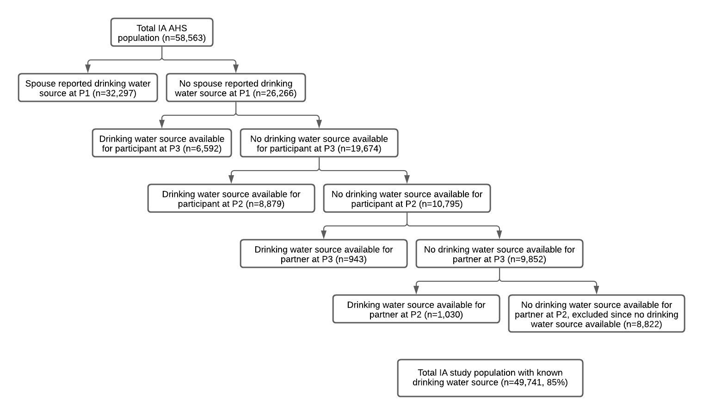
Supplemental Figure 1. Process used to assign drinking water source at enrollment to Iowa (IA) Agricultural Health Study (AHS) participants. Assignments based on responses collected from questionnaires at enrollment (phase (P)1:1993-1997), P2: 1999-2000, and P3: 2005-2010. Order of assignments was based on reliability and accuracy of reporting at each phase. Later phase reporting only used if participant had not moved since enrollment. Participants missing drinking water source were assigned their partner’s source if still living together.

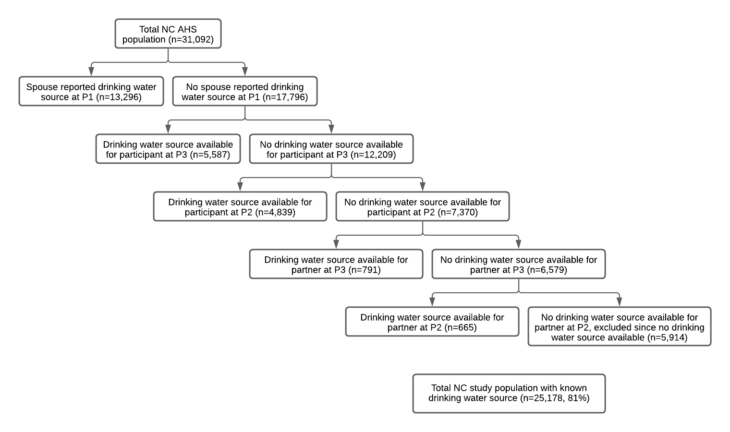
Supplemental Figure 2. Process used to assign drinking water source at enrollment to North Carolina (NC) Agricultural Health Study (AHS) participants. Assignments based on responses collected from questionnaires at enrollment (phase (P)1:1993-1997), P2: 1999-2000, and P3: 2005-2010. Order of assignments was based on reliability and accuracy of reporting at each phase. Later phase reporting only used if participant had not moved since enrollment. Participants missing drinking water source were assigned their partner’s source if still living together.

Supplemental Table 1. Characteristics of Agricultural Health Study private well users by private well nitrate test status at enrollment for Iowa (IA) and North Carolina (NC) participants who participated in phase 2 and/or phase 3, excluding commercial applicators.
 | Iowa (N=24,923) |  | North Carolina (N=14,804)
Reported NO₃-N testing | No (N=5,144) | Yes (N=19,779) | No (N=8,370) | Yes (N=6,434)
Age, mean(sd)
Years | 47.6 (11.5) | 45.9 (11.2) | 49.8 (12.2) | 50.6 (12.6)
Race & ethnicity, n(%)
White, non-Hispanic | 4,899 (99.0) | 18869 (99.1) | 6,872 (94.6) | 5,269 (94.8)
White, Hispanic | 46 (0.9) | 162 (0.9) | 57 (0.8) | 60 (1.1)
Black/African American, non-Hispanic | 1 (<0.1) | 4 (<0.1) | 252 (3.5) | 181 (3.3)
Black/African American, Hispanic | -- | -- | 2 (<0.1) | 3 (<0.1)
Other, non-Hispanic | 3 (<0.1) | 9 (<0.1) | 81 (1.1) | 42 (0.8)
Other, Hispanic | -- | -- | 3 (<0.1) | 1 (<0.1)
Missing (n) | 195 | 735 | 1,103 | 878
Sex (n (%))
Male | 3,047 (59.2) | 10,601 (53.6) | 5,214 (62.3) | 3,718 (57.8)
Female | 2,097 (40.8) | 9,178 (46.4) | 3,156 (37.7) | 2,716 (42.2)
Missing (n) | -- | -- | -- | --
Education, n(%)
<High school | 214 (4.3) | 645 (3.3) | 1,133 (14.5) | 870 (14.6)
High school graduate | 2,447 (48.6) | 8,209 (42.4) | 3,463 (44.4) | 2,531 (42.3)
Some college or 1-3 yr vocational education after high school | 1,330 (26.4) | 5,630 (29.1) | 1,649 (21.1) | 1,271 (21.3)
College graduate | 685 (13.6) | 3,199 (16.5) | 1,018 (13.0) | 833 (13.9)
>1 year of grad or professional school completed | 157 (3.1) | 745 (3.8) | 346 (4.4) | 297 (5.0)
Other | 205 (4.1) | 953 (4.9) | 196 (2.5) | 177 (3.0)
Missing (n) | 106 | 398 | 565 | 455
Smokingª, n(%)
Never smokers | 3,348 (66.9) | 13,397 (69.4) | 3,912 (50.9) | 3,062 (51.8)
Current smokers | 495 (9.9) | 1,602 (8.3) | 1,448 (18.8) | 1,147 (19.4)
Past smokers | 1,160 (23.2) | 4,307 (22.3) | 2,332 (30.3) | 1,701 (28.8)
Missing (n) | 141 | 473 | 678 | 524
Alcohol^{b}, n(%)
Never | 1,392 (27.8) | 4,846 (25.1) | 4,982 (66.3) | 3,772 (65.4)
<1 time a month | 1,195 (23.8) | 4,760 (24.7) | 1,013 (13.5) | 812 (14.1)
1–3 times a month | 965 (19.3) | 4,209 (21.8) | 563 (7.5) | 449 (7.8)
1 time a week | 553 (11.0) | 2,450 (12.7) | 316 (4.2) | 276 (4.8)
2–4 times a week | 652 (13.0) | 2,284 (11.8) | 431 (5.7) | 326 (5.7)
Almost every day to every day | 257 (5.1) | 762 (3.9) | 215 (2.9) | 135 (2.3)
Missing (n) | 130 | 468 | 850 | 664
Marital Status, n(%)
Married or living as married | 4,553 (88.5) | 18,657 (94.3) | 7,541 (90.7) | 5,939 (92.7)
Divorced or separated | 133 (2.6) | 264 (1.3) | 253 (3.0) | 152 (2.4)
Widowed | 19 (0.4) | 90 (0.5) | 83 (1.0) | 57 (0.9)
Never married | 439 (8.5) | 765 (3.9) | 441 (5.3) | 256 (4.0)
Children
No | 584 (19.2) | 1,221 (11.6) | 782 (15.9) | 499 (14.1)
Yes | 2,451 (80.8) | 9,309 (88.4) | 4,145 (84.1) | 3,039 (85.9)
Missing | 2,109 | 9,249 | 3,443 | 2,896
Missing (n) | 0 | 3 | 52 | 30
Children <10 years at home, n(%)
No | 889 (30.6) | 2,472 (24.4) | 1,851 (41.3) | 1,363 (42.0)
Yes | 942 (32.5) | 4,374 (43.2) | 1,635 (36.5) | 1,213 (37.4)
No births within last 9 years | 1,071 (36.9) | 3,289 (32.5) | 998 (22.3) | 668 (20.6)
Missing (n) | 2,242 | 9,644 | 3,886 | 3,190
Owned or worked on a farm^{c}, n(%)
Yes | 3,061 (99.8) | 10,642 (99.7) | 4,724 (93.4) | 3,416 (93.6)
No | 7 (0.2) | 37 (0.4) | 333 (6.6) | 235 (6.4)
Missing (n) | 26 | 86 | 332 | 223
Applied natural or chemical fertilizer to farmland, n(%)
Yes | 1,898 (51.6) | 6,829 (47.0) | 3,095 (59.7) | 2,301 (56.2)
No | 1,778 (48.4) | 7,717 (53.1) | 2,092 (40.3) | 1,796 (43.8)
Missing (n) | 1,468 | 5,233 | 3,183 | 2,337
Age of home, n(%)
<10 years | 136 (4.3) | 842 (6.3) | 559 (13.7) | 452 (14.4)
10-20 years | 321 (10.1) | 1,611 (12.1) | 971 (23.8) | 751 (23.8)
21-40 years | 497 (15.6) | 1,968 (14.8) | 1,617 (39.6) | 1,227 (39.0)
41-99 years | 1,678 (52.6) | 6,523 (49.1) | 787 (19.3) | 585 (18.6)
100+ years | 557 (17.5) | 2,352 (17.7) | 149 (3.7) | 135 (4.3)
Missing (n) | 1,955 | 6,483 | 4,287 | 3,284
Housing foundation type, n(%)
slab | 39 (1.2) | 169 (1.3) | 178 (4.4) | 125 (4.0)
crawl space | 86 (2.7) | 243 (1.8) | 2,055 (51.2) | 1,575 (50.5)
combination crawl space/basement | 760 (23.9) | 2,912 (21.9) | 389 (9.7) | 329 (10.5)
full basement | 2,236 (70.3) | 9,737 (73.1) | 1,006 (25.1) | 808 (25.9)
other | 54 (1.7) | 229 (1.7) | 230 (5.7) | 189 (6.1)
Did not know | 7 (0.2) | 31 (0.2) | 157 (3.9) | 95 (3.0)
Missing (n) | 1,962 | 6,458 | 4,355 | 3,313
Well depth^{d} (P1-P3), n(%)
<50 ft | 806 (21.1) | 2,429 (16.3) | 1,429 (22.1) | 941 (18.6)
50-150 ft | 1,362 (35.6) | 5,515 (37.0) | 2,343 (36.2) | 1,832 (36.3)
>150 ft | 410 (10.7) | 1,524 (10.2) | 841 (13.0) | 758 (15.0)
>100 ft (P2) | 1,244 (32.6) | 5,450 (36.5) | 1,861 (28.8) | 1,522 (30.1)
Missing | 1,322 | 4,861 | 1,896 | 1,381
Safe nitrate levels for bottle-fed infants ^{e}
(P2-P3), n(%)
Yes (n (%)) | -- | 16,757 (87.7) | -- | 6,053 (99.1)
No (n (%)) | -- | 2,346 (12.3) | -- | 53 (0.9)
Don’t know/ Missing ^{g} | -- | 676 | -- | 328
Well distance from pesticide mixing site^{f} (P1-P2)
No pesticides mixed on farm | 524 (10.9) | 2,081 (10.7) | 764 (9.9) | 575 (9.3)
<150 ft | 1,278 (26.5) | 5,227 (26.8) | 1,356 (17.6) | 1,017 (16.4)
150-300 ft | 861 (17.9) | 3,611 (18.5) | 986 (12.8) | 750 (12.1)
>300 ft | 2,152 (44.7) | 8,605 (44.1) | 4,616 (59.8) | 3,859 (62.2)
Missing | 329 | 255 | 648 | 233
Well distance from pesticide application site^{h} (P2)
No Pesticides applied on farm | 55 (1.2) | 186 (1.0) | 611 (8.4) | 504 (8.4)
<100 ft | 885 (19.7) | 3,236 (16.8) | 1,008 (13.9) | 799 (13.3)
100 to 200 ft | 917 (20.4) | 3,691 (19.1) | 1,057 (14.5) | 798 (13.2)
>200 ft | 2,632 (58.6) | 12,188 (63.2) | 4,597 (63.2) | 3,927 (65.2)
Missing | 655 | 478 | 1,097 | 406
Predicted NO3-N, Median (IQR)
mg/L | 1.45 (0.8-5.2) | 1.52 (0.8-4.8) | 1.84 (1.4-2.5) | 1.88 (1.4-2.5)
Missing (n) | 278 | 772 | 844 | 556
Nitrate level above ½ MCL, n(%)
 | 1,256 (25.8) | 4,617 (24.3) | 66 (0.9) | 69 (1.2)
Missing (n) | 278 | 772 | 844 | 556
Nitrate level above MCL, n(%)
 | 627 (12.9) | 2,148 (11.3) | 0 (0.0) | 1 (<0.1)
Missing (n) | 278 | 772 | 844 | 556
ªCurrent smokers at enrollment; ^{b}How often participants drank any alcoholic beverages in the past year; ^{c}Total= 23,122 , spouses excluded due to no reporting; ^{d}Information on well depth was collected in P1-P3; ^{e}Information on nitrate testing and safety was collected in P2 and P3, ^{f}Includes those who responded don’t know and those who skipped the question; ^{g}Information on distance from pesticide application

