Epigenome-Wide Association of Neonatal Methylation and Prenatal PM_{2.5} Exposure Suggests Timing-Specific Effects
Milan N. Parikh¹, Cole Brokamp^{1,2}, Erika Rasnick¹, Lili Ding^{1,2}, Tesfaye B. Mersha^{2,3}, Katherine Bowers^{1,2}, Alonzo T. Folger^{1,2}
¹ Division of Biostatistics and Epidemiology, Cincinnati Children's Hospital Medical Center, Cincinnati, OH, USA
² Department of Pediatrics, University of Cincinnati College of Medicine, Cincinnati, OH, USA
³ Division of Asthma Research, Cincinnati Children’s Hospital Medical Center, Cincinnati, OH, USA

Supplementary Materials

Average Prenatal PM_{2.5} Exposure

Trimester 1
Analyzing average PM_{2.5} concentrations over trimester 1 generated a genomic control factor of 0.941 and a QQ plot showing minimal deviation of the observed p-value distribution from the expected under the null hypothesis (eFigure 1). The SVA was not included in the model as it negatively impacted the QQ plot.

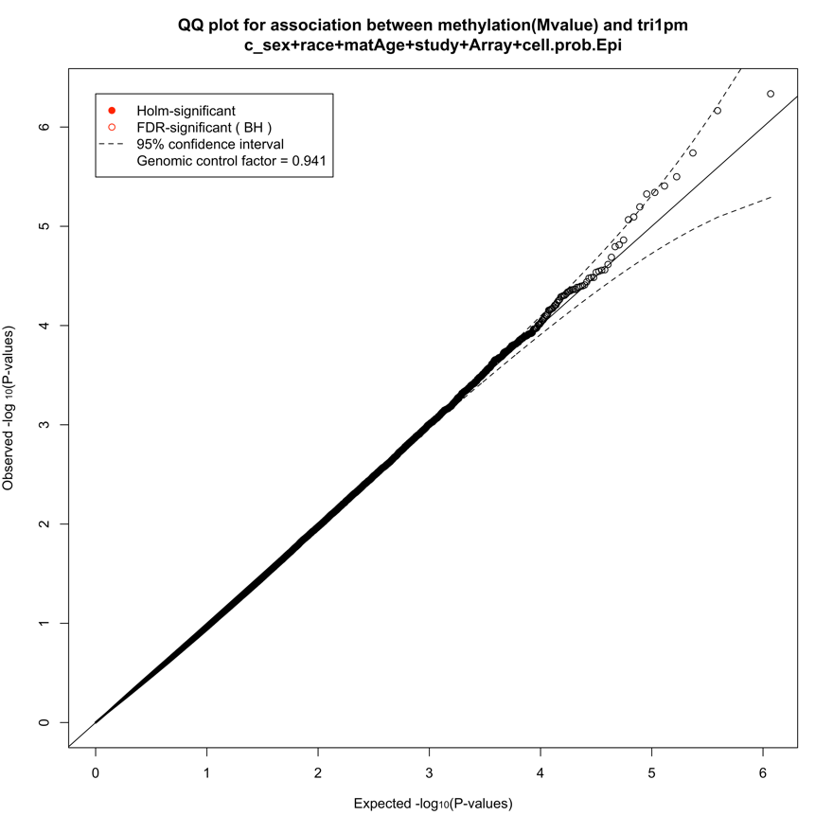
eFigure 1. QQ plot for the analysis between DNA methylation at each studied CpG site and PM_{2.5} averaged over trimester 1 of pregnancy with observed and expected p-values transformed on a negative log₁₀ scale.

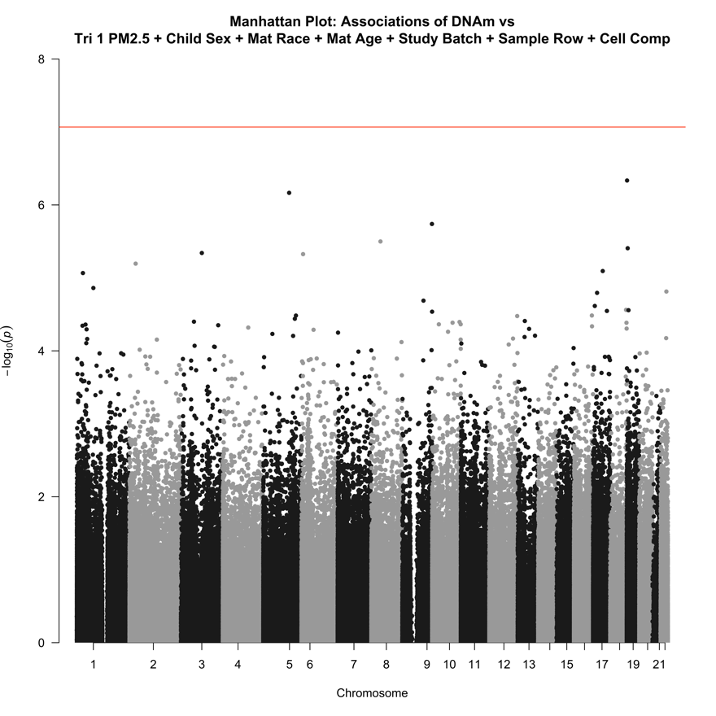
eFigure 2. Manhattan plots for the association between DNA methylation at each studied CpG site and PM_{2.5} averaged over trimester 1 of pregnancy adjusted for specified covariates. The vertical axis plots the negative log₁₀ p-value for each association. The Bonferroni cutoff for significance is denoted by the horizontal red line.

Trimester 2
Analyzing average PM_{2.5} concentrations over trimester 2 generated a genomic control factor of 1.01 and a QQ plot with minimal deviations from expected (eFigure 3). This model was additionally adjusted for SVA as its inclusion greatly improved the QQ plot and the genomic control factor.
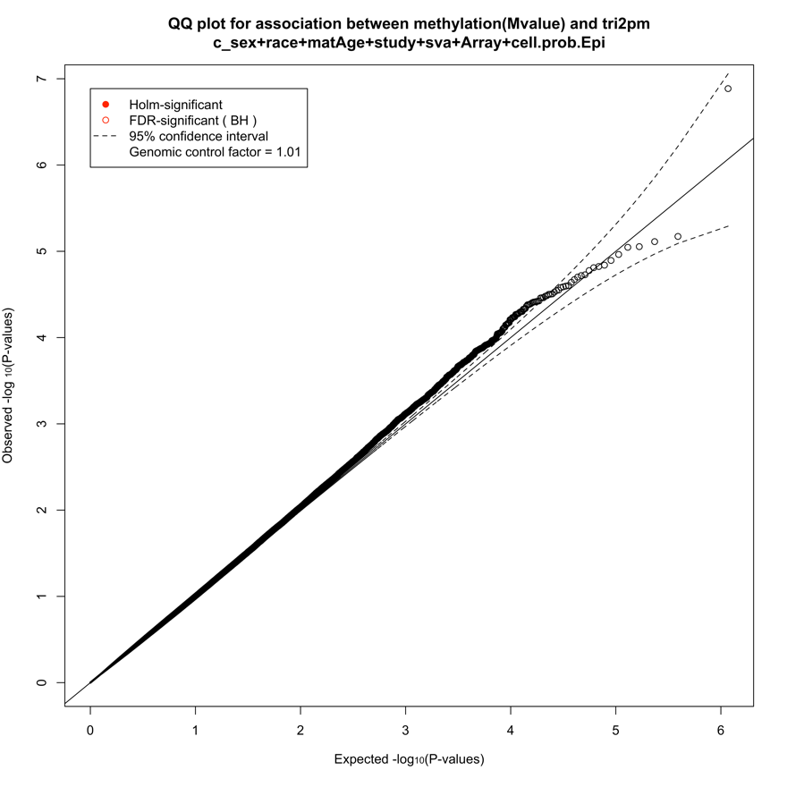
eFigure 3. QQ plot for the analysis between DNA methylation at each studied CpG site and PM_{2.5} averaged over trimester 2 of pregnancy with observed and expected p-values transformed on a negative log₁₀ scale.

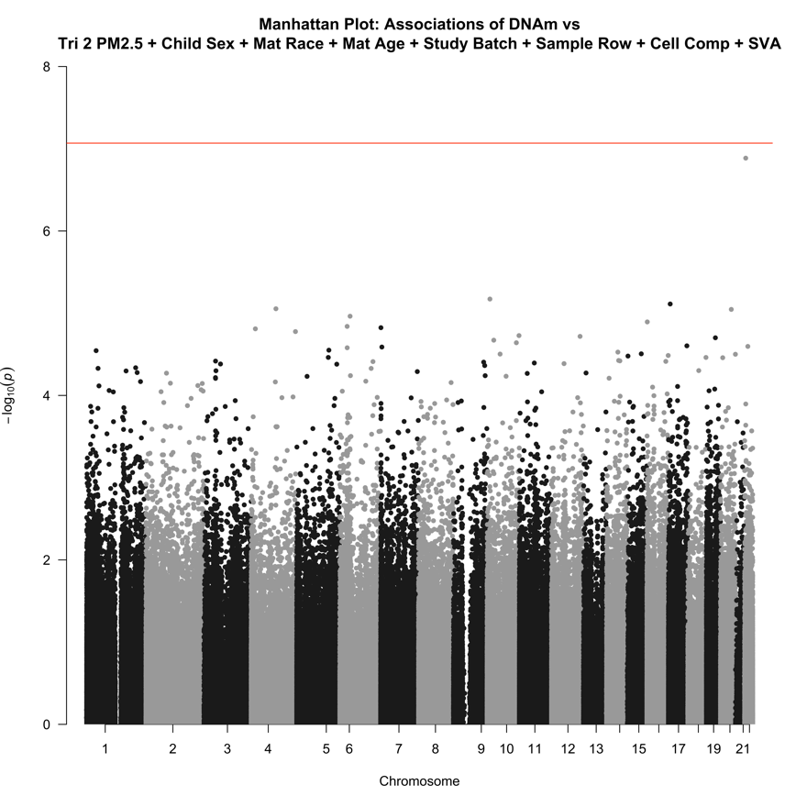
eFigure 4. Manhattan plots for the association between DNA methylation at each studied CpG site and PM_{2.5} averaged over trimester 2 of pregnancy adjusted for specified covariates. The vertical axis plots the negative log₁₀ p-value for each association. The Bonferroni cutoff for significance is denoted by the horizontal red line.

Combined
Analyzing average PM_{2.5} concentrations across the first two trimesters generated a genomic control factor of 0.881 and a QQ plot with minimal deviations from expected (eFigure 5). The SVA was not included in the model as it negatively impacted the QQ plot.

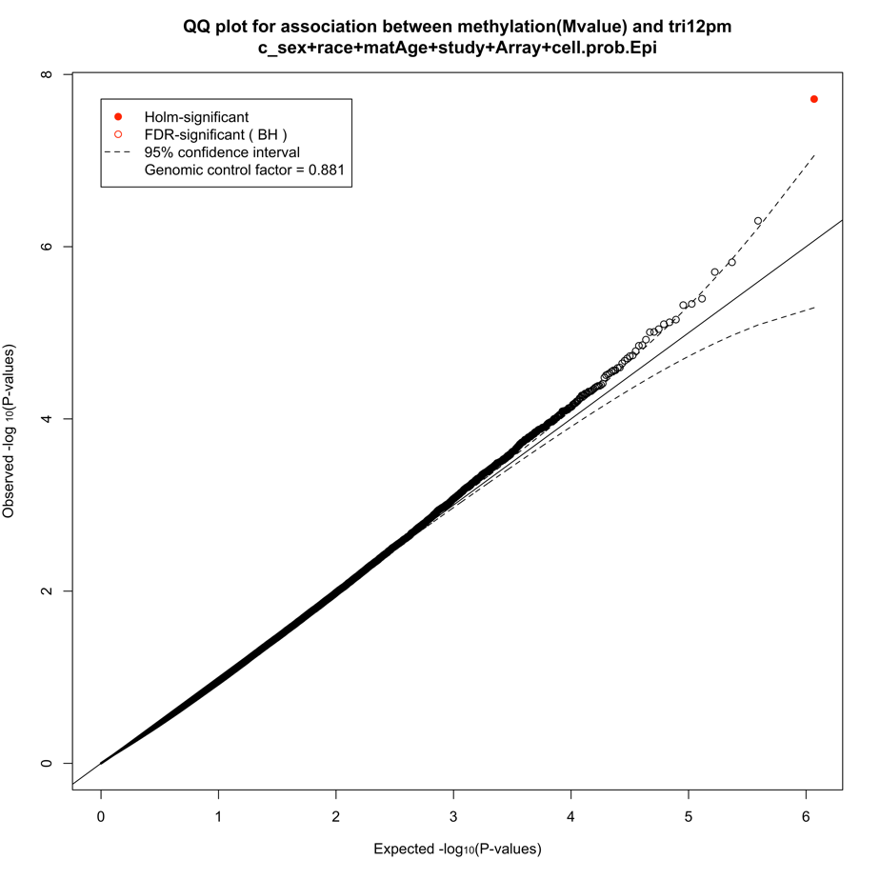
eFigure 5. QQ plot for the analysis between DNA methylation at each studied CpG site and PM_{2.5} averaged over trimesters 1 and 2 of pregnancy with observed and expected p-values transformed on a negative log₁₀ scale.

