Ambient exposures to selected volatile organic compounds and the risk of prostate cancer in Montreal

Mark S. Goldberg, Sara Zapata-Marin, France Labrèche, Vikki Ho, Eric Lavigne, Marie-France Valois, Marie-Elise Parent

Supplement

October 17, 2022

Estimating occupational exposures
During the in-depth interview, we used methods developed originally by Gérin, Siemiatycki and colleagues¹ to obtain detailed information on jobs. We used a semi-structured questionnaire that elicited details regarding participants’ work histories that included all jobs held during their lifetime. For jobs held for two or more years, we asked for a detailed description of their workplace characteristics, tasks, products, and equipment used, and protective measures. Thirty specialized questionnaires were also used for complex occupations.

We translated these job histories to occupational exposures ¹⁻⁴. Using a hybrid expert-based approach ⁴ which is an updated version of the expert-based method ¹, a team of trained chemists-hygienists, unaware of participants’ disease status, reviewed each job description to assign exposures to 345 chemical agents. These method of attributing exposure from detailed job histories using experts has been shown to be reliable ⁵⁻⁸.

For each agent and for each job, the coding team assigned three ordinal indicators: the degree of confidence that the exposure occurred (possible, probable, certain); the relative concentration level (low, medium, high, with low representing a level above the background environmental level); and the frequency of exposure in a usual workweek (<5%, 5-30%, 30-90%, 90-100%). The coding team used the literature and their experience, but they also consulted job-exposure profiles developed to provide guidelines on exposure patterns typically encountered in each occupation and derived from exposure data of some 20,000 jobs coded in previous population-based studies conducted by our group in Montreal ⁹. All jobs were coded by two different chemists with final ratings representing a consensus.
References
1. Gerin M, Siemiatycki J, Kemper H, Begin D. Obtaining occupational exposure histories in epidemiologic case-control studies. Journal of Occupational.Medicine. 1985;27(6):420-426.
2. Gerin M, Siemiatycki JS, Laroche LM. Translating job histories into histories of occupational exposure for epidemiological purposes. Job Exposure Matrices, Proceedings of a Conference 1983:78-82-78-82.
3. Stewart PA, Stewart WF, Siemiatycki J, Heineman EF, Dosemeci M. Questionnaires for collecting detailed occupational information for community-based case control studies. Am Ind.Hyg.Assoc.J 1998;59(1):39-44.
4. Sauve JF, Lavoue J, Nadon L, et al. A hybrid expert approach for retrospective assessment of occupational exposures in a population-based case-control study of cancer. Environ Health 2019;18(1):14.
5. Goldberg MS, Siemiatycki J, Gerin M. Inter-rater agreement in assessing occupational exposure in a case-control study. Br.J.Ind.Med. 1986;43(10):667-676.
6. Fritschi L, Nadon L, Benke G, et al. Validation of expert assessment of occupational exposures. Am.J.Ind.Med. 2003;43(5):519-522.
7. Florath I, Glass DC, Rhazi MS, Parent ME, Fritschi L. Inter-rater Agreement Between Exposure Assessment Using Automatic Algorithms and Using Experts. Ann Work Expo Health 2019;63(1):45-53.
8. Batisse E, Labrèche F, Goldberg MS, et al. Inter-rater reliability of occupational exposure assessment in a case-control study of female breast cancer. Journal of Occupational and Environmental Hygiene 2021:1-10.
9. Wynant W, Siemiatycki J, Parent ME, Rousseau MC. Occupational exposure to lead and lung cancer: results from two case-control studies in Montreal, Canada. Occup Environ Med 2013;70(3):164-70.
10. Goldberg MS, Baumgartner J, Chevrier J. Statistical adjustments of environmental pollutants arising from multiple sources in epidemiologic studies: The role of markers of complex mixtures. Atmospheric Environment 2022;270:118788.

Supplement Figure 1. Hypothetical and simplified directed acyclic graph. This DAG does not include all possible pathways between causal variables as it would overcomplicate the figure.

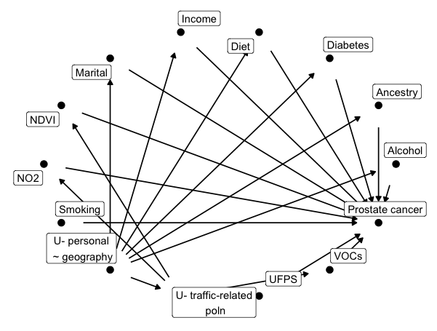
Open backdoor paths
voc -> br
voc <- u2 -> ndvi -> br
voc <- u2 -> no2 -> br
voc <- u2 -> ufp -> br
voc <- u2 <- u1 -> afftp -> br
voc <- u2 <- u1 -> alc -> br
voc <- u2 <- u1 -> bmi -> br
voc <- u2 <- u1 -> educn -> br
voc <- u2 <- u1 -> ethnic -> br
voc <- u2 <- u1 -> smk -> br

Supplemental Figure 2. Age-adjusted response functions for the five VOCs and the risk of prostate cancer. The dark line represents the maximum likelihood fit using a natural cubic spline function on 3 degrees of freedom. The grey band shows the 95% confidence interval, and the rug plots are shown in the bottom (for controls) and top (for cases) parts of the figures.
Supplemental Figure 2.1 Mean estimate for benzene (µg/m³)
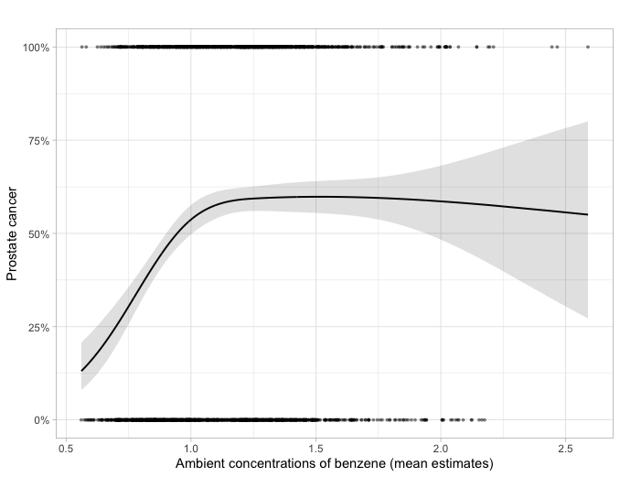
Supplemental Figure 2.2 Mean estimate for n-decane (µg/m³)
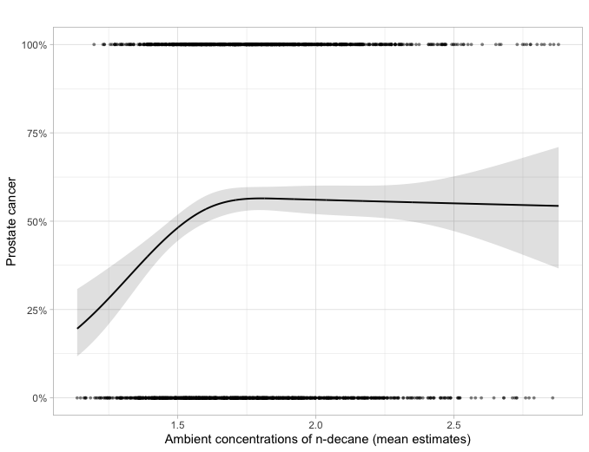
Supplemental Figure 2.3 Mean estimate for ethylbenzene (µg/m³)
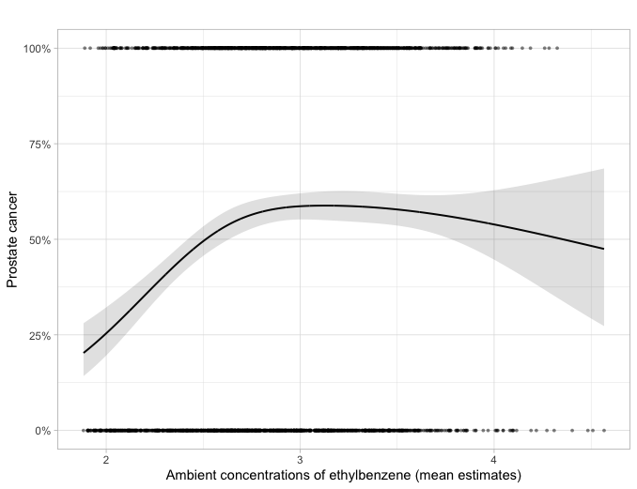
Supplemental Figure 2.4 Mean estimate for hexane (µg/m³)
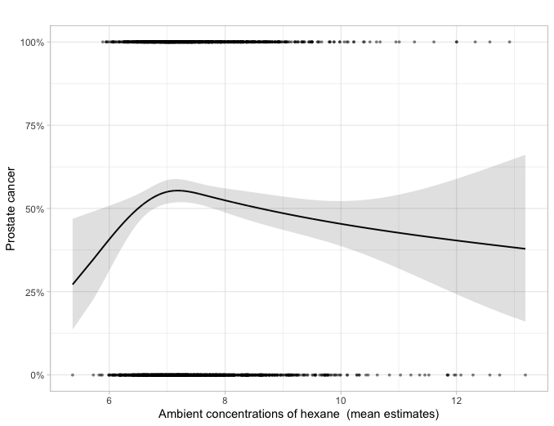

Supplemental Figure 2.5 Mean estimate for 1,2,4-trimethylbenzene (µg/m³)
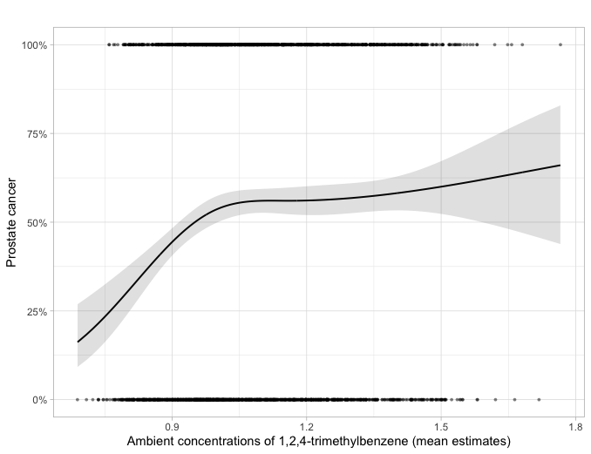

Supplement Figures 3. Trends in selected VOCs according to four fixed-site monitoring stations in Montreal of the Canadian National Air Pollution Surveillance Program (NAPS)
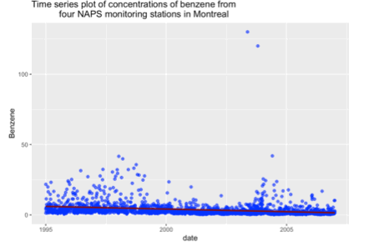
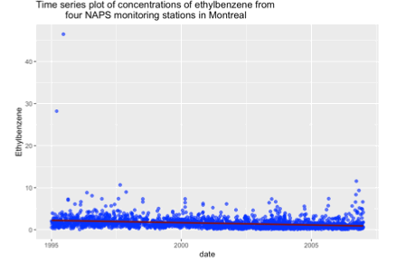
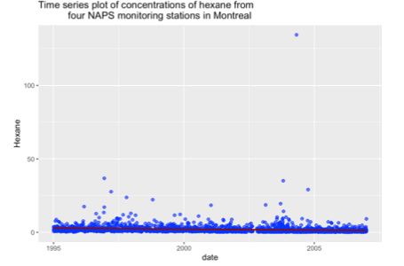
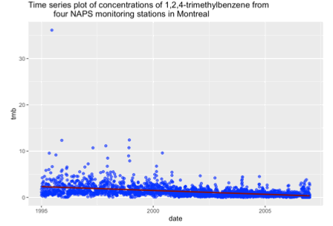
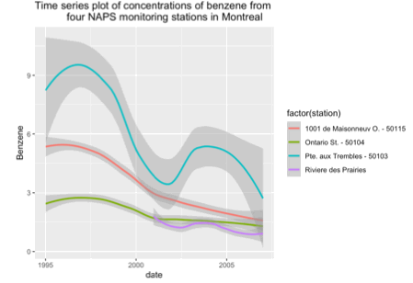
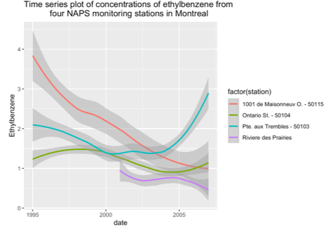
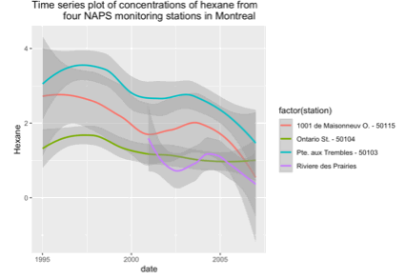
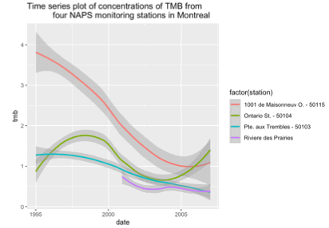

Supplemental Table 1. Analytical detection limits for the VOCs (from the August 2006 survey) in ng/µL

 | Detection Limit (ng/µL)¹
Benzene | 0.014
n-decane | 0.024
Ethylbenzene | 0.011
Hexane | 0.024
1,2,4-Trimethylbenzene | 0.010

¹ Detection limits for the study were based on the U.S. Federal Register CFR 40 method.

According TSI, the manufacturer of the Condensation Particle Counter 3007 (https://tsi.com/products/particle-counters-and-detectors/condensation-particle-counters/condensation-particle-counter-3007/), the range is 0 – 100,000 particles/cm³ (particle size range of 0.01 to >1.0 µm). For the Ogawa passive diffusion monitor that we used to measure 2-week integrated samples of NO₂, we estimated the detection limit as 0.01- 0.02 µg/m³. There are no detection limits for the occupational exposures as these were assessed by an expert team of coders.

Supplemental Table 2. Covariables included in the unconditional logistic regression models*
 | Covariables
Model-1 | VOC + age
Model-2 | M1 + ancestry + 1st degree family history + family income + marital status + smoking + alcohol + diet + history of diabetes
Model-3 | M2 - any covariables in Model-2 that are not associated with the VOC (“5% rule”¹)
Model-4 | M3 + NDVI
Model-5 | M4 + set of socio-demographic, contextual variables from the census
Model-6 | M5 + ultrafines + NO₂
Model-7 | M6 - any covariables in Model-6 that are not associated with the VOC (“5% rule”¹))
Model-8 | M1 + all occupational exposures by duration of exposure for reliability of exposure greater than possible
Model-9 | M7 + all occupational exposures by duration of exposure for reliability of exposure greater than possible
Model-10 | M9 - any covariables in Model-9 that are not associated with the VOC (“5% rule”¹))
Modelling all VOCs together
 | M1, M2, and M7 + all 5 VOCs together

* Models were developed for each VOC using the mean and median values in separate models. See the supplement for the directed acyclic graph.
¹ The 5% rule refers to excluding a variable that, in the age-adjusted models for each VOC, did not change the estimate of effect by more than 5%. For VOCs modeled as cubic splines, we applied this rule to any of the regression coefficients on the natural cubic spline function.

Supplement Tables 3. Complete results for all models

Table 3.1 Associations for ambient benzene (µg/m³)
 | Model 1 |  | Model 2 | Model 3 | Model 4 | Model 5 | Model 6 | Model 7 | Model 8 | Model 9 | Model 10
 | OR (95% CI) |  | OR (95% CI) | OR (95% CI) | OR (95% CI) | OR (95% CI) | OR (95% CI) | OR (95% CI) | OR (95% CI) | OR (95% CI) | OR (95% CI)
Mean benzene – change from 5% to 25% percentile (0.73 to 0.92) |  | 2.35 (1.82, 3.03) | 2.28 (1.76, 2.95) | 2.35 (1.82, 3.03) | 2.24 (1.73, 2.90) | 1.99 (1.47, 2.70) | 2.01 (1.48, 2.73) | 2.00 (1.47, 2.71) | 2.34 (1.81, 3.02) | 2.00 (1.47, 2.72) | 2.00 (1.47, 2.71)
Mean benzene – change from 25% to 75% percentile (0.92 to 1.33) |  | 1.60 (1.33, 1.93) | 1.65 (1.35, 2.01) | 1.60 (1.33, 1.93) | 1.52 (1.25, 1.84) | 1.42 (1.15, 1.75) | 1.50 (1.19, 1.88) | 1.42 (1.16, 1.74) | 1.59 (1.32, 1.92) | 1.42 (1.16, 1.75) | 1.42 (1.16, 1.74)
Mean benzene – change from 75% to 95% percentile (1.33 to 1.64) |  | 1.01 (0.88, 1.15) | 1.01 (0.88, 1.16) | 1.01 (0.88, 1.15) | 1.00 (0.87, 1.15) | 0.93 (0.79, 1.09) | 0.94 (0.80, 1.09) | 0.95 (0.82, 1.10) | 1.00 (0.87, 1.15) | 0.95 (0.82, 1.10) | 0.95 (0.82, 1.10)

Table 3.2 Associations for ambient n-decane

 | Model 1 | Model 2 | Model 3 | Model 4 | Model 5 | Model 6 | Model 7 | Model 8 | Model 9 | Model 10
 | OR (95% CI) | OR (95% CI) | OR (95% CI) | OR (95% CI) | OR (95% CI) | OR (95% CI) | OR (95% CI) | OR (95% CI) | OR (95% CI) | OR (95% CI)
Mean decane – IQR change (0.38) | 1.24 (1.12, 1.39) | 1.26 (1.12, 1.40) | 1.24 (1.12, 1.39) | 1.17 (1.05, 1.31) | 1.08 (0.95, 1.22) | 1.08 (0.95, 1.24) | 1.08 (0.96, 1.21) | 1.25 (1.12, 1.39) | 1.08 (0.96, 1.21) | 1.08 (0.96, 1.21)
Mean decane – change from 5% to 25% percentile (1.37 to 1.56) | 1.72 (1.38, 2.13) | 1.65 (1.32, 2.06) | 1.71 (1.38, 2.13) | 1.56 (1.24, 1.95) | 1.24 (0.97, 1.60) | 1.24 (0.97, 1.60) | 1.26 (0.98, 1.61) | 1.71 (1.38, 2.13) | 1.27 (0.99, 1.63) | 1.26 (0.98, 1.61)
Mean decane – change from 25% to 75% percentile (1.56 to 1.94) | 1.20 (0.99, 1.46) | 1.21 (0.99, 1.48) | 1.19 (0.98, 1.44) | 1.16 (0.95, 1.41) | 1.05 (0.85, 1.30) | 1.06 (0.85, 1.31) | 1.09 (0.88, 1.33) | 1.21 (1.00, 1.47) | 1.09 (0.88, 1.33) | 1.09 (0.88, 1.33)
Mean decane – change from 75% to 95% percentile (1.94 to 2.30) | 0.97 (0.82, 1.15) | 1.01 (0.85, 1.21) | 1.00 (0.84, 1.18) | 0.97 (0.82, 1.15) | 1.03 (0.86, 1.23) | 1.03 (0.86, 1.24) | 0.97 (0.82, 1.16) | 0.97 (0.82, 1.15) | 0.97 (0.82, 1.16) | 0.97 (0.82, 1.16)

Table 3.3 Associations for ambient ethylbenzene

 | Model 1 | Model 2 | Model 3 | Model 4 | Model 5 | Model 6 | Model 7 | Model 8 | Model 9 | Model 10
 | OR (95% CI) | OR (95% CI) | OR (95% CI) | OR (95% CI) | OR (95% CI) | OR (95% CI) | OR (95% CI) | OR (95% CI) | OR (95% CI) | OR (95% CI)
Mean ethylbenzene – change from 5% to 25% percentile (2.08 to 2.55) | 2.55 (1.91, 3.40) | 2.47 (1.84, 3.33) | 2.55 (1.91, 3.40) | 2.37 (1.76, 3.20) | 1.79 (1.20, 2.66) | 1.79 (1.20, 2.67) | 1.82 (1.26, 2.62) | 2.48 (1.86, 3.32) | 1.78 (1.23, 2.57) | 1.82 (1.26, 2.62)
Mean ethylbenzene – change from 25% to 75% percentile (2.55 to 3.22) | 1.35 (1.10, 1.66) | 1.37 (1.10, 1.71) | 1.35 (1.10, 1.66) | 1.27 (1.02, 1.58) | 1.16 (0.92, 1.47) | 1.16 (0.90, 1.49) | 1.34 (1.07, 1.68) | 1.36 (1.11, 1.68) | 1.35 (1.07, 1.69) | 1.34 (1.07, 1.68)
Mean ethylbenzene – change from 75% to 95% percentile (3.22 to 3.70) | 0.91 (0.75, 1.11) | 0.93 (0.76, 1.13) | 0.91 (0.75, 1.11) | 0.89 (0.73, 1.08) | 0.88 (0.72, 1.07) | 0.88 (0.71, 1.08) | 0.89 (0.73, 1.08) | 0.91 (0.75, 1.10) | 0.88 (0.72, 1.08) | 0.89 (0.73, 1.08)

Table 3.4 Associations for ambient hexane
 | Model 1 |  | Model 2 | Model 3 | Model 4 | Model 5 | Model 6 | Model 7 |  | Model 8 | Model 9 | Model 10
 | OR (95% CI) |  | OR (95% CI) | OR (95% CI) | OR (95% CI) | OR (95% CI) | OR (95% CI) | OR (95% CI) |  | OR (95% CI) | OR (95% CI) | OR (95% CI)
Mean hexane – change from 5% to 25% percentile (6.38 to 6.88) |  | 1.28  (1.06, 1.56) | 1.24  (1.02, 1.52) | 1.28  (1.06, 1.56) | 1.21  (0.99, 1.47) | 1.15  (0.94, 1.40) | 1.15  (0.94, 1.41) |  | 1.28  (1.06, 1.56) | 1.29  (1.07, 1.57) | 1.29  (1.07, 1.57) | 1.28  (1.06, 1.56)
Mean hexane– change from 25% to 75% percentile (6.88 to 7.90) |  | 0.94  (0.81, 1.10) | 0.95  (0.81, 1.11) | 0.94  (0.81, 1.10) | 0.81  (0.69, 0.95) | 0.85  (0.72, 1.01) | 0.85  (0.72, 1.01) |  | 0.94  (0.81, 1.10) | 0.94  (0.80, 1.09) | 0.94  (0.80, 1.09) | 0.94  (0.81, 1.10)
Mean hexane– change from 75% to 95% percentile (7.90 to 9.19) |  | 0.82  (0.71, 0.95) | 0.84  (0.73, 0.98) | 0.82  (0.71, 0.95) | 0.73  (0.63, 0.84) | 0.80  (0.69, 0.94) | 0.80  (0.69, 0.94) |  | 0.82  (0.71, 0.95) | 0.81  (0.70, 0.94) | 0.81  (0.70, 0.94) | 0.82  (0.71, 0.95)

Table 3.5 Associations for ambient 1,2,4 trimethylbenzene (TMB)

 | Model 1 | Model 2 | Model 3 | Model 4 | Model 5 | Model 6 | Model 7 | Model 8 | Model 9 | Model 10
 | OR (95% CI) | OR (95% CI) | OR (95% CI) | OR (95% CI) | OR (95% CI) | OR (95% CI) | OR (95% CI) | OR (95% CI) | OR (95% CI) | OR (95% CI)
Mean TMB – change from 5% to 25% percentile (0.83 to 0.96) | 1.94 (1.51, 2.49) | 1.87 (1.45, 2.41) | 1.94 (1.51, 2.49) | 1.79 (1.38, 2.31) | 1.31 (0.96, 1.78) | 1.31 (0.96, 1.78) | 1.33 (0.98, 1.79) | 1.90 (1.48, 2.44) | 1.32 (0.97, 1.78) | 1.33 (0.98, 1.79)
Mean TMB – change from 25% to 75% percentile (0.96 to 1.21) | 1.24 (1.00, 1.53) | 1.26 (1.01, 1.57) | 1.24 (1.00, 1.53) | 1.13 (0.91, 1.42) | 1.03 (0.80, 1.33) | 1.03 (0.79, 1.36) | 1.03 (0.80, 1.32) | 1.25 (1.01, 1.54) | 1.02 (0.80, 1.32) | 1.03 (0.80, 1.32)
Mean TMB – change from 75% to 95% percentile (1.21 to 1.43) | 1.11 (0.89, 1.39) | 1.15 (0.91, 1.45) | 1.11 (0.89, 1.39) | 1.06 (0.85, 1.34) | 1.02 (0.80, 1.29) | 1.01 (0.78, 1.31) | 1.03 (0.81, 1.32) | 1.12 (0.89, 1.40) | 1.03 (0.81, 1.31) | 1.03 (0.81, 1.32)

Supplement Tables 4. Complete Results for high- and low-grade tumours
Table 4.1 Associations for ambient benzene

 | Model 1 | Model 2 | Model 3 | Model 4 | Model 5 | Model 6 | Model 7 | Model 8 | Model 9 | Model 10
 | OR (95% CI) | OR (95% CI) | OR (95% CI) | OR (95% CI) | OR (95% CI) | OR (95% CI) | OR (95% CI) | OR (95% CI) | OR (95% CI) | OR (95% CI)
High grade
Mean benzene – change from 5% to 25% percentile (0.72 to 0.89) | 2.83  (1.82, 4.40) | 2.65  (1.69, 4.14) | 2.83  (1.82, 4.40) | 2.65  (1.69, 4.14) | 2.14  (1.28, 3.59) | 2.15  (1.28, 3.59) | 2.15  (1.28, 3.60) | 2.75  (1.76, 4.28) | 2.06  (1.23, 3.47) | 2.15  (1.28, 3.60)
Mean benzene – change from 25% to 75% percentile (0.89 to 1.32) | 1.78  (1.34, 2.37) | 1.69  (1.25, 2.28) | 1.78  (1.34, 2.37) | 1.65  (1.23, 2.21) | 1.54  (1.11, 2.13) | 1.60  (1.12, 2.27) | 1.55  (1.12, 2.15) | 1.80  (1.35, 2.39) | 1.56  (1.12, 2.16) | 1.55  (1.12, 2.15)
Mean benzene – change from 75% to 95% percentile (1.32 to 1.64) | 0.99  (0.80, 1.21) | 0.97  (0.78, 1.20) | 0.99  (0.80, 1.21) | 0.98  (0.79, 1.20) | 0.97  (0.76, 1.23) | 0.97  (0.77, 1.23) | 0.98  (0.78, 1.24) | 0.99  (0.80, 1.22) | 1.00  (0.79, 1.27) | 0.98  (0.78, 1.24)
Low grade
Mean benzene – change from 5% to 25% percentile (0.73 to 0.91) | 2.17  (1.64, 2.87) | 2.12  (1.59, 2.82) | 2.17  (1.64, 2.87) | 2.09  (1.57, 2.78) | 2.05  (1.48, 2.84) | 2.07  (1.49, 2.86) | 2.43  (1.79, 3.31) | 2.17  (1.64, 2.88) | 2.04  (1.47, 2.82) | 2.43  (1.79, 3.31)
Mean benzene – change from 25% to 75% percentile (0.91 to 1.33) | 1.64  (1.34, 2.02) | 1.75  (1.41, 2.18) | 1.64  (1.34, 2.02) | 1.56  (1.26, 1.94) | 1.42  (1.12, 1.79) | 1.54  (1.19, 1.98) | 1.64  (1.32, 2.02) | 1.64  (1.33, 2.02) | 1.43  (1.13, 1.81) | 1.64  (1.32, 2.02)
Mean benzene – change from 75% to 95% percentile (1.33 to 1.64) | 1.02  (0.87, 1.18) | 1.01  (0.86, 1.18) | 1.02  (0.87, 1.18) | 1.01  (0.87, 1.18) | 0.94  (0.79, 1.11) | 0.95  (0.80, 1.12) | 0.95  (0.81, 1.12) | 1.00  (0.86, 1.17) | 0.94  (0.79, 1.11) | 0.95  (0.81, 1.12)

Table 4.2 Associations for ambient n-decane

 | Model 1 | Model 2 | Model 3 | Model 4 | Model 5 | Model 6 | Model 7 | Model 8 | Model 9 | Model 10
 | OR (95% CI) | OR (95% CI) | OR (95% CI) | OR (95% CI) | OR (95% CI) | OR (95% CI) | OR (95% CI) | OR (95% CI) | OR (95% CI) | OR (95% CI)
High grade
Mean n-decane – change from 5% to 25% percentile (1.36 to 1.55) | 2.25  (1.48, 3.42) | 2.11  (1.38, 3.25) | 2.25  (1.48, 3.42) | 2.01  (1.31, 3.09) | 1.68  (1.04, 2.72) | 1.68  (1.04, 2.72) | 1.55  (0.97, 2.48) | 2.24  (1.47, 3.41) | 1.55  (0.97, 2.49) | 1.55  (0.97, 2.48)
Mean n-decane – change from 25% to 75% percentile (1.55 to 1.94) | 1.43  (1.07, 1.91) | 1.41  (1.04, 1.91) | 1.43  (1.07, 1.91) | 1.38  (1.03, 1.85) | 1.29  (0.95, 1.75) | 1.30  (0.95, 1.79) | 1.30  (0.96, 1.77) | 1.43  (1.07, 1.91) | 1.29  (0.95, 1.75) | 1.30  (0.96, 1.77)
Mean n-decane – change from 75% to 95% percentile (1.94 to 2.29) | 0.98  (0.77, 1.24) | 1.00  (0.78, 1.28) | 0.98  (0.77, 1.24) | 0.94  (0.74, 1.20) | 0.95  (0.74, 1.22) | 0.95  (0.73, 1.23) | 0.95  (0.74, 1.22) | 0.98  (0.77, 1.24) | 0.95  (0.74, 1.22) | 0.95  (0.74, 1.22)
Low grade
Mean n-decane – change from 5% to 25% percentile (1.36 to 1.55) | 1.62  (1.27, 2.07) | 1.57  (1.22, 2.02) | 1.62  (1.27, 2.07) | 1.47  (1.15, 1.90) | 1.17  (0.88, 1.54) | 1.17  (0.88, 1.54) | 1.20  (0.91, 1.59) | 1.63  (1.28, 2.09) | 1.22  (0.92, 1.61) | 1.20  (0.91, 1.59)
Mean n-decane – change from 25% to 75% percentile (1.55 to 1.93) | 1.15  (0.93, 1.41) | 1.15  (0.93, 1.43) | 1.15  (0.93, 1.41) | 1.12  (0.90, 1.38) | 0.95  (0.76, 1.19) | 0.96  (0.76, 1.22) | 1.04  (0.84, 1.30) | 1.15  (0.93, 1.42) | 1.04  (0.84, 1.30) | 1.04  (0.84, 1.30)
Mean n-decane – change from 75% to 95% percentile (1.93 to 2.30) | 0.96  (0.80, 1.17) | 1.01  (0.83, 1.23) | 0.96  (0.80, 1.17) | 0.93  (0.77, 1.13) | 0.99  (0.82, 1.20) | 0.99  (0.81, 1.22) | 0.94  (0.78, 1.14) | 0.96  (0.79, 1.16) | 0.93  (0.77, 1.13) | 0.94  (0.78, 1.14)

Table 4.3 Associations for ambient ethylbenzene

 | Model 1 | Model 2 | Model 3 | Model 4 | Model 5 | Model 6 | Model 7 | Model 8 | Model 9 | Model 10
 | OR (95% CI) | OR (95% CI) | OR (95% CI) | OR (95% CI) | OR (95% CI) | OR (95% CI) | OR (95% CI) | OR (95% CI) | OR (95% CI) | OR (95% CI)
High grade
Mean ethylbenzene – change from 5% to 25% percentile (2.05 to 2.50) | 2.23  (1.64, 3.02) | 2.09  (1.53, 2.87) | 2.23  (1.64, 3.02) | 1.98  (1.44, 2.73) | 1.51  (1.01, 2.26) | 1.49  (0.99, 2.23) | 1.54  (1.05, 2.28) | 2.20  (1.62, 2.98) | 1.52  (1.03, 2.24) | 1.54  (1.05, 2.28)
Mean ethylbenzene – change from 25% to 75% percentile (2.50 to 3.17) | 1.60  (1.31, 1.96) | 1.51  (1.22, 1.87) | 1.60  (1.31, 1.96) | 1.42  (1.13, 1.78) | 1.16  (0.88, 1.54) | 1.13  (0.84, 1.51) | 1.23  (0.94, 1.62) | 1.59  (1.30, 1.95) | 1.21  (0.92, 1.60) | 1.23  (0.94, 1.62)
Mean ethylbenzene – change from 75% to 95% percentile (3.17 to 3.66) | 0.76  (0.59, 1.00) | 0.76  (0.57, 1.00) | 0.76  (0.59, 1.00) | 0.73  (0.56, 0.96) | 0.75  (0.57, 1.00) | 0.73  (0.54, 0.98) | 0.80  (0.61, 1.05) | 0.77  (0.59, 1.01) | 0.80  (0.61, 1.05) | 0.80  (0.61, 1.05)
Low grade
Mean ethylbenzene – change from 5% to 25% percentile (2.07 to 2.54) | 2.04  (1.65, 2.52) | 2.08  (1.67, 2.60) | 2.04  (1.65, 2.52) | 1.94  (1.56, 2.43) | 1.62  (1.22, 2.14) | 1.63  (1.23, 2.16) | 1.86  (1.44, 2.40) | 2.03  (1.64, 2.51) | 1.85  (1.43, 2.39) | 1.86  (1.44, 2.40)
Mean ethylbenzene – change from 25% to 75% percentile (2.54 to 3.22) | 1.59  (1.39, 1.82) | 1.64  (1.42, 1.90) | 1.59  (1.39, 1.82) | 1.51  (1.30, 1.77) | 1.32  (1.10, 1.60) | 1.36  (1.11, 1.66) | 1.51  (1.28, 1.79) | 1.59  (1.39, 1.82) | 1.51  (1.27, 1.79) | 1.51  (1.28, 1.79)
Mean ethylbenzene – change from 75% to 95% percentile (3.22 to 3.70) | 0.89  (0.74, 1.07) | 0.91  (0.75, 1.10) | 0.89  (0.74, 1.07) | 0.87  (0.72, 1.05) | 0.88  (0.72, 1.08) | 0.91  (0.73, 1.12) | 0.92  (0.76, 1.10) | 0.89  (0.74, 1.07) | 0.92  (0.76, 1.11) | 0.92  (0.76, 1.10)

Table 4.4 Associations for ambient hexane

 | Model 1 | Model 2 | Model 3 | Model 4 | Model 5 | Model 6 | Model 7 | Model 8 | Model 9 | Model 10
 | OR (95% CI) | OR (95% CI) | OR (95% CI) | OR (95% CI) | OR (95% CI) | OR (95% CI) | OR (95% CI) | OR (95% CI) | OR (95% CI) | OR (95% CI)
High grade
Mean hexane – change from 5% to 25% percentile (6.35 to 6.86) | 1.39  (1.01, 1.92) | 1.32  (0.95, 1.85) | 1.39  (1.01, 1.92) | 1.28  (0.92, 1.77) | 1.30  (0.93, 1.81) | 1.30  (0.93, 1.82) | 1.28  (0.92, 1.77) | 1.42  (1.03, 1.97) | 1.30  (0.93, 1.80) | 1.28  (0.92, 1.77)
Mean hexane – change from 25% to 75% percentile (6.86 to 7.92) | 0.94  (0.73, 1.20) | 0.93  (0.72, 1.20) | 0.94  (0.73, 1.20) | 0.76  (0.59, 0.99) | 0.84  (0.64, 1.09) | 0.84  (0.64, 1.10) | 0.76  (0.59, 0.99) | 0.92  (0.72, 1.18) | 0.75  (0.57, 0.97) | 0.76  (0.59, 0.99)
Mean hexane – change from 75% to 95% percentile (7.92 to 9.20) | 0.71  (0.55, 0.92) | 0.74  (0.57, 0.95) | 0.71  (0.55, 0.92) | 0.61  (0.47, 0.80) | 0.68  (0.52, 0.90) | 0.68  (0.52, 0.90) | 0.61  (0.47, 0.80) | 0.70  (0.54, 0.90) | 0.60  (0.46, 0.78) | 0.61  (0.47, 0.80)
Low grade
Mean hexane – change from 5% to 25% percentile (6.38 to 6.87) | 1.05  (0.95, 1.16) | 1.03  (0.93, 1.15) | 1.05  (0.95, 1.16) | 0.97  (0.88, 1.08) | 0.94  (0.85, 1.06) | 0.94  (0.84, 1.05) | 0.97  (0.87, 1.09) | 1.05  (0.95, 1.17) | 0.98  (0.88, 1.09) | 0.97  (0.87, 1.09)
Mean hexane – change from 25% to 75% percentile (6.87 to 7.91) | 1.04  (0.90, 1.19) | 1.02  (0.88, 1.18) | 1.04  (0.90, 1.19) | 0.91  (0.78, 1.06) | 0.89  (0.76, 1.04) | 0.89  (0.76, 1.03) | 0.91  (0.79, 1.06) | 1.04  (0.90, 1.19) | 0.91  (0.79, 1.06) | 0.91  (0.79, 1.06)
Mean hexane – change from 75% to 95% percentile (7.91 to 9.24) | 0.91  (0.78, 1.05) | 0.93  (0.79, 1.08) | 0.91  (0.78, 1.05) | 0.82  (0.71, 0.96) | 0.86  (0.74, 1.01) | 0.86  (0.74, 1.01) | 0.83  (0.71, 0.96) | 0.90  (0.78, 1.04) | 0.82  (0.70, 0.96) | 0.83  (0.71, 0.96)

Table 4.5 Associations for ambient 1,2,4 trimethylbenzene (TMB)

 | Model 1 |  | Model 2 |  | Model 3 |  | Model 4 |  | Model 5 |  | Model 6 |  | Model 7 |  | Model 8 |  | Model 9 |  | Model 10
 | OR (95% CI) |  | OR (95% CI) |  | OR (95% CI) |  | OR (95% CI) |  | OR (95% CI) |  | OR (95% CI) |  | OR (95% CI) |  | OR (95% CI) |  | OR (95% CI) |  | OR (95% CI)
High grade
Mean TMB – change from 5% to 25% percentile (0.82 to 0.95) | 2.08  (1.34, 3.22) | 1.94  (1.24, 3.04) |  | 2.08  (1.34, 3.22) |  | 1.79  (1.14, 2.82) |  | 1.22  (0.73, 2.04) |  | 1.22  (0.73, 2.03) |  | 1.10  (0.67, 1.82) |  | 2.03  (1.30, 3.16) |  | 1.09  (0.66, 1.81) |  | 1.10  (0.67, 1.82)
Mean TMB – change from 25% to 75% percentile (0.95 to 1.20) | 1.32  (0.96, 1.80) | 1.26  (0.90, 1.74) |  | 1.32  (0.96, 1.80) |  | 1.12  (0.80, 1.57) |  | 0.97  (0.66, 1.42) |  | 0.91  (0.60, 1.37) |  | 1.01  (0.70, 1.47) |  | 1.34  (0.98, 1.84) |  | 1.01  (0.69, 1.47) |  | 1.01  (0.70, 1.47)
Mean TMB – change from 75% to 95% percentile (1.20 to 1.42) | 0.91  (0.65, 1.27) | 0.90  (0.64, 1.27) |  | 0.91  (0.65, 1.27) |  | 0.85  (0.60, 1.19) |  | 0.83  (0.58, 1.19) |  | 0.79  (0.54, 1.16) |  | 0.89  (0.62, 1.27) |  | 0.92  (0.66, 1.29) |  | 0.88  (0.61, 1.26) |  | 0.89  (0.62, 1.27)
Low grade
Mean TMB – change from 5% to 25% percentile (0.83 to 0.96) | 1.92  (1.45, 2.53) | 1.90  (1.42, 2.53) |  | 1.92  (1.45, 2.53) |  | 1.81  (1.35, 2.42) |  | 1.36  (0.97, 1.91) |  | 1.36  (0.97, 1.91) |  | 1.54  (1.11, 2.12) |  | 1.88  (1.42, 2.49) |  | 1.52  (1.10, 2.10) |  | 1.54  (1.11, 2.12)
Mean TMB – change from 25% to 75% percentile (0.96 to 1.21) | 1.23  (0.98, 1.54) | 1.29  (1.01, 1.64) |  | 1.23  (0.98, 1.54) |  | 1.15  (0.90, 1.47) |  | 1.06  (0.80, 1.39) |  | 1.11  (0.83, 1.49) |  | 1.15  (0.86, 1.53) |  | 1.24  (0.98, 1.55) |  | 1.16  (0.86, 1.55) |  | 1.15  (0.86, 1.53)
Mean TMB – change from 75% to 95% percentile (1.21 to 1.43) | 1.20  (0.94, 1.52) | 1.23  (0.96, 1.58) |  | 1.20  (0.94, 1.52) |  | 1.16  (0.91, 1.49) |  | 1.11  (0.85, 1.44) |  | 1.14  (0.87, 1.49) |  | 1.19  (0.91, 1.55) |  | 1.20  (0.95, 1.53) |  | 1.19  (0.91, 1.55) |  | 1.19  (0.91, 1.55)

Supplemental Table 5. Adjusted models for mean VOCs, for addresses in 1996 (1,625 participants)

 | change from 5% to 25% percentile | change from 25% to 75% percentile | change from 75% to 95% percentile
 | OR (95% CI) | OR (95% CI) | OR (95% CI)
 | Benzene
Mean benzene range | 0.74 to 0.93 | 0.93 to 1.31 | 1.31 to 1.63
Age adjusted | 2.30 (1.71, 3.09) | 1.35 (1.08, 1.68) | 0.90 (0.77, 1.07)
Model 2 | 2.16 (1.57, 2.97) | 1.50 (1.17, 1.93) | 0.92 (0.77, 1.10)
Model 7 | 2.41 (1.67, 3.48) | 1.26 (0.99, 1.60) | 0.82 (0.68, 0.99)
 | n-decane
Mean n-decane range | 1.37 to 1.56 | 1.56 to 1.94 | 1.94 to 2.27
Age adjusted | 1.55 (1.21, 1.99) | 1.07 (0.85, 1.34) | 1.01 (0.83, 1.22)
Model 2 | 1.52 (1.16, 2.00) | 1.11 (0.86, 1.43) | 1.04 (0.83, 1.30)
Model 7 | 1.25 (0.93, 1.67) | 0.98 (0.77, 1.25) | 0.97 (0.80, 1.18)
 | Ethylbenzene
Mean ethylbenzene range | 2.10 to 2.54 | 2.54 to 3.22 | 3.22 to 3.70
Age adjusted | 2.20 (1.60, 3.02) | 1.20 (0.93, 1.53) | 0.92 (0.74, 1.15)
Model 2 | 2.19 (1.56, 3.09) | 1.25 (0.94, 1.65) | 0.93 (0.73, 1.19)
Model 7 | 1.85 (1.23, 2.79) | 1.12 (0.84, 1.49) | 0.88 (0.70, 1.11)
 | Hexane
Mean hexane range | 6.37 to 6.89 | 6.89 to 7.82 | 7.82 to 9.06
Age adjusted | 1.12 (0.89, 1.41) | 0.96 (0.81, 1.14) | 0.96 (0.81, 1.15)
Model 2 | 1.15 (0.89, 1.49) | 0.99 (0.82, 1.19) | 0.98 (0.80, 1.19)
Model 7 | 1.05 (0.83, 1.33) | 0.86 (0.71, 1.02) | 0.87 (0.72, 1.04)
 | 1,2,4 trimethylbenzene
Mean TMB range | 0.83 to 0.96 | 0.96 to 1.22 | 1.22 to 1.44
Age adjusted | 1.65 (1.23, 2.20) | 1.22 (0.95, 1.59) | 0.90 (0.67, 1.21)
Model 2 | 1.57 (1.15, 2.14) | 1.28 (0.95, 1.71) | 0.92 (0.67, 1.27)
Model 7 | 1.19 (0.84, 1.67) | 0.96 (0.69, 1.33) | 0.79 (0.57, 1.10)

