Supplemental Material

Exposure to ultrafine particles and the incidence of asthma in children: A population-based open cohort study in Montreal, Canada.

Authors: Alan da Silveira Fleckª (co-first author), Julien Vachon^{a,e} (co-first author), Stéphane Buteau^{a,b}, Elhadji Anassour Laouan Sidi^{b}, Marianne Hatzopoulou^{c}, Scott Weichenthal^{d}, Audrey Smargiassi^{a,b,e}.
Affiliations:
ªDepartment of Environmental and Occupational Health, School of Public Health, University of Montreal, Montreal, Canada
^{b}Institut national de santé publique du Québec (INSPQ), Montreal, Canada
^{c}Department of Civil Engineering, University of Toronto, Toronto, Canada
^{d}Department of Epidemiology, Biostatistics, and Occupational Health, McGill University, Montreal, Canada
^{e}Center for Public Health Research (CReSP), University of Montreal and CIUSSS du Centre-Sud-de-l’Île-de-Montréal, Montreal, Canada

Correspondence: Audrey Smargiassi
7101 av. du Parc local 3259, Montréal, Québec, Canada,
E-mail : audrey.smargiassi@umontreal.ca,
Telephone: 514 343-6111 #38528

eTable 1. AIC and adjusted hazard ratio per interquartile range increment from single pollutant models for the association between childhood asthma onset and childhood exposure to ambient UFPs, NO₂ and PM_{2.5} in Montréal, Québec, Canada.^{a,b}
Models | UFPs |  | NO₂ |  | PM_{2.5}
 | AIC | HR (95% CI) | AIC | HR (95% CI) | AIC | HR (95% CI)
Crude model | 745,224 | 0.991 (0.984, 0.999) | 745,217 | 1.025 (1.011, 1.039) | 743,471 | 1.172 (1.163, 1.180)
+ Sex (strata)  + Quintile of material deprivation | 703,092 | 0.991 (0.984, 0.999) | 703,090 | 1.020 (1.006, 1.035) | 701,352 | 1.171 (1.163, 1.180)
+ Sex (strata)  + Quintile of social deprivation  + Quintile of material deprivation | 703,089 | 0.991 (0.983, 0.998) | 703,088 | 1.021 (1.006, 1.037) | 701,326 | 1.174 (1.165, 1.182)
+ Sex (strata)  + Quintile of material deprivation  + Calendar year (strata) | 544,064 | 0.991 (0.984, 0.999) | 544,058 | 1.025 (1.011, 1.040) | 544,045 | 1.026 (1.015, 1.036)
+ Sex (strata)  + Quintile of social deprivation  + Quintile of material deprivation  + Calendar year (strata) | 544,055 | 0.990 (0.983, 0.998) | 544,054 | 1.022 (1.007, 1.038) | 544,041 | 1.025 (1.014, 1.035)
Non-linear pollutant (spline)  + Sex (strata)  + Quintile of social deprivation  + Quintile of material deprivation  + Calendar year (strata) | 544,050 | - | 544,051 | - | 544,030 | -
Abbreviations: AIC, Akaike information criterion; CI, confidence interval; HR, hazard ratio.
ª Crude model: Cox model for air pollutant(s) exposure fitted as linear.
^{b} Interquartile range (IQR) increments are 3,427 particles/cm³ for UFPs, 11.06 ppb for NO₂ and 0.77 µg/m³ for PM_{2.5}

eTable 2. AIC and adjusted hazard ratio per interquartile range increment from multipollutant models for the association between childhood asthma onset and childhood exposure to ambient UFPs, NO₂ and PM_{2.5} in Montréal, Québec, Canada.^{a,b}
Models | UFPs + NO₂ |  |  | UFPs + PM_{2.5} |  |  | UFPs + NO₂ + PM_{2.5}
 | AIC | HR (95% CI) for UFPs | HR (95% CI) for NO₂ | AIC | HR (95% CI) | HR (95% CI) for PM_{2.5} | AIC | HR (95% CI) for UFPs | HR (95% CI) for NO₂ | HR (95% CI) for PM_{2.5}
Crude model | 745,209 | 0.987 (0.980, 0.995) | 1.031 (1.017, 1.046) | 743,458 | 0.985 (0.978, 0.993) | 1.172 (1.164, 1.181) | 743,352 | 0.995 (0.987, 1.003) | 0.922 (0.908, 0.937) | 1.186 1.177, 1.195)
+ Sex (strata)  + Quintile of material deprivation | 703,083 | 0.988 (0.981, 0.996) | 1.025 (1.011, 1.041) | 701,339 | 0.986 (0.978, 0.993) | 1.172 (1.163, 1.180) | 701,224 | 0.995 (0.988, 1.003) | 0.917 (0.904, 0.932) | 1.187 (1.178, 1.196)
+ Sex (strata)  + Quintile of social deprivation  + Quintile of material deprivation | 703,080 | 0.988 (0.980, 0.996) | 1.027 (1.012, 1.043) | 701,316 | 0.987 (0.979, 0.994) | 1.174 (1.165, 1.183) | 701,217 | 0.995 (0.988, 1.003) | 0.920 (0.906, 0.936) | 1.187 (1.178, 1.196)
+ Sex (strata)  + Quintile of material deprivation  + Calendar year (strata) | 544,049 | 0.987 (0.980, 0.995) | 1.031 (1.016, 1.047) | 544,040 | 0.990 (0.983, 0.997) | 1.026 (1.016, 1.037) | 544,039 | 0.988 (0.981, 0.996) | 1.015, 0.999, 1.033) | 1.021 (1.009, 1.033)
+ Sex (strata)  + Quintile of social deprivation  + Quintile of material deprivation  + Calendar year (strata) | 544,045 | 0.987 (0.979, 0.995) | 1.029 (1.013, 1.04) | 544,035 | 0.989 (0.982, 0.997) | 1.025 (1.015, 1.036) | 544,034 | 0.988 (0.981, 0.996) | 1.012 (0.996, 1.032) | 1.021 (1.009, 1.033)
Non-linear pollutants (spline)  + Sex (strata)  + Quintile of social deprivation  + Quintile of material deprivation  + Calendar year (strata) | 544,038 | - | - | 544,019 | - | - | 544,017 | - | - | -
Abbreviations: AIC, Akaike information criterion; CI, confidence interval; HR, hazard ratio.
ª Crude model: Cox model for air pollutant(s) exposure fitted as linear.
^{b} Interquartile range (IQR) increments are 3,427 particles/cm³ for UFPs, 11.06 ppb for NO₂ and 0.77 µg/m³ for PM_{2.5}

eTable 3. AIC and adjusted hazard ratio per interquartile range increment from single pollutant models for the association between childhood asthma onset and prenatal exposure to ambient UFPs, NO₂ and PM_{2.5} in Montréal, Québec, Canada.^{a,b}
Models | UFPs |  | NO₂ |  | PM_{2.5}
 | AIC | HR (95% CI) | AIC | HR (95% CI) | AIC | HR (95% CI)
Crude model | 752,915 | 0.988 (0.980, 0.996) | 748,085 | 1.023 (1.012, 1.035) | 705,506 | 1.340 (1.325, 1.357)
+ Sex (strata)  + Quintile of material deprivation | 710,394 | 0.987 (0.980, 0.996) | 705,820 | 1.018 (1.005, 1.035) | 707,994 | 1.342 (1.327, 1.359)
+ Sex (strata)  + Quintile of social deprivation  + Quintile of material deprivation | 710,398 | 0.988 (0.980, 0.996) | 705,824 | 1.022 (1.006, 1.037) | 707,968 | 1.349 (1.332, 1.366)
+ Sex (strata)  + Quintile of material deprivation  + Calendar year (strata) | 551,125 | 0.988 (0.980, 0.996) | 547,477 | 1.024 (1.009, 1.035) | 550,928 | 1.065 (1.045, 1.084)
+ Sex (strata)  + Quintile of social deprivation  + Quintile of material deprivation  + Calendar year (strata) | 551,128 | 0.987 (0.980, 0.995) | 547,483 | 1.022 (1.006, 1.035) | 550,934 | 1.063 (1.045, 1.084)
Non-linear pollutant (spline)  + Sex (strata)  + Quintile of social deprivation  + Quintile of material deprivation  + Calendar year (strata) | 551,126 | - | 547,473 | - | 550,917 | -
Abbreviations: AIC, Akaike information criterion; CI, confidence interval; HR, hazard ratio.
ª Crude model: Cox model for air pollutant(s) exposure fitted as linear.
^{b} Interquartile range (IQR) increments are 3,785 particles/cm³ for UFPs, 11.48 ppb for NO₂ and 1.53 ug/m³ for PM_{2.5}

eTable 4. AIC and adjusted hazard ratio per interquartile range increment from multipollutant models for the association between childhood asthma onset and prenatal exposure to ambient UFPs, NO₂ and PM_{2.5} in Montréal, Québec, Canada.^{a,b}
Models | UFPs + NO₂ |  |  | UFPs + PM_{2.5} |  |  | UFPs + NO₂ + PM_{2.5}
 | AIC | HR (95% CI) for UFPs | HR (95% CI) for NO₂ | AIC | HR (95% CI) | HR (95% CI) for PM_{2.5} | AIC | HR (95% CI) for UFPs | HR (95% CI) for NO₂ | HR (95% CI) for PM_{2.5}
Crude model | 748,073 | 0.984 (0.976, 0.993) | 1.030 (1.015, 1.047) | 750,489 | 0.983 (0.975, 0.991) | 1.342 (1.327, 1.359) | 745,561 | 0.994 (0.986, 1.002) | 0.914 (0.900, 0.929) | 1.369 (1.352, 1.386)
+ Sex (strata)  + Quintile of material deprivation | 705,809 | 0.985 (0.977, 0.993) | 1.027 (1.010, 1.042) | 707,978 | 0.983 (0.975, 0.991) | 1.344 (1.327, 1.361) | 703,295 | 0.994 (0.986, 1.002) | 0.910 (0.895, 0.925) | 1.371 (1.354, 1.388)
+ Sex (strata)  + Quintile of social deprivation  + Quintile of material deprivation | 705,812 | 0.985 (0.976, 0.993) | 1.029 (1.013, 1.046) | 707,955 | 0.984 (0.976, 0.992) | 1.349 (1.332, 1.366) | 703,296 | 0.994 (0.986, 1.002) | 0.915 (0.900, 0.931) | 1.371 (1.354, 1.390)
+ Sex (strata)  + Quintile of material deprivation  + Calendar year (strata) | 547,463 | 0.984 (0.976, 0.992) | 1.031 (1.016, 1.048) | 550,918 | 0.986 (0.979, 0.994) | 1.065 (1.046, 1.085) | 547,274 | 0.986 (0.978, 0.994) | 1.005 (0.987, 1.023) | 1.062 (1.040, 1.084)
+ Sex (strata)  + Quintile of social deprivation  + Quintile of material deprivation  + Calendar year (strata) | 547,469 | 0.984 (0.975, 0.991) | 1.030 (1.014, 1.047) | 550,924 | 0.986 (0.978, 0.994) | 1.065 (1.046, 1.085) | 547,280 | 0.986 (0.978, 0.994) | 1.005 (0.986, 1.023) | 1.062 (1.040, 1.084)
Non-linear pollutants (spline)  + Sex (strata)  + Quintile of social deprivation  + Quintile of material deprivation  + Calendar year (strata) | 547,461 | - | - | 550,908 | - | - | 547,253 | - | - | -
Abbreviations: AIC, Akaike information criterion; CI, confidence interval; HR, hazard ratio.
ª Crude model: Cox model for air pollutant(s) exposure fitted as linear.
^{b} Interquartile range (IQR) increments are 3,785 particles/cm³ for UFPs, 11.48 ppb for NO₂ and 1.53 ug/m³ for PM_{2.5}

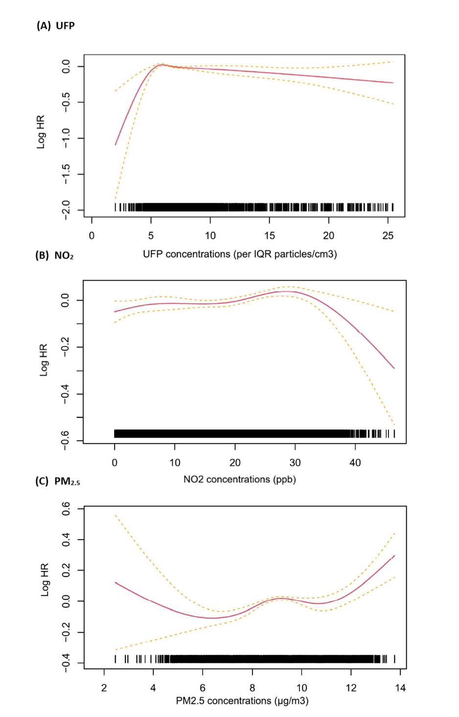
eFigure 1. Adjusted response functions between childhood exposure to (A) UFP, (B) NO₂ and (C) PM_{2.5} and the hazard of childhood-onset asthma in children born in Montreal. The horizontal axis represents the concentrations of UFPs, NO₂ and PM_{2.5}. The vertical axis represents the hazard ratio (HR). The solid red line represents the mean HR from the non-linear function fitted using restricted cubic splines with three knots (10th, 50th and 90th percentile of the exposure distribution), with the dashed blue lines representing the 95% confidence interval. The response functions are adjusted for quintiles of material deprivation, social deprivation, sex (as strata) and calendar year (as strata).
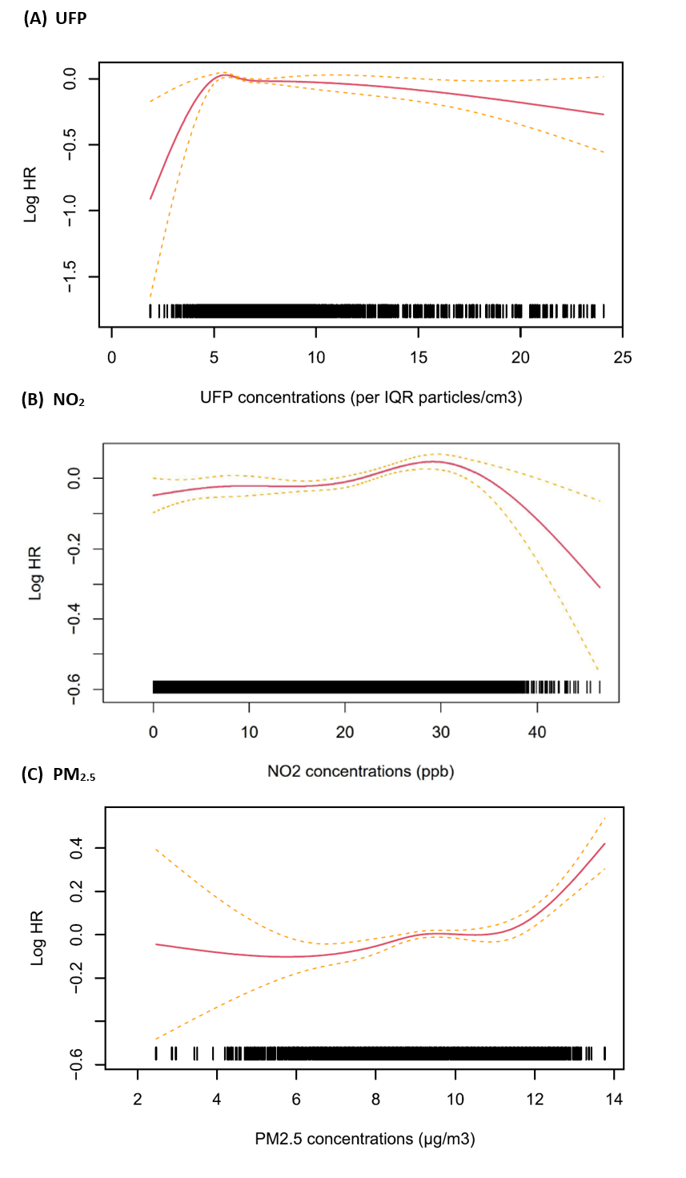
eFigure 2. Adjusted response functions between prenatal exposure to (A) UFP, (B) NO₂ and (C) PM_{2.5} and the hazard of childhood-onset asthma in children born in Montreal. The horizontal axis represents the concentrations of UFPs, NO₂ and PM_{2.5}. The vertical axis represents the log-hazard ratio (log HR). The solid red line represents the mean HR from the non-linear function fitted using restricted cubic splines with three knots (10th, 50th and 90th percentile of the exposure distribution), with the dashed orange lines representing the 95% confidence interval. The response functions are adjusted for quintiles of material deprivation, social deprivation, sex (as strata) and calendar year (as strata).

eFigure 3. Number of events (asthma cases) by age group in the cohort.

