SUPPLEMENTAL TABLES AND FIGURES

Table S1. Absolute difference in proportions of PTB pre-intervention versus post-intervention to reduce SO₂ emissions at CFPPs in NC for CFPP-scrubber, CFPP-retired, and CFPP-all: overall, stratified by early and moderate-to-late PTB, and stratified by gestational parent race/ethnicity.

Table S2. Sensitivity Analyses: Absolute difference in proportions of PTB pre-intervention versus post-intervention to reduce SO₂ emissions at 14 largest CFPPs in NC (pooled analyses).

Table S3. Sensitivity Analyses: Absolute difference in proportions of PTB pre-intervention versus post-intervention to reduce SO₂ emissions at 14 largest CFPPs in NC (plant-specific analyses).

Table S4. Distance between gestational parent home address at time of delivery and nearest CFPP, among gestational parents living <4 miles, by race/ethnicity

Figure S1. Flowchart for study population inclusion and exclusion

Figure S2. Distance (in miles) between the 14 largest CFPPs in North Carolina

Figure S3. Monthly SO₂ emissions (tons) reported by each CFPP. A) CFPP-scrubber. B) CFPP-retired. C) and D) show boxplots of monthly SO₂ emissions by 1 year pre- and post- intervention exposure windows. (For CFPP-retired, monthly SO2 emissions were 0 tons in the post-intervention period for Riverbend and essentially 0 tons for the other 6 CFPPs within CFPP-retired.)

Figure S4. Annual preterm birth prevalence nearby CFPP-GG Allen by distance buffer (0-<4 miles, 4-<10 miles, and 10-<15 miles) prior to installation of scrubbers in 2009

Figure S5. Unadjusted annual trends in means for key gestational parent sociodemographic characteristics by distance buffers (0-<4 miles, 4-<10 miles, and 10-<15 miles) nearby CFPP-GG Allen prior to installation of scrubbers in 2009

Figure S6. Meta-Analysis for CFPPs. Absolute difference in proportions of PTB pre-intervention versus post-intervention to reduce SO₂ emissions at CFPPs in NC by individual CFPP as well as grouped by CFPP-scrubber, CFPP-retired, and CFPP-all. Fixed = fixed effects. Random = random effects. Distance categories are 0 miles to less than 4 miles (grey circles) and 4 miles to less than 10 miles (black triangles), compared to 10 miles to less than 15 miles.

Table S1. Absolute difference in proportions of PTB pre-intervention versus post-intervention to reduce SO₂ emissions at CFPPs in NC for CFPP-scrubber, CFPP-retired, and CFPP-all: overall, stratified by early and moderate-to-late PTB, and stratified by gestational parent race/ethnicity.
 | CFPP-scrubber |  |  |  |  | CFPP-retired |  |  |  |  | CFPP-all
 | 0-<4 miles |  | 4-<10 miles |  | N for 10-<15 miles | 0-<4 miles |  | 4-<10 miles |  | N for 10-<15 miles | 0-<4 miles |  | 4-<10 miles |  | N for 10-<15 miles
 | Nª | DiD  (95% CI) | N | DiD  (95% CI) |  | N | DiD  (95% CI) | N | DiD  (95% CI) |  | N | DiD  (95% CI) | N | DiD  (95% CI)
PTB (dicotomous) | 1,892  171 | 0.015  (-0.010, 0.040) | 15,268  1,546 | -0.015  (-0.026,  -0.004) | 21,246  2,108 | 2,734  256 | 0.003  (-0.018, 0.025) | 15,022  1,361 | -0.005  (-0.016, 0.006) | 20,071  1,774 | 4,626  427 | 0.007  (-0.009, 0.023) | 30,290  2,907 | -0.010  (-0.018,  -0.002) | 41,317  3,882
PTB (polytomous)
Early PTB | 1,892  29 | 0.003  (-0.008, 0.014) | 15,268  237 | -0.001  (-0.006, 0.004) | 21,246  372 | 2,734  45 | 0.002  (-0.008, 0.012) | 15,022  221 | -0.004  (-0.008, 0.001) | 20,071  279 | 4,626  74 | 0.002  (-0.005, 0.010) | 30,290  458 | -0.002  (-0.006, 0.001) | 41,317  651
Moderate-to-late PTB | 1,892  142 | 0.012  (-0.011, 0.035) | 15,268  1,309 | -0.014  (-0.025,  -0.004) | 21,246  1,736 | 2,734  211 | 0.002  (-0.018, 0.022) | 15,022  1,140 | -0.002  (-0.012, 0.009) | 20,071  1,495 | 4,626  353 | 0.005  (-0.010, 0.020) | 30,290  2,449 | -0.008  (-0.015, 0.000) | 41,317  3,231
Gestational parent race/ethnicity
American Indian, nH^{b} | 10  0 | --- | 46  5 | --- | 51  7 | 148  16 | --- | 311  46 | --- | 509  56 | 158  16 | --- | 357  51 | --- | 560  63
Asian, nH^{c} | 82  4 | -0.040  (-0.139, 0.058) | 532  46 | -0.082  (-0.141,  -0.024) | 688  46 | 55  1 | --- | 438  31 | --- | 1,068  85 | 137  5 | --- | 970  77 | --- | 1,756  131
Black, nH | 182  28 | 0.019  (-0.075, 0.112) | 3,427  492 | -0.004  (-0.032, 0.023) | 4,884  736 | 817  112 | 0.019  (-0.027, 0.064) | 4,118  504 | 0.003  (-0.022, 0.028) | 4,504  571 | 999  140 | 0.011  (-0.029, 0.052) | 7,545  996 | -0.002  (-0.020, 0.017) | 9,388  1307
Hispanic | 232  18 | 0.070  (0.006, 0.134) | 2,436  210 | -0.000  (-0.026, 0.026) | 3,763  316 | 337  21 | 0.014  (-0.038, 0.066) | 1,998  145 | 0.000  (-0.026, 0.027) | 3,370  241 | 569  39 | 0.036  (-0.004, 0.076) | 4,434  355 | -0.000  (-0.019, 0.018) | 7,133  557
white, nH | 1,386  121 | 0.007  (-0.022, 0.036) | 8,800  790 | -0.020  (-0.034,  -0.006) | 11,831  1,000 | 1,367  105 | -0.001  (-0.029, 0.026) | 8,122  631 | -0.008  (-0.023, 0.006) | 10,576  817 | 2,753  226 | 0.002  (-0.018, 0.022) | 16,922  1,421 | -0.014  (-0.024,  -0.004) | 22,407  1,817
other, nH/ unknown | 0  0 | --- | 27  3 | --- | 29  3 | 10  1 | --- | 35  4 | --- | 44  4 | 10  1 | --- | 62  7 | --- | 73  7
other, nH/ unknown^{d} | 92  4 | -0.045  (-0.133, 0.043) | 605  54 | -0.086  (-0.143,  -0.030) | 768  56 | 213  18 | --- | 784  81 | --- | 1,621  145 | 305  22 | -0.019  (-0.074, 0.036) | 1,389  135 | -0.040  (-0.075,  -0.005) | 2,389  201
ªN = sample size within that distance buffer for controls (top) and cases (bottom)
^{b}Model convergence issues for CFPP-scrubber, CFPP-retired, and CFPP-all. For CFPP-retired, n=957 (88%) of births are nearby WH Weatherspoon.
^{c}Model convergence issues for CFPP-retired. n=1,296 (77%) of births are nearby Riverbend.
^{d}American Indian, nH; Asian, nH; other, nH; unknown collasped together due to convergence issues when stratified.
Abbreviations: CFPP = coal-fired power plants; DID = difference-in-differences estimate; LCI = Lower 95% Confidence Interval; UCL = Upper 95% Confidence Interval; early PTB = 20 to <32 weeks completed gestation ; moderate-to-late PTB = 32 to <37 weeks completed gestation; nH = non-Hispanic
Table S2. Sensitivity Analyses: Absolute difference in proportions of PTB pre-intervention versus post-intervention to reduce SO₂ emissions at 14 largest CFPPs in NC (pooled analyses).
PTB (dicotomous) | CFPP-scrubber |  |  |  |  | CFPP-retired |  |  |  |  | CFPP-all
 | 0-<4 miles |  | 4-<10 miles |  | N for 10-<15 miles | 0-<4 miles |  | 4-<10 miles |  | N for 10-<15 miles | 0-<4 miles |  | 4-<10 miles |  | N for 10-<15 miles
 | N ª | DiD  (95% CI) | N | DiD  (95% CI) |  | N | DiD  (95% CI) | N | DiD  (95% CI) |  | N | DiD  (95% CI) | N | DiD  (95% CI)
Main Analysis for comparison | 1,892  171 | 0.015  (-0.010, 0.040) | 15,268  1,546 | -0.015  (-0.026, -0.004) | 21,246  2,108 | 2,734  256 | 0.003  (-0.018, 0.025) | 15,022  1,361 | -0.005  (-0.016, 0.006) | 20,071  1,774 | 4,626  427 | 0.007  (-0.009, 0.023) | 30,290  2,907 | -0.010  (-0.018, -0.002) | 41,317  3,882
Sensitivity Analysis - ADJUSTED 1^{b} | 1,892  171 | 0.014  (-0.010, 0.039) | 15,259  1,546 | -0.015  (-0.026, -0.004) | 21,241  2,108 | 2,734  256 | 0.003  (-0.018, 0.024) | 15,019  1,359 | -0.005  (-0.016, 0.006) | 20,061  1,773 | 4,626  427 | 0.007  (-0.009, 0.023) | 30,278  2,905 | -0.010  (-0.018, -0.002) | 41,302  3,881
Sensitivity Analysis - ADJUSTED 2^{c} | 1,892  171 | 0.014  (-0.010, 0.039) | 15,259 1,546 | -0.015  (-0.026 -0.004) | 21,240  2,108 | 2,734  256 | 0.002  (-0.019, 0.022) | 15,019  1,359 | -0.005  (-0.016, 0.005) | 20,061  1,773 | 4,626  427 | 0.007  (-0.009, 0.022) | 30,278  2,905 | -0.010  (-0.017, -0.002) | 41,301  3,881
Sensitivity Analysis - ADJUSTED 3^{d} | 1,891  171 | 0.016  (-0.009, 0.040) | 15,252  1,546 | -0.014  (-0.025, -0.003) | 21,225  2,107 | 2,734  256 | 0.002  (-0.019, 0.022) | 15,016  1,359 | -0.005  (-0.016, 0.005) | 20,054  1,773 | 4,625  427 | 0.007  (-0.008, 0.023) | 30,268  2,905 | -0.010  (-0.017, -0.002) | 41,279  3,880
Sensitivity Analysis - Fixed effect meta-analysis | 1,892  171 | 0.012  (-0.013, 0.037) | 15,268  1,546 | -0.016  (-0.027, -0.004) | 21,246  2,108 | 2,734  256 | -0.001  (-0.024, 0.021) | 15,022  1,361 | -0.006  (-0.018, 0.006) | 20,071  1,774 | 4,626  427 | 0.005  (-0.012, 0.022) | 30,290  2,907 | -0.011  (-0.019, -0.003) | 41,317  3,882
Sensitivity Analysis - Random effects meta-analysis | 1,892  171 | 0.014  (-0.013, 0.042) | 15,268  1,546 | -0.016  (-0.027, -0.004) | 21,246  2,108 | 2,734  256 | -0.001  (-0.024, 0.021) | 15,022  1,361 | -0.006  (-0.018, 0.006) | 20,071  1,774 | 4,626  427 | 0.005  (-0.012, 0.022) | 30,290  2,907 | -0.011  (-0.019, -0.003) | 41,317  3,882
Sensitivity Analysis -Removed observations from comparison group (10-<15 mi) that are within 15 mi of CFPP-all | 1,892  171 | 0.013  (-0.013, 0.038) | 15,268  1,546 | -0.017  (-0.029, -0.004) | 13,703  1,299 | 2,734  256 | 0.001  (-0.021, 0.023) | 15,022  1,361 | -0.008  (-0.020, 0.005) | 11,808  1,000 | 4,626  427 | 0.004  (-0.012, 0.021) | 30,290  2,907 | -0.012  (-0.021, -0.003) | 25,511  2,299
ªN = sample size within that distance buffer for controls (top) and cases (bottom)
^{b}Models adjusted for race/ethnicity (Black, nH; Hispanic; white, nH; other, nH/ unknown), marital status (yes; no), Medicaid status (yes; no).
^{c}Models adjusted for race/ethnicity (Black, nH; Hispanic; white, nH; other, nH/ unknown), marital status (yes; no), Medicaid status (yes; no), maternal age (quadratic).
^{d}Models adjusted for race/ethnicity (Black, nH; Hispanic; white, nH; other, nH/ unknown), marital status (yes; no), Medicaid status (yes; no), maternal age (quadratic), parity (1st live birth; 2nd live birth; 3rd+ live birth).
Abbreviations: CFPP = coal-fired power plants; DID = difference-in-differences estimate; LCI = Lower 95% Confidence Interval; UCL = Upper 95% Confidence Interval; nH = non-Hispanic

Table S3. Sensitivity Analyses: Absolute difference in proportions of PTB pre-intervention versus post-intervention to reduce SO₂ emissions at the 14 largest CFPPs in NC (plant-specific analyses).
CFPP | 0-<4 miles  vs 10-<15 miles |  | 4-<10 miles  vs 10-<15 miles |  | 10-<15 miles
 | N for  0-<4: controls  cases | DiD  (95% CI) | N for  4-<10:  controls  cases | DiD  (95% CI) | N for 10-<15:  controls  cases
CFPP-scrubber: Plant Name (electricity generation capacity in MW)
Roxboro (2,422 MW) &  Mayo (727 MW) | 49  9 | 0.075  (-0.123, 0.272) | 496  60 | -0.009  (-0.093, 0.075) | 248  24
Belews (2,240 MW) | 82  10 | 0.142  (0.015, 0.270) | 975  109 | -0.017  (-0.058, 0.024) | 3,236  364
Marshall (2,090 MW) | 250  18 | -0.006  (-0.068, 0.056) | 2,253  182 | -0.012  (-0.039, 0.015) | 3,768  344
GG Allen (1,140 MW) | 660  49 | -0.005  (-0.044, 0.034) | 8,029  837 | -0.020  (-0.036, -0.004) | 10,569  1,038
Cliffside (819 MW)ª | 128  10 | 0.059  (-0.029, 0.147) | 706  67 | -0.017  (-0.069, 0.035) | 1,096  122
Asheville (376 MW) | 723  75 | 0.013  (-0.033, 0.059) | 2,809  291 | -0.007  (-0.037, 0.023) | 2,329  216
CFPP-retired: Plant Name (electricity generation capacity in MW)
LV Sutton (575 MW)^{b} | 343  26 | -0.035  (-0.094, 0.023) | 3,462  313 | -0.022  (-0.054, 0.010) | 1,310  104
Riverbend (454 MW) | 696  58 | -0.004  (-0.043, 0.036) | 6,006  534 | -0.001  (-0.018, 0.016) | 10,892  996
HF Lee (382 MW)^{b} | 213  13 | -0.010  (-0.077, 0.057) | 1,957  148 | -0.002  (-0.038, 0.035) | 1,103  86
Cape Fear (316 MW) | 33  9 | -0.125  (-0.369, 0.119) | 373  31 | -0.012  (-0.066, 0.043) | 3,484  283
Dan River (276 MW)^{b} | 431  45 | 0.003  (-0.065, 0.072) | 568  59 | -0.015  (-0.078, 0.049) | 999  42
Buck (256 MW)^{b} | 232  24 | 0.027  (-0.050, 0.105) | 1,933  213 | -0.007  (-0.042, 0.029) | 1,717  165
Weatherspoon (171 MW) | 786  81 | 0.024  (-0.027, 0.075) | 723  89 | -0.003  (-0.057, 0.051) | 1,048  98
ª Cliffside had a capacity of 819 MW prior to start of new coal electricity generating unit with desulfurization equipment (scrubbers) installed upon start of unit operation, which increased capacity to 1,387 MW.
^{b} CFPP transitioned to natural gas-fired power plant upon retirement of coal EGUs
Abbreviations: CFPP = coal-fired power plants; MW= megawatt; DiD = difference-in-differences estimate; LCI = Lower 95% Confidence Interval; UCL = Upper 95% Confidence Interval
Table S4. Distance between gestational parent home address at time of delivery and nearest CFPP, among gestational parents living <4 miles, by race/ethnicity

 | Distance in miles
 | CFPP-scrubber |  |  |  | CFPP-retired
 | N | Mean (SD) | Median (IQR) | N | Mean (SD) | Median (IQR)
Overall | 2,063 | 2.6 (0.9) | 2.8 (1.9, 3.5) | 2,990 | 3.0 (0.7) | 3.2 (2.5, 3.6)
GP race/ethnicity
American Indian, nH | 10 | 2.4 (1.0) | 2.3 (1.3, 3.5) | 164 | 2.8 (0.7) | 2.9 (2.3, 3.2)
Asian/Pacific Islander, nH | 86 | 2.6 (0.9) | 2.6 (2.1, 3.5) | 56 | 2.9 (0.9) | 3.1 (2.3, 3.6)
Black, nH | 210 | 2.8 (0.9) | 2.9 (2.2, 3.6) | 929 | 3.1 (0.7) | 3.2 (2.8, 3.5)
Hispanic, regardless of race | 250 | 2.6 (1.0) | 2.8 (1.6, 3.5) | 358 | 3.0 (0.8) | 3.2 (2.7, 3.6)
white, nH | 1,507 | 2.6 (0.9) | 2.7 (1.9, 3.5) | 1,472 | 2.9 (0.8) | 3.1 (2.4, 3.6)
other, nH / unknown | 0 | --- | --- | 11 | 3.3 (0.8) | 3.5 (2.5, 3.9)
Abbreviations: CFPP = coal-fired power plants; N = sample size within 0-<4 mile distance bin; SD = standard deviation; IQR = interquartile range; GP = gestational parent; nH = non-Hispanic.

Figure S1. Flowchart for study population inclusion and exclusion
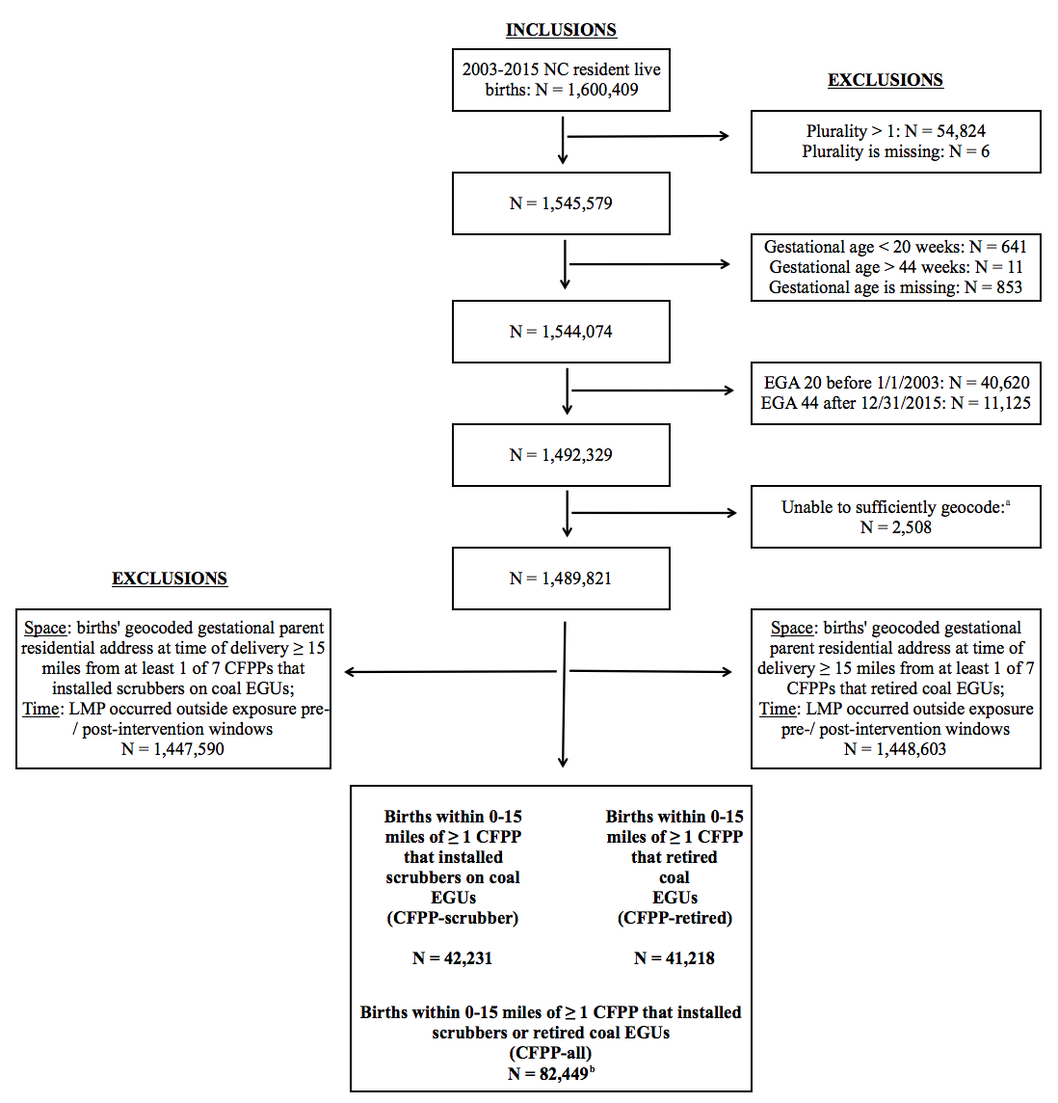
ªThese observations either 1) were not geocoded; 2) could only be geocoded at a locality, subadmin, or admin level; 3) were geocoded outside of NC.
^{b}The observations within CFPP-scrubber and CFPP-retired are not mutually exclusive.

Figure S2. Distance (in miles) between the 14 largest CFPPs in North Carolina
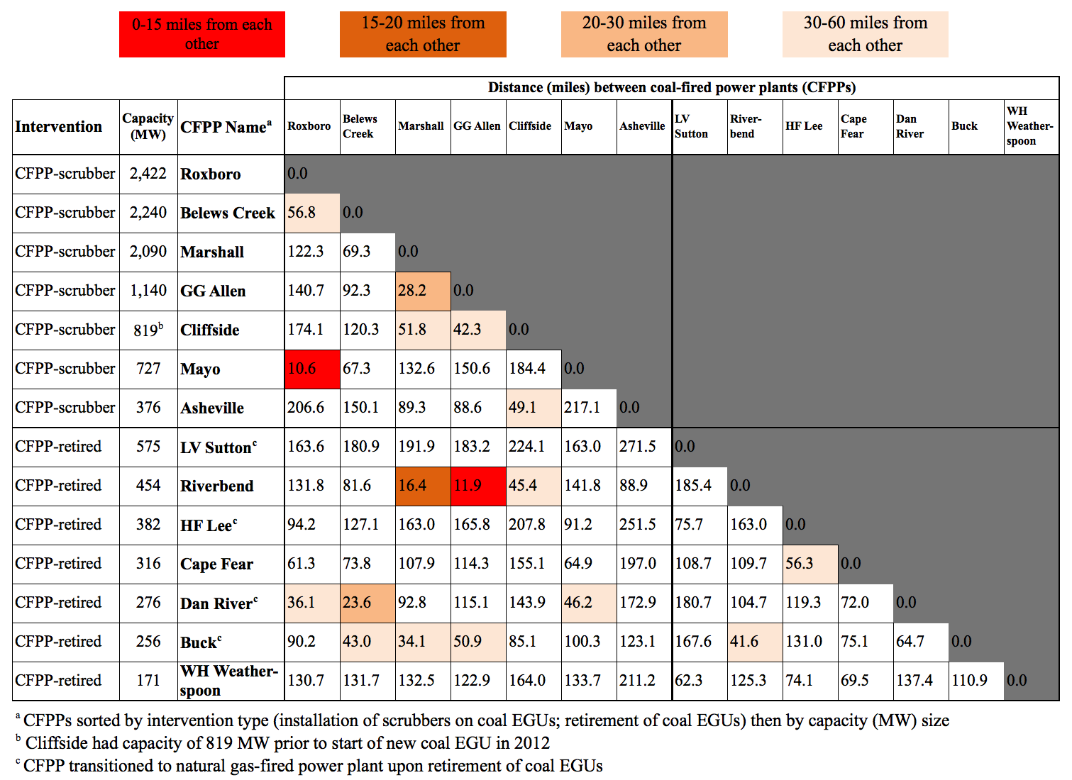

Figure S3. Monthly SO₂ emissions (tons) reported by each CFPP. A) CFPP-scrubber. B) CFPP-retired. C) and D) show boxplots of monthly SO₂ emissions by 1 year pre- and post- intervention exposure windows. (For CFPP-retired, monthly SO₂ emissions were 0 tons in the post-intervention period for Riverbend and essentially 0 tons for the other 6 CFPPs within CFPP-retired.)

A. B.
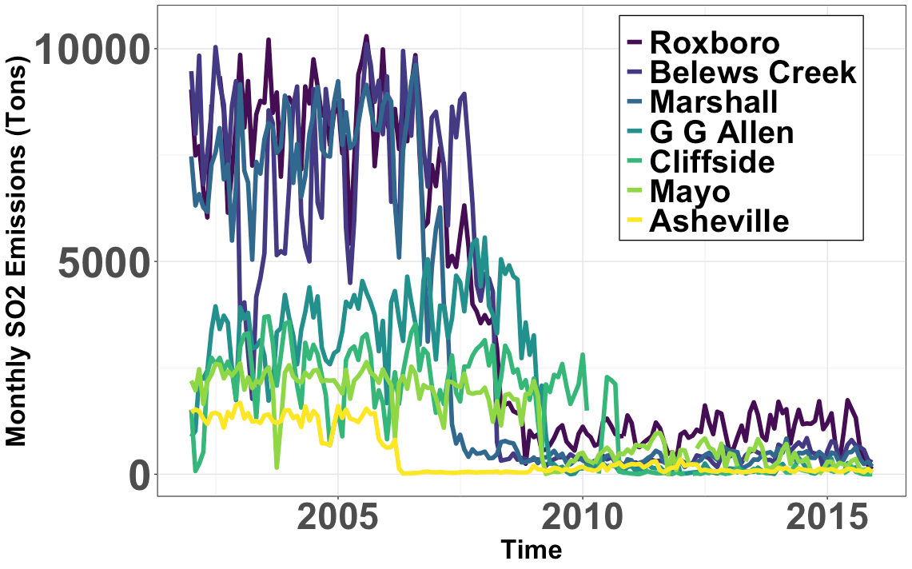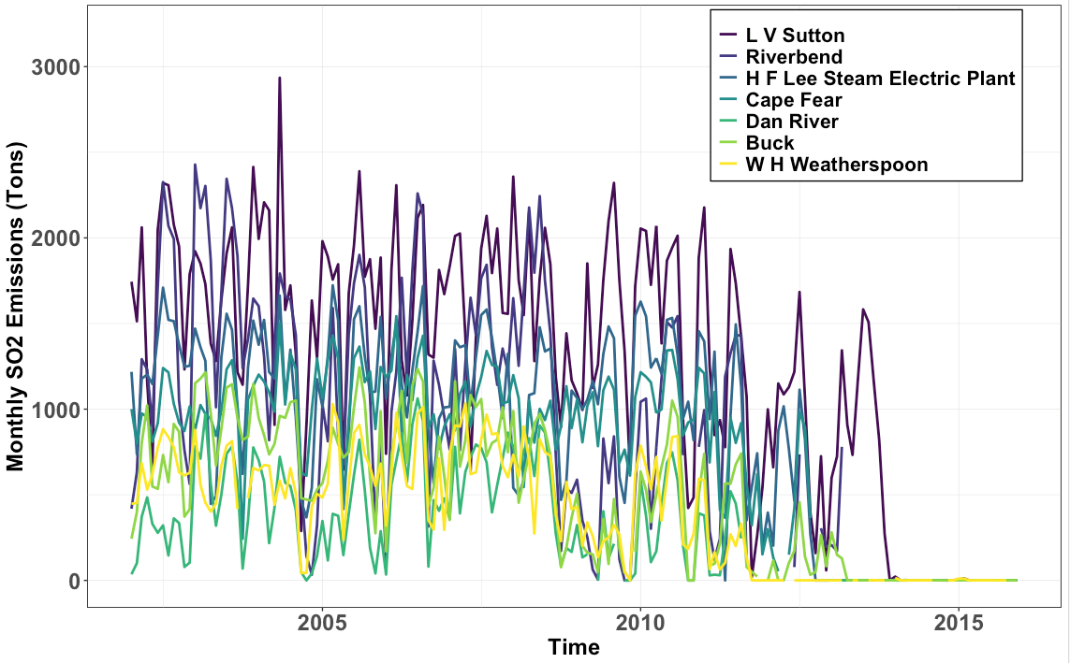
C. D.
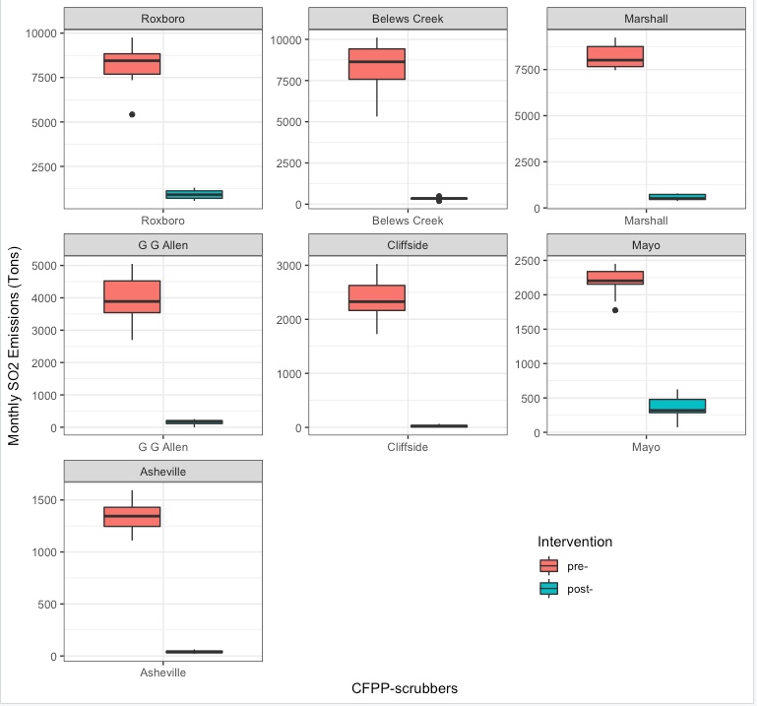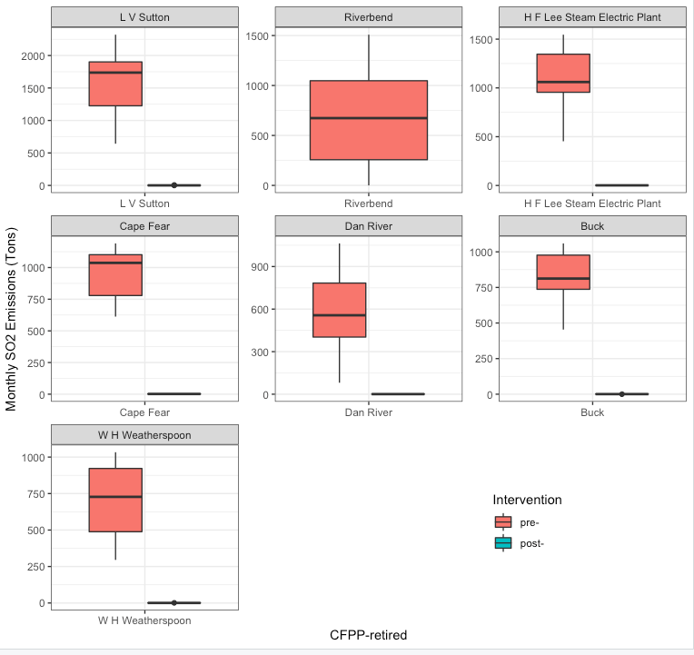

Figure S4. Annual preterm birth prevalence nearby CFPP-GG Allen by distance buffer (0-<4 miles, 4-<10 miles, and 10-<15 miles) prior to installation of scrubbers in 2009
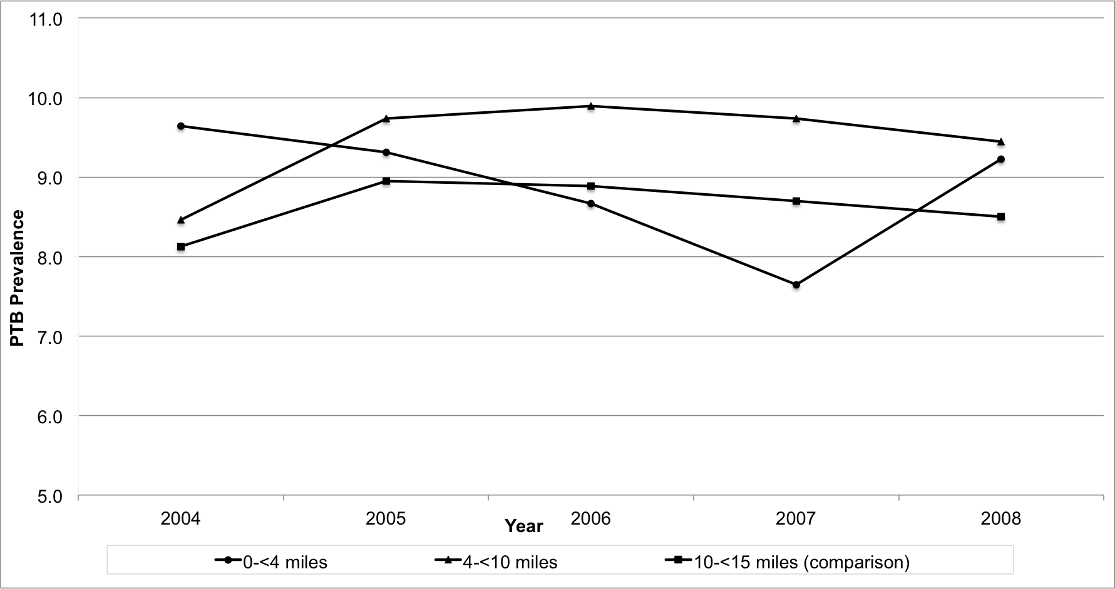
Each point is an unadjusted prevalence for preterm birth by birth year and distance between CFPP-GG Allen and gestational parent residence. CFPP-GG Allen had its first scrubber installed February 2009.

Figure S5. Unadjusted annual trends in means for key gestational parent sociodemographic characteristics by distance buffers (0-<4 miles, 4-<10 miles, and 10-<15 miles) nearby CFPP-GG Allen prior to installation of scrubbers in 2009
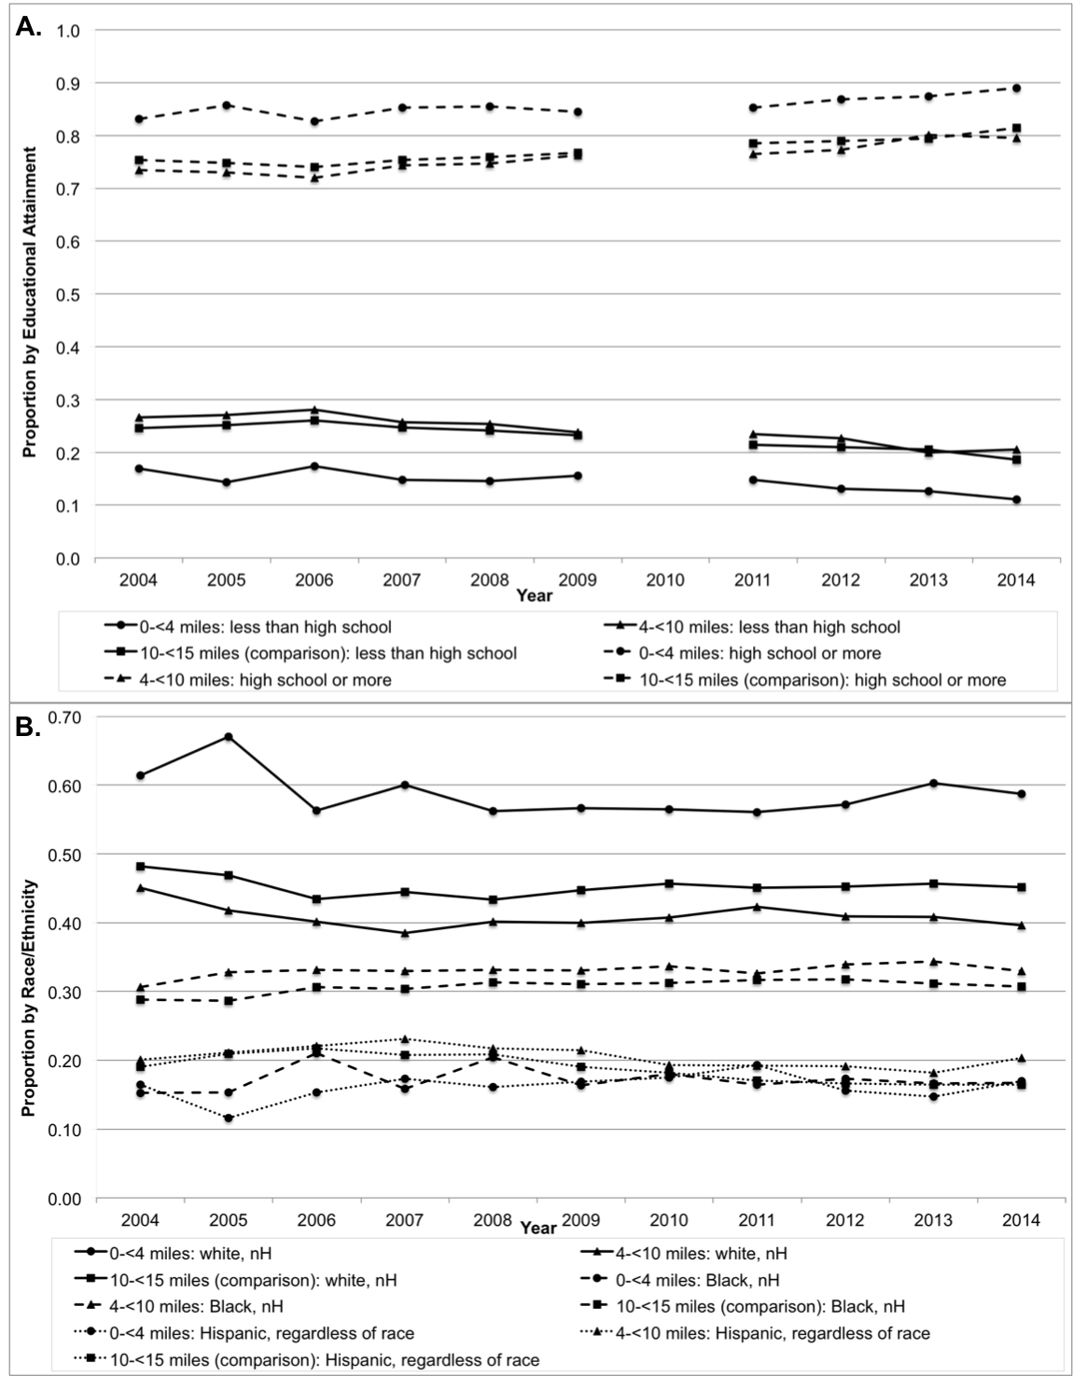
Each point is an unadjusted mean proportion for that characteristic (A. gestational parent educational attainment, B. gestational parent race/ethnicity) by birth year and distance buffer between CFPP-GG Allen and gestational parent residence. CFPP-GG Allen had its first scrubber installed February 2009 and the final scrubber installed May 2009. The 1-year last menstrual period (LMP) for the post-intervention exposure period began September 1, 2009 and ended August 31, 2010 (making the possible range of live births occurring between February 2010 and July 2011). The 1-year LMP for the pre-intervention exposure period began September 1, 2006 and ended August 31, 2007 (making the possible range of live births occurring between February 2007 and July 2008). Educational attainment is missing from records for births in 2010.
Figure S6. Meta-Analysis for CFPPs. Absolute difference in proportions of PTB pre-intervention versus post-intervention to reduce SO₂ emissions at CFPPs in NC by individual CFPP as well as grouped by CFPP-scrubber, CFPP-retired, and CFPP-all. Fixed = fixed effects. Random = random effects. Distance categories are 0 miles to less than 4 miles (grey circles) and 4 miles to less than 10 miles (black triangles), compared to 10 miles to less than 15 miles.
