Deep vs. moderate neuromuscular blockade during laparoscopic surgery: a systematic review and meta-analysis

Sun-Kyung Park¹, Young Gon Son¹, Seokha Yoo¹, Taeyoun Lim¹, Won Ho Kim^{1*}, Jin-Tae Kim¹

¹Department of Anesthesiology and Pain Medicine, Seoul National University Hospital, Seoul, Republic of Korea

Supplemental Digital Content

Text S1. Searching strategies.
Table S1. Outcome distribution of the included studies.
Figure S1. Flow Diagram of study search and selection. RCT, randomised controlled trial.
Figure S2. Risk of bias assessment.
Figure S3. Forest plots of the secondary outcomes. PACU, post-anaesthesia care unit.

Text S1. Searching strategies.
1. (Deep neuromuscular block) OR (deep block) OR (deep neuromuscular blockade) OR (deep blockade) OR (moderate neuromuscular block) OR (moderate block) OR (moderate neuromuscular blockade) OR (moderate blockade) OR (shallow block) OR (shallow neuromuscular block) OR (shallow neuromuscular blockade) OR (anesth* technique) OR (anaesth* technique) OR (train-of-four) OR (partial block) OR (partial neuromuscular block) OR (partial neuromuscular blockade) OR (relax) OR (relaxant)
2. (Laparoscopy) OR (laparoscopic) OR (robotic) OR (robot) OR (pneumoperitoneum)
3. (Surgery) OR (surgical) OR (operation) OR (operating) OR (surgical condition) OR (surgical conditions) OR (surgical space conditions) OR (surgical procedures) OR (ambulatory surgical procedure) OR (anastomosis) OR (Cholecystectomy) OR (gastrectomy) OR (pancreaticoduodenectomy) OR (hepatectomy) OR (nephrectomy) OR (prostatectomy) OR (cystectomy) OR (hysterectomy) OR (bariatric surgery) OR (Urogenital) OR (urologic) OR (gynecologic) OR (gynaecologic) OR (abdominal surg*)
4. 1 and 2 and 3

Pubmed: in all field
Embase: in title and abstract
Cochrane library: in title, abstract, keywords

Table S1. Outcome distribution of the included studies.
Study | Total sample size | Deep block | Moderate block | Incidence of excellent or good SRS | SRS as a continuous variable | Analgesia consumption in the PACU | Duration of surgery | Incidence of PONV
Baete 2017 | 60 | 30 | 30 | 60 | 60 | - | 60 | -
Dubios 2014 | 100 | 50 | 50 | 100 | - | - | 100 | -
Kim 2016 | 61 | 30 | 31 | 61 | - | 61 | 61 | -
Koo 2016 | 64 | 32 | 32 | 64 | - | 64 | 64 | 64
Madsen 2016 | 99 | 49 | 50 | - | - |  | 99 | -
Martini 2014 | 24 | 12 | 12 | 24 | 24 | - | 24 | -
Putz 2016 | 100 | 50 | 50 | - | - | 100 | 100 | 100
Rosenberg 2017 | 122 | 61 | 61 | 122 | - | - | - | -
Staehr-Rye 2014 | 48 | 25 | 23 | 48 | - | - | 48 | -
Torensma 2016 | 100 | 50 | 50 | 100 | 100 | 100 | 100 | 100
Yoo 2015 | 66 | 34 | 32 | - | 66* | - | 66 | -
Total | 844 | 423 | 421 | 579 | 250 | 325 | 722 | 264
SRS = surgical rating scale, PONV = postoperative nausea and vomiting.
* SRS was reporting using the 5-point scale, however, only mean with standard deviation was reported.

Figure S1. Flow Diagram of study search and selection. RCT, randomised controlled trial.
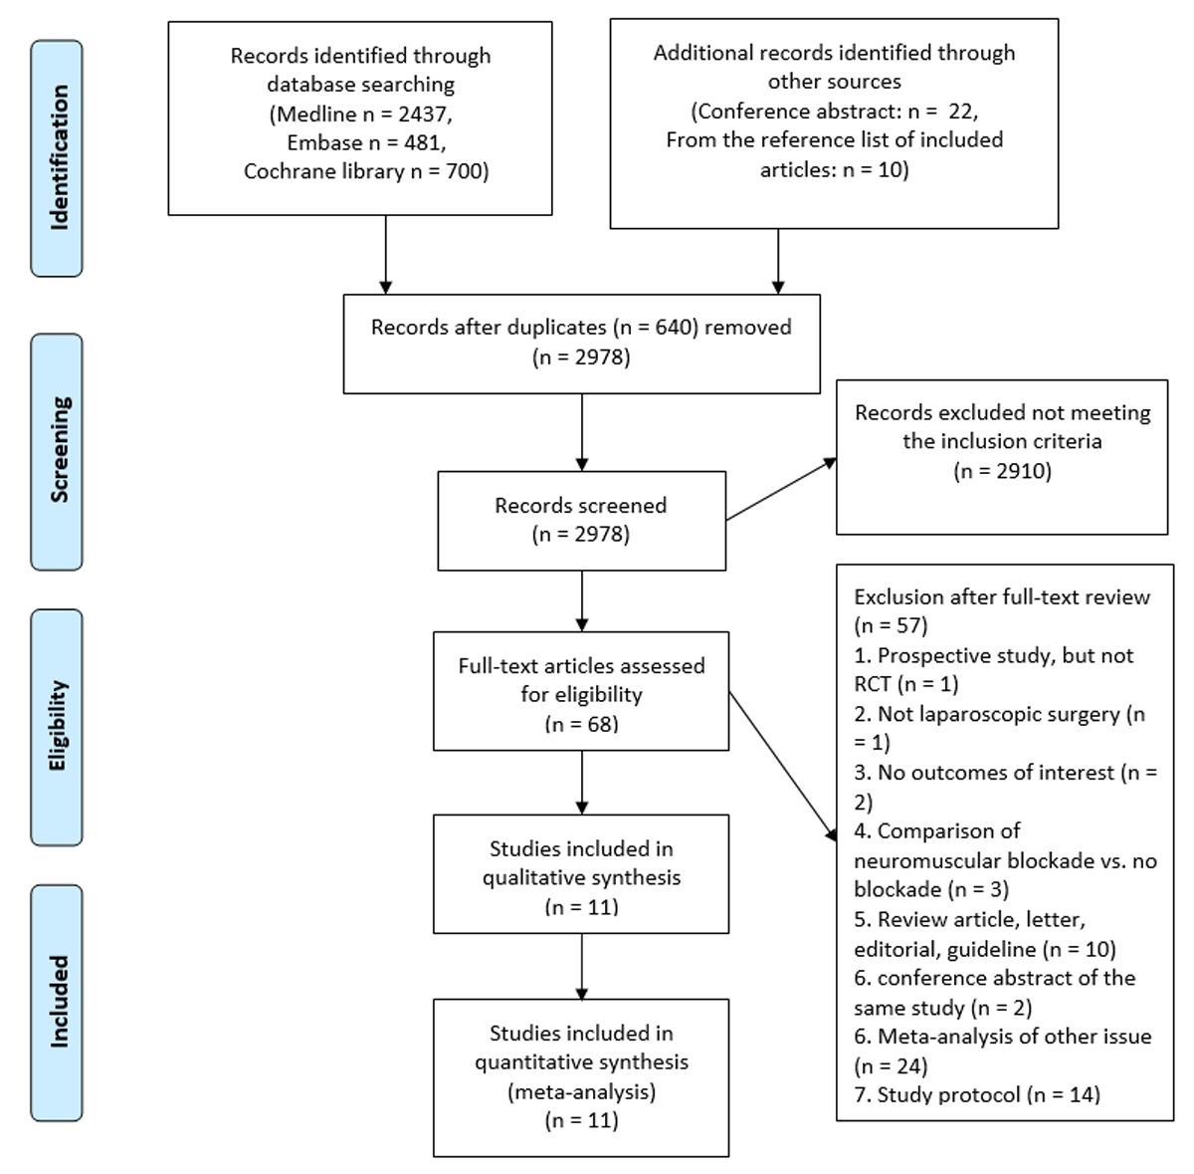

Figure S2. Risk of bias assessment.
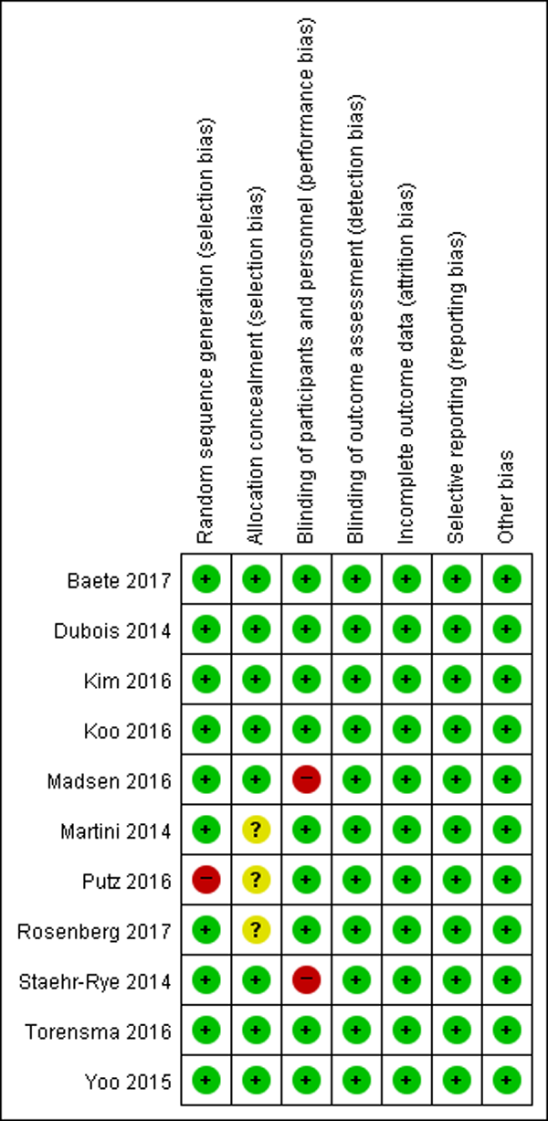
Figure S3. Forest plots of the secondary outcomes.

