Figure 4. Risk of bias for individual studies
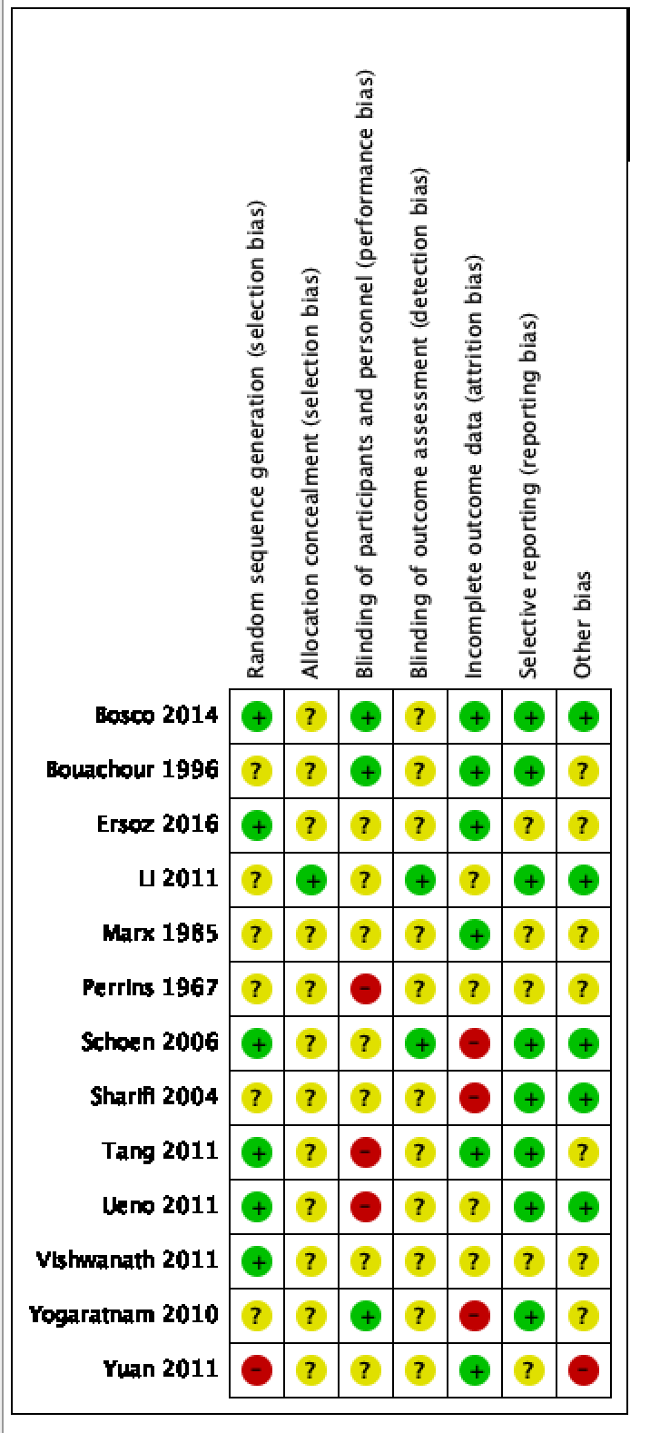
Legend
green = low risk
yellow = intermediate risk or unclear
red = high risk

