Trial Sequential Analysis for Post Operative Pain
A post hoc Trial Sequential Analysis was performed on the basis of the least likely anticipated interventions effect. This post hoc conservative approach allows us to assess if the data are convincing enough to prove that there is such a small effect (Wetterslev 2017 et al. Trial Sequential Analysis in systematic reviews with meta-analysis- BMC Medical Research Methodology). The post hoc Trial Sequential Analysis was performed using the TSA software version 0.9.5.10 beta (Thorlund K, Wetterslev J, Brok J, Imberger G, Gluud G. Trial Sequential Analysis (TSA) manual. Copenaghen, Denmark 2011). We used a two-sided trial sequential monitoring boundary type. We calculated the diversity-adjusted required information size based on the desired anticipated minimal intervention effect (MIREDIF); the standard error or variance of the mean difference between intervention groups; the alpha level of 1%; the beta level (power) of 10%; and the diversity based on the meta-analysis model. The diversity (D²) represents the percentage of the between trial variance of the total variance (sum of between trial variance and the sampling error) and it is always equal to or higher than I² (Wetterslev J, Thorlund K, Brok J, Gluud C. Estimating required information size by quantifying diversity in random-effects model meta-analyses. BMC medical research methodology. 2009;9:86). We chose as anticipated intervention effect the limit of the confidence interval closest to the null effect: we assumed this value as the least likely effect being clinically relevant.

- Follow up: 6 hours

The Required information size was calculated based on an anticipated intervention effect of – 1.37 as the least likely intervention effect on a Visual Analogue Scale (0-10) for post operative pain. The required information size was of 225 patients. The cumulative Z-curve crossed the monitoring boundary for benefit at the third trial yielding an effect that is both statistically and clinically significant. From the fourth trial, the cumulative z-curve also reached the required information size. Therefore, the TSA confirm the statistically significant effect of using SAPb for controlling pain at 6 hours of the meta-analysis. Nevertheless, looking at the diversity (D²=85.8%), we could conclude that the intervention does have an effect but there is a high level of heterogeneity across studies.

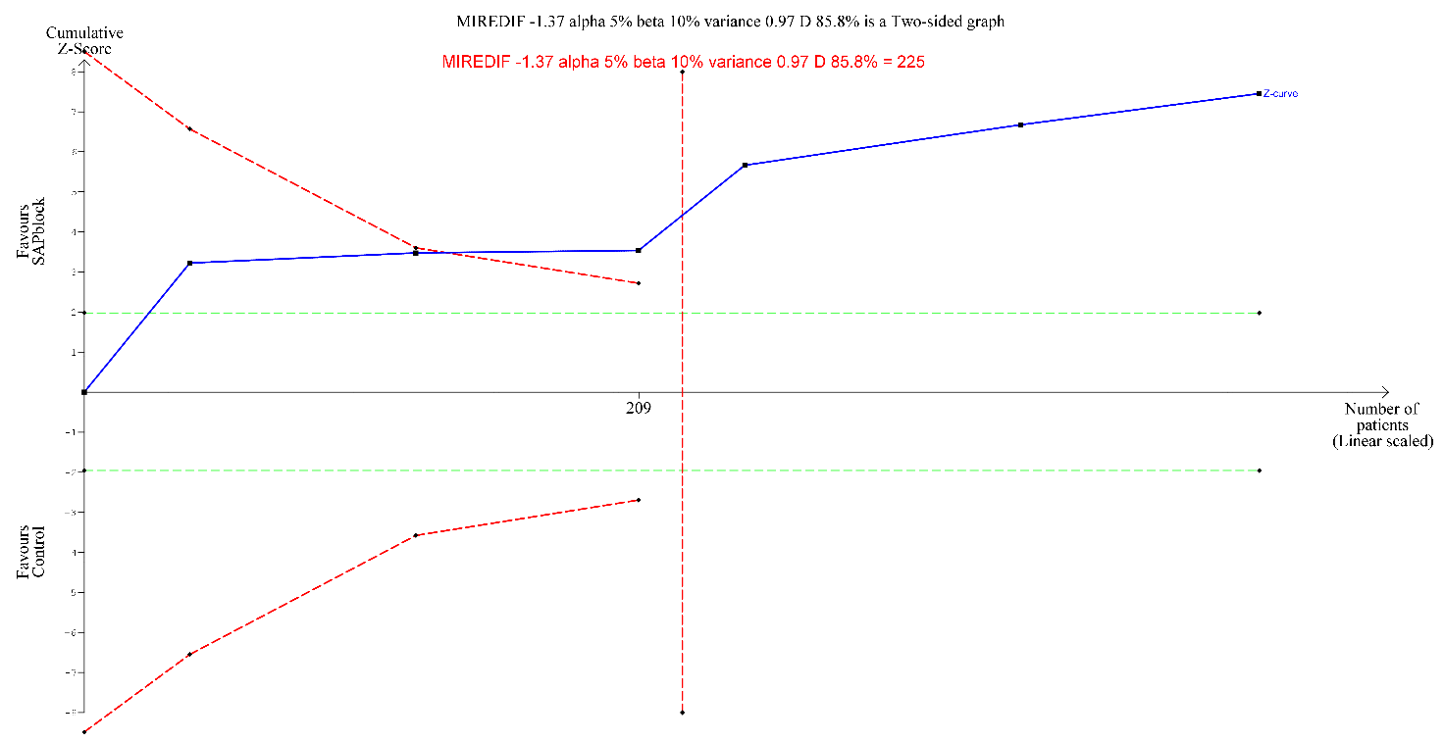
Figure S1. TSA on post operative pain at 6 hours.

- Follow up: 12 hours

The Required information size was calculated based on an anticipated intervention effect of – 1.25 as the least likely intervention effect on a Visual Analogue Scale (0-10) for post operative pain. We assumed a 50% of Diversity since no heterogeneity was found in the meta-analysis. The required information size was of 68 patients. The cumulative Z-curve crossed the monitoring boundary for benefit at the first trial yielding an effect that is both statistically and clinically significant. From the second trial, the cumulative z-curve also reached the required information size. Therefore, the TSA confirm the statistically significant effect of using SAPb for controlling pain at 12 hours of the meta-analysis.
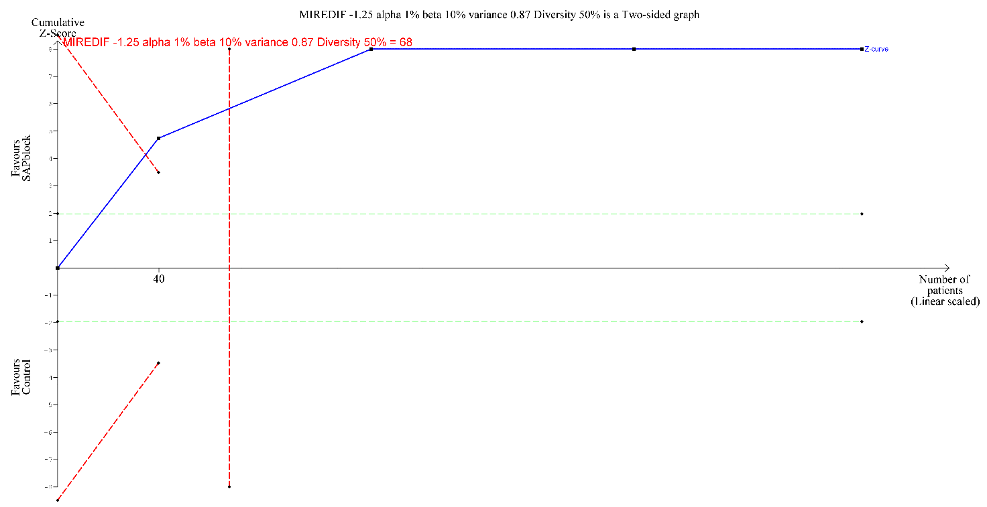
Figure S2. TSA on post operative pain at 12 hours.

- Follow up: 24 hours

The Required information size was calculated based on an anticipated intervention effect of – 0.56 as the least likely intervention effect on a Visual Analogue Scale (0-10) for post operative pain. The required information size was of 680 patients. The cumulative Z-curve crossed the monitoring boundary for benefit at the fourth trial yielding an effect that is both statistically and clinically significant. However, the cumulative z-curve not already reached the required information size. Therefore, the TSA confirm the statistically significant effect of using SAPb for controlling pain at 24 hours of the meta-analysis but further information is needed to reach conclusiveness in results. Since the required information size was not reached, the confidence interval has to be TSA-adjusted and it ranged from –1.82 to –0.14 points.

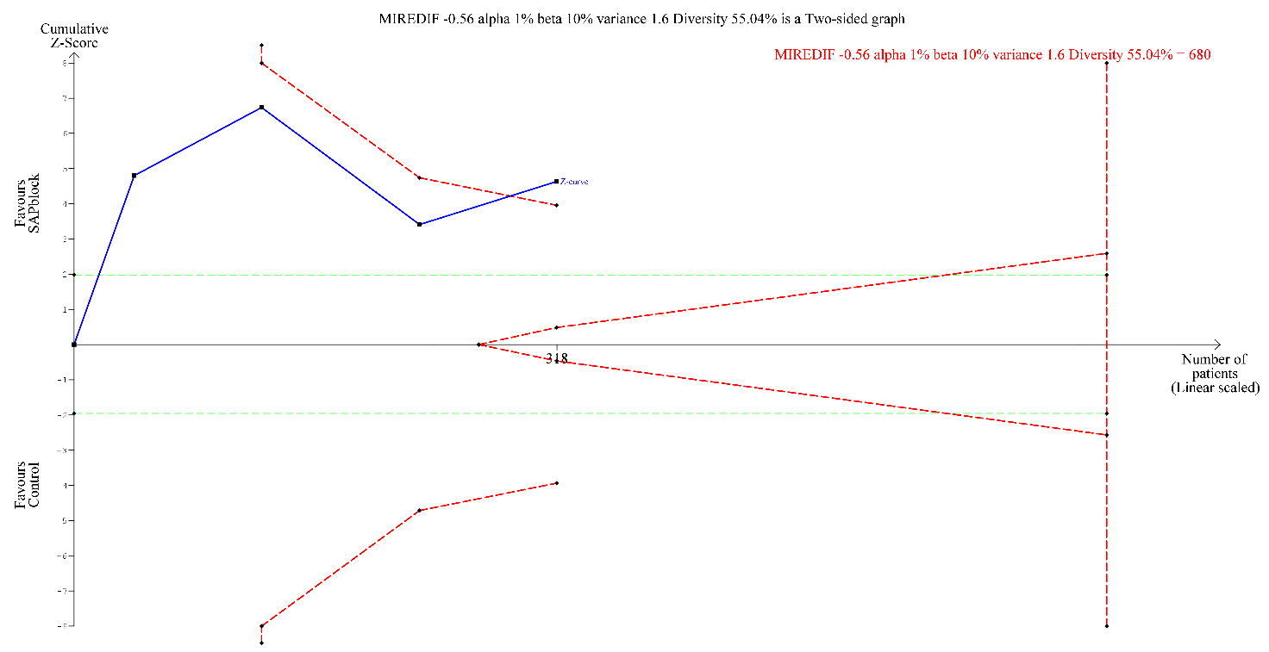
Figure S3. TSA on post operative pain at 24 hours.

