Supplemental Information
Distribution of patients among the surgical disciplines
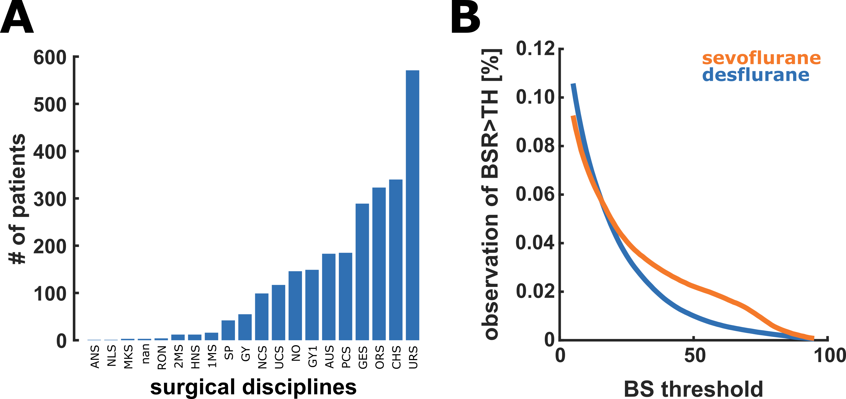

Figure S1:
- Histogram presenting the distribution of patients regarding the different surgical disciplines.
ANS-Anaesthesiology; NLS-Neurology; MKS-Maxillofacial surgery; RON-Radiology department; UCM-Traumatology; 2MS-Medical endoscopy department; HNS-Otolaryngology; PCM-Plastic surgery; GZ-Vascular surgery; SP-Sportorthopaedic surgery; GY-Gynaecology; NCS-Neurosurgery; UCS-Traumatology; NO-Emergency department; GY1-Obstetrics; PCS-Plastic surgery; AUS-Ophthalmic surgery; GES-Vascular surgery; ORS-Orthopedic surgery; CHS-Visceral surgery; URS-Urology; nan: no information available
- This figure presents the distribution of the fraction of observed BSR being above a defined threshold (TH). The fraction of BSR being above a certain threshold revealed a significant difference in the course of BS-threshold to observation fraction (p<0.001, Kolmogorov–Smirnov test). Further, we found that there was a significant (p=0.040. Mann-Whitney U test) but mostly irrelevant (AUC: 0.53 [0.50, 0.56]; AUC ~0.5 indicative of no effect) effect of the drug on age. The median (1st; 3rd quartile) age was 72 (66; 77) yr for sevoflurane and 70 (66; 76) yr for desflurane. We also found the age-adjusted to be very similar with 0.79 (0.66; 0.88) MAC for sevoflurane and 0.79 (0.66; 0.88) MAC for desflurane. The number of observations with a BSR≥5 was also similar with 10.5% for sevoflurane and 9.3% for desflurane.
AUC: area under the receiver operating curve; BSR: burst suppression ratio; MAC: minimum alveolar concentration

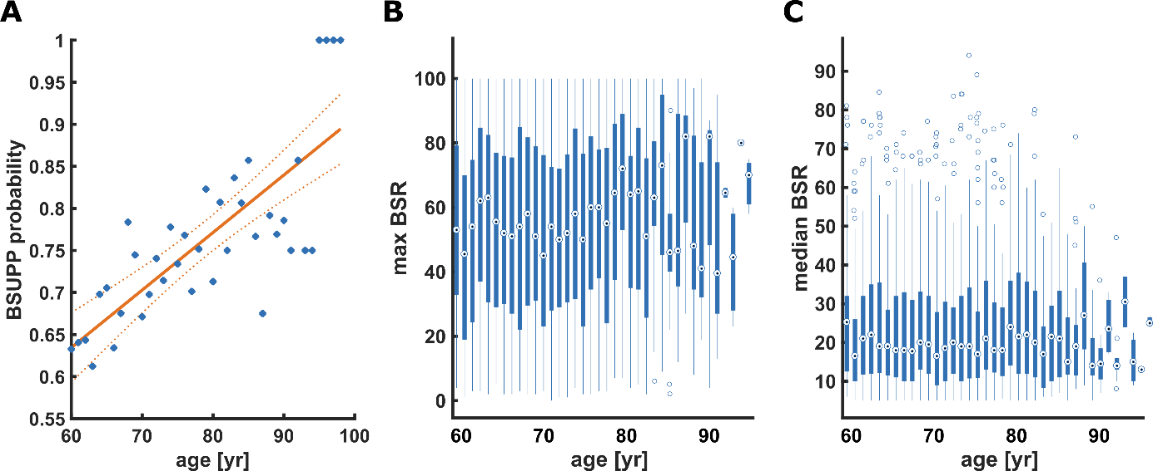
Figure S2: Age to burst suppression relationships
- The probability of a patient developing burst suppression increases with age in a linear fashion. The linear model is: BSUPP = 0.22+0.07*age with R²=0.59 (p<0.001)
- There was a significant increase of the maximum BSR observed with age. The linear model was: max BSR=35.22+0.26*age with R²<0.004 (p<0.001)
- There was no age to median BSR relationship in our data (only BSR≥5 considered). The linear model was: median BSR=25.78-0.03*age with R²<0.001 (p=0.425)

Distribution of age among the patients and duration of the surgical interventions
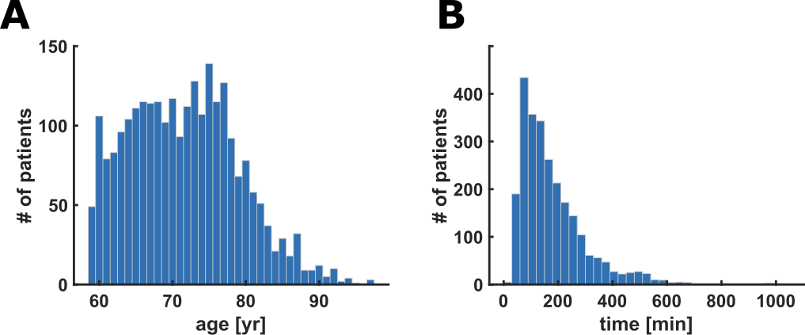
Figure S2: Histogram presenting the distribution of age among the patients (A) as well as the duration of the anesthesia procedure (B)
- The median age of was 71 years (25th percentile: 66 years; 75th percentile: 77 years)
- Median anaesthesia duration was 145 min (25th percentile: 60 min; 75th percentile 227 min)

Results of the analyses for BSR>0 instead of BSR≥5
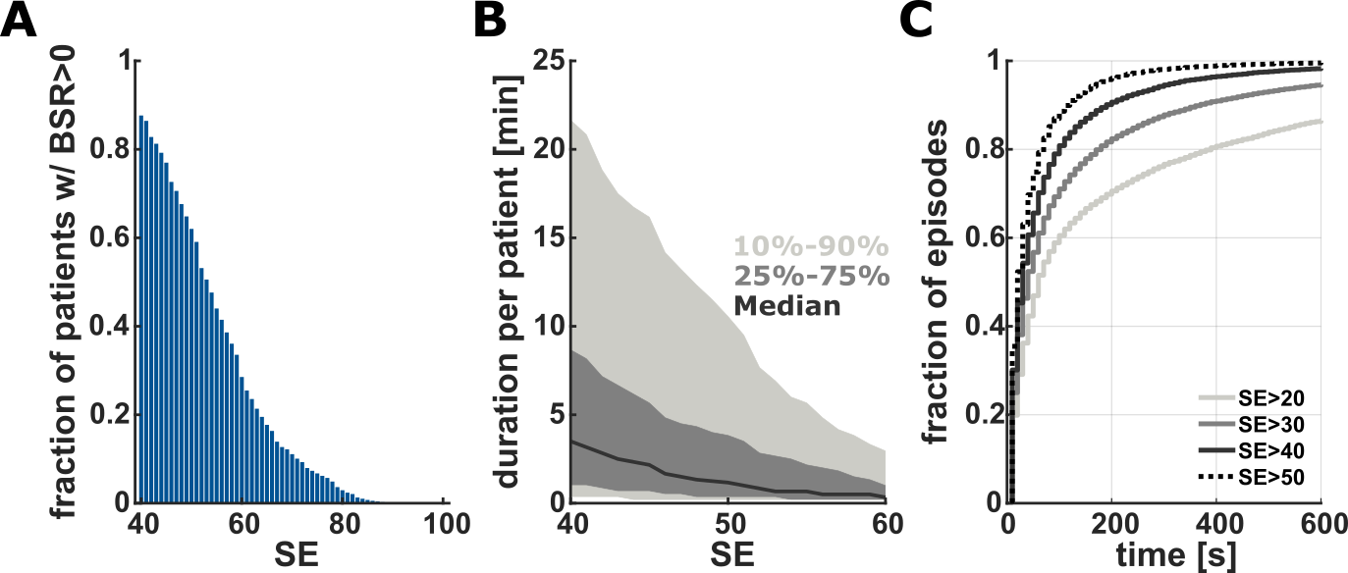
Figure S4: Description of the high SE (SE>40) characteristics with a BSR > 0
- Over 87% of the patients showed situations with SE≥40 when BSR was above 0. The fraction of patient decreased with increasing the SE threshold.
- The median duration of SE≥40 with BSR>0 was 3.5 min. This duration decreased for higher SE values with BSR>0. The solid black line indicates the median, the dark grey area indicates the 2nd and 3rd quartile and the light gray area the 10th to 90th percentile.
- Cumulative probability plots of episode duration, pooled for all patients, when SE was above a defined threshold (20, 30, 40, or 50) and BSR was>0. The episodes became shorter with increasing threshold. For the SE=40 threshold 50% of episodes were longer than 30s and 20% longer than 100s. Every 10th episode was longer than 190 s.

Relationship between BSR and aaMAC
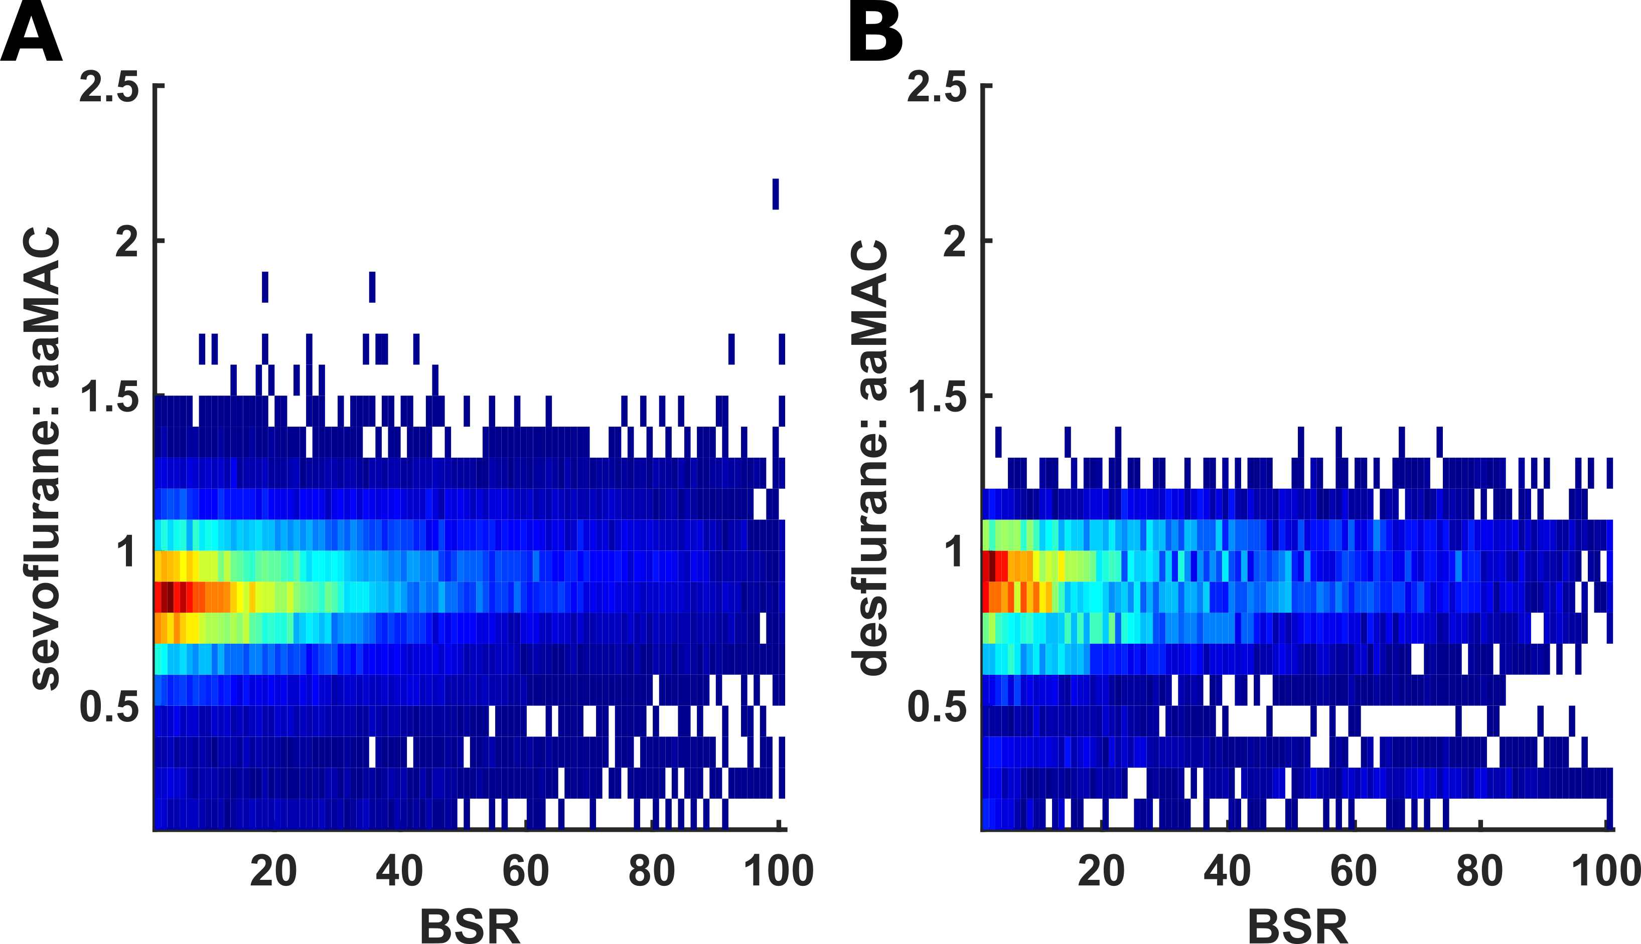

Figure S5: Heat maps of the number of observations for a certain BSR at a certain age-adjusted MAC (aaMAC) for sevoflurane (A) and desflurane (B). While there seems to be no strong trend of higher BSR at higher aaMAC, we could observe a number of high BSR at (very) low aaMAC<0.5. Further research should be conducted to investigate, if these patients are the ones with a ‘frail’ brain that may be at increased risk to develop some form of delirium postoperatively.

Additional detailed Case-Data
Table S1 - Demographic data Case A-D
 | Age | Sex | Height (cm) | Weight (kg) | BMI | ASA | Duration of surgery (min) | Kind of procedure | Anesthetics
Case A | 77 | M | 172 | 83 | 23 | IV | 156 | Urology | Balanced - Propofol & Sevoflurane & Sufentanil
Case B | 62 | M | 173 | 70 | 28 | I | 221 | Urology | Balanced - Propofol & Desflurane & Sufentanil
Case C | 67 | M | - | - | n.k. | n.k. | 133 | Visceral surgery | Balanced - Propofol & Sevoflurane & Sufentanil
Case D | 69 | W | 149 | 75 | 33 | II | 158 | Visceral surgery | Balanced - Propofol & Sevoflurane & Sufentanil

Table S2 - Drugs/Anesthesia Case A-D

 | Induction dose | Induction & positive BSR | BSR/SE at Maintenance & Anesth. Conc. | Max. anesth. conc. at maintenance & positive BSR | Min. anesth. conc. at maintenance & positive BSR | Katecholamin usage
Case A | 100 mg P  50 µg S | No | BSR at 0.2-1.3 MAC | Yes – 1.3 MAC | 0.2 MAC | Nor & Supra
Case B | 200+50 mg P  15 µg S | Yes | BSR at 0.8-1.1 MAC | Yes – 1.1 MAC | 0.8 MAC | Nor & Akrinor
Case C | 250 mg P  20 µg S | No | BSR at 0.8-1.1 MAC | Yes – 1.1 MAC | 0.8 MAC | Nor
Case D | 150 mg P  10 µg S | Yes | No BSR – min. SE (8) at 0.3 MAC | No BSR – 0.2-0.6 MAC | No BSR | Nor

P = Propofol
S = Sufentanil
Nor = Noradrenalin
Supra = Suprarenin/Adrenalin

Figure S6: Case scenario of a 62-year old patient with (very) low SE during induction with BS and a SE indicating adequate anesthesia (SE>40) during maintenance with positive BSR at the same time. The blue lines represent the SE (light blue) and RE (dark blue). The orange area depicts positive BSR. The green trend reflects the heart rate and the gray dots the blood pressure. The black dots present the MAC (multiplied by 100 to match the y-axis: 1.2 MAC = 120 on the y-axis).

For the Induction in Case B the 62-year old patient with 70 kilograms received a cumulative dose of 250 mg propofol and 15 µg sufentanil. This high dose of propofol caused reasonable low SE indices paired with positive BSR. Throughout maintainance however, the SE indices mostly were in range of values representing a level of adequate anaesthesia (40-60). Towards the second half of surgery positive BSR values occurred while the SE values remain stable at 40-60. Meanwhile the anaesthetic concentration varied between 0.8 to 1.1 MAC (age-adapted) which is in the range of recommended dosage for desflurane. Even more contradictory is the trend of haemodynamics. The heart rate as well as the blood pressure began to increase while the BSR begans to fluctuate. Usually, an increasing heart rate and blood pressure implicate a lightening of the anaesthaetic level instead of deepening of the anaesthetic level.

Figure S7: Case scenario of a 67-year old patient with an SE being in the recommended 40-60 range for the duration of the procedure, but with episodes of positive BSR. The blue lines represent the SE (light blue) and RE (dark blue). The orange area depicts positive BSR. The green trend reflects the heart rate and the gray dots the blood pressure. The black dots present the MAC (multiplied by 100 to match the y-axis: 1.2 MAC = 120 on the y-axis).

In Case C, the case of a 67-year old patient, the SE displays indices around 50 to 60 throughout the entire procedure indicating an adequate anaesthetic level. Within the course of maintenance, BSR becomes positive contradicting consistent SE values. The induction dose 250 mg of propofol in this case suggest a rather generous bolus, however the entropy does not present signs of burst suppression. During the maintenance an adequate dosage of sevoflurane (0.8-1.1 MAC) was applied. While the BSR randomly occurs during anaesthesia maintenance, the heart rate and blood pressure vary from standard to slightly increased values. This also is no plausible explanation for the course of SE and BSR.

Figure S8: Case scenario of a 69-year old patient with an SE being low throughout the entire intervention. Despite these very low values, positive BSR only occurred in the induction period. The blue lines represent the SE (light blue) and RE (dark blue). The orange area depicts positive BSR. The green trend reflects the heart rate and the gray dots the blood pressure. The black dots present the MAC (multiplied by 100 to match the y-axis: 1.2 MAC = 120 on the y-axis).

The last case of a 69-year old patient (Case D) showed an induction with very low SE associated with a short period of BSR >0. During the very long maintenance the SE indices seemed to decrease even more (SE down to 15-20) but the monitor did not show positive BSR (BSR=0). In this case the induction dose of 150 mg propofol may induce signs of burst suppression as shown in this case but does not necessarily result in positive BSR. During maintenance the maximal MAC was 0.6. From a clinical point of view, 0.6 MAC sevoflurane usually does not cause such deep SE-indices. Hence it questions the explicability of the measurements, especially when looking at the concentration of anesthetics and a negative burst suppression ratio at such low SE-values. However, looking from a more technical point of view one assumption might be that in the raw EEG dominant slow and regular theta-oscillation were detected causing such deep SE-values. Moreover, looking at the middle arterial blood pressure in this case most of the time the values did not exceed 60-70 mmHg. Low blood pressure levels can correlate with reduced cerebral perfusion which in turn could result in reduced cerebral activity causing low SE values.

