Appendix 4.
Forrest plots of the main results from the Revman analysis.

5.1. Upper limb blocks

5.1.1 Interscalene brachial plexus block
5.1.1.1. Adequacy of anaesthesia for intended surgery

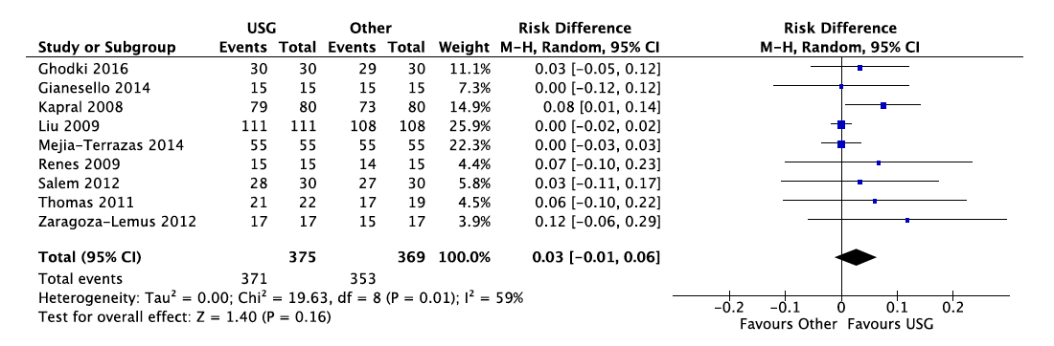
5.1.1.2. Adequacy of postoperative analgesia

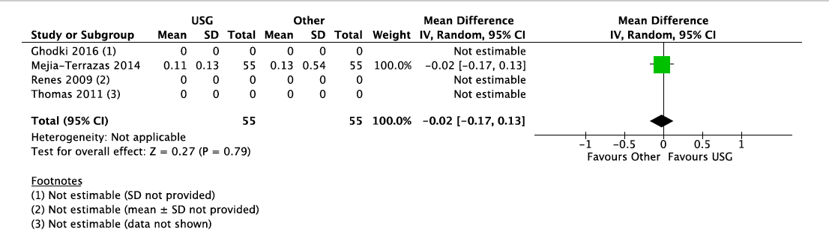
5.1.1.3. Time to perform and achieve block
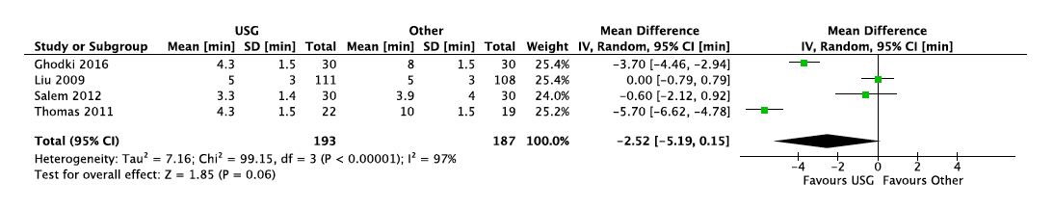
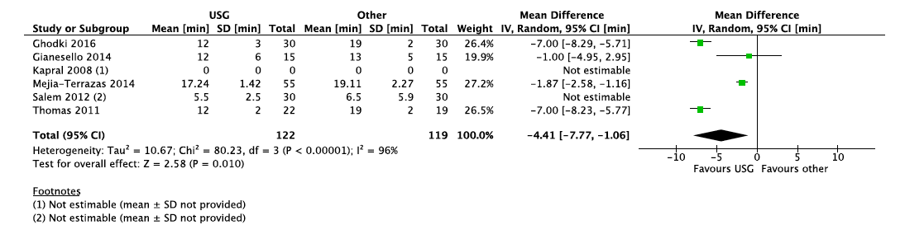

5.1.1.5. Incidence of complications
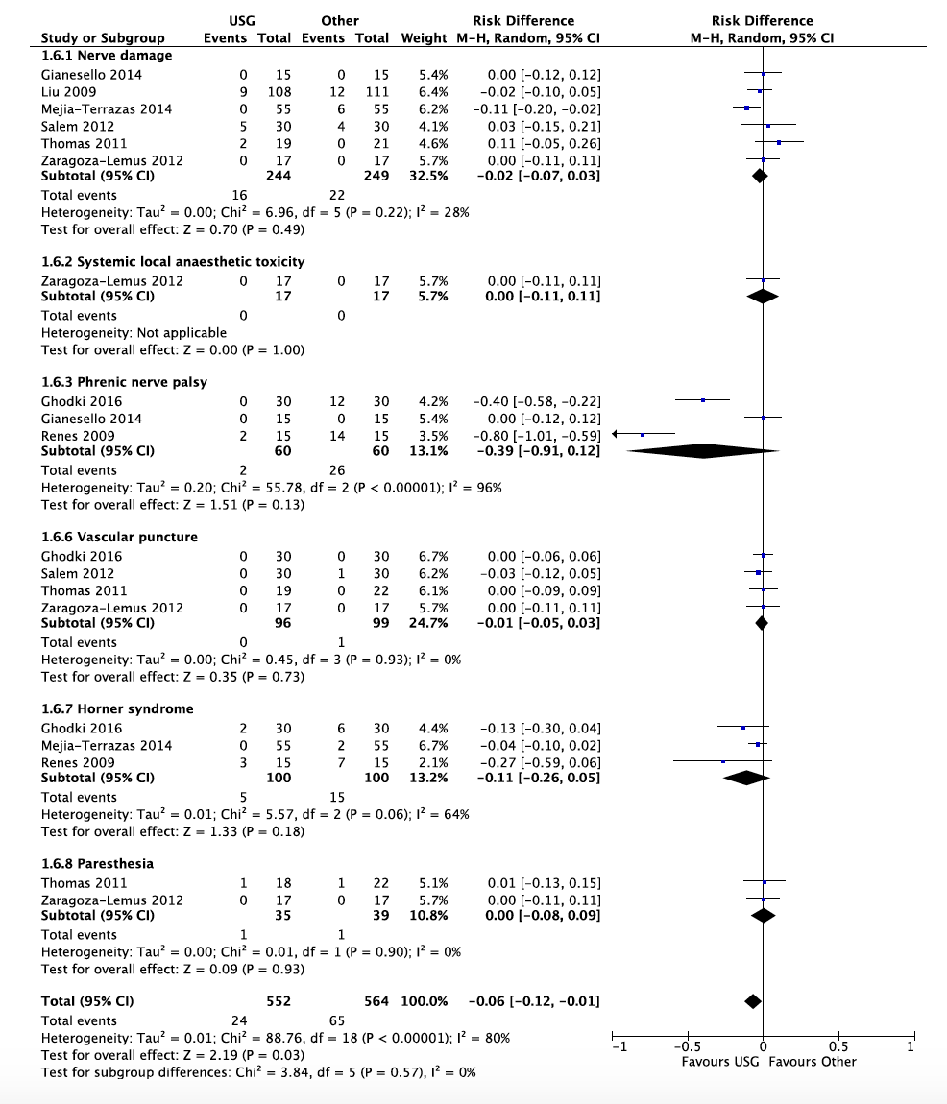
5.1.1.7. Patient satisfaction with the procedure
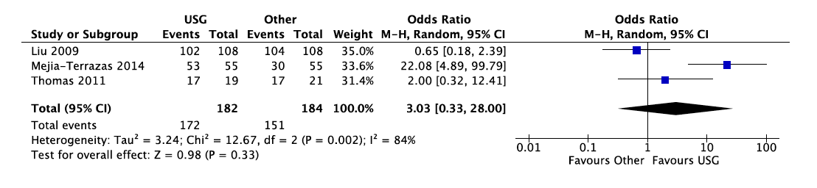
5.1.2 Supraclavicular block
5.1.2.1. Adequacy of anaesthesia for intended surgery
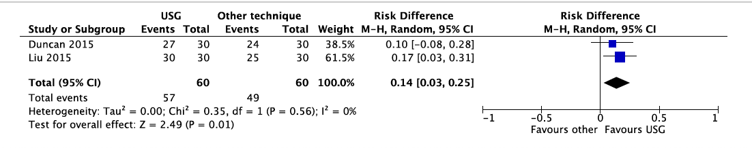
5.1.2.3. Time to perform block
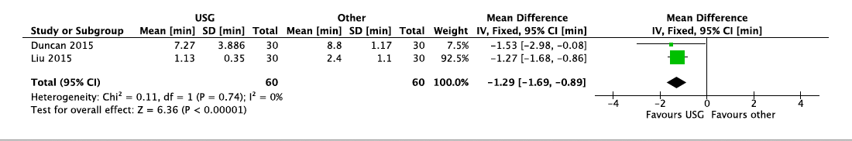
5.1.2.4. Time to achieve effective block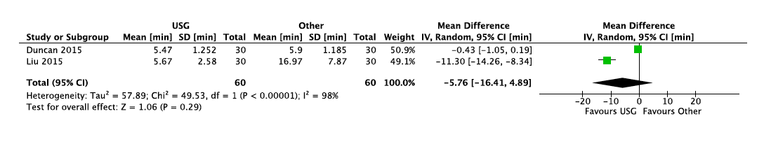
5.1.2.6. Incidence of complications
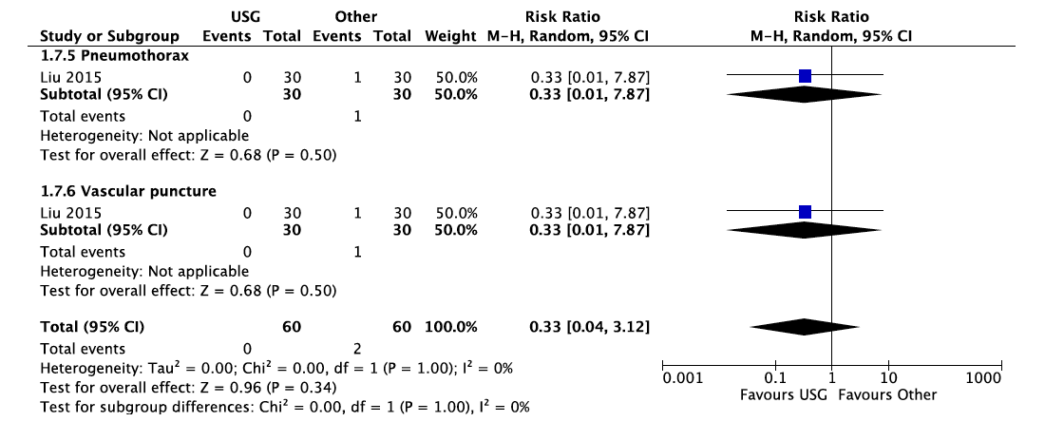

5.1.3 Infraclavicular nerve block
5.1.3.1. Adequacy of anaesthesia for intended surgery
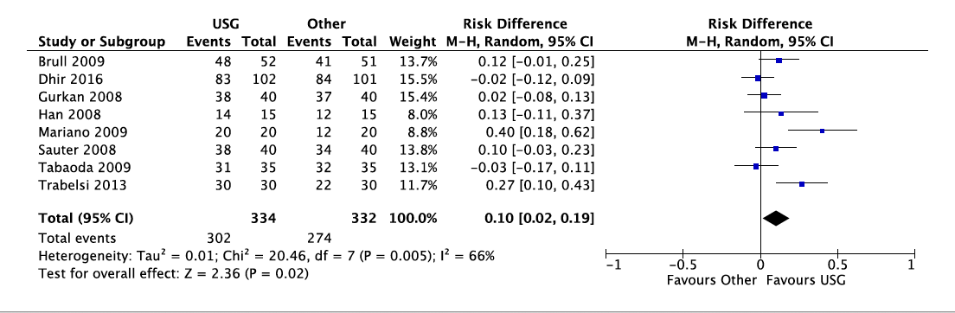
5.1.3.2. Adequacy of postoperative analgesia
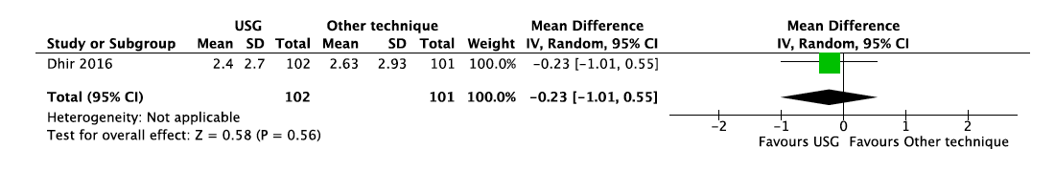
5.1.3.3. Time to perform block
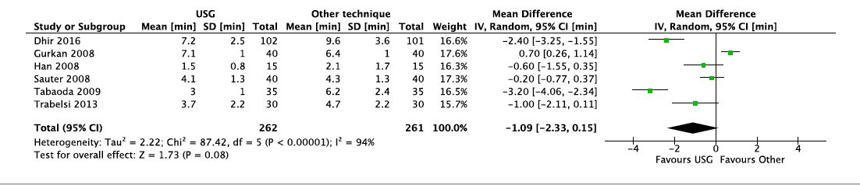
5.1.3.4. Time to achieve effective block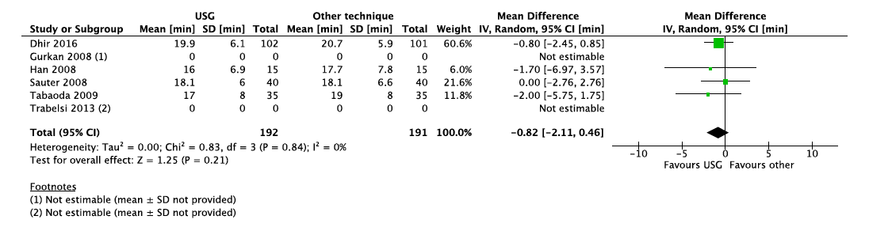

5.1.3.6. Incidence of complications
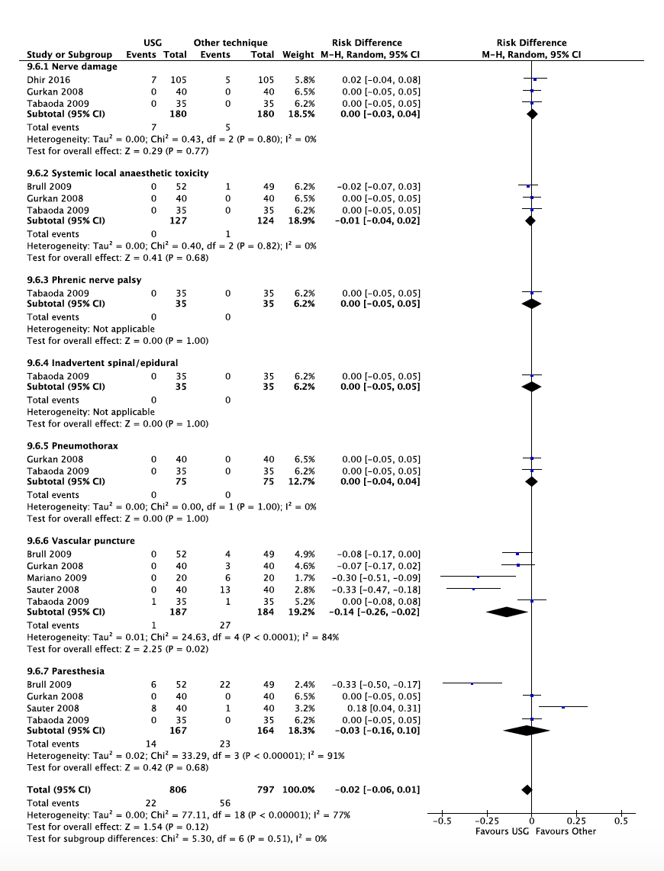
5.1.3.7. Patient discomfort during procedure
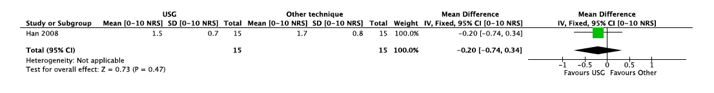

5.1.4 Axillary brachial plexus block
5.1.4.1. Adequacy of anaesthesia for intended surgery
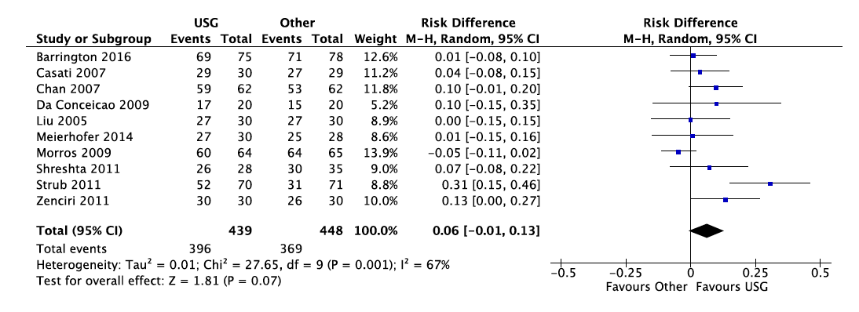
5.1.4.3. Time to perform block
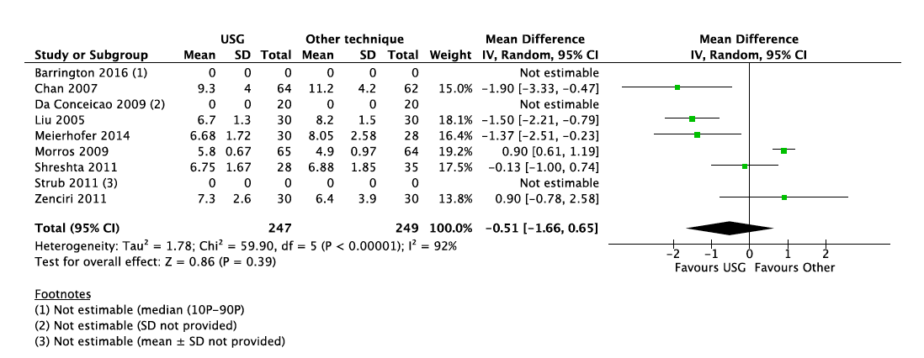
5.1.4.4. Time to achieve effective block
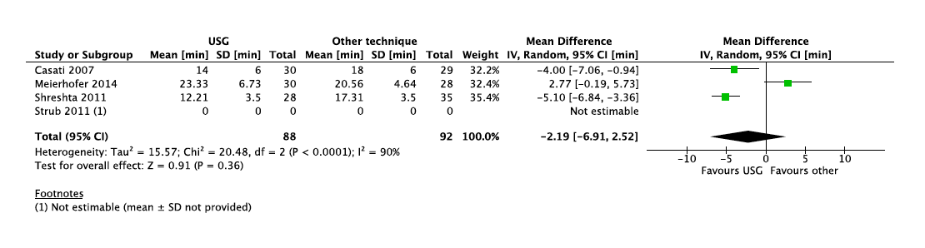

5.1.4.6. Incidence of complications
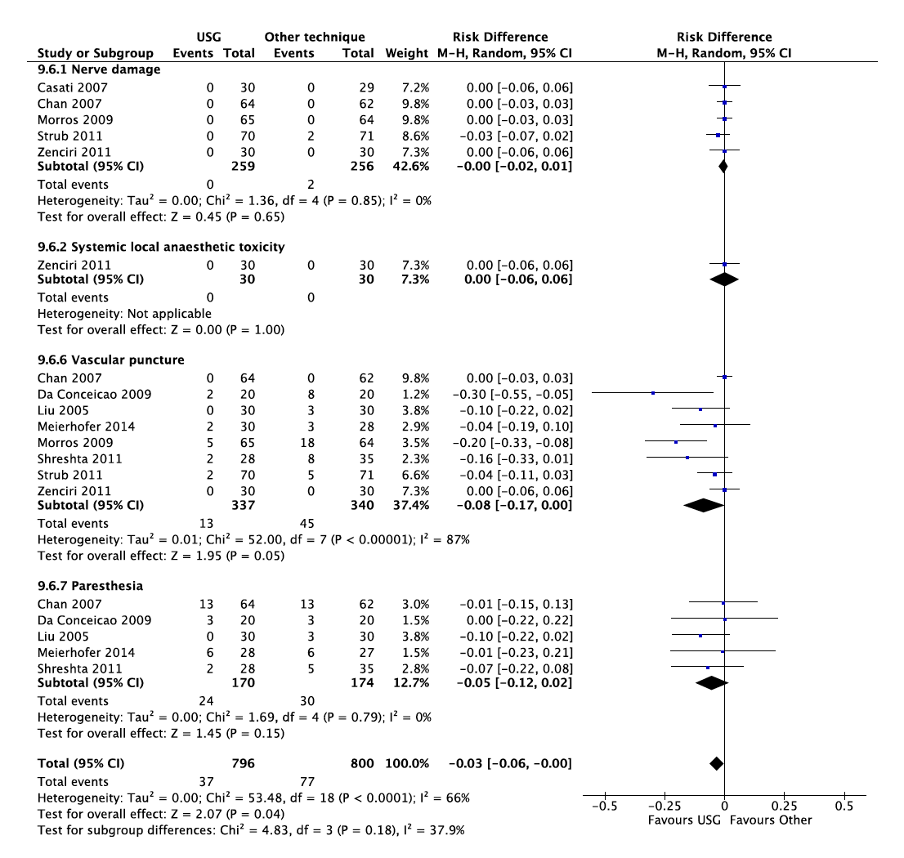
5.1.4.7. Patient discomfort or pain during procedure

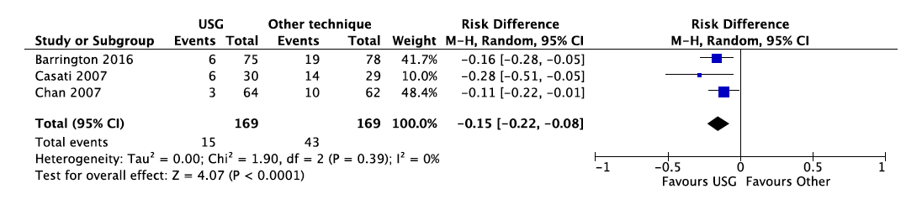

5.1.4.8. Patient satisfaction with the procedure
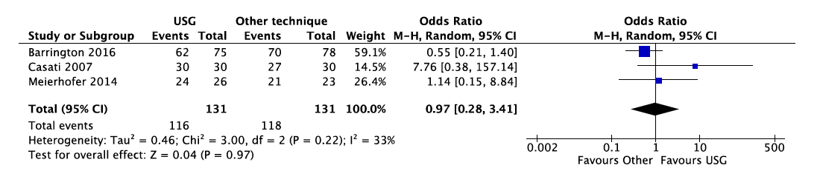

5.2 Lower limb blocks
5.2.1 Femoral nerve or fascia iliaca block
5.2.1.2. Adequacy of postoperative analgesia: requirement for morphine at 48hrs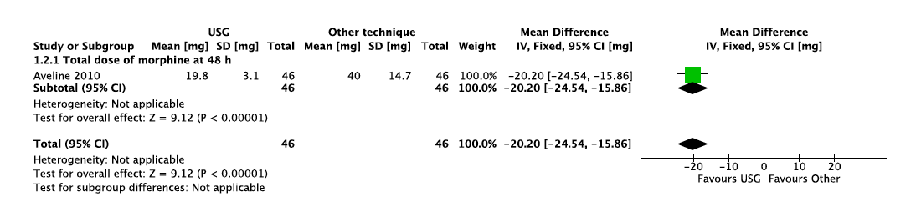
5.2.1.2. Adequacy of postoperative analgesia: VAS postop at mobilization 48hrs after surgery
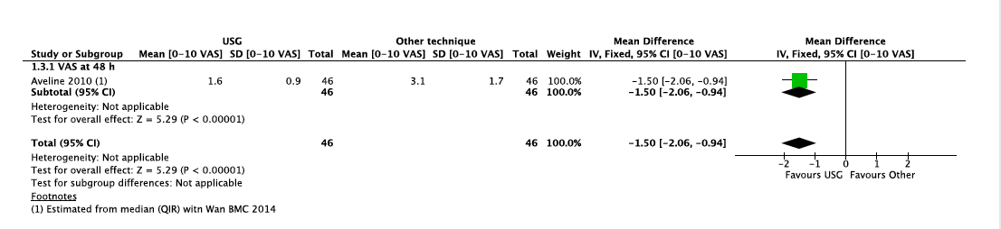
5.2.1.3. Time to perform block
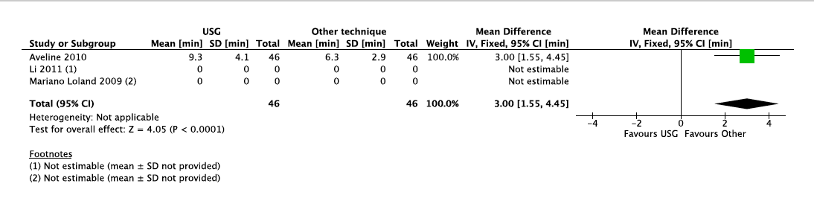

5.2.1.6. Incidence of complications
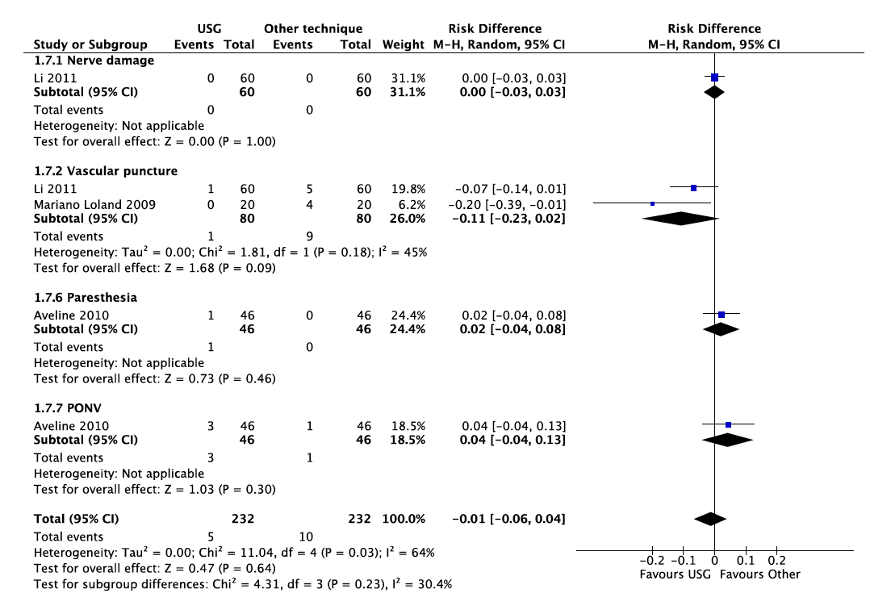
5.2.3 Subgluteal popliteal sciatic nerve block
5.2.3.1. Adequacy of anaesthesia for intended surgery
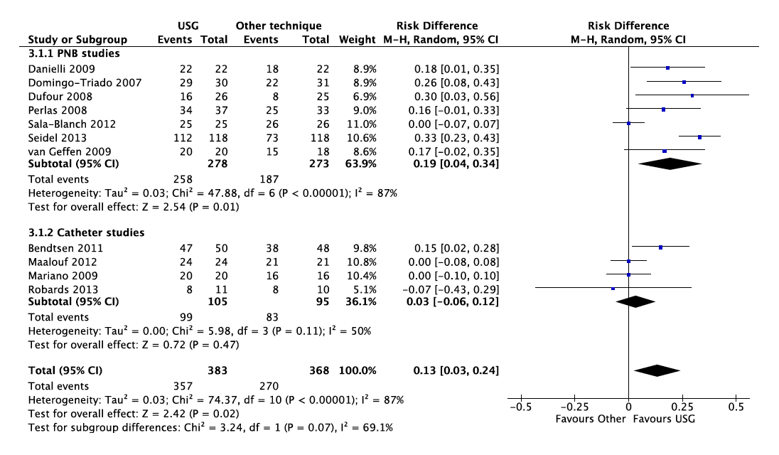

5.2.3.3. Time to perform block
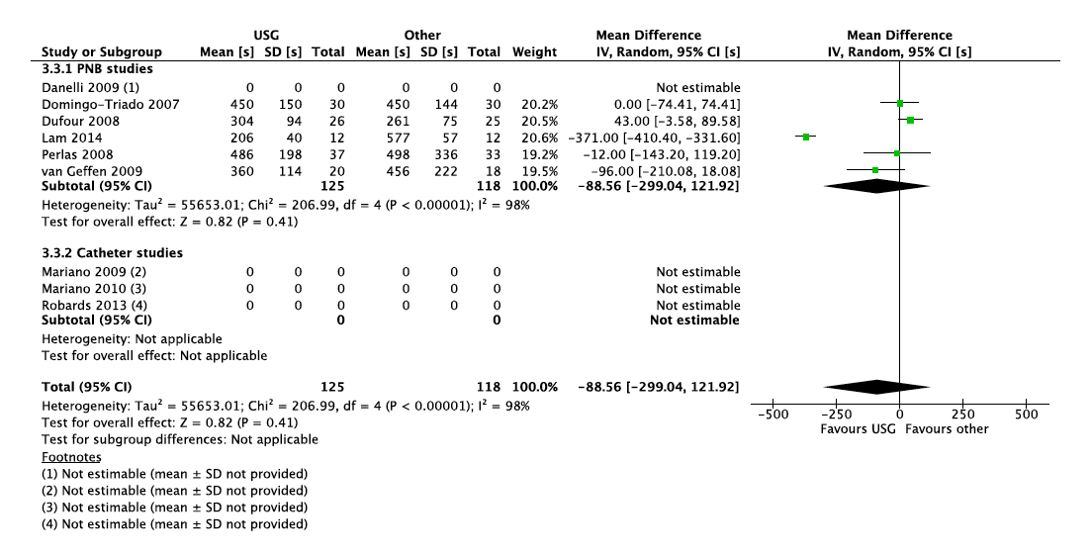
5.2.3.4. Time to achieve effective block
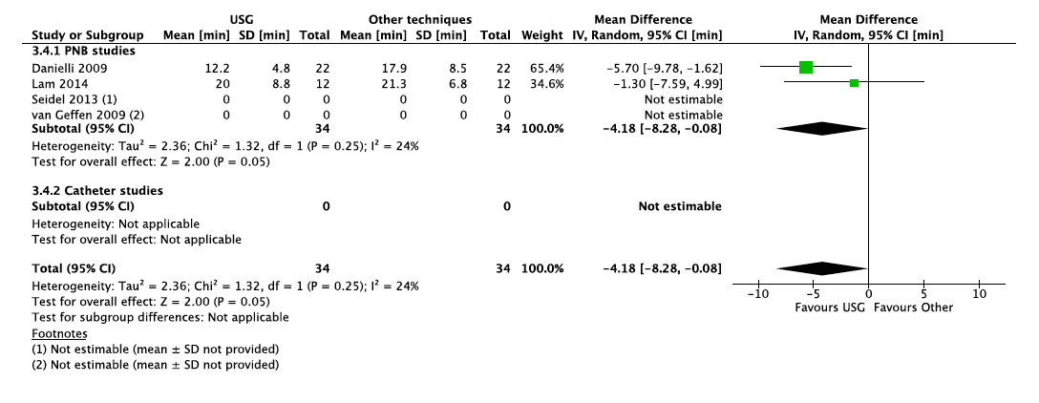

5.2.3.6. Incidence of complications
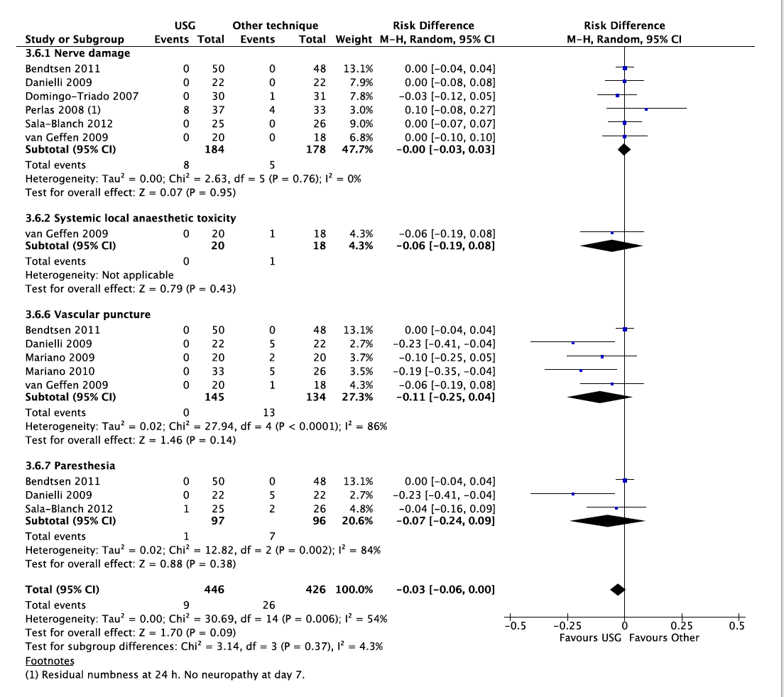
5.2.3.8. Patient satisfaction with the procedure
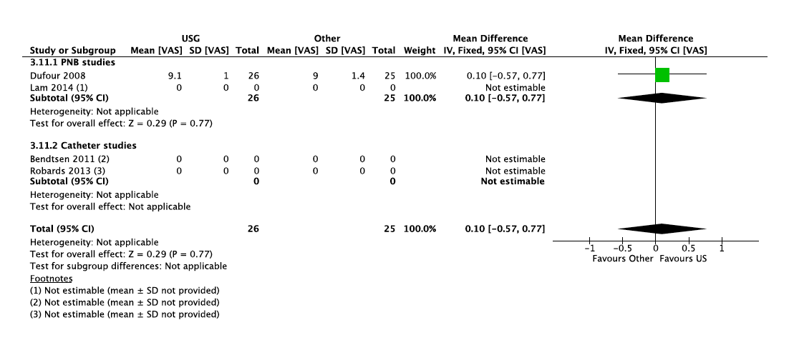

5.2.3.9. Needle passes
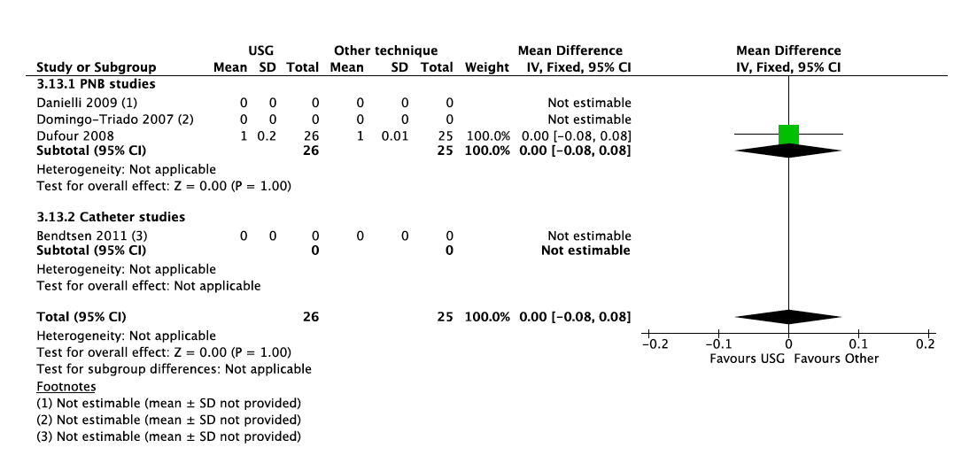

5.3. Abdominal and thoracic truncal blocks
5.3.1.1. Quality of analgesia: PACU morphine consumption (TAP block)
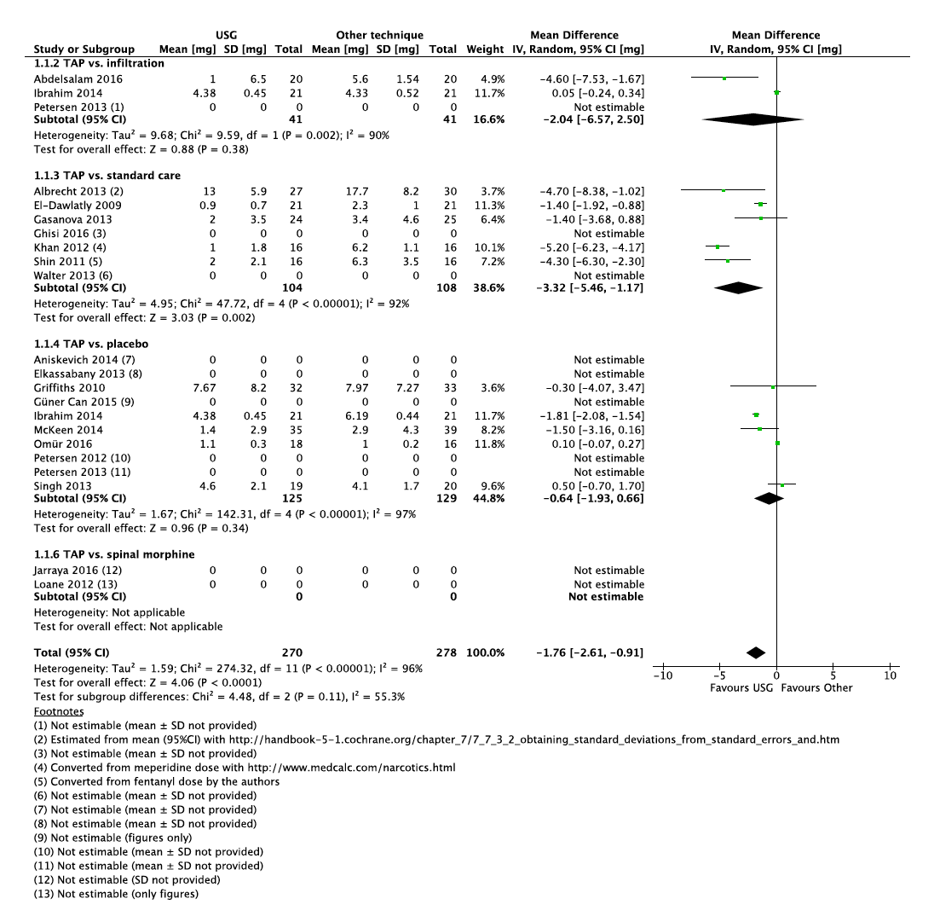
5.3.1.1. Quality of analgesia: PACU morphine consumption (rectus sheath block)
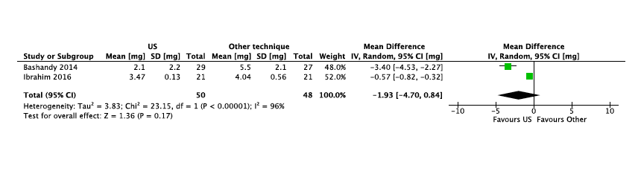

5.3.1.1. Quality of analgesia:24hrs morphine consumption (TAP block)
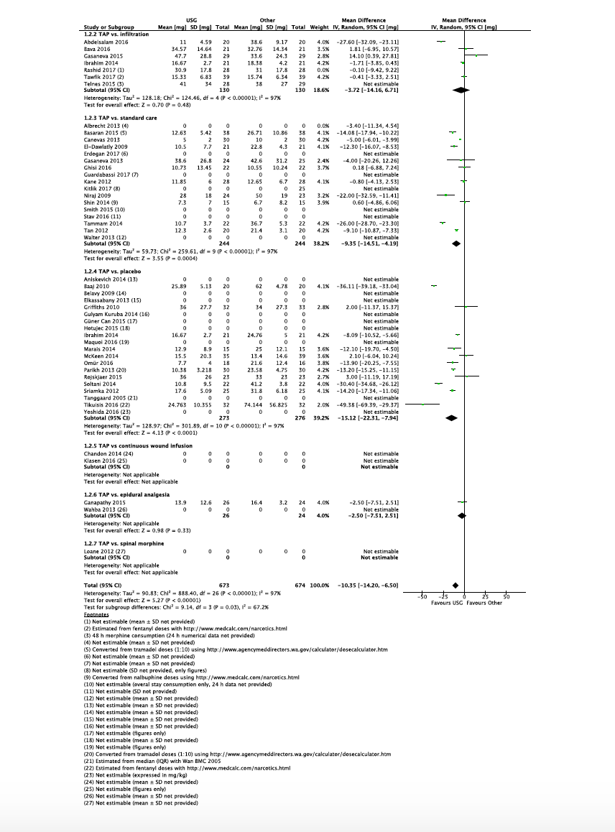

5.3.1.1. Quality of analgesia:24hrs morphine consumption (IHII)
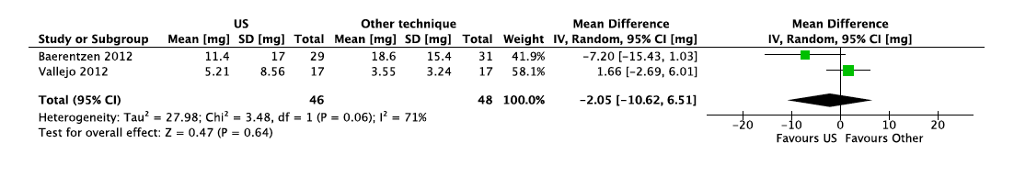

5.3.1.1. Quality of analgesia:24hrs morphine consumption (rectus sheath block)
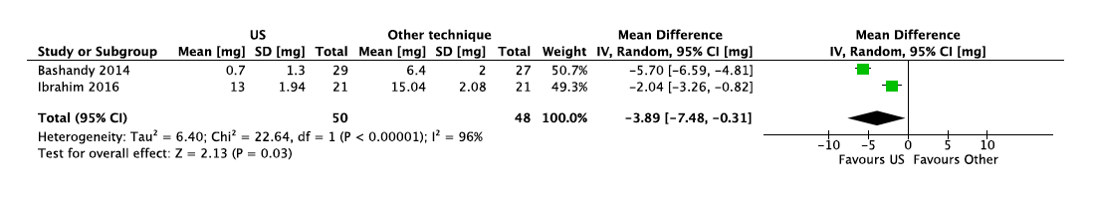
5.3.1.1. Quality of analgesia:24hrs morphine consumption (serratus anterior block)
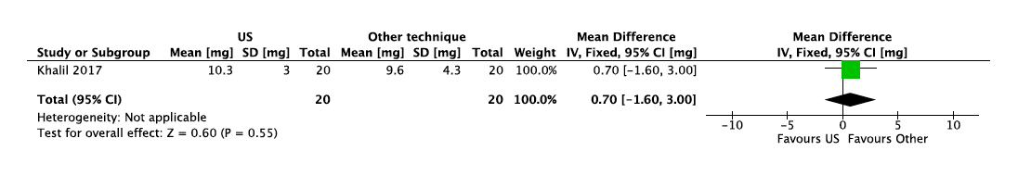

5.3.1.1. Quality of analgesia: NRS in PACU (TAP block)
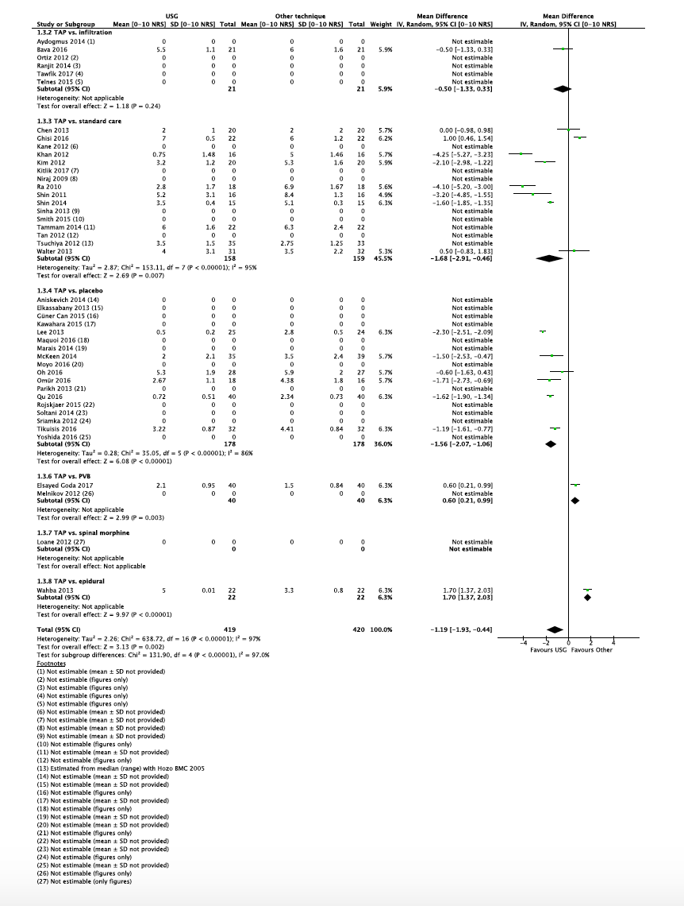

5.3.1.1. Quality of analgesia: NRS in PACU (IHII)
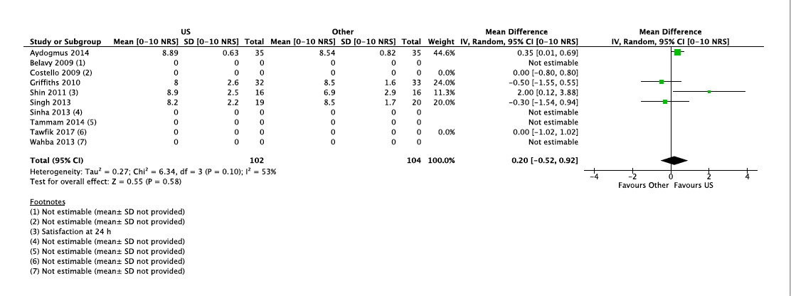

5.3.1.1. Quality of analgesia: NRS at 24hrs (TAP block)

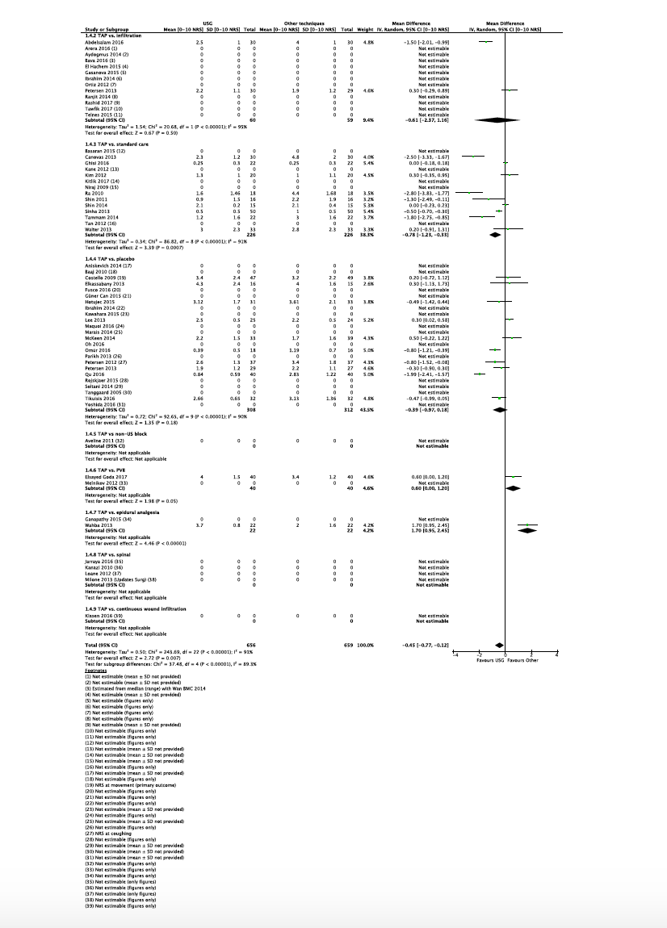

5.3.1.1. Quality of analgesia: NRS at 24hrs (IHII)
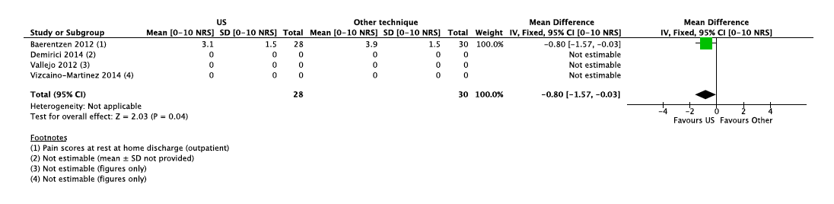

5.3.1.2. Incidence of complications (TAP block)

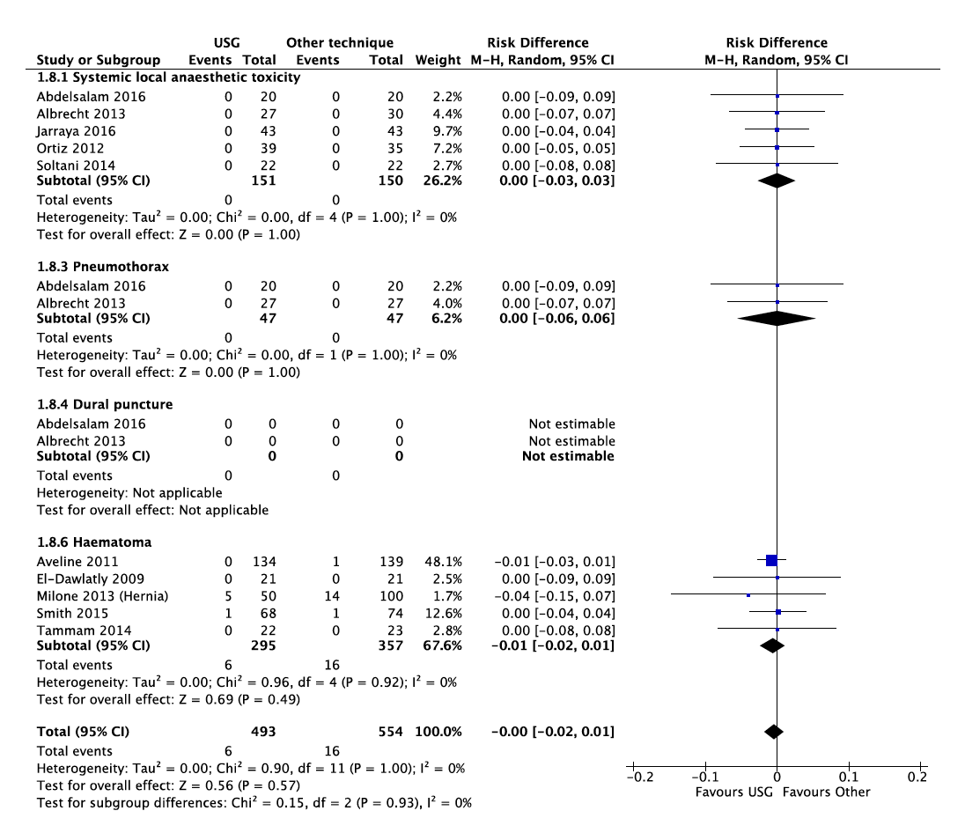

5.3.1.2. Incidence of complications (IHII)
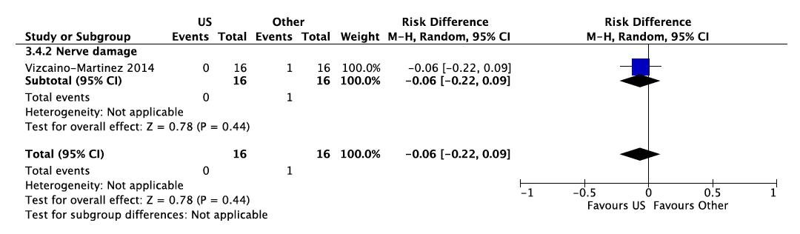
5.3.1.2. Incidence of complications (rectus sheath block)
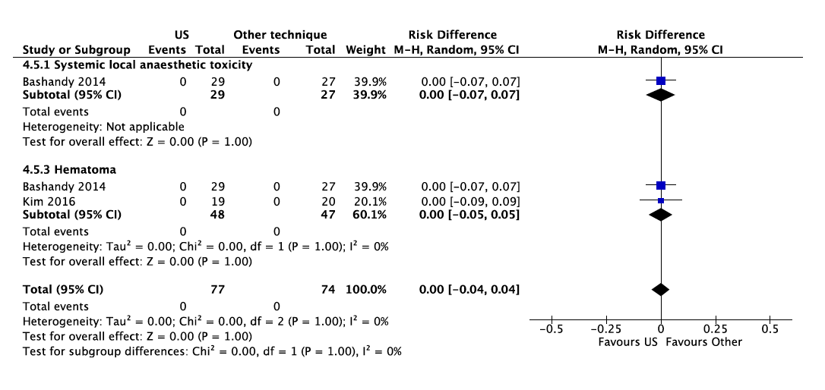

5.3.1.2. Incidence of complications: PONV (TAP block)
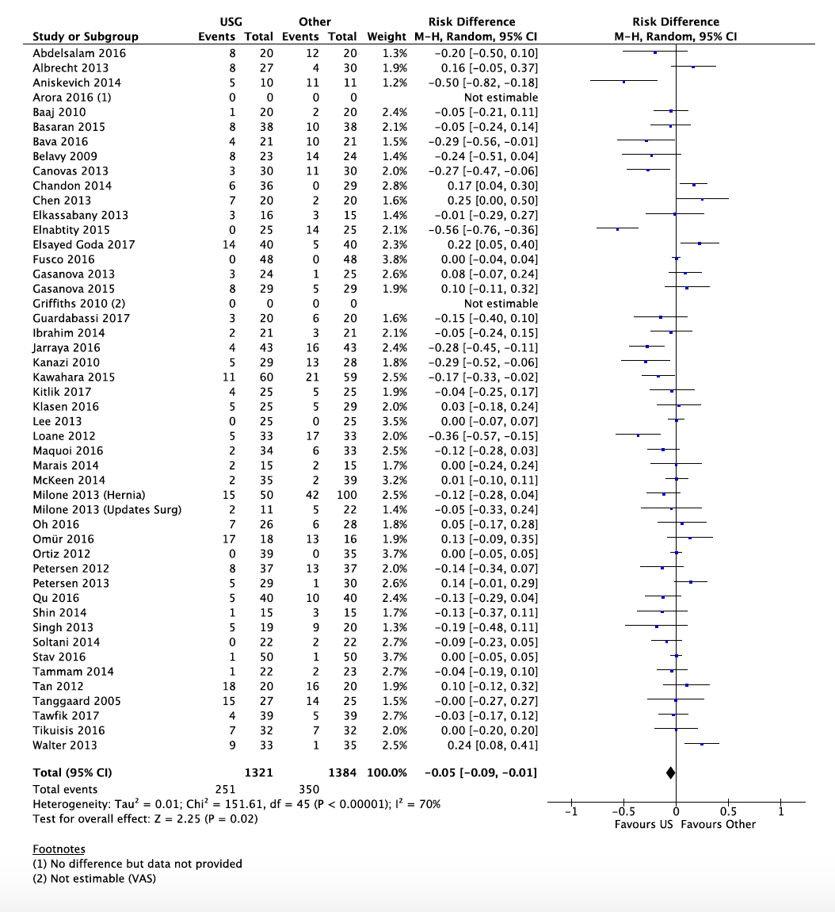

5.3.1.2. Incidence of complications: PONV (IHII)

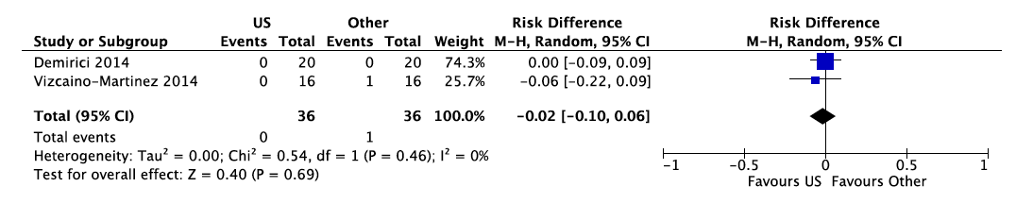

5.3.1.2. Incidence of complications: PONV (serratus anterior block)
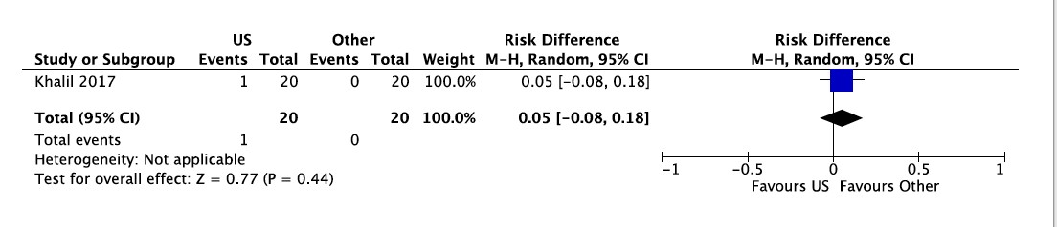

5.3.1.2. Incidence of complications: urinary retention (TAP block)
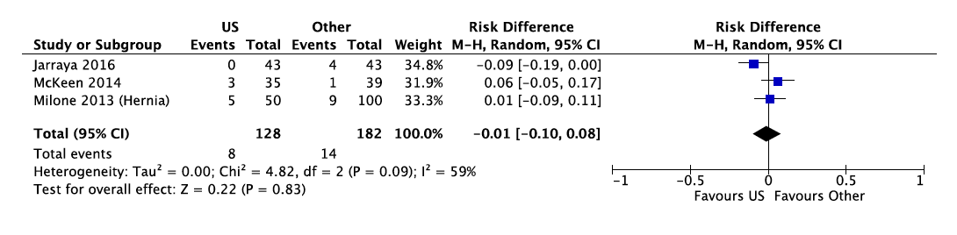
5.3.1.2. Incidence of complications: urinary retention (IHII)
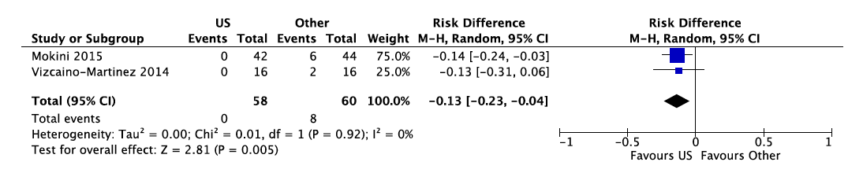

5.3.1.2. Time to postoperative mobilization (TAP block)

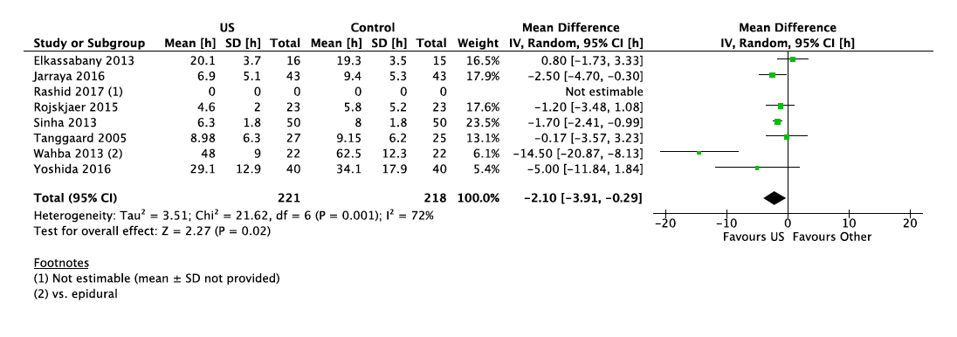

5.3.1.2. Time to postoperative mobilization (IHII)
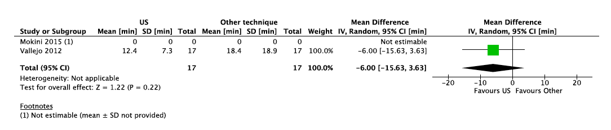

5.3.1.3. Time in PACU (TAP block)

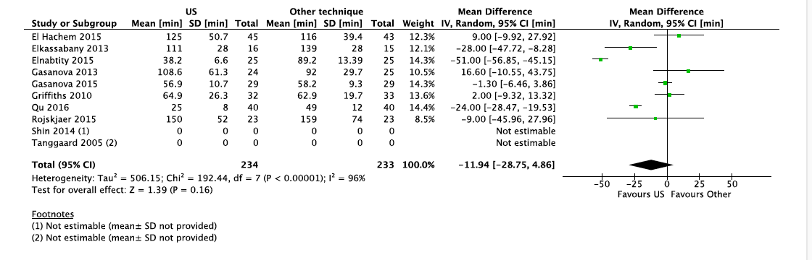

5.3.1.3. Time in PACU (IHII)
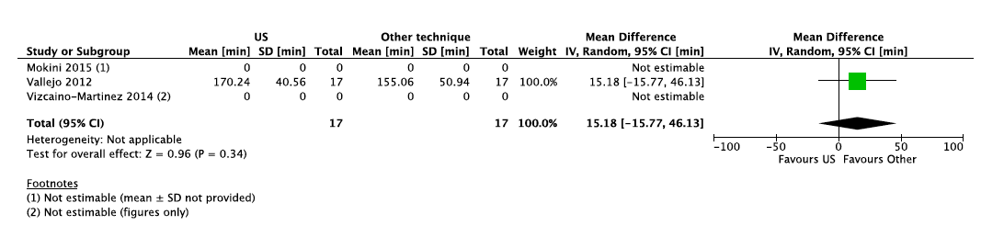

5.3.1.5. Time to discharge (TAP block)
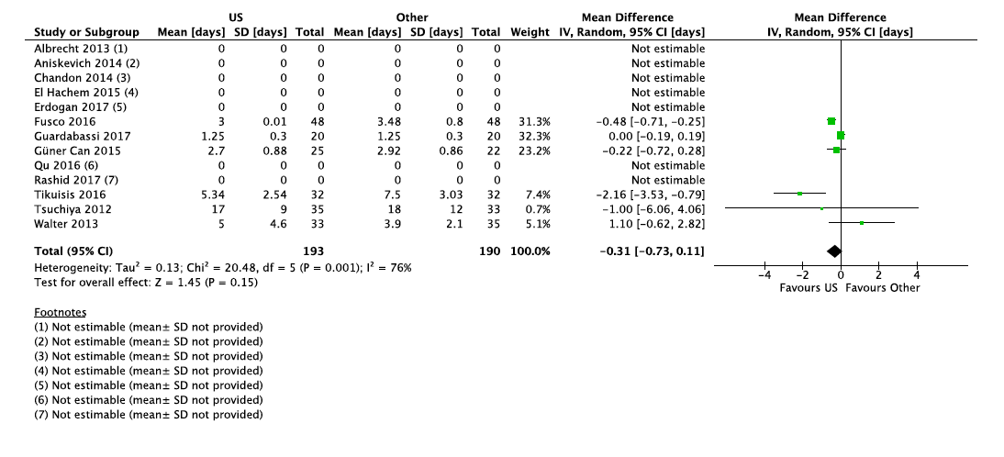
5.3.1.6. Patient satisfaction (TAP block)
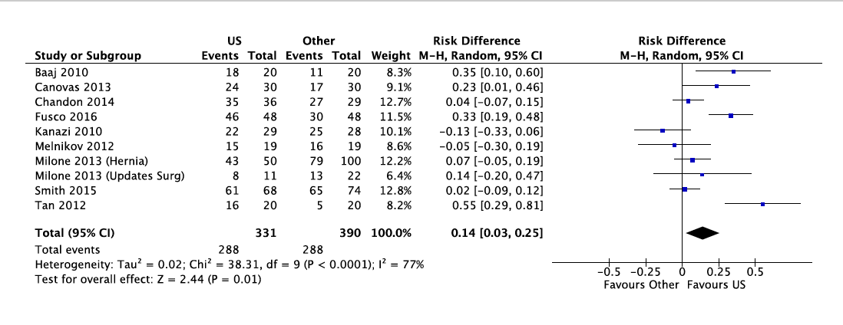
5.3.1.6. Patient satisfaction (TAP block: sub-analysis on NRS)

5.3.1.6. Patient satisfaction (IHII) 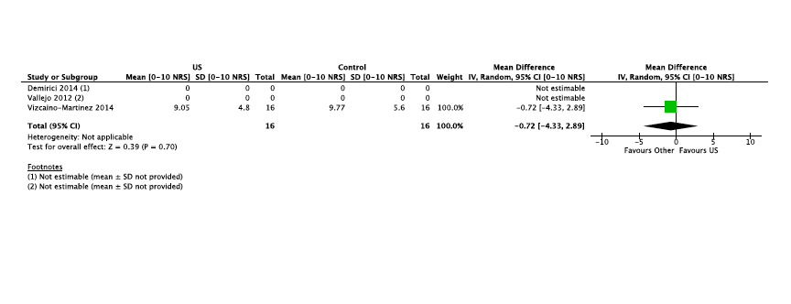

5.4 Neuraxial anaesthesia

5.4.1 Paravertebral blocks
5.4.2.1. Adequacy of anaesthesia for intended surgery
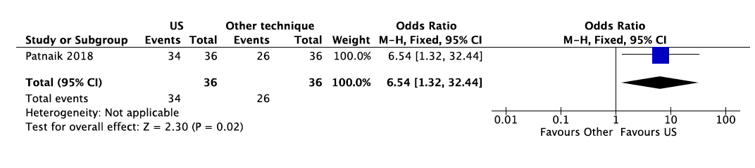
5.4.2.6. Incidence of complications
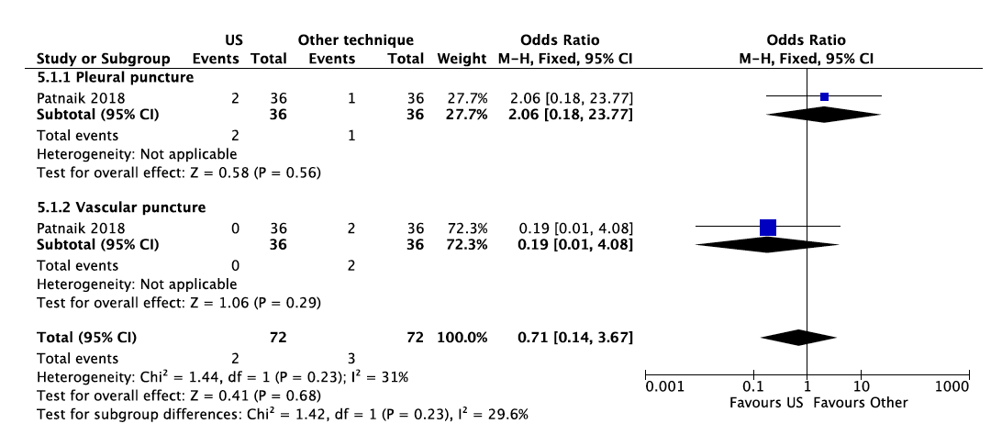

5.4.3 Epidural analgesia
5.4.3.1. Adequacy of epidural anaesthesia
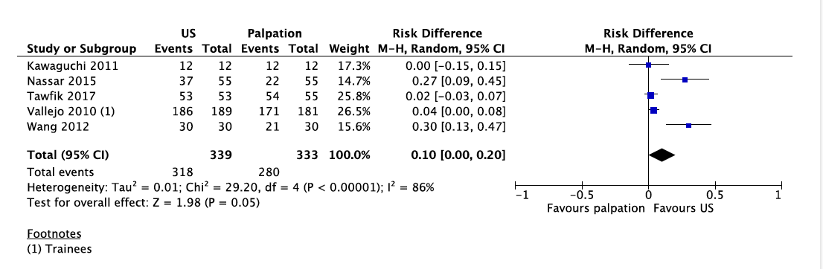
5.4.3.2. Time to perform epidural anaesthesia
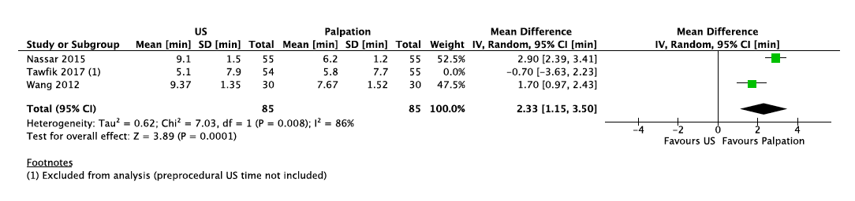
5.4.4. Incidence of complications
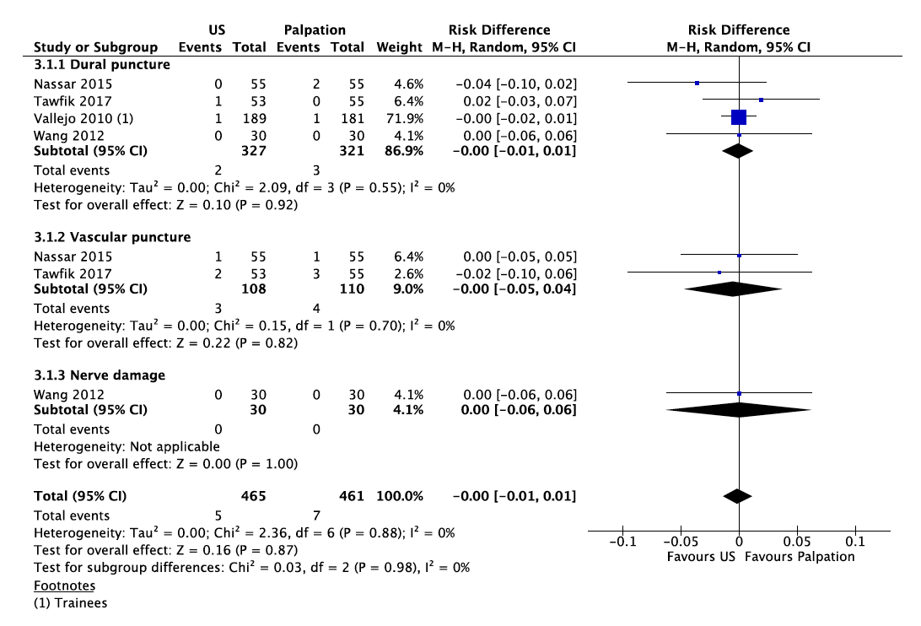

5.4.8. Postprocedural back pain
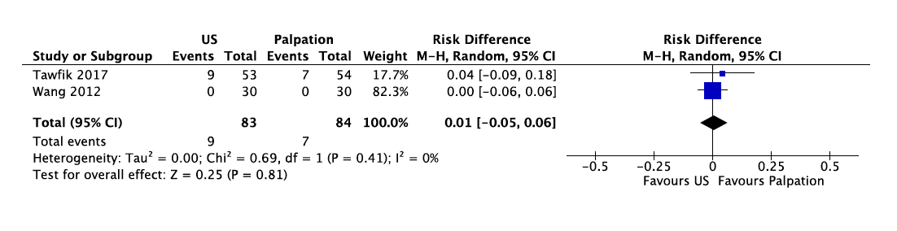
5.5 Spinal anaesthesia
5.4.10.1. Adequacy of anaesthesia for intended surgery
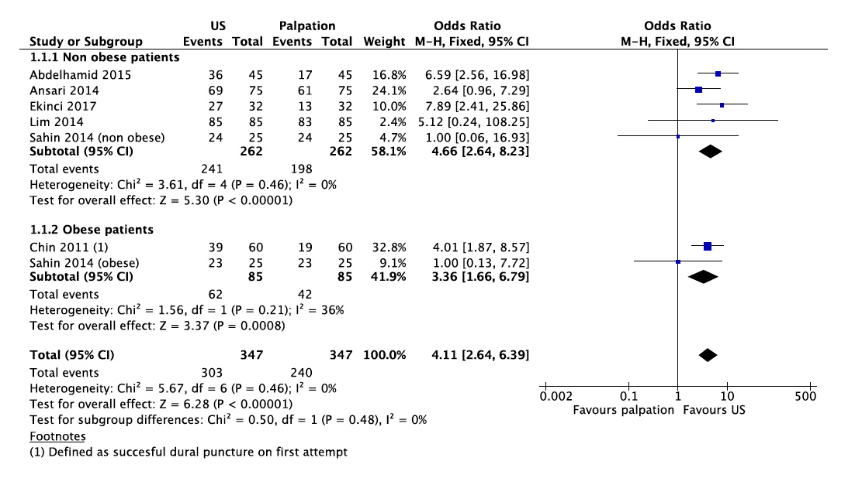
5.4.10.2. Time to perform spinal anaesthesia excluding scanning time
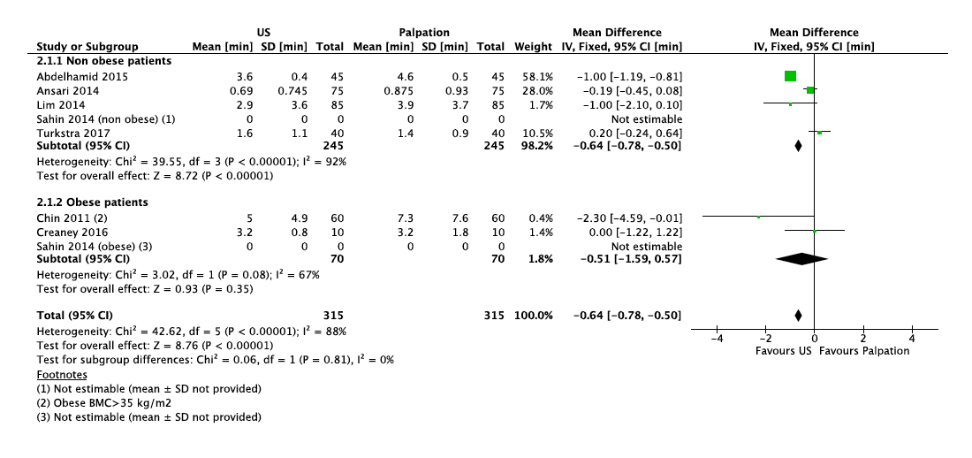

5.4.10.2. Time to perform spinal anaesthesia including scanning time
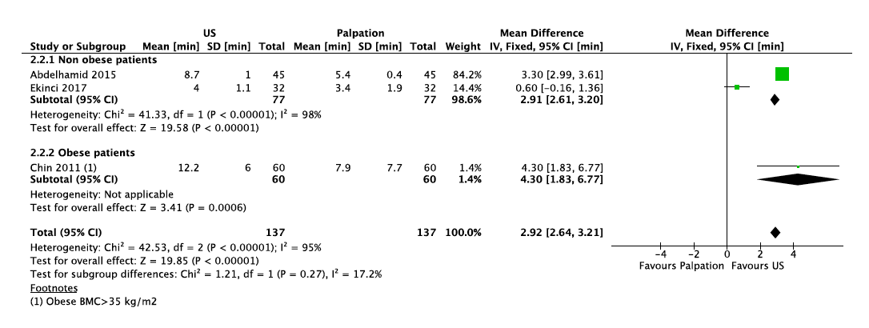
5.4.10.3. Incidence of complications
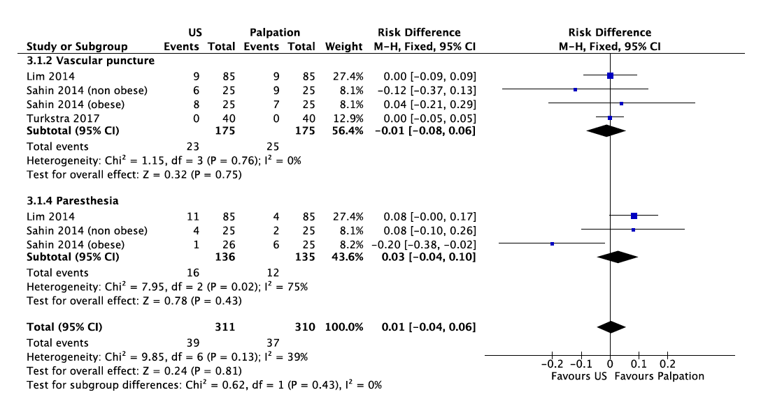
5.4.10.4. Patient satisfaction: patients satisfied and very satisfied
