Supplement Fig. 1 Measuring skeletal muscle on CT images of the level of the third lumbar vertebra by smartPACSTM. The thickness of rectus abdominis was measured as shown. The border of skeletal muscle was manually selected according to anatomical features, and the enclosed skeletal muscle area of this cross-section was calculated by the computer program.

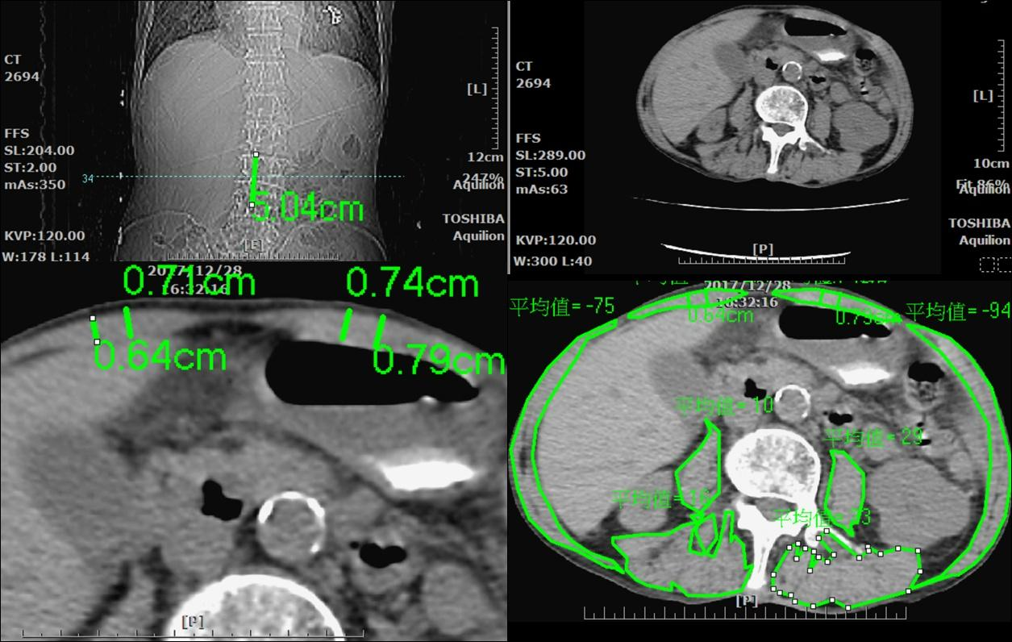

Supplement Fig. 2 Receiver operating characteristic curves of BMI-RA thickness ratio, BMI, and RA thickness for predicting in-hospital mortality. AUC, area under curve.



Supplement Fig. 3 Linear regression analyses show significant correlation between BMI-RA thickness ratio and hospital stay. Broken lines indicate 95% confidence interval.



Supplement Table 1. Outcomes of the 16 patients with CT scans done within the first week of admission to ICU.

|  |  |  |  |  |  |  |  |  |  |  |  |  |  |
| --- | --- | --- | --- | --- | --- | --- | --- | --- | --- | --- | --- | --- | --- |
|  | **Condition at discharge** | | | | | | | **Prolonged MV** | | | | | |
|  | **Dead** | | **Alive** | | ***P*** | **95% CI** | **>14 days** | | | **≤14 days** | | ***P*** | **95% CI** |
| Age (years) | 64.00 [61.00 to 71.00] | | 68.50 [57.50 to 81.50] | | 0.5608 | -11.00 to 18.00 | 64.00 [63.00 to 77.00] | | | 67.00 [49.50 to 75.50] | | 0.5824 | -11.00 to 18.00 |
| APACHE II score | 32.00 [25.75 to 36.75] | | 26.50 [19.00 to 30.50] | | 0.1385 | -13.000 to 3.000 | 30.00 [26.00 to 34.00] | | | 22.00 [19.00 to 30.50] | | 0.2566 | -3.000 to 13.00 |
| SOFA score | 9.000 [7.000 to 11.00] | | 5.500 [4.000 to 7.750] | | 0.1001 | -6.000 to 1.000 | 8.000 [4.000 to 10.00] | | | 5.000 [4.000 to 7.000] | | 0.1683 | -1.000 to 6.000 |
| CCI | 2.400 [3.750 to 5.500] | | 2.900 [2.000 to 6.250] | | 0.4258 | -3.000 to 2.000 | 4.000 [3.000 to 6.000] | | | 4.000 [2.000 to 5.500] | | 0.5483 | -2.000 to 3.000 |
| Albumin (g dl-1) | 2.300 [1.750 to 2.750] | | 2.550 [2.450 to 3.050] | | 0.0843 | 0.000 to 1.200 | 2.500 [2.200 to 2.900] | | | 2.900 [2.500 to 3.600] | | 0.1234 | -1.300 to 0.2000 |
| SMA at L3 (cm2) | 81.31 [66.02 to 113.4] | | 91.64 [66.78 to 118.5] | | 0.5622 | -43.98 to 27.09 | 86.59 [68.81 to 112.8] | | | 96.49 [68.76 to 123.8] | | 0.7427 | -42.36 to 29.88 |
| SMI (cm2/m2) | 33.83 [27.05 to 41.15] | | 36.67 [29.92 to 45.19] | | 0.6354 | -15.64 to 8.230 | 34.71 [28.27 to 44.61] | | | 37.22 [28.43 to 49.58] | | 0.8269 | -16.26 to 9.692 |
| RA thickness (cm) | 0.6076 [0.5188 to 0.7363] | | 0.7650 [0.6513 to 0.8163] | | 0.0934 | -0.0400 to 0.2800 | 0.7100[0.5400 to 0.7700] | | | 0.8050 [0.5450 to 0.9250 | | 0.3196 | -0.2900 to 0.1750 |
| BMI (kg/m2) | 26.51 [23.88 to 31.84] | | 27.35 [24.19 to 32.77] | | 0.9578 | -6.580 to 6.180 | 27.40 [24.44 to 32.55] | | | 25.49 [21.81 to 30.97] | | 0.4409 | -4.080 to 8.940 |
| BMI-RA thickness ratio | 46.34 [34.48 to 57.54] | | 39.61 [34.74 to 42.98] | | 0.2198 | -20.14 to 5.378 | 43.41 [35.13 to 47.86] | | | 40.76 [28.49 to 42.17] | | 0.2212 | -5.629 to 17.09 |
|  | **Dead** | **Alive** | | **OR** | ***P*** | **95% CI** | **>14 days** | | **≤14 days** | | **OR** | ***P*** | **95% CI** |
| With / without sarcopenia | 5/1 | 6/4 | | 3.333 | 0.5879 | 0.2756 to 40.31 | 8/3 | | 3/2 | | 1.778 | 1.000 | 0.1915 to 16.50 |

CT, computed tomography; APACHE II, Acute Physiology and Chronic Health Evaluation II; SOFA, Sequential Organ Failure Assessment; CCI, Charlson comorbidity index; SMA at L3, skeletal muscle area at the level of the third lumbar spine; SMI, skeletal muscle index; RA, rectus abdominis; BMI, body mass index.

*Sarcopenia is defined by SMI less than 49 cm2/m2 in males and less than 31 cm2/m2 in females.22

Supplement Table 2. Correlations of results from all 20 computed tomography scans and results from corresponding ultrasound measurements.

|  |  |  |  |  |  |  |  |  |
| --- | --- | --- | --- | --- | --- | --- | --- | --- |
|  | **Thickness of rectus abdominis** | | | | **BMI-RA thickness ratio** | | | |
| **Variable measured by CT** | ***R*** | **R2** | **95% CI** | ***P*** | ***R*** | **R2** | **95% CI** | ***P*** |
| Thickness of rectus abdominis | 0.5117 | 0.2618 | 0.08938 to 0.7780 | 0.0211 | -0.1928 | 0.03717 | -0.5854 to 0.2730 | 0.4154 |
| Area of rectus abdominis | 0.4432 | 0.1964 | 0.0008040 to 0.7405 | 0.0503 | -0.2162 | 0.04676 | -0.6012 to 0.2502 | 0.3598 |
| Skeletal muscle area at L3 | 0.6333 | 0.4011 | 0.2650 to 0.8403 | 0.0027 | -0.2211 | 0.04888 | -0.6045 to 0.2454 | 0.3489 |
| Skeletal muscle index* | 0.5807 | 0.3372 | 0.1860 to 0.8140 | 0.0073 | -0.1737 | 0.03017 | -0.5722 to 0.2912 | 0.4639 |

CT, computed tomography; L3, level of the third lumbar spine; CI: confidence interval.

*Skeletal muscle index is defined as skeletal muscle area (cm2) divided by the square of body height (m2).

Supplement Table 3. Comparison of patients with high and low BMI-RA thickness ratio.

|  |  |  |  |  |  |  |
| --- | --- | --- | --- | --- | --- | --- |
|  | **Ratio < 44.20** | | **Ratio > 44.20** | | ***P*** | **95% CI** |
| Age (years) | 68.00 [57.00 to 75.50] | | 73.00 [61.75 to 83.00] | | 0.3376 | -8.000 to 16.00 |
| APACHE II score | 26.00 [19.00 to 29.00] | | 32.00 [26.50 to 36.75] | | 0.0500 | -1.000 to 13.00 |
| SOFA score | 5.000 [4.000 to 7.000] | | 7.000 [4.000 to 9.500] | | 0.4258 | -2.000 to 4.000 |
| CCI | 4.000 [2.000 to 6.000] | | 5.000 [4.000 to 6.250] | | 0.1430 | -1.000 to 3.000 |
| Albumin (g dl-1) | 2.500 [2.300 to 2.900] | | 2.500 [1.600 to 2.900] | | 0.4468 | -0.9000 to 0.4000 |
| RA thickness (cm) | 0.7714 [0.6550 to 0.8275] | | 0.6467 [0.5188 to 0.8025] | | 0.2120 | -0.2650 to 0.05000 |
| BMI (kg m-2) | 25.49 [23.10 to 27.96] | | 32.79 [26.65 to 40.87] | | 0.0151 | 1.220 to 14.52 |
| ICU stay (days) | 7.000 [3.000 to 20.50] | | 21.00 [18.75 to 37.00] | | 0.0189 | 2.000 to 20.00 |
| Hospital stay (days) | 25.00 [13.00 to 37.00] | | 42.00 [33.25 to 54.00] | | 0.0348 | 1.000 to 33.00 |
| MV duration (days) | 6.000 [1.50 to 15.50] | | 28.50 [21.00 to 35.50] | | 0.0007† | 11.00 to 30.00 |
|  | **Ratio < 44.20** | **Ratio > 44.20** | | **OR** | ***P*** | **95% CI** |
| In-hospital mortality* | 2 (21) | 5 (6) | | 47.50 | 0.0014 | 3.544 to 636.6 |
| Prolonged MV* | 7 (21) | 6 (6) | | 25.13 | 0.0058 | 1.240 to 509.5 |

Data are presented as median [IQR]. Ratio, BMI-RA Thickness Ratio; CI, confidence interval; APACHE II, Acute Physiology Chronic Health Evaluation II score; SOFA, Sequential Organ Failure Assessment score; CCI, Charlson comorbidity index; RA, rectus abdominis; BMI, body mass index; ICU, intensive care unit; MV, mechanical ventilation; OR, odds ratio.

*In-hospital mortality and prolonged MV are presented as case number (total patients).

†Statistically significant with Benjamini-Hochberg correction.

Supplement Table 4. Thickness of rectus abdominis reported in previous studies.

|  |  |  |  |  |  |  |  |
| --- | --- | --- | --- | --- | --- | --- | --- |
| **Study (year/country)** | **Method** | **Population** | **Age (years)** | **Height (cm)** | **Weight (kg)** | **BMI (kg m-2)** | **Mean ± SD (mm)** |
| Kim at al (2012/Korea)33 | CT | 545 women | 43 | NS | NS | 23.35 | Right:10.26 ± 1.83  Left: 10.26 ± 1.85 |
| Ishida et al (2014/Japan)34 | US | 30 healthy men | 20.7 ± 2.7 | 170.6 ± 5.4 | 61.7 ± 9.1 | NS | 12.2 ± 1.9 |
| Bueno et al (2016/Brazil)35 | US | 17 ESRD patients  17 healthy control | 54.1 ± 14.1  48.3 ± 15.2 | 161.3 ± 8.1  166.0 ± 12.0 | 64.2 ± 11.8  73.0 ± 20.6 | 24.5 ± 3.1  26.4 ± 5.0 | 0.96 ± 0.10  2.21 ± 0.40 |
| Tahan et al (2016/Iran)36 | US | 75 healthy men  81 healthy women | 24.3 ± 7.2 | 167.9 ± 8.9 | 65.3 ± 11.9 | NS | M:4.5 ± 0.9  F:3.5 ± 0.8 |
| Choi et al (2017/Korea)8 | CT | 725 men | 49.1 ± 6.2 | 172.1 ± 5.33 | 74.1 ± 9.4 | 25.01 ± 2.8 | 12.45 ± 2.03 |
| Wachi et al (2017/Japan)12 | US | 24 healthy men | 22.2 ± 1.3 | 171.5 ± 10.9 | 64.7 ± 0.9 | NS | Right: 14.1 ± 2.0  Left: 13.9 ± 2.0 |
| MRI | Right: 14.2 ± 1.7  Left: 14.1 ± 1.6 |
| Current study | US | 16 men, 11 women received major abdominal surgery | M: 67.56 ± 10.01  F: 68.45 ± 13.44 | M: 165.1 ± 7.672  F: 152.5 ± 5.956 | M:70.94 ± 14.54  F: 59.00 ± 10.45 | M: 25.88 ± 4.388  F: 29.83 ± 8.775 | M: 7.825 ± 1.729  F: 6.873 ± 1.574 |

Data are presented as mean ± SD. BMI, body mass index; CT, computed tomography; US, ultrasound; MRI, magnetic resonance imaging; ESRD, end stage renal disease; M, male; F, female; NS, not specified.