Supplement Figure 1 Occurrence of adverse events during the study.
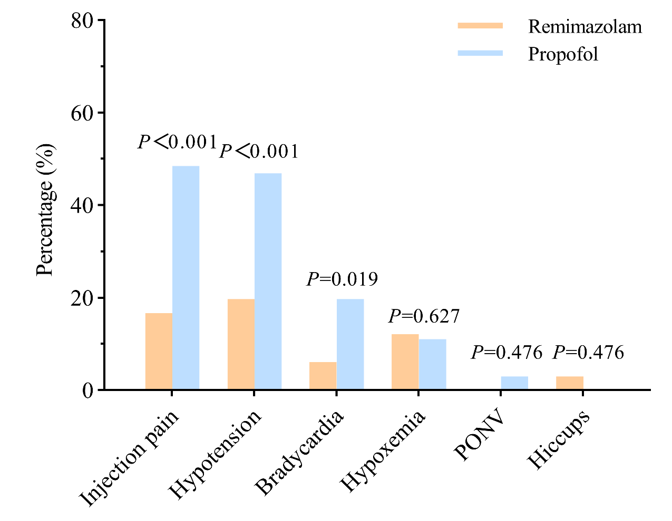Note: Percentage of sedation-related complications, including injection pain, hypotension, bradycardia, hypoxaemia, postoperative nausea or vomiting (PONV), and hiccups during the study.

