NOTE: This tip sheet is provided by the Health and Wellness Lab, Faculty of Kinesiology, University of Calgary. Please reference the Health and Wellness lab, wellnesslab@ucalgary.ca and www.thriveforcancersurvivors.com, for adapting this to use for your program.

PRIOR TO CLASS:
-Pilot your circuit: make sure the timing and style works for a virtual class.
-Download and set-up your Zoom account:
- Please orientate yourself with how Zoom works prior to your first class. Zoom has provided Tutorials on a number of its features.
- To ensure privacy of your class, each Zoom class MUST be created the Virtual Waiting Room feature. If you are using our X account, this feature will be automatically enabled. If you are not using our account, please confirm this feature is utilized for each Zoom class.
-Test your computer sound and video – make sure the sound is clear and that both audio & video work (i.e. clean camera lens, etc.).
-Find a location that has good lighting, so that participants can clearly see you.
*Tip: put your computer phone up high on a shelf or counter
*Tip: avoid standing in front of a large window – you want YOURSELF to be well lit
-Figure out your teaching set-up: where do you want the computer? What’s the best way to see participants? See if you can set-up your class on two devices: one that’s close to you so you can see participants, and the other further away, so they can see you.
-Ensure everything YOU need is gathered in the space you are delivering class.
WHAT TO SEND YOUR PARTICIPANTS:
-E-mail intro – see following template
-Participant PDF Document (Includes: class etiquette, expectations, safety and information document, RPE scale, instructions on how to access/set-up Zoom prior to class)
-What to prepare for class (space, equipment, what to wear, etc.).
-Zoom link.
-Outline of class structure. Example for a 9am class:
8:50am: instructor available for questions prior to class (i.e. to discuss injuries,
modifications, etc.).
9:00am: class starts
9:55am: class finishes
9:55am-10:05am: instructor available for post-class questions.
-A link to a playlist, if you have one.
*Tip: use a generic platform so everyone can access (e.g. YouTube), or a popular platform, such as Spotify or Apple Music.
DURING CLASS:
-As always, dress appropriately: no short-shorts, tank tops or other low-cut type clothing.
-Begin with a welcome.
-As participants ‘enter’ the Zoom class, ensure their names are displaying as FIRST NAME ONLY (participants were instructed to do this prior to class in their tip sheet document).
-Remind everyone of class etiquette (e.g. muted during workout, only instructor has sound on, different views, unmute to ask question, etc.).
Tip: ensure you remind participants to pin YOUR video and confirm that all participants have their viewing options on speaker view for duration of workout.
-Remind participants re: what equipment they will need in case they missed that detail in your e-mail.
-Get participants set up with the “long edge of their mat” in line with the camera – and then ensure you can see everyone before you start the class.
-Remind participants to give you “thumbs up” when you ask if they are ok, “thumbs down” if there is an issue (and then you’ll ask them to unmute), and a “wave” if they need to get your attention.
-Remind participants how to unmute, switch between speaker/gallery view…etc.
-When instructing, find a balance between demonstrating the exercises, but checking-in on participants’ form and effort.
-Make it personable – generic encouragement is great, but remember to personally acknowledge participants as well.
*Tip: include everyone! Try to avoid ‘picking favourites.’ Everyone is doing their best, it’s important to make each person feel important, even if they aren’t doing the ‘most challenging’ modification.
-Ensure no background noises are present during class. This includes music (hence, the playlist), other individuals.

AFTER CLASS:
-Schedule some time for answering participant questions after class.
-Reflect: what went well? What could have been better?
-Plan your next class.
SAFETY CONSIDERATIONS
Remote training considerations adapted from the Canadian Society for Exercise Physiology:
- Please take as many measures as is reasonable to ensure the safety of class participants depending on their treatment or training plan.
o If the class will be held indoors, ensure the space is clear of obstacles, slip/trip hazards. This may include children - are any children in danger of getting hurt from well-intentioned participation?
o Do participants have someone at home or nearby that they can signal, should they get hurt?
o Have you established a level of tolerance scale with your participants? How will you know if they are in pain or have over-exerted themselves?
- Refer to and use the RPE scale to help monitor participants’ perceived effort throughout class. You may choose to send this along with your pre-class instruction package.
- Make sure they are in full view for the duration of the workout. Try to avoid moving around too much (i.e., to stairs outside of the camera view) during the session.

E-MAIL TEMPLATE TO SEND PARTICIPANTS PRIOR TO CLASS:

Dear XXX Participants,
I am looking forward to meeting you all in our upcoming remote exercise class on XX (day of the week), XX (month), XX (date) at XX (time). In order to prepare yourself for this remote exercise class, please see attached for the following documents:
-Participant’s guide to success for participating in a remote exercise class
-A simple, user-friendly guide for using Zoom

The Zoom link to access this remote exercise class is: XXXX.
The link to our class playlist is: XXXX.
For this class, you will need: XXXX.

Class Outline:
XXam: instructor available for questions prior to class
XXam: class starts
XXam: class finishes
XXam: instructor available for post-class questions.

Class begins at XXX. As you would to a regular exercise class, please arrive a few minutes early so that we can all get started as a group. As a reminder, I will be on Zoom 10 minutes prior to class starting to answer any of your questions.

If you have any questions, comments or concerns after reading over the attached documents, please do not hesitate to contact me at: XXXXX.

I am looking forward to ‘seeing’ you in class!
Regards,

XXX (YOUR NAME)

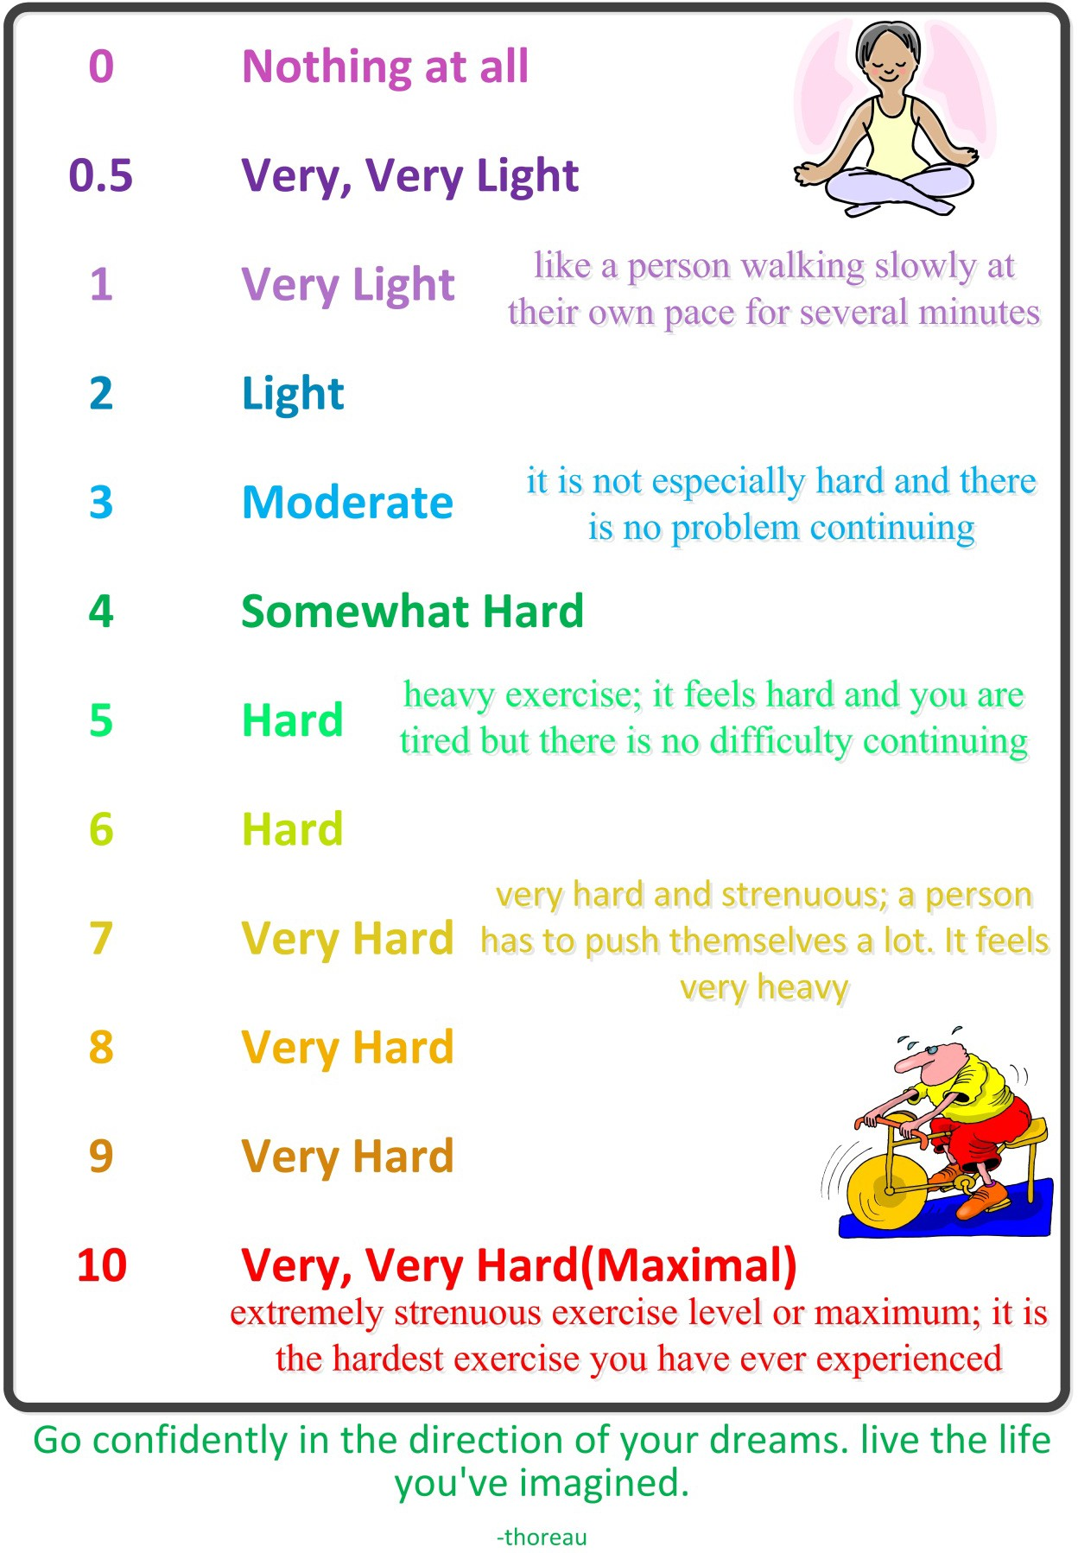
RPE SCALE – INCLUDED IN PARTICIPANT TIP SHEET

