Hello (Program Name) Participant!

We are excited to have you join our (Program Name) exercise classes online. Here are some instructions that will ensure you have a successful experience.

Exercise Class Requirements
You will need the following:
- An “exercise area” (~3-4m²) where you can move comfortably
- Access to a phone, computer, laptop, or tablet that can be set up in your “exercise area”
  - Please ensure that your phone, computer, laptop, or tablet has:
    - A video camera, so we can see you while you are exercising
    - A microphone, so we can communicate with you
    - ‘ZOOM’, our virtual exercise platform, downloaded
- High-speed internet connection
- A willingness to try something new, connect online and have some fun.

Note: You do not need exercise equipment to participate. Classes will be designed to work with your own bodyweight (and other common household items). If you already have exercise equipment at home, such as bands, dumbbells, stability balls, yoga mat, etc. make sure to have these ready and we will give you modifications during class for their use.

How It works:
You will receive an e-mail from your instructor with:
- A Zoom link/“meeting ID”
- Instructions for what to have for the exercise session
- A link to the class playlist
10 minutes prior to class, the instructor will be available to answer any questions you may have. They will remain online for 10 minutes after class as well. This is the time to connect with your instructor on any injuries, changes in health status, or concerns you may have.

Zoom Instructions:
- Download the ‘Zoom’ application onto your device: https://zoom.us/download
- You will receive an email with a “meeting ID”
  - Click on the link provided. Enter only your first name when prompted.
  - Your instructor will be on 10 minutes early to ensure everyone is set up, and answer any questions you might have
(Note: You will join a ‘waiting room’ where your instructor will enable entry prior to you joining.)
Zoom Class Etiquette
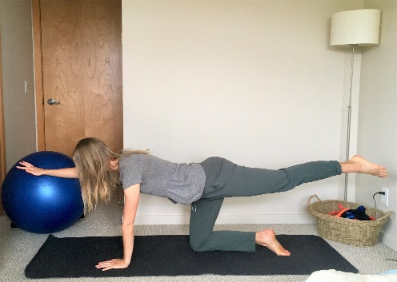
- Please be sure to place your phone, computer, laptop, or tablet on a high surface (e.g., table, counter, bookshelf) and ensure that when you step into your “exercise area” your entire body is visible in the screen (see pic ->)
  - This will ensure our instructors can see you and give you appropriate feedback throughout your class (see picture for optimal set-up)
  - If you have an exercise mat, place it with the long edge facing the camera – that ensures we can see your form more easily to provide feedback
- During class, we will mute everyone’s audio to ensure audio clarity for everyone. Before and after class if you wish to speak, please:
  - Click the 3 little dots in the top right corner of your video screen -> unmute my audio. (May differ across devices – look for a microphone symbol to find the ‘unmute audio’)
    - If you have a question during class, wave at me, or unmute yourself to speak up. Please ensure you return your audio to mute after.
- At the end of class, during stretching we will unmute everyone’s audio to chat/ask questions

Helpful Tips and Reminders:
- Wear indoor running shoes, if possible. If on carpet, you may prefer barefeet to avoid any tripping hazard.
- Fill up a water bottle and have it close by prior to class starting.
- Wear comfortable exercise clothing (taking into consideration the temperature of your house/workout space).
- If you are using a yoga mat – set your mat up with the long edge facing the camera.

We look forward to having you join us. Contact us if you have any questions at (EMAIL).

