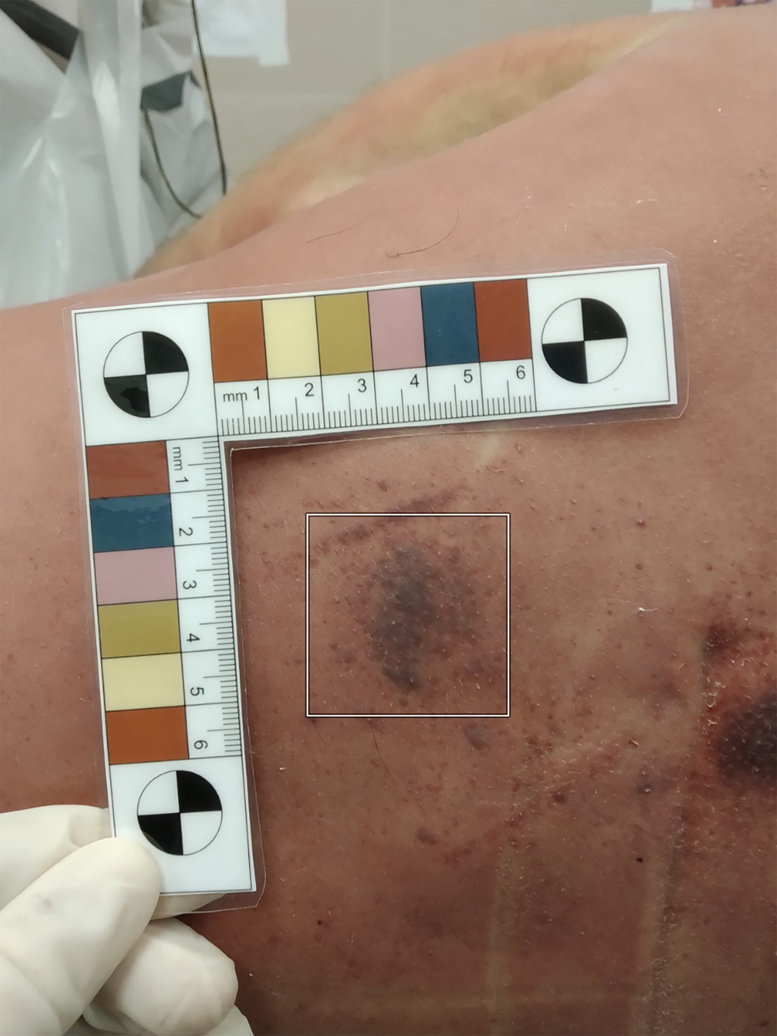

Supplemental Digital Content 1. Example of sampling of the area of interest through the GIMP eyedropper tool. An area of interest of 101 x 101-pixel is sampled on an image of about 3000 x 4000-pixel.

