Figure 4. Forest plot of bowel cleanliness for senna vs any regimen
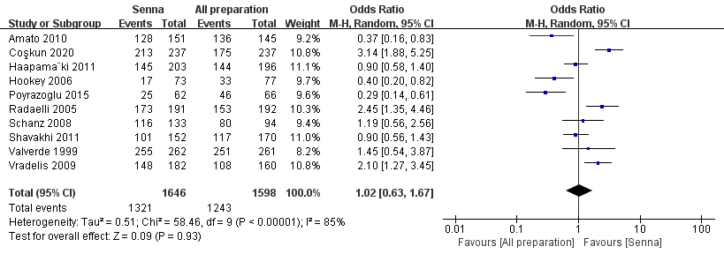
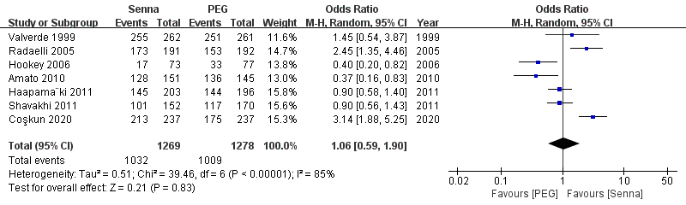
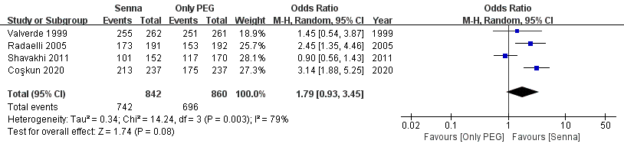
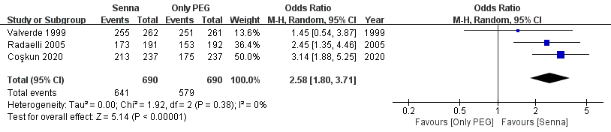
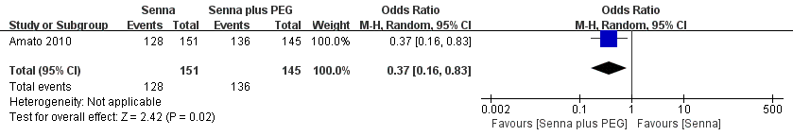
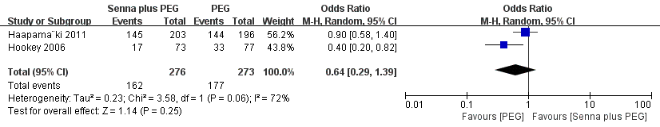
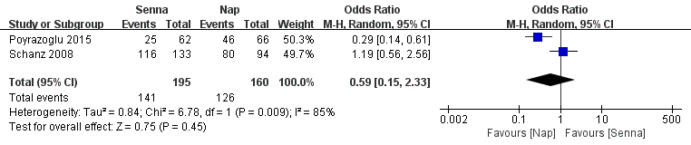
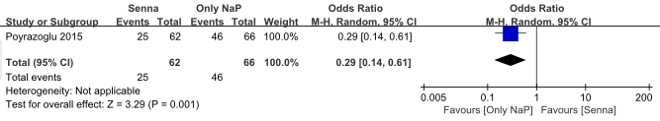

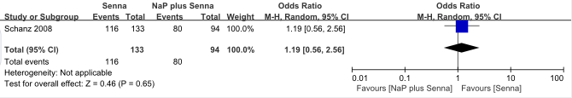

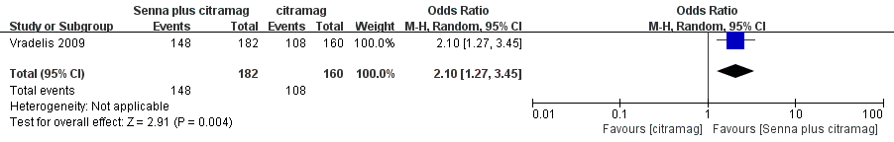

Figure 5. Forest plot of tolerability for senna vs. any regimen
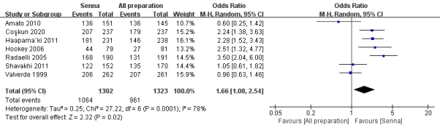
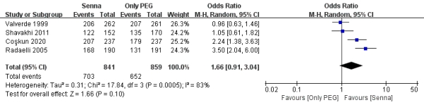
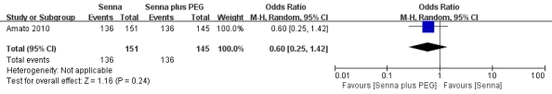
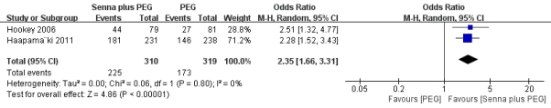

Figure 6. Forest plot of compliance for senna vs. any regimen
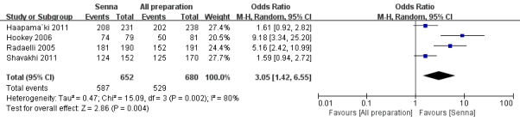
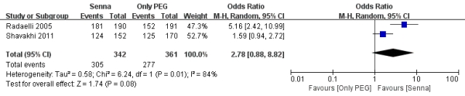
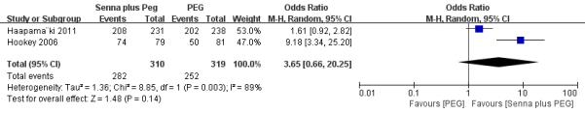

Figure 7. Forest plot of nausea for senna vs. any regimen.
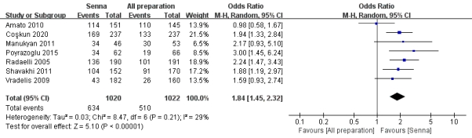
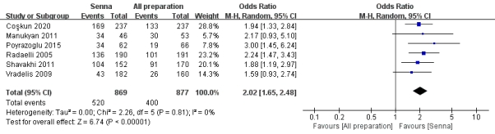
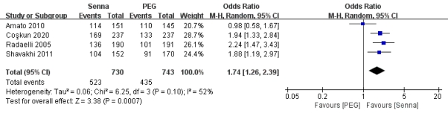
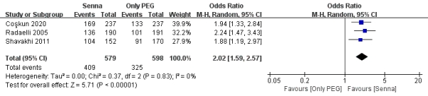
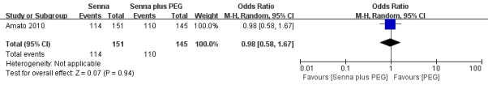
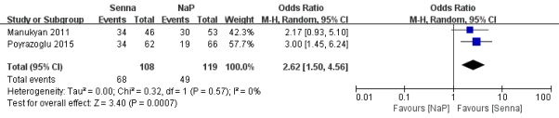
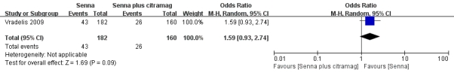

Figure 8. Forest plot of vomit for senna vs. any regimen.
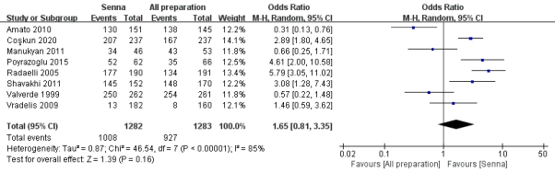
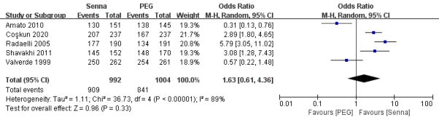
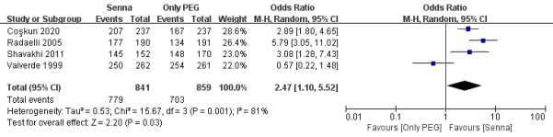
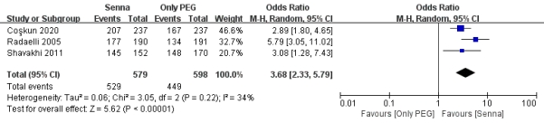
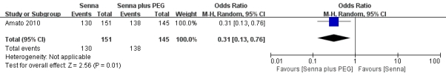
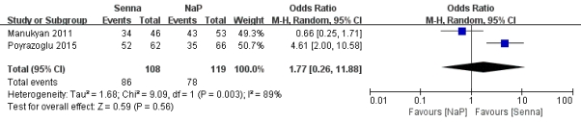
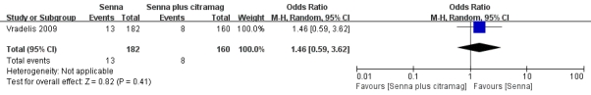
.

Figure 9. Forest plot of abdominal pain for senna vs. any regimen.
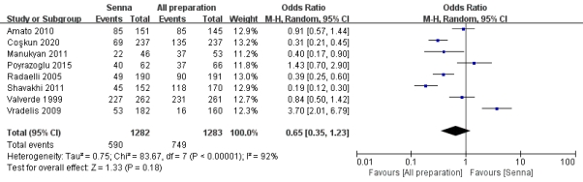
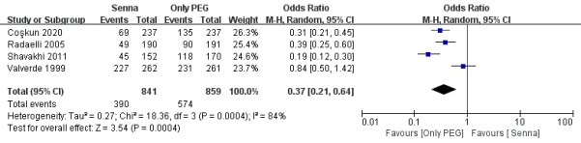
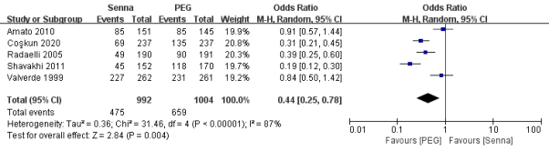
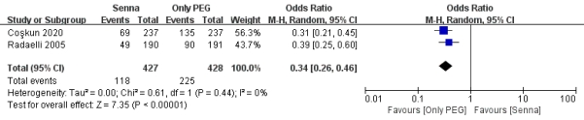
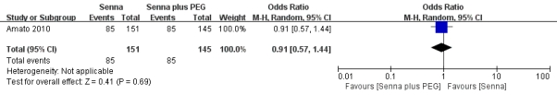
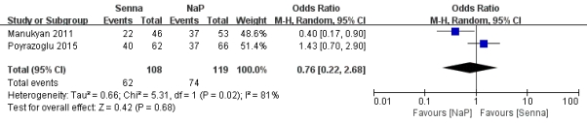
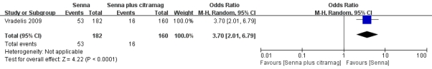

Figure 10. Forest plot of headache for senna vs. any regimen.
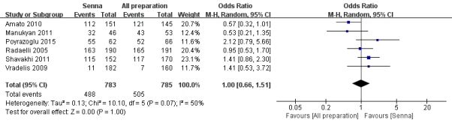
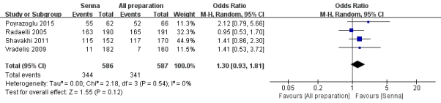
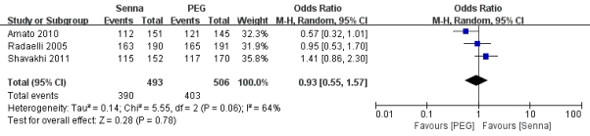
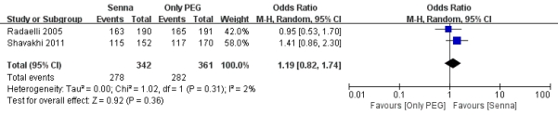
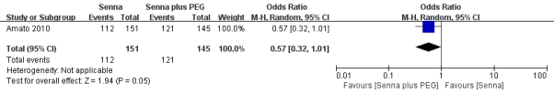
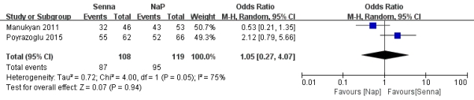
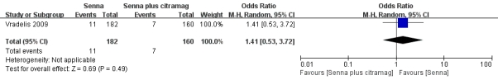

Figure 11. Forest plot of dizzy for senna vs. any regimen.
