Supplemental Materials and Methods

IL-18 and IL-18BP measurement
Serum levels of IL-18 were determined by LEGENDplex™ bead-based multiplex assay (BioLegend, San Diego, US), whereas the serum content of IL-18BP was measured by human IL-18 BPa DuoSet ELISA (R&D) according to the manufacturer’s instructions.

Histologic analysis and cellular stainings
Liver samples were fixed in 4% paraformaldehyde, embedded in paraffin, processed on slides, and stained for hematoxylin-eosin (H&E) and Sirius red by the Interdisciplinary Center for Clinical Research (IZKF) at RWTH University Hospital Aachen, Germany. For immunostainings, the specimens were deparaffinized, rehydrated and antigens were retrieved in citrate buffer (pH 6.0) for 30 minutes at 95°C. After blocking with 2% BSA in TBS-T and overnight incubation with primary antibodies anti-F4/80 (MCA497, BioRad, Hercules, CA, US), anti-alpha smooth muscle actin (αSma; ab124964, Abcam, Cambridge, UK) anti-myeloperoxidase (MPO; PA5-16672, ThermoFisher, Waltham, MA, US), secondary antibody was applied. After induction of color reaction with DAB-chromogen (Vector Laboratories, Burlingame, CA, US), slides were counterstained with hematoxylin. Immunofluorescence staining of liver tissue was performed with platelet-derived growth factor receptors (PDGFR; ab32570) and αSma (M085129-2; Agilent, Santa Clara, CA, US) followed by 1 h incubation with Alexa-Fluor 647 and Alexa-Fluor 750 conjugated secondary antibodies (Thermo Fisher, Waltham, MA, US).
HSCs were fixed with ice-cold methanol and blocked with 5% BSA in PBS-T. Following overnight incubation with primary antibodies (anti-αSma; ab124964, and anti-collagen 1; ab21286, Abcam), Alexa-Fluor 488 and Alexa-Fluor 546 conjugated secondary antibodies (A21202 and A10036, Thermo Fisher) were applied. Mounting solution containing DAPI (Vector Laboratories) was used to counterstain the nuclei. Negative controls in all procedures omitted primary antibody. Pictures were taken with Zeiss Observer 7 or Zeiss LSM 980 (Carl Zeiss, Jena, Germany). Five 10x fields per liver slide were selected (avoiding big vessels) and analyzed using ImageJ software (National Institute of Health, US). The average was calculated from these five values. For quantification of HSC stainings the corrected total cell fluorescence (CTCF) = Integrated Density – (Area of Selected Cell x Mean Fluorescence of Background readings) was calculated for each cell.

Real-time PCR
Total RNA was isolated using PeqGold TriFast following manufacturer´s instruction (PeqLab, Germany). Reverse transcript (cDNA) was synthesized from total RNA using iScript cDNA Synthesis kit (BioRad). Real-time PCR quantification was performed using Fast Sybr-Green and QuantStudio 3 (Applied Biosystems, Massachusetts, US). mRNA expression levels were normalized to the housekeeping gene Gapdh. Primer sequences for quantitative PCR were described previously ^{(1, 2)}.

Hydroxyproline Assay
Tissue hydroxyproline content was determined by homogenizing liver tissue (100 mg) in 6 N HCl. After an incubation at 110 °C for 24 h, the lysate was filtered using Whatman filter paper (Sigma-Aldrich). After incubation with chloramine T– (Sigma-Aldrich) and Ehrlich's perchloric acid solution (Thermo Fisher), samples were measured at 558 nm (VersaMax Microplate Reader; Molecular Devices LLC, Sunnyvale, CA).

RNA sequencing
Quality control of the raw fastq files was performed using the software tool FastQC⁽³⁾ v0.11.8. Sequencing reads were trimmed with Trimmomatic⁽⁴⁾ v0.38 and aligned to the mouse genome (GRCm38.p6) using the STAR aligner⁽⁵⁾ v2.5.1a. Read quantification was performed with RSEM⁽⁶⁾ v1.3.0 and the Ensembl release 98 annotation⁽⁷⁾. The R BioConductor packages edgeR⁽⁸⁾ and limma⁽⁹⁾ were used to implement the limma-voom⁽¹⁰⁾ method for differential expression analysis. In brief, lowly expressed genes—those not having counts per million (cpm) ≥ 1 in at least 4 of the samples—were filtered out and then trimmed mean of M-values (TMM)⁽¹¹⁾ normalization was applied. The experimental design was modeled upon condition, representing genotype and diet (~0 + condition). The voom method was employed to model the mean-variance relationship in the log-cpm, after which lmFit was used to fit per-gene linear models and empirical Bayes moderation was applied with the eBayes function. Significance was defined by using an adjusted p-value cut-off of 0.05 after multiple testing correction⁽¹²⁾ using a moderated t-statistic in limma. Functional enrichment of the differentially expressed genes was performed using WebGestalt⁽¹³⁾ (including GSEA⁽¹⁴⁾) and gProfiler⁽¹⁵⁾.
Supplement Tables and Figures

Suppl. table 1: Characteristics of patients with liver cirrhosis and control cohort.

Characteristic | LC | Controls
Individuals, n | 38 | 50
Age (years): median (IQR) | 59 (56-62,5) | 34 (25,5-51)
Male, n (%) | 27 (71%) | 32 (64%)
MELD score: median (IQR) | 12 (8-14,5) | -

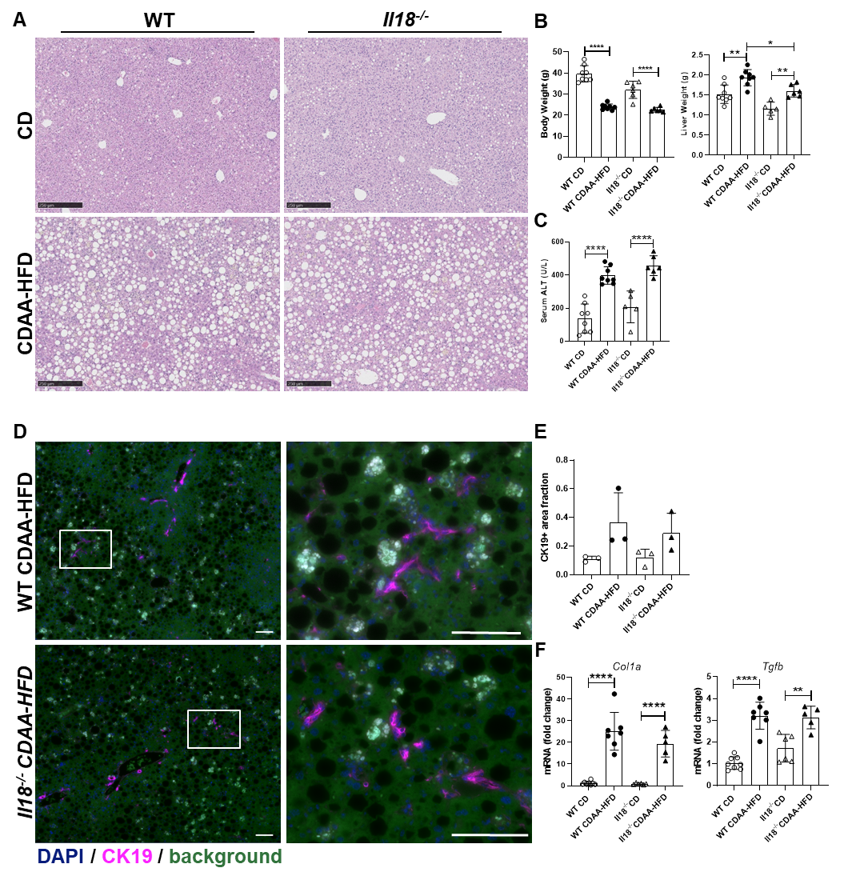
FIGURE S1 CDAA-HFD promoted macrovesicular steatosis with incipient NASH in WT and Il18^{−/−} mice after 10 weeks of feeding. (A) H&E staining (scale bar ≙ 250 µm), (B) body weight and liver weight, (C) serum ALT, (D) CK19 staining (scale bar ≙ 100 µm), and (E) CK19 quantification, (F) mRNA expression levels of the profibrotic genes Col1a and Tgfb of CDAA-HFD-fed WT and Il18^{−/−} mice in comparison with CD-fed mice. ALT, alanine aminotransferase; CD, control diet; CDAA-HFD, choline-deficient, L-amino acid-defined high fat diet; CK19, cytokeratin 19; Col1a, collagen type I alpha; H&E, hematoxylin–eosin; WT, wild type. n = 5–8 mice per group for all measured values; *p < 0.05; **p < 0.01; ****p < 0.0001.

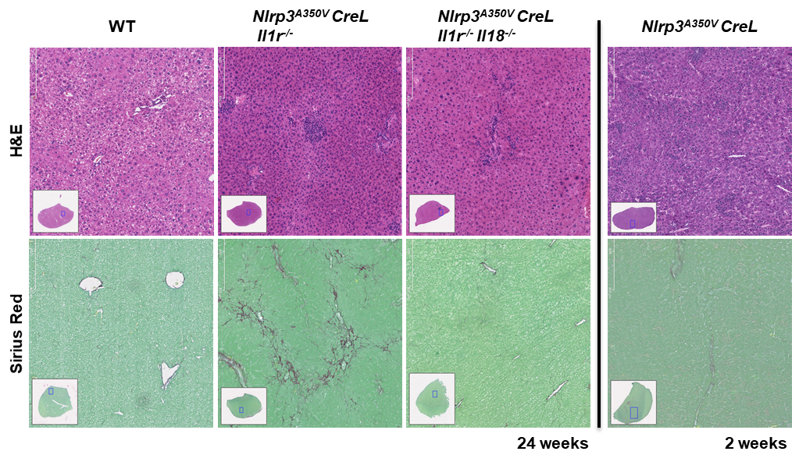
Figure S2 IL-18 ablation reduced fibrosis in Nlrp3^{A350V} CreL mutant mice. H&E- and Sirius Red-stained liver sections from 24-week-old WT, Nlrp3^{A350V} CreL Il1r^{−/−}, Nlrp3^{A350V} CreL Il1r^{−/-}Il18^{−/−}, and 2-week-old Nlrp3^{A350V}CreL mice. Nlrp3^{A350V} CreL Il1r^{−/−} partially rescued the hepatic and systemic inflammatory phenotype concomitant with growth impairment and shortened lifespan of Nlrp3^{A350V} CreL mice. Interestingly, double knockout of IL-18 and IL-1R (Nlrp3^{A350V} CreL Il1r^{−/-}Il18^{−/−}) displayed mitigated fibrosis. H&E hematoxylin–eosin; WT, wild type. [Sections are representative of three mice per strain.]
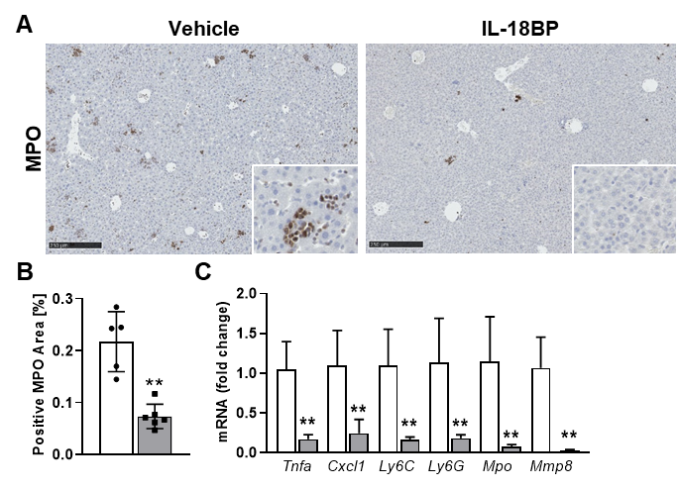
FIGURE S3 Treatment of Nlrp3D301N CreL mice with IL-18BP ameliorated neutrophil infiltration in liver. Nlrp3D301N CreL mice were treated with 6 µg/g rhIL-18BP (Tadekinig Alfa) or PBS from day 2 to 14. (A) MPO-stained liver sections and (B) quantification, (C) immune cell-attracting cytokines/chemokines (Tnfa, Cxcl1, Ly6C, Ly6G, Mpo, Mmp8). BP, binding protein; Mmp, matrix metalloproteinase; Mpo, myeloperoxidase; Nlrp3, nucleotide-binding oligomerization domain-like receptor-family pyrin domain-containing 3. (n = 5–6 mice per group for all measured values; scale bars represent 250 µm; **p < 0.01).

References
1. Inzaugarat ME, Johnson CD, Holtmann TM, McGeough MD, Trautwein C, Papouchado BG, et al. NLR Family Pyrin Domain-Containing 3 Inflammasome Activation in Hepatic Stellate Cells Induces Liver Fibrosis in Mice. Hepatology. 2019;69(2):845-859.
2. Wree A, Eguchi A, McGeough MD, Pena CA, Johnson CD, Canbay A, et al. NLRP3 inflammasome activation results in hepatocyte pyroptosis, liver inflammation, and fibrosis in mice. Hepatology (Baltimore, Md). 2014;59(3):898-910.
3. Andrews S. FastQC: a quality control tool for high throughput sequence data. 2010. Available from: http://www.bioinformatics.babraham.ac.uk/projects/fastqc.
4. Bolger AM, Lohse M, Usadel B. Trimmomatic: a flexible trimmer for Illumina sequence data. Bioinformatics. 2014;30(15):2114-2120.
5. Dobin A, Davis CA, Schlesinger F, Drenkow J, Zaleski C, Jha S, et al. STAR: ultrafast universal RNA-seq aligner. Bioinformatics. 2013;29(1):15-21.
6. Li B, Dewey CN. RSEM: accurate transcript quantification from RNA-Seq data with or without a reference genome. BMC Bioinformatics. 2011;12(1):323.
7. Cunningham F, Achuthan P, Akanni W, Allen J, Amode M R, Armean IM, et al. Ensembl 2019. Nucleic Acids Research. 2018;47(D1):D745-D751.
8. Robinson MD, McCarthy DJ, Smyth GK. edgeR: a Bioconductor package for differential expression analysis of digital gene expression data. Bioinformatics. 2010;26(1):139-140.
9. Ritchie ME, Phipson B, Wu D, Hu Y, Law CW, Shi W, et al. limma powers differential expression analyses for RNA-sequencing and microarray studies. Nucleic Acids Res. 2015;43(7):e47.
10. Law CW, Chen Y, Shi W, Smyth GK. voom: precision weights unlock linear model analysis tools for RNA-seq read counts. Genome Biology. 2014;15(2):R29.
11. Robinson MD, Oshlack A. A scaling normalization method for differential expression analysis of RNA-seq data. Genome Biol. 2010;11(3):R25.
12. Benjamini Y, Hochberg Y. Controlling the False Discovery Rate: A Practical and Powerful Approach to Multiple Testing. Journal of the Royal Statistical Society: Series B (Methodological). 1995;57(1):289-300.
13. Zhang B, Kirov S, Snoddy J. WebGestalt: an integrated system for exploring gene sets in various biological contexts. Nucleic Acids Res. 2005;33(Web Server issue):W741-748.
14. Subramanian A, Tamayo P, Mootha VK, Mukherjee S, Ebert BL, Gillette MA, et al. Gene set enrichment analysis: a knowledge-based approach for interpreting genome-wide expression profiles. Proc Natl Acad Sci U S A. 2005;102(43):15545-15550.
15. Kolberg L, Raudvere U, Kuzmin I, Vilo J, Peterson H. gprofiler2 -- an R package for gene list functional enrichment analysis and namespace conversion toolset g:Profiler. F1000Res. 2020;9.

