Supplementary Table 1. Eligibility criteria for The GALA Study.
Category | Pathogenic Variant in JAG1 or NOTCH2 | Family History of ALGS | Number of Clinical Features Requiredª
A | Identified | Present | Any or none
B | Identified | None (proband) | At least 1
C | Not identified^{b} or not screened for | Present | 2 or more
D | Not identified^{b} or not screened for | None (proband) | 3 or more
ªClinical features of ALGS include bile duct paucity and/or cholestasis, cardiac, renal, ocular or skeletal manifestations, structural vascular anomalies or events, and/or characteristic ALGS facies.

^{b}Known disease-causing mutations were not identified during genetic screening or were not screened for.

Supplementary Table 2. High-level summary of data elements collected in The GALA Study.
Baseline | ALGS  characteristics | Follow-up clinical and laboratory data | Events during  long-term follow-up
Biological sex | Native liver biopsy reports | Growth parameters | Hepatoportoenterostomy
Date of birth | Echocardiogram reports | Liver function tests | Surgical  biliary diversion
Birth history | Ophthalmology examinations | Pruritus | Solid  organ transplantation
Variant details | Skeletal involvement | Xanthomas | Pregnancy
Family history | Renal involvement | Medications for  cholestasis-associated pruritus | Mortality
- | MRI and CT scan reports | Manifestations  of portal hypertension | -
Abbreviations: MRI, magnetic resonance imaging; CT, computerized tomography.

Supplementary Table 3. Summary of native liver survival (NLS) rates across geographic regions at 5, 10, and 18-years in 1184 children with ALGS who presented with neonatal cholestasis.
NLS rates | 5-years | 10-years | 18-years
Entire Cohort | 66.8% | 54.4% | 40.3%
Africa | 79.3% | 67.9% | 67.9%
Asia | 77.0% | 73.6% | 67.9%
Europe | 63.8% | 49.7% | 37.9%
Middle East | 51.1% | 28.8% | 28.8%
North America | 68.8% | 57.7% | 41.3%
Oceania | 69.1% | 51.3% | 28.0%
South America | 32.3% | 23.1% | 11.5%

Supplementary Table 4. Indications for liver transplantation in children with ALGS who presented with neonatal cholestasis.
Indications for Liver Transplantation |  | n
Persistent cholestasis |  | 48% (n=158/328)
Complications of  persistent cholestasis | Intractable pruritus | 69% (n=161/235)
 | Growth failure | 54% (n=127/235)
 | Xanthomas | 49% (n=116/235)
 | Metabolic bone disease | 7% (n=16/235)
 | Fat soluble vitamin deficiency | 1% (n=3/235)
 | ≥1 complication of persistent cholestasis | 72% (n=235/328)
Cirrhosis |  | 3% (n=11/328)
Manifestations of  portal hypertension | Ascites | 20% (n=19/97)
 | GI varices requiring intervention | 16% (n=16/97)
 | Not specified | 65% (n=63/97)
 | ≥1 manifestation of portal hypertension | 30% (n=97/328)
Other |  | 7% (n=24/328)
*The indication for LT was missing in 5% (n=17/345) of ALGS patients.

Supplementary Table 5. Effect median values of laboratory data from the first year of life on the risk of liver transplantation or death among ALGS patients who presented with neonatal cholestasis. The results are presented on the log10-scale.

Cox regression - risk of liver transplantation or death after 12 months of age
Effect Median laboratory values on NLS in the first year of life in ALGS patients who presented with neonatal cholestasis | ≤6 months |  | >6 and ≤12 months |  | 12 months
 | HR  (95% CI) | p-value | HR  (95% CI) | p-value | HR  (95% CI) | p-value
Bile acids, μmol/L | 1.42  (0.69 – 2.93) | 0.339 | 0.78  (0.49 –1.24) | 0.287 | 0.86  (0.57 – 1.29) | 0.467
Total bilirubin, mg/dL | 10.41  (5.07 – 21.35) | <0.0001 | 13.88  (7.68 –25.1) | <0.0001 | 8.24  (5.3 – 12.79) | <0.0001
Conjugated bilirubin, mg/dL | 2.52  (1.51 – 4.21) | <0.0001 | 5.13  (3.22 – 8.16) | <0.0001 | 4.09  (2.74 – 6.09) | <0.0001
ALT, IU/L | 1.6  (0.96 – 2.68) | 0.072 | 3.61  (1.89 – 6.91) | <0.0001 | 2.11  (1.26 – 3.53) | 0.004
AST, IU/L | 1.81  (1.05 – 3.11) | 0.031 | 2.37  (1.7 – 3.3) | <0.0001 | 3.45  (2.01 – 5.92) | <0.0001
GGT, IU/L | 1.05 (0.68 – 1.61) | 0.835 | 0.81  (0.53 – 1.25) | 0.35 | 0.9  (0.62 – 1.31) | 0.581
Cholesterol, mg/dL | 2.15  (0.94 – 4.9) | 0.07 | 2.31  (0.9 – 5.95) | 0.083 | 2.45  (1.25 – 4.81) | 0.009
Triglycerides, mg/dL | 2.08  (0.66 – 6.5) | 0.209 | 4.09  (0.97 – 17.26) | 0.055 | 3.07 (1.15 – 8.21) | 0.025
Platelet Count, (50 × 10⁹/L) | 0.98  (0.94 – 1.03) | 0.455 | 0.94  (0.88 – 1.01) | 0.088 | 0.97  (0.93 – 1.02) | 0.293
APRI | 1.27  (1.05 – 1.55) | 0.016 | 1.4  (1.27 – 1.54) | <0.0001 | 1.51  (1.35 – 1.69) | <0.0001
* Cox-model of each laboratory measurement, adjusted for sex and year of birth and stratified by region

**In children who underwent Kasai portoenterostomy during the first year of life, laboratory data was only collected up until the procedure. Those who underwent LT or died in the first year of life or their follow-up ended before 1 year of age were excluded from the laboratory analysis.

Supplementary Table 6. Baseline histopathologic findings in 604 children with ALGS who presented with neonatal cholestasis stratified by the presence of bile duct paucity on baseline biopsy.
 | Bile duct paucity, present | Bile duct paucity, absent | p-value
n | 421 | 183
Median age at bx, months | 3.0 (IQR 2.0 – 21.8) | 2.5 (IQR 1.8 – 4.3)
Histopathologic Findings, % (n)
Giant cell transformation | 25% (n=105) | 48% (n=87) | <0.001*
Hepatic Fibrosis | 29% (n=121) | 26% (n=47) | 0.44
Bile duct proliferation | 12% (n=49) | 31% (n=56) | <0.001*
Duct/ductular bile plugs | 6% (n=26) | 11% (n=20) | 0.04*
Features of biliary obstruction, any | 15% (n=65) | 36% (n=66) | <0.001*

Supplementary Table 7. Baseline histopathologic findings in 604 children with ALGS and a history of neonatal cholestasis stratified by age at first biopsy.
 | Biopsy  ≤6 months | Biopsy  >6 and ≤24 months | Biopsy  >24 months | p-value
n | 408 | 82 | 114
Median age at biopsy, months (IQR) | 2.0 (IQR 1.5 – 3.0) | 11.3 (IQR 7.4 – 17.2) | 49.8 (IQR 35.6 – 80.4)
Histopathologic Findings, % (n)
Bile duct paucity | 64% (n=262) | 73% (n=60) | 87% (n=100) | <0.001*
Giant cell transformation | 43% (n=176) | 16% (n=13) | 2% (n=2) | <0.001*
Hepatic Fibrosis | 22% (n=88) | 37% (n=30) | 45% (n=51) | <0.001*
Bile duct proliferation | 21% (n=86) | 16% (n=13) | 5% (n=6) | <0.001*
Duct/ductular bile plugs | 9% (n=35) | 7% (n=6) | 4% (n=5) | 0.32
Features of biliary obstruction, any | 26% (n=105) | 21% (n=17) | 8% (n=9) | <0.001*

Supplementary Table 8. Histopathologic findings at baseline and follow-up (>12 months apart) in 85 Children with ALGS and a history of neonatal cholestasis.
 | First Liver Biopsy | Second Liver Biopsy | p-value
n | 85 | 85
Median age at bx, months (IQR) | 2.3 (IQR 1.8 – 4.8) | 35.0 (IQR 24.4 – 75.0)
Histopathologic Findings, % (n)
Bile duct paucity | 66% (n=56) | 86% (n=73) | 0.53
Giant cell transformation | 47% (n=40) | 4% (n=3) | 0.10
Hepatic Fibrosis | 28% (n=24) | 62% (n=53) | 0.01*
Bile duct proliferation | 25% (n=21) | 11% (n=9) | 0.04*
Duct/ductular bile plugs | 8% (n=7) | 7% (n=6) | 0.41
Features of biliary obstruction, any | 29% (n=25) | 16% (n=14) | 0.02

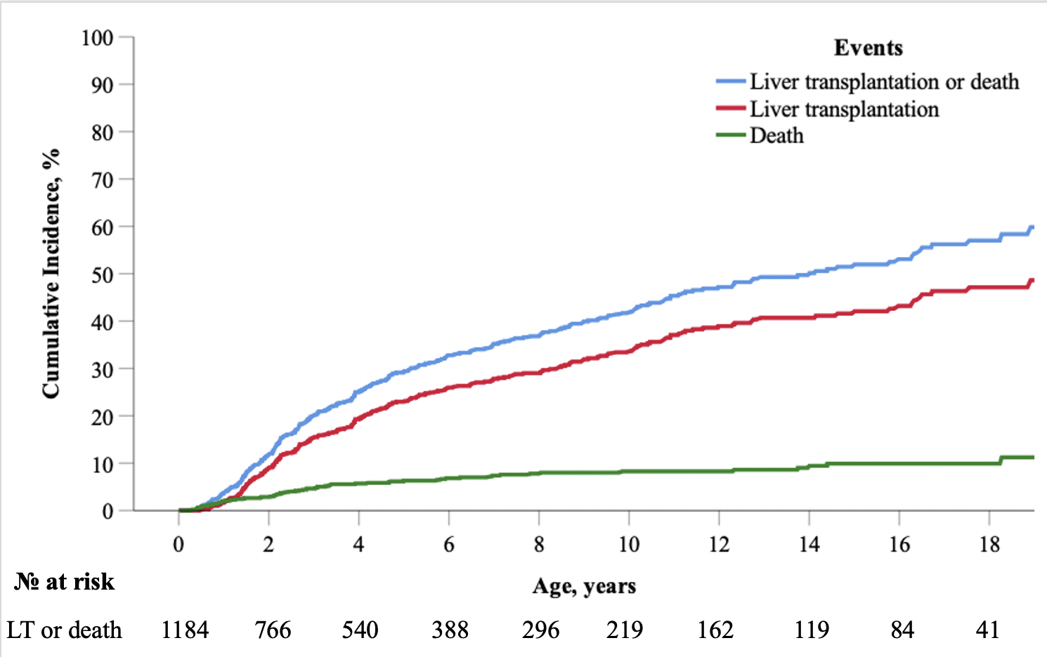
Supplementary Fig. 1. Cumulative incidence of native liver survival (NLS) in the presence of competing events (LT or risk of death without liver transplantation) in children with Alagille syndrome (ALGS) who presented with neonatal cholestasis, where those who underwent KPE were truncated at the time of their procedure. At 5, 10, and 18-years the rate of NLS was 70.7% (95% CI, 26.2 – 32.5), 58.3% (95% CI, 37.8 – 45.5), and 43.0% (95% CI, 51.5 – 62.2).

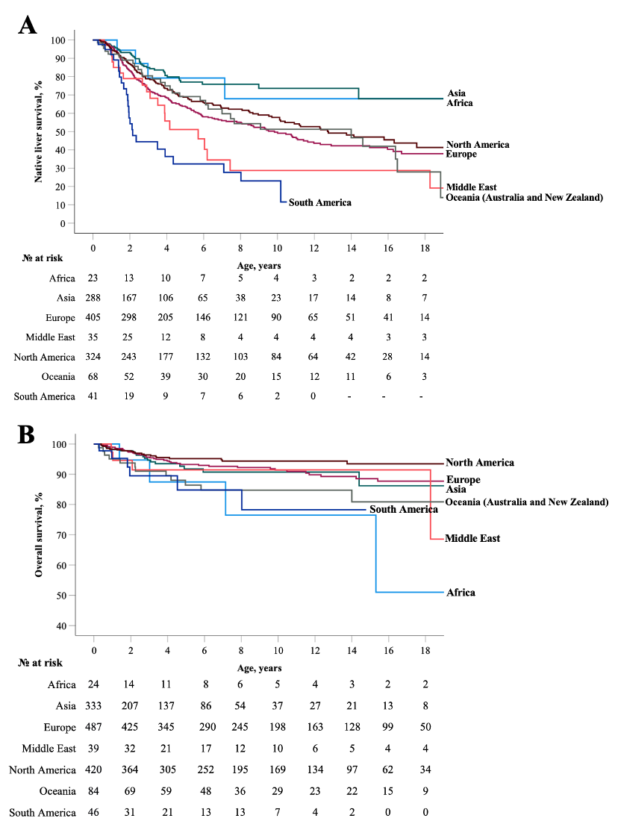
Supplementary Fig. 2. Geographic differences in rates of native liver survival (NLS) and overall survival (OS) in a large, international cohort of children with Alagille syndrome (ALGS). The cohort was stratified into one of seven geographic regions – (1) Africa; (2) Asia; (3) Europe; (4) the Middle East; (5) North America; (6) Oceania (Australia and New Zealand); and (7) South America. (A) A Kaplan-Meier analysis in 1184 children with ALGS who presented with neonatal cholestasis revealed a statistically significant difference between rates of NLS and geographic region (log-rank, p<0.001). (B) A Kaplan-Meier analysis in 1433 children with ALGS revealed a statistically significant difference in OS rates across geographic regions (log-rank, p=0.002). Two subjects were excluded from the NLS and OS analysis due to missing dates of LT and death.

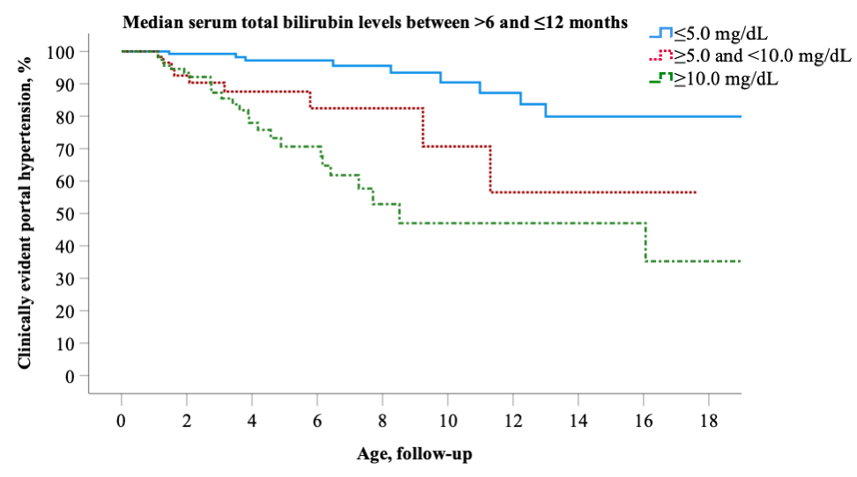
Supplementary Fig. 3. Early total bilirubin (TB) levels are predictive of developing clinically evident portal hypertension in children with Alagille syndrome (ALGS). Those who had CEPH in the first year of life or their follow-up ended before 1 year of age were excluded from the laboratory analysis. Children (>6 and ≤12 months) with median total bilirubin (TB) levels between ≥5.0 and <10.0 mg/dL had a 4.1-fold (95% CI 1.6 – 10.8) and those ≥10.0 mg/dL had an 8.0-fold (95% CI 3.4 – 18.4) increased risk of developing CEPH compared with <5.0 mg/dL.

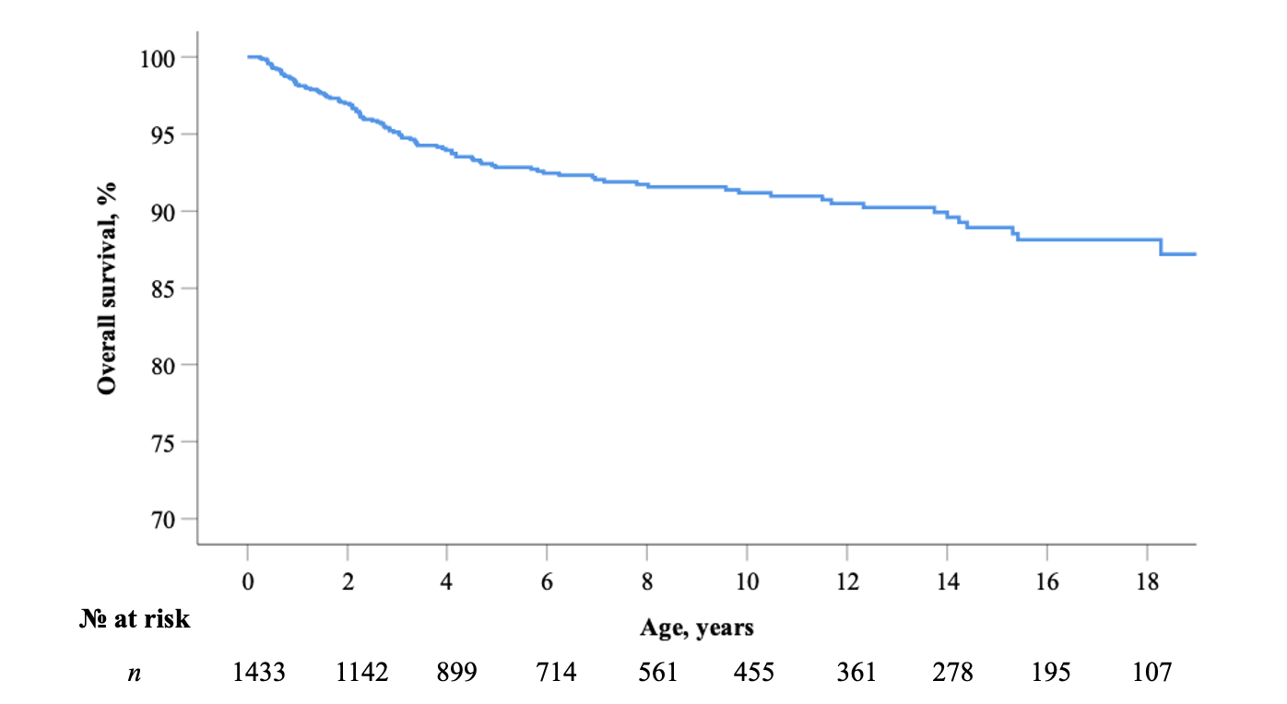Supplementary Fig. 4. Overall patient survival rates in 1433 children with Alagille syndrome (ALGS). A Kaplan–Meier survival analysis for all-cause mortality showed at 5, 10 and 18-years the rate of overall survival was 92.8%, 91.2%, and 88.1%, respectively. Two subjects were excluded from this analysis due to missing dates of death.

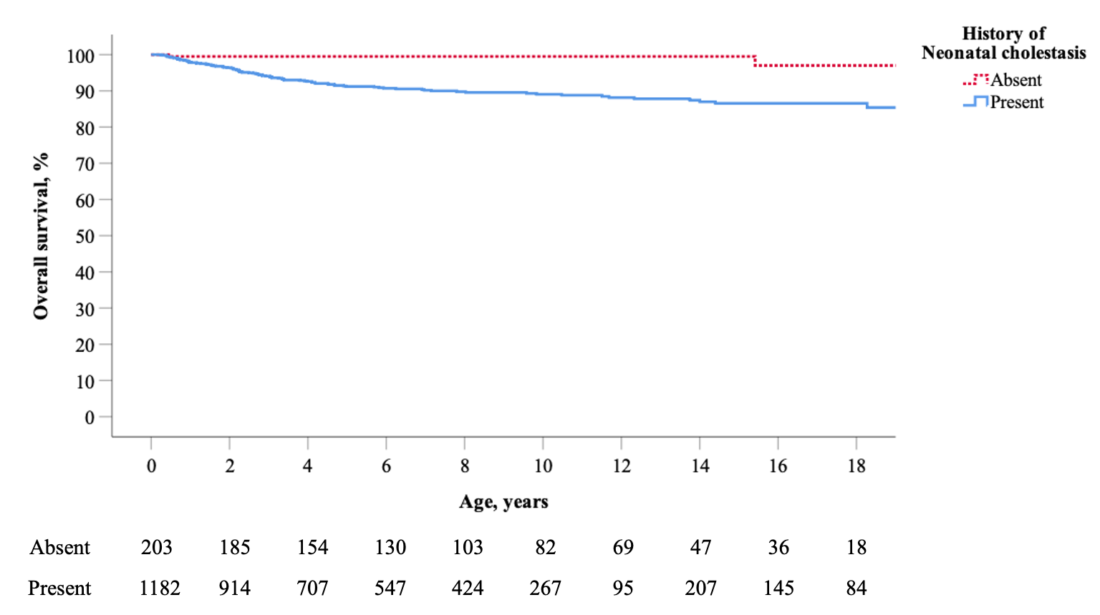
Supplementary Fig. 5. Overall survival in Alagille syndrome (ALGS) children with and without a history of neonatal cholestasis (n=1387). Survival analysis using Kaplan-Meier and log rank test revealed overall survival rates at 10- and 18-years were significantly lower in children with ALGS who presented with neonatal cholestasis in comparison with those who did not (log-rank p<0.001). Two subjects who presented with neonatal cholestasis were excluded from this analysis due to missing dates of death.

