Supplementary Experimental Procedures

Computed tomography
Computed tomography (CT) was performed using an industrial combined planar X-ray micro-CT-system (Y.Fox, Yxlon) equipped with an open multifocus X-ray tube and a 14-bit direct amorphous silicon flat panel detector (Varian PaxScan 2520 D/CL, Varian) (1). Three months old mice were injected 250 µL contrast agent (ExiTron nano 6000, Miltenyi Biotec) into the pre-warmed lateral tail vein (2). After 60 minutes, mice were anesthetized with Isoflurane (Baxter) and CT imaging was performed as described before (3) using the following scan parameters: tube voltage 80 kV (current 75 µA), 360° rotation within 33s scan time and continuous image acquisition at 30 frames per second (fps) resulting in 990 projections. Raw-data were reconstructed using a filtered back-projection algorithm applying the Shepp–Logan filter and a matrix of 512 × 512 × 512 voxels (Reconstruction Studio Software, TeraRecon). The created DICOM data were assessed using OsiriX imaging software (OsiriX v. 5.0.2, 64-bit, Pixmeo, SARL).
Hepatic large vessel density was measured in representative coronal sections. The contour of the liver was used as region of interest and the threshold function of ImageJ (Fiji ImageJ 2.0.0-rc69/1.53c) (4,5) was used to identify contrast medium positive vessels. A mask was created and the measured vessel area was normalized by the whole liver area in each section.

Echocardiography and Doppler analyses
Echocardiography and doppler analyses of the liver and vena cava were performed with six months old mice using a high-frequency ultrasonography device (VEVO 3100, VisualSonics). Before investigation, mice were anesthetized with 3% isoflurane (CP-Pharma) in 1 Lpm oxygen and maintained at 1% isoflurane. The heart ventricles were recorded in the short long axis at papillary muscle level (left ventricle, LV) and apical five chamber view at the level of aortic root (right ventricle, RV). B-mode images were analyzed with VevoLab 5.5.0 and the integrated cardiac measurement package.
Liver echography as well as inferior vena cava (IVC) and portal vein (PV) flow analyses were conducted utilizing Color and Pulsed-wave Doppler. IVC flow was recorded in long axis at a distal, pre-hepatic, and a proximal post-hepatic position. PV flow and diameter were recorded in long axis with PW Doppler and M-mode, resp., at para-hepatic position. Capillarization of the liver parenchyma was visualized with Color Doppler (CD) in axial plane of the mouse abdomen. The CD window was set to maximum gate size (4 AU) and the beam induced with a transmit frequency of 24 MHz and a Doppler gain of 6 dB.

Tissue preparation
Isofluran (Baxter) anesthetized mice were sacrificed by cervical dislocation. The liver, spleen, and heart were removed and weighed. Sectioned organs were fixed in phosphate-buffered 4 % formaldehyde solution (P087, Carl Roth) at room temperature for one to five days, followed by paraffin embedding according to standard protocols and as described before (6). Liver tissue pieces were also snap-frozen in liquid nitrogen (Broser).
Formalin-fixed paraffin-embedded (FFPE) tissue sections (3 μm) were deparaffinized and rehydrated according to standard protocols. Sections were stained with hematoxylin & eosin (H&E) and Sirius Red (SR) according to standard protocols.

Blood collection
For blood collection, mice were deeply anesthetized and sacrificed subsequently. Blood samples were taken from the retrobulbar venous plexus during day cycle in lithium heparin tubes (Microvette 500 LH, 20.1345.100, Sarstedt). Plasma was separated using centrifugation at 7000 x g for 7 min and analyzed for standard plasma values in a cobas c311 analyzer (Roche Diagnostics). For serum, blood was collected in 1.5 mL reaction tubes without any additives. After two hours of clotting at room temperature, blood was centrifuged for 20 minutes at 2000 x g. Then, the supernating serum was transferred to a new reaction tube.

Immunofluorescence and immunohistochemistry
3 µm paraffin sections were de-paraffinized, rehydrated, and stained according to standard protocols and as described before (6). Heat induced epitope retrieval (HIER) citrate buffer pH 6.0 (ZUC028-500, Zytomed Sytems) was used for antigen retrieval at 95 °C for 45 min.
Cryosections (8 µm) were fixed with phosphate-buffered 4 % paraformaldehyde (PFA) (0335, Carl Roth) for 10 min after air drying. Blocking was conducted for 30 min using 5 % normal donkey serum (017-000-121, Dianova, Hamburg, Germany).
For immunofluorescence staining, primary antibodies were diluted in Dako antibody diluent (S202230-2, Agilent Technologies) and incubated over night at 4 °C. Subsequently, sections were washed three times with phosphate-buffered saline (PBS) (A0964.9050, VWR International) and incubated with fluorophore-conjugated secondary antibodies diluted in Dako antibody diluent for one hour at room temperature followed by another washing step with PBS. Finally, sections were mounted with Dako fluorescence mounting medium (S302380-2, Agilent Technologies), dried for one day at room temperature, and stored at 4 °C
For immunohistochemical staining, sections were blocked with Dako peroxidase solution (S2023, Agilent Technologies) and primary antibodies diluted in Dako antibody diluent were incubated over night at 4 °C. At the following day, the sections were washed three times in PBS and incubated with horseradish peroxidase (HRP)-conjucated secondary antibody diluted in 1 % bovine serum albumine (BSA) (J642, VWR International) for one hour at room temperature. After three washing steps with PBS, Dako AEC substrate chromogen (K3464, Agilent Technologies) was added and incubated for 5 to 30 min. Subsequently, the sections were counterstained with Mayer’s hemalum solution (1.09249.2500, Merck) and mounted with Dako aqueous mounting medium (S3025, Agilent Technologies).
Antibodies used for immunofluorescence and immunohistochemistry are listed in Table S3.

Microscopy
Images were acquired as described before (6) using an Eclipse Ni-E motorized upright microscope equipped with CFI Plan Apochromat Lambda series objective lenses (4x, 10x, 20x, 40x, 60x), an Intensilight Epifluorescence Illuminator, a DS-Ri2 high-definition color camera, and a DS-Qi2 high-definition monochrome camera controlled by NIS-Elements AR 5.02 software (Nikon Instruments). To capture the total thickness of the specimen, fluorescence microscopy images were acquired as series of z-axis images. Acquired images were background corrected, deconvoluted, and focused NIS-Elements AR 5.02 and Fiji ImageJ 2.0.0-rc69/1.53c (4,5).
For quantification of immunofluorescence or in-situ-hybridization images, representative areas per sample were chosen. “Auto threshold” function (Otsu-algorithm) of ImageJ or individual thresholds were used to create masks of the corresponding channels. Then, the area was measured with the implemented “Measure” tool in ImageJ. For immunofluorescence images, intensity was measured using the implemented tool in ImageJ before masks were created.
Since RNA in situ hybridization (ISH) images are recorded in RGB, we split the images into separate channels by using the “Color deconvolution” command in ImageJ. Masks were created by setting color thresholds. Then, the area of masks was measured and analyzed.

Transmission Electron Microscopy (TEM)
After perfusion-fixation with 4% formaldehyde, 2% glutaraldehyde, 1 mM MgCl2, 1 mM CaCl2, in 100 mM Na-cacodylate buffer, pH 7.2, the large lobe of livers was excised, submitted to vibratome sectioning and 200µm-slices immersed in 2.5% buffered glutaraldehyde for further 2 days. Next, treatment for conventional epoxy-resin embedding and TEM consisted of post-fixation in 1% osmium tetroxide, dehydration in grades steps of ethanol and embedding in epoxide (Glycidether, NMA, DDSA: Serva). Ultrathin sections at nominal thickness of 60 nm and contrast-stained with lead-citrate and uranylacetate were observed in EM 910 at 80 kV (Zeiss) and micrographs taken with a slow scan CCD camera (TRS).

Isolation of hepatic endothelial cells
Isolation of hepatic endothelial cells was performed as described before (6). Mice were deeply anesthetized with Isoflurane (Baxter) and sacrificed by cervical dislocation. Livers were perfused in situ via the portal vein with a 0.05% collagenase/amino acid/saccharide solution (C2674, Sigma-Aldrich). Livers were dissected and mechanically disrupted. Liver tissue from three mice was pooled and digested at 38 °C in collagenase/Gey’s balanced salt solution (G9779, Sigma-Aldrich). Then, the tissue was filtered through a 250 μm mesh. Non-parenchymal cells were separated by a 19.3 % Nycodenz (1002424, Axis-Shield, Alere Technologies) gradient. Subsequently, magnetic-activated cell sorting (MACS) was used with anti-CD146 MicroBeads (ME-9F1, 130-092-007, Miltenyi Biotech) to purify endothelial cells.

RNA isolation and cDNA synthesis
We extracted total RNA with the innuPREP RNA Mini Kit 2.0 (845-KS-2040250, Analytik Jena) followed by DNA digestion using the TURBO DNA-free Kit (AM1907, Thermo Fisher Scientific). RNA concentration and quality were measured using a NanoPhotometer NP80 (Implen) and a 2100 Bioanalyzer (Agilent Technologies).
We performed reverse transcription with Maxima Reverse Transcriptase (EP0752, Thermo Fisher Scientific) and Oligo(dT)18 primers (SO131, Thermo Fisher Scientific) according to the manufacturer’s instructions.

RNA sequencing
Library prepararation and sequencing was conducted by BGI Tech Solutions (Hong Kong) using the BGISEQ-500 platform and paired-end 100-bp read length. Raw reads were filtered using the SOAPnuke software to obtain clean reads (filter parameters: -n 0.03 -l 20 -q 0.4 -A 0.28). At least 20 × 10⁶ clean reads per sample were obtained.

RNA-seq data processing
RNA-seq data processing was performed with R (version 3.6.3) and bioconductor (version 3.9) using the NGS analysis plackage systempipeR (7) in Rstudio (version 1.1.463). Quality control of clean sequencing reads was performed using FastQC (Babraham Bioinformatics). Low-quality reads were removed using trim_galore (version 0.6.4). The resulting reads were aligned to the mouse genome version GRCm38.p6 from GeneCode and counted using kallisto version 0.46.1 (8). The count data was transformed to log2-counts per million (logCPM) using the voom-function from the limma package (9). Differential expression analysis was performed using the limma package in R. A false positive rate of α= 0.05 with FDR correction was taken as the level of significance. Volcano plots and heatmaps were created using ggplot2 package (version 2.2.1) and the complexHeatmap package (version 2.0.0) (10). For enrichment analysis, we used the fgsea (11), the enrichmentbrowser (12), and the Enrichr packages (13).

Integration of published gene sets in bulk RNA-seq data from hepatic endothelial cells
To decipher the differentiation of hepatic endothelial cells in Alk1^{HEC-KO} mice, we used publicly available gene sets from Kalucka et al. (14). Kalucka et al. distinguished seven endothelial subpopulations (Large artery, Capillary arterial, Capillary, Capillary venous, Vein, Proliferating, and Lymphatic) generated by single-cell RNA sequencing and provide the genes defining these subpopulations on their database that is accessible online (https://endotheliomics.shinyapps.io/ec_atlas/ > Liver > Marker set). We generated an expression heatmap for all significantly up- or down-regulated genes in RNA-seq data of Alk1^{HEC-KO} EC and extended this heatmap with another heatmap indicating whether a gene is part of a gene set from Kalucka et al. For each gene set, a fourfold table was considered consisting of: A1) all significantly up-regulated genes, A2) all significantly down-regulated genes, B1) significantly up-regulated genes that are part of the respective gene set, and B2) significantly down-regulated genes that are part of the respective gene set. The gene distribution within this fourfold table was analyzed using Fisher’s exact test.
In the same way, we used the gene sets from Halpern et al. (15) (Periportal, and Pericentral) that were also annotated to the significantly regulated genes in bulk-RNA-seq data from endothelial cells of Alk1^{HEC-KO} mice.

Integration of published single-cell RNA-seq data in bulk RNA-seq data of whole liver
For our whole liver bulk RNA-seq data, we used another dataset from Halpern et al. (16) providing expression data along the liver lobule (Layer.1 = pericentral to Layer.9 = periportal). In a first step, we generated an expression heatmap for significantly regulated genes in whole liver lysates from our Alk1^{HEC-KO} mice and extended this heatmap with another heatmap showing the physiological gene expression in each layer.
In the next step, we performed gene set enrichment analysis (GSEA) for our whole liver RNA-seq data using the expression data from Halpern et al. (16). To this end, we defined periportal and pericentral gene sets filtering for genes with a q value < 0.05 and a fold-change between Layer.1 and Layer.9 that is < 0.5 or > 2. GSEA was performed using the fgsea package (11) .

qPCR
innuMIX qPCR SyGreen Sensitive (845-AS-1310200, Analytik Jena, Jena, Germany) was used on a qTOWER 3 G touch thermal cycler (Analytik Jena) for quantitative PCR (qPCR). qPCR primers were designed with NCBIs PrimerBLAST (https://www.ncbi.nlm.nih.gov/tools/primer-blast/). For mRNA specificity, qPCR primers were designed to span an exon-exon junction where possible. Primers were tested with no template controls, original RNA, and melt curve analysis. Primer sequences are listed in Table S4. qPCR output files were analyzed in qPCRsoft 4.0.8.0 (Analytik Jena) and normalized expressions (ddCt algorithm) were calculated using the reference genes Gak, Mrpl46, and Srp72 (17).

In-situ-hybridization
For RNA in situ hybridization (ISH), we used RNAscope 2.5 HD Red (322350, Advanced Cell Diagnostics) on FFPE tissue sections (3 μm) according to the manufacturer’s protocols. ISH probes are listed in Table S5.

Enzyme-linked Immunosorbent Assay (ELISA)
Serum was analyzed using the placenta growth factor isoform 2 (PlGF-2) Quantikine ELISA Kit (MP200, R&D Systems) according to the manufacturer’s instructions. In mice, PlGF-2 is the single isoform that is encoded by the Pgf gene (18). Optical densities were detected with an Infinite 200 plate reader (Tecan Group) set to 450 nm and a wavelength correction set to 540 nm.
In vitro stimulation of LSEC
For stimulation of primary LSEC with BMP-9 (5566-BP-010, R&D Systems), BMP-10 (6038-BP-025, R&D Systems), ALK-1 Fc (770-MA-100, R&D Systems), TGF-β1 (100-21C, PeproTech) or inhibition of ID’s using AGX51 (HY129241-5mg, Hycultec) in vitro, first, LSEC of wildtype mice were isolated as described above. After isolation, cells were washed once in PBS and 1.5 x 10⁶ cells/well were seeded in Collagen IV coated 6-well plates (354428, neoLab Migge) at 37 °C and 5 % CO₂ in pre-warmed high glucose DMEM with GlutaMAX™ (61965059, Life Technologies). For the first 24 h, culture medium was supplemented with 10 % fetal bovine serum (FBS) (10270106, Life Technologies), 1 % Penicillin-Streptomycin (15140122, Thermo Fisher Scientific), and either no stimulant, DMSO, BMP-9 (10 ng/mL), BMP-10 (90 ng/mL), ALK-1 Fc (200 ng/mL), TGF-β1 (5 ng/mL) or BMP-9 and AGX51 (10 µM). After 24 h, the culture medium was replaced completely and the cells were stimulated for another 24 h in starvation medium (0,5 % FBS) containing the same above-mentioned stimulants. 48 h after seeding, the cells were washed twice with PBS and cell lysis buffer was added using the innuPREP RNA Mini Kit 2.0 (845-KS-2040250, Analytik Jena). The adherent cells were detached using a cell scraper and transferred to a reaction tube followed by RNA isolation according to the manufacturer’s protocol.

Genetic analysis of human HHT samples
Genetic analysis of human HHT samples was in accordance with the approval by the local ethics committee (Ethik-Kommission der Landesärztekammer Rheinland-Pfalz, 837.146.17 (10980), as well as addendum 2018-13857_1 and 2021-16239 to BKS). Investigation was done commercially by SYNLAB MVZ Humangenetik Mannheim, Germany, using the HHT panel ID155.01.

Supplementary Figures
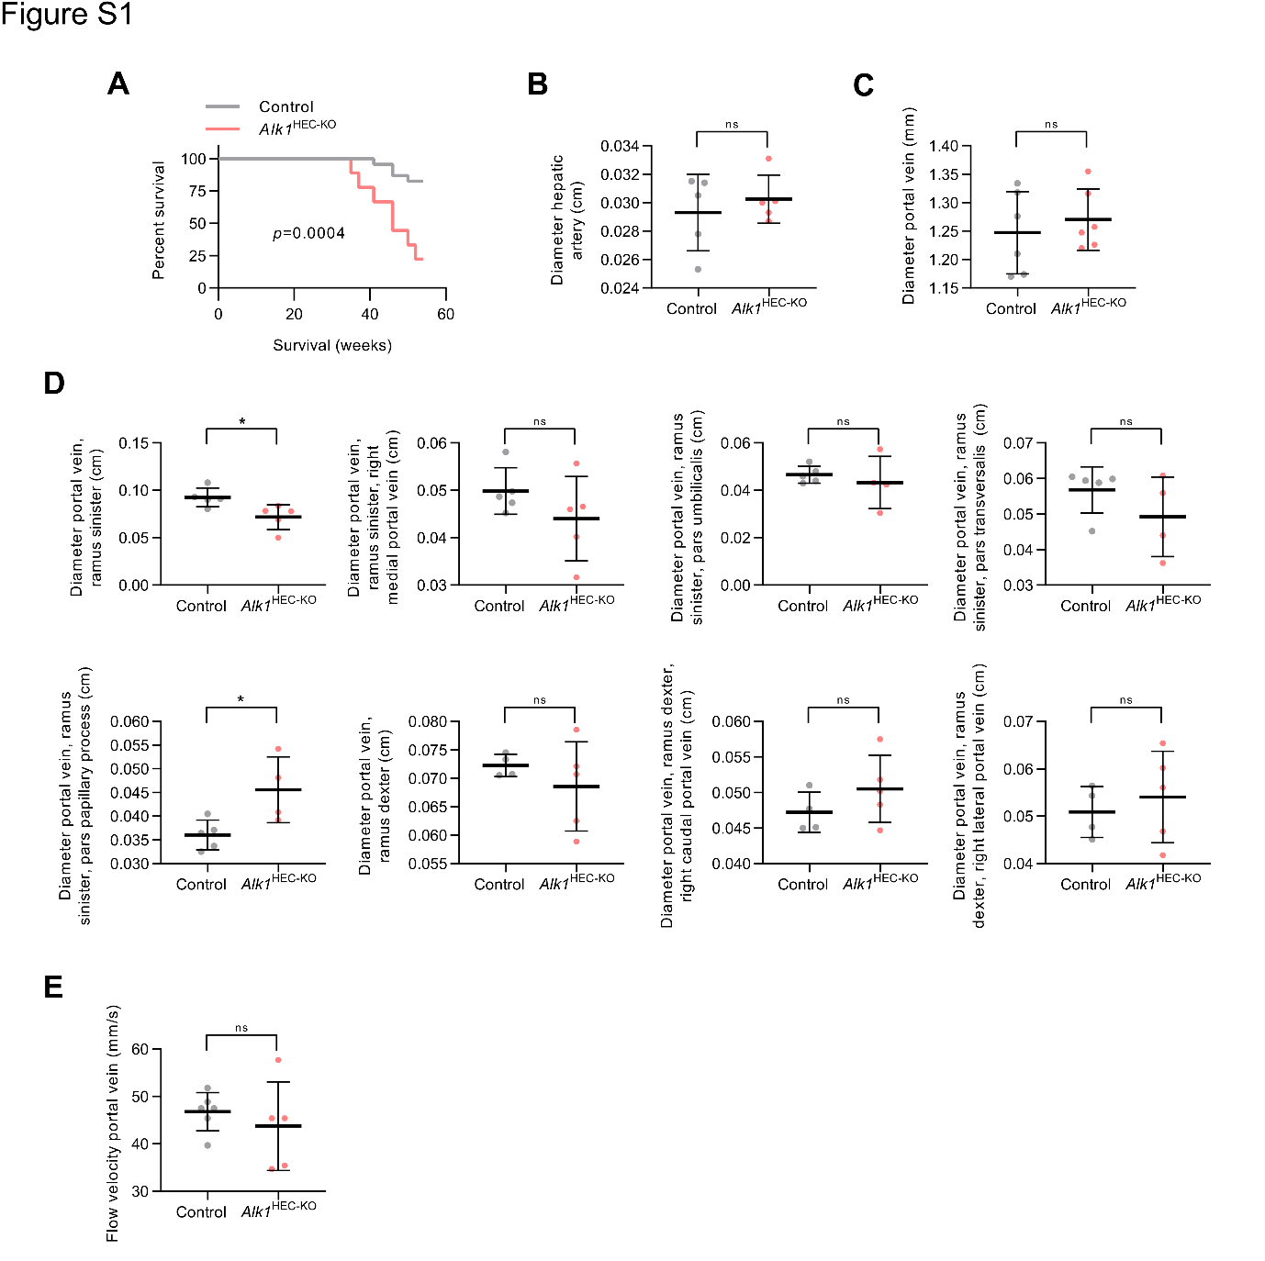
Figure S1. Portal vein and hepatic artery vessel diameters are unchanged in Alk1^{HEC-KO} mice. (A) Kaplan-Meier curve for the survival of Alk1^{HEC-KO} and control mice (n ≥ 9). (B) Diameter of hepatic artery using computed tomography (CT) (n = 5). (C) Diameter of portal vein using sonography (n ≥ 5). (D) Diameters of portal vein branches using CT (n = 5). (E) Flow velocity of portal vein using Doppler ultrasonography (n ≥ 5). (A) Log-rank test; (B-E) Mann–Whitney U test. * p < 0.05.

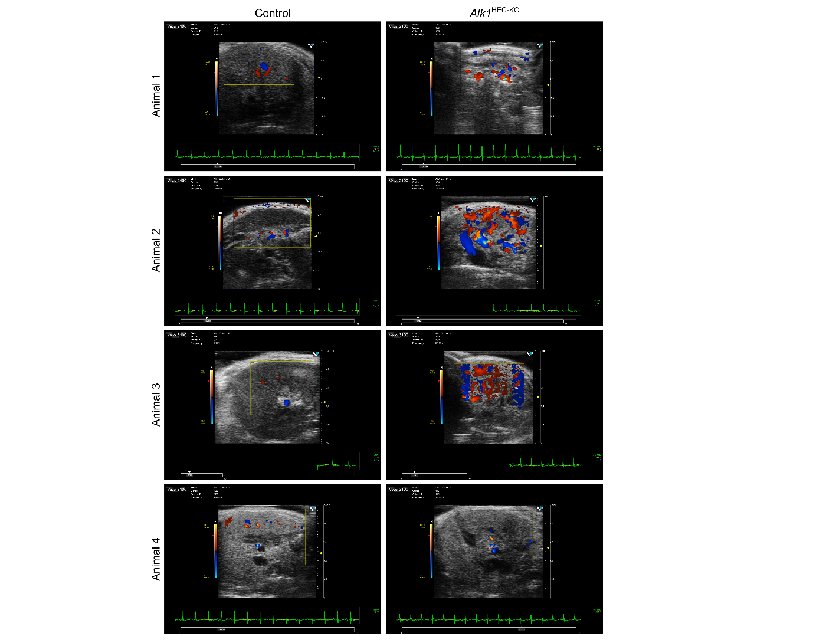
Figure S2. Duplex ultrasonography of livers indicates increased vessel density in Alk1 deficient mice. Images of duplex ultrasonography of the liver (n = 4).

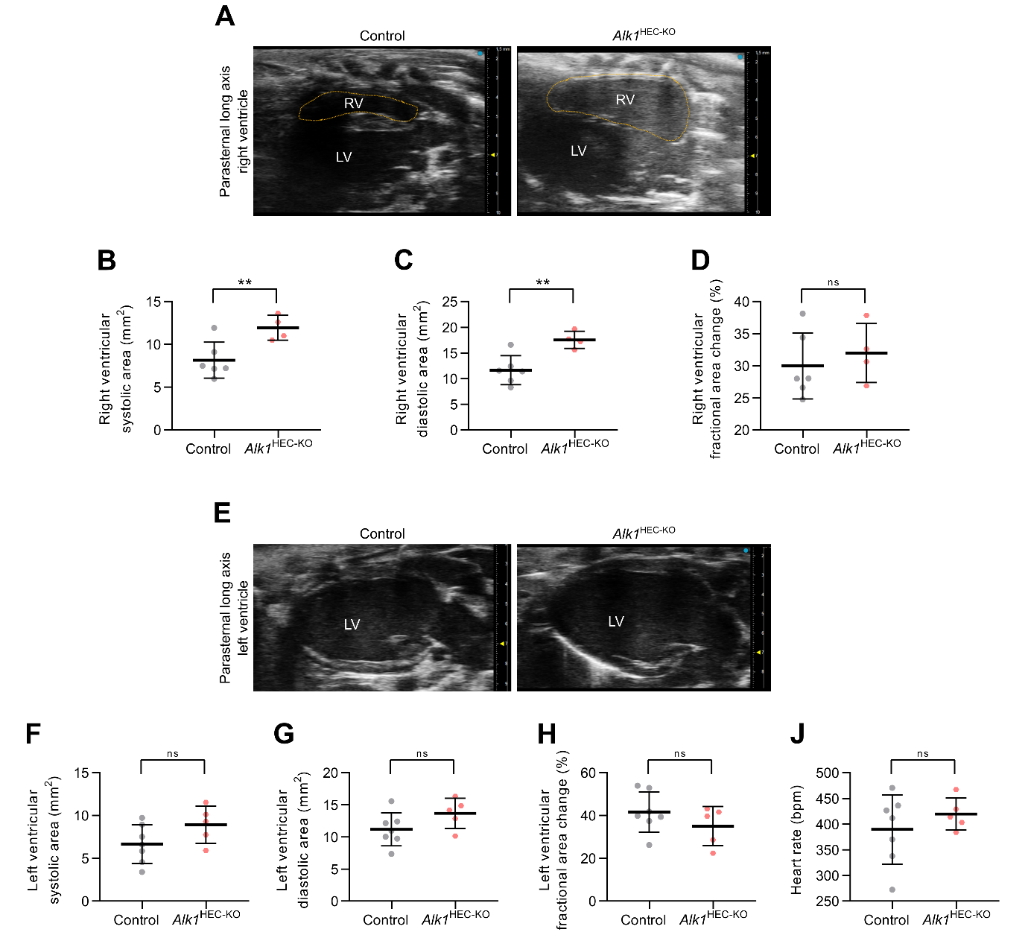
Figure S3. Echocardiography reveals a compensated right heart overload in Alk1^{HEC-KO} mice. (A) Echocardiography of the right ventricle using the parasternal long axis view (n ≥ 4). (B-C) Area measurements for the right ventricle in the systolic (B) (n ≥ 4) and diastolic (C) (n ≥ 4) phases. (D) Fractional area changes of the right ventricle during systolic and diastolic phases (i.e. ejection fraction) (n ≥ 4). (E) Echocardiography of the left ventricle using the parasternal long axis view (n ≥ 5). (F-G) Area measurements for the left ventricle in the systolic (F) (n ≥ 5) and diastolic (G) (n ≥ 5) phases. (H) Fractional area changes of the left ventricle during systolic and diastolic phases (i.e. ejection fraction) (n ≥ 5). (J) Comparison of the heart rate (n ≥ 5). RV, right ventricle; LV, left ventricle. (B-D, F-J) Welch’s t test. ** p < 0.01.

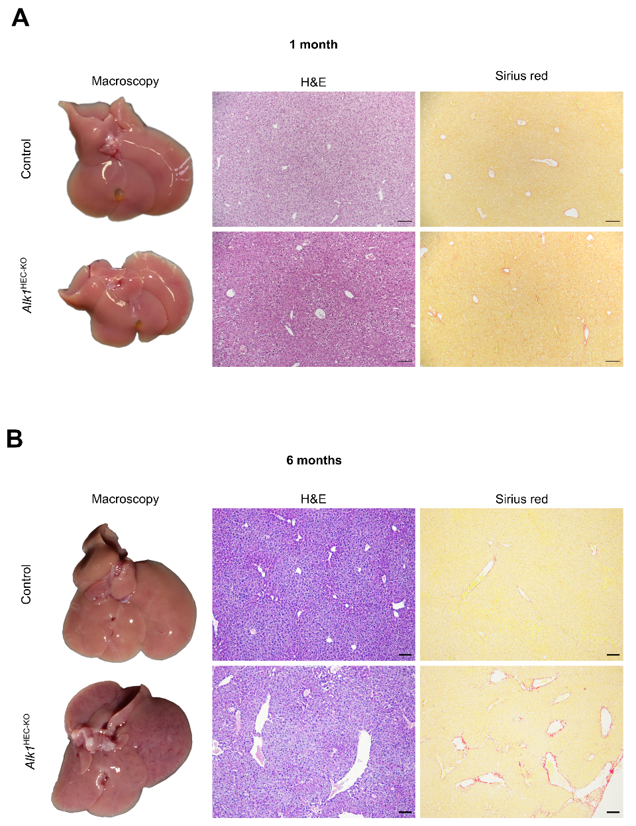
Figure S4. Liver macroscopy and basic histology of one and six months old Alk1^{HEC-KO} mice. (A-B) Macroscopic liver, H&E, and Sirius Red staining for (A) one and (B) six months old mice (n ≥ 4). Scale bars: 100 µm.

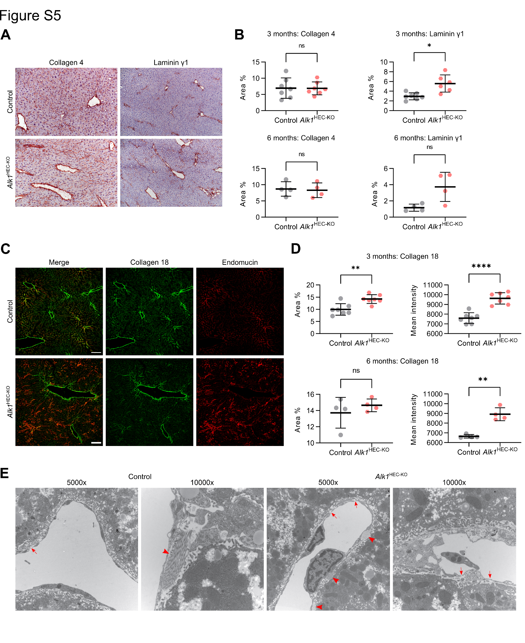
Figure S5. Hepatic endothelial Alk1 deficiency increases sinusoidal deposition of extracellular matrix proteins LAMC1 and COL18A1 but does not lead to fully developed sinusoidal capillarization or significant liver fibrosis. (A-B) Immunohistochemistry and quantification for Collagen 4 and Laminin y1 of livers (n ≥ 4). (C-D) Immunofluorescence for Collagen 18 and Endomucin of livers and quantification for Collagen 18 (n ≥ 4) . (E) Electron microscopy of livers. Arrows indicate gaps between endothelial cells. Arrowheads indicate extracellular matrix bundles. Scale bars: 100 µm. (B, D) Welch’s t test. * p < 0.05; ** p < 0.01; **** p < 0.0001.

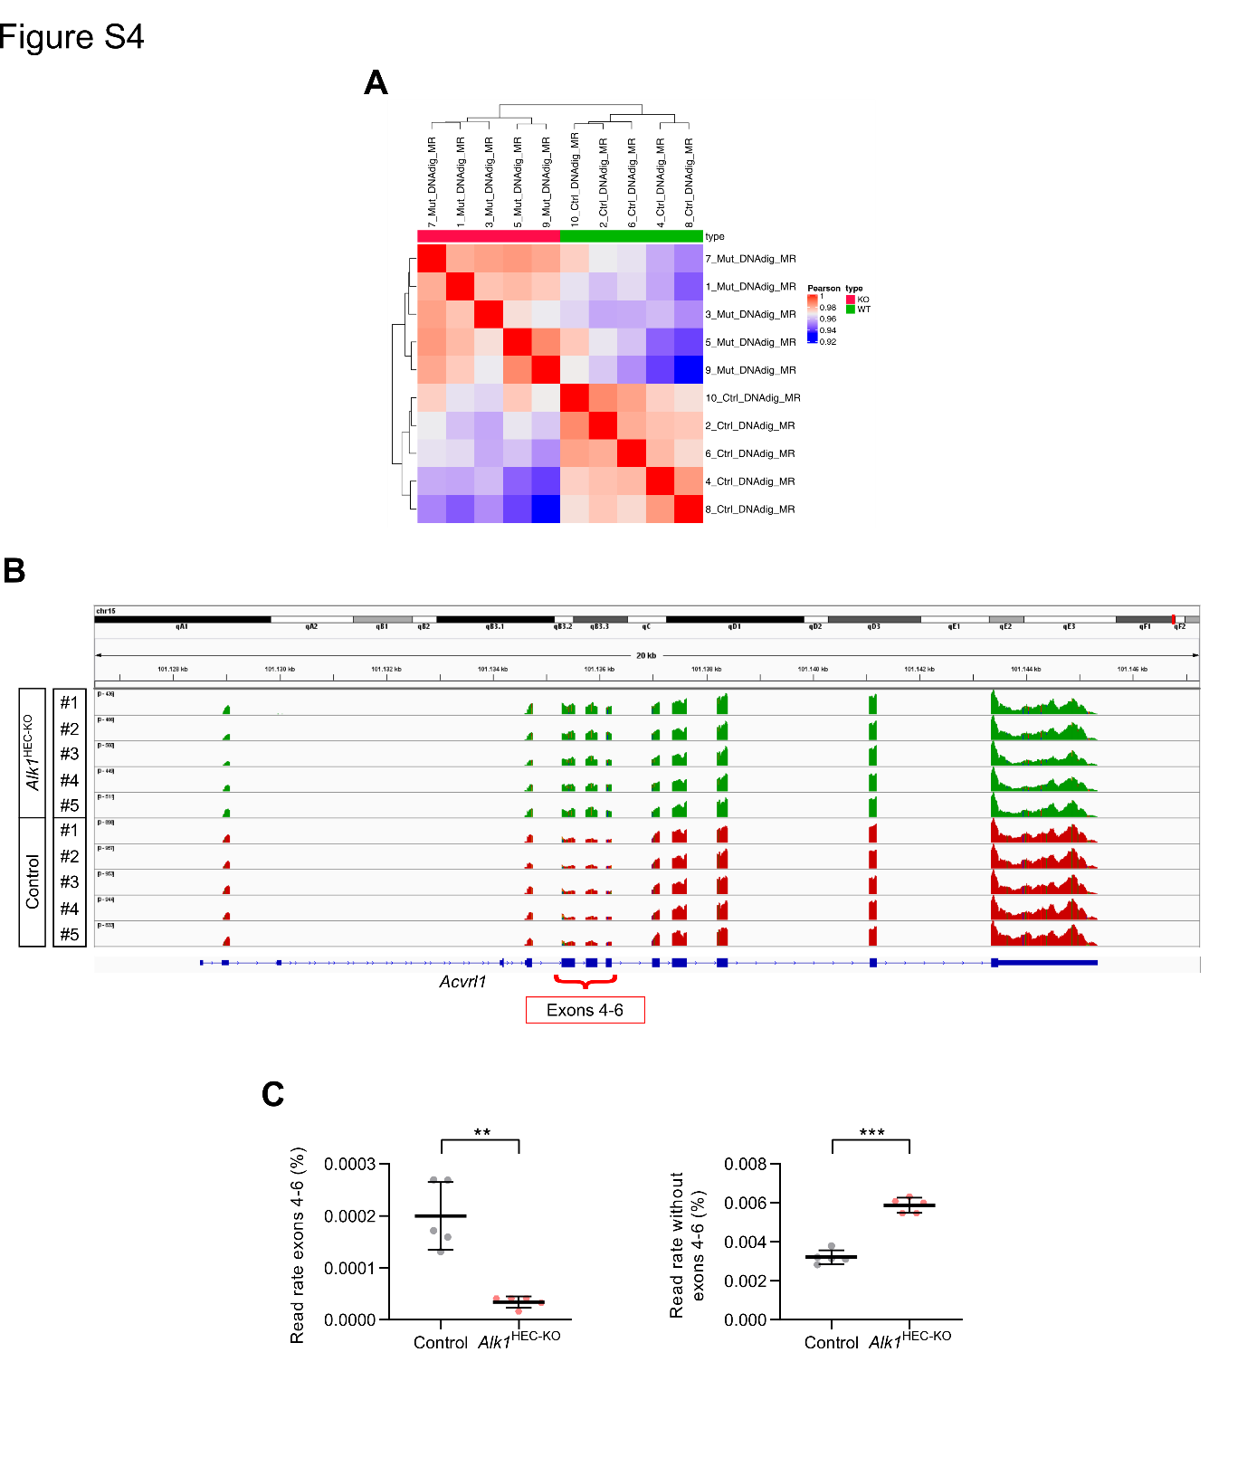
Figure S6. Acvrl1 is successfully recombined in hepatic endothelial cells of Alk1^{HEC-KO} mice. (A) Hierarchical clustering for principal components of RNA sequencing data from isolated hepatic endothelial cells (n = 5). (B) Gene tracks for isolated hepatic endothelial RNA samples at the Acvrl1 gene (alias Alk1) with annotation for Exons 4-6 that are flanked by loxP sites (n = 5). (C) Quantification for the Acvrl1 gene reads mapped to the exons 4-6 or to the region outside exons 4-6 (n = 5). (C) Welch’s t test. ** p < 0.01; *** p < 0.001.

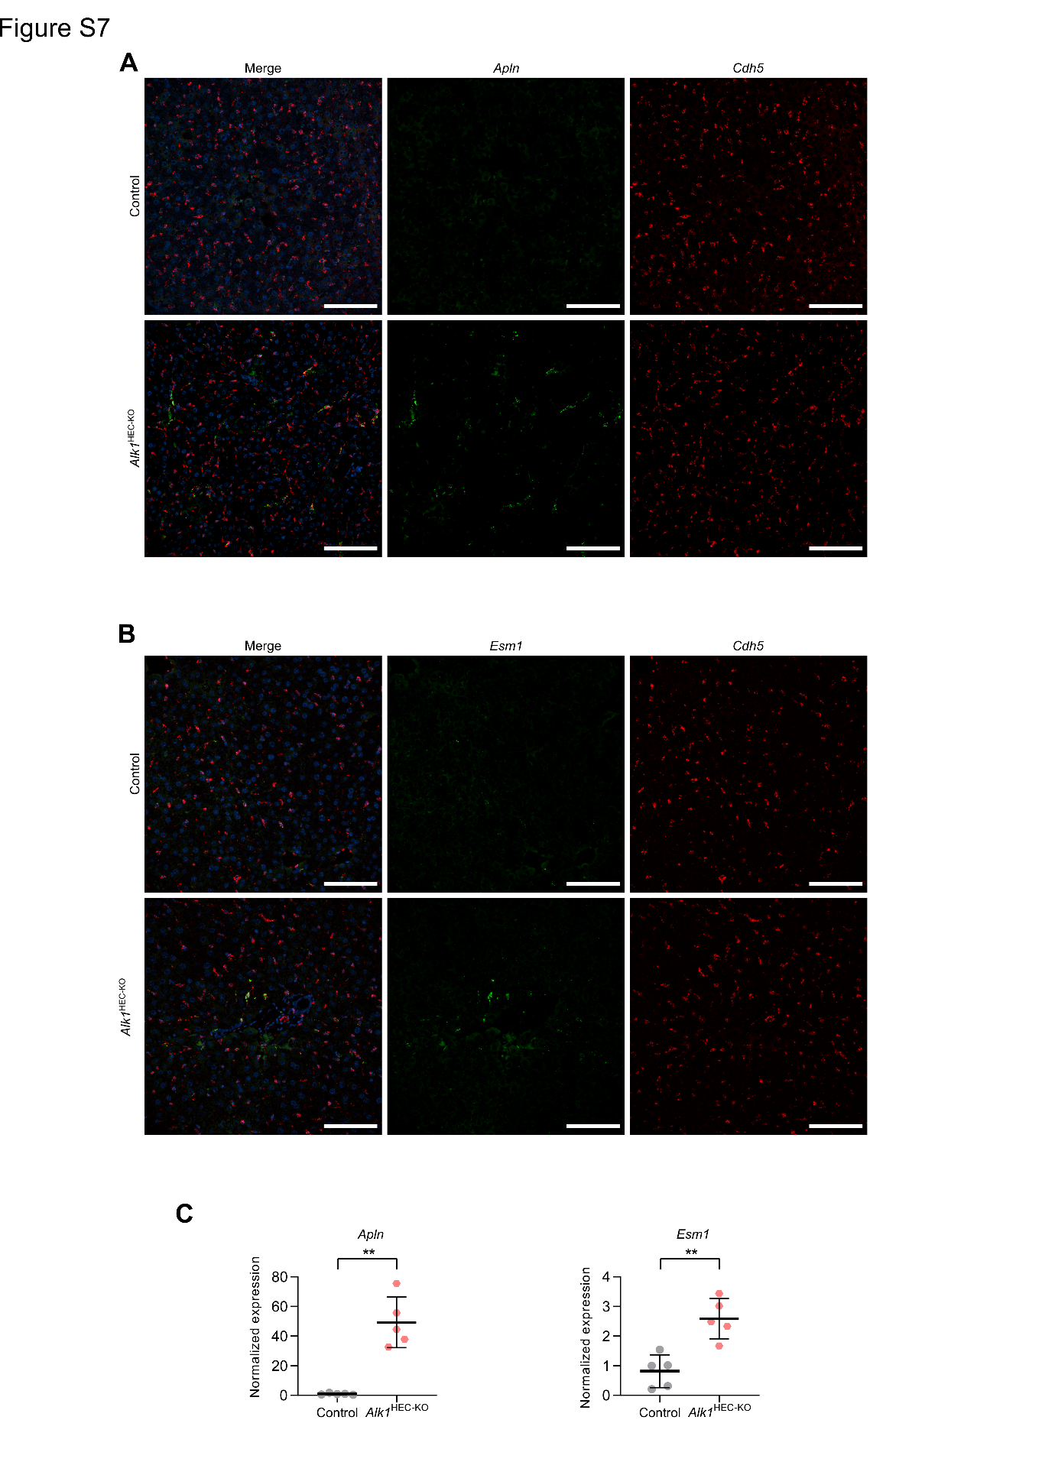
Figure S7. Increased expression of tip cell markers Apln and Esm1 in Alk1^{HEC-KO} mice. (A) FISH for Apln and Cdh5 of livers (n = 5). (B) FISH for Esm1 and Cdh5 of livers (n = 5). (C) qPCR of isolated hepatic endothelial cells for Apln and Esm1. Scale bars: 100 µm. (C) Mann–Whitney U test. ** p < 0.01.
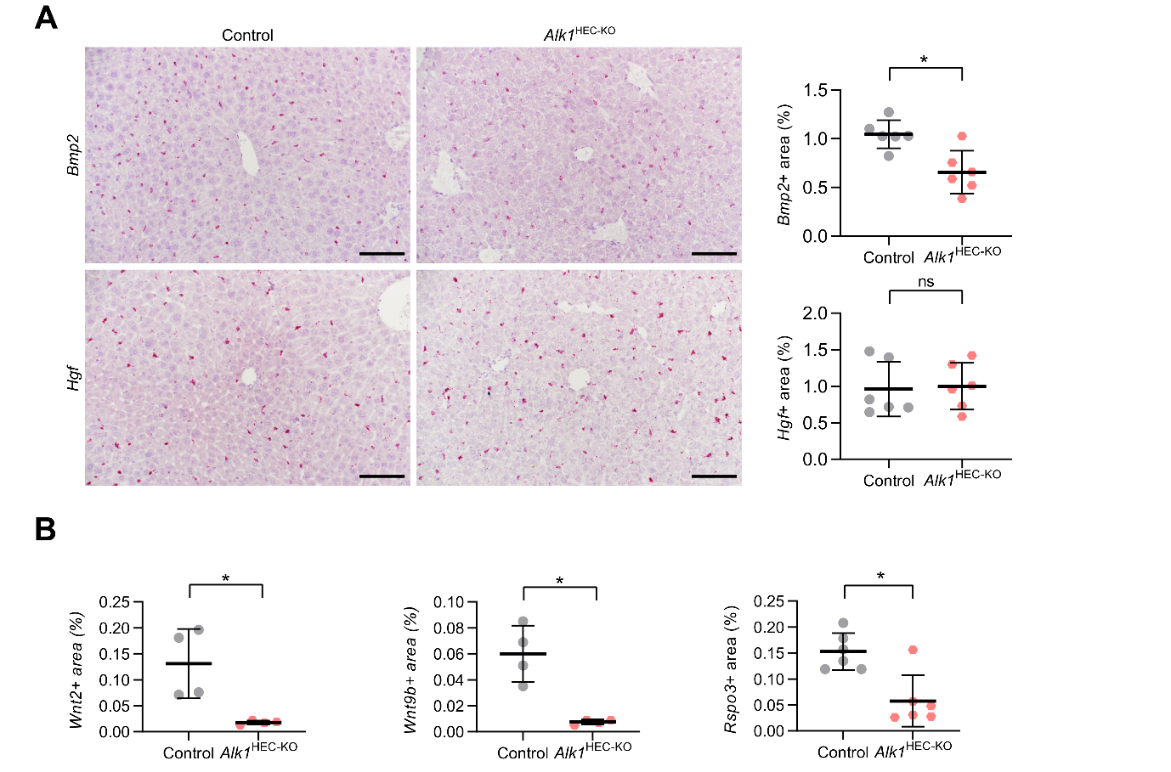
Figure S8. Angiocrine factors are dysregulated in Alk1^{HEC-KO} mice. (A) In-situ hybridization and quantification for Bmp2 and Hgf in livers (n = 6). (B) Quantification of in-situ hybridizations for Wnt2, Wnt9b, and Rspo3 in Figure 6 C (n ≥ 4). Scale bars: 100 µm. (B) Mann–Whitney U test. * p < 0.05.

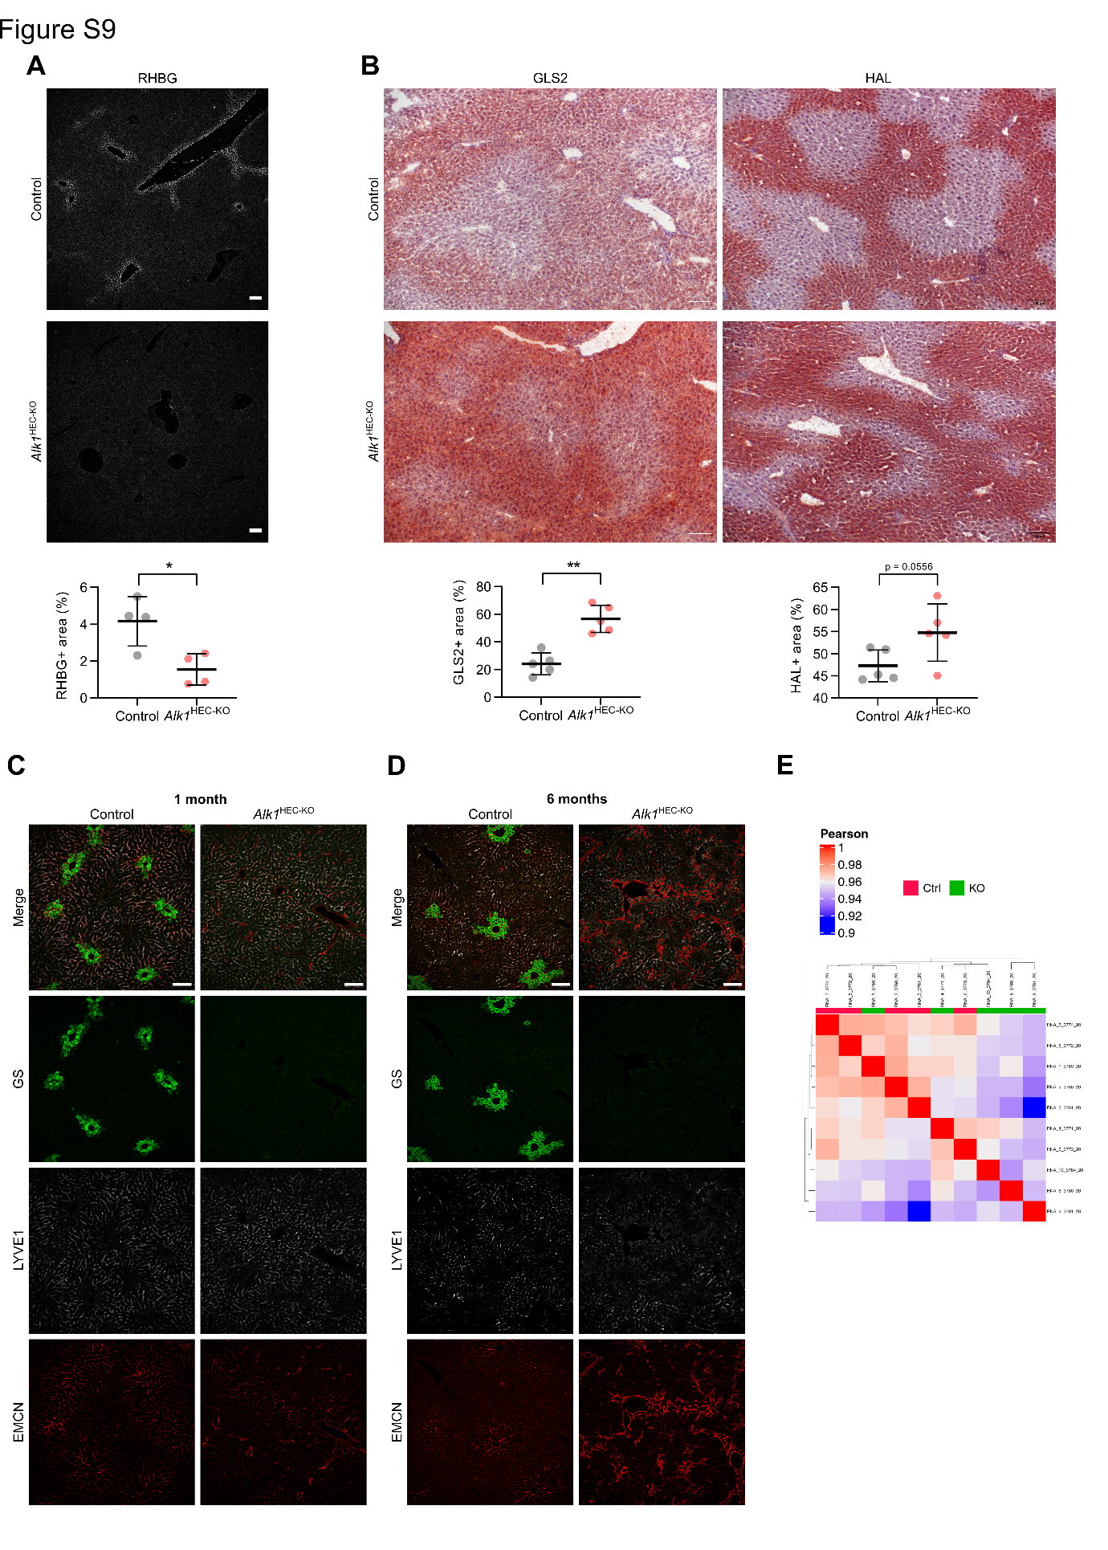
Figure S9. Loss of endothelial Alk1 disrupts hepatic metabolic zonation. (A) Immunofluorescence and quantification for RHBG (n = 4). (B) Immunohistochemistry and quantification for GLS2 and HAL (n = 5). (C-D) Immunofluorescence of livers for GS, LYVE1, and EMCN at the age of (C) one or (D) six months. (E) Hierarchical clustering for principal components of RNA sequencing data from whole liver lysates (n = 5). Scale bars: 100 µm. (A) Welch’s t test; (B) Mann–Whitney U test. * p < 0.05; ** p < 0.01.

Table S1. Plasma values.
Females, 3 months
 | Control |  |  |  | Alk1-HEC-KO
 | Mean | Min. | Max. | N | Mean | Min. | Max. | N | p (t test)
Body weight (g) | 21.97 | 19.76 | 23.16 | 7 | 21.10 | 20.14 | 22.36 | 5 | ns
Liver weight (g) | 1.08 | 0.96 | 1.17 | 7 | 1.00 | 0.90 | 1.15 | 5 | ns
Liver/body weight ratio | 0.0492 | 0.0424 | 0.0576 | 7 | 0.0474 | 0.0431 | 0.0539 | 5 | ns
Heart weight (g) | 0.13 | 0.10 | 0.18 | 7 | 0.13 | 0.11 | 0.16 | 5 | ns
Heart/body weight ratio | 0.0060 | 0.0047 | 0.0078 | 7 | 0.0061 | 0.0054 | 0.0070 | 5 | ns
Spleen weight (g) | 0.08 | 0.07 | 0.10 | 7 | 0.13 | 0.10 | 0.17 | 5 | 0.013
Spleen/body weight ratio | 0.0038 | 0.0033 | 0.0044 | 7 | 0.0062 | 0.0048 | 0.0074 | 5 | 0.0053
ALT (U/L) | 19.43 | 15.00 | 24.00 | 7 | 21.40 | 19.00 | 25.00 | 5 | ns
AST (U/L) | 41.57 | 33.00 | 53.00 | 7 | 54.20 | 51.00 | 59.00 | 5 | 0.0046
GLDH (U/L) | 7.05 | 5.20 | 9.67 | 7 | 6.53 | 3.61 | 8.28 | 5 | ns
ChE (U/L) | 6290.17 | 5646.00 | 6974.00 | 6 | 5921.50 | 5844.00 | 5999.00 | 2 | ns
Bilirubin (mg/dL) | 0.15 | 0.15 | 0.15 | 6 | 0.15 | 0.15 | 0.16 | 2 | ns
Urea (mg/dL) | 48.8 | 35.60 | 60.60 | 7 | 47.28 | 37.50 | 56.10 | 5 | ns
Creatinine (mg/dL) | 0.10 | 0.07 | 0.15 | 7 | 0.12 | 0.08 | 0.15 | 4 | ns
Glucose (mg/dL) | 295.14 | 253.00 | 355.00 | 7 | 270.80 | 233.00 | 292.00 | 5 | ns
Protein (mg/mL) | 47.94 | 45.30 | 50.00 | 7 | 45.14 | 43.00 | 47.40 | 5 | 0.0307
Cholesterol (mg/dL) | 65.57 | 49.00 | 83.00 | 7 | 58.00 | 53.00 | 64.00 | 5 | ns
Triglycerides (mg/dL) | 83.43 | 49.00 | 111.00 | 7 | 56.80 | 39.00 | 71.00 | 5 | 0.0373
Natrium (mmol/L) | 146.57 | 144.00 | 152.00 | 7 | 149.40 | 145.00 | 152.00 | 5 | ns
Kalium (mmol/L) | 4.23 | 3.97 | 4.87 | 7 | 4.38 | 3.83 | 5.13 | 5 | ns
Calcium (mmol/L) | 2.20 | 2.07 | 2.29 | 7 | 2.30 | 2.24 | 2.41 | 4 | ns

Table S1. Plasma values (continued).
Males, 3 months
 | Control |  |  |  | Alk1-HEC-KO
 | Mean | Min. | Max. | N | Mean | Min. | Max. | N | p (t test)
Body weight (g) | 26.87 | 24.53 | 29.62 | 11 | 27.02 | 23.20 | 30.30 | 6 | ns
Liver weight (g) | 1.21 | 0.97 | 1.38 | 11 | 1.28 | 1.03 | 1.53 | 6 | ns
Liver/body weight ratio | 0.0451 | 0.0381 | 0.0502 | 11 | 0.0473 | 0.0422 | 0.0506 | 6 | ns
Heart weight (g) | 0.16 | 0.12 | 0.22 | 11 | 0.19 | 0.15 | 0.27 | 6 | ns
Heart/body weight ratio | 0.0061 | 0.0049 | 0.0080 | 11 | 0.0071 | 0.0054 | 0.0090 | 6 | ns
Spleen weight (g) | 0.08 | 0.07 | 0.12 | 11 | 0.11 | 0.09 | 0.17 | 6 | 0.042
Spleen/body weight ratio | 0.0030 | 0.0023 | 0.0044 | 11 | 0.0042 | 0.0031 | 0.0057 | 6 | 0.0158
ALT (U/L) | 29.27 | 20.00 | 52.00 | 11 | 25.33 | 18.00 | 42.00 | 6 | ns
AST (U/L) | 59.91 | 32.00 | 181.00 | 11 | 51.50 | 34.00 | 82.00 | 6 | ns
GLDH (U/L) | 19.04 | 5.89 | 67.99 | 11 | 13.10 | 5.36 | 25.80 | 6 | ns
ChE (U/L) | 4904.50 | 4226.00 | 6425.00 | 8 | 4737.20 | 4066.00 | 5581.00 | 5 | ns
Bilirubin (mg/dL) | 0.15 | 0.15 | 0.15 | 8 | 0.15 | 0.15 | 0.15 | 5 | ns
Urea (mg/dL) | 47.86 | 35.60 | 61.60 | 10 | 55.58 | 47.00 | 72.90 | 6 | ns
Creatinine (mg/dL) | 0.16 | 0.07 | 0.29 | 10 | 0.20 | 0.07 | 0.35 | 5 | ns
Glucose (mg/dL) | 315.64 | 213.00 | 380.00 | 11 | 292.67 | 231.00 | 342.00 | 6 | ns
Protein (mg/mL) | 48.25 | 43.80 | 53.90 | 11 | 48.65 | 45.00 | 53.80 | 6 | ns
Cholesterol (mg/dL) | 80.25 | 58.00 | 91.00 | 8 | 88.20 | 79.00 | 114.00 | 5 | ns
Triglycerides (mg/dL) | 83.67 | 50.00 | 133.00 | 9 | 81.00 | 69.00 | 104.00 | 6 | ns
Natrium (mmol/L) | 151.10 | 145.00 | 160.00 | 10 | 150.00 | 146.00 | 158.00 | 6 | ns
Kalium (mmol/L) | 4.46 | 3.67 | 5.12 | 10 | 4.25 | 3.86 | 4.65 | 6 | ns
Calcium (mmol/L) | 2.32 | 2.22 | 2.46 | 8 | 2.32 | 2.16 | 2.47 | 5 | ns

Table S2. Genetic analysis of HHT samples.
Patient # | Sample # | Gene | Variant | Allele frequency | Function | Impact | Clinical significance
1 | A | EPHB4 | NC_000007.13:g.100424588C>T  NM_004444.5:c.52+13G>A  p.(=) | 0.17 | coding_transcript_intron_variant | LOW | Likely benign
1 | A | ENG | NC_000009.11:g.130605542G>A  NM_000118.3:c.68-18C>T  p.(=) | 0.25 | coding_transcript_intron_variant | LOW | Likely benign
1 | B | ACVRL1 | NC_000012.11:g.52310034C>T  NM_000020.3:c.1246+17C>T  p.(=) | 0.33 | coding_transcript_intron_variant | LOW | Likely benign
1 | B | ACVRL1 | NC_000012.11:g.52310027C>T  NM_000020.3:c.1246+10C>T  p.(=) | 0.4 | coding_transcript_intron_variant | LOW | Likely benign
1 | B | ACVRL1 | NC_000012.11:g.52306333G>A  NM_000020.3:c.61+14G>A  p.(=) | 0.16 | coding_transcript_intron_variant | LOW | Likely benign
1 | B | ENG | NC_000009.11:g.130587067A>C  NM_000118.3:c.991+12T>G  p.(=) | 0.13 | coding_transcript_intron_variant | LOW | Likely benign
1 | B | ENG | NC_000009.11:g.130587061C>G  NM_000118.3:c.991+18G>C  p.(=) | 0.14 | coding_transcript_intron_variant | LOW | Likely benign
2 | A | ACVRL1 | NC_000012.11:g.52306961G>C  NM_000020.3:c.140G>C  p.(Arg47Pro) | 0.35 | missense_variant | MODERATE | Pathogenic
3 | A | ACVRL1 | NC_000012.11:g.52308372A>C  NM_000020.3:c.772+3A>C  p.? | 0.55 | splice_region_variant, coding_transcript_intron_variant | MODERATE | Uncertain significance
4 | A | ACVRL1 | NC_000012.11:g.52314541A>G  NM_000020.3:c.1378-2A>G  p.? | 0.47 | splice_acceptor_variant, coding_transcript_intron_variant | HIGH | Pathogenic
4 | B | ACVRL1 | NC_000012.11:g.52314541A>G  NM_000020.3:c.1378-2A>G  p.? | 0.44 | splice_acceptor_variant, coding_transcript_intron_variant | HIGH | Pathogenic

Table S3. Antibodies.
Target | Research Resource Identifier (RRID) | Supplier | Cat Num | Clone ID | Host Organism
Endomucin mouse | AB_891529 | Thermo Fisher Scientific | 14-5851-81 | Clone eBioV.7C7 (V.7C7) | Rat
Endoglin/CD105 mouse | AB_354735 | R and D Systems | AF1320 | NA | Goat
LYVE-1 mouse | AB_2297188 | R and D Systems | AF2125 | NA | Goat
CD31/PECAM-1 epitope: aa 18-590 mouse | AB_2161028 | R and D Systems | AF3628 | NA | Goat
ACTA2 mouse | AB_2223021 | Abcam | ab5694 | NA | Rabbit
Glutamine Synthetase mouse, human | AB_259853 | Sigma-Aldrich | G2781 | NA | Rabbit
ARG1 mouse | AB_2800207 | Cell Signaling Technology | 93668 | Clone D4E3M™ | Rabbit
Fc gamma RII/CD32 human | AB_354737 | R and D Systems | AF1330 | NA | Goat
CD34 Monoclonal Antibody (QBEND/10) | AB_11156010 | Thermo Fisher Scientific | MA-1-10202 | Clone QBEND/10 | Mouse
RHBG mouse | AB_10990341 | Thermo Fisher Scientific | PA5-19369 | NA | Goat
Laminin beta-2/gamma-1 Monoclonal Antibody (A5) | AB_559896 | Thermo Fisher Scientific | MA1-06100 | Clone A5 | Rat
Mouse Endostatin Antibody (Col18A1) | AB_2081736 | R and D Systems | AF570 | NA | goat
Glutamine Synthetase mouse, human | AB_2620128 | Synaptic Systems | 367 005 | NA | guinea pig
GLS2 antibody | AB_10866157 | Abcam | ab113509 | NA | rabbit
HAL antibody | AB_1850484 | Sigma-Aldrich | AV45694 | NA | rabbit
Collagen IV antibody | AB_789360 | Novus | NB120-6586 | NA | rabbit
PRND polyclonal antibody | AB_2678450 | Atlas Antibodies | HPA043373 | NA | rabbit

Table S4. Primers.
Name | Sequence | Supplier
Mm-Pgf_fw | TCTGGAGACGACAAAGGCAG | metabion international AG
Mm-Pgf_rv | CGGGAAATGACATCACGGGT | metabion international AG
Mm-Prnd_fw | CAGCCACAGAGGACTCCAG | metabion international AG
Mm-Prnd_rv | AACCGATTGCACTGGGAACT | metabion international AG
Mm-Wnt2_fw | GCCCTGATGAACCTTCACAAC | metabion international AG
Mm-Wnt2_rv | GGAGCCACTCACACCATGAC | metabion international AG
Mm-Wnt9b_fw | GGGCTGCTGGAATGTCAGTT | metabion international AG
Mm-Wnt9b_rv | CGTCTCCTTAAAGCCTCTCTGG | metabion international AG
Mm-Rspo3_fw | ACACCTTGGAAAGTGCCTTGA | metabion international AG
Mm-Rspo3_rv | TGGCCTCACAGTGTACAATAC | metabion international AG
Mm-iCre_fw | AAGCTGAACAACAGGAAATGGTTC | metabion international AG
Mm-iCre_rv | GGAGATGTCCTTCACTCTGATTCT | metabion international AG
Mm-Acvrl1-flox_6F_#3710 | CCTGGACAGCGACTGTACTAC | metabion international AG
Mm-Acvrl1-flox_6R #3711 | GCCCCATTGCTCTCCTCAAAC | metabion international AG
Mm-Esm1-fw | TGCAAAGACTGTCCCTATGGC | metabion international AG
Mm-Esm1-rv | CCATCTCCGGATGCTGAGTC | metabion international AG
Mm-Apln-fw | TTTGTGGAGTGCCACTGATGTT | metabion international AG
Mm-Apln-rv | TGGAGTAGAGAGACCGGCAC | metabion international AG
Mm-Id1-fw | GAACCGCAAAGTGAGCAAGG | metabion international AG
Mm-Id1-rv | GGAACACATGCCGCCTCA | metabion international AG
Mm-Id2-fw | CCTGCATCACCAGAGACCTG | metabion international AG
Mm-Id2-rv | GGGAATTCAGATGCCTGCAA | metabion international AG
Mm-Id3-fw | ACATGAACCACTGCTACTCGC | metabion international AG
Mm-Id3-rv | GTGAGCTCAGCTGTCTGGATCG | metabion international AG
Mm-Gak-fw | CTGCCCACCAGGCATTTG | metabion international AG
Mm-Gak-rv | CCATGTCACATACATATTCAATGTACCT | metabion international AG
Mm-Mrpl46-fw | GGGAGCAGGCATTCCTACAG | metabion international AG
Mm-Mrpl46-rv | GGTCCGGTCATTTTTTTTGTCA | metabion international AG
Mm-Srp72-fw | CACCCAGCAGACAGACAAACTG | metabion international AG
Mm-Srp72-rv | GCACTCATCGTAGCGTTCCA | metabion international AG

Table S5. ISH-probes.
Probe | Supplier | Order No.
Mm-Prnd | Advanced Cell Diagnostics | 457951
Mm-Pgf | Advanced Cell Diagnostics | 405921
Mm-Wnt2 | Advanced Cell Diagnostics | 313601
Mm-Wnt9b | Advanced Cell Diagnostics | 405091
Mm-Rspo3 | Advanced Cell Diagnostics | 402011
Mm-Bmp2-E3 | Advanced Cell Diagnostics | 427341
Mm-Hgf | Advanced Cell Diagnostics | 315631
Mm-Cdh5-C2 | Advanced Cell Diagnostics | 312531-C2
Mm-Esm1_E3 | Advanced Cell Diagnostics | 411761
Mm-Apln | Advanced Cell Diagnostics | 415371
Hs-PGF | Advanced Cell Diagnostics | 311771
Hs-CDH5-C2 | Advanced Cell Diagnostics | 437451-C2

References
1. Weyer V, Maros ME, Kronfeld A, Kirschner S, Groden C, Sommer C, et al. Longitudinal imaging and evaluation of SAH-associated cerebral large artery vasospasm in mice using micro-CT and angiography. J Cereb Blood Flow Metab. 2020;40:2265–2277.
2. Boll H, Nittka S, Doyon F, Neumaier M, Marx A, Kramer M, et al. Micro-CT Based Experimental Liver Imaging Using a Nanoparticulate Contrast Agent: A Longitudinal Study in Mice. PLoS One. 2011;6:e25692.
3. Schambach SJ, Bag S, Steil V, Isaza C, Schilling L, Groden C, et al. Ultrafast high-resolution in vivo volume-CTA of mice cerebral vessels. Stroke. 2009;40:1444–1450.
4. Schindelin J, Arganda-Carreras I, Frise E, Kaynig V, Longair M, Pietzsch T, et al. Fiji: an open-source platform for biological-image analysis. Nature methods. 2012;9:676–82.
5. Schneider CA, Rasband WS, Eliceiri KW. NIH Image to ImageJ: 25 years of image analysis. Nat Methods. 2012;9:671–675.
6. Winkler M, Staniczek T, Kürschner SW, Schmid CD, Schönhaber H, Cordero J, et al. Endothelial GATA4 controls liver fibrosis and regeneration by preventing a pathogenic switch in angiocrine signaling. Journal of Hepatology. 2021;74:380–393.
7. H Backman TW, Girke T. systemPipeR: NGS workflow and report generation environment. BMC Bioinformatics. 2016;17:388.
8. Bray NL, Pimentel H, Melsted P, Pachter L. Near-optimal probabilistic RNA-seq quantification. Nat Biotechnol. 2016;34:525–527.
9. Ritchie ME, Phipson B, Wu D, Hu Y, Law CW, Shi W, et al. limma powers differential expression analyses for RNA-sequencing and microarray studies. Nucleic acids research. 2015;43:e47.
10. Gu Z, Eils R, Schlesner M. Complex heatmaps reveal patterns and correlations in multidimensional genomic data. Bioinformatics. 2016;32:2847–2849.
11. Korotkevich G, Sukhov V, Budin N, Shpak B, Artyomov MN, Sergushichev A. Fast gene set enrichment analysis [Internet]. 2021 [cited 2021 Aug 26]. Available from: https://www.biorxiv.org/content/10.1101/060012v3
12. Geistlinger L, Csaba G, Zimmer R. Bioconductor’s EnrichmentBrowser: seamless navigation through combined results of set- & network-based enrichment analysis. BMC Bioinformatics. 2016;17:45.
13. Chen EY, Tan CM, Kou Y, Duan Q, Wang Z, Meirelles GV, et al. Enrichr: interactive and collaborative HTML5 gene list enrichment analysis tool. BMC Bioinformatics. 2013;14:128.
14. Kalucka J, de Rooij LPMH, Goveia J, Rohlenova K, Dumas SJ, Meta E, et al. Single-Cell Transcriptome Atlas of Murine Endothelial Cells. Cell. 2020;180:764-779.e20.
15. Halpern KB, Shenhav R, Massalha H, Toth B, Egozi A, Massasa EE, et al. Paired-cell sequencing enables spatial gene expression mapping of liver endothelial cells. Nature Biotechnology. 2018;36:962.
16. Halpern KB, Shenhav R, Matcovitch-Natan O, Toth B, Lemze D, Golan M, et al. Single-cell spatial reconstruction reveals global division of labour in the mammalian liver. Nature. 2017;542:352–356.
17. Hruz T, Wyss M, Docquier M, Pfaffl MW, Masanetz S, Borghi L, et al. RefGenes: identification of reliable and condition specific reference genes for RT-qPCR data normalization. BMC Genomics. 2011;12:156.
18. De Falco S. The discovery of placenta growth factor and its biological activity. Exp Mol Med. 2012;44:1–9.

