Supplemental Digital Content

Table S1. Changes from baseline to week 108 in blood pressure, heart rate, rate pressure product, and concomitant antihypertensive medication use (2-year cohort).[1, 2]_ENREF_1
Mean change at week 108 | Placebo | PHEN/TPM ER 7.5/46 | PHEN/TPM ER 15/92
Systolic BP, mm Hg (ITT-LOCF)
n | 227 | 153 | 295
Baseline mean | 128.5 | 127.8 | 127.3
LS mean change (SE) | -3.2 (0.9) | -4.7 (1.1) | -4.3 (0.8)
Diastolic BP, mm Hg (ITT-LOCF)
n | 227 | 153 | 295
Baseline mean | 79.9 | 80.1 | 80.1
LS mean change (SE) | -3.9 (0.6) | -3.7 (0.7) | -3.5 (0.5)
Antihypertensive medication use (safety set)
n | 227 | 153 | 295
Percentage of subjects with net change† in concomitant antihypertensive medication | 3.5 | -3.9‡ | -9.8‡
Heart rate, bpm (safety set)
n | 197 | 129 | 248
Baseline mean | 70.6 | 72.0 | 73.0
Mean change (SD) | 0.4 (9.9) | 1.3 (10.2) | 1.7(10.6)
Rate pressure product* (safety set)
n | 197 | 129 | 248
Baseline mean | 90.6 | 92.1 | 92.9
Mean change (SD) | -2.2 (17.2) | -2.0 (18.8) | -0.6 (16.2)
*Rate pressure product is calculated as heart rate (bpm) multiplied by systolic blood pressure (mm Hg), divided by 1000; †Percent increase minus percent decrease; ‡P=.0165 for between-group differences (Fisher’s exact test).
PHEN/TPM ER, phentermine and topiramate extended-release; BP, blood pressure; ITT, intention to treat; LOCF, last observation carried forward; LS, least squares; SE, standard error; bpm, beats per minute; SD, standard deviation.

Figure S1. Change in (a) blood pressure, and (b) concomitant antihypertensive medication use from baseline to week 108 in subjects with hypertension*† at baseline (2-year cohort; ITT-LOCF).[2]
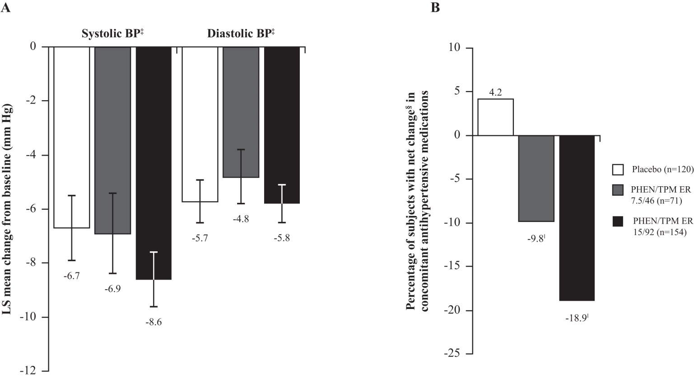
*Patients were managed to standard of care; †Hypertension was defined as having baseline systolic BP ≥140 mm Hg and ≤160 mm Hg (≥130 mm Hg and ≤160 mm Hg if diabetic) or diastolic BP ≥90 mm Hg and ≤100 mm Hg (≥85 mm Hg and ≤100 mm Hg if diabetic) or on 2 or more antihypertensive medications to achieve BP control;
‡P=NS for both doses of PHEN/TPM ER versus placebo, all comparisons; §Percent increase minus percent decrease; ‖P=.0012 for between-group differences (Fisher’s exact test).
ITT, intention to treat; LOCF, last observation carried forward; BP, blood pressure; LS, least squares; PHEN/TPM ER, phentermine and topiramate extended-release.

References
1. U.S. Food and Drug Administration. (2012). Briefing Information for the February 22, 2012 Meeting of the Endocrinologic and Metabolic Drugs Advisory Committee. [WWW document]. URL http://www.fda.gov/AdvisoryCommittees/CommitteesMeetingMaterials/Drugs/EndocrinologicandMetabolicDrugsAdvisoryCommittee/ucm292314.htm.
2. Davidson M, Bowden CH, Day WW. Weight loss and cardiovascular risk reduction over 2 years with controlled-release phentermine-topiramate. Presented at the 60th Annual Scientific Session and Expo of the American College of Cardiology (ACC). New Orleans; April 2011.

