Supplementary data to
Plasma Creatine Concentration is Associated With Incident Hypertension in a Cohort Enriched for the Presence of High Urinary Albumin Concentration: The PREVEND Study

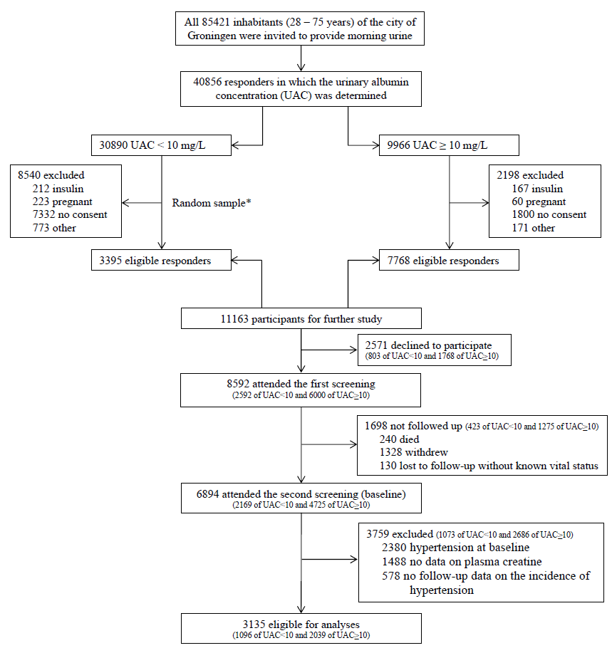
Figure S1. Flow of the participants through the study. * Out of 30,890 participants with an UAC < 10 mg/L, 22,350 were eligible responders. Out of these eligible responders, a random sample was selected in order to obtain a total cohort size of roughly 10,000, taking into account a 15% non-participation rate.

Table S1. Prospective associations of plasma creatine with risk of incident hypertension after exclusion the highest and lowest 2.5 percentiles.
 | Total cohort |  | Males |  | Females
 | Per doubling |  | Per doubling |  | Per doubling
 | HR [95% CI] | P-value | HR [95% CI] | P-value | HR [95% CI] | P-value
Model 1 | 1.41 [1.26 – 1.58] | <0.001 | 1.49 [1.28 – 1.73] | <0.001 | 1.30 [1.09 – 1.55] | 0.004
Model 2 | 1.24 [1.10 – 1.40] | <0.001 | 1.28 [1.10 – 1.50] | 0.002 | 1.17 [0.98 – 1.41] | 0.09
Model 3 | 1.22 [1.08 – 1.37] | 0.002 | 1.27 [1.08 – 1.49] | 0.004 | 1.13 [0.94 – 1.37] | 0.20
Model 4 | 1.22 [1.08 – 1.38] | 0.001 | 1.28 [1.09 – 1.50] | 0.003 | 1.13 [0.94 – 1.38] | 0.20
Model 5 | 1.29 [1.08 – 1.54] | 0.005 | 1.24 [1.05 – 1.46] | 0.01 | 1.12 [0.93 – 1.36] | 0.23
Model 6 | 1.18 [1.04 – 1.33] | 0.01 | 1.20 [1.02 – 1.41] | 0.03 | 1.12 [0.92 – 1.35] | 0.25
Model 1: adjusted for sex (only for total cohort) and systolic blood pressure. Model 2: as model 1, additionally adjusted for age and BMI. Model 3; as model 2, additionally adjusted for eGFR and urinary albumin excretion. Model 4, as model 3, additionally adjusted for parental history of hypertension and NT-proBNP. Model 5, as model 3, additionally adjusted for total cholesterol, HDL cholesterol, triglycerides and usage of lipid-lowering drugs. Model 6, as model 3, additionally adjusted for smoking and alcohol intake.

Table S2. Prospective associations of plasma creatine with risk of incident hypertension after exclusion of participants with a systolic blood pressure between 130 and 139 mmHg and/or a diastolic blood pressure between 80 and 90 mmHg
 | Total cohort |  | Males |  | Females
 | Per doubling |  | Per doubling |  | Per doubling
 | HR [95% CI] | P-value | HR [95% CI] | P-value | HR [95% CI] | P-value
Model 1 | 1.39 [1.26 – 1.54] | <0.001 | 1.47 [1.29 – 1.69] | <0.001 | 1.29 [1.10 – 1.51] | 0.002
Model 2 | 1.22 [1.10 – 1.36] | <0.001 | 1.27 [1.11 – 1.46] | <0.001 | 1.15 [0.98 – 1.36] | 0.09
Model 3 | 1.21 [1.09 – 1.35] | <0.001 | 1.30 [1.13 – 1.50] | <0.001 | 1.10 [0.93 – 1.30] | 0.28
Model 4 | 1.22 [1.09 – 1.36] | <0.001 | 1.31 [1.14 – 1.51] | <0.001 | 1.10 [0.93 – 1.30] | 0.28
Model 5 | 1.27 [1.08 – 1.48] | 0.003 | 1.26 [1.09 – 1.46] | 0.002 | 1.08 [0.92 – 1.28] | 0.35
Model 6 | 1.17 [1.05 – 1.30] | 0.005 | 1.22 [1.05 – 141] | 0.008 | 1.08 [0.91 – 1.27] | 0.37
Model 1: adjusted for sex (only for total cohort) and systolic blood pressure. Model 2: as model 1, additionally adjusted for age and BMI. Model 3; as model 2, additionally adjusted for eGFR and urinary albumin excretion. Model 4, as model 3, additionally adjusted for parental history of hypertension and NT-proBNP. Model 5, as model 3, additionally adjusted for total cholesterol, HDL cholesterol, triglycerides and usage of lipid-lowering drugs. Model 6, as model 3, additionally adjusted for smoking and alcohol intake.

Table S3. Prospective associations of plasma creatine with risk of incident hypertension after exclusion of participants with a parental history of hypertension .
 | Total cohort |  | Males |  | Females
 | Per doubling |  | Per doubling |  | Per doubling
 | HR [95% CI] | P-value | HR [95% CI] | P-value | HR [95% CI] | P-value
Model 1 | 1.37 [1.22 – 1.54] | <0.001 | 1.48 [1.27 – 1.71] | <0.001 | 1.20 [0.99 – 1.45] | 0.06
Model 2 | 1.18 [1.05 – 1.33] | 0.005 | 1.24 [1.07 – 1.45] | 0.005 | 1.09 [0.89 – 1.32] | 0.40
Model 3 | 1.18 [1.04 – 1.33] | 0.008 | 1.26 [1.08 – 1.47] | 0.003 | 1.06 [0.86 – 1.30] | 0.57
Model 4 | 1.18 [1.03 – 1.35] | 0.02 | 1.27 [1.06 – 1.52] | 0.009 | 1.06 [0.85 – 1.32] | 0.60
Model 5 | 1.23 [1.03 – 1.47] | 0.02 | 1.23 [1.05 – 1.44] | 0.01 | 1.06 [0.86 – 1.30] | 0.57
Model 6 | 1.15 [1.02 – 1.30] | 0.03 | 1.20 [1.02 – 1.41] | 0.03 | 1.05 [0.86 – 1.29] | 0.63
Model 1: adjusted for sex (only for total cohort) and systolic blood pressure. Model 2: as model 1, additionally adjusted for age and BMI. Model 3; as model 2, additionally adjusted for eGFR and urinary albumin excretion. Model 4, as model 3, additionally adjusted for and NT-proBNP. Model 5, as model 3, additionally adjusted for total cholesterol, HDL cholesterol, triglycerides and usage of lipid-lowering drugs. Model 6, as model 3, additionally adjusted for smoking and alcohol intake.

Table S4. Baseline clinical and laboratory characteristics in participants with and without creatine data available
Variables | No creatine available | Creatine available | P-value
Age, years | 50.0 ± 10.6 | 49.3 ± 10.2 | 0.12
Sex, n male (%) | 433 (54) | 1441 (46) | <0.001
BMI, kg/m² | 25.9 ± 4.0 | 25.7 ± 3.8 | 0.18
Systolic blood pressure, mm Hg | 118 ± 11 | 118 ± 11 | 0.08
Diastolic blood pressure, mm Hg | 71 ± 7 | 70 ± 7 | 0.38
Pulse rate, bpm | 68 ± 9 | 68 ± 9 | 0.83
NT-proBNP, ng/L | 34 [18, 61] | 35.0 [18, 62] | 0.50
eGFR, ml/min/1.73m² | 96.4 ± 13.6 | 97.2 ± 14.3 | 0.15
Parental history of hypertension, n (%) | 206 (28) | 952 (33) | 0.03
Smoking status, current n (%) | 254 (32) | 930 (30) | 0.28
Alcohol intake, n yes (%) | 626 (78) | 2440 (78) | 0.92
Lipid lowering drugs, n (%) | 31 (4) | 94 (4) | 0.41
Total cholesterol, mmol/L | 5.46 ± 1.06 | 5.36 ± 1.03 | 0.01
HDL cholesterol, mmol/L | 1.28 ± 0.32 | 1.28 ± 0.30 | 0.76
Triglycerides, mmol/L | 1.04 [0.75, 1.53] | 1.03 [0.76, 1.47] | 0.74
Glucose, mmol/L | 4.7 [4.3, 5.1] | 4.7 [4.4, 5.1] | 0.53
Insulin, mU/L | 7.5 [5.3, 10.9] | 7.3 [5.3, 10.5] | 0.59
Plasma branched chain amino acids, μmol/L | 383.8 ± 77.3 | 370.74 ± 69.8 | <0.001
Urinary albumin excretion, mg/24-h | 7.9 [5.9, 12.1] | 7.8 [5.8, 12.3] | 0.81
Urinary sodium excretion, mmol/24-h | 148 ± 54 | 145 ± 55 | 0.21
Urinary potassium excretion, mmol/24-h | 70.7 ± 21.9 | 70.4 ± 22.2 | 0.70
Urinary urea excretion, mmol/24-h | 381 ± 113 | 366 ± 113 | 0.001
Urinary sulfate excretion, mmol/24-h | 17.3 ± 6.6 | 17.4 ± 17.8 | 0.91
Sodium reabsorption, % | 99.4 ± 0.2 | 99.4 ± 0.2 | 0.63
Results were expressed as mean ± standard deviation (SD), median [interquartile range], or number (percentage) for normally distributed, skewed, and categorical data, respectively.

