Potential role of plasma extracellular vesicles in prediction of cardiovascular risk and alterations in response to statin therapy in hypertensive patients: findings from in-vitro studies and a nested case-control study from the Anglo-Scandinavian Cardiac Outcomes (ASCOT) Trial
Authors:
Oggero S^{1*}, PhD, Godec T², MSc, Van Gorp R³, Ph.D., Pinto AL⁴, MSc, PhD, Schurgers LJ^{3,6}, PhD, Reutelingsperger C³, PhD, Sever PS⁷, MD FRCP., Norling LV^{1,5}, Ph.D, Perretti M^{1,5}, PhD, Gupta A^{1,7,8}, PhD
Institution:
¹ William Harvey Research Institute, Barts and the London School of Medicine, Queen Mary University of London, London, United Kingdom.
- London School of Hygiene and Tropical Medicine, London, UK
³ Department of Biochemistry, Cardiovascular Research Institute Maastricht, University of Maastricht, Maastricht, The Netherlands.
⁴ Royal Brompton & Harefield NHS Foundation Trust, London, United Kingdom.
⁵ Centre for inflammation and Therapeutic Innovation, Queen Mary University of London, London, United Kingdom
⁶ Department of Nephro-Cardiology, University Hospital RWTH Aachen, Aachen, Germany
⁷ National Heart & Lung Institute, Imperial College London, London, United Kingdom.
⁸ Barts Blood Pressure Centre of Excellence, Barts Heart Centre, Barts Health NHS Trust, London, UK

* present address: Wolfson Centre for Age-related Diseases, King’s College London

Supplementary figures
Figure S1. Schematic representation of the study. In this nested case-control study (nCCS), plasma samples were obtained at two years from the randomizations from cases and controls (see Supplementary Figure S1). Cases (n, 20) were patients who had a major adverse CV event [MACE] (defined as either coronary event or non-fatal stroke, or death) during a median 3.5 years of follow-up subsequent to collection of the samples. Controls (n, 20) were propensity score matched patients with similar age, duration of in-trial treatment and who did not have any CV event during the subsequent follow-up. Both case and control groups had the same number of patients who were initially randomized to a statin or a placebo arm.

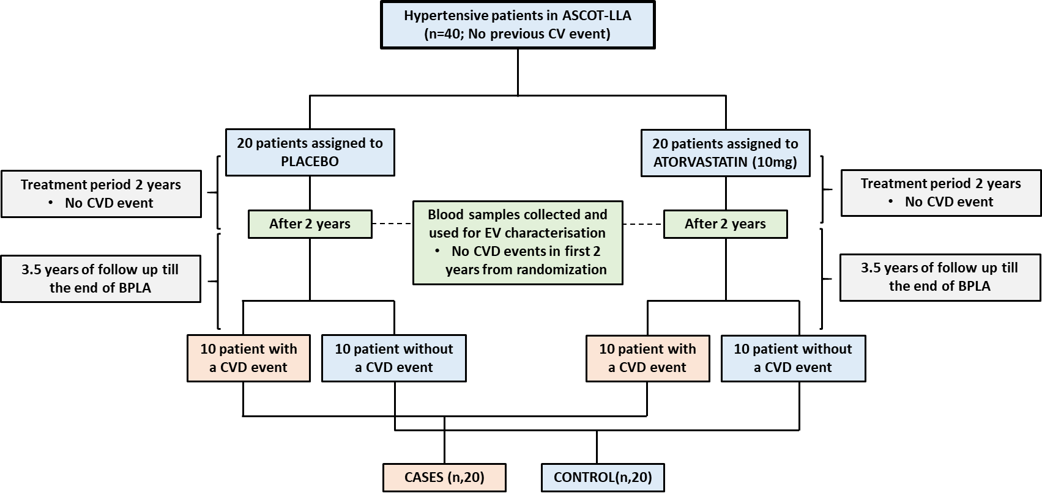

Figure S2. Characterization of monocyte EVs. Monocytes were isolated using the RosetteSep™ purification protocol. Cells (1x10⁶/ml) were incubated with vehicle (V) or TNF-α (50 ng/ml), in presence or absence of Iloprost (1 µM; PGI₂) for 60 min. EV generation in cell-free supernatants was quantified by nanoparticle tracking analysis as both size distribution of isolated EVs (a) and mean and mode of size (b). EV phenotypic characterization was quantified following the described gating strategy (c) and Bodipy staining for total vesicles with; monocyte CD14+ EVs ; platelet CD41+ EVs and double positive CD14/CD41+ vesicles were measured (d). (*p<0.05, **p<0.01, ***p< 0.001; one-way ANOVA post Bonferroni test, mean ± SEM, n=5 distinct preparations). (e) Western blot analysis of the vesicle showing positive controls Annexin A1 (AnxA1), CD9, negative control Calnexin (Cnxn) and loading control Actin-β1 (ACTB1) (f) Visualization of EVs by TEM. Representative of n=5 distinct cell preparations.

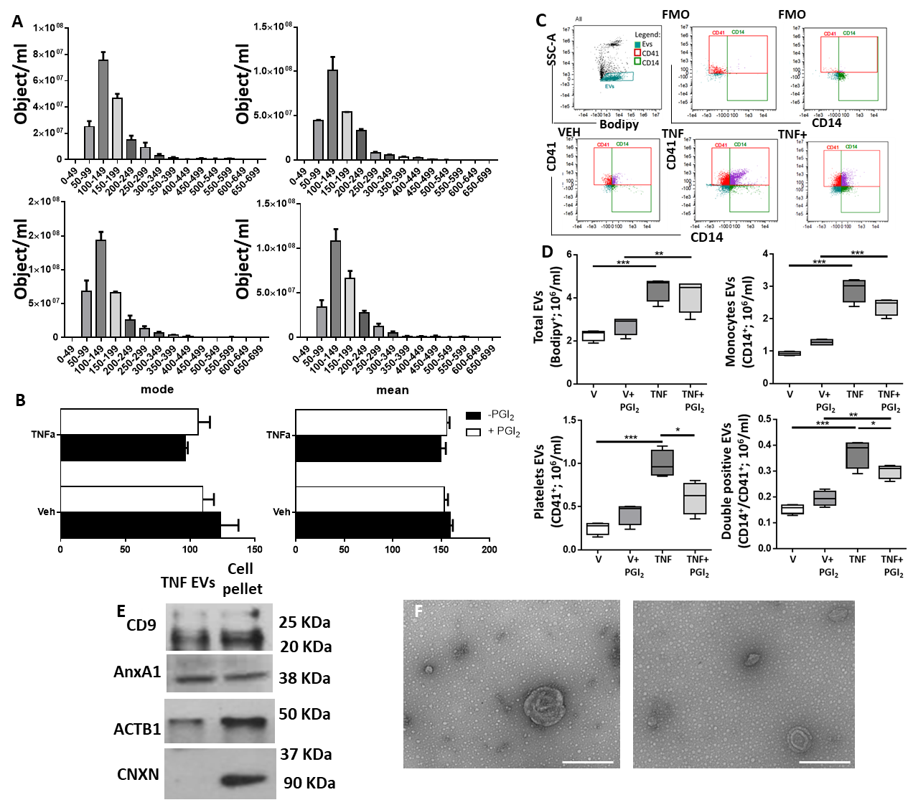
Supplementary Tables
Table S1. Baseline characteristics and investigated EV markers amongst hypertensive patients who did and did not have a major adverse CV event (MACE) during the median follow-up of 3.1 years.

Characteristic | Control* (N=20)* | Case (N=20)*
Age mean (SD), years | 69.94 (5.21) | 69.94 (5.23)
Female, n (%) | 8 (40) | 1 (5)
Male, n (%) | 12 (60) | 19 (95)
SBP mean (SD), mmHg | 167.25 (16.89) | 170.35 (14.46)
DBP mean (SD), mmHg | 89.20 (10.69) | 92.72 (11.57)
Total Cholesterol mean (SD), mmol/l | 5.73 (0.75) | 5.59 (0.72)
BMI mean (SD), kg/m² | 28.17 (3.83) | 27.70 (4.05)
Current smoker, n (%) | 10 (50) | 16 (80)
Diabetes status, n (%) | 3 (15) | 6 (30)
Randomised to amlodipine-based treatment, n (%) | 10 (50) | 6 (30)
EV markers
Mode median , nm | 155.80 | 142.20
CD14 median , objects x10⁵/mL | 6.80 | 14.20
CD146 median , objects x10⁵/mL | 15.65 | 18.40
CD14/CD41 median , objects x10⁵/mL | 2.34 | 4.65
CD14 median , | 1.11 | 1.22
CD146 median | 2.84 | 2.67
CD14/CD41 median | 0.31 | 0.51
Note: there is no missing data
* Cases are defined as those who had a MACE during a median 3.1 years of follow-up. Controls are matched for age, duration of treatment (n, 20) and statin/placebo treatment allocation, and did not have a MACE during follow-up

Table S2: descriptive analysis by LL allocation.
Characteristic | Placebo (N=20) | Atorvastatin (N=20)
Age mean (SD), years | 70.50 (5.52) | 69.38 (4.83)
Female, n (%) | 6 (30) | 3 (15)
Male, n (%) | 14 (70) | 17 (85)
SBP mean (SD), mmHg | 169.32 (12.49) | 168.28 (18.51)
DBP mean (SD), mmHg | 89.95 (9.84) | 91.97 (12.48)
Total Cholesterol mean (SD), mmol/l | 5.77 (0.88) | 5.55 (0.55)
BMI mean (SD), kg/m² | 27.37 (3.80) | 28.51 (4.01)
Current smoker, n (%) | 12 (60) | 14 (70)
Diabetes status, n (%) | 5 (25) | 4 (20)
Randomised to amlodipine-based treatment, n (%) | 8 (40) | 8 (40)
EV markers
Mode median, nm | 156 | 138.70
CD14+ median, objects 10⁵/mL | 7.37 | 8.37
CD146+ median, objects 10⁵/mL | 34.40 | 14.55
CD14+/CD41+ median, objects 10⁵/mL | 3.26 | 2.34
CD14+ median, % | 1.08 | 1.25
CD146+ median, % | 4.15 | 1.54
CD14+/CD41+ median, % | 0.51 | 0.21

Note: there are no missing data.

Table S3: Risk of MACE (odds ratios [95% CI]) with increase in one unit of EV markers stratified by allocation to placebo or a statin, interaction test.
EV marker | Placebo arm (n,20) |  | Statin arm (n,20) |  | Interaction p-value
 | odds ratio**  (95% CI) | p-value | odds ratio***  (95% CI) | p-value
Mode, per nm | 0.98 (0.95, 1.02) | 0.377 | 0.93 (0.85, 1.01) | 0.088 | 0.211
CD14+, log₂ (objects/mL)** | 6.35 (0.57, 70.93) | 0.133 | 2.94 (0.77, 11.21) | 0.115 | 0.584
CD146+, log₂ (objects/mL)** | 1.46 (0.75, 2.84) | 0.269 | 1.30 (0.45, 3.75) | 0.631 | 0.855
CD14+/CD41+, log₂ (objects/mL)* | 1.99 (0.87, 4.53) | 0.101 | 1.20 (0.82, 1.82) | 0.394 | 0.283
* Note that these variables have been transformed to log base 2, so a 1 unit increase represents a doubling of the variable on the original scale.
**risk of MACE for one unit raise amongst patient taking placebo
***risk of MACE for one unit raise amongst patient taking statin

Table S4: Difference in mean level of EV markers in plasma samples between statin treatment allocation groups of ASCOT patients.

EV marker | Difference in means placebo-statin in CONTROLS  (p-value from unpaired t-test) | Difference in means placebo-statin in CASES  (p-value from unpaired t-test) | Interaction p-value
Mode, nm | 12.26 (p=0.289) | 28.51 (p=0.017) | p=0.319
CD14, objects x10⁵/mL | 0.95 (p=0.913) | -13.19 (p=0.137) | p=0.256
CD146, objects x10⁵/mL | 9.97 (p=0.320) | 31.93 (p=0.003) | p=0.125
CD14/CD41, objects x10⁵/mL | 0.25 (p=0.951) | -2.69 (p=0.509) | p=0.609

Table S5 Mean differences in EV markers between cases and controls, or those allocated to atorvastatin or placebo, with further respective stratification using 2X2 factorial allocation.

Table S5a: Overall mean difference between case and control, and stratified mean levels amongst those on atorvastatin and placebo regardless of whether case or control.

EV marker | Case and control group analysis with overall mean differences, and using 2X2 stratification the mean differences between cases and control amongst those on statin or placebo
EV marker | Overall mean difference between cases/controls (n=40)* | Mean differences between cases and controls on those on atorvastatin (n,20) [10 each from cases and controls]* | Mean differences between cases and controls on those on placebo(n,20) [10 each from cases and controls]* | Interaction p-value
Mode, nm | -16.07 (p=0.055) | -25.97 (p=0.016) | -2.43 (p=0.839) | p=0.132
CD14, objects x10⁵/mL | 12.72 (p=0.070) | 19.58 (p=0.030) | 3.25 (p=0.749) | p=0.216
CD146, objects x10⁵/mL | 11.62 (p=0.159) | -0.11 (p=0.992) | 27.78 (p=0.023) | p=0.071
CD14/CD41, objects x10⁵/mL | 7.10 (p=0.025) | 8.81 (p=0.032) | 4.74 (p=0.309) | p=0.494

*Adjusted for age at baseline and sex

Table S5b : Overall mean difference between those allocated to atorvastatin or placebo, and stratified mean differences amongst those that are cases or control, regardless of whether previously allocated to statin or a placebo.
EV marker | Allocation to statin or placebo groups with overall mean differences, and using2X2 stratification, the average mean differences amongst those on statin and placebo amongst those who are cases or control
 | Overall mean difference between Statin/placebo(n=40)* | Mean difference between statin/placebo amongst cases (n,20) [10 each from those on statin and placebo]* | Mean difference between statin and placebo amongst those who are control (n,20) [10 each from those on statin and placebo]* | Interaction p-value
Mode, nm | -21.39 (p=0.007) | -32.32 (p=0.003) | -8.78 (p=0.430) | p=0.132
CD14, objects x10⁵/mL | 5.04 (p=0.431) | 12.62 (p=0.156) | -3.71 (p=0.694) | p=0.216
CD146, objects x10⁵/mL | -20.03 (p=0.011) | -32.98 (p=0.002) | -5.09 (p=0.641) | p=0.071
CD14/CD41, objects x10⁵/mL | 0.40 (p=0.889) | 2.29 (p=0.566) | -1.78 (p=0.678) | p=0.494

*Adjusted for age at baseline and sex

