Supplemental Materials:
Effect of IV Antihypertensives on Outcomes of Severe Hypertension in Hospitalized Patients without Acute Target Organ Damage
Lama Ghazi MD, PhDª, Fan Li PhD^{b}, Michael Simonov MDª, Yu Yamamoto MSª, James T. Nugent, MD, MPH^{a,c}, Jason H. Greenberg MD, MHS^{a,c}, Christine Y. Bakhoum, MD, MAS^{a,c}, Aldo Peixoto, MD^{d}*, F. Perry Wilson MD, MSCEª*
- Department of Internal Medicine, Clinical and Translational Research Accelerator, Yale University, New Haven, CT
- Department of Biostatistics, Yale School of Public Health, New Haven, CT
- Section of Nephrology, Department of Pediatrics, Yale University School of Medicine, New Haven, Connecticut
- Department of Internal Medicine, Section of Nephrology, Yale School of Medicine, and the Hypertension Program, Yale New Haven Hospital Heart and Vascular Center, New Haven, CT.
*These authors contributed equally to this work

Supplemental Materials:
Table S1: Common IV antihypertensives given over 3 hours from time of severe HTN development in the non-weighted population
Table S2: Inpatient outcomes for treated vs. untreated Patients by CVD admission status and treatment route
Table S3: Inpatient outcomes for treated vs. untreated patients by ward on admission
Table S4: Inpatient outcomes for treated vs. untreated patients by treatment route
Table S5: Inpatient Outcomes for Treated with IV Antihypertensives vs. Treated with Oral Antihypertensives
Table S6: Admission diagnosis groupings in the overall cohort and by treatment group
Table S7.A: Inpatient outcomes for treated vs. untreated patients by treatment route in patients admitted for cardiovascular and cerebrovascular disease based on admission ICD-10 codes
Table S7.B: Inpatient outcomes for treated vs. untreated patients by treatment route in patients admitted for fractures or injuries based on admission ICD-10 codes
Table S7.C. Inpatient outcomes for treated vs. untreated patients by treatment route in patients admitted for gastrointestinal and genitourinary disease based on admission ICD-10 codes
Table S7.D. Inpatient outcomes for treated vs. untreated patients by treatment route in patients admitted for infection based on admission ICD-10 codes
Table S7.E. Inpatient outcomes for treated vs. untreated patients by treatment route in patients admitted for kidney related disease based on admission ICD-10 codes
Table S7.F. Inpatient outcomes for treated vs. untreated patients by treatment route in patients admitted for neurological disease based on admission ICD-10 codes
Table S7.G. Inpatient outcomes for treated vs. untreated patients by treatment route in patients admitted for respiratory disease based on admission ICD-10 codes
Figure S1: Propensity score distribution in treated and untreated groups
Figure S2. Systolic blood pressure over 12 hours from time of severe inpatient hypertension development
Figure S3. Diastolic blood pressure over 12 hours from time of severe inpatient hypertension development

Table S1: Common IV antihypertensives given over 3 hours from time of severe HTN development in the non-weighted population
Within 3 hours of severe HTN development
IV medications (n=1,056)
Hydralazine | 667
Labetalol | 390
Metoprolol | 534
Nicardipine | 79
Number of IV meds among those who received IV meds | 2 [1, 4]
Numbers do not add up to 1,056 because some patients received more than 1 IV antihypertensive during 3 hours.

Table S2: Inpatient outcomes for treated vs. untreated Patients by CVD admission status and treatment route
 | Events in Treated | Events in Untreated | Unweighted crude HR [95% CI] | Overlap propensity weighted HR [95% CI]
CVD admissions (Total:6,525, 472 treated and 6,053 did not receive any treatment within 3 hours of severe inpatient hypertension)
Myocardial Injury
IV vs. no treatment | 42 (8.9%) | 417 (6.9%) | 1.31 [0.95, 1.80] | 1.27 [0.84, 1.90]
Stroke
IV vs. no treatment | 7 (1.5%) | 107 (1.8%) | 0.84 [0.39, 1.80] | 0.52 [0.21, 1.28]
AKI
IV vs. no treatment | 138 (29.2%) | 1,436 (23.7%) | 0.98 [0.82, 1.17] | 0.92 [0.73, 1.16]
Death
IV vs. no treatment | 24 (5.1%) | 121 (2.0%) | 1.08 [0.69, 1.67] | 0.91 [0.54, 1.53
 | Events in Treated | Events in Untreated | HR [95% CI]
Non- CVD admissions (Total:10,738, 587 treated and 10,151 did not receive any treatment within 3 hours of severe inpatient hypertension)
Myocardial Injury
IV vs. no treatment | 20 (3.4%) | 174 (1.7%) | 2.01 [1.26, 3.19] | 1.75 [0.94, 3.26]
Stroke
IV vs. no treatment | ----- | ----- | ----- | -----
AKI
IV vs. no treatment | 107 (18.2%) | 1,440 (14.2%) | 1.17 [0.96, 1.42] | 1.06 [0.79, 1.42]
Death
IV vs. no treatment | 4 (0.7%) | 87 (0.9%) | 1.18 [0.43, 3.26] | 0.92 [0.49, 1.74]
HR (Hazard Ratio) calculated while accounting for overlap propensity weights
95%CI: 95% confidence interval, CVD: cardiovascular disease
CVD admissions included patients who were admitted with cerebrovascular events, myocardial infarction, heart failure or abdominal aortic aneurysm. These are based on whether a new, not historical, ICD-10 code for any of these events during hospitalization was coded.
No stroke events following severe inpatient hypertension development in patients admitted for non-cardiovascular disease reasons

Table S3: Inpatient outcomes for treated vs. untreated patients by ward on admission
 | Events in Treated | Events in Untreated | Unweighted crude HR [95% CI] | Overlap propensity weighted HR [95% CI]
Medical ward (Total: 13,949, 750 treated and 13,199 did not receive any treatment within 3 hours of developing severe inpatient hypertension)
Myocardial Injury
IV vs. no treatment | 50 (6.7%) | 491 (3.7%) | 1.83 [1.37, 2.44] | 1.74 [1.17, 2.59]
Stroke
IV vs. no treatment | 3 (0.4%) | 79 (0.6%) | 0.67 [0.21, 2.12] | 0.42 [0.12, 1.43]
AKI
IV vs. no treatment | 179 (23.9%) | 2,326 (17.6%) | 1.09 [0.93, 1.26] | 0.99 [0.81, 1.22]
Death
IV vs. no treatment | 21 (2.8%) | 179 (1.4%) | 0.98 [0.62, 1.54] | 0.79 [0.41, 1.50]
 | Events in Treated | Events in Untreated | Unweighted crude HR [95% CI] | Overlap propensity weighted HR [95% CI]
Surgical ward (Total; 3,314, 309 treated and 3,005 did not receive any treatment within 3 hours of developing severe inpatient hypertension)
Myocardial Injury
IV vs. no treatment | 12 (3.9%) | 10 (3.3%) | 1.17 [0.64, 2.13] | 0.87 [0.44, 1.72]
Stroke
IV vs. no treatment | 4 (1.3%) | 28 (0.9%) | 1.39 [0.49, 3.96] | 1.14 [0.33, 3.95]
AKI
IV vs. no treatment | 66 (21.4%) | 550 (18.3%) | 0.99 [0.76, 1.28] | 0.92 [0.64, 1.33]
Death
IV vs. no treatment | 7 (2.3%) | 29 (1.0%) | 1.45 [0.63, 3.38] | 1.58 [0.80, 3.09]
HR (Hazard Ratio) calculated while accounting for overlap propensity weights
95%CI: 95% confidence interval, CVD: cardiovascular disease

Table S4: Inpatient outcomes for treated vs. untreated patients by treatment route*
 | Events in Treated | Events in Untreated | Unweighted crude HR [95% CI] | Overlap propensity weighted HR [95% CI]
Myocardial Injury
IV vs. no treatment or oral treatment | 62 (5.9%) | 693 (3.6%) | 1.66 ]1.27, 2.15] | 1.59 [1.13, 2.24]
Stroke
IV vs. no treatment or oral treatment | 7 (0.7%) | 126 (0.7%) | 1.01 [0.47, 2.17] | 0.69 [0.29, 1.61]
Acute Kidney Injury
IV vs. no treatment or oral treatment | 245 (23%) | 3,450 (17.9%) | 1.05 [0.92, 1.19] | 0.98 [0.82, 1.17]
Stroke
IV vs. no treatment or no treatment | 28 (2.6%) | 237 (1.2%) | 1.09 [0.74, 1.63] | 0.87 [0.49, 1.53]
HR (Hazard Ratio) calculated while accounting for overlap propensity weights
95%CI: 95% confidence interval, CVD: cardiovascular disease
*We compare events in patients treated with IV antihypertensives over 3 hours vs. those treated with oral only antihypertensives (no IV) or those who did not treatment over 3 hours. 1,059 were treated vs. 19,324 were not treated.

Table S5. Inpatient Outcomes for Treated with IV Antihypertensives vs. Treated with Oral Antihypertensives
 | Events in Treated with IV Antihypertensives Only | Events in Treated with Oral Antihypertensives Only | Unweighted crude HR [95% CI] | Overlap propensity weighted HR [95% CI]
Myocardial Injury
IV vs. oral | 46 (5.1%) | 102 (3.3%) | 1.57 [1.11, 2.22] | 1.91 [1.16, 3.16]
Stroke
IV vs. oral | 4 (0.4%) | 19 (0.6%) | 0.72 [0.25, 2.13] | 0.29 [0.09, 0.92]
Acute Kidney Injury
IV vs. oral | 189 (20.8%) | 574 (18.4%) | 0.95 [0.80, 1.12] | 0.91 [0.74, 1.10]
Death
IV vs. oral | 25 (2.8%) | 29 (0.9%) | 1.20 [0.69, 2.09] | 0.94 [0.48, 1.85]
IV: intravenous
Hazard Ratio (HR) calculated while accounting for overlap propensity weights
95%CI: 95% confidence interval
We compare events in patients treated with IV antihypertensives (only) over 3 hours vs. those treated with oral only antihypertensives (no IV) over 3 hours. 908 were treated with IV antihypertensives vs. 3,120 were treated with oral only antihypertensives.

Table S6. Admission diagnosis groupings in the overall cohort and by treatment group
Diagnosis Grouping | Overall  n=17,623 | Treated with IV  n=1,081 | Untreated  n=16,542
Acquired absence of limb or organ | 9 (0.1) | 0 (0) | 9 (0.1)
Cardiovascular and cerebrovascular | 2,427 (13.8) | 250 (23.1) | 2,177 (13.2)
Dermatological | 158 (0.9) | 7 (0.6) | 151 (0.9)
Endocrine | 628 (3.6) | 39 (3.6) | 589 (3.6)
External exposure | 60 (0.3) | 1 (0.1) | 59 (0.4)
Fracture or injury | 960 (5.4) | 55 (5.1) | 905 (5.5)
Gastrointestinal and genitourinary | 2,150 (12.2) | 138 (12.8) | 2,012 (12.2)
HEENT | 66 (0.4) | 3 (0.3) | 63 (0.4)
Hematologic | 536 (3) | 27 (2.5) | 509 (3.1)
Infection | 2,537 (14.4) | 130 (12) | 2,407 (14.6)
Kidney related | 1,594 (9) | 87 (8) | 1,507 (9.1)
Miscellaneous | 1,217 (6.9) | 66 (6.1) | 1,151 (7)
Musculoskeletal and rheumatological disorders | 428 (2.4) | 16 (1.5) | 412 (2.5)
Neoplasms | 574 (3.3) | 43 (4) | 531 (3.2)
Neurological | 1,479 (8.4) | 110 (10.2) | 1,369 (8.3)
Pain | 254 (1.4) | 11 (1) | 243 (1.5)
Post procedure complications | 267 (1.5) | 15 (1.4) | 252 (1.5)
Psychological | 296 (1.7) | 3 (0.3) | 293 (1.8)
Respiratory | 1,386 (7.9) | 57 (5.3) | 1,329 (8)
Substance abuse | 485 (2.8) | 13 (1.2) | 472 (2.9)
Missing | 112 (0.6) | 10 (0.9) | 102 (0.6)

Table S7.A. Inpatient outcomes for treated vs. untreated patients by treatment route in patients admitted for cardiovascular and cerebrovascular disease based on admission ICD-10 codes
 | Events in Treated (treated n=250) | Events in Untreated (untreated n=2,177) | Unweighted crude HR [95% CI] | Overlap propensity weighted HR [95% CI]
Cardiovascular and cerebrovascular
Myocardial Injury
IV vs. no treatment | 24 (9.6%) | 161 (7.4%) | 1.32 [0.86, 2.03] | 1.43 [0.81, 2.53]
Stroke
IV vs. no treatment | 1 (0.4%) | 25 (1.1%) | 0.35 [0.05, 2.56] | 0.11 [0.02, 0.85]
Acute Kidney Injury
IV vs. no treatment | 64 (25.6%) | 435 (20%) | 0.87 [0.67, 1.14] | 0.84 [0.61, 1.14]
Death
IV vs. no treatment | 10 (4%) | 30 (1.4%) | 1.08 [0.52, 2.24] | 1.26 [0.68, 2.34]
Table S7.B. Inpatient outcomes for treated vs. untreated patients by treatment route in patients admitted for fractures or injuries based on admission ICD-10 codes
 | Events in Treated (treated n=55) | Events in Untreated  (untreated n=905) | Unweighted crude HR [95% CI] | Overlap propensity weighted HR [95% CI]
Fracture or injury
Myocardial Injury
IV vs. no treatment | 2 (4%) | 32 (3.5%) | 1.04 [0.25, 4.33] | 0.47 [0.09, 2.57]
Stroke
IV vs. no treatment | 3 (0.3%) | 0 (0%) | --------- | ---------
Acute Kidney Injury
IV vs. no treatment | 10 (18.2%) | 152 (16.8%) | 0.70 [0.37, 1.34] | 0.64 [0.38, 1.06]
Death
IV vs. no treatment | 1 (1.8%) | 5 (0.6%) | 0.59 [0.06, 5.66] | 0.29 [0.04, 1.91]

Table S7.C. Inpatient outcomes for treated vs. untreated patients by treatment route in patients admitted for gastrointestinal and genitourinary disease based on admission ICD-10 codes
 | Events in Treated (treated n=138) | Events in Untreated (untreated n=2,012) | Unweighted crude HR [95% CI] | Overlap propensity weighted HR [95% CI]
Gastrointestinal and genitourinary
Myocardial Injury
IV vs. no treatment | 55 (2.7%) | 4 (2.9%) | 1.06 [0.39, 2.94] | 0.82 [0.29, 2.35]
Stroke
IV vs. no treatment | 1 (0.7%) | 14 (0.7%) | 1.04 [0.14, 7.93] | 0.39 [0.06, 2.99]
Acute Kidney Injury
IV vs. no treatment | 25 (18.1%) | 376 (18.7%) | 1.46 [0.94, 2.26] | 1.69 [1.06, 2.69]
Death
IV vs. no treatment | 1 (0.7%) | 16 (0.8%) | 0.59 [0.08, 4.57] | 0.39 [0.16, 0.99]

Table S7.D. Inpatient outcomes for treated vs. untreated patients by treatment route in patients admitted for infection based on admission ICD-10 codes
 | Events in Treated (treated n=130) | Events in Untreated (untreated n=2,407) | Unweighted crude HR [95% CI] | Overlap propensity weighted HR [95% CI]
Infection
Myocardial Injury
IV vs. no treatment | 8 (6.2%) | 66 (2.7%) | 2.27 [1.09, 4.73] | 2.05 [0.75, 5.61]
Stroke
IV vs. no treatment | 1 (0.8%) | 11 (0.5%) | 1.69 [0.22, 13.1] | 1.59 [0.21, 12.32]
Acute Kidney Injury
IV vs. no treatment | 28 (21.5%) | 383 (15.9%) | 0.96 [0.67, 1.36] | 0.90 [0.57, 1.41]
Death
IV vs. no treatment | 7 (5.4%) | 35 (1.5%) | 1.29 [0.62, 2.65] | 1.03 [0.49, 2.12]

Table S7.E. Inpatient outcomes for treated vs. untreated patients by treatment route in patients admitted for kidney related disease based on admission ICD-10 codes
 | Events in Treated (treated n=87) | Events in Untreated (untreated n=1,507) | Unweighted crude HR [95% CI] | Overlap propensity weighted HR [95% CI]
Kidney related
Myocardial Injury
IV vs. no treatment | 2 (2.3%) | 52 (3.5%) | 0.67 [0.16, 2.75] | 0.43 [0.08, 2.21]
Stroke
IV vs. no treatment | 1 (1.1%) | 12 (0.8%) | 1.44 [0.19, 11.08] | 0.83 [0.11, 6.39]
Acute Kidney Injury
IV vs. no treatment | 29 (33.3%) | 350 (23.2%) | 1.55 [1.06, 2.27] | 1.57 [1.03, 2.39]
Death
IV vs. no treatment | 3 (3.4%) | 27 (1.8%) | 0.97 [0.29, 3.31] | 0.87 [0.39, 1.90]

Table S7.F. Inpatient outcomes for treated vs. untreated patients by treatment route in patients admitted for neurological disease based on admission ICD-10 codes
 | Events in Treated (treated n=110) | Events in Untreated (untreated n=1,369) | Unweighted crude HR [95% CI] | Overlap propensity weighted HR [95% CI]
Neurological
Myocardial Injury
IV vs. no treatment | 9 (8.2%) | 39 (2.8%) | 2.95 [1.35, 6.44] | 3.13 [1.32, 7.48]
Stroke
IV vs. no treatment | 1 (0.9%) | 9 (0.7%) | 1.39 [0.18, 10.98] | 2.15 [0.28, 16.83]
Acute Kidney Injury
IV vs. no treatment | 22 (20%) | 184 (13.4%) | 0.79 [0.46, 1.37] | 0.68 [0.39, 1.18]
Death
IV vs. no treatment | 0 (0%) | 22 (1.6%) | --------- | ---------

Table S7.G. Inpatient outcomes for treated vs. untreated patients by treatment route in patients admitted for respiratory disease based on admission ICD-10 codes
 | Events in Treated (treated n=110) | Events in Untreated Only (untreated n=1,369) | Unweighted crude HR [95% CI] | Overlap propensity weighted HR [95% CI]
Respiratory
Myocardial Injury
IV vs. no treatment | 9 (8.2%) | 39 (2.8%) | 2.95 [1.35, 6.44] | 3.14 [1.32, 7.48]
Stroke
IV vs. no treatment | 9 (0.7%) | 1 (0.9%) | 1.39 [0.18, 10.98] | 2.15 [0.28, 16.83]
Acute Kidney Injury
IV vs. no treatment | 22 (20.0%) | 184 (13.4%) | 0.79 [0.46, 1.37] | 0.68 [0.39, 1.18]
Death
IV vs. no treatment | 0 (0%) | 22 (1.6%) | --------- | ---------

Figure S1: Propensity score distribution in treated and untreated groups
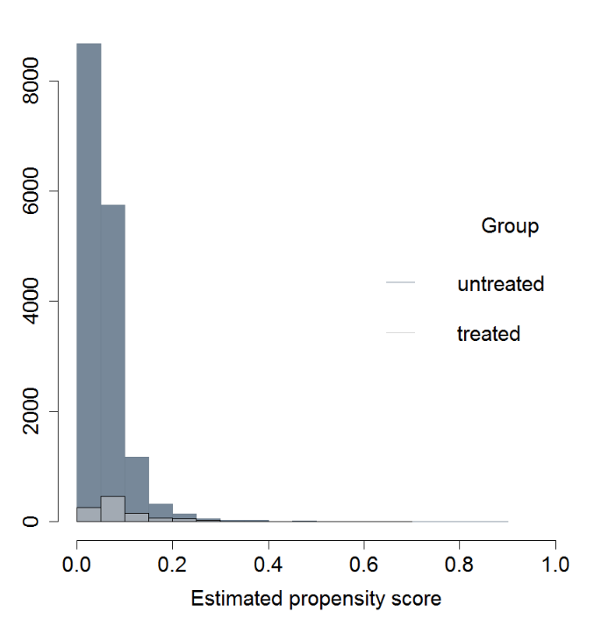
Estimated propensity score

Dark grey shading refers to untreated severe hypertension patients
Light grey shading refers to treated severe hypertension patients

Figure S2. Systolic blood pressure over 12 hours from time of severe inpatient hypertension development
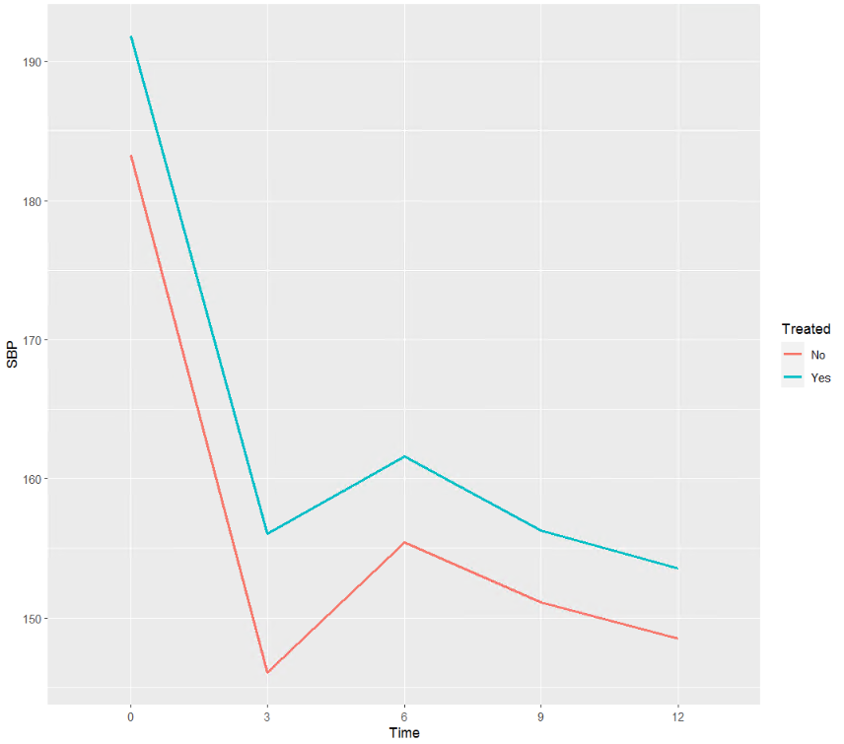
Time: 0 refers to time of severe hypertension development.
Treated: “No” refers to NOT being treated with IV antihypertensives within 3 hours of developing severe hypertension (in orange) and “Yes” refers to being treated with IV antihypertensives within 3 hours of developing severe hypertension (in blue)

Figure S3. Diastolic blood pressure over 12 hours from time of severe inpatient hypertension development
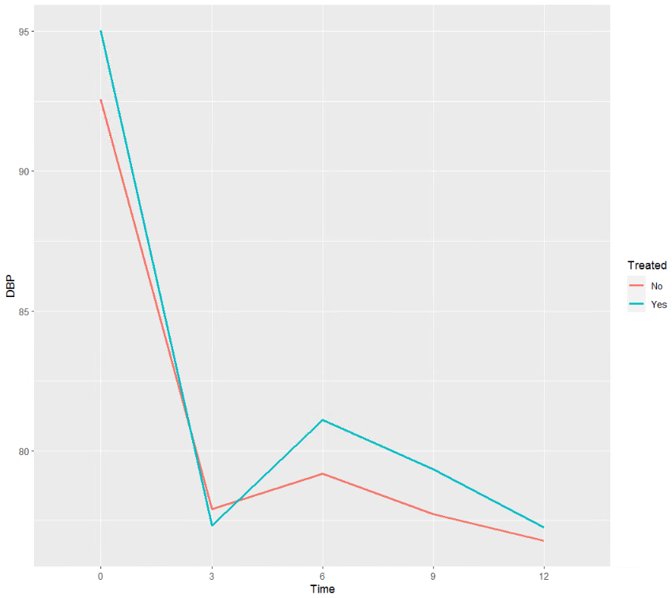

Time: 0 refers to time of severe hypertension development.
Treated: “No” refers to NOT being treated with IV antihypertensives within 3 hours of developing severe hypertension (in orange) and “Yes” refers to being treated with IV antihypertensives within 3 hours of developing severe hypertension (in blue)

