Supplemental Figure 1. Bland-Altman plots for daytime SBP/DBP.

- SBP difference between Fixed time wide and Actigraphy
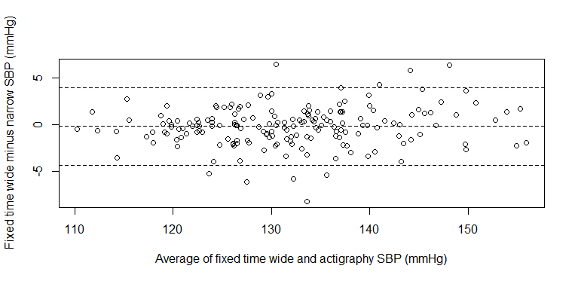
*Beta-coefficients = 0.031, p = 0.067; 95% limit of agreement is -4.30 to 3.96 mmHg

- DBP difference between Fixed time wide and Actigraphy
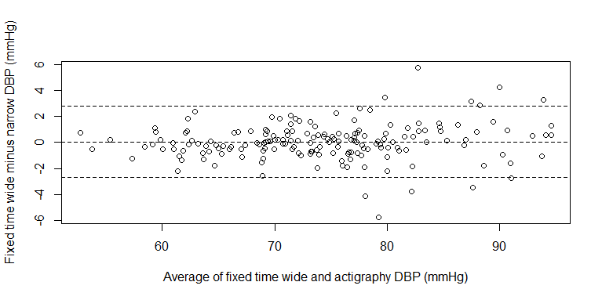
*Beta-coefficients = 0.018, p = 0.120; 95% limit of agreement is -2.68 to 2.76 mmHg

- SBP difference between Fixed time narrow and Actigraphy
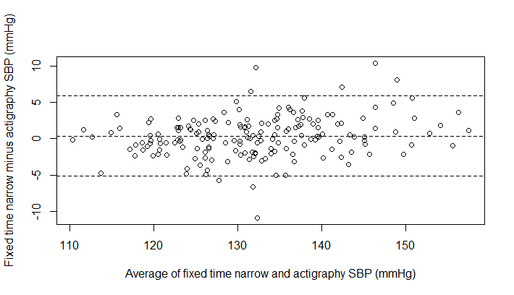
*Beta-coefficients = 0.07, p = 0.001; 95% limit of agreement is -5.17 to 5.90 mmHg

- DBP difference between Fixed time narrow and Actigraphy
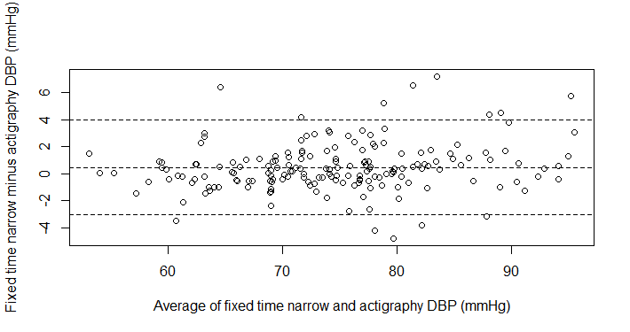
*Beta-coefficients = 0.037, p = 0.014; 95% limit of agreement is -3.04 to 4.00 mmHg

- SBP difference between Diary and Actigraphy
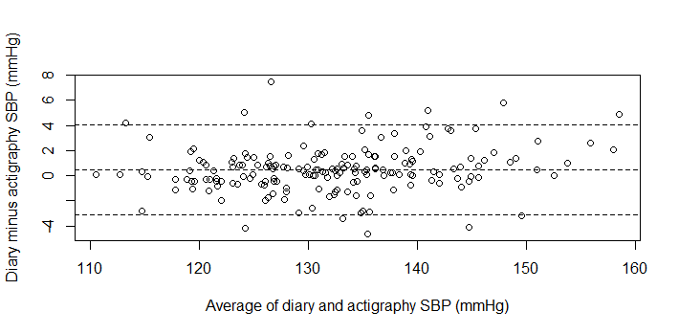
*Beta-coefficients = 0.036, p = 0.014; 95% limit of agreement is -3.11 to 4.06 mmHg

- DBP difference between Diary and Actigraphy
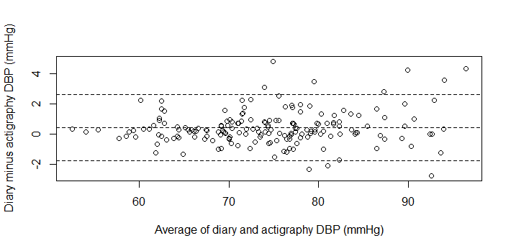
*Beta-coefficients = 0.017, p = 0.071; 95% limit of agreement is -1.78 to 2.58 mmHg

- SBP difference between Fixed time wide and Fixed time narrow
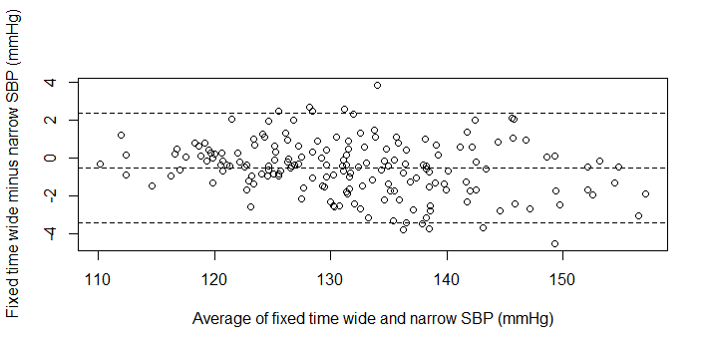
*Beta-coefficients = -0.039, p < 0.001; 95% limit of agreement is -3.41 to 2.34 mmHg

- DBP difference between Fixed time wide and Fixed time narrow
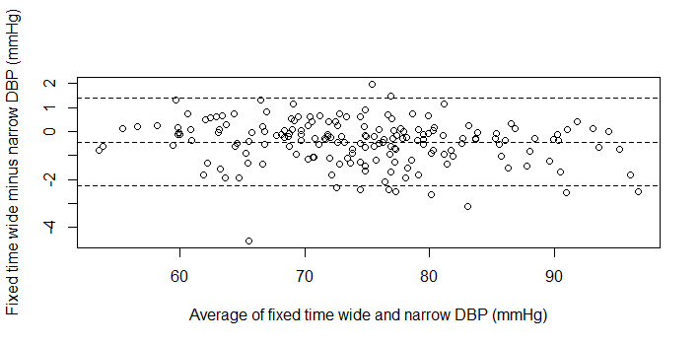
*Beta-coefficients = -0.018, p = 0.016; 95% limit of agreement is -2.26 to 1.38 mmHg

- SBP difference between Fixed time wide and Diary
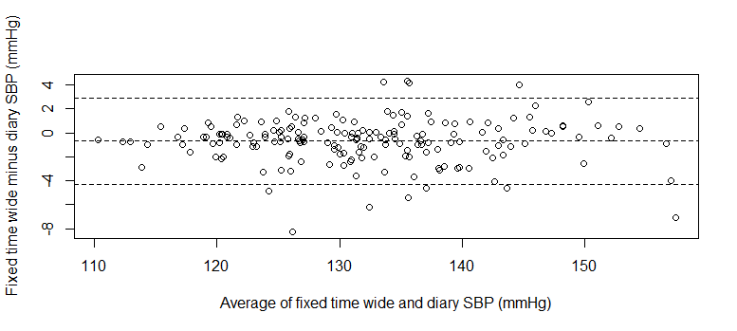
*Beta-coefficients = -0.004, p = 0.799; 95% limit of agreement is -4.28 to 2.90 mmHg

- DBP difference between Fixed time wide and Diary
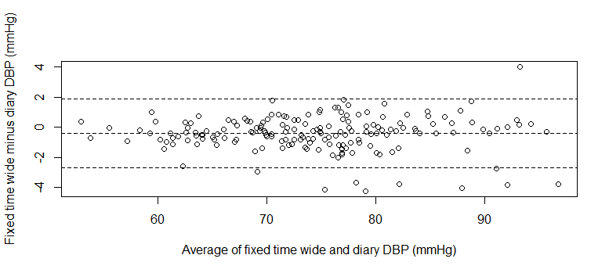
*Beta-coefficients = -0.002, p = 0.873; 95% limit of agreement is -2.68 to 1.87 mmHg

- SBP difference between Fixed time narrow and Diary
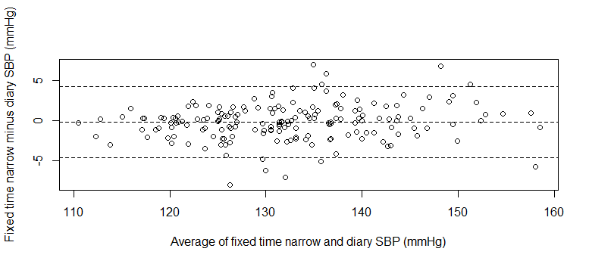
*Beta-coefficients = 0.035, p = 0.044; 95% limit of agreement is -4.61 to 4.28mmHg

- DBP difference between Fixed time narrow and Diary
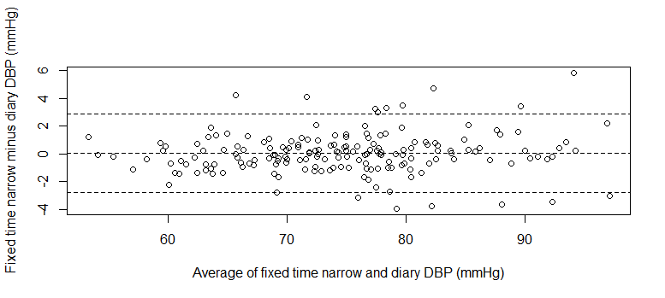
*Beta-coefficients = 0.016, p = 0.189; 95% limit of agreement is -2.82 to 2.89 mmHg

