Supplementary Table 1
 | OH including SBP < 90 mmHg |  | P
 | Yes | No
Age | 58 (4.4) | 57.4 (4.3) | 0.149
Male sex % | 40.3 % | 46.8 % | 0.172
BMI | 26 (3.9) | 27 (4.4) | 0.007
Weight (kg) | 77 (15.4) | 80 (15.7) | 0.035
Height (cm) | 171.6 (9.1) | 171.6 (9.7) | 0.985
WC (cm) | 91.5 (12) | 94.9 ( 12.7) | 0.004
RHR (bpm) | 60 (10) | 61 (9) | 0.567
SBP (mmHg) | 128 (26) | 123 ( 16) | 0.001
DBP (mmHg) | 77 (14) | 76 (10) | 0.816
PP (mmHg) | 51 (15) | 46 (10) | 0.000
CACS ª | 2 (57) | 0 (27) | 0.022
PWV | 8.2 (1.5) | 8.3 (1.3) | 0.375
Pack-years | 28 (31) | 27 (34) | 0.902
Hemoglobin | 140 (13) | 143 (12) | 0.037
Creatinine | 76 (14) | 77 (15) | 0.235
Triglycerides | 1.1 (0.7) | 1.3 (0.8) | 0.052
Cholesterol | 5.4 (1) | 5.5 (1) | 0.260
HDL | 1.8 (0.6) | 1.7 (0.5) | 0.079
LDL | 3.5 (0.9) | 3.6 (0.9) | 0.141
Chol/HDL | 3.3 (1.2) | 3.6 (1.3) | 0.043
CRP | 1.9 (3.2) | 2.4 (4.4) | 0.278
HbA1c | 38 (12) | 37 (7) | 0.022
Glucose | 5.7 (1.9) | 5.5 (1.2) | 0.262
DM | 7.7 % | 8.5 % | 0.393
Smoking | 10.5 % | 14.9 % | 0.201
HTD treatment | 19.4 % | 20 % | 0.915
Legend:
Values expressed are means (±SD) or percentages.
ª expressed as median and 3rd quartile due to skewed distribution.
OH: Orthostatic hypotension; WC: Waist circumference; RHR: Resting heart rate; Bpm: Beats per minute; SBP: Systolic blood pressure; DBP: Diastolic blood pressure; PP: Pulse pressure; CACS: Coronary artery calcification score; PWV: Pulse wave velocity; Chol: Cholesterol; DM: Diabetes; HTD: Hypertensive drug.

Supplementary figure 1: The distribution of body mass index in the study population.
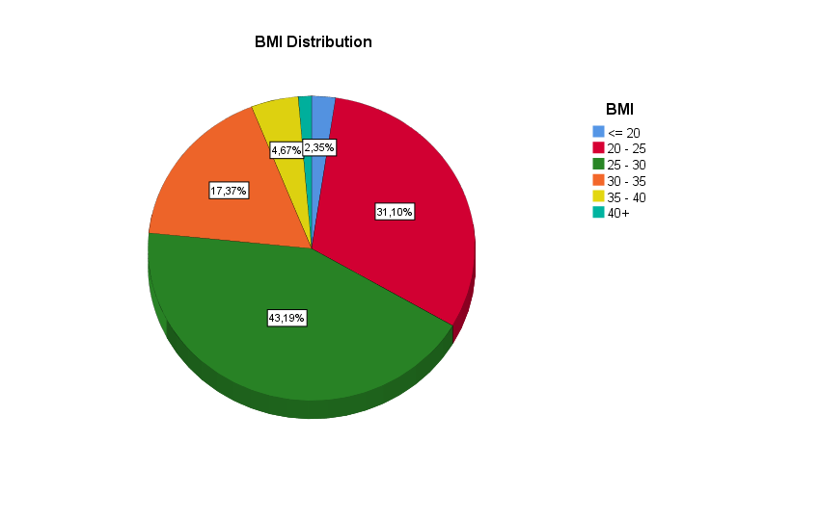

Supplementary figures 2A-D: Relations between hemodynamic parameters and cardiovascular risk factors.

