Supplemental Figure 2. Bland-Altman plots for nighttime SBP/DBP:

- SBP difference between Fixed time wide and Actigraphy
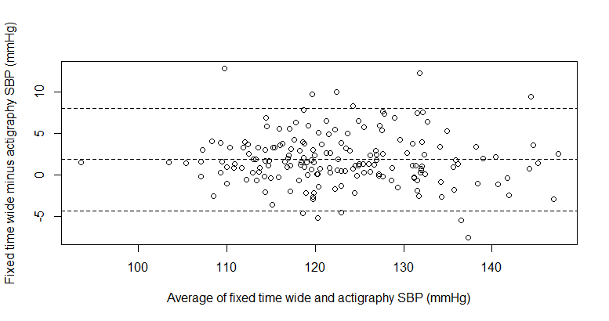
*Beta-coefficients = -0.019, p = 0.442; 95% limit of agreement is -4.33 to 8.07 mmHg

- DBP difference between Fixed time wide and Actigraphy
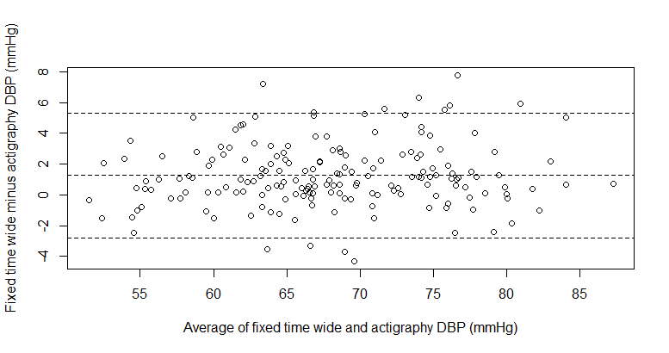
*Beta-coefficients = 0.026, p = 0.206; 95% limit of agreement is -2.80 to 5.34mmHg

- SBP difference between Fixed time narrow and Actigraphy
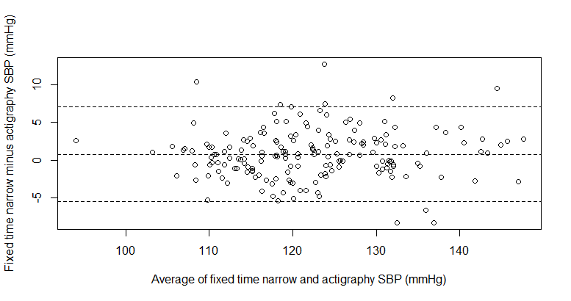
*Beta-coefficients = 0.019, p = 0.459; 95% limit of agreement is -5.57 to 7.12 mmHg

- DBP difference between Fixed time narrow and Actigraphy
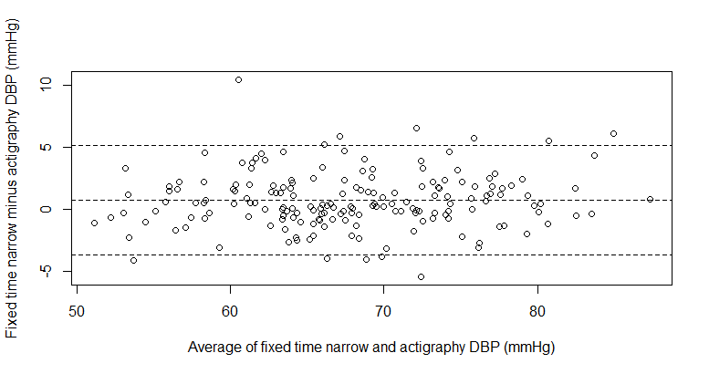
*Beta-coefficients = 0.023, p = 0.301; 95% limit of agreement is -3.70 to 5.12 mmHg

- SBP difference between Diary and Actigraphy
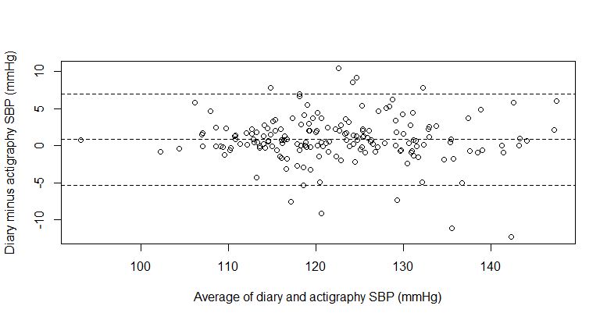
*Beta-coefficients = -0.015, p = 0.532; 95% limit of agreement is -5.29 to 6.97 mmHg

- DBP difference between Diary and Actigraphy
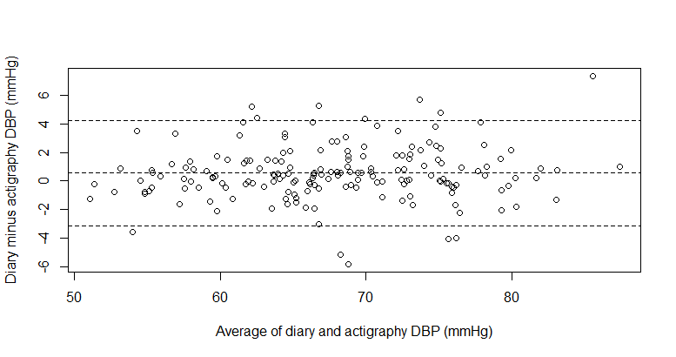
*Beta-coefficients = 0.024, p = 0.206; 95% limit of agreement is -3.15 to 4.28 mmHg

- SBP difference between Fixed time wide and Fixed time narrow
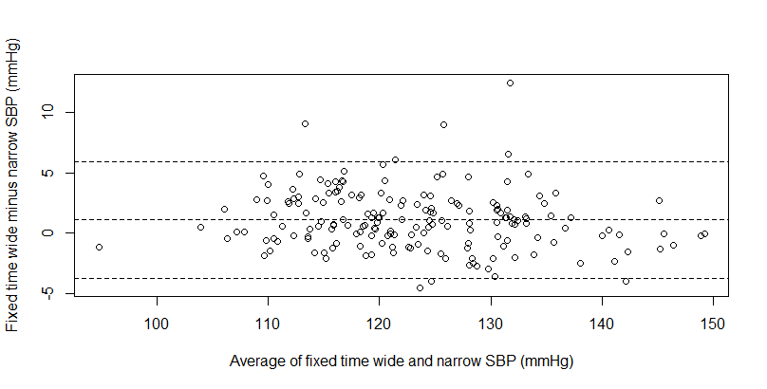
*Beta-coefficients = -0.037, p = 0.049; 95% limit of agreement is -3.71 to 5.90 mmHg

- DBP difference between Fixed time wide and Fixed time narrow
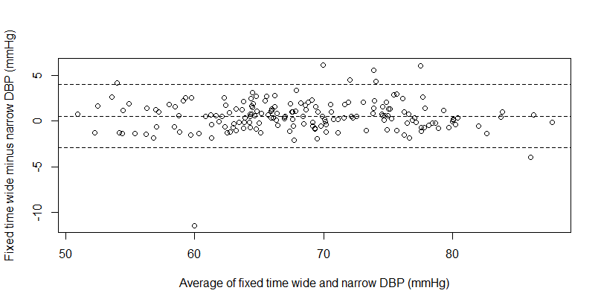
*Beta-coefficients = 0.003, p = 0.865; 95% limit of agreement is -2.93 to 4.04 mmHg

- SBP difference between Fixed time wide and Diary
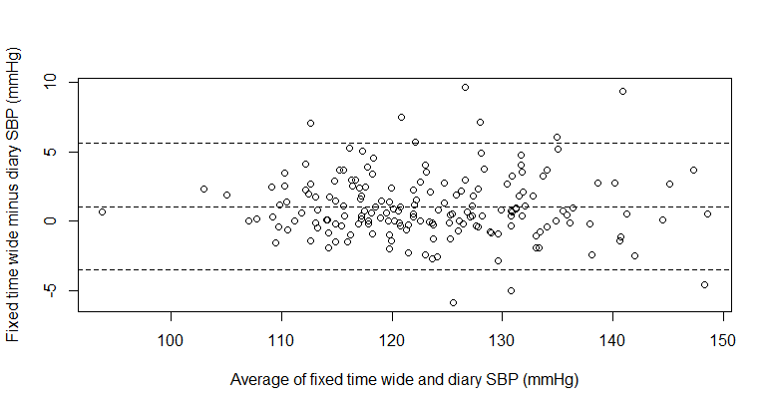
*Beta-coefficients = -0.008, p = 0.681; 95% limit of agreement is -3.51 to 5.61mmHg

- DBP difference between Fixed time wide and Diary
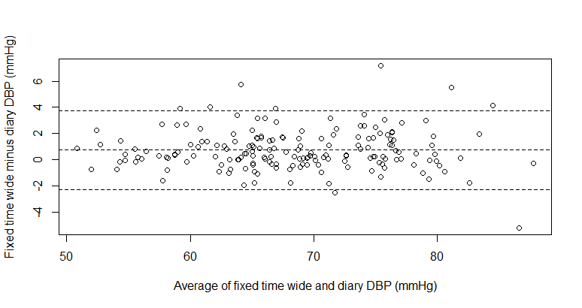
*Beta-coefficients = 0.0002, p = 0.988; 95% limit of agreement is -2.29 to 3.75 mmHg

- SBP difference between Fixed time narrow and Diary
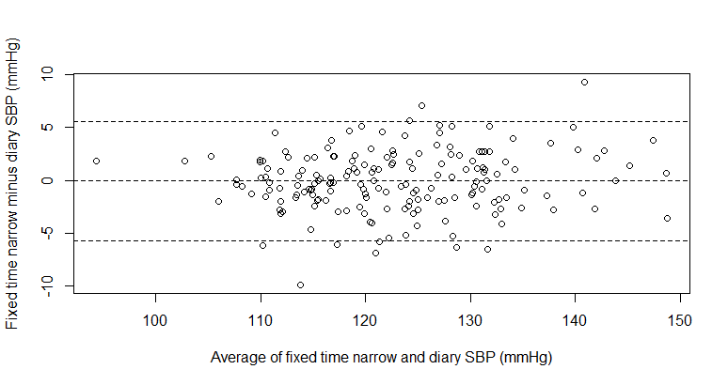
*Beta-coefficients = 0.032, p = 0.160; 95% limit of agreement is -5.70 to 5.59 mmHg

- DBP difference between Fixed time narrow and Diary
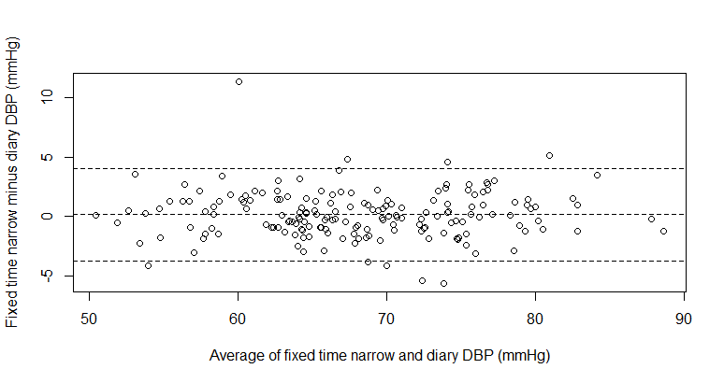
*Beta-coefficients = -0.001, p = 0.942; 95% limit of agreement is -3.74 to 4.06 mmHg

