Table S1: Relevant terms for Search Strategy
Category | Search Terms
Population | African filter((((Angola[tw] OR Benin[tw] OR Botswana[tw] OR “Burkina Faso”[tw] OR Burundi[tw] OR Cameroon[tw] OR “Cape Verde”[tw] OR “Central African Republic”[tw] OR Chad[tw] OR Comoros[tw] OR Congo[tw] OR “Democratic Republic of Congo”[tw] OR Djibouti[tw] OR “Equatorial Guinea”[tw] OR Eritrea[tw] OR Ethiopia[tw] OR Gabon[tw] OR Gambia[tw] OR Ghana[tw] OR Guinea[tw] OR “Guinea Bissau”[tw] OR “Ivory Coast”[tw] OR “Cote d’Ivoire”[tw] OR Kenya[tw] OR Lesotho[tw] OR Liberia[tw] OR Madagascar[tw] OR Malawi[tw] OR Mali[tw] OR Mauritania[tw] OR Mauritius[tw] OR Mozambique[tw] OR Namibia[tw] OR Niger [tw] OR Nigeria[tw] OR Principe[tw] OR Reunion[tw] OR Rwanda[tw] OR “Sao Tome”[tw] OR Senegal[tw] OR Seychelles[tw] OR “Sierra Leone”[tw] OR Somalia[tw] OR “South Africa”[tw] OR Sudan[tw] OR Swaziland[tw]OR Tanzania[tw] OR Togo[tw] OR Uganda[tw] OR “Western Sahara”[tw] OR Zambia[tw] OR Zimbabwe[tw]OR “Central Africa”[tw] OR “Central African”[tw] OR “West Africa”[tw] OR “West African”[tw] OR “Western Africa”[tw] OR “Western African”[tw] OR “East Africa”[tw] OR “East African”[tw] OR “Eastern Africa”[tw] OR“Eastern African”[tw] OR “South African”[tw] OR “Southern Africa”[tw] OR “Southern African”[tw] OR “subSaharan Africa”[tw] OR “sub Saharan African”[tw] OR “subSaharan Africa”[tw] OR “subSaharan African”[tw] NOT “guinea pig” [tw] NOT “guinea pigs” [tw] NOT “aspergillus niger” [tw]))))  (("Africa South of the Sahara"[Mesh] OR "Sub-Saharan Africa" OR "Subsaharan Africa" OR "Africa, Sub-Saharan" OR "Africa" OR "African" OR "West Africa" OR "Central Africa" OR "East Africa" OR "West Africa" OR "Southern Africa")
Exposure | AND ("Hypertension"[Mesh] OR "Blood Pressure, High" OR "Blood Pressures, High" OR "High Blood Pressure" OR "High Blood Pressures" OR "Blood Pressure")AND ("Life Style"[Mesh] OR "Life Style" OR "Life Styles" OR "Lifestyle" OR "Lifestyles" OR "Diet"[Mesh] OR "Diet Therapy"[Mesh] OR "Diet" OR "diet therapy" OR "Sodium Restriction" OR "salt Restriction" OR "low Sodium" OR "low salt" OR "fat Restriction" OR "low fat" OR "Carbohydrate Restriction" OR "low carb" OR "Caloric Restriction" OR "Food, Formulated" OR "Formulated Food" OR "dietary" OR "Weight Loss"[Mesh] OR "weight loss" OR "losing weight" OR "Weight Reduction" OR "Dietary Approach to Stop hypertension (DASH)" OR "DASH Diet" OR "Mediterranean Dietary patterns" OR "Mediterranean Diet" OR "Low Carbohydrate Diet" OR "low carb diet" OR "high protein Diet" OR "Vegetarian Diet" OR "Low Sodium Diet" OR "Low Glycemic Index Diet" OR "Low Glycemic Load" OR "Paleolithic diet" OR "Paleo Diet" OR "Disease Management"[Mesh] OR "Disease Management" OR "Social Support"[Mesh] OR "Social Support" OR "Social Network" OR "Tobacco Use Cessation"[Mesh] OR "Tobacco Use Cessation" OR "Smoking cessation" OR "Tobacco Cessation" OR "Cessation, Tobacco" OR "Alcohol Drinking"[Mesh] OR "Drinking Alcohol" OR "Alcohol Drinking Habits" OR "Alcohol Drinking Habit" OR "Alcohol Consumption" OR "Consumption, Alcohol" OR "Alcohol" OR "non pharmacol" OR "non pharmacological" OR "magnesium"))
Outcomes | AND ("heart diseases"[Mesh] OR "Heart Disease" OR "Cardiac Diseases" OR "Cardiac Disease" OR "Cardiac Disorders" OR "Cardiac Disorder" OR "Heart Disorders" OR "Heart Disorder" OR "cardiovascular disease" OR "CVD") OR Lipids OR Cholesterol OR Hyperlipidemia OR Hypertriglyceridemia OR Adiposity OR Hyperglycemia OR Diabetes OR glycemia OR Metabolic syndrome

Table S2: Bias reporting in the studies for the meta-analysis

Author and Date | Study Type | Sample Size Calculation | Randomization  Selection bias) | Allocation concealment  (Selection bias) | Blinding of participants and personnel | Blinding outcome | Incomplete  Outcome  (Attrition bias) | Selective reporting  (Reporting bias) | Overall Risk of Bias
Siervo et al 2020 | Randomized controlled feasibility trial | Some concerns | Yes  Block randomization  (Low risk) | Yes  (Low risk) | Yes | Yes | Not likely  (Low risk) | Not likely | Some concerns
Schouw et al 2020 | Before and after study | Yes | Incomplete Only at initial selection of participants  (High-risk) | No  (high-risk) | No | No | Yes | Not likely | Some concerns
Babiker et al | Randomized, double blinded, placebo-controlled trial | No information | Yes  (Low risk) | Yes  (Low risk) | Yes | Yes | Not likely  low risk | Not likely | Some concern
Charlton et al | Randomized control trial | Yes | Yes  (Low risk) | Yes  (Low risk) | Yes | Yes | No | Not likely | Low
Cappuccio et al | Community based clustered randomized trial | Yes | Incomplete randomization  Block and then stratified  (High risk not completed) | Likely  (high-risk) | No | No | Likely  (High-risk) | Likely  (high-risk) | Some concerns
Forrester et al | RCT with crossover design | No information | Yes  (Low risk) | Not likely | Not likely | Not likely | Some concerns | Not likely | Some concerns

Figure S1: Funnel Plots for the Metanalysis showing Mean Differences for Systolic and Diastolic Blood Pressure Measurements for Lifestyle Interventions for Blood Pressure in sub-Saharan Africa
Figure S1A: Funnel Plot for Systolic Blood Pressure Measurement
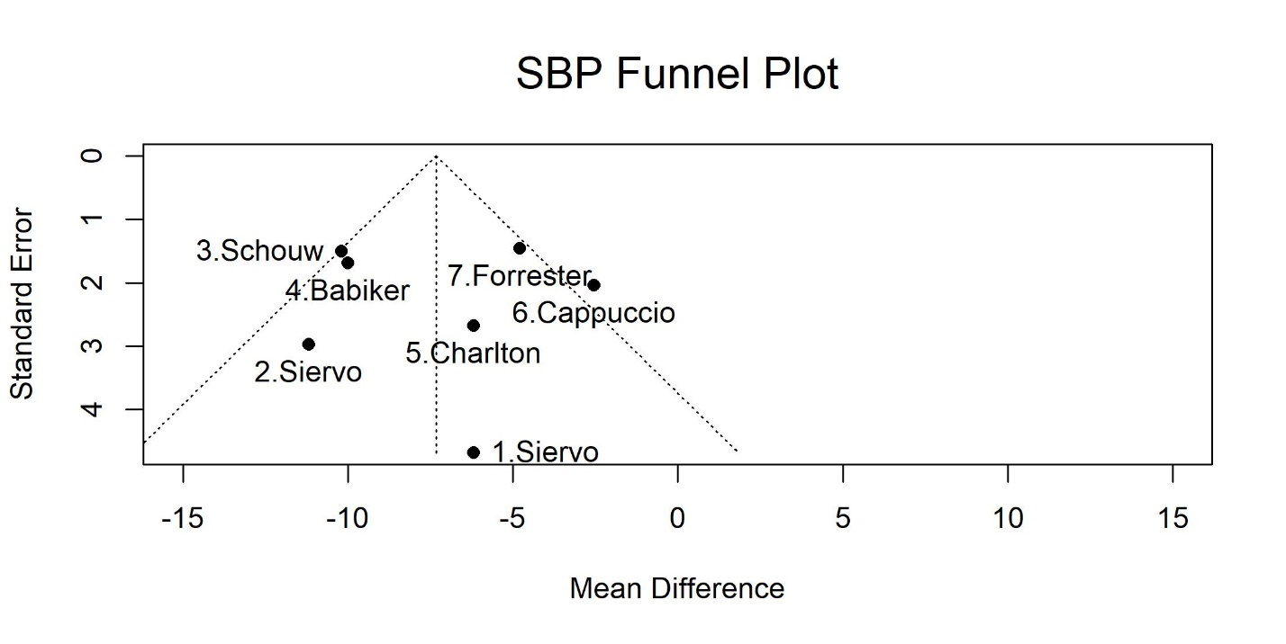
SBP= Systolic Blood Pressure

Figure S1B: Funnel Plot for Diastolic Blood Pressure Measurement
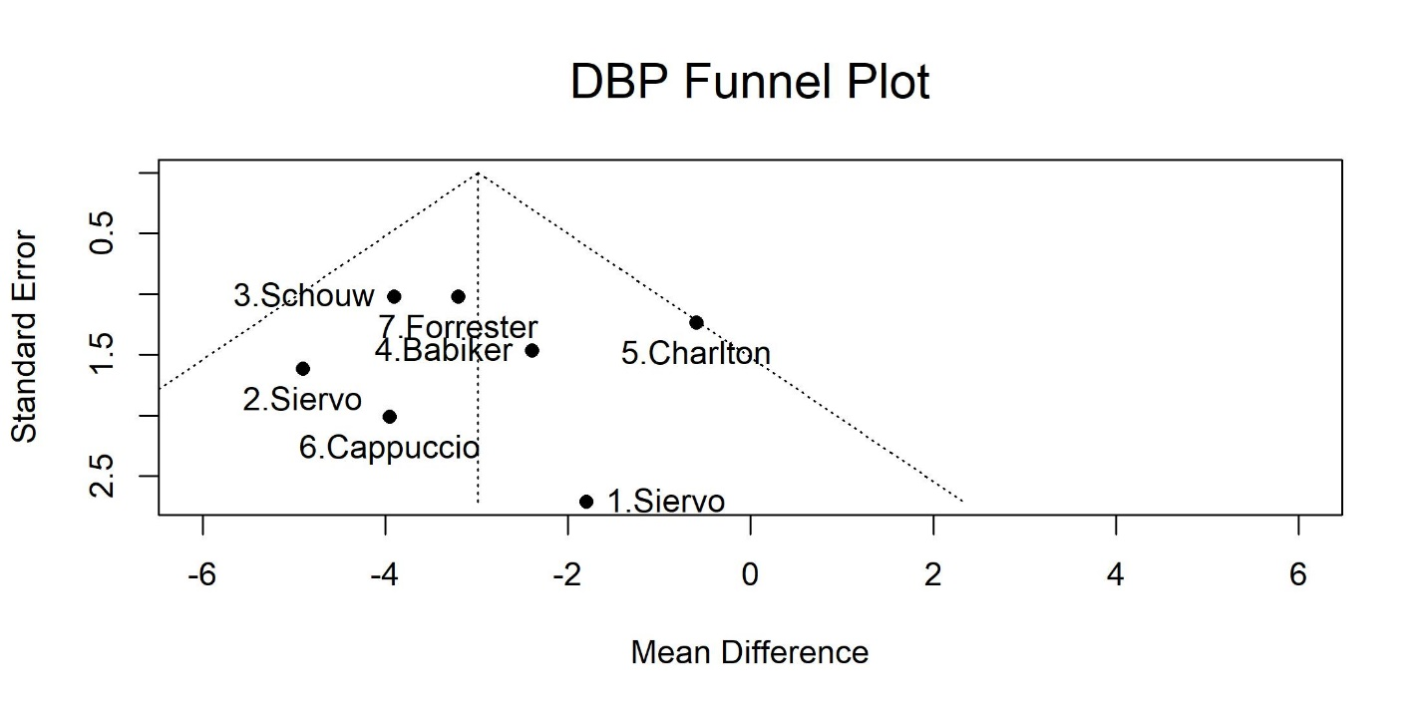
DBP = Diastolic Blood Pressure

Figure S2: Bubble Plots Showing the Effect of Treatment Time on Systolic and Diastolic Blood Pressure in the Metanalysis of Lifestyle Interventions on Blood Pressure in sub-Saharan Africa
Figure S2A: The Effect of Treatment Time on Systolic Blood Pressure
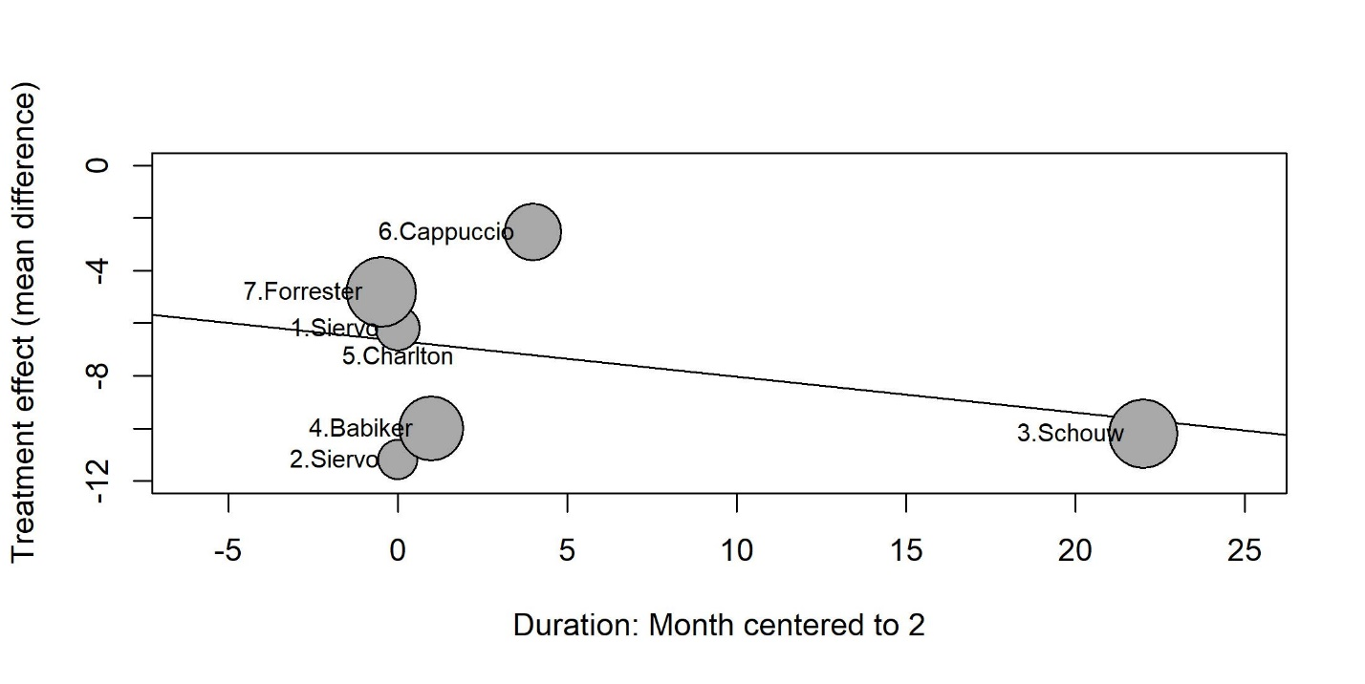

Figure S2B: The Effect of Treatment Time on Diastolic Blood Pressure
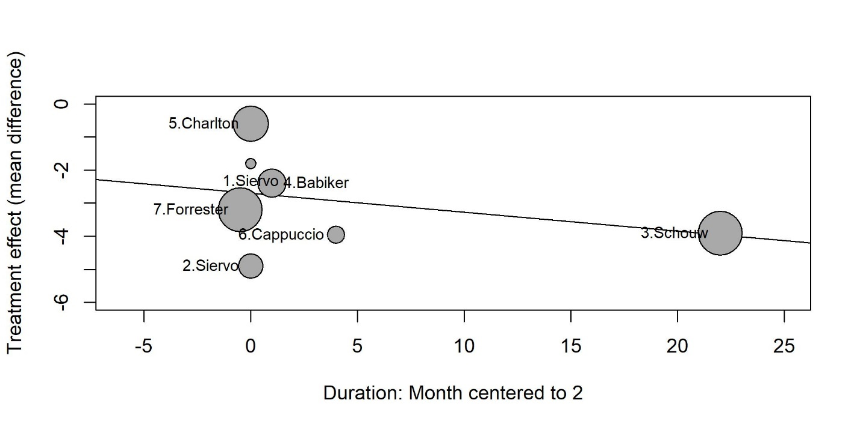

Figure S3: Leave-One-Out Sensitivity Test Showing the Effect of each Study on Overall Effect of Systolic and Diastolic Blood Pressure in the Metanalysis of Lifestyle Interventions on Blood Pressure in sub-Saharan Africa
Figure S3A: Leave-One-Out Sensitivity Test for Systolic Blood Pressure
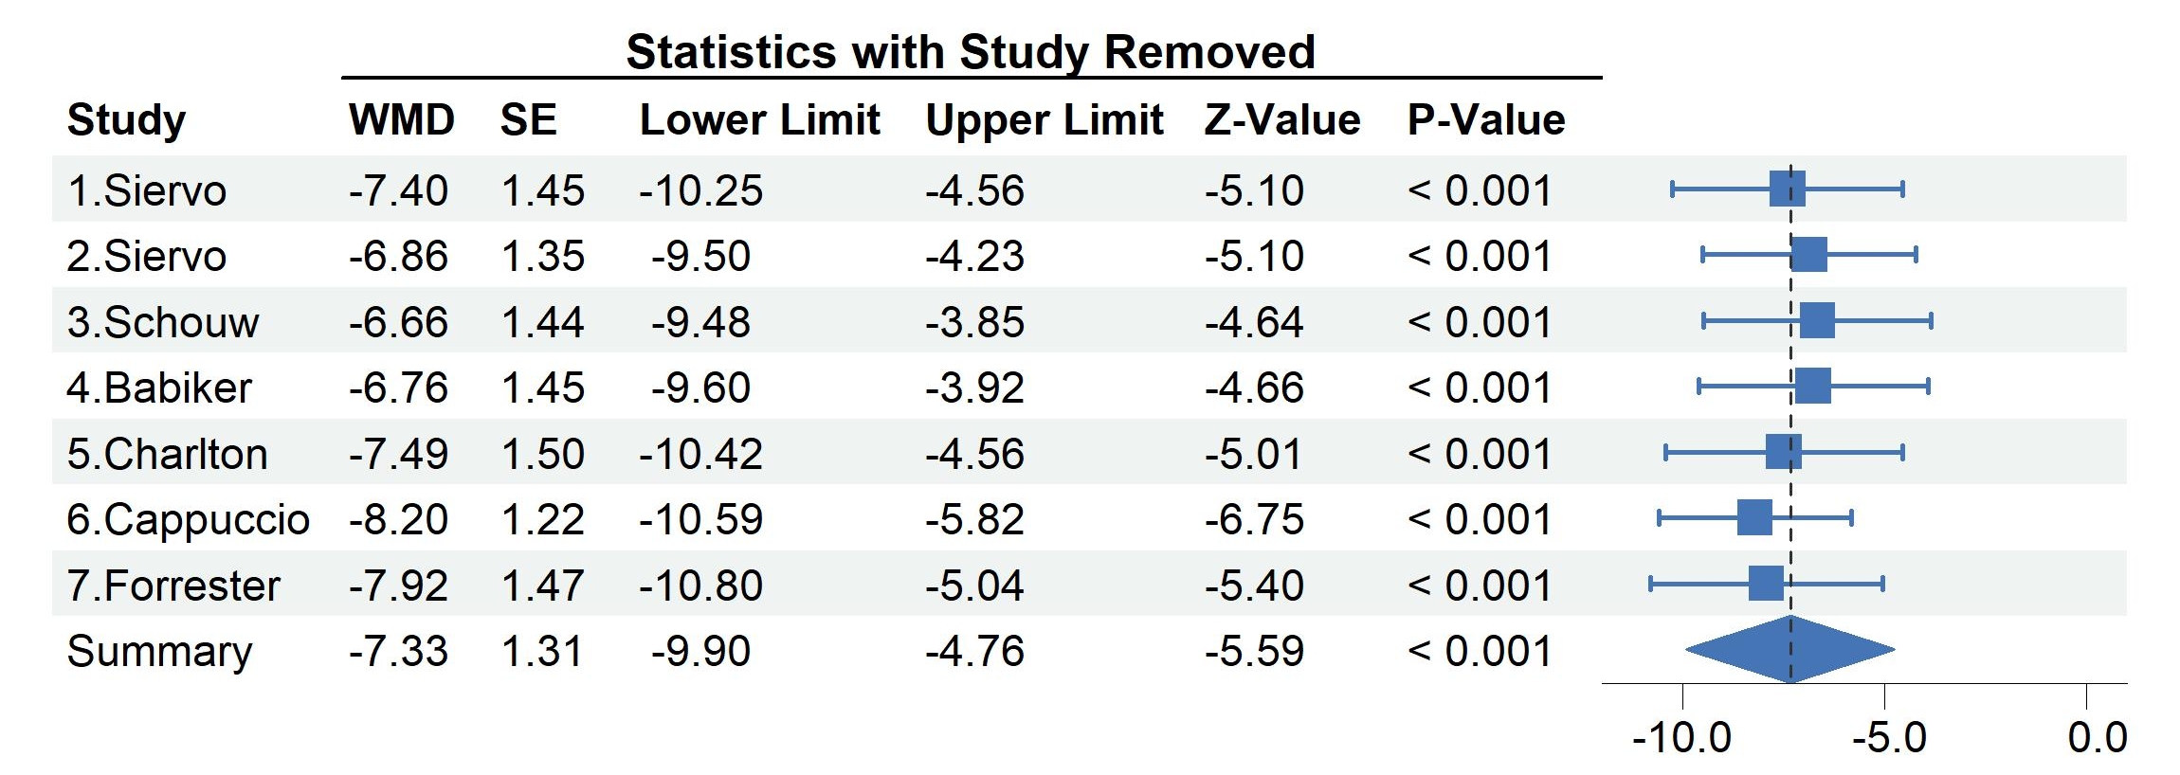
[1] Results are reported in mmHg. Horizontal lines are reported as 95% CI.
[2] Studies 1 and 2 by Siervo are the same study with 2 intervention groups[17], include 2 groups (high nitrate beetroot juice with folic acid (1) and high-nitrate beetroot juice without folic acid (2).
[3] WMD = weighted mean difference; SE = standard error of treatment effect.

Figure S3B: Leave-One-Out Sensitivity Test for Diastolic Blood Pressure
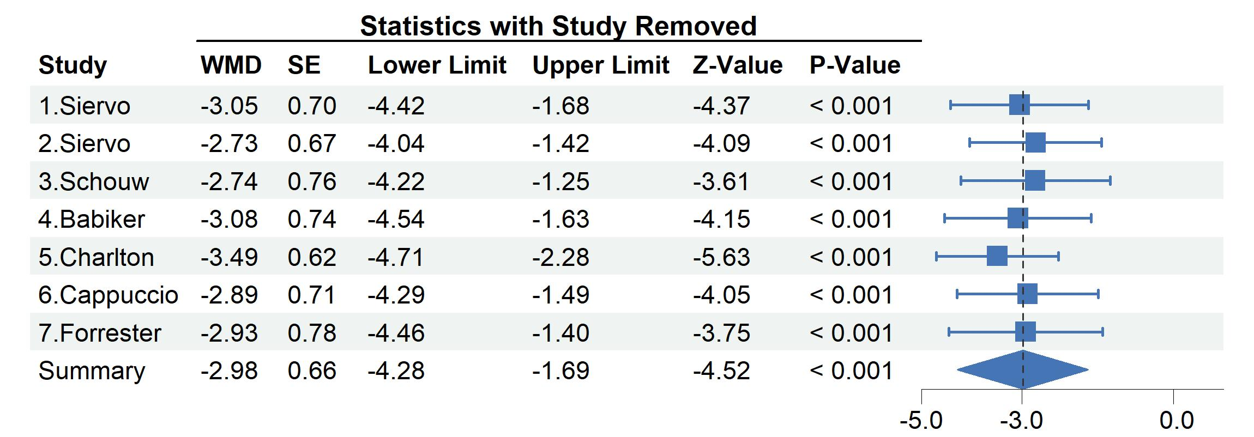
[1] Results are reported in mmHg. Horizontal lines are reported as 95% CI.
[2] Studies 1 and 2 by Siervo are the same study with 2 intervention groups[17], include 2 groups (high nitrate beetroot juice with folic acid (1) and high-nitrate beetroot juice without folic acid (2).
[3] WMD = weighted mean difference; SE = standard error of treatment effect.

