Supplemental Figure 3a. Correlation matrix among clinic SBP and ABPM (daytime SBP) by different diurnal definition.
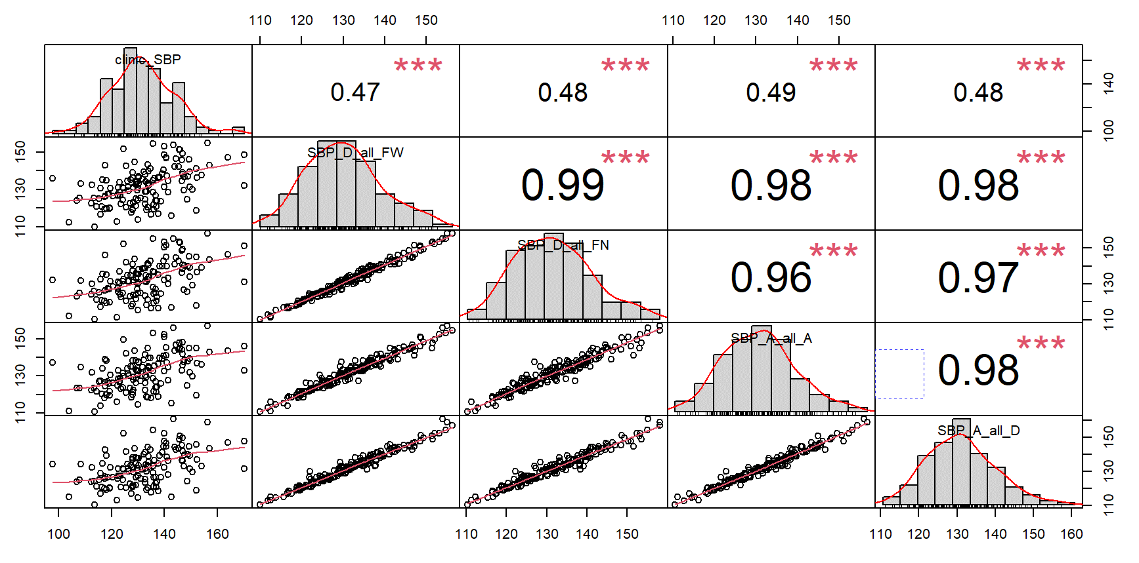
Abbreviations: SBP_D_all_FW: ABPM daytime SBP by fixed time period; SBP_D_all_FN: ABPM daytime SBP by narrow time period; SBP_A_all_A: ABPM daytime SBP by actigraphy; SBP_A_all_D: ABPM daytime SBP by diary.

Supplemental Figure 3b. Correlation matrix among clinic DBP and ABPM (daytime DBP) by different diurnal definition.
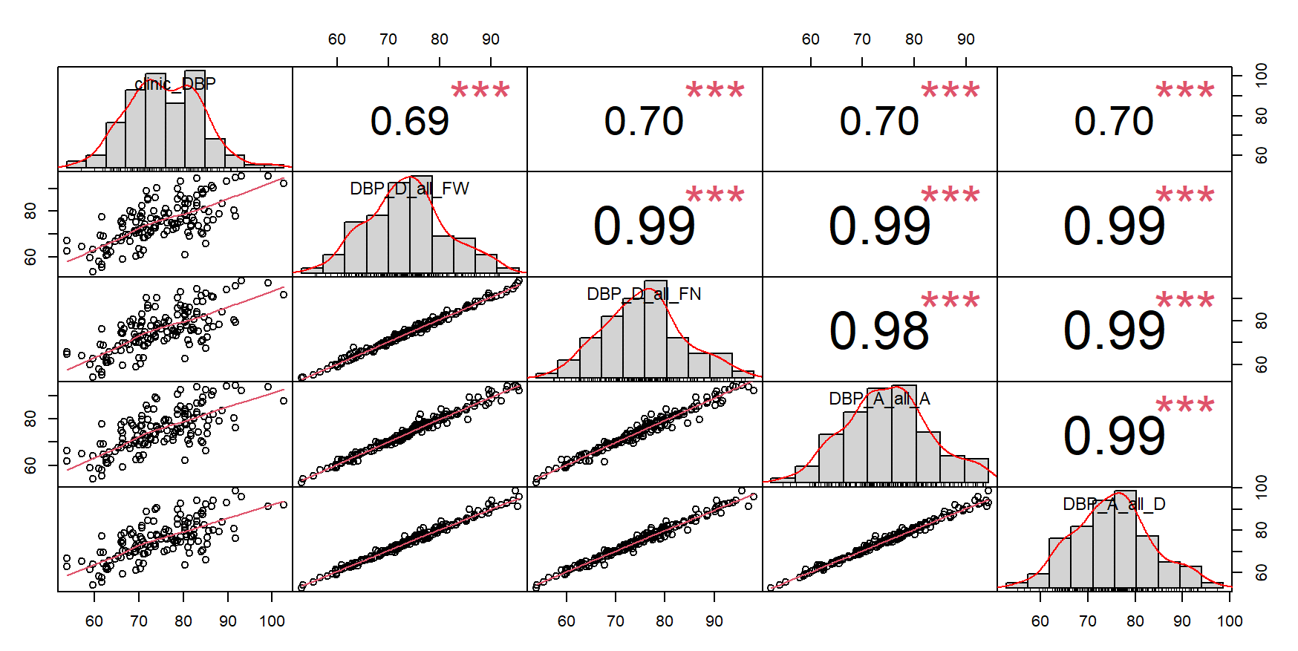

Abbreviations: DBP_D_all_FW: ABPM daytime DBP by fixed time period; DBP_D_all_FN: ABPM daytime DBP by narrow time period; DBP_A_all_A: ABPM daytime DBP by actigraphy; DBP_A_all_D: ABPM daytime DBP by diary.

