Appendix
Figure A1: Four-field-panels comparing classification elevated/normal blood pressure for mean systolic and diastolic 24 hour blood pressure. Panel A and B depict results for the whole study population. Panel C and D depict results for participant with antihypertensive medication, whereas Panel E and F depict results for participants without antihypertensive medication.
BP blood pressure; RefBP standard cuff-based BP measurement; TestBP cuffless BP measurement

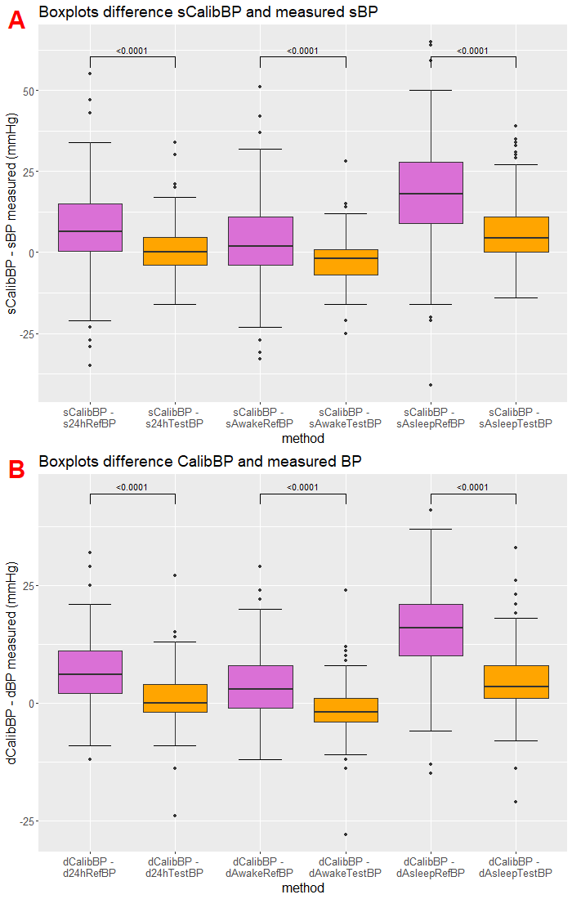
Figure A2: Boxplots comparing the difference between the systolic (panel A) or diastolic (panel B) CalibBP and the systolic (panel A) or diastolic (panel B) 24-hour, awake and asleep RefBP (purple) / TestBP (orange; Schiller) with p-values generated by a one-sided Wilcoxon BP blood pressure, CalibBP calibration BP measurement, d diastolic, RefBP standard cuff-based BP measurement, s systolic, TestBP cuffless BP measurement.

Figure A3: Plots comparing the difference between systolic or diastolic CalibBP and 24-hour, awake and asleep systolic or diastolic RefBP on the y-axis and the difference between the 24-hour, awake and asleep systolic or diastolic RefBP and corresponding TestBP (Schiller) on the x-axis.
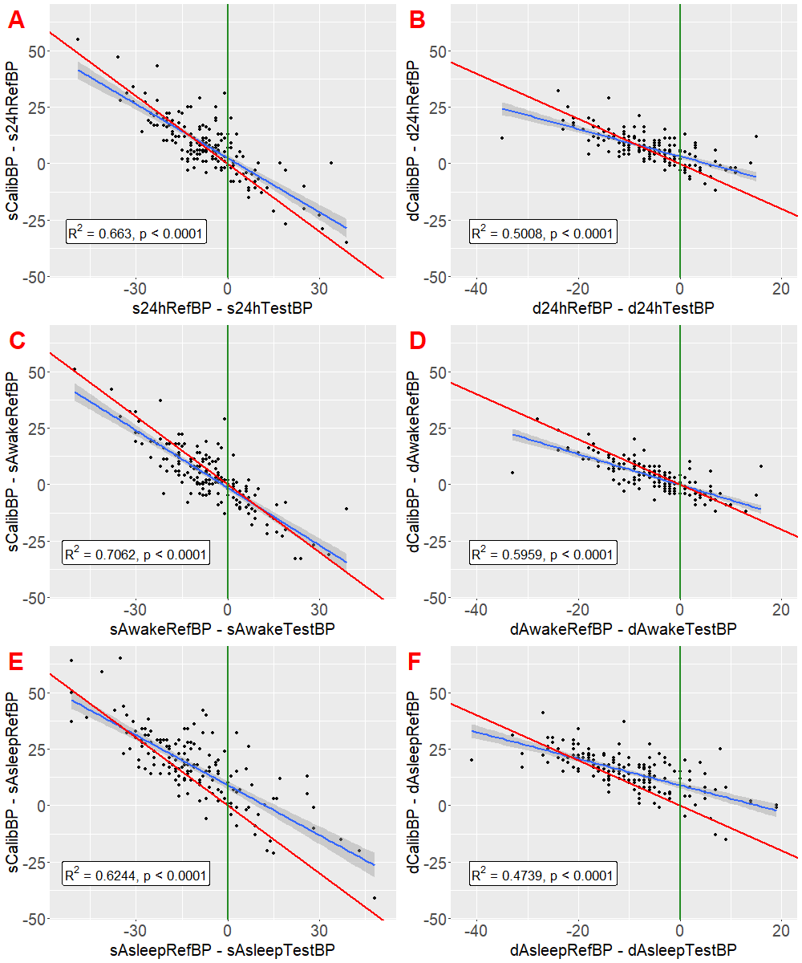

Plots A, C and E are showing the systolic BP and plots B, D and F the diastolic BP. BP blood pressure, CalibBP calibration BP measurement, d diastolic, RefBP standard cuff-based BP measurement, s systolic, TestBP cuffless BP measurement. Red line shows the assumption that TestBP follows CalibBP without changes, the blue line shows the generated linear regression for the data and the green line shows an ideal agreement between RefBP and TestBP

Table A1: Comparison of RefBP and TestBP (Schiller) measurement results
 | RefBP | TestBP | P-value
s24hBP, mmHg; mean (SD) | 129.9 (14.4) | 136.2 (9.5) | <0.0001
sAwakeBP, mmHg; mean (SD) | 133.8 (12.8) | 139.7 (8.8) | <0.0001
sAsleepBP, mmHg; mean (SD) | 119.8 (10.8) | 131.3 (7.0) | <0.0001
d24hBP, mmHg; mean (SD) | 79.4 (11.0) | 84.9 (5.5) | <0.0001
dAwakeBP, mmHg; mean (SD) | 82.7 (9.5) | 87.7 (4.3) | <0.0001
dAsleepBP, mmHg; mean (SD) | 70.9 (8.6) | 81.3 (4.1) | <0.0001
24hHR, bpm; mean (SD) | 70.3 (10.5) | 72.6 (15.8) | <0.0001
AwakeHR, bpm; mean (SD) | 73.6 (9.6) | 77.4 (15.2) | <0.0001
AsleepHR , bpm; mean (SD) | 62.1 (5.9) | 63.4 (9.2) | <0.0001

Data are mean (± standard deviation). BP blood pressure, d diastolic, HR heart rate, RefBP standard cuff-based BP measurement, s systolic, TestBP cuffless BP measurement.

Table A2: Comparison of the differences between the CalibBP and the mean BP of the RefBP and TestBP device (Schiller) with p-values generated by a one-sided Wilcoxon signed-rank test.
 | RefBP, mmHg;  mean (SD) | RefBP, mmHg;  range | TestBP, mmHg;  mean (SD) | TestBP, mmHg; range | p-value
sCalibBP - s24hBP | 7.4 (13.2) | -35 – 55 | 1.1 (8.1) | -16 – 34 | <0.0001
sCalibBP - sAwakeBP | 3.5 (13.3) | -33 – 51 | -2.4 (7.5) | -25 – 28 | <0.0001
sCalibBP - sAsleepBP | 17.5 (15.6) | -41 – 65 | 6.0 (10.5) | -14 – 39 | <0.0001
dCalibBP - d24hBP | 6.6 (6.8) | -12 – 32 | 1.0 (5.8) | -24 – 27 | <0.0001
dCalibBP - dAwakeBP | 3.3 (7.0) | -12 – 29 | -1.7 (5.1) | -28 – 24 | <0.0001
dCalibBP - dAsleepBP | 15.1 (8.7) | -15 – 41 | 4.7 (7.6) | -21 – 33 | <0.0001

Data are mean (± standard deviation) or range. BP blood pressure, CalibBP calibration BP measurement, d diastolic, RefBP standard cuff-based BP measurement, s systolic, TestBP cuffless BP measurement.

