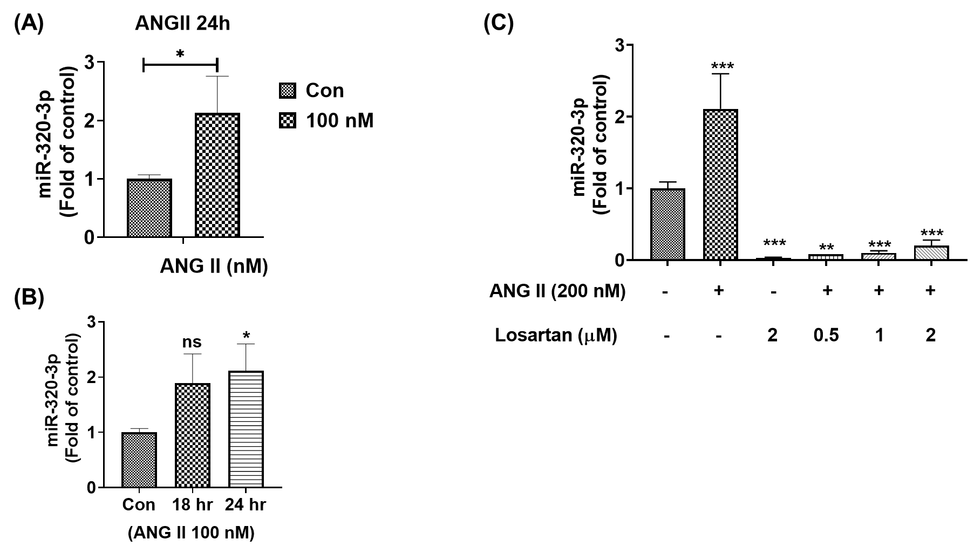

**Figure 1. Ang II upregulated miR-320-3p expression in H9c2 cardiomyoblasts**

The miR-320-3p fold-change qPCR quantification in Ang II and Losartan treated H9c2 cardiomyoblasts. (A) The expression of miR-320-3p was increased in Ang II-exposed H9c2 cardiomyoblasts. (B) The increase in mir-320-3p was even more significant over time in Ang II-exposed H9c2 cardiomyoblasts. (C) The increased level of mir-320-3p was reduced by losartan (AT1R inhibitor). (The expression levels of mir-320-3p were normalized to GAPDH internal control expression level. The results are expressed mir-320-3p fold change in treated groups compared to the control. Data are represented as mean ± standard deviation from three independent experiments (ns: not significant, *P < 0.05, **P < 0.01, ***P < 0.001)).

**Figure 2. The PI3K-AKT pathway in Ang II-exposed H9c2 cardiomyoblasts was regulated**

**by miR-320-3p**

(A) The expression of PI3K and Akt was downregulated when H9c2 cardiomyoblasts were co-treated with Ang II and a mir-320 mimic. (B) The mir-320 inhibitor enhanced the phosphorylation of PI3K and AKT to reduce apoptosis in Ang II-exposed H9c2 cardiomyoblasts. (The protein expression levels were normalized to β-actin internal control, the results are expressed as protein fold change in treated groups compared to the control. ANOVA followed by the Tukey test was used to analyze the differences between the groups. Data are represented as mean ± standard deviation from three independent experiments (ns: not significant, *P < 0.05, **P < 0.001, ***P < 0.0001)).