**Figure S1**

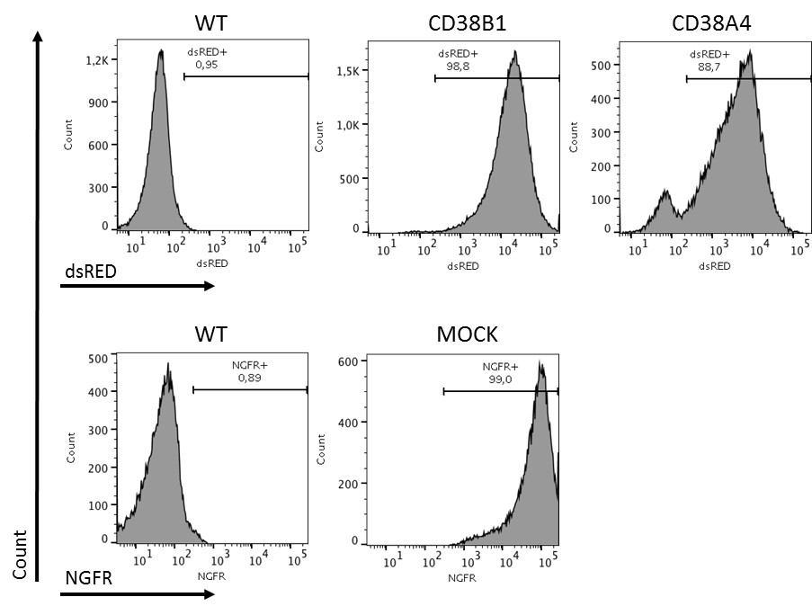

Figure S1. Transduction efficiency.

Transduction efficiency was over 85% 3 to 4 days post transduction regardless of the vector transduced. WT KHYG-1 expression of dsRED and NGFR was used to gate for positive cells. FlowJo was used for analysis.

**Figure S2**



Figure S2. Expansion *in vitro*

Following a short dip in expansion shortly post transfection, KHYG-1 cells expanded rapidly and consistently, regardless of the CAR used. There was no significant difference in expansion rates between the different CAR-KHYG-1 cells.

**Figure S3**

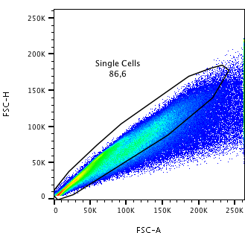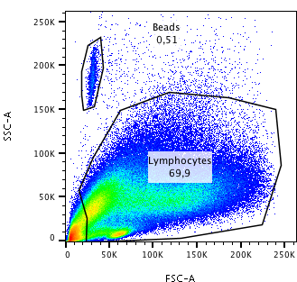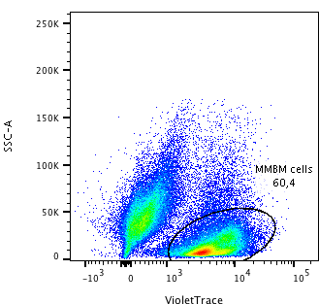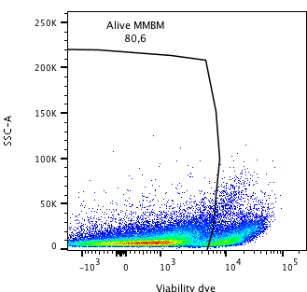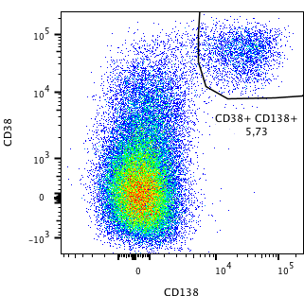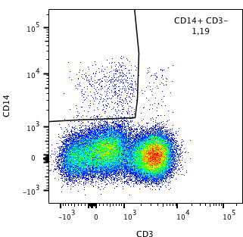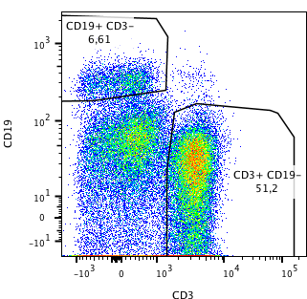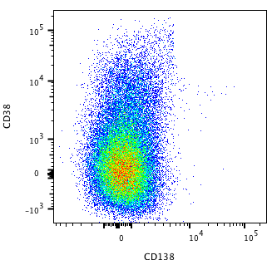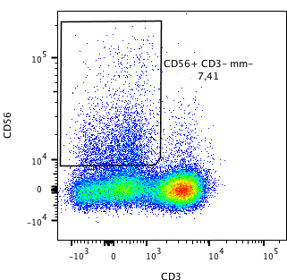

Figure S3. Gating strategy

Cells were gated first for single events, then for lymphocytes or beads. Consequently, cells were separated between effector CAR cells or MMBM target cells. From the MMBM target cells, viable cells were gated. Lastly from the viable MMBM cells appropriate gating was done, such as CD38+CD138+ (MM) cells, CD19+ (B) cells, CD14+ (monocytes) and CD3+ (T) cells. Since MM cells are often CD56+, we excluded the CD38+CD138+ cells before gating for CD56+ CD3- (NK) cells.

**Figure S4**

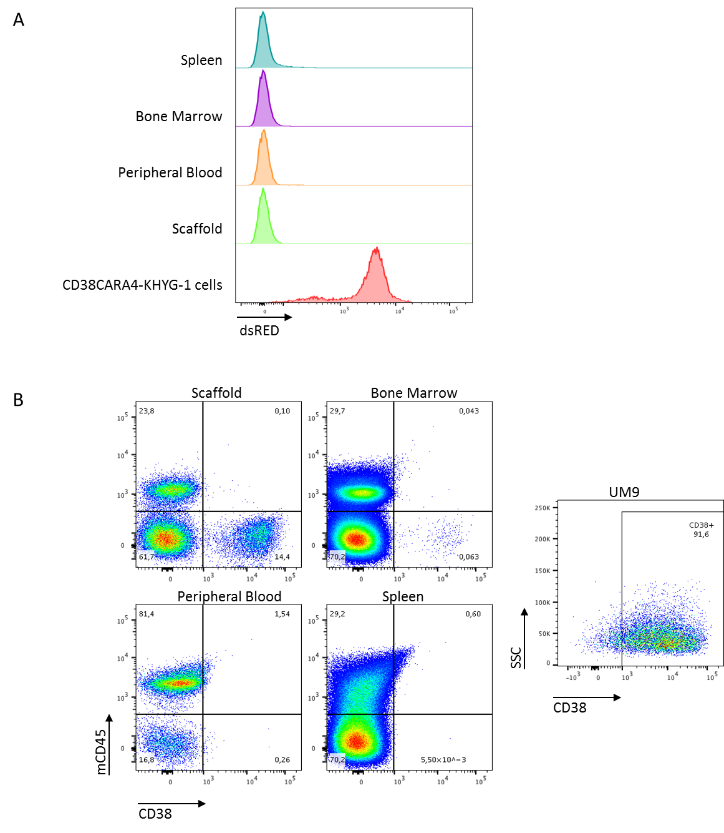

Figure S4. Representative flow cytometry plots of *in vivo* results.

(A) Post mortem analysis indicated no viable CD38CAR KHYG-1 cells remained in the spleen, BM, blood or scaffolds. For indication of normal dsRED expression, a sample of the CD38CAR KHYG-1 cells is shown at the bottom of the histogram plot. (B) Cells harvested from mouse tissue did not indicate spread of the malignant UM9 cells to the spleen, BM or blood. UM9 cells remaining in the scaffolds did not indicate a loss of CD38 expression. As an example of normal CD38 expression on UM9 cells, a graph displaying UM9 cells kept in culture is shown to the right of the figure. mCD45 indicates mouse specific CD45 antibody.

**Figure S5**



Figure S5. CD38CAR KHYG-1 cytotoxic in *in vivo* setting in suboptimal dosing scheme.

All animal experiments were approved by the local ethical committee for animal experimentation and were in compliance with the Dutch Animal Experimentation Act. (A) Specifics of the *in vivo* experiment set-up may be found in the relevant methods section. In short, mice were s.c. inoculated with human BMMSC coated scaffolds. Post-implantation Luc+ UM9 MM cells were injected into the scaffolds, after which i.v. CD38A4 KHYG-1 treatment was started. Tumor growth was monitored weekly by BLI analysis and by manual tumor-size measurements. (B) MOCK treated and untreated mice showed a similar tumor progression, while the CD38A4 treated mice displayed a delayed tumor growth. Mean values are displayed. (C) This delayed tumor growth was found to be significant at day 41 between the untreated controls and the CD38A4 treated mice. (* p< 0.05, Mean + SEM). (D) Overall survival of the untreated controls and CD38A4 treated mice was not significantly different, though a trend could be observed.

**Figure S6**

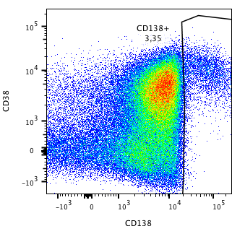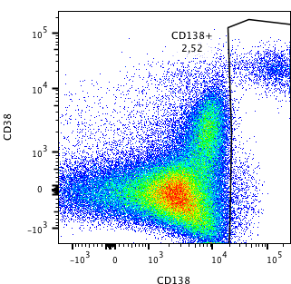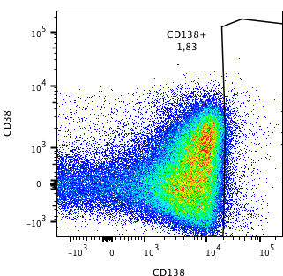

CD38

CD138

Figure S6. Representative flow cytometry plots of three daratumumab refractory patients.

Expression of CD38 and CD138 on CD2- MMBM cells from three daratumumab refractory patients.