Supplemental Digital Content
SDC, Materials and Methods
Cloning of LeGO vectors and production of lentiviral particles
Cloning of LeGO vector was performed as previously described¹ (for detailed protocols and vector maps refer to http://www.lentigo-vectors.de). For overexpression of human AXL, the full-length cDNA was cloned from pDONR223 AXL (Addgene Plasmid #23945) by PCR (forward primer: 5’-atatGAATTCcgccaccATGGCGTGGCGGTGCC and reverse primer: 5’-atatGCGGCCGCCTAGGCACCATCCTCCTGCC) into the lentiviral vector LeGO-iG2-Puro⁺ using EcoRI and NotI restriction enzymes (New England Biolabs) according to standard protocols. All PCR amplified sequences were verified by sanger sequencing. Overexpression of AXL was confirmed by qPCR. Percentage of transduced cells was determined using flow cytometry. Only cells with a minimum of 80-fold overexpression as measured by qPCR compared to controls were used for experiments.
Co-Immunoprecipitation
For co-immmunoprecipitation, proteins were crosslinked by incubation with 1mM DSP (Pierce) for 30 minutes followed by cell lysis using NP-40 buffer (both ThermoFisher). 1mg of protein was incubated with anti-JAK2 antibody or the same amount of anti-IgG isotype (both purchased from Cell Signaling) and Protein G Sepharose (Invitrogen) overnight. After centrifugation and washing at 4°C, protein-bead complexes were boiled and subjected to immunoblot analysis.
Measurement of transaminases and creatinine
Alanine transaminase (ALT), aspartate transaminase (AST) (both IFCC method) and creatinine levels (Jaffé method) were determined by spectrophotometric analysis using a Siemens Atelica CH 930.

SDC, References
1. Weber K, Bartsch U, Stocking C, et al. A multicolor panel of novel lentiviral "gene ontology" (LeGO) vectors for functional gene analysis. Mol Ther 2008; 16: 698-706. 2008/03/26. DOI: 10.1038/mt.2008.6.

SDC, Tables
SDC, Table 1. Patient characteristics. This table summarizes characteristics of patients of which PB and BM samples were used in this study. All patients were untreated at time point of sample taking.
Patient # | Disease | Genetics | Sex | Age | Source | Material | Experiment
1 | PV | JAK2V617F | male | 58 | BM | protein, plasma | WB, ELISA
 |  |  |  |  | PB | MNC, plasma | WB, ELISA
2 | PV | JAK2V617F | female | 74 | BM | protein, plasma | WB, ELISA
3 | PV | JAK2V617F | male | 54 | BM | protein, plasma | WB, ELISA
4 | ET | JAK2V617F | male | 38 | BM | protein, plasma | WB, ELISA
5 | PV | JAK2V617F | male | 56 | BM | protein, plasma | WB, ELISA
6 | MPN | JAK2V617F | female | 40 | BM | protein, plasma | WB, ELISA
 |  |  |  |  | PB | MNC, plasma | CFU, ELISA
7 | PV | JAK2V617F | Male | 46 | BM | plasma | ELISA
8 | ET | CALR | Male | 41 | BM | plasma | ELISA
9 | ET | CALR | female | 61 | BM | plasma | ELISA
10 | MPN | JAK2V617F | Male | 70 | BM | plasma | ELISA
11 | ET | JAK2V617F | female | 79 | BM | plasma | ELISA
12 | ET | n.a. | female | 36 | PB | MNC | CFU
13 | PV | JAK2V617F | female | 45 | PB | plasma, MNC | ELISA, CFU
14 | MF | JAK2V617F | female | 75 | PB | plasma, MNC | ELISA, CFU
15 | ET | CALR | male | 77 | PB | plasma | ELISA
16 | PV | JAK2V617F | male | 42 | PB | plasma | ELISA
17 | PMF | JAK2V617F | male | 75 | PB | plasma | ELISA
18 | ET | JAK2V617F | female | 71 | PB | plasma | ELISA
19 | ET | WT | female | 37 | PB | plasma | ELISA
20 | PV | JAK2V617F | female | 77 | PB | plasma | ELISA
21 | PV | JAK2V617F | female | 69 | PB | plasma | ELISA
22 | PV | JAK2V617F | male | 66 | PB | plasma | ELISA
23 | ET-MF | JAK2V617F | male | 70 | PB | plasma | ELISA
24 | MF | n.a. | female | n.a. | PB | plasma | ELISA
25 | MF | n.a. | male | n.a. | PB | plasma | ELISA
26 | MF | n.a. | female | 76 | PB | plasma | ELISA
27 | MF | n.a. | n.a. | n.a. | PB | plasma | ELISA
28 | MF | n.a. | n.a. | n.a. | PB | plasma | ELISA
29 | MF | n.a. | male | 81 | PB | plasma | ELISA
30 | MF | n.a. | female | 82 | PB | plasma | ELISA
31 | MF | WT | male | 45 | PB | plasma | ELISA
32 | MF | n.a. | male | 40 | PB | plasma | ELISA
33 | ET | n.a. | female | n.a. | PB | plasma | ELISA
34 | PV | JAK2V617F | male | 51 | PB | plasma | ELISA
35 | PV | JAK2V617F | male | 51 | PB | plasma | ELISA
36 | MF | JAK2V617F | male | 70 | PB | plasma | ELISA
37 | MPN | JAK2V617F | female | 63 | PB | plasma | ELISA
38 | PV | JAK2V617F | male | 40 | PB | plasma | ELISA
39 | PV | JAK2V617F | female | 64 | PB | plasma | ELISA
40 | ET | JAK2V617F | female | 73 | PB | plasma | ELISA
BM Bone Marrow; PB Peripheral Blood; ET Essential Thrombocythemia; MF Myelofibrosis; PMF Primary Myelofibrosis; PV Polycythemia Vera; MNC Mononuclear cells; WB Western blot; CFU Colony Formation Assay; n.a. data not available.

SDC, Table 2. Western blot antibodies.
Target | Company | Catalogue No. | Source | Dilution
pAXL (Y779) | R&D | AF2228 | rabbit | 1:333
AXL | gift from Björn Dahlbäck | n.a. | rabbit | 1:1000
pAKT (Ser473) (193H12) | Cell Signaling | 4058 | rabbit | 1:1000
AKT | Cell Signaling | 9272 | rabbit | 1:1000
p-p44/42 MAPK (pERK1/2) | Cell Signaling | 4370 | rabbit | 1:2000
p44/42 MAPK (ERK1/2) (3A7) | Cell Signaling | 9107 | mouse | 1:1000
pSTAT5 (Tyr694) | Cell Signaling | 9351 | rabbit | 1:1000
STAT5 (D2O6Y) | Cell Signaling | 94205 | rabbit | 1:1000
STAT5A (4H1) | Cell Signaling | 4807 | mouse | 1:1000
STAT5B | Cell Signaling | 34662 | rabbit | 1:1000
pSTAT3 (Tyr705) | Cell Signaling | 9131 | rabbit | 1:1000
STAT3 | Cell Signaling | 9139 | mouse | 1:1000
BCL-2 (D17C4) | Cell Signaling | 3498 | rabbit | 1:1000
Cleaved Caspase 3 (Asp175) | Cell Signaling | 9664 | rabbit | 1:1000
XIAP (3B6) | Cell Signaling | 2045 | rabbit | 1:1000
β-Actin (C4) | Santa Cruz | sc-47778 | mouse | 1:1000
β-Tubulin (D-10) | Santa Cruz | sc5274 | mouse | 1:500
JAK2 (D2E12) | Cell Signaling | 3230 | rabbit | 1:50 (IP)
α-Tubulin (B-5-1-2) | Sigma Aldrich | T5168 | mouse | 1:8000
Lamin B1 (D4Q4Z) | Cell Signaling | 12586 | rabbit | 1:1000
Rabbit IgG Isotype (DA1E) | Cell Signaling | 3900 | rabbit | 50 µg/ml (IP)
SDC, Figures

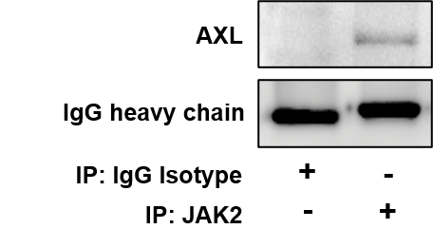
SDC, Figure 1. AXL is bound to JAK2. SET-2 cells were used for co-immunoprecipitation. Immunoprecipitation was performed using anti-IgG Isotype antibody (used as negative control) or an anti-JAK2 antibody. Western blot analysis was performed to detect AXL.

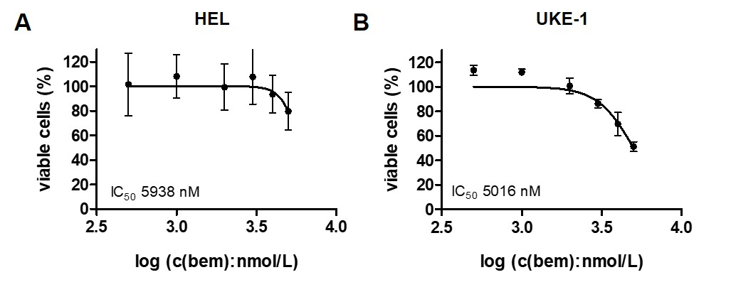
SDC, Figure 2. Bemcentinib reduces viability in AXL⁻ MPN cell lines. Assessment of half maximal inhibitory concentration (IC₅₀) for bemcentinib (bem). Treatments were performed with increasing concentrations (0, 0.5, 1, 2, 3, 4, 5 µmol/L) of bem (log10 scale) for 48h with human HEL (A) and UKE-1 (B) cells in serum deprived conditions. WST-1 cell viability assays were performed (n=3). Percentage of viable cells was normalized to control-treated cells.
SDC, Figure 3. GAS6 increases viability of AXL⁺ but not AXL⁻ MPN cell. SET-2, BaF3-EpoR-JAK2V617F, HEL, and UKE-1 cells were treated with increasing concentrations (0, 3.5, 7, 10, and 30 ng/ml) of recombinant human or murine GAS6, respectively, in serum deprived conditions. After 48h WST-1 cell viability assays were performed. Percentage of viable cells was normalized to control-treated cells (n=3, *p<0.05).
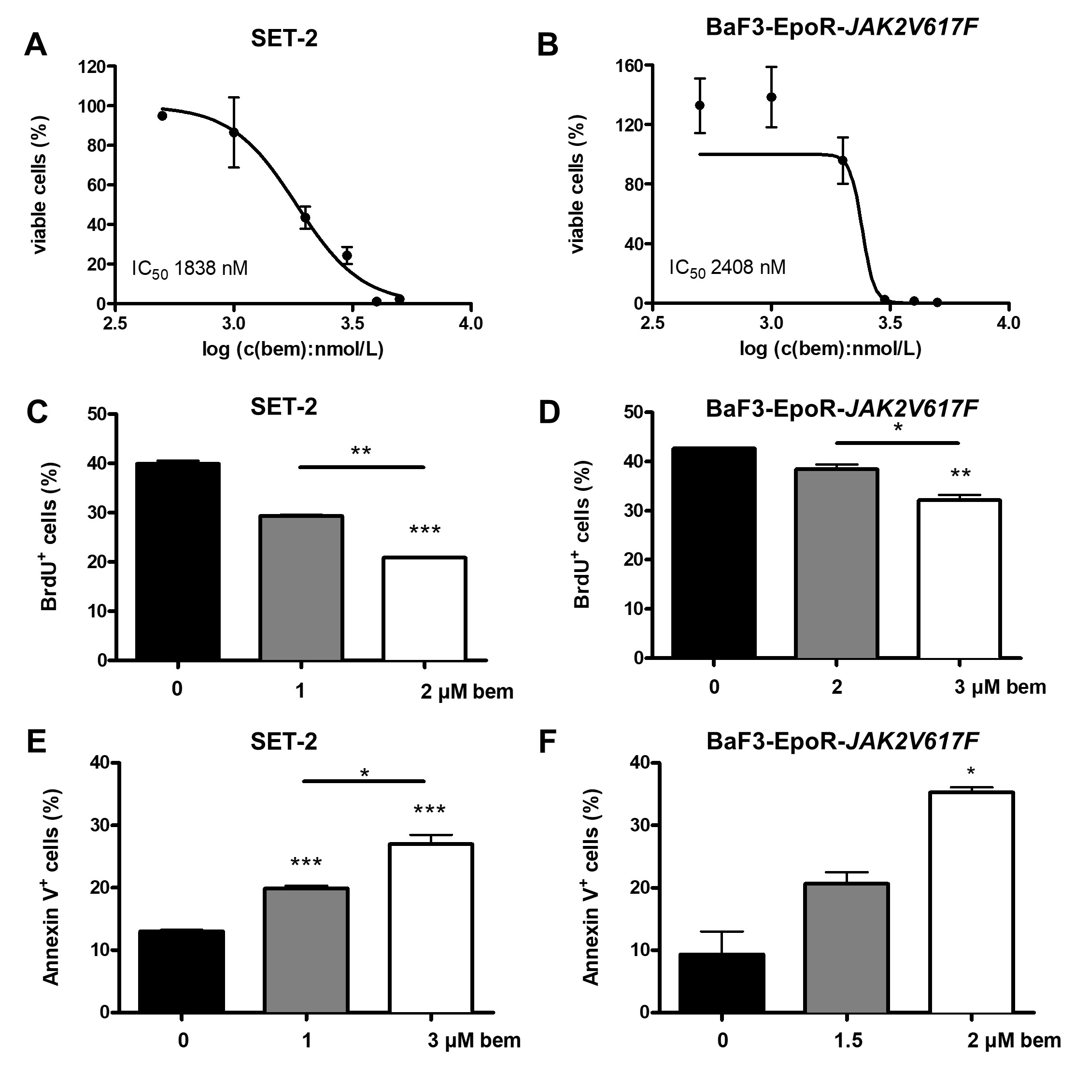
SDC, Figure 4. Bemcentinib inhibits proliferation and induces apoptosis in MPN cell lines. Assessment of half maximal inhibitory concentration (IC₅₀) for bemcentinib (bem). Treatments were performed in normal medium (10% FBS) with increasing concentrations (0, 0.5, 1, 2, 3, 4, 5 µmol/L) of bem (log10 scale) for 48h with human SET-2 and murine BaF3-EpoR-JAK2V617F cells, WST-1 cell viability assays were performed. Percentage of viable cells was normalized to control-treated cells (A-B). FACS quantification of proliferation (BrdU staining) showed a dose dependent decrease in proliferation rates after incubation of SET-2 and BaF3-EpoR-JAK2V617F cells with bem for 24h in serum containing medium (n=2) (C-D). FACS quantification of apoptosis (Annexin V staining) showed increased apoptosis of SET-2 and BaF3-EpoR-JAK2V617F cells after treatment with bem in normal medium conditions (n=2, *p<0.05, **p<0.01, ***p<0.001) (E-F).

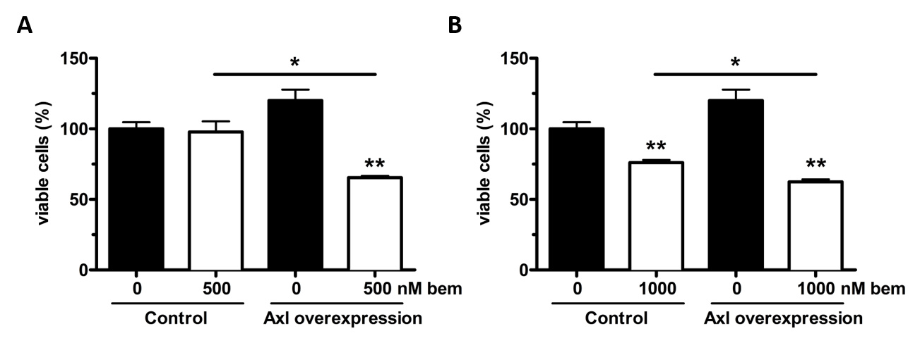
SDC, Figure 5. Overexpression of Axl increases sensitivity to bemcentinib. Overexpression of AXL was induced by lentiviral gene transfer. AXL overexpressing cells and control-transduced cells were incubated with 500nM (A) and 1000nM (B) bemcentinib (bem) for 48h in normal medium conditions followed by WST-1 cell viability assay. Percentage of viable cells was normalized to control-transduced untreated cells (n=3, *p<0.05, **p<0.01).
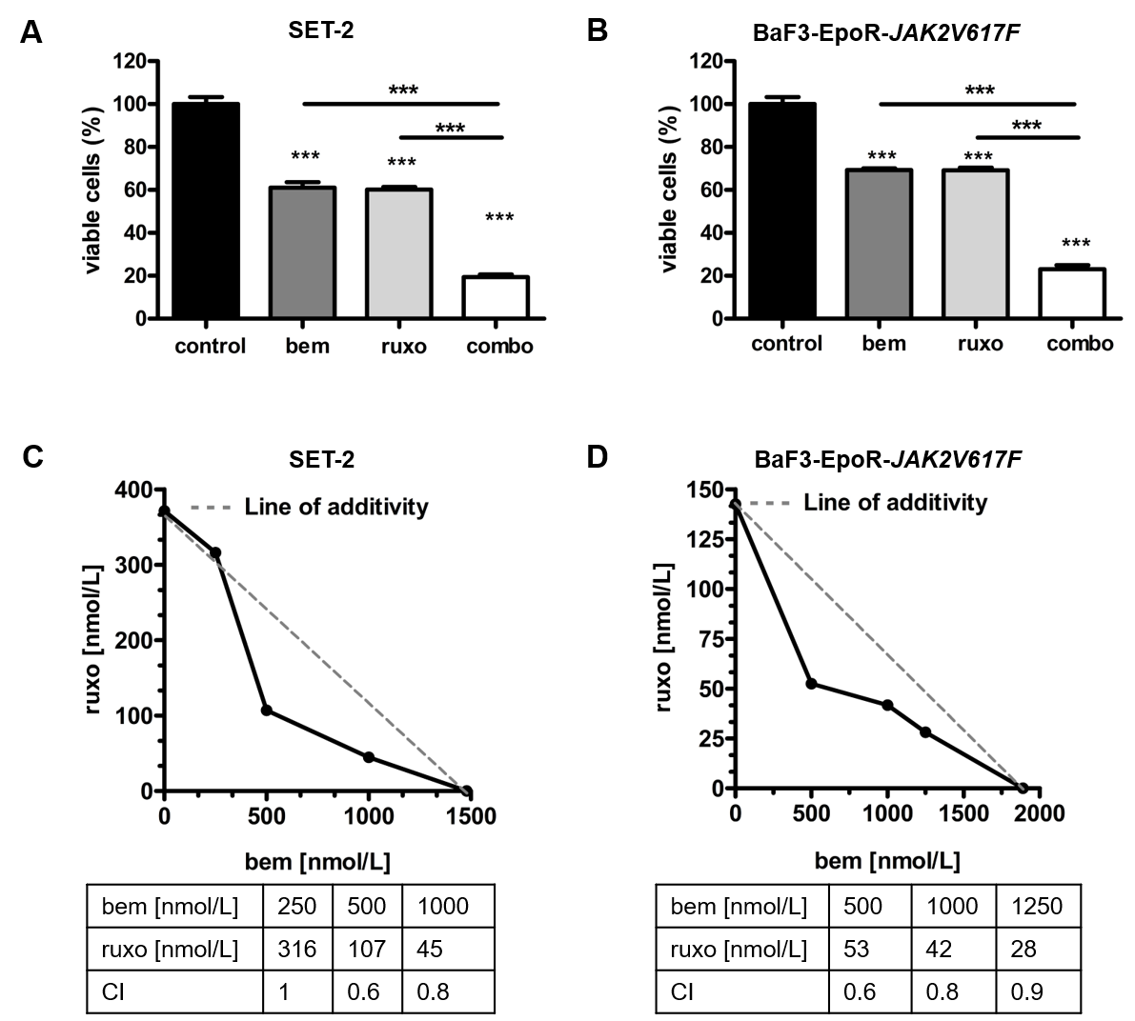
SDC, Figure 6. Bemcentinib and ruxolitinib exert additive inhibitory effects in vitro. SET-2 and BaF3-EpoR-JAK2V617F cells were treated with different concentrations of bemcentinib (bem) and ruxolitinib (ruxo) as single treatment or in combination for 48 hours in normal medium conditions, and cell viability was measured by WST-1 assay (n=3). Percentage of viable cells was normalized to control-treated cells (***p<0.001). For SET-2 cells combination of 1000 nM bem and 200 nM ruxo is shown (A), for BaF3-EpoR-JAK2V617F cells combination of 1000 nM bem and 100 nM ruxo is shown (B). Isobologram analysis was performed to test for combination effects of bem and ruxo, combination indices (CI) were calculated based on Loewe Additivity. CI <0.8 indicate synergism, CI 0.8-1.2 indicate additivity (C-D).

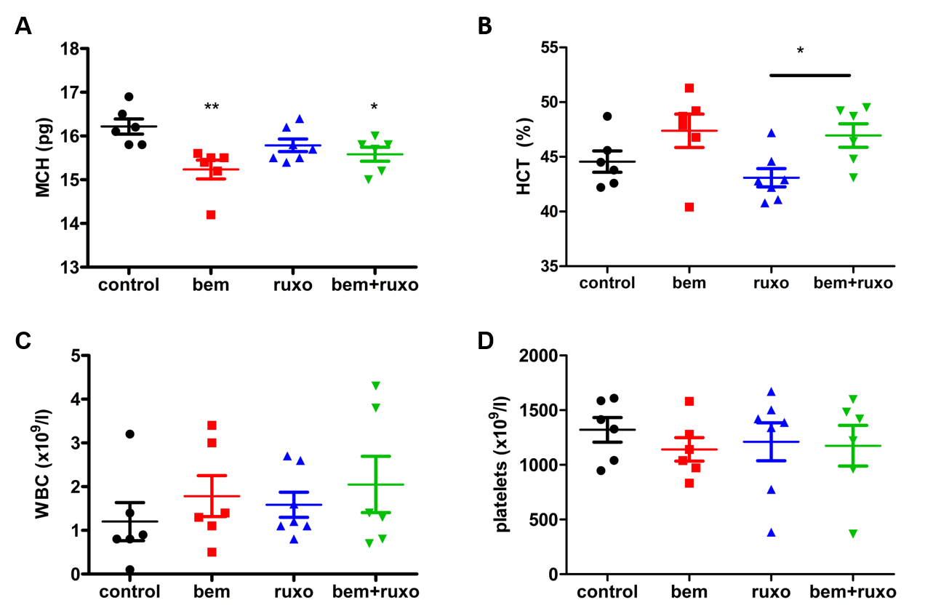
SDC, Figure 7. Blood count analysis shows good tolerability of combined bemcentinib and ruxolitinib treatment in vivo. In a systemic model of JAK2V617F-driven disease, mice were treated with vehicle, bem (50mg/kg), ruxo (50mg/kg) or bem and ruxo (50mg/kg each) twice daily. Mice were sacrificed on day 18 (n=6/6/7/7) and blood counts were analyzed. Mean cellular hemoglobin (MCH) of erythrocytes (A), hematocrit (B), white blood cell count (WBC) (C) and platelet count (D) are presented. Significant outliers were identified using Grubb’s test and excluded from analysis. T-test was performed for analysis of statistical difference (*p<0.05, **p<0.01).
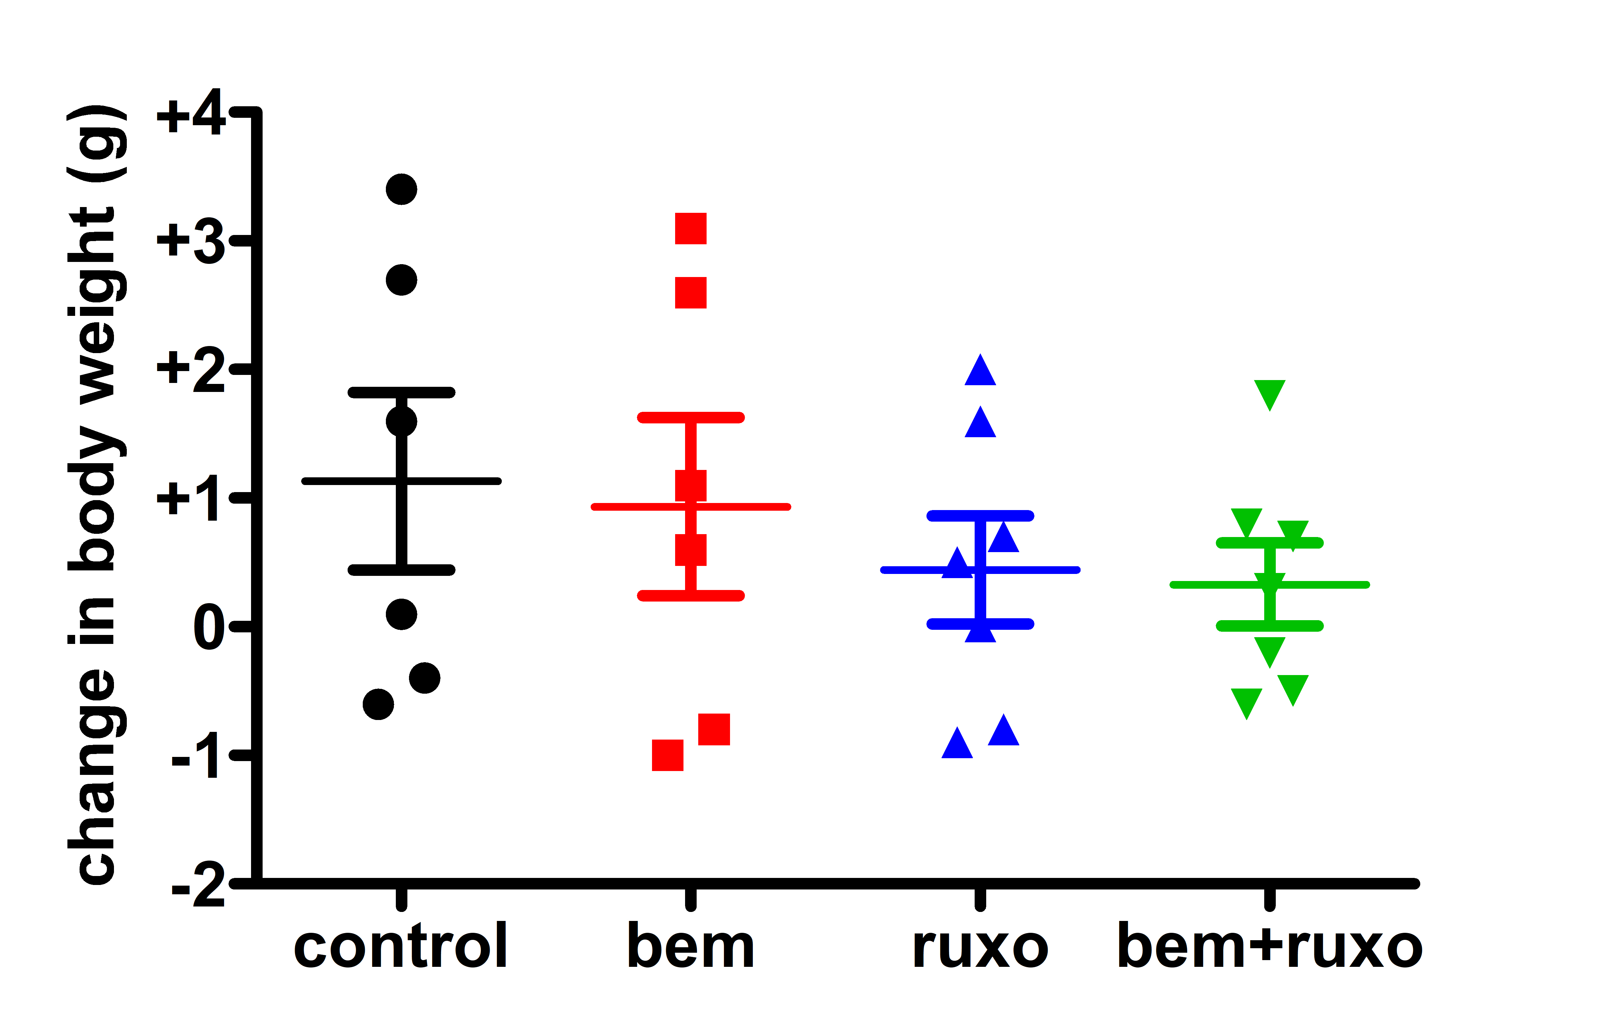
SDC, Figure 8. Combined bemcentinib and ruxolitinib treatment showed no effect on body weight in vivo. In a systemic model of JAK2V617F-driven disease, mice were treated with vehicle, bemcentinib (bem, 50mg/kg), ruxolitinib (ruxo, 50mg/kg) or bem and ruxo (50mg/kg each) twice daily and body weight was monitored (n=6/6/7/7). Change in body weight after 18 days of treatment in relation to body weight pre-treatment is presented.

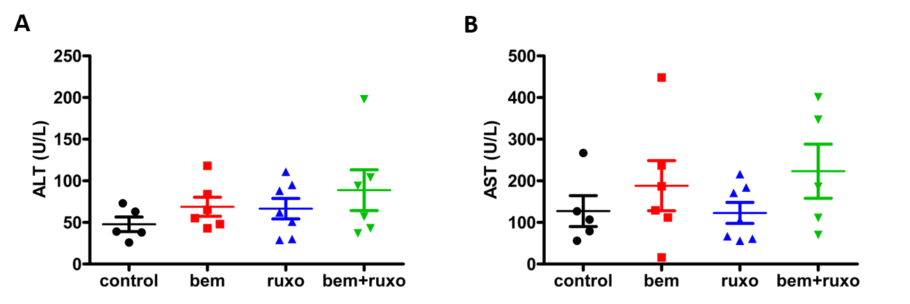
SDC, Figure 9. Combined bemcentinib and ruxolitinib treatment shows no hepatotoxicity in vivo. In a systemic model of JAK2V617F-driven disease, mice were treated with vehicle, bem (50mg/kg), ruxo (50mg/kg) or bem and ruxo (50mg/kg each) twice daily. On day 18, alanine transaminase (ALT) (A) and aspartate transaminase (AST) (B) levels were measured by spectrophometric analysis.

