Modelling benefits, costs and affordability of a novel gene therapy in hemophilia A

Renske M.T. ten Ham^{1,2,3}*, Simon Walker², Marta Soares², Geert W. J. Frederix^{1,3}, Frank W.G. Leebeek⁴, Kathelijn Fischer⁵, Michiel Coppens⁶, Stephen Palmer²

¹ Division of Pharmacoepidemiology and Clinical Pharmacology of the Utrecht Institute for Pharmaceutical Sciences (UIPS), Utrecht, The Netherlands,
² Centre for Health Economics, University of York, York, United Kingdom,
³ Julius Centre for Health Sciences and Primary Care, University Medical Centre Utrecht, Utrecht University,
⁴ Department of Hematology, Erasmus University Medical Center, Rotterdam, the Netherlands,
⁵ Division Internal Medicine and Dermatology, Van Creveldkliniek, University Medical Center Utrecht,
⁶ Department of Vascular Medicine, Amsterdam University Medical Centres, Amsterdam, the Netherlands.
*Corresponding author: R.M.T.tenHam-2@UMCUtrecht.nl.

SUPPLEMENTAL MATERIALS

Figure S1: Cost-effectiveness acceptability curve showing pairwise comparison. 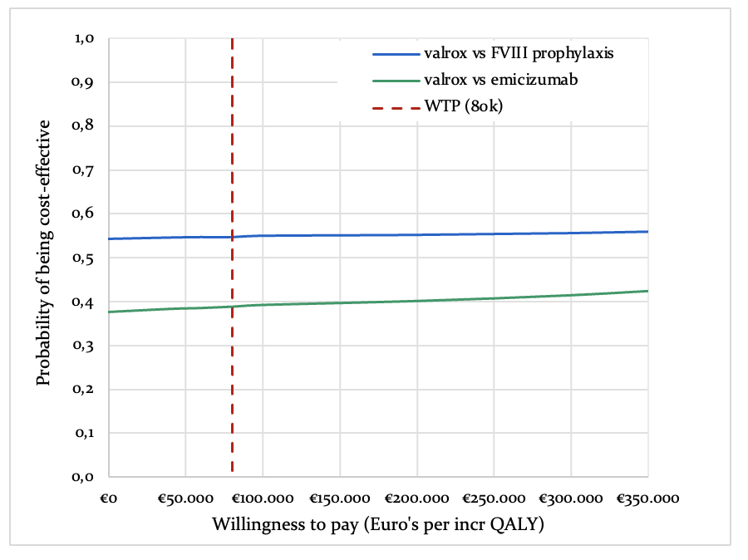
Valrox - valoctocogene roxaparvovec (Roctavian®). WTP – Willingness to pay threshold.
QALY – Quality adjusted life year. inc – incremental.

Figure S2: Deterministic sensitivity analysis valrox compared to prophylactic FVIII. Listed are the parameters displaying largest spread of incremental QALYs [A] and incremental costs [B].
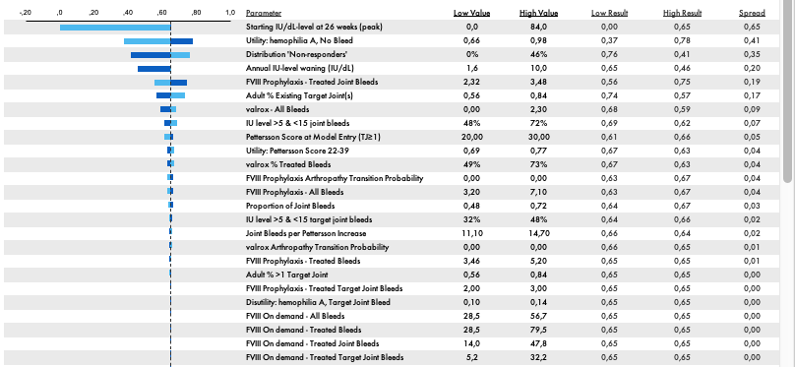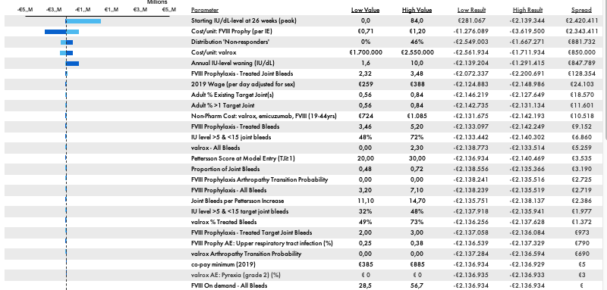
B
A
Valrox - valoctocogene roxaparvovec (Roctavian®). QALY – Quality adjusted life year.

Figure S3: Deterministic sensitivity analysis valrox compared to prophylactic emicizumab. Listed are the parameters displaying largest spread of incremental QALYs [A] and incremental costs [B].
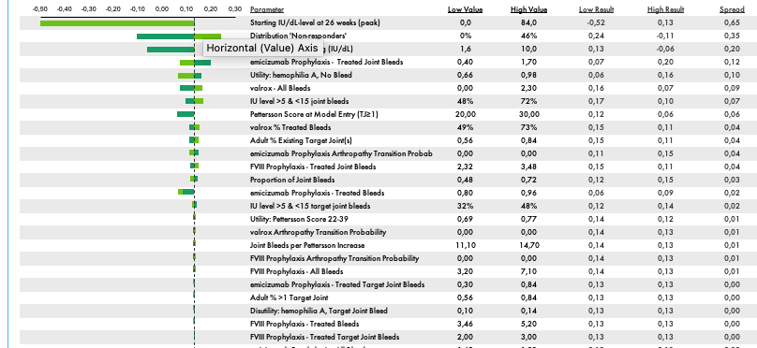
A

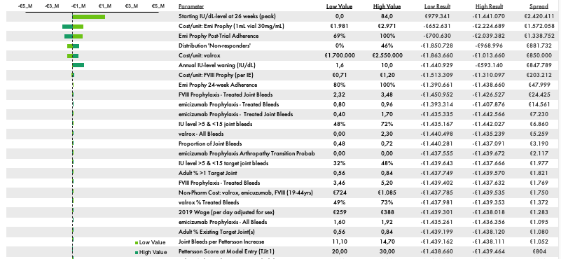
B
Valrox - valoctocogene roxaparvovec (Roctavian®). QALY – Quality adjusted life year.

Figure 4: Results of the probabilistic sensitivity analysis in a cost-effectiveness plane (1000 iterations). [A] valrox compared to FVIII prophylaxis and [B] valrox compared to emicizumab.
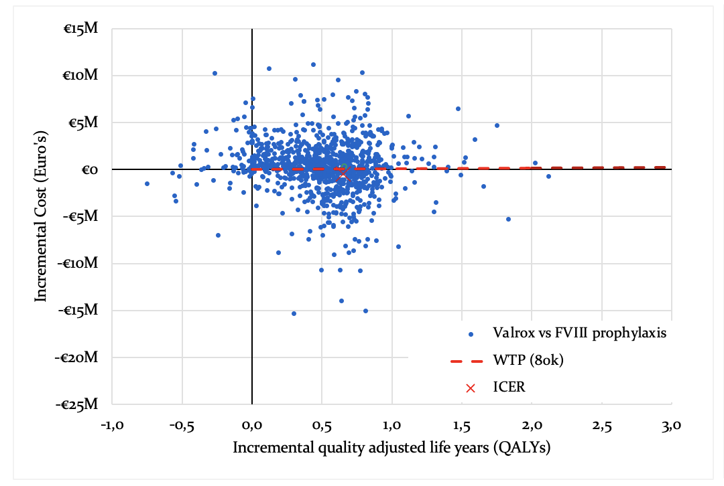
A
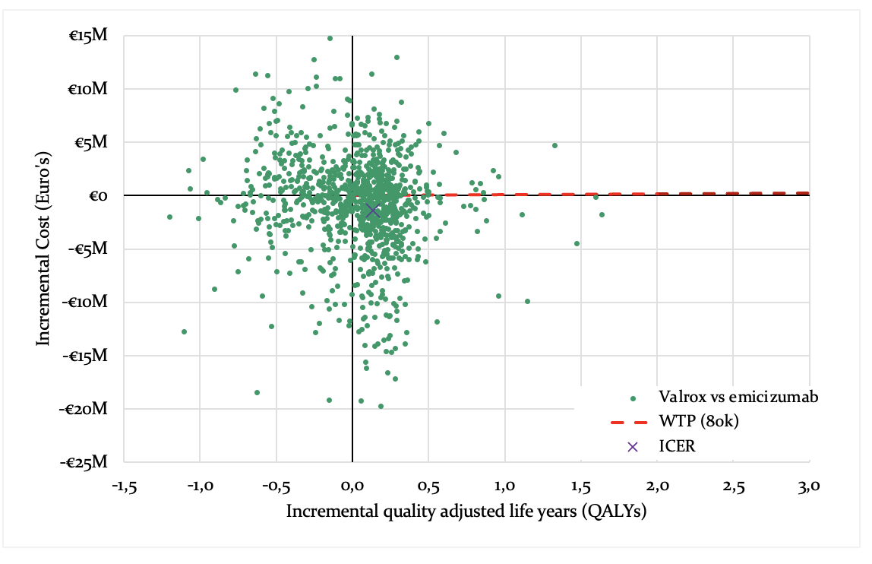
B
ICER - Incremental cost-effectiveness ration. Valrox - valoctocogene roxaparvovec (Roctavian®). WTP – Willingness to pay threshold.

