Supplemental

Supplemental Figure 1: Duodenal expression of ferritin, FPN and HEPH in mice exposed to stress erythropoiesis.

Supplemental Table 1: Hematological parameters in mice subjected to chronic dietary iron deficiency versus acute erythropoietic stresses.

Supplemental Table 2: List of oligonucleotides and antibodies used in the study.

Supplemental experimental procedures.

Supplemental References.

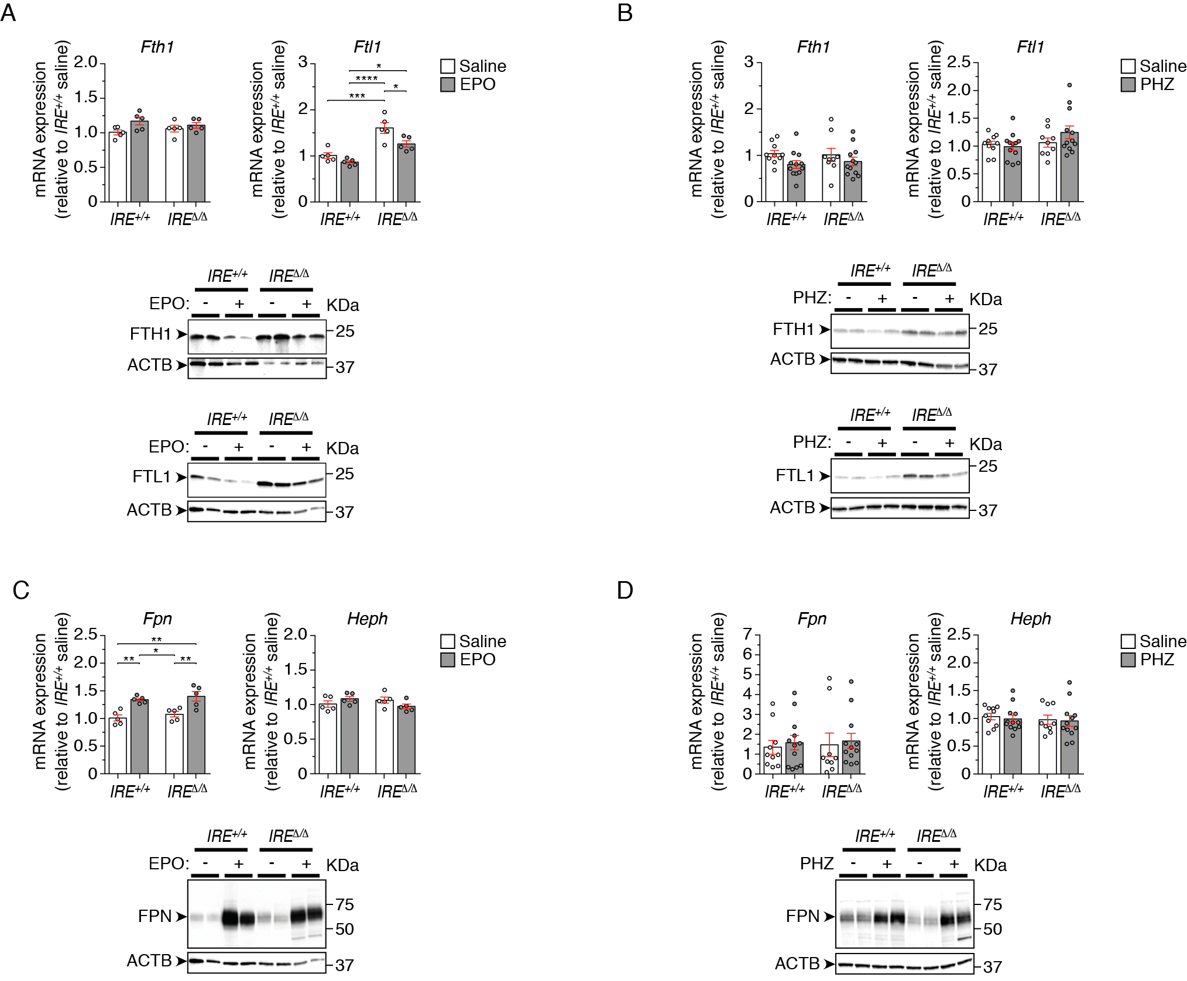
Supplemental Figure 1: Duodenal expression of ferritin, FPN and HEPH in mice exposed to stress erythropoiesis.
Adult WT (IRE^{+/+}) and Dmt1^{IREΔ/Δ} (IRE^{Δ/Δ}) mice were treated with EPO (A, C) or PHZ (B, D), respectively. (A, B) top histograms: qRT-PCR analysis of Fth1 and Ftl1 mRNA levels in the duodenum (A, n=5; B, n=10 to 12). Bottom panels: representative western-blot analysis of FTH1 and FTL1 protein expression in the duodenum. Dmt1^{IREΔ/Δ} mice in (A) exhibit a slight elevation in Ftl1 mRNA levels that is not consistently observed across all experiments. Upon EPO treatment (A), WT mice display a reduction in FTH1 and FTL1 protein levels, possibly reflecting ferritinophagy and/or repression of ferritin translation by the IRPs; although basal ferritin protein levels are higher in Dmt1^{IREΔ/Δ} compared to wild-type, a similar reduction in ferritin expression is observed in response to EPO (A). Ferritin expression is barely affected upon PHZ treatment (B). (C, D) top histograms: qRT-PCR analysis of Fpn and Heph mRNA levels in the duodenum (C, n=5; D, n=10 to 12). Mice treated with EPO exhibit a mild increase in Fpn mRNA expression regardless of genotype (C). Bottom panels: representative western-blot analysis of FPN protein expression in the duodenum, showing evident upregulation of FPN in both WT and Dmt1^{IREΔ/Δ} mice upon treatment with EPO or with PHZ. In A to D, qRT-PCR results are presented as fold change over WT mice injected with saline. Average mRNA levels of Actb, Tubb5 and Gapdh served as reference. Statistical significance was determined using two-way ANOVA with Tuckey’s multiple comparisons test, and a p-value inferior to 0.05 was considered significant. For western blotting, ACTB served as loading control.
Supplemental Table 1: Hematological parameters in mice subjected to chronic dietary iron deficiency versus acute erythropoietic stresses.

 |  | IRE^{+/+}control  (a) | IRE^{+/+}treated  (b) | IRE^{Δ/Δ} control  (c) | IRE^{Δ/Δ} treated  (d)
Fe-deficient diet | RBC (10⁶/mm³) | 8.5 ± 0.5 | 8.3 ± 1.0 | 8.6 ± 0.4 | 8.0 ± 1.7
 | HBG (g/dL) | 13.5 ± 0.6 ^{b,d} | 10.4 ± 2.0 ^{a,c} | 13.6 ± 0.5 ^{b,d} | 9.6 ± 2.3 ^{a,c}
 | HCT (%) | 41.6 ± 2.9 ^{b,d} | 32.0 ± 6.3 ^{a,c} | 41.6 ± 1.8 ^{b,d} | 29.0 ± 8.0 ^{a,c}
 | MCV (µm³) | 49 ± 1 ^{b,d} | 38 ± 5 ^{a,c} | 48 ± 1 ^{b,d} | 37 ± 4 ^{a,c}
 | MCH (pg) | 15.9 ± 0.4 ^{b,d} | 12.5 ± 1.8 ^{a,c} | 15.8 ± 0.5 ^{b,d} | 12.1 ± 1.2 ^{a,c}
 | MCHC (g/dL) | 32.6 ± 1.1 | 31.7 ± 2.3 | 32.7 ± 0.9 | 32.6 ± 2.2
 | RDW (%) | 16.3 ± 0.8 ^{b,d} | 19.0 ± 1.7 ^{a,c} | 15.8 ± 0.7 ^{b,d} | 18.2 ± 0.9 ^{a,c}
 |  | n=15 | n=14 | n=14 | n=13
EPO | RBC (106/mm3) | 8.5 ± 0.5 ^{b,d} | 9.2 ± 0.6 ª | 8.8 ± 0.4 ^{d} | 9,3 ± 0.3 ^{a,c}
 | HBG (g/dL) | 12.8 ± 0.6 ^{b,d} | 14.4 ± 0.8 ^{a,c} | 13.1 ± 0.4 ^{b,d} | 14.6 ± 0.2 ^{a,c}
 | HCT (%) | 40.0 ± 2.4 ^{b,d} | 46.9 ± 3.6 ^{a,c} | 42.1 ± 2.4 ^{b,d} | 47.1 ± 1.6 ^{a,c}
 | MCV (µm³) | 47 ± 1 ^{b,d} | 51 ± 1 ^{a,c} | 48 ± 1 ^{b,d} | 50 ± 1 ^{a,c}
 | MCH (pg) | 15.0 ± 0.3 ^{b,d} | 15.7 ± 0.4 ^{a,c} | 15.0 ± 0.4 ^{b,d} | 15.7 ± 0.4 ^{a,c}
 | MCHC (g/dL) | 32.0 ± 0.6 | 30.8 ± 0.9 | 31.2 ± 0.8 | 31.0 ± 0.8
 | RDW (%) | 16.3 ± 0.5 ^{b,d} | 17.2 ± 0.4 ^{a,c} | 15.9 ± 0.6 ^{b,d} | 17.0 ± 0.5 ^{a,c}
 |  | n=8 | n=9 | n=10 | n=9
PHZ | RBC (10⁶/mm³) | 8.3 ± 0.4 ^{b,d} | 3.5 ± 0.6 ^{a,c,d} | 8.5 ± 0.6 ^{b,d} | 4.7 ± 0.5 ^{a,b,c}
 | HBG (g/dL) | 12.8 ± 0.4 ^{b} | 9.5 ± 1.6* ^{a,c,d} | 13.1 ± 1.0 ^{b} | 13.1 ± 1.3* ^{b}
 | HCT (%) | 39.2 ± 1.4 ^{b,d} | 18.6 ± 2.7 ^{a,c,d} | 40.0 ± 2.4 ^{b,d} | 23.3 ± 2.3 ^{a,b,c}
 | MCV (µm³) | 47.3 ± 1.9 ^{b} | 54.2 ± 3.2 ^{a,c,d} | 47.4 ± 0.9 ^{b} | 49.4 ± 1.3 ^{b}
 | MCH (pg) | 15.4 ± 0.7 ^{b,d} | 27.3 ± 1.3* ^{a,c} | 15.5 ± 0.4 ^{b,d} | 27.7 ± 1.1* ^{a,c}
 | MCHC (g/dL) | 32.6 ± 1.0 ^{b,d} | 50.5 ± 3.7* ^{a,c,d} | 32.8 ± 0.7 ^{b,d} | 56.2 ± 2.3* ^{a,b,c}
 | RDW (%) | 16.9 ± 1.2 ^{d} | 17.1 ± 3.3 | 16.0 ± 0.5 | 14.4 ± 2.0 ª
 |  | n=10 | n=11 | n=9 | n=12

WT (IRE^{+/+}) and Dmt1^{IREΔ/Δ} (IRE^{Δ/Δ}) mice were subjected to, respectively, chronic dietary iron deficiency (indicated Fe-deficient diet), EPO-mediated stimulation of erythropoiesis (indicated EPO), or hemolytic anemia (indicated PHZ). Control groups (a and c) correspond either to mice fed with a normal iron diet (Fe-deficient diet experiment) or mice injected with saline (EPO and PHZ experiments). Treated groups (b and d) correspond either to mice given a low iron diet (Fe-deficient diet experiment) or to animals injected with EPO or PHZ, respectively (EPO and PHZ experiments). The sample size (n) is indicated for each experimental group. The hematological values (as measured with the Scil Vet ABC Plus+ hematology analyzer) are given as mean ±SD. For each experiment, two-way ANOVA with the Tukey post hoc test for pair-wise multiple comparisons was used to test significance of genotype and treatment effects. A p-value inferior to 0.05 was considered significant. The means that differ are marked with superscript letters; the letters indicate the experimental group(s) whith wich the mean value differs. Note that values marked with (*) may be over-estimated due to autofluroescence interfering with the measurement in haemolytic samples.

Supplemental Table 2: Primers and antibodies used in the study.

Primers for qRT-PCR
Gene | Primer name | Sequence (5’ to 3’) | Note
Dmt1  (Slc11a2) | Dmt1-IRE-fwd | ATGTTGCCACCGCTGGTATC | Analysis of Dmt1-IRE mRNA isoform
 | Dmt1-IRE-rev | AGCTAGGCCATGTGGCACTCT
 | Dmt1-noIRE-fwd | GCGGTCAGTCCCAGGCGGTACG | Analysis of Dmt1-noIRE mRNA isoform
 | DMT1-noIRE-rev | GTGGTGGCTGCAGTGGTTAGCG
 | Dmt1-IRE-premRNA-fwd | GGAGAGTGACGACTGTGTTTTG | Analysis of Dmt1-IRE pre-mRNA isoform
 | Dmt1-IRE-premRNA-rev | TCAGCAGGACTTTCGAGATG
Cybrd1 | Cybrd1-fwd | GAAAAGCTGTTCTTTGTCCTGAAAC | Analysis of Cybrd1 mRNA
 | Cybrd1-rev | GCCCAGCGTATTTGTAAAAACAC
Fpn  (Slc40a1) | Fpn-fwd | GGGTGGATAAGAATGCCAGACTT | Analysis of Fpn mRNA
 | Fpn-rev | GTCAGGAGCTCATTCTTGTGTAGGA
Fth1 | Fth1-fwd | TGGAACTGCACAAACTGGCTACT | Analysis of Fth1 mRNA
 | Fth1-rev | ATGGATTTCACCTGTTCACTCAGATAA
Ftl1 | Ftl1-fwd | CGTGGATCTGTGTCTTGCTTCA | Analysis of Ftl1 mRNA
 | Ftl1-rev | GCGAAGAGACGGTGCAGACT
Actb | Actb-fwd | GGCCAGGATGGAGCCACCGATC | Analysis of Actb mRNA
 | Actb-rev | CAGCCATTGCTGACAGGATGCA
 | Actb-premRNA-fwd | AAGCATCCTTAGCTTGGTGAG | Analysis of Actb pre-mRNA
 | Actb-premRNA-rev | TGCTGGGATTCCCCTTAAAC
Tubb5 | Tubb5-fwd | GGGAAATCGTGCACATCCA | Analysis of Tubb5 mRNA
 | Tubb5-rev | ATGCCATGTTCATCGCTTATCA
Gapdh | Gapdh-fwd | GTGGAGATTGTTGCCATCAACGA | Analysis of Gapdh mRNA
 | Gapdh-rev | CCCATTCTCGGCCTTGACTGT
Antibodies
Target | Source | Note | Purpose
DMT1 | Self generated (19) | Rabbit polyclonal, used at 1:300 | Primary antibodies for western blotting
FPN | MTP11-A, Alpha Diagnostics Intl. Inc., USA | Rabbit polyclonal, affinity-purified, used at 1:500
FTH1 | ab183781, Abcam (Cambridge, UK) | Rabbit monoclonal (Epr18878), used at 1:1000
FTL1 | ab69090, Abcam (Cambridge, UK) | Rabbit polyclonal, used at 1:1000
ACTB | Sigma-Aldrich | Mouse monoclonal (AC-15), used 1:5000
Mouse IgG | Sigma-Aldrich | Goat polyclonal (A4416), used at 1:5000 | Peroxidase-conjugated secondary antibodies for western blotting
Rabbit IgG | Sigma-Aldrich | Goat polyclonal (A6154), used at 1:5000
CD45 | Biolegend (San Diego, CA) | Clone 30-F11, conjugated to Pacific Blue | Flow cytometry
TER119 | Biolegend | Clone TER-119, conjugated to Phycoerythrin/Cyanine7

Supplemental Experimental procedures

Mice
The Dmt1^{IREΔ/Δ} mouse line was generated by disrupting the IRE in the 3’-UTR of the Slc11a2 locus, as described previously.¹ Dmt1^{IREΔ/Δ} male mice on a homogenous C57BL6/J genetic background were used throughout the study. Age- and -sex-matched wild-type C57BL6/J male mice were subjected to the exact same regimen in parallel and served as reference. All animals were housed under specific pathogen-free and light-, temperature- (21°C), and humidity (50-60% relative humidity)-controlled conditions. Unless specified, mice received a standard chow containing around 250 ppm of iron (3432, Kliba Nafag, Kaiseraugst, Switzerland). Food and water were available ad libitum. Blood was collected by cardiac puncture after deep anesthesia of the mice with a Ketamin/Xylazin mixture. Tissues were either fixed in formalin for histology, preserved in RNAlater solution (Thermo Fisher Scientific, Darmstadt, Germany) for RNA work, or flash-frozen in liquid nitrogen and stored at -80°C for biochemical and protein analyses. Animal care, husbandry, and killing were performed according to national guidelines and were approved by an institutional review board headed by the local animal welfare officers. Animal treatments were performed according to project license G-206/19, as approved by the Regiergrungspräsidium of Karlsruhe (Baden-Württemberg, Germany).
Dietary iron restriction: 3 to 4 week-old Dmt1^{IREΔ/Δ} versus wild-type C57BL6/J mice were given a low iron-diet (≤ 9 mg Fe/Kg, E15510-24, ssniff-Spezialdiäten GmbH, Soest, Germany) for 8 to 9 weeks. As control, mice were fed with the same diet supplemented with 200 mg Fe/kg of iron (as iron fumarate, iron citrate and iron sulfate). As precaution, the animals’ weight was recorded twice a week for the duration of the experiment.
Stimulation of erythropoiesis with EPO: 11 to 12 week-old mice were injected intraperitoneally (i.p.) daily with recombinant human EPO (2 U/g of body weight of Erypo®, Janssen-Cilag GmbH, Neuss, Germany) on 3 consecutive days. Control mice were injected with saline only. The mice were sacrificed on day 5 from the experiment’s commencement.
Phenylhydrazine model of intravascular hemolysis: 11 to12 week-old mice were injected (i.p.) with PHZ (60 mg/Kg of body weight of Phenylhydrazine hydrochloride (PHZ), Sigma-Aldrich Chemie GmbH, Munich, Germany) versus vehicle (0.9% NaCl) on 2 consecutive days. On day 3, a small blood sample was taken from the submandibular vein and tested to ensure HGB levels did not drop below 7.0 g/dl. The mice were weighed daily throughout the experiment’s duration. The mice were sacrificed on day 5 from the experiment’s commencement.

Hematology
Blood profiles and hemoglobin content were determined using an ABC Vet Plus+ hematology analyzer (scil animal care company GmbH, Viernheim, Germany). To determine the percentage of reticulocytes in peripheral blood, blood cells were washed and resuspended in PBS + 2% fetal bovine serum (FBS, Thermo Fischer Scientific), and incubated with anti-CD45 and anti-TER119 antibodies (Supplemental Table 2) for 30 minutes on ice. Following a PBS wash, the cells were resuspended in PBS + 2% FBS containing thiazol orange (Sigma-Aldrich) disolved in methanol to stain the residual RNA present in reticulocytes. After a 30 minutes incubation on ice, the cells were directly analyzed by flow cytometry on a LSR Fortessa device (BD Biosciences, Heidelberg, Germany). The reticulocyte fraction was determined as the CD45⁻,TER119⁺, and thiazol orange-positive population. Due to the hemolysis and strong autofluorescence from damaged RBCs, reticulocyte counts in PHZ-treated mice could not be reliably analyzed by flow cytometry.

Serum parameters
Serum samples were prepared using Z-gel containing microvette® tubes (Sarstedt, Nümbrecht, Germany). Serum iron, ferritin and transferrin were measured with an automated biochemical analyzer (Beckman Coulter AU-480, USA) at the Centre de Recherche sur l’Inflammation (Paris, France). Serum hepcidin and erythroferrone concentrations were determined using the Hepcidin-Murine Compete™ ELISA and Intrinsic Mouse Erythroferrone™ ELISA Kits, respectively (both from Intrinsic Lifescience, La Jolla, CA). Serum EPO was measured using Quantikine® ELISA (Bio-Techne, Wiesbaden, Germany).

Tissue iron
Duodenum, liver and spleen non-heme iron concentration was determined using the bathophenanthroline procedure, as previously described.² In brief, the tissues were incubated at 45ºC until completely desiccated. The dry mass was then incubated at 65ºC for 48 hours in 1 ml, 6 ml or 4.5 ml of lysis buffer (10% TCA and 10% HCl in distilled water) for every 100 mg liver, duodenum or spleen tissue, respectively. The extracts were further diluted in lysis buffer at a ratio of 1:10 for liver, 1:5 for duodenum, and 1:20 for spleen, and were incubated for 10 minutes with 1 ml of either the chromogenic solution (0.01% bathophenanthroline-disulphonic acid, 0.1% thioglycolic acid in 7M sodium acetate) or a blank solution (without bathophenanthroline-disulphonic acid), before measuring absorbance at 535 nm using an Ultrospec™ 3100 pro spectrophotometer (Amersham Bioscience, Amersham, UK). Iron concentrations were measured against an Iron atomic absorption standard solution (305952, Merck, Darmstadt, Germany).
Additionally, formalin-fixed, paraffin-embedded duodenum tissue sections were stained with Prussian blue, by incubating with 4% potassium ferrocyanide in 4% HCl for 1 h at RT, followed by diaminobenzidine enhancement, to detect tissue iron. Images were acquired using an Axio Scan.Z1 scanning microscope equipped with a 20× objective, and were processed on the ZEN 2011 (Blue edition) software (Carl Zeiss Microscopy GmbH).

RNA analyses
Total RNA was extracted from duodenum tissue with the Monarch Total RNA Miniprep Kit (New England Biolabs GmbH, Frankfurt am Main, Germany). RNA concentration was determined using the NanoDrop 1000 spectrophotometer (Peqlab Biotechnologie GmbH, Erlangen, Germany). cDNA synthesis was performed in duplicates using random primers and the High-Capacity cDNA Reverse Transcription Kit (4368814, Applied Biosystems). Quantitative real time PCR reactions were run in iTaq Universal SYBR® Green Supermix using a CFX Connect Real-Time PCR System (L001752B, Bio-Rad Laboratories GmbH, Feldkirchen, Germany) and the primers listed in Supplemental table 2. Relative gene expression ratios were calculated using the “gene expression’s Ct difference” method, described by Schefe et al.;³ average levels of Actb, Tubb5 and Gapdh served as reference.

Protein analysis
Duodenum tissue samples were homogenized in 200 μl RIPA buffer (10mM Tris-HCl pH 8, 150mM NaCl, 1mM EDTA, 1% NP-40 and 0.1% SDS), supplemented with 0.8 mg Pefabloc® SC, 0.02 mg Aprotonin, 0.004 mg Leupeptin, 0.008 mg E-64, 0.0008 mg Pepstatin (all from Merck) and 0.05 M EDTA. The homogenates were incubated on ice for 30 minutes with occasional vortexing and the debris was pelleted at 10000 ×g for 10 minutes at 4°C. Protein concentration in the supernatant was determined using the Pierce™ BCA Protein Assay Kit (Thermo Fisher Scientific). To detect DMT1 and FPN, 20 µg of protein were mixed with 1× Laemmli sample buffer (Bio-Rad Laboratories GmbH) supplemented with 2.5% β-mercaptoethanol and 50mM dithiothreitol (DTT), and were incubated at RT for 10 minutes. Proteins were separated on 4–15% Criterion™ TGX™ Precast Midi Protein Gels (Bio-Rad Laboratories GmbH). To analyze ferritin expression, 10 μg of protein in Laemmli sample buffer were heated at 95°C for 5 minutes, then loaded on AnykD™ Criterion™ TGX™ Precast Midi Protein Gel (Bio-Rad Laboratories GmbH). Proteins were then transferred onto Trans-Blot® Turbo™ Midi Nitrocellulose Transfer Packs in a Trans-Blot Turbo transfer system (all from Bio-Rad Laboratories GmbH). Following blocking in 5% blotting grade milk powder (Carl Roth GmbH, Karlsruhe, Germany) solution in Tris-buffered saline with 0.1% Tween-20 (TBS-T), the membranes were incubated with the antibodies listed in Supplemental Table 2. Immuno-positive bands were visualized using Clarity™ Western ECL Substrate (Bio-Rad Laboratories GmbH), and imaged using an ECL Chemocam Imager, supplied with a ChemoStar Imager software (Intas Science Imaging Instruments GmbH, Göttingen, Germany). Band densitometry analysis was performed using LabImage 1D L340 software (Kapelan Bio-Imaging GmbH, Leipzig, Germany).

Statistics
All values herein are presented as mean ± standard error of the mean (SEM), unless indicated otherwise. Two-way analysis of variance (ANOVA) was used together with Tuckey’s multiple comparisons post hoc test to assess treatment and genotype effects. For ERFE measurements, detectable values could be obtained for treated groups only and in this the effect of genotype was assessed using a 2-tailed unpaired Student t test. In all statistical analyses, the null hypothesis was rejected for p values below 0.05. All analyses were performed using the Prism application version 6.07 from GraphPad (GraphPad Software San Diego, CA).

Supplemental References

1. Tybl E, Gunshin H, Gupta S, et al. Control of Systemic Iron Homeostasis by the 3' Iron-Responsive Element of Divalent Metal Transporter 1 in Mice. HemaSphere. 2020;4:e459-e459.
2. Galy B, D Ferring, Hentze MW. Generation of conditional alleles of the murine iron regulatory protein (IRP)-1 and -2 genes. Genesis. 2005;43:181-188.
3. Schefe JH, Lehmann KE, Buschmann IR, Unger T, Funke-Kaiser H. Quantitative real-time RT-PCR data analysis: current concepts and the novel “gene expression’s CTdifference” formula. J Mol Med. 2006; 84:901-910.

