Supplementary Digital Content File

Manuscript Title: The Peptide Drug Conjugate Melflufen Modulates the Unfolded Protein Response of Multiple Myeloma and Amyloidogenic Plasma Cells and Induces Cell Death

Manuscript Authors: Ken Flanagan, Romika Kumari, Juho J. Miettinen, Staci L. Haney, Michelle L. Varney, Jacob T. Williams, Muntasir M. Majumder, Minna Suvela, Ana Slipicevic, Fredrik
Lehmann, Nina N. Nupponen, Sarah A. Holstein, and Caroline A. Heckman

Manuscript Citation: HemaSphere. 2022;6:e687. DOI: 10.1097/HS9.0000000000000687

Supplementary Figure 1

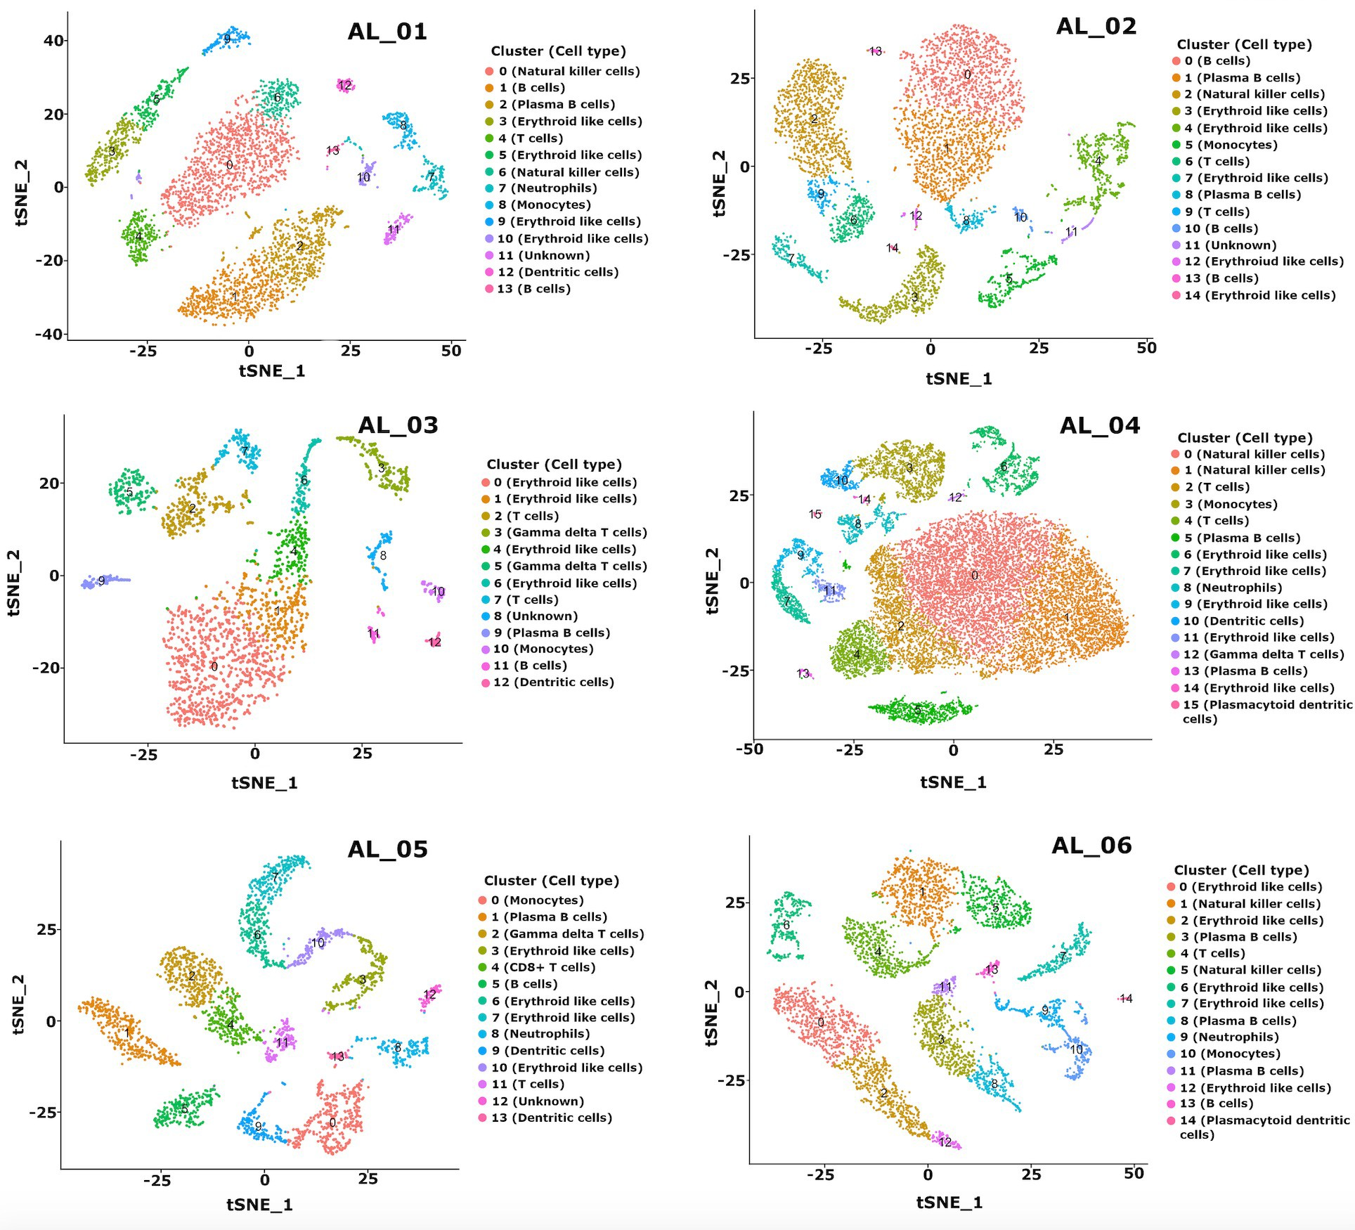

Supplementary Figure 1: Single cell RNA sequencing of BM-MNCs from amyloidosis patients revealing clusters of cells with identifiable plasma cell populations.

Supplementary Figure 2
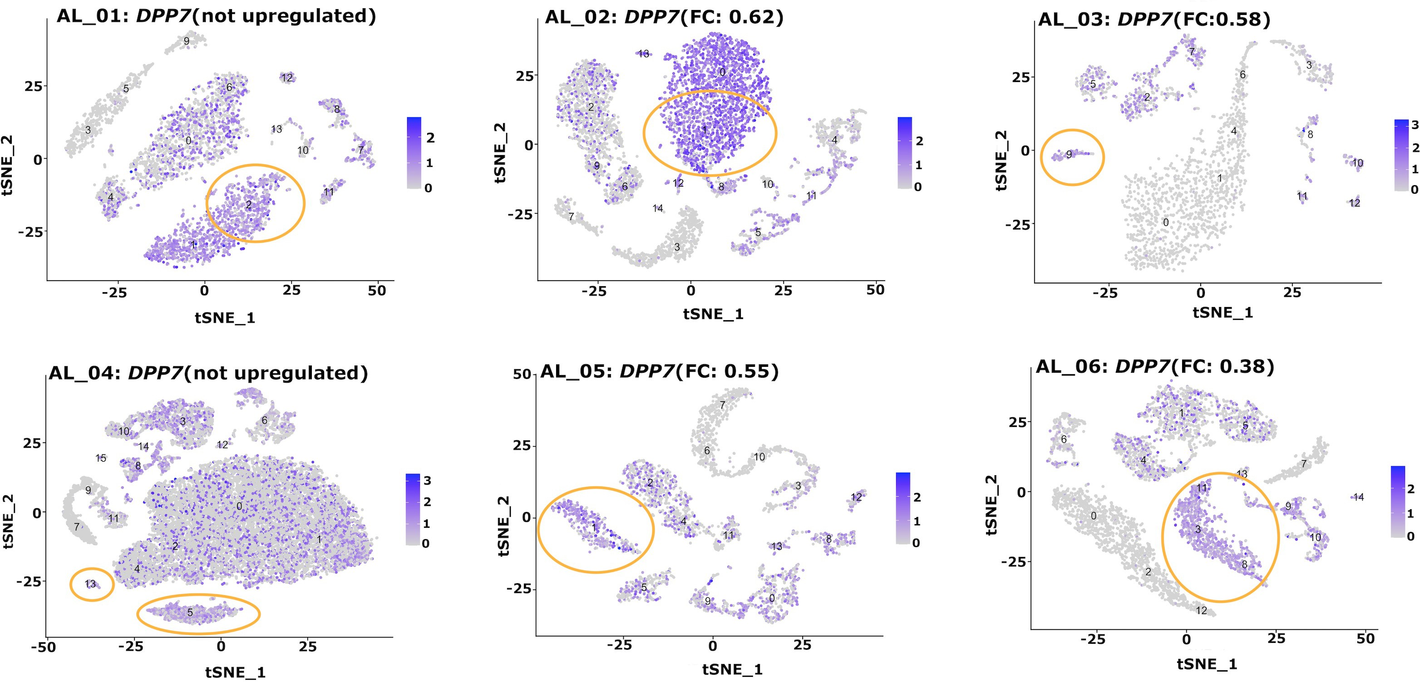
Supplementary Figure 2: Identification of over expression of DPP7 in plasma cell clusters of 4 of the 6 samples of in plasma cell clusters. Sample AL_01 and AL_04 demonstrated no increased expression of DPP7 in plasma cells compared to other cell clusters.
Supplementary Figure 3

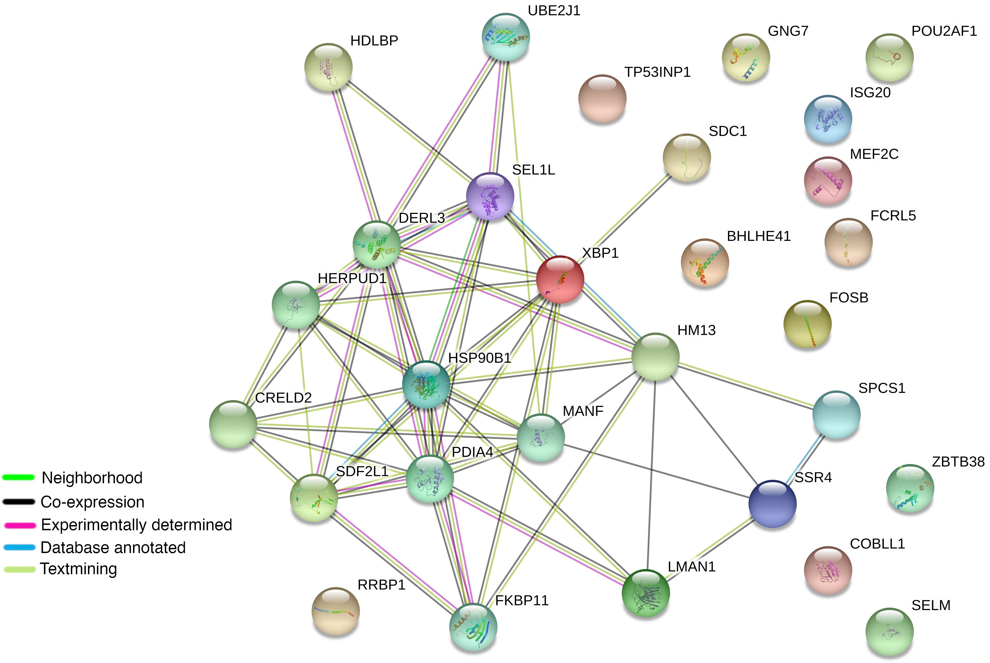

Supplementary Figure 3: Protein-protein interaction (PPI) analysis from 30 genes found to be over expressed in plasma cell clusters by scRNAseq analysis revealed significant functional associations.

Supplementary Figure 4

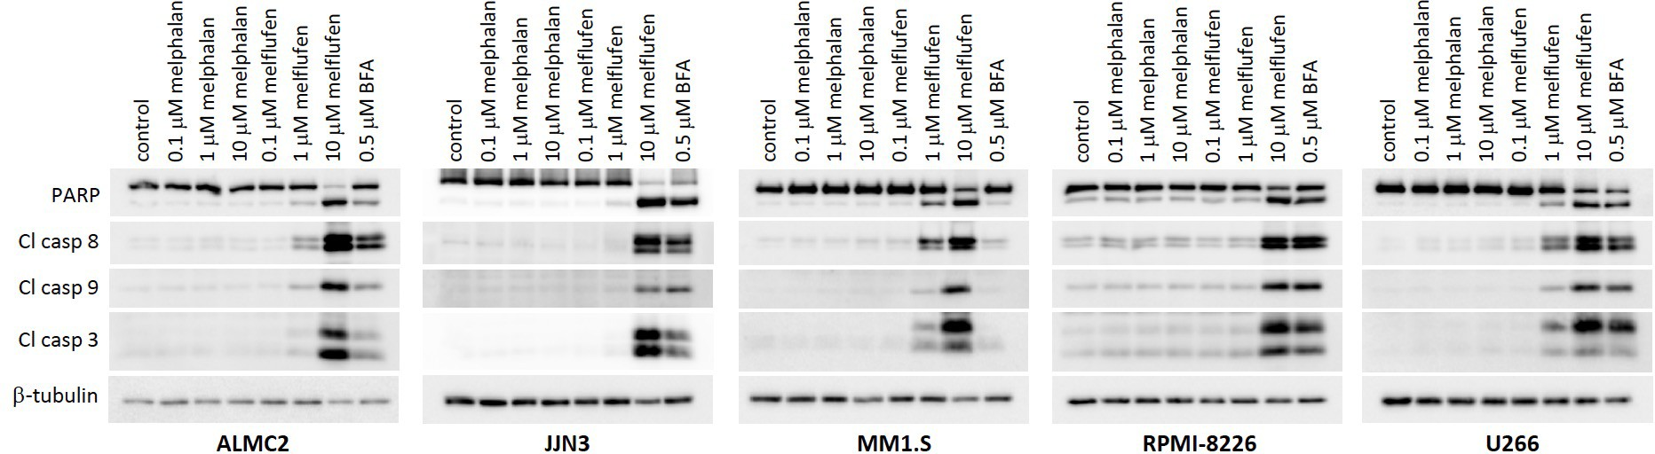

Supplementary Figure 4: Melflufen mediates cellular events associated with apoptosis within 6 hours. The indicated cells were incubated in the presence of melphalan or melflufen (with Brefeldin A as a positive control) for 6 hours and cells were harvested and analyzed cleavage of PARP, or caspase 3, 8 and 9 as indicated, by immunoblot analysis, with β-tubulin as a loading control.

Supplementary Table 1
Characteristics of amyloidosis patients used for ex vivo analysis of melflufen and melphalan sensitivity.

Sample ID | Disease  status | Age | Gender | Light chain  type | FISH findings
AL_01 | Diagnosis | 61 | Female | lambda | t(11;14), Trisomy 11 and Del chr12
AL_02 | Diagnosis | 64 | Male | lambda | Del(13q) and Del(14q32)
AL_03 | Diagnosis | 72 | Male | lambda | Del in the 14q32 region
AL_04 | Diagnosis | 53 | Female | kappa | t(14;20) and Del(13q)
AL_05 | Diagnosis | 81 | Male | lambda | Not checked
AL_06 | Diagnosis | 63 | Female | kappa | Del(13q), Del(14q32), abnormal chr1

Supplementary Table 2
EC50 values (in uM) for melflufen and melphalan ex vivo sensitivity of plasma cells from amyloidosis patients.

Sample ID | Melphalan  EC50 | Melflufan  EC50
AL_01 | ~7842 | ~66364
AL_02 | NA | 19.12
AL_03 | 6886 | 22.55
AL_04 | ~11656 | 15.34
AL_05 | ~9897 | 0.1833
AL_06 | 9514 | 0.3601

Supplementary Table 3
EC50 values for melflufen and melphalan sensitivity of light chain producing human cell lines, JJN3, ALMC1 and ALMC2.

 | ALMC-1 | ALMC-2 | JJN3
Melphalan | ND | ND | 5.4
Melflufen | 1.6 | 1.2 | 1.2

Supplementary Table 4
EC50 values for melflufen induction of apoptosis of plasma cells from cell lines. Melphalan treatment did not induce calculable EC50 values in any cell line tested.

 | ALMC2 | JJN3 | MM.1S | RPMI 8226 | U266
EC₅₀ (µM) | 0.77 | 1.84 | 2.14 | 1.54 | 2.5

Supplementary Table 5
PCR primers for CHOP quantification.

Gene | Primer sequence
CHOP | F: TCTTCACCACTCTTGACCCTGCTT  R: GTTCTTTCTCCTTCATGCGCTGCT
β-actin | F: ACGTTGCTATCCAGGCTGTGCTAT  R: TAATGTCACGCACGATTTCCCGC

