Supplemental File

Phase 1b dose-finding study of venetoclax with ibrutinib and rituximab in patients with relapsed/refractory diffuse large B-cell lymphoma (DLBCL)
Alessandra Petrillo, MD,¹ Andrew Ip, MD,^{1,2,3} Alexandra Della Pia, PharmD, MBA,^{1,4} Saravinder Gill, MD,¹ Joshua Zenreich,³ Martin Gutierrez, MD,^{1,3} Ann McNeill, APN,³ Tatyana Feldman, MD,^{1,2,3} Lori Leslie, MD,^{1,2,3} Andre Goy, MD^{1,2,3}
¹Hackensack University Medical Center, Hackensack, NJ
²Hackensack Meridian School of Medicine, Nutley, NJ
³John Theurer Cancer Center, Hackensack University Medical Center, Hackensack, NJ
⁴Ernest Mario School of Pharmacy at Rutgers University, Piscataway, NJ

Supplemental Methods
Inclusion Criteria
- Eastern Cooperative Oncology Group Performance Status </= 2.
- Histologically or cytologically confirmed diagnosis of advanced DLBCL.
- Ability and willingness to comply with the requirements of the study protocol
- Prior therapy: relapsed or refractory patients who have received one prior therapy are eligible. If treated with small molecule, washout therapy with a period of greater than 5x the half-life of the molecule. Patients who have previously received high-dose chemotherapy with peripheral stem cell support are eligible. Washout period of 21 days.
- Presence of at least one lymph node evaluable or mass measurable for response.
- Age greater than or equal to 18 years.
- Recovery from any previous treatment therapy.
- Laboratory parameters:
  - Absolute neutrophil count (ANC) 1000/mm³ independent of growth factor support (unless the treating physician deems the neutropenia is related to bone marrow involvement, then an ANC of > 750/mm³ is allowed)
  - Platelets 100,000/mm³ or 50,000/mm³ if bone marrow involvement independent of transfusion support in either situation
  - Total bilirubin ≤ 1.5 x ULN unless bilirubin rise is due to Gilbert’s syndrome or of non-hepatic origin
  - AST (SGOT) and ALT (SGPT) ≤ 3 x upper limit of normal (ULN)
  - Creatinine: CrCl 50 ml/min (calculated using Cockcroft-Gault Formula-Appendix 2) Prothrombin time (PT)or international normalized ratio and partial thromboplastin time (PTT) not to exceed 1.2 times the institution’s normal range
- Women of childbearing potential and men who are sexually active must be practicing a highly effective method of birth control during and after the study consistent with local regulations regarding the use of birth control methods for subjects participating in clinical trials. Men must agree to not donate sperm during and after the study. For females, these restrictions apply for 3 months after Venetoclax and 12 months after Rituximab For males, these restrictions apply for 3 months after the last dose of study drug.
- Women of childbearing potential must have a negative serum (beta-human chorionic gonadotropin [-hCG]) or urine pregnancy test at Screening. Women who are pregnant or breastfeeding are ineligible for this study.
- Sign (or their legally acceptable representatives must sign) an informed consent document indicating that they understand the purpose of and procedures required for the study, including biomarkers, and are willing to participate in the study
Exclusion Criteria
- Known central nervous system lymphoma.
- History of stroke or intracranial hemorrhage within 6 months prior to enrollment.
- Requires anticoagulation with warfarin or equivalent vitamin K antagonists (eg, phenprocoumon).
- Received the following agents within 7 days prior to the first dose of venetoclax or requires chronic treatment with strong CYP3A inhibitors (e.g., ketoconazole, ritonavir, clarithromycin, itraconazole, voriconazole), moderate CYP3A inhibitors (e.g., erythromycin, ciprofloxacin, diltiazem, fluconazole, verapamil), strong CYP3A inducers (e.g., carbamazepine, phenytoin, rifampin, St. John's wort) or moderate CYP3Ainducers (e.g., bosentan, efavirenz, etavirine). (See Appendix 4)
- Clinically significant cardiovascular disease such as uncontrolled or symptomatic arrhythmias, congestive heart failure, or myocardial infarction within 6 months of Screening, or any Class 3 (moderate) or Class 4 (severe) cardiac disease as defined by the New York Heart Association Functional Classification.
- Vaccinated with live, attenuated vaccines within 4 weeks of enrollment.
- Use of any other standard chemotherapy, radiation therapy, or experimental drug therapy for the treatment of DLBCL within 21 days of starting treatment
- Known history of human immunodeficiency virus (HIV) or active Hepatitis C Virus or active Hepatitis B Virus infection or any uncontrolled active systemic infection or human T-cell leukemia virus 1 (HTLV-1) seropositive status or a Child – Pugh Class of B or C.
- Any life-threatening illness, medical condition, or organ system dysfunction which, in the investigator’s opinion, could compromise the subject’s safety, interfere with the absorption or metabolism of ibrutinib capsules, venetoclax or rituximab or put the study outcomes at undue risk.
- History of uncontrolled or symptomatic angina
- Ejection fraction below the institutional normal limit
- History of other malignancy that could affect compliance with the protocol or interpretation of results
  - Patients with a history of curatively treated basal or squamous cell carcinoma of the skin or in situ carcinoma of the cervix are generally eligible. Patients with a malignancy that has been treated, but not with curative intent, will also be excluded, unless the malignancy has been in remission without treatment for 2 years prior to enrollment.
- Evidence of other clinically significant uncontrolled condition(s) including, but not limited to, uncontrolled systemic infection (viral, bacterial, or fungal)
- Major surgery (within 4 weeks prior to the start of the first dose of study treatment), other than for diagnosis
- Women who are pregnant or lactating
- Female patients who are not surgically sterile or postmenopausal (for at least 1 year) must practice at least one of the following methods of birth control throughout the duration of study participation and for at least 12 months after study treatment:
  - Total abstinence from sexual intercourse
  - A vasectomized partner
  - Hormonal contraceptives (oral, parenteral, vaginal ring, or transdermal) that started at least 3 months prior to study drug administration
  - Double-barrier method (condom diaphragm or cervical cup with spermicidal contraceptive sponge, jellies, or cream)
- Non-vasectomized male patients must comply with at least one of the following methods of birth control throughout the duration of study participation and for at least 12 months after study treatment:
  - A partner who is surgically sterile or postmenopausal (for at least 1 year) or who is taking hormonal contraceptives (oral, parenteral, vaginal ring, or transdermal) for at least 3 months prior to study drug administration
  - Total abstinence from sexual intercourse
  - Double-barrier method (condom diaphragm or cervical cup with spermicidal, contraceptive sponge, jellies, or cream)
- Malabsorption syndrome or other condition that precludes enteral route of administration
- Known allergy to both xanthine oxidase inhibitors and rasburicase
Maximum Tolerated Dose (MTD)
The MTD was defined as the highest dose of venetoclax with an observed incidence of dose limiting toxicities (DLTs) of less than 33% in the first 29 days of therapy with venetoclax, ibrutinib, and rituximab. A DLT was defined as any grade 2-4 hematologic or non-hematologic toxicity related to venetoclax. In the first-in-human single-agent study, the MTD of venetoclax was 1,200 mg for patients with DLBCL and follicular lymphoma. However, less than dose-proportional changes in plasma exposure of venetoclax were seen at higher doses (1). When given in combination with other therapies, the MTD of venetoclax ranges between 200 mg to 800 mg, and therefore, 800 mg was selected as the maximum dose for this study (2). Each cycle of combination therapy consisted of 28 days.
Response Assessment
Response was evaluated after cycles 2, 4 and 6 after initiation of treatment, and later every 3 cycles until disease progression, removal from study, or study termination. Radiological tumor assessment included chest CT/MRI, abdomen and pelvis CT/MRI, and PET scan evaluations every 2 cycles (based on investigator's criteria). Response evaluation used the Cheson Criteria 2014 (3).

Supplemental Tables
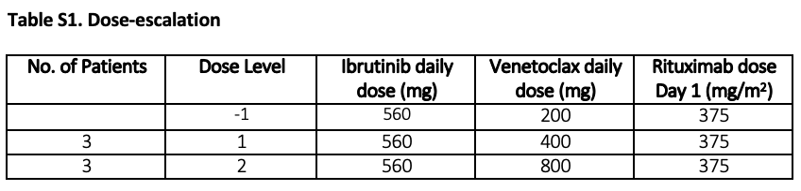
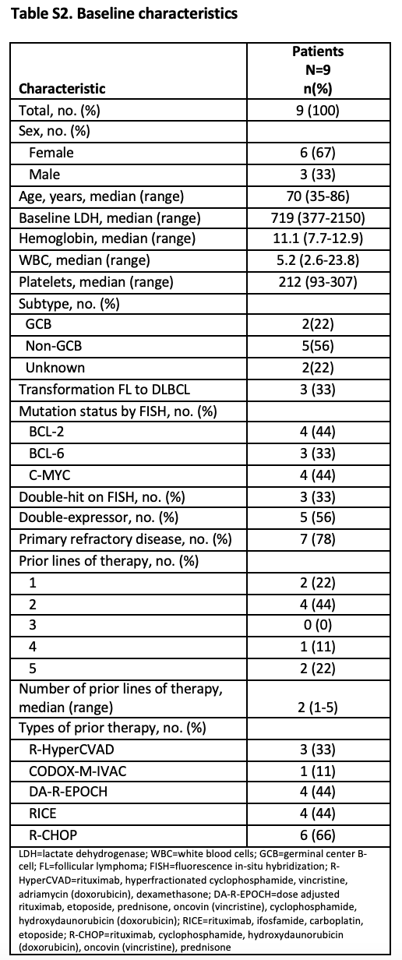

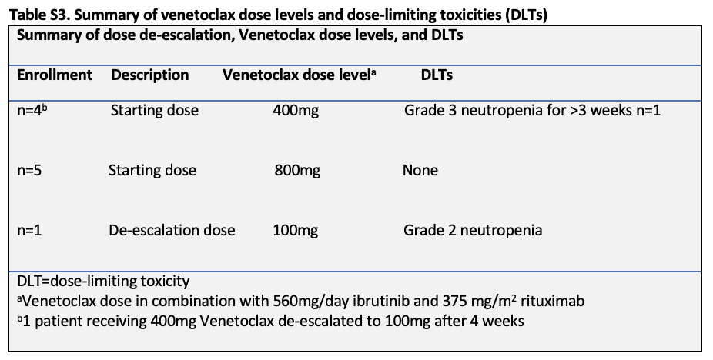

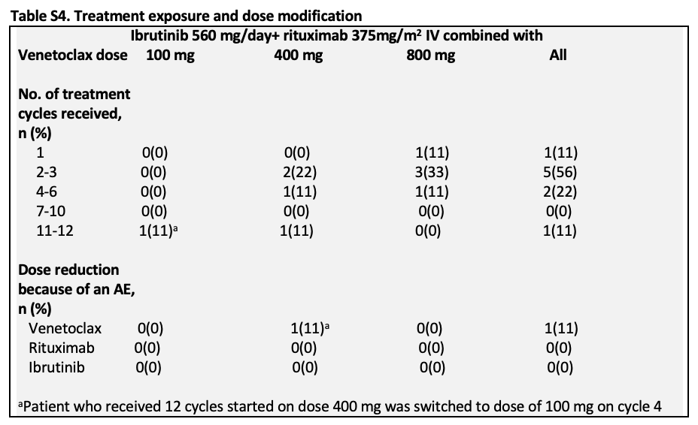

References
- Davids, M. S., Roberts, A. W., Seymour, J. F., et al. Phase I First-in-Human Study of Venetoclax in Patients With Relapsed or Refractory Non-Hodgkin Lymphoma. Journal of clinical oncology : official journal of the American Society of Clinical Oncology, 35(8), 826–833.
- Zelenetz AD, Salles G, Mason KD, et al. Venetoclax plus R- or C-CHOP in non-Hodgkin lymphoma: results from the CAVALLI phase 1b trial. Blood. 2019. 133(18): 1964–1976.
- Cheson BD, Fisher RI, Barrington SF, et al. Recommendations for initial evaluation, staging, and response assessment of Hodgkin and non-Hodgkin lymphoma: the Lugano classification. J Clin Oncol. 2014;32(27):3059-3068.

