Supplementary Digital Content File

Manuscript Title: Different gene sets are associated with azacitidine response in vitro and myelodysplastic syndrome patients

Manuscript Authors: Marguerite-Marie Le Pannérer, Jeannine Diesch, Raquel Casquero, Michael Maher, Olga Garcia, Torsten Haferlach, Johannes Zuber, Andrea Kündgen, Katharina S. Götze, Marcus Buschbeck

Supplementary Table S1

Results of shRNA screen
Gene.name | mean logFC AZA / untreated
CDY1B | -1.9684775
HDAC10 | -1.8563883
RNF40 | -1.79403
PCGF1 | -1.65212
BOP1 | -1.618008
PRDM9 | -1.609028
ATR | -1.586082
RPA1 | -1.571868
ERG | -1.5679633
CBX2 | -1.5138367
PARP16 | -1.511028
MCM5 | -1.473812
TADA3 | -1.4713233
BAHCC1 | -1.46677
MBD2 | -1.4483117
ACTL6A | -1.44777
METTL2B | -1.40923
ADPRH | -1.36103
APOBEC2 | -1.333872
SMN1 | -1.292944
CDY1 | -1.27898
COMMD3-BMI1 | -1.252568
KDM2B | -1.22677
SP110 | -1.2202271
EYA2 | -1.215744
DHX33 | -1.211902
MBTD1 | -1.189178
RUVBL2 | -1.175552
RUNX1 | -1.158752
DDX19B | -1.1540833
AURKB | -1.117082
PHF8 | -1.1156
DOT1L | -1.107182
DAXX | -1.106246
HDGF | -1.1051583
MYSM1 | -1.094018
L3MBTL2 | -1.093234
CDYL | -1.092738
SUV420H2 | -1.078686
MEN1 | -1.0723625
MTF2 | -1.072186
DHX38 | -1.0701683
KAT8 | -1.0699367
TADA2A | -1.0638
ZBTB33 | -1.06041
TRIM28 | -1.059908
MORC3 | -1.052252
YWHAQ | -1.051102
PARP2 | -1.0500086
DNMT1 | -1.047738
EIF4A1 | -1.0463433
BRWD1 | -1.04497
PARP10 | -1.039958
BAZ1A | -1.0308833
USP3 | -1.0284133
ZMYM3 | -1.027215
METTL7A | -1.023222
EED | -1.016012
SSRP1 | -1.011255
AKAP8 | -1.009242
TDRD12 | -1.003732
MTA2 | -1.0020617
CHD2 | -1.00157
SVEP1 | -1.00075
CREBBP | -0.9975783
DDX47 | -0.996254
FBXO10 | -0.9956043
PRDM4 | -0.994925
TFPT | -0.99374
NR0B2 | -0.988238
DHX15 | -0.983876
SMARCA5 | -0.9809375
APOBEC4 | -0.98053
TAF3 | -0.980444
BMI1 | -0.9798017
SETD4 | -0.9760829
PRDM6 | -0.96831
DHX58 | -0.964115
CARM1 | -0.951272
WDR82 | -0.9508917
VRK2 | -0.946378
DDX19A | -0.9410617
MORC1 | -0.939378
HDAC5 | -0.938386
SNRNP200 | -0.92763
CDK3 | -0.927025
USP46 | -0.921672
PRKDC | -0.920046
GATAD2A | -0.916284
PRMT6 | -0.906658
SRC | -0.9023867
PRDM5 | -0.899026
TDG | -0.8974817
UCHL5 | -0.895576
HDAC4 | -0.892114
ZHX2 | -0.8914983
PRDM12 | -0.887998
LNX1 | -0.885342
ING4 | -0.882965
TAF1 | -0.8827267
HJURP | -0.879302
TRIM13 | -0.879178
MACROD1 | -0.8742833
DDX24 | -0.8715033
BRD4 | -0.869475
METTL10 | -0.869385
MCM7 | -0.868865
NTMT1 | -0.8683171
UBE2C | -0.867828
SATB1 | -0.867608
L3MBTL3 | -0.8661057
CBX3 | -0.863148
HMGN2 | -0.85897
CTSL2 | -0.857845
CBX8 | -0.8508
DDX58 | -0.850042
SKIV2L | -0.8464167
GLYR1 | -0.8449083
KIF22 | -0.840152
PARP12 | -0.8385767
PHF21B | -0.8372433
RECQL4 | -0.830454
NONO | -0.8261267
SIAH2 | -0.8223583
PHRF1 | -0.820552
TBL1X | -0.8204767
HOXC11 | -0.819978
DQX1 | -0.81922
TDRD1 | -0.818574
SIN3A | -0.815922
PARP9 | -0.815128
SETD7 | -0.812358
CBX7 | -0.81129
PARG | -0.805736
BAZ1B | -0.797384
IGHMBP2 | -0.796935
DDX51 | -0.796524
FAM175A | -0.7929217
NAT10 | -0.792344
BRD8 | -0.792332
MTERF | -0.787804
TET1 | -0.784516
TDRD9 | -0.778852
UBR2 | -0.776058
MCRS1 | -0.775992
PKN1 | -0.774172
HDAC2 | -0.773036
FEN1 | -0.7726683
SUV420H1 | -0.7718329
DDX60 | -0.767688
JAK2 | -0.762795
SUB1 | -0.76157
RING1 | -0.75963
ELP2 | -0.758954
ATAT1 | -0.7579371
UBE2E3 | -0.757214
RNF2 | -0.755448
RPS6KA3 | -0.754652
ERCC6L2 | -0.7521486
SIRT2 | -0.748572
ADA | -0.74851
DPF2 | -0.748416
CHAF1A | -0.74783
FKBP1A | -0.746815
NNMT | -0.744914
SMARCC1 | -0.741546
SP140 | -0.740926
HIRA | -0.73763
RBL1 | -0.734398
KDM4E | -0.734106
PSIP1 | -0.7308983
HDAC8 | -0.730838
METTL12 | -0.7293329
PRKCB | -0.727824
DTX3L | -0.72686
MDC1 | -0.71842
PADI2 | -0.7085457
GSG2 | -0.703038
NAP1L3 | -0.702052
DDX3Y | -0.700172
CHRAC1 | -0.69956
ZNF519 | -0.69798
ASH1L | -0.691284
ASMT | -0.690882
DMTF1 | -0.689734
SUPT16H | -0.6867825
ZNF787 | -0.68136
NCOA1 | -0.6813017
GPS2 | -0.67902
BRPF1 | -0.6744314
BRIP1 | -0.671135
AICDA | -0.6706333
C14orf169 | -0.67023
PCGF6 | -0.668248
ZMYND11 | -0.6680933
SMARCB1 | -0.6679483
DNAJC1 | -0.6636486
ATF2 | -0.66315
PADI6 | -0.6629683
SMARCAL1 | -0.659718
NCOR2 | -0.659355
LRWD1 | -0.6581733
ZCWPW2 | -0.6577013
HNRNPA0 | -0.6567371
SFMBT2 | -0.65492
GDAP2 | -0.650594
PRMT2 | -0.649284
MYPOP | -0.644888
UBR7 | -0.6407743
NSUN6 | -0.6388443
DHX8 | -0.637378
SMARCC2 | -0.636165
TP53BP1 | -0.6355533
UBA7 | -0.634175
HMGN5 | -0.63004
PSD3 | -0.62954
MPHOSPH8 | -0.629146
FXR1 | -0.629088
YTHDC2 | -0.627666
FUS | -0.6252157
LMNB1 | -0.62298
ATAD2 | -0.6201
UBE2A | -0.619238
POLE3 | -0.618138
GATAD2B | -0.610286
HMGN1 | -0.6094014
SP140L | -0.60809
DDX10 | -0.605315
RPS6KA5 | -0.603635
PARP11 | -0.598466
DHX40 | -0.5983633
PHF19 | -0.591374
BCL6 | -0.5898983
ATAD2B | -0.58448
UIMC1 | -0.582756
CDK5 | -0.5798971
RECQL | -0.577075
MLL3 | -0.5766
KAT6A | -0.5764233
MINA | -0.576216
SMYD2 | -0.57563
DNMT3B | -0.57274
CHD6 | -0.5726857
ELP4 | -0.567325
PARP3 | -0.56181
DHX57 | -0.5602267
RFXANK | -0.557796
ZRANB3 | -0.5505429
DDX56 | -0.545508
EIF4A2 | -0.5447486
USP13 | -0.54463
CSNK2B | -0.5444029
USP17L5 | -0.540152
JMJD6 | -0.538842
CBL | -0.538126
ERCC6 | -0.53392
TNKS | -0.53368
PRDM8 | -0.532016
DDX20 | -0.5251183
ZZZ3 | -0.520558
KDM5B | -0.5190167
KDM1B | -0.5185933
ZHX1 | -0.518345
BRCC3 | -0.514866
INTS12 | -0.51054
KDM4A | -0.510198
PARP8 | -0.5069033
SFMBT1 | -0.506535
HELQ | -0.50603
SETDB2 | -0.5026367
NSUN2 | -0.49818
SUPT7L | -0.49281
MIS18BP1 | -0.49264
PHC3 | -0.48977
UHRF1 | -0.48844
ASXL2 | -0.4876843
ESCO2 | -0.4839817
TCF20 | -0.481195
SETD8 | -0.4762833
SETMAR | -0.4761083
RCOR2 | -0.472546
GTF3C5 | -0.469762
MIER2 | -0.465866
PRKAA2 | -0.4642967
ATXN7 | -0.463936
CCDC79 | -0.45905
MECOM | -0.458822
PARP1 | -0.458532
PARP6 | -0.457448
RC3H1 | -0.45502
WIZ | -0.453304
NAT6 | -0.452926
G2E3 | -0.447154
OGT | -0.445164
FKBP5 | -0.4409467
PRDM1 | -0.4358983
CHD5 | -0.43333
MGMT | -0.431916
JHDM1D | -0.431562
NAP1L1 | -0.4310414
HMGN3 | -0.425242
MLLT6 | -0.423818
INO80E | -0.422652
DHX9 | -0.4146625
CUX1 | -0.4088
NCOA6 | -0.408236
ZBED5 | -0.4075771
USP12 | -0.40473
METTL13 | -0.400888
PRDM2 | -0.3998583
MACROD2 | -0.39737
BRD9 | -0.394225
HNRNPA2B1 | -0.392018
CSTL1 | -0.391604
PHC1 | -0.391438
PRDM15 | -0.3906867
ASF1A | -0.389504
METTL6 | -0.3888571
NBN | -0.386688
HMGA1 | -0.38033
BTAF1 | -0.3779667
BRE | -0.377662
HDAC6 | -0.377018
ECE2 | -0.373955
HLTF | -0.371352
GTF2B | -0.368712
TLE4 | -0.368552
SP100 | -0.3675733
MYBL1 | -0.367242
CHD9 | -0.366514
NCOA3 | -0.36565
ACTR5 | -0.3563263
MIER1 | -0.355478
PAXIP1 | -0.347712
INO80D | -0.346496
TAF12 | -0.3405233
RFWD2 | -0.33959
L3MBTL4 | -0.3388467
SBNO1 | -0.331224
NSUN7 | -0.328222
ENY2 | -0.3276817
RAG2 | -0.327446
TRIM24 | -0.32404
METTL11B | -0.30761
MTA3 | -0.303285
ZGPAT | -0.29751
TMPO | -0.290555
AKAP1 | -0.2903571
KAT2B | -0.2902767
YEATS4 | -0.2793967
CAMKMT | -0.2762533
CDC6 | -0.249616
TRIM5 | -0.237648
WDR77 | -0.225752
TLK1 | -0.211544
NUFIP1 | 0.133774
CALCOCO1 | 0.238528
GADD45B | 0.239975
CHD3 | 0.24018667
CBX5 | 0.266098
ALKBH3 | 0.274552
NSUN5 | 0.278965
BPTF | 0.28234
CAMK4 | 0.28278667
HMG20B | 0.28633167
TRIM66 | 0.319188
ZBTB40 | 0.329568
TDRKH | 0.33141167
RPH3A | 0.339798
PHF21A | 0.34409429
FAM175B | 0.34681
METTL20 | 0.349916
DDX43 | 0.352846
WNT5A | 0.36729
FIZ1 | 0.37604
ORC2 | 0.380392
HOMEZ | 0.38260571
RNF8 | 0.38953
RFX4 | 0.389868
SETD2 | 0.397355
ING1 | 0.399308
CDYL2 | 0.39980429
GTF3C4 | 0.407084
DDX4 | 0.41276
MLL5 | 0.41822167
RCOR3 | 0.42175
CDCA7L | 0.42221333
PBX1 | 0.428052
UBE2B | 0.432308
ATXN7L3 | 0.43403
PHF20L1 | 0.435114
TET3 | 0.43612
RCBTB1 | 0.43845
RERE | 0.4384925
SND1 | 0.45013
PRMT7 | 0.45919833
UBE3A | 0.45926
GON4L | 0.463256
USP35 | 0.464112
KDM3B | 0.47176667
L3MBTL1 | 0.473744
MUM1 | 0.476714
DDX52 | 0.477578
ASCC3 | 0.481096
ZNF740 | 0.48353833
UBE2N | 0.48435
BLM | 0.48615833
PCGF5 | 0.48857667
PHF15 | 0.493652
TDRD3 | 0.494698
VPS72 | 0.496832
NSD1 | 0.497444
USP22 | 0.49769
ZSCAN21 | 0.49779167
KIAA1045 | 0.501526
SIRT4 | 0.50639667
YY1 | 0.51137167
NEK9 | 0.5180825
PHC2 | 0.519456
KDM4D | 0.519818
SKIV2L2 | 0.520522
SIRT5 | 0.521988
ASAP1 | 0.531568
SNAPC4 | 0.53386
PRMT1 | 0.535548
HIF1AN | 0.53948714
NCOR1 | 0.54383
EZH2 | 0.548916
SAP30L | 0.54913429
MAEL | 0.55249286
SMARCAD1 | 0.55272667
TNRC18 | 0.554806
UBR3 | 0.555846
BRD1 | 0.56498
PRDM10 | 0.567872
DDX21 | 0.569074
DCTD | 0.569218
SMARCD3 | 0.572164
ZC3HAV1 | 0.57662833
JMJD4 | 0.57866333
WHSC1 | 0.58113667
TAF6L | 0.58259
BDP1 | 0.583544
GADD45A | 0.584522
WDR61 | 0.584542
MED1 | 0.585424
MORC4 | 0.589222
NFRKB | 0.591494
NSUN3 | 0.600362
KDM6A | 0.60108
PARP15 | 0.608438
SETD5 | 0.60896
JMJD1C | 0.61706571
PPIB | 0.617278
RBBP7 | 0.617704
ING2 | 0.619876
CHD8 | 0.62046
RBBP4 | 0.620664
RAG1 | 0.62651286
PHF16 | 0.627595
PRMT5 | 0.629782
CECR2 | 0.63344167
PBRM1 | 0.633834
BRWD3 | 0.634066
USP51 | 0.635182
C16orf53 | 0.638284
KIAA2026 | 0.63828714
ASF1B | 0.64561
MIS18A | 0.646604
SCML2 | 0.648318
SMYD5 | 0.648398
KDM6B | 0.653832
PPARGC1A | 0.654706
DNAJC2 | 0.65473833
RNF168 | 0.654842
SUPV3L1 | 0.655068
RPA3 | 0.66259
RNF20 | 0.665242
BABAM1 | 0.665585
BRD7 | 0.66637
RNF17 | 0.670876
TADA2B | 0.67095333
KDM2A | 0.67115833
HDGFL1 | 0.672062
NR2C1 | 0.673965
MCM3 | 0.675688
MLL | 0.67765667
SLK | 0.680842
DDX17 | 0.681044
DDX42 | 0.682078
ESCO1 | 0.687092
DHX29 | 0.69519833
UHRF2 | 0.69686833
PHF20 | 0.69832857
EYA1 | 0.6992
USP16 | 0.700932
GLI3 | 0.70212
MBD1 | 0.707574
DDX3X | 0.708322
TAF9 | 0.708962
MSL3 | 0.70984
ASXL1 | 0.711672
PPP4C | 0.715162
ZBTB12 | 0.715385
RPS19BP1 | 0.72056714
CXXC1 | 0.72171167
KDM3A | 0.72323667
ARID1B | 0.725382
UTY | 0.726758
SETDB1 | 0.72922571
PHF17 | 0.737048
APBB1 | 0.73915
ARID2 | 0.74405667
FTSJ3 | 0.74438
LCOR | 0.744762
SIRT3 | 0.74696143
MORF4L1 | 0.748912
JMJD7-PLA2G4B | 0.75259667
STAT5B | 0.75345833
SIRT6 | 0.75404714
BRCA1 | 0.754274
ING5 | 0.755398
CDK2AP1 | 0.75959
TRDMT1 | 0.760745
LMNA | 0.763978
POLR2B | 0.77304
BUB3 | 0.777036
PAX5 | 0.778214
FUBP3 | 0.77867333
LMNB2 | 0.77871833
C6orf130 | 0.779606
PRDM13 | 0.78281
SAP25 | 0.782854
MSL2 | 0.78309429
ZBTB9 | 0.78561286
ERCC5 | 0.786076
SETD3 | 0.786638
TBL1XR1 | 0.78854667
DDX11 | 0.795514
BRD3 | 0.796028
TET2 | 0.796418
CCDC101 | 0.79702
BRCA2 | 0.798526
HDAC3 | 0.79923
PHF6 | 0.79957
INO80C | 0.800155
FKBP2 | 0.801736
CHD7 | 0.80374
NAP1L2 | 0.805564
KDM1A | 0.811376
SF3B1 | 0.811874
PHF23 | 0.8129
DHX36 | 0.81537
NSUN4 | 0.821822
METTL8 | 0.82190667
PRMT8 | 0.82559167
SMARCE1 | 0.82604333
WRN | 0.828036
C14orf43 | 0.828864
DDX28 | 0.82983833
STK31 | 0.831795
AFF1 | 0.834325
CBX1 | 0.8365
NEDD4L | 0.838672
TSPYL2 | 0.838706
DPF1 | 0.83920667
KDM4B | 0.84126167
ZNF451 | 0.841745
PIAS1 | 0.84269
KAT6B | 0.843132
SMARCA2 | 0.84676
IKBKAP | 0.847776
YBX2 | 0.850764
C14orf93 | 0.850895
DMAP1 | 0.85409333
TRERF1 | 0.85478857
DNMT3L | 0.85635286
ACTL6B | 0.86272
MCM4 | 0.866698
MBD5 | 0.86868
SMARCA1 | 0.868836
UBE2I | 0.878722
NDUFAF5 | 0.87911333
HR | 0.88049
PRMT10 | 0.882325
UBR5 | 0.887848
RAI1 | 0.888392
DDX27 | 0.893795
EHMT1 | 0.899178
DDX6 | 0.90151
CDA | 0.905562
ASH2L | 0.90705125
SOX15 | 0.91041167
UBE2E1 | 0.911412
EP400 | 0.913315
UTP3 | 0.917168
EPC2 | 0.91831
TCP1 | 0.92105833
USF2 | 0.927488
SETD1B | 0.92950714
ZNF541 | 0.929758
ZMYM2 | 0.929825
HELLS | 0.933685
EMG1 | 0.93799833
EIF4A3 | 0.94021
SUV39H1 | 0.94027
DDX54 | 0.943625
DDX5 | 0.951025
SOX10 | 0.95983
KLHDC3 | 0.960302
HPRT1 | 0.969264
TLE1 | 0.97152667
DDX41 | 0.973106
KAT5 | 0.975758
DDX39B | 0.978672
MAP3K12 | 0.9788
POGZ | 0.986
DPY30 | 0.98792
ART1 | 0.989605
SIK1 | 0.99178833
ARID1A | 0.99222571
FBXW9 | 0.994245
BAHD1 | 0.994416
JARID2 | 1.01771143
WHSC1L1 | 1.020324
PRDM16 | 1.043404
MLL4 | 1.04496833
KDM8 | 1.04684167
PHF13 | 1.060628
KDM5D | 1.064752
PHIP | 1.066008
RPS6KA4 | 1.068886
DDX1 | 1.073698
CBX4 | 1.09476
MBD6 | 1.10097167
POLR1B | 1.10928
RAD54L2 | 1.115076
DHX16 | 1.11724
WBSCR27 | 1.119308
SIN3B | 1.12020667
PRDM11 | 1.1329
MYB | 1.134064
HDAC9 | 1.14666
CDC34 | 1.14687
SAP130 | 1.15010667
GTF2H1 | 1.15050667
PCGF2 | 1.151825
BCORL1 | 1.156682
ATOH1 | 1.156892
HNRNPA1 | 1.157175
ADAR | 1.16675167
GTF2F1 | 1.178176
BAZ2A | 1.18074833
SMARCD2 | 1.181084
NAA15 | 1.18849667
WDR5 | 1.189496
HCFC1 | 1.194672
ORC1 | 1.199822
HMGA2 | 1.20182
TRIM37 | 1.208512
HUWE1 | 1.219846
KEAP1 | 1.227966
FBXO11 | 1.23004
TAF5L | 1.242128
PHF12 | 1.25690286
MSH6 | 1.313894
UBR4 | 1.325288
EHMT2 | 1.32939571
FBXO17 | 1.348732
METTL2A | 1.37949
HDAC7 | 1.380272
RBBP5 | 1.401376
CDY2B | 1.4031125
MBD3 | 1.413504
NOC2L | 1.41865
SMARCA4 | 1.43164
PAX9 | 1.44152167
CHD4 | 1.46402
NAA10 | 1.474764
FBXL19 | 1.53445333
RUVBL1 | 1.535796
DDB1 | 1.563694
FLYWCH1 | 1.59535143
ERCC2 | 1.64447333
DDX46 | 1.816905
KAT2A | 1.85034
PHF5A | 2.306418
CDY2A | 3.27143

Supplementary Table S2

Clinical data MDS patient cohort. RCMD, refractory cytopenias with multilineage dysplasia; CMML2, chronic myelomonocytic leukemia type 2; RAEB, refractory anemia with excess blasts; MPD, myeloproliferative disorder; del, deletion; Tris, trisomy. IWG, international working group; HI, hematological improvement; HI-E, hematological improvement in erythroids; HI-N, hematological improvement in neutrophils; HI-P, hematological improvement in platelets; SD, stable disease; PD, progressive disease; CR, complete remission/response.
Sample.No.MLL | Nanostring.ID | Age Vidaza | Gender | Date diagnosis | WHO | Tris8 | X5q | chr7 | abnormal.karyotype | Response | Time.of.death | date.firstdiagnosis | Date.Vidaza.  Start | last.follow.up | Number.cycles.  AZA | Response.IWG | Comments
05-002017 | JD-1 | 72 | f | 30/8/03 | sAML/MDS | no | no | no | no | no | 15/2/07 | 30/8/03 | 17/11/05 | 15/2/07 | 5 | KM-CR
05-003477 | JD-2 | 81 | m | 20/12/05 | RAEB II | no | no | yes | yes | no | 20/3/07 | 20/12/05 | 9/1/06 | 20/3/07 | 3 | SD without HI
06-013375 | JD-4 | 78 | m | 28/12/06 | RAEB II | no | no | no | no | no | 20/4/07 | 28/12/06 | 16/1/07 | 20/4/07 | 3 | Failure/death due to infection
07-004170 | JD-5 | 75 | m | 30/3/07 | sAML/MDS | no | no | no | yes | yes | 30/12/08 | 30/3/07 | 23/4/07 | 30/12/08 | 6 | CR+CCR
07-006418 | JD-6 | 70 | m | 3/5/07 | RAEB II | no | no | no | no | yes | unknown | 3/5/07 | 13/6/07 | 31/10/07 | 5 | SD + HI-N
07-006554 | JD-7 | 65 | m | 13/6/06 | RAEB II | no | no | no | yes | no | 1/3/08 | 13/6/06 | 23/7/07 | 1/3/08 | 4 | SD without HI
07-009067 | JD-8 | 74 | f | 10/4/06 | sAML/MDS | no | no | yes | yes | no | 15/12/07 | 10/4/06 | 28/6/07 | 15/12/07 | 3 | Failure/progression
07-019138 | JD-10 | 74 | m | 28/9/05 | sAML/MDS | no | no | no | no | no | 27/2/09 | 28/9/05 | 14/1/08 | 27/2/09 | 8 | SD without HI
07-019907 | JD-11 | 71 | f | 12/12/07 | RAEB I | no | yes | no | yes | no | 20/8/08 | 12/12/07 | 4/2/08 | 20/8/08 | 4 | SD without HI
08-010265 | JD-12 | 74 | f | 2/11/02 | RCMD | yes | yes | no | yes | yes | 3/5/09 | 2/11/02 | 19/9/05 | 3/5/09 | 6 | SD + HI-E
08-016665 | JD-13 | 77 | m | 14/8/08 | CMML II | no | no | no | yes | no | 20/11/09 | 14/8/08 | 25/5/09 | 20/11/09 | 4 | SD without HI
09-004394 | JD-14 | 72 | f | 26/1/09 | RAEB II | no | yes | yes | yes | no | 17/8/09 | 26/1/09 | 17/3/09 | 17/8/09 | 4 | Failure/death due to infection
09-010307 | JD-15 | 68 | m | 10/1/08 | RAEB II | no | no | yes | yes | no | 10/10/10 | 10/1/08 | 7/12/09 | 10/10/10 | 5 | Failure/progression
09-015623 | JD-16 | 65 | f | 12/6/07 | sAML/MDS | no | yes | no | yes | no | 30/8/10 | 12/6/07 | 11/1/10 | 30/8/10 | 3 | SD
09-017511 | JD-17 | 84 | m | 21/5/08 | sAML/MDS | no | no | no | no | no | 16/1/11 | 21/5/08 | 5/8/09 | 16/1/11 | 20 | SD without HI
10-001154 | JD-18 | 77 | m | 14/1/10 | sAML/MDS | no | no | no | no | no | 20/1/11 | 14/1/10 | 1/2/10 | 20/1/11 | 8 | SD without HI
10-004703 | JD-19 | 73 | f | 22/4/08 | RAEB II | yes | no | no | yes | no | 24/9/10 | 22/4/08 | 2/6/08 | 24/9/10 | 5 | SD
10-010880 | JD-20 | 68 | f | 20/8/08 | CMML II | yes | no | no | yes | yes | 27/5/13 | 20/8/08 | 16/6/10 | 27/5/13 | 4 | SD + HI-E+P
10-026543 | JD-21 | 74 | f | 17/9/10 | MDS/MPD | no | no | yes | yes | no | 13/12/11 | 17/9/10 | 31/1/11 | 13/12/11 | 6 | SD without HI
10-029355 | JD-22 | 69 | f | 29/6/09 | RAEB II | no | no | no | no | yes | 31/1/12 | 29/6/09 | 26/1/10 | 31/1/12 | 17 | HI-P | Hb not assessable due to hemolysis
10-031857 | JD-23 | 71 | f | 3/2/09 | RAEB II | no | yes | no | yes | no | 9/3/11 | 3/2/09 | 24/11/10 | 9/3/11 | 3 | SD
11-001798 | JD-25 | 65 | m | 15/3/07 | sAML/MDS | no | no | no | yes | yes | xxx | 15/3/07 | 1/1/11 | 22/4/13 | 5 | HI-E, HI-P
11-002381 | JD-26 | 77 | m | 8/12/10 | RAEB I | no | no | no | no | yes | 21/1/13 | 8/12/10 | 4/7/11 | 21/1/13 | 16 | HI-E
11-004721 | JD-27 | 58 | f | 28/1/11 | sAML/MDS | no | no | no | no | no | xxx | 28/1/11 | 30/5/11 | 22/12/14 | 4 | SD without HI
11-008692 | JD-29 | 67 | m | 2/6/09 | sAML/MDS | no | no | no | yes | yes | xxx | 2/6/09 | 4/4/11 | 22/12/14 | 4 | SD+HI-N
11-019839 | JD-30 | 65 | f | 27/7/11 | tAML/MDS | no | no | no | no | yes | 23/11/11 | 27/7/11 | 16/8/11 | 23/11/11 | 3 | HI-P
11-022308 | JD-32 | 68 | m | 23/7/10 | pAML | no | no | no | no | no | xxx | 23/7/10 | 7/2/12 | 10/12/14 | 4 | SD | censored after allo
11-025179 | JD-34 | 81 | m | 8/11/06 | RAEB II | no | no | no | yes | no | 10/12/12 | 8/11/06 | 15/8/11 | 10/12/12 | 6 | SD without HI
11-025748 | JD-35 | 73 | m | 7/2/11 | RAEB II | no | no | no | no | no | 23/8/13 | 7/2/11 | 19/12/11 | 23/8/13 | 6 | SD
11-030187 | JD-36 | 65 | m | 23/7/07 | RAEB II | yes | no | no | yes | yes | 8/1/13 | 23/7/07 | 26/9/11 | 8/1/13 | 4 | SD + HI-E
11-031302 | JD-37 | 68 | f | 7/9/11 | RAEB I | no | no | no | yes | no | xxx | 7/9/11 | 29/9/11 | 24/11/14 | 4 | PD | AML progression, CR after allo
11-031667 | JD-38 | 72 | m | 4/8/09 | RAEB I | no | yes | yes | yes | yes | 5/11/11 | 4/8/09 | 9/9/09 | 5/11/11 | 25 | HI-P | recurrence due to therapy break, 2.response with lenalidomid
11-035065 | JD-39 | 68 | m | 28/1/09 | tAML/MDS | no | no | no | no | yes | 23/11/12 | 28/1/09 | 13/12/10 | 23/11/12 | 14 | HI-P, HI-N
11-035988 | JD-40 | 69 | f | 29/6/07 | RAEB II | no | no | no | no | yes | xxx | 29/6/07 | 21/2/12 | 9/7/13 | 9 | PR
11-038468 | JD-41 | 77 | f | 16/11/10 | tAML/MDS | no | no | no | no | yes | 11/1/13 | 16/11/10 | 28/12/10 | 11/1/13 | 15 | PR | recurrence due to therapy break (Chemo CCC)
11-044820 | JD-42 | 50 | m | 29/12/11 | RAEB II | no | yes | no | yes | no | xxx | 29/12/11 | 16/1/12 | 22/12/14 | 3 | PD | CR after allo

Supplementary Table S3

Mutation status MDS patient cohort
MLL.ID | Nanostring.ID | Gene | Nucleotide change | Aminoacid change | Load | Gene | Nucleotide change | Aminoacid change | Load | Gene | Nucleotide change | Aminoacid change | Load
05-002017 | JD-1 | DNMT3A | c.1627G>T | p.Gly543Cys | 46 | KRAS | c.36_38dupTGG | p.Gly13dup | 7 | NRAS | c.35G>T | p.Gly12Val | 6
 |  | SRSF2 | c.284C>G | p.Pro95Arg | 33 | TET2 | c.2800G>T  c.3622A>T | p.Gly934*  p.Lys1208* | 27  50
05-003477 | JD-2 | ASXL1 | c.1773C>A  c.2388G>A | p.Tyr591*  p.Trp796* | 20  26 | SRSF2 | c.284_307del | p.Pro95_Arg102del | 40
06-013375 | JD-4 | ASXL1 | c.1934dup | p.Gly646Trpfs*12 | 16 | IDH1 | c.395G>A | p.Arg132His | 43 | SRSF2 | c.284C>A | p.Pro95His | 43
07-004170 | JD-5 | RUNX1 | c.307G>T | p.Val103Phe | 57 | SF3B1 | c.1998G>T | p.Lys666Asn | 43
07-006418 | JD-6 | ASXL1 | c.1934dup | p.Gly646Trpfs*12 | 15 | RUNX1 | c.606_607delinsAT  c.1345delinsAGGACCCT | p.Gln203*  p.Val449Argfs*126 | 38  28 | TET2 | c.986_987insC | p.Glu330* | 39
07-006554 | JD-7 | ASXL1 | c.1774C>T | p.Gln592* | 51 | SRSF2 | c.284C>T | p.Pro95Leu | 61 | TP53 | c.723del | p.Cys242Alafs*5 | 82
07-009067 | JD-8 | DNMT3A | c.2150A>G  c.2651C>T | p.Asn717Ser  p.Ala884Val | 48  45 | TET2 | c.822del  c.3732_3733del | p.Asn275Ilefs*18  p.Tyr1245Leufs*22 | 56  45
07-019138 | JD-10 | ASXL1 | c.1934dup | p.Gly646Trpfs*12 | 17 | IDH1 | c.394C>T | p.Arg132Cys | 22 | IDH2 | c.419G>A | p.Arg140Gln | 6
 |  | RUNX1 | c.428-2A>G | p.splice site mutation | 42 | SRSF2 | c.284C>G | p.Pro95Arg | 44 | TET2 | c.2689C>T  c.3755T>C | p.Gln897*  p.Leu1252Pro | 50  46
07-019907 | JD-11 | TP53 | c.946_967del  c.714dup | p.Pro316Trpfs*22  p.Asn239* | 46  43
08-010265 | JD-12 | NRAS | c.37G>C | p.Gly13Arg | 45
08-016665 | JD-13 | ASXL1 | c.1585C>T | p.Gln529* | 45 | EZH2 | c.100del | p.Arg34Glufs*5 | 91 | TET2 | c.4481C>G | p.Ser1494* | 46
 |  | TP53 | c.733G>A | p.Gly245Ser | 48
09-004394 | JD-14 | TP53 | c.732del  c.375+1G>A  c.314_375del | p.Gly245Alafs*2  p.splice site mutation  p.Gly105Valfs*23 | 43  28  11
09-010307 | JD-15 | SRSF2 | c.284C>T | p.Pro95Leu | 33 | TET2 | c.3824G>T | p.Gly1275Val | 93
09-015623 | JD-16 | IDH2 | c.419G>A | p.Arg140Gln | 24 | RUNX1 | c.416_417insGGCA | p.Ser140Alafs*47 | 10 | SF3B1 | c.2098A>G | p.Lys700Glu | 41
 |  | TP53 | c.763A>T | p.Ile255Phe | 4
09-017511 | JD-17 | IDH1 | c.394C>T | p.Arg132Cys | 5 | NRAS | c.35G>A  c.35G>T | p.Gly12Asp  p.Gly12Val | 4  7 | RUNX1 | c.412_413dup | p.Arg139Valfs*11 | 13
 |  | SRSF2 | c.284C>T | p.Pro95Leu | 38
10-001154 | JD-18 | ASXL1 | c.1934dup | p.Gly646Trpfs*12 | 28 | SRSF2 | c.283C>A | p.Pro95Thr | 45 | TET2 | c.3851C>T  c.3781C>T | p.Ser1284Phe  p.Arg1261Cys | 49  47
10-004703 | JD-19 | RUNX1 | c.955del | p.Arg319Alafs*248 | 37 | SRSF2 | c.284C>A | p.Pro95His | 44
10-010880 | JD-20 | ASXL1 | c.1934dup | p.Gly646Trpfs*12 | 26 | NRAS | c.38G>A | p.Gly13Asp | 42 | RUNX1 | c.235T>A | p.Trp79Arg | 80
10-026543 | JD-21 | ASXL1 | c.1934dup | p.Gly646Trpfs*12 | 16 | DNMT3A | c.875T>C | p.Ile292Thr | 46 | EZH2 | c.81_84del | p.Arg27Serfs*11 | 56
 |  | KRAS | c.34G>C | p.Gly12Arg | 4 | NRAS | p.Gly12Ser | 42,00 | 42 | TET2 | c.1771del  c.4706dup | p.Gln591Serfs*10  p.Tyr1569* | 49  46
10-029355 | JD-22 | ASXL1 | c.1934dup | p.Gly646Trpfs*12 | 50 | NRAS | c.35G>A | p.Gly12Asp |  | SRSF2 | c.284C>A | p.Pro95His | 38
10-031857 | JD-23 | IDH1 | c.394C>T | p.Arg132Cys | 31 | RUNX1 | c.1172T>G | p.Met391Arg | 50 | SF3B1 | c.2225G>A | p.Gly742Asp | 38
11-001798 | JD-25 | ASXL1 | c.1940_1941insCG | p.Gly649Valfs*54 | 40 | EZH2 | c.2069G>A | p.Arg690His | 32 | RUNX1 | c.146_147dupGC | p.Ser50Alafs*46 | 40
 |  | SRSF2 | c.284C>A | p.Pro95His | 43
11-002381 | JD-26 | RUNX1 | c.667_668insCG  c.133dup | p.Arg223Profs*5  p.Arg45Lysfs*66 | 3,5  18 | SF3B1 | c.1998G>T | p.Lys666Asn | 35 | SRSF2 | c.284C>T | p.Pro95Leu | 25
 |  | TET2 | c.3863G>A | p.Gly1288Asp | 40
11-004721 | JD-27 | ASXL1 | c.1900_1922del | p.Glu635Argfs*15 | 29
11-008692 | JD-29 | ASXL1 | c.1900_1922del | p.Glu635Argfs*15 | 39 | RUNX1 | c.513T>A  c.341_342insTA | p.Asp171Glu  p.Ala115Argfs*4 | 27  9 | SRSF2 | c.284C>T | p.Pro95Leu | 44
11-019839 | JD-30 | ASXL1 | c.3558del | p.Gly1187Valfs*30 | 10 | IDH2 | c.419G>A | p.Arg140Gln |  | SRSF2 | c.284C>A | p.Pro95His | 11
11-022308 | JD-32 | TET2 | c.3872G>A | p.Trp1291* | 34
11-025179 | JD-34
11-025748 | JD-35 | SRSF2 |  |  |  | TET2 | c.1469del  c.4500_4501insT | p.Ile490Asnfs*7  p.Gln1501Serfs*3 | 34  36
11-030187 | JD-36 | IDH2 | c.419G>A | p.Arg140Gln | 38,2 | SRSF2 | c.284C>T | p.Pro95Leu | 41,1
11-031302 | JD-37 | RUNX1 | c.520C>T | p.Arg174* | 42 | SRSF2 | c.284_307del | p.Pro95_Arg102del | 27
11-031667 | JD-38 | IDH1 | c. 395C>G | p.Arg132Gly | 25 | TP53 | c.614A>G | p.Tyr205Cys | 49
11-035065 | JD-39 | ASXL1
11-035988 | JD-40 | ASXL1 | c.1927_1928insA | p.Gly643Glufs*15 | 50
11-038468 | JD-41 | DNMT3A | c.2128T>A | p.Cys710Ser | 9
11-044820 | JD-42 | IDH1 | c.394C>T | p.Arg132Cys | 30

Supplementary Table S4

Nanostring codeset
Customer Identifier | Accession | Position | Target Sequence | Tm CP | Tm RP | Flags | HUGO Gene | NSID
ASXL1 | NM_015338.5 | 5796-5895 | GCAGGTGAATTCCTCTGCTTGACATCCTCCCTGTCACTTTGGACCCTATGGGAGTGGGCATCTCCACGCACCTGTGTATGTGAAAGTCATTTTACATTTC | 83 | 78 |  | ASXL1 | NM_015338.5:5795
BAZ1A | NM_013448.2 | 5095-5194 | CCCTCGTAACACAAGTGAAGCAAAAGCTGGAACTAGGCTTCAAGCATTTTTTCATATTCAGGCTCAAAAGCTTGGACTCCACGTCACACCCAGTAATGTG | 82 | 81 |  | BAZ1A | NM_013448.2:5094
BAZ1B | NM_032408.3 | 1861-1960 | TCGTCTTCTCTCTAGTGAAGATAGAGCTCGTCTCCCAGAAGAATTGCGAAGTCTTGTTCAAAAACGCTATGAACTTCTAGAGCACAAAAAGAGGTGGGCT | 80 | 82 |  | BAZ1B | NM_032408.3:1860
BCL2L10 | NM_020396.2 | 771-870 | TTTTATCTGAATGCATACAAGGAGTCCTGAGGTGGTGATTTGGCCAGTGTTTTAACTTGTGACAAGTACTCAGGTGTGAGGACAAGAATGCAAATGGCTC | 80 | 83 |  | BCL2L10 | NM_020396.2:770
CDA | NM_001785.2 | 323-422 | AATCTTCAAAGGGTGCAACATAGAAAATGCCTGCTACCCGCTGGGCATCTGTGCTGAACGGACCGCTATCCAGAAGGCCGTCTCAGAAGGGTACAAGGAT | 86 | 86 |  | CDA | NM_001785.2:322
CHRAC1 | NR_023360.2 | 368-467 | TTTTAGCTAGTAAATACCTGAAAATGCTTAAAGAGGAAAAGAGGGAAGAAGATGAGGAGAATGACAATGATAATGAAAGTGACCATGATGAAGCTGACTC | 79 | 85 |  | CHRAC1 | NR_023360.2:367
CREBBP | NM_004380.2 | 1302-1401 | GTGTCAGAGACGAGAGCAAGCAAACGGAGAGGTTCGGGCCTGCTCGCTCCCGCATTGTCGAACCATGAAAAACGTTTTGAATCACATGACGCATTGTCAG | 84 | 81 |  | CREBBP | NM_004380.2:1301
DNMT1 | NM_001379.2 | 1496-1595 | CAAAACCAATCTATGATGATGACCCATCTCTTGAAGGTGGTGTTAATGGCAAAAATCTTGGCCCCATAAATGAATGGTGGATCACTGGCTTTGATGGAGG | 81 | 83 |  | DNMT1 | NM_001379.2:1495
DNMT3A | NM_022552.4 | 2057-2156 | GGCGAGAGGACTGGCCCTCCCGGCTCCAGATGTTCTTCGCTAATAACCACGACCAGGAATTTGACCCTCCAAAGGTTTACCCACCTGTCCCAGCTGAGAA | 83 | 83 |  | DNMT3A | NM_022552.4:2056
EP300 | NM_001362843.2 | 438-537 | GGGCCGCCTTCAGCCAAGCGGCCTAAACTCTCATCTCCGGCCCTCTCGGCGTCCGCCAGCGATGGCACAGATTTTGGCTCTCTATTTGACTTGGAGCACG | 93 | 82 |  | EP300 | NM_001362843.2:437
ERCC2 | NM_000400.2 | 241-340 | CATCTACTGCTCAAGAACTGTGCCAGAGATTGAGAAGGTGATTGAAGAGCTTCGAAAGTTGCTCAACTTCTATGAGAAGCAGGAGGGCGAGAAGCTGCCG | 81 | 81 |  | ERCC2 | NM_000400.2:240
FBXO11 | NM_018693.2 | 201-300 | TGCAGATATGGTTGCAGAAGAATCAGGTCCTGGTGCACAAAATAGTCCATACCAACTTCGTAGAAAAACTCTTTTGCCGAAAAGAACAGCGTGTCCCACA | 84 | 80 |  | FBXO11 | NM_018693.2:200
FLYWCH1 | NM_020912.1 | 232-331 | GCCAGCGCCGTGACCCAGGTGTGGGGGATGATGGTGACGCTTCTCACTCACGTGTGAAGGACGGAACCACTGCACTCCAGGTTCCTTGCTGGGTGCTGAG | 83 | 83 |  | FLYWCH1 | NM_020912.1:231
GAPDH | NM_001256799.1 | 387-486 | GAACGGGAAGCTTGTCATCAATGGAAATCCCATCACCATCTTCCAGGAGCGAGATCCCTCCAAAATCAAGTGGGGCGATGCTGGCGCTGAGTACGTCGTG | 85 | 86 | HK | GAPDH | NM_001256799.1:386
GUSB | NM_000181.3 | 1900-1999 | CCGATTTCATGACTGAACAGTCACCGACGAGAGTGCTGGGGAATAAAAAGGGGATCTTCACTCGGCAGAGACAACCAAAAAGTGCAGCGTTCCTTTTGCG | 84 | 83 | HK | GUSB | NM_000181.3:1899
HELLS | NM_018063.3 | 2041-2140 | GATGGGTCCATGTCTTACTCAGAGAGAGAAAAAAACATGCACAGCTTCAACACGGATCCAGAGGTGTTTATCTTCTTAGTGAGTACACGAGCTGGTGGCC | 83 | 83 |  | HELLS | NM_018063.3:2040
IDH1 | NM_005896.3 | 419-518 | TATGATTTAGGCATAGAGAATCGTGATGCCACCAACGACCAAGTCACCAAGGATGCTGCAGAAGCTATAAAGAAGCATAATGTTGGCGTCAAATGTGCCA | 83 | 84 |  | IDH1 | NM_005896.3:418
IDH2 | NM_002168.2 | 945-1044 | CACCGGCTCATTGATGACATGGTGGCTCAGGTCCTCAAGTCTTCGGGTGGCTTTGTGTGGGCCTGCAAGAACTATGACGGAGATGTGCAGTCAGACATCC | 85 | 85 |  | IDH2 | NM_002168.2:944
MACROH2A1 | NM_001040158.1 | 546-645 | GTTGCTAGCGAAGAAGCGGGGATCCAAAGGAAAGTTGGAAGCCATCATCACACCACCCCCAGCCAAAAAGGCCAAGTCTCCATCCCAGAAGAAGCCTGTA | 79 | 83 |  | MACROH2A1 | NM_001040158.1:545
MACROH2A2 | NM_018649.2 | 1041-1140 | ACAGAAGCTGTCCTTAACCCAGAGTGACATCAGCCATATTGGCTCCATGAGAGTGGAGGGCATTGTCCACCCAACCACAGCCGAAATTGACCTCAAAGAA | 82 | 82 |  | MACROH2A2 | NM_018649.2:1040
MALSU1 | NM_138446.1 | 281-380 | CGCGGCAGATCATACTGGTCCCAAGTTTGACATCGATATGATGGTTTCACTTCTGAGGCAAGAAAATGCAAGAGACATTTGTGTGATCCAGGTTCCTCCA | 79 | 81 |  | MALSU1 | NM_138446.1:280
MRPL4 | NM_015956.2 | 767-866 | AAGTTACTACTACATGCTGCCCATGAAGGTGCGGGCGCTGGGTCTCAAAGTGGCACTGACCGTCAAGCTGGCCCAGGACGACCTGCACATCATGGACTCC | 89 | 92 |  | MRPL4 | NM_015956.2:766
MRPL52 | NM_178336.2 | 275-374 | AGGAAATGGACGCTGGATTACAAGCATGGCAGCTCAGGCAGCAGAAGTTGCAGGAAGAACAAAGGAAGCAGGAAAATGCTCTTAAACCCAAAGGGGCTTC | 82 | 83 |  | MRPL52 | NM_178336.2:274
MRPS26 | NM_030811.3 | 701-800 | CATGGCGGAAGAGTTGGCCCTGACCTGGAATAAAGCAGTTGGTGTTGCTTATGAGGAAGGTTCAGCCTTATCCAGCACAGCCTTCACGTTTTGCCCTCTG | 83 | 82 |  | MRPS26 | NM_030811.3:700
MRTO4 | NM_016183.3 | 309-408 | AGGCTTGGAATTGAAACAAAACCTGATAGAAGAGCTTCGGAAATGTGTGGACACCTACAAGTACCTTTTCATCTTCTCTGTGGCCAACATGAGGAACAGC | 83 | 83 |  | MRTO4 | NM_016183.3:308
NAA10 | NM_003491.3 | 990-1089 | CTTTCACAATAAATTCGCTCCGTGGCACTGGGGAACTTTGTGTGTGAGCGCGCGCACATTTAGAGGGTGTGTTTCTCCAGGTCCTCTGGTGGGGATGTGA | 80 | 84 |  | NAA10 | NM_003491.3:989
NAA15 | NM_057175.3 | 4146-4245 | GTGGAAACAGAGGTGCAAGCCAGAGGCAATGTAATATGCTGTAAGGCTAGTGCAGATGGGAGCTTTTTAGAAGGGGCTAAGTGCTGGTGTCAGGGAAATT | 82 | 81 |  | NAA15 | NM_057175.3:4145
NSUN3 | NM_022072.3 | 311-410 | GGAAAAGGATTTACATTTGAAGGGCTATCACACACTCTCTCAGGGATCTTTACCCAACTATCCTAAATCAGTGAAGTGTTACCTTAGCAGAACTCCGGGC | 81 | 84 |  | NSUN3 | NM_022072.3:310
POLE3 | NR_027261.1 | 1408-1507 | AGACCCACTTGGCCCAAAACCTTTCTATATTGCCTGTAGATGATCGGCCTGCTGGTGTGGTAGTAATCTGATCACAGATATTCTTAAATCAGCAGTGTGG | 84 | 79 |  | POLE3 | NR_027261.1:1407
POLR1A | NM_015425.3 | 26-125 | AGCAATCATAAAATGGGAGGTTGCAAGCTCATGGTTTGAAAGACTTCGTCACGGAAGCTAAAAGCTCTATACACCCGATTTGCCTCGGAGGAATTTTCCT | 80 | 81 |  | POLR1A | NM_015425.3:25
POLR1B | NM_019014.3 | 3321-3420 | GGAGAACTCGGCCTTAGAATACTTTGGTGAGATGTTAAAGGCTGCTGGCTACAATTTCTATGGCACCGAGAGGTTATATAGTGGCATCAGTGGGCTAGAA | 81 | 80 |  | POLR1B | NM_019014.3:3320
POLR1C | NM_004875.2 | 271-370 | ATTGCCAATGCTTTTCGACGAATTCTGCTAGCTGAGGTGCCAACTATGGCTGTGGAGAAGGTCCTGGTGTACAATAATACATCCATTGTTCAGGATGAGA | 82 | 81 |  | POLR1C | NM_004875.2:270
POLR1E | NM_022490.1 | 1214-1313 | GCCAAAGCCATGAGGCTGAAGATCTCCAAAAGAAGGGTGTCTGTGGCCGCCGGCAGTGAAGAAGATCACAAACTGGGCACCCTGTCCCTCCCGCTGCCTC | 83 | 86 |  | POLR1E | NM_022490.1:1213
POLR3D | NM_001722.2 | 1718-1817 | CTTAAGCACTCGGTCCCAGCTTGCCAGTTCCTGGTTCTGTGTCCTTGGACAAACTACCTAACCTTTCTGAGCCTCCTATACCTCATCCGACACAAATGGG | 83 | 84 |  | POLR3D | NM_001722.2:1717
POLR3H | NM_138338.2 | 691-790 | GTGGACCCTACCAGCCTGCGGGAAGGTGGTATGGCCGGCTGTGAAGACAACAGCAGCTGAGGCCGATGCTAAGGAGATAGTGTCTCGAGCTGGACAGTGA | 83 | 83 |  | POLR3H | NM_138338.2:690
PWWP2B | NM_001098637.1 | 1145-1244 | CCCTGCCGGTGGGCTGGCGGACTTGTCTTCTGGAAGTTCGGGTGAGGACGATGACTTCAAGAGCTGTCCCCAGGGTCCACAGGGACGCGAGGGCTTGGCT | 87 | 87 |  | PWWP2B | NM_001098637.1:1144
RING1 | NM_002931.3 | 385-484 | GCCTCCACAGATTCTGCTCTGACTGCATTGTCACAGCCCTACGGAGCGGGAACAAGGAGTGTCCTACCTGCCGAAAGAAGCTGGTGTCCAAGCGATCCCT | 85 | 86 |  | RING1 | NM_002931.3:384
RIOX2 | NM_153182.3 | 499-598 | AGAAAAGGGCAACGATTCAGTTTCACCAACCTCAGAGATTTAAGGATGAGCTTTGGAGGATCCAGGAGAAGCTGGAATGTTACTTTGGCTCCTTGGTTGG | 81 | 82 |  | RIOX2 | NM_153182.3:498
RRM1 | NM_001033.3 | 2445-2544 | ACATCCACATTGCTGAGCCTAACTATGGCAAACTCACTAGTATGCACTTCTACGGCTGGAAGCAGGGTTTGAAGACTGGGATGTATTATTTAAGGACAAG | 83 | 83 |  | RRM1 | NM_001033.3:2444
RRM2 | NM_001034.1 | 491-590 | TTCCTTTTGGACCGCCGAGGAGGTTGACCTCTCCAAGGACATTCAGCACTGGGAATCCCTGAAACCCGAGGAGAGATATTTTATATCCCATGTTCTGGCT | 82 | 78 |  | RRM2 | NM_001034.1:490
RRP1 | NM_003683.5 | 247-346 | CTGCTGAAGGTGTGGAAAGGACTGTTTTATTGCATGTGGATGCAGGACAAGCCACTCCTCCAGGAAGAATTAGGAAGGACTATTTCCCAGCTCGTTCATG | 83 | 83 |  | RRP1 | NM_003683.5:246
RRP9 | NM_004704.3 | 1017-1116 | CATCGACTGCATCCACCTAATCAATGAGGAGCACATGGTGTCCGGCGCGGACGATGGCTCTGTGGCCTTGTGGGGTCTCTCCAAGAAGCGACCACTTGCC | 84 | 84 |  | RRP9 | NM_004704.3:1016
SLC28A3 | NM_001199633.1 | 826-925 | GACCTGTCTTATGGGGAATCGGGCTACAGTTTCTTCTTGGGCTCTTGATTCTAAGGACTGACCCTGGATTTATAGCTTTTGATTGGTTGGGCAGACAAGT | 79 | 80 |  | SLC28A3 | NM_001199633.1:825
SLC29A1 | NM_001078177.1 | 1726-1825 | GCCTCTGCATGTGCTTCGGGCCCAAGAAAGTGAAGCCAGCTGAGGCAGAGACCGCAGGAGCCATCATGGCCTTCTTCCTGTGTCTGGGTCTGGCACTGGG | 82 | 82 |  | SLC29A1 | NM_001078177.1:1725
SMARCA5 | NM_003601.2 | 2666-2765 | AACGAGAAAGAAAAGCCAACTATGCCGTTGATGCATATTTCAGGGAAGCTCTTCGTGTTAGTGAACCTAAAGCACCCAAGGCTCCTCGACCTCCAAAACA | 83 | 83 |  | SMARCA5 | NM_003601.2:2665
TET2 | NM_001127208.2 | 2883-2982 | CTCATAATGTCCAAATGGGACTGGAGGAAGTACAGAATATAAATCGTAGAAATTCCCCTTATAGTCAGACCATGAAATCAAGTGCATGCAAAATACAGGT | 81 | 79 |  | TET2 | NM_001127208.2:2882
TP53 | NM_000546.2 | 1331-1430 | GGGGAGCAGGGCTCACTCCAGCCACCTGAAGTCCAAAAAGGGTCAGTCTACCTCCCGCCATAAAAAACTCATGTTCAAGACAGAAGGGCCTGACTCAGAC | 81 | 79 |  | TP53 | NM_000546.2:1330
TUBB | NM_178014.2 | 1956-2055 | TTCTAAGTATGTCCATTTCCCATCTCAGCTTCAAGGGAGGTGTCAGCAGTATTATCTCCACTTTCAATCTCCCTCCAAGCTCTACTCTGGAGGAGTCTGT | 79 | 81 | HK | TUBB | NM_178014.2:1955
UCK1 | NM_031432.3 | 233-332 | GGAGTTGCTGGGACAGAACGAGGTGGAACAGCGGCAGCGGAAGGTGGTCATCCTGAGCCAGGACAGGTTCTACAAGGTCCTGACGGCAGAGCAGAAGGCC | 92 | 92 |  | UCK1 | NM_031432.3:232
UCK2 | NM_012474.3 | 731-830 | CAGTACATTACGTTCGTCAAGCCTGCCTTTGAGGAATTCTGCTTGCCAACAAAGAAGTATGCTGATGTGATCATCCCTAGAGGTGCAGATAATCTGGTGG | 79 | 83 |  | UCK2 | NM_012474.3:730

Supplementary Table S5

Nanostring results. RNA counts per gene probe and sample.
Probe Name | JD-1 | JD-10 | JD-11 | JD-12 | JD-13 | JD-14 | JD-15 | JD-16 | JD-17 | JD-18 | JD-19 | JD-2 | JD-20 | JD-21 | JD-22 | JD-23 | JD-25 | JD-26
ASXL1 | 130 | 137 | 178 | 212 | 193 | 373 | 178 | 289 | 335 | 170 | 148 | 212 | 185 | 117 | 436 | 306 | 325 | 252
BAZ1A | 278 | 104 | 777 | 1170 | 943 | 1256 | 284 | 382 | 447 | 693 | 450 | 1183 | 859 | 354 | 565 | 572 | 1090 | 1459
BAZ1B | 963 | 1201 | 1630 | 1455 | 1551 | 1562 | 999 | 983 | 1730 | 1066 | 1227 | 1570 | 1220 | 769 | 1272 | 1688 | 1825 | 1694
BCL2L10 | 12 | 7 | 14 | 9 | 23 | 17 | 9 | 12 | 6 | 7 | 8 | 10 | 18 | 15 | 34 | 23 | 13 | 7
CDA | 865 | 1792 | 6306 | 1958 | 2176 | 1122 | 2782 | 86 | 414 | 926 | 193 | 2328 | 3742 | 2988 | 1256 | 597 | 1686 | 5357
CHRAC1 | 1325 | 1639 | 2822 | 1485 | 863 | 2358 | 1354 | 3075 | 1839 | 958 | 1930 | 1035 | 1820 | 1714 | 2077 | 2722 | 2203 | 2525
CREBBP | 2088 | 4315 | 4418 | 1958 | 2419 | 3298 | 3974 | 2218 | 4551 | 1425 | 2036 | 2119 | 2489 | 2982 | 4172 | 3579 | 5271 | 6867
DNMT1 | 1751 | 1450 | 4264 | 1714 | 2172 | 5985 | 1601 | 1085 | 822 | 1718 | 2572 | 1839 | 2021 | 1674 | 2419 | 2929 | 1882 | 1528
DNMT3A | 356 | 284 | 699 | 822 | 953 | 937 | 418 | 807 | 1771 | 1025 | 926 | 726 | 589 | 529 | 1654 | 763 | 1066 | 1379
ERCC2 | 83 | 34 | 66 | 101 | 105 | 148 | 78 | 37 | 50 | 81 | 140 | 75 | 102 | 79 | 140 | 123 | 126 | 75
FBXO11 | 1551 | 2224 | 2595 | 1583 | 1631 | 2309 | 2128 | 3120 | 5599 | 1088 | 1789 | 1396 | 1732 | 2557 | 3115 | 3794 | 3695 | 5124
FLYWCH1 | 20 | 26 | 24 | 48 | 51 | 49 | 33 | 25 | 70 | 25 | 42 | 22 | 47 | 20 | 69 | 88 | 57 | 43
HELLS | 299 | 362 | 779 | 486 | 1005 | 791 | 301 | 457 | 305 | 451 | 733 | 703 | 715 | 492 | 1078 | 930 | 166 | 606
IDH1 | 870 | 299 | 1099 | 2261 | 1450 | 1646 | 476 | 531 | 873 | 1307 | 1891 | 499 | 1816 | 398 | 584 | 736 | 3794 | 903
IDH2 | 2701 | 2453 | 2977 | 2354 | 3891 | 3873 | 2634 | 1767 | 2558 | 2444 | 2820 | 2225 | 2411 | 2441 | 3752 | 4813 | 2365 | 2982
MACROH2A1 | 16116 | 16012 | 14401 | 8883 | 14624 | 11667 | 16548 | 7609 | 31178 | 14009 | 23459 | 10167 | 17591 | 23609 | 22405 | 14831 | 28649 | 21156
MACROH2A2 | 24 | 27 | 121 | 31 | 148 | 327 | 63 | 9 | 22 | 54 | 149 | 145 | 203 | 128 | 246 | 90 | 174 | 39
MALSU1 | 448 | 513 | 676 | 564 | 468 | 764 | 538 | 465 | 537 | 341 | 421 | 450 | 842 | 330 | 749 | 798 | 707 | 761
MRPL4 | 489 | 406 | 717 | 665 | 454 | 2027 | 333 | 685 | 329 | 485 | 936 | 419 | 607 | 455 | 792 | 1000 | 743 | 472
MRPL52 | 561 | 429 | 820 | 832 | 836 | 1892 | 512 | 565 | 605 | 521 | 864 | 584 | 990 | 685 | 742 | 899 | 1276 | 834
MRPS26 | 307 | 289 | 532 | 746 | 319 | 959 | 312 | 314 | 210 | 460 | 889 | 372 | 640 | 339 | 626 | 925 | 614 | 345
MRTO4 | 445 | 158 | 382 | 721 | 616 | 1795 | 313 | 316 | 217 | 593 | 1057 | 597 | 786 | 531 | 808 | 964 | 416 | 284
NAA10 | 8 | 12 | 30 | 9 | 11 | 8 | 9 | 15 | 22 | 7 | 11 | 7 | 7 | 7 | 6 | 16 | 7 | 7
NAA15 | 197 | 299 | 234 | 251 | 228 | 368 | 229 | 410 | 603 | 219 | 252 | 243 | 259 | 231 | 517 | 504 | 387 | 211
NSUN3 | 636 | 873 | 682 | 486 | 1235 | 1060 | 799 | 617 | 3120 | 752 | 1452 | 1613 | 2025 | 534 | 5313 | 2646 | 1725 | 4616
POLE3 | 2535 | 2908 | 4162 | 2231 | 1442 | 6357 | 2641 | 3376 | 4439 | 2105 | 2820 | 2133 | 4307 | 3025 | 3760 | 4219 | 3016 | 2702
POLR1A | 18 | 19 | 41 | 16 | 18 | 58 | 25 | 14 | 50 | 15 | 19 | 23 | 35 | 43 | 85 | 48 | 18 | 37
POLR1B | 187 | 189 | 307 | 323 | 230 | 432 | 188 | 268 | 202 | 266 | 347 | 214 | 349 | 109 | 469 | 493 | 212 | 194
POLR1C | 124 | 71 | 103 | 168 | 129 | 179 | 84 | 211 | 118 | 75 | 88 | 95 | 150 | 88 | 227 | 306 | 73 | 91
POLR1E | 79 | 41 | 61 | 114 | 107 | 181 | 61 | 33 | 171 | 105 | 180 | 101 | 172 | 69 | 198 | 144 | 62 | 71
POLR3D | 211 | 144 | 322 | 309 | 194 | 627 | 180 | 141 | 447 | 307 | 749 | 301 | 438 | 242 | 680 | 583 | 447 | 377
POLR3H | 111 | 51 | 143 | 225 | 220 | 538 | 104 | 84 | 42 | 115 | 180 | 217 | 277 | 75 | 171 | 228 | 166 | 159
PWWP2B | 34 | 41 | 90 | 56 | 94 | 53 | 47 | 100 | 202 | 80 | 94 | 41 | 70 | 94 | 64 | 116 | 161 | 157
RING1 | 595 | 339 | 1081 | 1019 | 871 | 2620 | 596 | 700 | 375 | 668 | 1324 | 936 | 821 | 756 | 1528 | 1744 | 1614 | 1269
RIOX2 | 116 | 36 | 113 | 483 | 263 | 451 | 93 | 89 | 121 | 241 | 952 | 150 | 253 | 133 | 429 | 425 | 611 | 244
RRM1 | 506 | 361 | 622 | 686 | 1006 | 1302 | 445 | 280 | 340 | 537 | 491 | 899 | 693 | 657 | 588 | 970 | 189 | 289
RRM2 | 2448 | 2681 | 7562 | 2951 | 7552 | 8225 | 3435 | 978 | 353 | 2736 | 810 | 4349 | 3680 | 7047 | 1501 | 6163 | 145 | 1659
RRP1 | 122 | 126 | 225 | 292 | 236 | 335 | 156 | 273 | 81 | 187 | 235 | 200 | 253 | 172 | 323 | 299 | 75 | 121
RRP9 | 37 | 24 | 26 | 84 | 84 | 114 | 31 | 26 | 18 | 54 | 85 | 75 | 59 | 50 | 78 | 70 | 59 | 67
SLC28A3 | 30 | 12 | 677 | 24 | 158 | 64 | 23 | 8 | 6 | 147 | 8 | 44 | 45 | 49 | 91 | 21 | 10 | 47
SLC29A1 | 321 | 277 | 498 | 346 | 665 | 1195 | 340 | 38 | 90 | 390 | 303 | 606 | 536 | 249 | 374 | 650 | 185 | 220
SMARCA5 | 2689 | 2314 | 4522 | 3497 | 3128 | 8758 | 3628 | 2218 | 4426 | 2610 | 4908 | 3259 | 4310 | 3806 | 6763 | 7133 | 4754 | 5603
TET2 | 2592 | 2776 | 3203 | 2545 | 2459 | 2650 | 4230 | 1916 | 5581 | 2192 | 3225 | 2213 | 3613 | 3403 | 6086 | 4502 | 11051 | 12569
TP53 | 740 | 328 | 197 | 1894 | 1192 | 590 | 627 | 350 | 316 | 1465 | 2230 | 587 | 1280 | 822 | 1244 | 1280 | 1674 | 1123
UCK1 | 240 | 417 | 636 | 327 | 326 | 514 | 287 | 474 | 531 | 170 | 389 | 251 | 465 | 325 | 503 | 460 | 649 | 698
UCK2 | 520 | 524 | 683 | 778 | 551 | 974 | 452 | 1107 | 563 | 618 | 795 | 587 | 901 | 514 | 1049 | 1198 | 231 | 293
EP300 | 431 | 783 | 834 | 352 | 597 | 698 | 819 | 506 | 697 | 204 | 259 | 442 | 358 | 747 | 683 | 737 | 858 | 998
GAPDH | 79761 | 112210 | 182257 | 53792 | 43129 | 75900 | 101885 | 89411 | 165074 | 61737 | 82047 | 55833 | 91774 | 173593 | 111888 | 90737 | 107144 | 65052
GUSB | 3363 | 4594 | 7147 | 3170 | 2514 | 3271 | 4059 | 3913 | 6232 | 3066 | 3429 | 2374 | 3426 | 3232 | 3905 | 2679 | 5560 | 4825
TUBB | 3543 | 2594 | 1667 | 3758 | 4739 | 3643 | 2935 | 3044 | 1912 | 3886 | 3474 | 5018 | 3477 | 3686 | 3051 | 4448 | 2143 | 2469

Probe Name | JD-27 | JD-29 | JD-30 | JD-32 | JD-34 | JD-35 | JD-36 | JD-37 | JD-38 | JD-39 | JD-4 | JD-40 | JD-41 | JD-42 | JD-5 | JD-6 | JD-7 | JD-8
ASXL1 | 179 | 272 | 778 | 230 | 137 | 259 | 131 | 392 | 197 | 490 | 229 | 320 | 508 | 284 | 236 | 156 | 181 | 364
BAZ1A | 203 | 515 | 1133 | 206 | 1123 | 250 | 344 | 624 | 361 | 1060 | 1788 | 1212 | 4672 | 1253 | 889 | 722 | 806 | 727
BAZ1B | 1253 | 1927 | 2986 | 1118 | 1005 | 1655 | 1231 | 2221 | 732 | 2428 | 1454 | 1635 | 2157 | 1631 | 1053 | 1198 | 1208 | 771
BCL2L10 | 5 | 6 | 14 | 15 | 10 | 4 | 8 | 5 | 20 | 31 | 13 | 33 | 27 | 14 | 5 | 10 | 12 | 49
CDA | 1149 | 2240 | 1588 | 4998 | 725 | 801 | 2047 | 1507 | 1250 | 6134 | 607 | 1447 | 13215 | 2951 | 739 | 955 | 3872 | 133
CHRAC1 | 1398 | 1493 | 4526 | 1505 | 1301 | 1887 | 1829 | 3027 | 1901 | 4112 | 1275 | 2894 | 5724 | 1666 | 1328 | 737 | 1178 | 2185
CREBBP | 2240 | 12449 | 10408 | 5616 | 997 | 5703 | 3539 | 8528 | 1783 | 11980 | 1397 | 5808 | 23549 | 2443 | 1471 | 1892 | 2665 | 3290
DNMT1 | 1942 | 1695 | 1773 | 794 | 1839 | 1011 | 1895 | 1913 | 1568 | 2062 | 2394 | 2023 | 1637 | 1877 | 1719 | 1911 | 1703 | 1959
DNMT3A | 378 | 787 | 1023 | 185 | 374 | 590 | 516 | 1514 | 1378 | 2034 | 754 | 951 | 2095 | 897 | 1140 | 361 | 841 | 3463
ERCC2 | 42 | 61 | 57 | 118 | 85 | 152 | 75 | 189 | 62 | 131 | 115 | 120 | 154 | 109 | 100 | 66 | 103 | 179
FBXO11 | 1418 | 4550 | 7779 | 4601 | 1067 | 4155 | 2184 | 6138 | 2391 | 5600 | 1177 | 4246 | 7526 | 1655 | 1191 | 972 | 1291 | 3418
FLYWCH1 | 9 | 6 | 138 | 21 | 9 | 63 | 23 | 112 | 33 | 122 | 28 | 40 | 77 | 26 | 60 | 18 | 23 | 34
HELLS | 611 | 686 | 599 | 636 | 351 | 474 | 452 | 554 | 452 | 516 | 654 | 333 | 393 | 811 | 596 | 609 | 704 | 597
IDH1 | 329 | 535 | 374 | 397 | 902 | 353 | 313 | 799 | 585 | 694 | 1545 | 3175 | 1776 | 1193 | 1763 | 796 | 378 | 1123
IDH2 | 4125 | 5629 | 3056 | 2902 | 3635 | 3685 | 3657 | 3903 | 2477 | 3451 | 3681 | 2989 | 2577 | 2903 | 2359 | 3726 | 2697 | 4007
MACROH2A1 | 9483 | 16878 | 16951 | 17550 | 15533 | 15766 | 14917 | 19312 | 14704 | 21955 | 12048 | 32504 | 40616 | 11987 | 20702 | 11485 | 13344 | 28142
MACROH2A2 | 12 | 252 | 121 | 33 | 100 | 22 | 88 | 70 | 37 | 108 | 275 | 100 | 89 | 23 | 95 | 25 | 178 | 474
MALSU1 | 426 | 686 | 1557 | 572 | 676 | 461 | 453 | 1051 | 220 | 1025 | 658 | 631 | 832 | 513 | 440 | 595 | 658 | 438
MRPL4 | 424 | 494 | 934 | 448 | 880 | 519 | 462 | 701 | 667 | 908 | 823 | 804 | 647 | 497 | 579 | 573 | 615 | 1152
MRPL52 | 427 | 1695 | 692 | 597 | 1062 | 649 | 485 | 925 | 429 | 934 | 796 | 1254 | 847 | 599 | 766 | 500 | 616 | 1107
MRPS26 | 271 | 393 | 767 | 309 | 488 | 246 | 302 | 575 | 452 | 619 | 748 | 523 | 539 | 598 | 576 | 381 | 436 | 949
MRTO4 | 419 | 444 | 782 | 276 | 1050 | 170 | 395 | 308 | 701 | 399 | 1029 | 373 | 300 | 499 | 608 | 697 | 735 | 1297
NAA10 | 7 | 6 | 24 | 5 | 8 | 27 | 6 | 5 | 9 | 6 | 14 | 6 | 23 | 5 | 8 | 7 | 10 | 23
NAA15 | 206 | 272 | 992 | 145 | 236 | 237 | 260 | 561 | 198 | 535 | 237 | 335 | 173 | 206 | 363 | 173 | 218 | 881
NSUN3 | 907 | 18351 | 3936 | 14097 | 502 | 8883 | 2970 | 20342 | 586 | 2787 | 836 | 8607 | 3744 | 2706 | 899 | 1803 | 1380 | 1297
POLE3 | 2525 | 2603 | 7550 | 2532 | 2489 | 3820 | 2781 | 3742 | 3020 | 3986 | 3182 | 2065 | 3366 | 2482 | 3041 | 2014 | 2754 | 3662
POLR1A | 18 | 131 | 20 | 42 | 20 | 58 | 39 | 91 | 25 | 56 | 17 | 58 | 50 | 14 | 17 | 32 | 18 | 31
POLR1B | 135 | 151 | 400 | 164 | 212 | 148 | 163 | 175 | 241 | 357 | 368 | 220 | 254 | 280 | 393 | 207 | 219 | 589
POLR1C | 96 | 6 | 309 | 127 | 117 | 98 | 69 | 133 | 208 | 136 | 160 | 70 | 58 | 99 | 141 | 99 | 68 | 371
POLR1E | 92 | 6 | 552 | 27 | 145 | 22 | 69 | 98 | 53 | 230 | 179 | 50 | 143 | 76 | 211 | 99 | 113 | 521
POLR3D | 250 | 666 | 874 | 145 | 203 | 434 | 226 | 855 | 242 | 873 | 466 | 596 | 451 | 323 | 592 | 238 | 442 | 1134
POLR3H | 239 | 222 | 193 | 94 | 225 | 94 | 170 | 147 | 226 | 169 | 317 | 135 | 173 | 194 | 272 | 187 | 181 | 279
PWWP2B | 37 | 182 | 243 | 70 | 21 | 116 | 49 | 161 | 96 | 127 | 70 | 188 | 162 | 90 | 148 | 25 | 43 | 202
RING1 | 841 | 1120 | 755 | 712 | 800 | 818 | 789 | 1696 | 1688 | 1703 | 940 | 1447 | 2480 | 1305 | 1021 | 673 | 1000 | 2101
RIOX2 | 130 | 182 | 402 | 97 | 198 | 85 | 153 | 350 | 105 | 528 | 292 | 293 | 574 | 273 | 402 | 193 | 197 | 699
RRM1 | 691 | 888 | 942 | 663 | 971 | 577 | 666 | 469 | 295 | 481 | 952 | 313 | 181 | 619 | 555 | 921 | 671 | 766
RRM2 | 5060 | 5518 | 3256 | 2908 | 5901 | 5072 | 3935 | 764 | 1231 | 847 | 4370 | 1727 | 682 | 5005 | 2741 | 6456 | 3708 | 2433
RRP1 | 117 | 151 | 408 | 151 | 252 | 116 | 159 | 329 | 335 | 282 | 293 | 323 | 223 | 263 | 358 | 216 | 175 | 455
RRP9 | 42 | 111 | 96 | 21 | 96 | 22 | 41 | 49 | 49 | 87 | 108 | 80 | 108 | 58 | 100 | 83 | 80 | 173
SLC28A3 | 9 | 61 | 67 | 73 | 195 | 22 | 14 | 5 | 18 | 19 | 200 | 33 | 35 | 23 | 62 | 37 | 94 | 37
SLC29A1 | 640 | 777 | 52 | 582 | 439 | 559 | 593 | 266 | 375 | 174 | 822 | 243 | 185 | 432 | 351 | 592 | 687 | 280
SMARCA5 | 3382 | 6800 | 9410 | 2254 | 2795 | 3269 | 3665 | 6965 | 3160 | 10015 | 4138 | 5843 | 12714 | 4153 | 2530 | 4372 | 4255 | 4920
TET2 | 1682 | 20853 | 8435 | 11126 | 2346 | 9885 | 4683 | 13223 | 1931 | 11204 | 2186 | 13209 | 27870 | 2255 | 1692 | 1220 | 3026 | 5398
TP53 | 821 | 1069 | 573 | 512 | 1277 | 689 | 629 | 1254 | 976 | 1234 | 1930 | 1850 | 1171 | 1305 | 1824 | 1452 | 115 | 3733
UCK1 | 275 | 565 | 1215 | 491 | 220 | 590 | 295 | 1093 | 329 | 887 | 253 | 428 | 1044 | 354 | 377 | 213 | 351 | 293
UCK2 | 327 | 353 | 215 | 248 | 822 | 286 | 523 | 266 | 646 | 249 | 1008 | 518 | 254 | 806 | 686 | 585 | 547 | 1749
EP300 | 414 | 1402 | 1773 | 1100 | 311 | 1637 | 644 | 1605 | 640 | 1935 | 249 | 1092 | 3112 | 529 | 355 | 411 | 499 | 460
GAPDH | 53505 | 71023 | 83287 | 117764 | 80105 | 56395 | 73852 | 71587 | 78145 | 79776 | 66200 | 113316 | 134796 | 64820 | 46158 | 44250 | 84772 | 112170
GUSB | 3457 | 3773 | 5377 | 4434 | 3277 | 3055 | 2822 | 4583 | 3461 | 4136 | 2416 | 3996 | 4503 | 3226 | 2901 | 2680 | 3125 | 1856
TUBB | 3447 | 3158 | 2216 | 2687 | 3636 | 3900 | 4221 | 2600 | 3443 | 2881 | 4931 | 2982 | 2646 | 3693 | 4107 | 4446 | 3813 | 6420

Supplementary data S1

Results of the overall survival analysis. Patients were divided into low (below median, blue) and high (above median, green) expression and the survival probability calculated. Statistical analysis was performed using the Log Rank (Mantel-Cox) test.

Medium and Median time of survival
ASXL1 recodified by median | Mediumª |  |  |  | Median
 | Estimation | Standard error | Confidence intervall of 95% |  | Estimation | Standard error | Confidence intervall of 95%
 |  |  | Lower limit | Upper limit |  |  | Lower limit | Upper limit
<=Median | 18.235 | 3.128 | 12.104 | 24.365 | 14.500 | 2.325 | 9.943 | 19.057
>Median | 24.087 | 3.731 | 16.775 | 31.400 | 20.567 | 3.214 | 14.268 | 26.865
Global | 21.031 | 2.418 | 16.292 | 25.770 | 17.633 | 3.011 | 11.733 | 23.534
a. The estimation is limited to the longest time of survival for censored samples.

p-value (logrank/Mantel-Cox) = 0.180
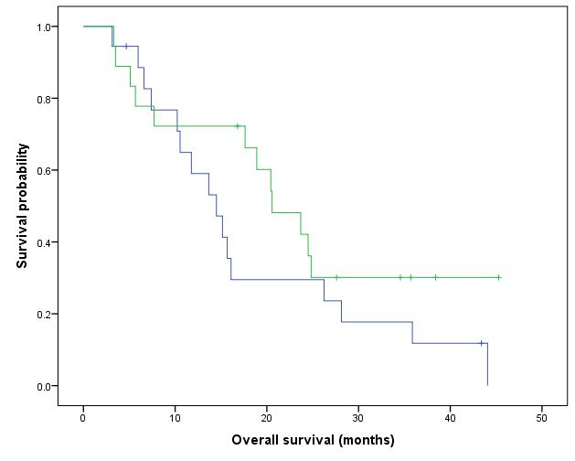
≤ Median

> Median

Medium and Median time of survival
BAZ1A recodified by median | Mediumª |  |  |  | Median
 | Estimation | Standard error | Confidence intervall of 95% |  | Estimation | Standard error | Confidence intervall of 95%
 |  |  | Lower limit | Upper limit |  |  | Lower limit | Upper limit
<=Median | 22.786 | 3.377 | 16.167 | 29.406 | 17.633 | 3.602 | 10.574 | 24.693
>Median | 19.256 | 3.480 | 12.435 | 26.078 | 16.100 | 4.392 | 7.491 | 24.709
Global | 21.031 | 2.418 | 16.292 | 25.770 | 17.633 | 3.011 | 11.733 | 23.534
a. The estimation is limited to the longest time of survival for censored samples.

p-value (logrank/Mantel-Cox) = 0.433

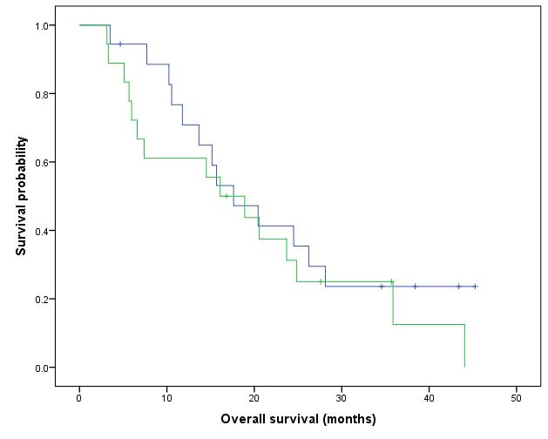
≤ Median

> Median

Medium and Median time of survival
BAZ1B recodified by median | Mediumª |  |  |  | Median
 | Estimation | Standard error | Confidence intervall of 95% |  | Estimation | Standard error | Confidence intervall of 95%
 |  |  | Lower limit | Upper limit |  |  | Lower limit | Upper limit
<=Median | 19.543 | 2.764 | 14.126 | 24.961 | 15.667 | 1.669 | 12.395 | 18.938
>Median | 22.434 | 3.895 | 14.800 | 30.068 | 18.900 | 2.751 | 13.507 | 24.293
Global | 21.031 | 2.418 | 16.292 | 25.770 | 17.633 | 3.011 | 11.733 | 23.534
a. The estimation is limited to the longest time of survival for censored samples.

p-value (logrank/Mantel-Cox) = 0.513

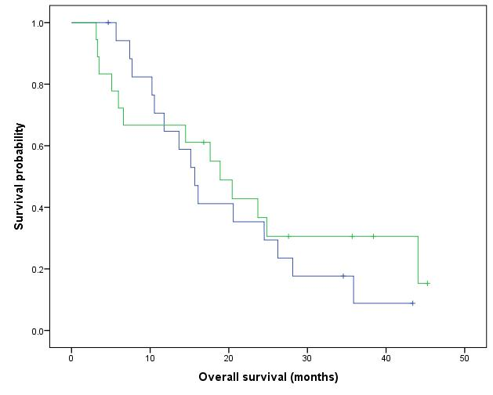
≤ Median

> Median

Medium and Median time of survival
BCL2L10 recodified by median | Mediumª |  |  |  | Median
 | Estimation | Standard error | Confidence intervall of 95% |  | Estimation | Standard error | Confidence intervall of 95%
 |  |  | Lower limit | Upper limit |  |  | Lower limit | Upper limit
<=Median | 22.890 | 3.118 | 16.778 | 29.002 | 17.633 | 2.218 | 13.286 | 21.981
>Median | 18.015 | 3.206 | 11.731 | 24.300 | 10.533 | 16.272 | .000 | 42.426
Global | 21.031 | 2.418 | 16.292 | 25.770 | 17.633 | 3.011 | 11.733 | 23.534
a. The estimation is limited to the longest time of survival for censored samples.

p-value (logrank/Mantel-Cox) = 0.479

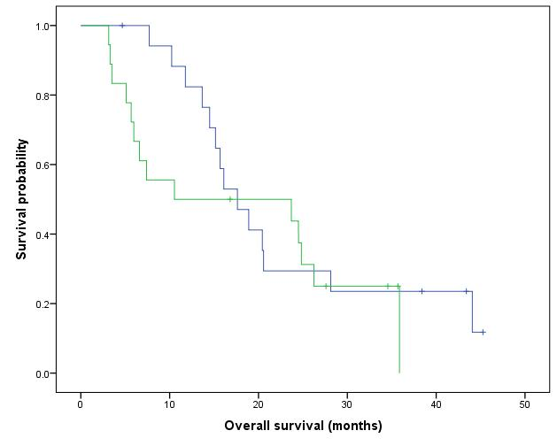
≤ Median

> Median

Medium and Median time of survival
CDA recodified by median | Mediumª |  |  |  | Median
 | Estimation | Standard error | Confidence intervall of 95% |  | Estimation | Standard error | Confidence intervall of 95%
 |  |  | Lower limit | Upper limit |  |  | Lower limit | Upper limit
<=Median | 18.966 | 3.043 | 13.003 | 24.930 | 17.633 | 3.358 | 11.051 | 24.215
>Median | 22.539 | 3.537 | 15.606 | 29.472 | 15.667 | 4.667 | 6.520 | 24.814
Global | 21.031 | 2.418 | 16.292 | 25.770 | 17.633 | 3.011 | 11.733 | 23.534
a. The estimation is limited to the longest time of survival for censored samples.

p-value (logrank/Mantel-Cox) = 0.521

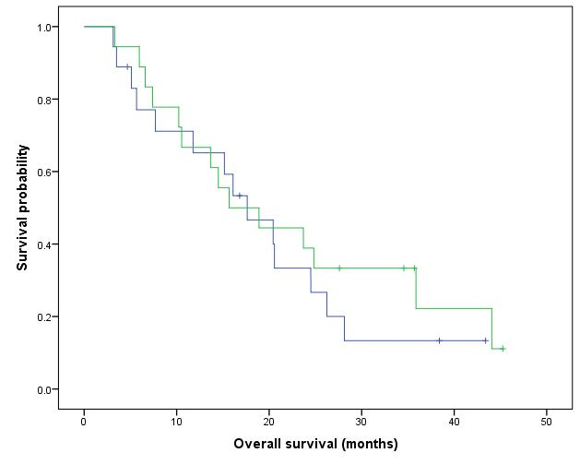
≤ Median

> Median

Medium and Median time of survival
CHRAC1 recodified by median | Mediumª |  |  |  | Median
 | Estimation | Standard error | Confidence intervall of 95% |  | Estimation | Standard error | Confidence intervall of 95%
 |  |  | Lower limit | Upper limit |  |  | Lower limit | Upper limit
<=Median | 22.646 | 3.737 | 15.322 | 29.970 | 15.167 | 1.664 | 11.905 | 18.428
>Median | 18.287 | 2.575 | 13.241 | 23.334 | 18.900 | 2.751 | 13.507 | 24.293
Global | 21.031 | 2.418 | 16.292 | 25.770 | 17.633 | 3.011 | 11.733 | 23.534
a. The estimation is limited to the longest time of survival for censored samples.

p-value (logrank/Mantel-Cox) = 0.477

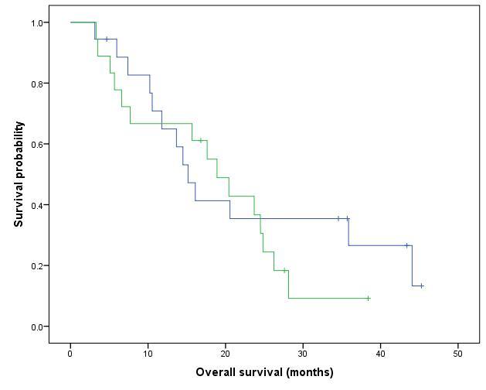
≤ Median

> Median

Medium and Median time of survival
CREBBP recodified by median | Mediumª |  |  |  | Median
 | Estimation | Standard error | Confidence intervall of 95% |  | Estimation | Standard error | Confidence intervall of 95%
 |  |  | Lower limit | Upper limit |  |  | Lower limit | Upper limit
<=Median | 19.952 | 3.454 | 13.183 | 26.722 | 15.167 | 2.963 | 9.358 | 20.975
>Median | 22.236 | 3.535 | 15.307 | 29.164 | 18.900 | 2.751 | 13.507 | 24.293
Global | 21.031 | 2.418 | 16.292 | 25.770 | 17.633 | 3.011 | 11.733 | 23.534
a. The estimation is limited to the longest time of survival for censored samples.

p-value (logrank/Mantel-Cox) = 0.608

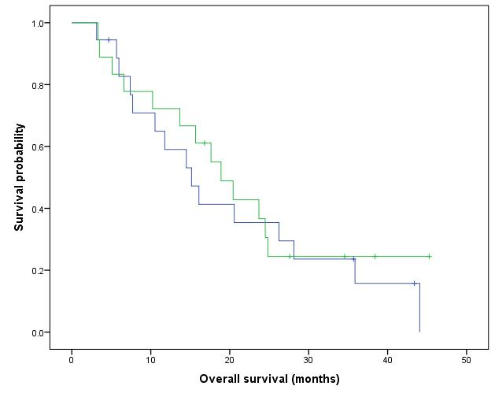
≤ Median

> Median

Medium and Median time of survival
DNMT1 recodified by median | Mediumª |  |  |  | Median
 | Estimation | Standard error | Confidence intervall of 95% |  | Estimation | Standard error | Confidence intervall of 95%
 |  |  | Lower limit | Upper limit |  |  | Lower limit | Upper limit
<=Median | 19.915 | 2.949 | 14.136 | 25.694 | 16.100 | 2.616 | 10.972 | 21.228
>Median | 22.087 | 3.732 | 14.773 | 29.402 | 23.700 | 6.376 | 11.203 | 36.197
Global | 21.031 | 2.418 | 16.292 | 25.770 | 17.633 | 3.011 | 11.733 | 23.534
a. The estimation is limited to the longest time of survival for censored samples.

p-value (logrank/Mantel-Cox) = 0.574

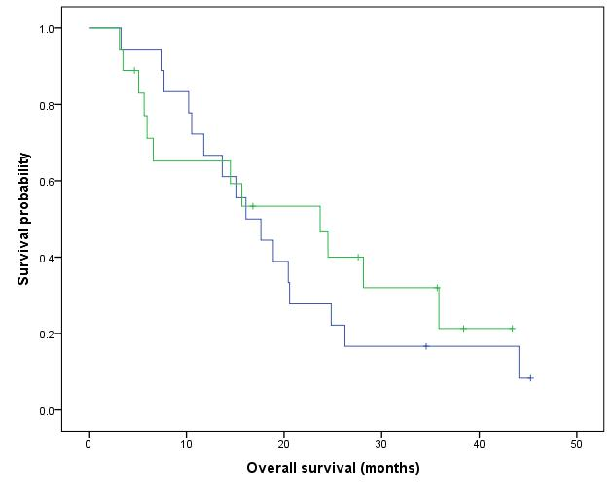
≤ Median

> Median

Medium and Median time of survival
DNMT3A recodified by median | Mediumª |  |  |  | Median
 | Estimation | Standard error | Confidence intervall of 95% |  | Estimation | Standard error | Confidence intervall of 95%
 |  |  | Lower limit | Upper limit |  |  | Lower limit | Upper limit
<=Median | 20.690 | 3.622 | 13.592 | 27.789 | 15.167 | 1.363 | 12.496 | 17.837
>Median | 20.134 | 2.731 | 14.781 | 25.487 | 20.567 | 4.024 | 12.680 | 28.454
Global | 21.031 | 2.418 | 16.292 | 25.770 | 17.633 | 3.011 | 11.733 | 23.534
a. The estimation is limited to the longest time of survival for censored samples.

p-value (logrank/Mantel-Cox) = 0.909

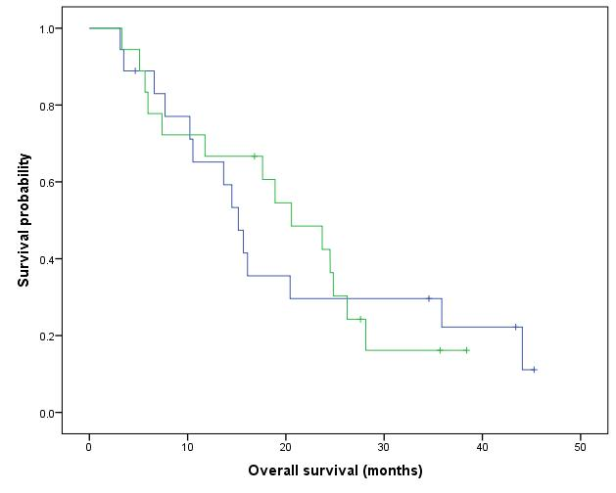
≤ Median

> Median

Medium and Median time of survival
ERCC2 recodified by median | Mediumª |  |  |  | Median
 | Estimation | Standard error | Confidence intervall of 95% |  | Estimation | Standard error | Confidence intervall of 95%
 |  |  | Lower limit | Upper limit |  |  | Lower limit | Upper limit
<=Median | 17.644 | 2.763 | 12.229 | 23.059 | 15.167 | 1.368 | 12.486 | 17.847
>Median | 23.976 | 3.842 | 16.446 | 31.506 | 24.500 | 2.918 | 18.780 | 30.220
Global | 21.031 | 2.418 | 16.292 | 25.770 | 17.633 | 3.011 | 11.733 | 23.534
a. The estimation is limited to the longest time of survival for censored samples.

p-value (logrank/Mantel-Cox) = 0.212

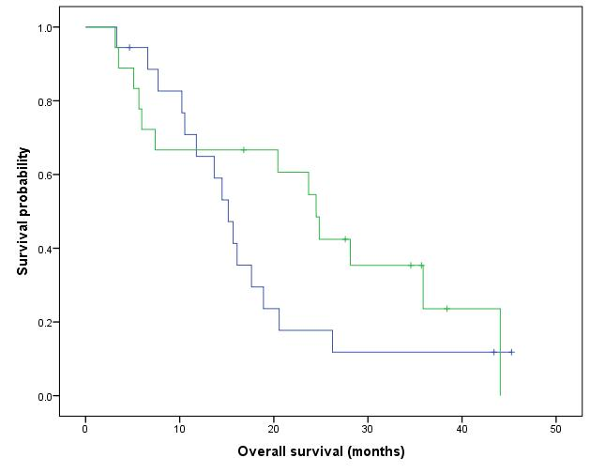
≤ Median

> Median

Medium and Median time of survival
FBXO11 recodified by median | Mediumª |  |  |  | Median
 | Estimation | Standard error | Confidence intervall of 95% |  | Estimation | Standard error | Confidence intervall of 95%
 |  |  | Lower limit | Upper limit |  |  | Lower limit | Upper limit
<=Median | 19.630 | 3.393 | 12.978 | 26.281 | 15.167 | 1.368 | 12.486 | 17.847
>Median | 22.515 | 3.558 | 15.542 | 29.488 | 20.433 | 4.024 | 12.546 | 28.320
Global | 21.031 | 2.418 | 16.292 | 25.770 | 17.633 | 3.011 | 11.733 | 23.534
a. The estimation is limited to the longest time of survival for censored samples.

p-value (logrank/Mantel-Cox) = 0.464

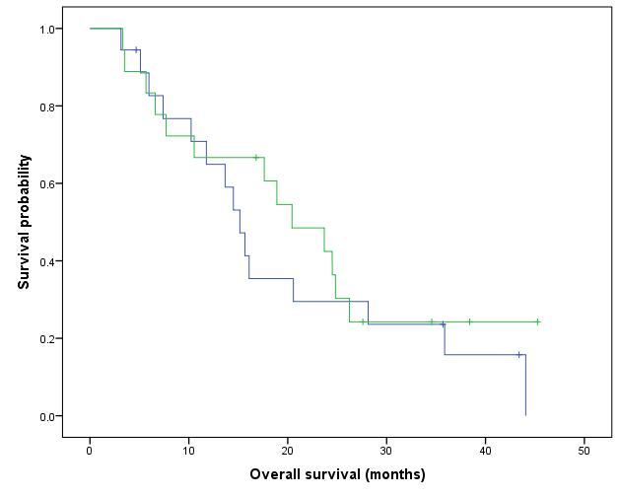
≤ Median

> Median

Medium and Median time of survival
FLYWCH1 recodified by median | Mediumª |  |  |  | Median
 | Estimation | Standard error | Confidence intervall of 95% |  | Estimation | Standard error | Confidence intervall of 95%
 |  |  | Lower limit | Upper limit |  |  | Lower limit | Upper limit
<=Median | 20.045 | 3.597 | 12.995 | 27.095 | 14.500 | 2.325 | 9.943 | 19.057
>Median | 21.815 | 3.326 | 15.295 | 28.334 | 20.567 | 3.214 | 14.268 | 26.865
Global | 21.031 | 2.418 | 16.292 | 25.770 | 17.633 | 3.011 | 11.733 | 23.534
a. The estimation is limited to the longest time of survival for censored samples.

p-value (logrank/Mantel-Cox) = 0.824

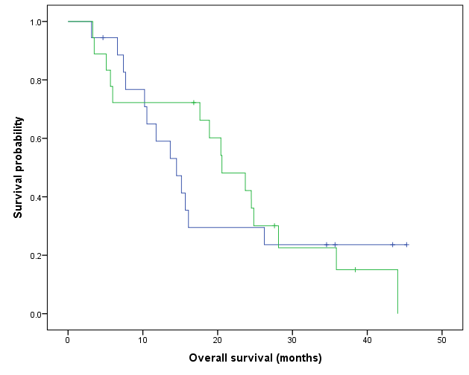
≤ Median

> Median

Medium and Median time of survival
HELLS recodified by median | Mediumª |  |  |  | Median
 | Estimation | Standard error | Confidence intervall of 95% |  | Estimation | Standard error | Confidence intervall of 95%
 |  |  | Lower limit | Upper limit |  |  | Lower limit | Upper limit
<=Median | 21.997 | 2.918 | 16.277 | 27.717 | 17.633 | 4.186 | 9.428 | 25.839
>Median | 20.042 | 3.953 | 12.294 | 27.790 | 14.500 | 8.342 | .000 | 30.850
Global | 21.031 | 2.418 | 16.292 | 25.770 | 17.633 | 3.011 | 11.733 | 23.534
a. The estimation is limited to the longest time of survival for censored samples.

p-value (logrank/Mantel-Cox) = 0.976

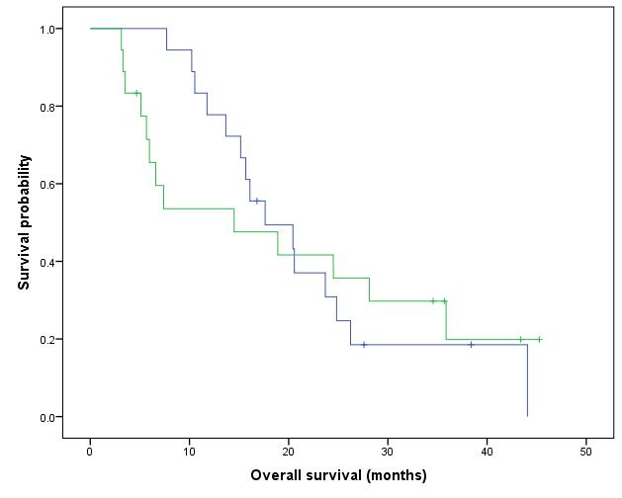
≤ Median

> Median

Medium and Median time of survival
IDH1 recodified by median | Mediumª |  |  |  | Median
 | Estimation | Standard error | Confidence intervall of 95% |  | Estimation | Standard error | Confidence intervall of 95%
 |  |  | Lower limit | Upper limit |  |  | Lower limit | Upper limit
<=Median | 21.452 | 3.580 | 14.436 | 28.468 | 15.667 | 4.610 | 6.631 | 24.703
>Median | 20.341 | 3.284 | 13.905 | 26.777 | 17.633 | 2.705 | 12.331 | 22.935
Global | 21.031 | 2.418 | 16.292 | 25.770 | 17.633 | 3.011 | 11.733 | 23.534
a. The estimation is limited to the longest time of survival for censored samples.

p-value (logrank/Mantel-Cox) = 0.760

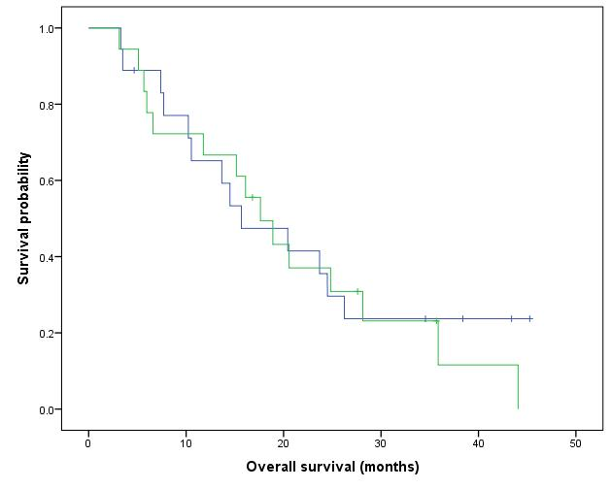
≤ Median

> Median

Medium and Median time of survival
IDH2 recodified by median | Mediumª |  |  |  | Median
 | Estimation | Standard error | Confidence intervall of 95% |  | Estimation | Standard error | Confidence intervall of 95%
 |  |  | Lower limit | Upper limit |  |  | Lower limit | Upper limit
<=Median | 22.546 | 3.055 | 16.559 | 28.533 | 17.633 | 5.728 | 6.407 | 28.859
>Median | 19.024 | 3.733 | 11.708 | 26.340 | 16.100 | 7.963 | .493 | 31.707
Global | 21.031 | 2.418 | 16.292 | 25.770 | 17.633 | 3.011 | 11.733 | 23.534
a. The estimation is limited to the longest time of survival for censored samples.

p-value (logrank/Mantel-Cox) = 0.624

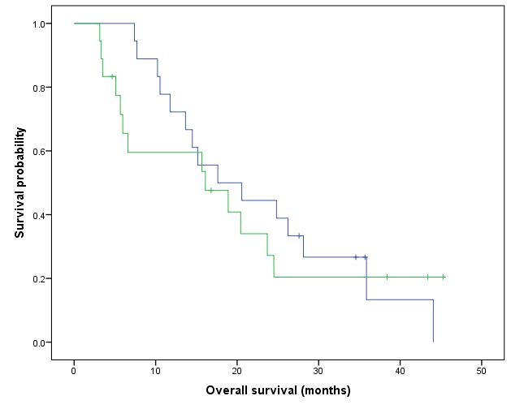
≤ Median

> Median

Medium and Median time of survival
MACROH2A1 recodified by median | Mediumª |  |  |  | Median
 | Estimation | Standard error | Confidence intervall of 95% |  | Estimation | Standard error | Confidence intervall of 95%
 |  |  | Lower limit | Upper limit |  |  | Lower limit | Upper limit
<=Median | 17.159 | 3.479 | 10.339 | 23.978 | 13.667 | 4.633 | 4.586 | 22.747
>Median | 24.530 | 3.217 | 18.225 | 30.836 | 23.700 | 3.749 | 16.351 | 31.049
Global | 21.031 | 2.418 | 16.292 | 25.770 | 17.633 | 3.011 | 11.733 | 23.534
a. The estimation is limited to the longest time of survival for censored samples.

p-value (logrank/Mantel-Cox) = 0.120

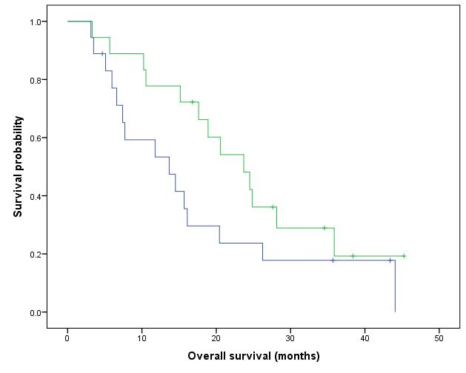
≤ Median

> Median

Medium and Median time of survival
MACROH2A2 recodified by median | Mediumª |  |  |  | Median
 | Estimation | Standard error | Confidence intervall of 95% |  | Estimation | Standard error | Confidence intervall of 95%
 |  |  | Lower limit | Upper limit |  |  | Lower limit | Upper limit
<=Median | 23.957 | 3.544 | 17.010 | 30.904 | 18.900 | 3.260 | 12.511 | 25.289
>Median | 17.966 | 3.169 | 11.756 | 24.177 | 14.500 | 5.904 | 2.927 | 26.073
Global | 21.031 | 2.418 | 16.292 | 25.770 | 17.633 | 3.011 | 11.733 | 23.534
a. The estimation is limited to the longest time of survival for censored samples.

p-value (logrank/Mantel-Cox) = 0.330

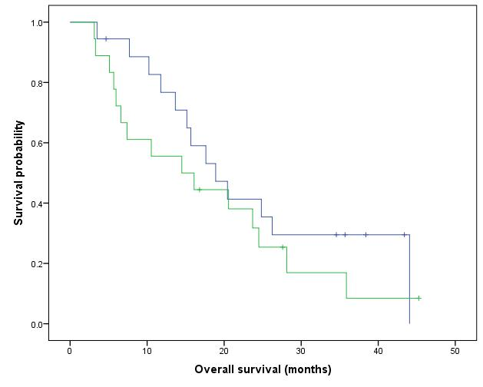
≤ Median

> Median

Medium and Median time of survival
MALSU1 recodified by median | Mediumª |  |  |  | Median
 | Estimation | Standard error | Confidence intervall of 95% |  | Estimation | Standard error | Confidence intervall of 95%
 |  |  | Lower limit | Upper limit |  |  | Lower limit | Upper limit
<=Median | 19.781 | 3.018 | 13.866 | 25.697 | 15.167 | 1.237 | 12.741 | 17.592
>Median | 22.660 | 3.878 | 15.059 | 30.261 | 23.700 | 5.238 | 13.433 | 33.967
Global | 21.031 | 2.418 | 16.292 | 25.770 | 17.633 | 3.011 | 11.733 | 23.534
a. The estimation is limited to the longest time of survival for censored samples.

p-value (logrank/Mantel-Cox) = 0.441

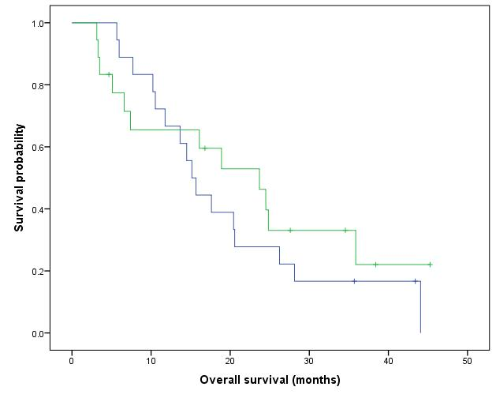
≤ Median

> Median

Medium and Median time of survival
MRPL4 recodified by median | Mediumª |  |  |  | Median
 | Estimation | Standard error | Confidence intervall of 95% |  | Estimation | Standard error | Confidence intervall of 95%
 |  |  | Lower limit | Upper limit |  |  | Lower limit | Upper limit
<=Median | 22.688 | 3.254 | 16.311 | 29.066 | 17.633 | 2.561 | 12.614 | 22.653
>Median | 19.143 | 3.583 | 12.121 | 26.165 | 16.100 | 15.972 | .000 | 47.406
Global | 21.031 | 2.418 | 16.292 | 25.770 | 17.633 | 3.011 | 11.733 | 23.534
a. The estimation is limited to the longest time of survival for censored samples.

p-value (logrank/Mantel-Cox) = 0.513

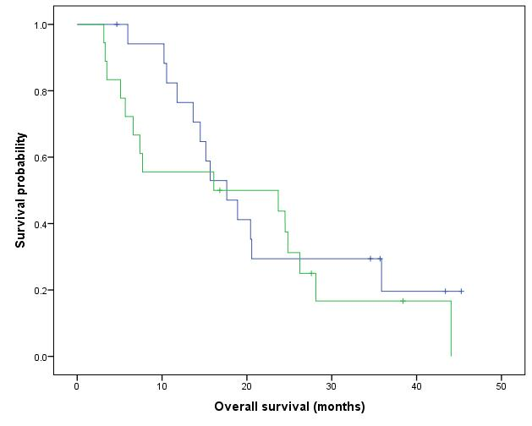
≤ Median

> Median

Medium and Median time of survival
MRPL52 recodified by median | Mediumª |  |  |  | Median
 | Estimation | Standard error | Confidence intervall of 95% |  | Estimation | Standard error | Confidence intervall of 95%
 |  |  | Lower limit | Upper limit |  |  | Lower limit | Upper limit
<=Median | 19.405 | 3.024 | 13.478 | 25.331 | 15.167 | 1.368 | 12.486 | 17.847
>Median | 22.457 | 3.651 | 15.300 | 29.614 | 20.567 | 4.717 | 11.322 | 29.812
Global | 21.031 | 2.418 | 16.292 | 25.770 | 17.633 | 3.011 | 11.733 | 23.534
a. The estimation is limited to the longest time of survival for censored samples.

p-value (logrank/Mantel-Cox) = 0.459

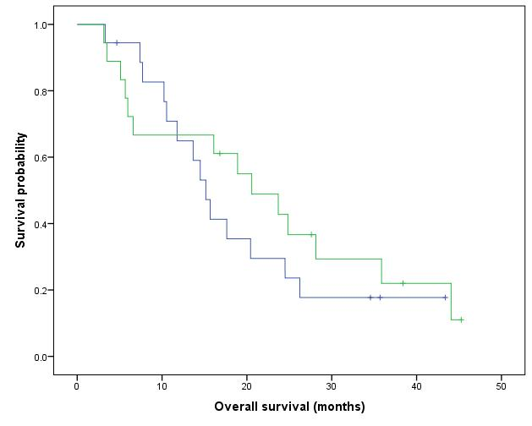
≤ Median

> Median

Medium and Median time of survival
MRPS26 recodified by median | Mediumª |  |  |  | Median
 | Estimation | Standard error | Confidence intervall of 95% |  | Estimation | Standard error | Confidence intervall of 95%
 |  |  | Lower limit | Upper limit |  |  | Lower limit | Upper limit
<=Median | 19.506 | 3.129 | 13.373 | 25.638 | 15.167 | 1.372 | 12.478 | 17.856
>Median | 22.319 | 3.725 | 15.017 | 29.620 | 23.700 | 3.865 | 16.124 | 31.276
Global | 21.031 | 2.418 | 16.292 | 25.770 | 17.633 | 3.011 | 11.733 | 23.534
a. The estimation is limited to the longest time of survival for censored samples.

p-value (logrank/Mantel-Cox) = 0.601

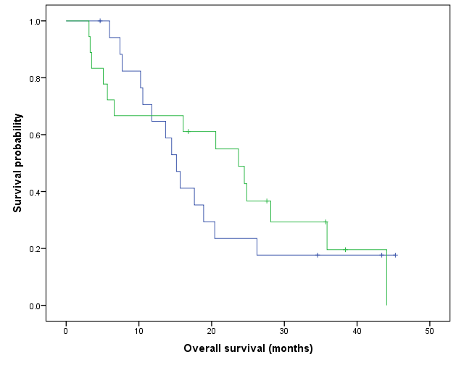
≤ Median

> Median

Medium and Median time of survival
MRTO4 recodified by median | Mediumª |  |  |  | Median
 | Estimation | Standard error | Confidence intervall of 95% |  | Estimation | Standard error | Confidence intervall of 95%
 |  |  | Lower limit | Upper limit |  |  | Lower limit | Upper limit
<=Median | 26.690 | 3.554 | 19.725 | 33.655 | 20.433 | 4.024 | 12.546 | 28.320
>Median | 15.814 | 3.001 | 9.931 | 21.697 | 11.767 | 4.815 | 2.329 | 21.205
Global | 21.031 | 2.418 | 16.292 | 25.770 | 17.633 | 3.011 | 11.733 | 23.534
a. The estimation is limited to the longest time of survival for censored samples.

p-value (logrank/Mantel-Cox) = 0.024

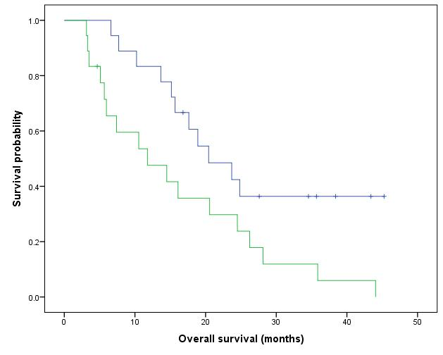
≤ Median

> Median

Medium and Median time of survival
NAA10 recodified by median | Mediumª |  |  |  | Median
 | Estimation | Standard error | Confidence intervall of 95% |  | Estimation | Standard error | Confidence intervall of 95%
 |  |  | Lower limit | Upper limit |  |  | Lower limit | Upper limit
<=Median | 28.937 | 3.363 | 22.346 | 35.528 | 24.500 | 3.807 | 17.039 | 31.961
>Median | 13.820 | 2.641 | 8.644 | 18.997 | 7.700 | 3.005 | 1.810 | 13.590
Global | 21.031 | 2.418 | 16.292 | 25.770 | 17.633 | 3.011 | 11.733 | 23.534
a. The estimation is limited to the longest time of survival for censored samples.

p-value (logrank/Mantel-Cox) = 0.002

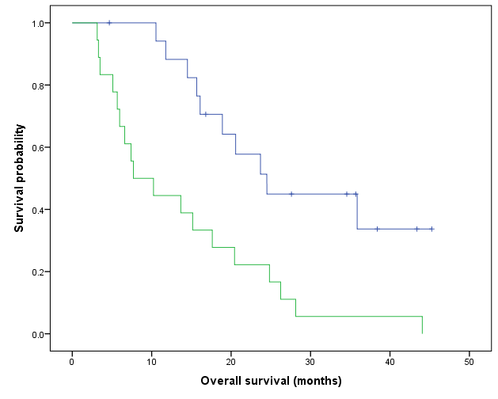
≤ Median

> Median

Medium and Median time of survival
NAA15 recodified by median | Mediumª |  |  |  | Median
 | Estimation | Standard error | Confidence intervall of 95% |  | Estimation | Standard error | Confidence intervall of 95%
 |  |  | Lower limit | Upper limit |  |  | Lower limit | Upper limit
<=Median | 18.996 | 3.123 | 12.875 | 25.117 | 15.167 | 2.963 | 9.358 | 20.975
>Median | 22.833 | 3.558 | 15.859 | 29.808 | 20.567 | 5.962 | 8.882 | 32.251
Global | 21.031 | 2.418 | 16.292 | 25.770 | 17.633 | 3.011 | 11.733 | 23.534
a. The estimation is limited to the longest time of survival for censored samples.

p-value (logrank/Mantel-Cox) = 0.422

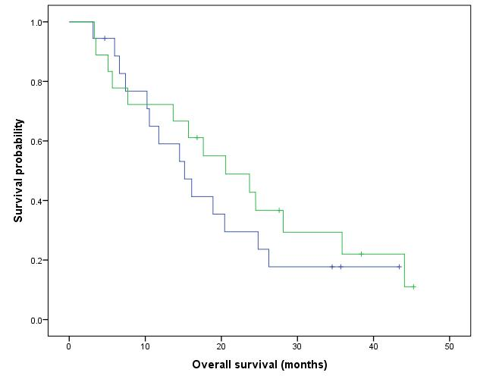
≤ Median

> Median

Medium and Median time of survival
NSUN3 recodified by median | Mediumª |  |  |  | Median
 | Estimation | Standard error | Confidence intervall of 95% |  | Estimation | Standard error | Confidence intervall of 95%
 |  |  | Lower limit | Upper limit |  |  | Lower limit | Upper limit
<=Median | 15.672 | 2.952 | 9.887 | 21.457 | 10.533 | 1.626 | 7.346 | 13.721
>Median | 26.740 | 3.443 | 19.992 | 33.488 | 24.500 | 3.943 | 16.773 | 32.227
Global | 21.031 | 2.418 | 16.292 | 25.770 | 17.633 | 3.011 | 11.733 | 23.534
a. The estimation is limited to the longest time of survival for censored samples.

p-value (logrank/Mantel-Cox) = 0.024
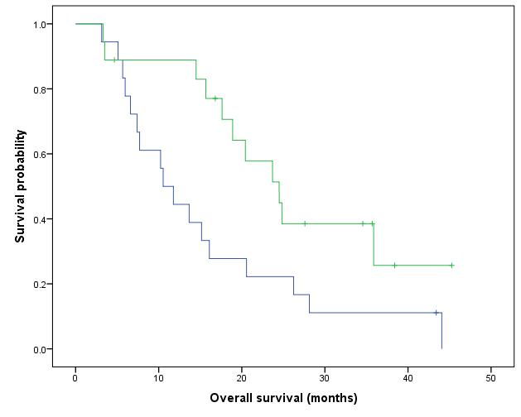
≤ Median

> Median

Medium and Median time of survival
POLE3 recodified by median | Mediumª |  |  |  | Median
 | Estimation | Standard error | Confidence intervall of 95% |  | Estimation | Standard error | Confidence intervall of 95%
 |  |  | Lower limit | Upper limit |  |  | Lower limit | Upper limit
<=Median | 24.674 | 3.695 | 17.431 | 31.917 | 16.100 | 2.445 | 11.309 | 20.891
>Median | 17.491 | 2.811 | 11.981 | 23.001 | 17.633 | 10.501 | .000 | 38.214
Global | 21.031 | 2.418 | 16.292 | 25.770 | 17.633 | 3.011 | 11.733 | 23.534
a. The estimation is limited to the longest time of survival for censored samples.

p-value (logrank/Mantel-Cox) = 0.194

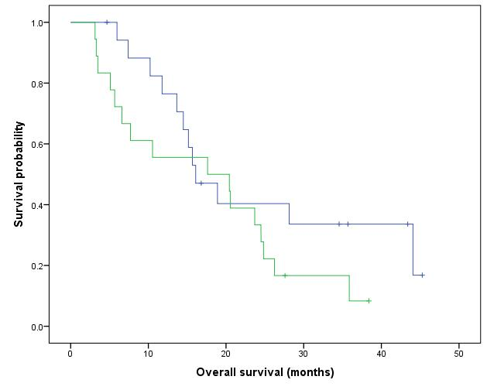
≤ Median

> Median

Medium and Median time of survival
POLR1A recodified by median | Mediumª |  |  |  | Median
 | Estimation | Standard error | Confidence intervall of 95% |  | Estimation | Standard error | Confidence intervall of 95%
 |  |  | Lower limit | Upper limit |  |  | Lower limit | Upper limit
<=Median | 19.786 | 3.496 | 12.935 | 26.637 | 14.500 | 1.591 | 11.382 | 17.618
>Median | 22.150 | 3.412 | 15.462 | 28.838 | 20.433 | 3.865 | 12.859 | 28.008
Global | 21.031 | 2.418 | 16.292 | 25.770 | 17.633 | 3.011 | 11.733 | 23.534
a. The estimation is limited to the longest time of survival for censored samples.

p-value (logrank/Mantel-Cox) = 0.585

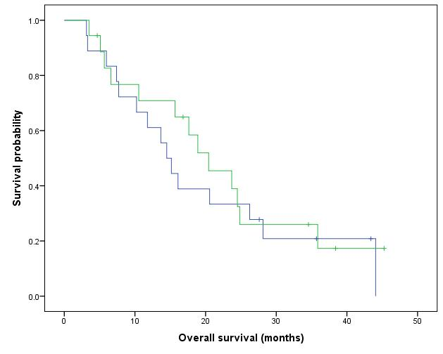
≤ Median

> Median

Medium and Median time of survival
POLR1B recodified by median | Mediumª |  |  |  | Median
 | Estimation | Standard error | Confidence intervall of 95% |  | Estimation | Standard error | Confidence intervall of 95%
 |  |  | Lower limit | Upper limit |  |  | Lower limit | Upper limit
<=Median | 24.822 | 3.654 | 17.661 | 31.983 | 17.633 | 2.075 | 13.566 | 21.700
>Median | 17.811 | 3.243 | 11.455 | 24.167 | 11.767 | 13.647 | .000 | 38.515
Global | 21.031 | 2.418 | 16.292 | 25.770 | 17.633 | 3.011 | 11.733 | 23.534
a. The estimation is limited to the longest time of survival for censored samples.

p-value (logrank/Mantel-Cox) = 0.164

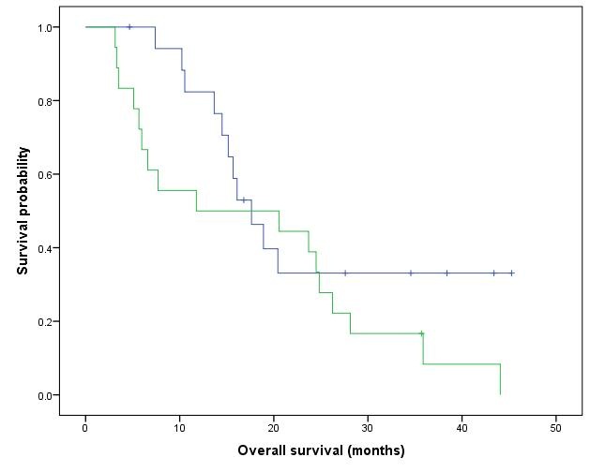
≤ Median

> Median

Medium and Median time of survival
POLR1C recodified by median | Mediumª |  |  |  | Median
 | Estimation | Standard error | Confidence intervall of 95% |  | Estimation | Standard error | Confidence intervall of 95%
 |  |  | Lower limit | Upper limit |  |  | Lower limit | Upper limit
<=Median | 23.123 | 3.509 | 16.245 | 30.000 | 18.900 | 3.808 | 11.437 | 26.363
>Median | 19.089 | 3.449 | 12.328 | 25.849 | 16.100 | 2.616 | 10.972 | 21.228
Global | 21.031 | 2.418 | 16.292 | 25.770 | 17.633 | 3.011 | 11.733 | 23.534
a. The estimation is limited to the longest time of survival for censored samples.

p-value (logrank/Mantel-Cox) = 0.377

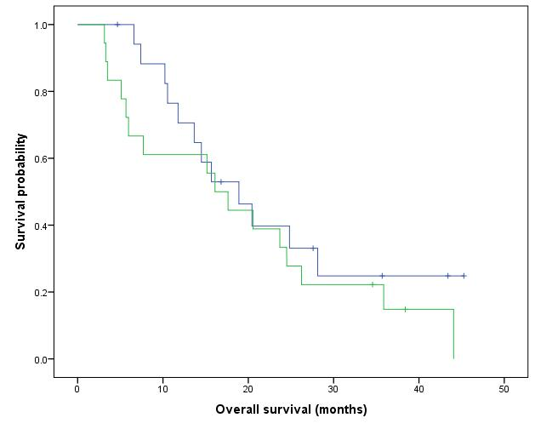
≤ Median

> Median

Medium and Median time of survival
POLR1E recodified by median | Mediumª |  |  |  | Median
 | Estimation | Standard error | Confidence intervall of 95% |  | Estimation | Standard error | Confidence intervall of 95%
 |  |  | Lower limit | Upper limit |  |  | Lower limit | Upper limit
<=Median | 26.717 | 3.844 | 19.183 | 34.252 | 20.433 | 6.658 | 7.384 | 33.483
>Median | 16.430 | 2.837 | 10.869 | 21.990 | 14.500 | 4.596 | 5.491 | 23.509
Global | 21.031 | 2.418 | 16.292 | 25.770 | 17.633 | 3.011 | 11.733 | 23.534
a. The estimation is limited to the longest time of survival for censored samples.

p-value (logrank/Mantel-Cox) = 0.03

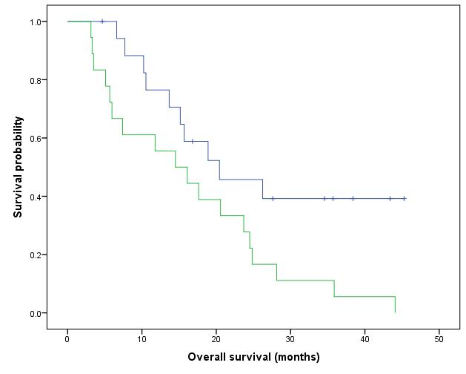
≤ Median

> Median

Medium and Median time of survival
POLR3D recodified by median | Mediumª |  |  |  | Median
 | Estimation | Standard error | Confidence intervall of 95% |  | Estimation | Standard error | Confidence intervall of 95%
 |  |  | Lower limit | Upper limit |  |  | Lower limit | Upper limit
<=Median | 20.547 | 3.485 | 13.716 | 27.379 | 15.167 | 1.372 | 12.478 | 17.856
>Median | 21.248 | 3.433 | 14.519 | 27.977 | 20.567 | 4.024 | 12.680 | 28.454
Global | 21.031 | 2.418 | 16.292 | 25.770 | 17.633 | 3.011 | 11.733 | 23.534
a. The estimation is limited to the longest time of survival for censored samples.

p-value (logrank/Mantel-Cox) = 0.729

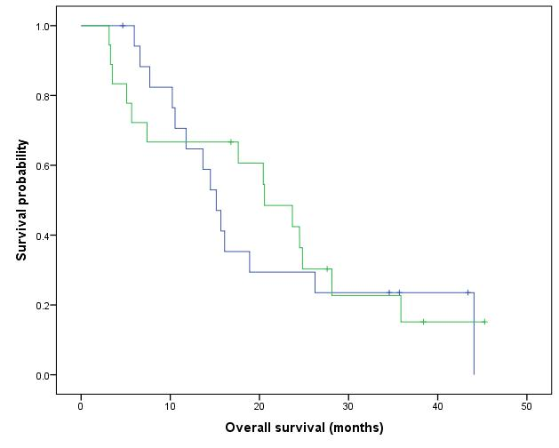
≤ Median

> Median

Medium and Median time of survival
POLR3H recodified by median | Mediumª |  |  |  | Median
 | Estimation | Standard error | Confidence intervall of 95% |  | Estimation | Standard error | Confidence intervall of 95%
 |  |  | Lower limit | Upper limit |  |  | Lower limit | Upper limit
<=Median | 20.210 | 2.447 | 15.414 | 25.006 | 17.633 | 3.124 | 11.511 | 23.756
>Median | 20.909 | 3.879 | 13.305 | 28.513 | 16.100 | 8.930 | .000 | 33.602
Global | 21.031 | 2.418 | 16.292 | 25.770 | 17.633 | 3.011 | 11.733 | 23.534
a. The estimation is limited to the longest time of survival for censored samples.

p-value (logrank/Mantel-Cox) = 0.880

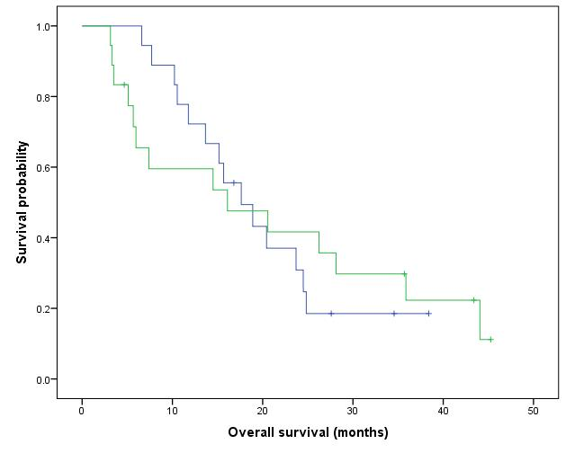
≤ Median

> Median

Medium and Median time of survival
PWWP2B recodified by median | Mediumª |  |  |  | Median
 | Estimation | Standard error | Confidence intervall of 95% |  | Estimation | Standard error | Confidence intervall of 95%
 |  |  | Lower limit | Upper limit |  |  | Lower limit | Upper limit
<=Median | 20.678 | 3.631 | 13.562 | 27.795 | 15.167 | 1.368 | 12.486 | 17.847
>Median | 20.857 | 3.259 | 14.469 | 27.244 | 20.433 | 1.946 | 16.620 | 24.247
Global | 21.031 | 2.418 | 16.292 | 25.770 | 17.633 | 3.011 | 11.733 | 23.534
a. The estimation is limited to the longest time of survival for censored samples.

p-value (logrank/Mantel-Cox) = 0.782

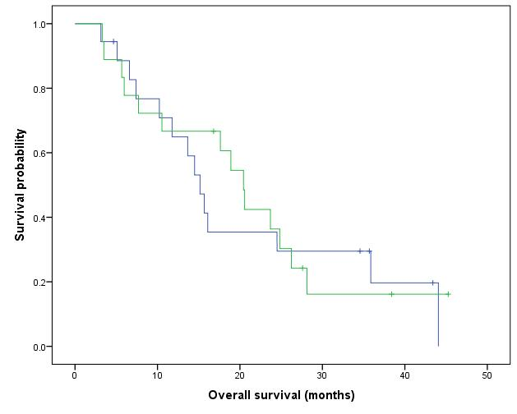
≤ Median

> Median

Medium and Median time of survival
RING1 recodified by median | Mediumª |  |  |  | Median
 | Estimation | Standard error | Confidence intervall of 95% |  | Estimation | Standard error | Confidence intervall of 95%
 |  |  | Lower limit | Upper limit |  |  | Lower limit | Upper limit
<=Median | 16.847 | 2.836 | 11.288 | 22.406 | 14.500 | 2.316 | 9.960 | 19.040
>Median | 24.856 | 3.580 | 17.838 | 31.873 | 24.500 | 2.857 | 18.901 | 30.099
Global | 21.031 | 2.418 | 16.292 | 25.770 | 17.633 | 3.011 | 11.733 | 23.534
a. The estimation is limited to the longest time of survival for censored samples.

p-value (logrank/Mantel-Cox) = 0.076

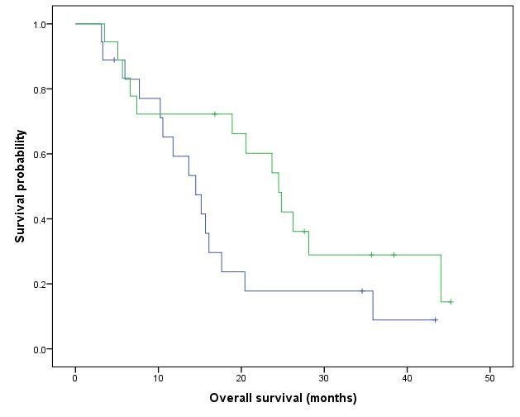
≤ Median

> Median

Medium and Median time of survival
RIOX2 recodified by median | Mediumª |  |  |  | Median
 | Estimation | Standard error | Confidence intervall of 95% |  | Estimation | Standard error | Confidence intervall of 95%
 |  |  | Lower limit | Upper limit |  |  | Lower limit | Upper limit
<=Median | 19.378 | 3.126 | 13.252 | 25.505 | 15.167 | 1.372 | 12.478 | 17.856
>Median | 22.370 | 3.718 | 15.082 | 29.658 | 23.700 | 3.714 | 16.420 | 30.980
Global | 21.031 | 2.418 | 16.292 | 25.770 | 17.633 | 3.011 | 11.733 | 23.534
a. The estimation is limited to the longest time of survival for censored samples.

p-value (logrank/Mantel-Cox) = 0.577

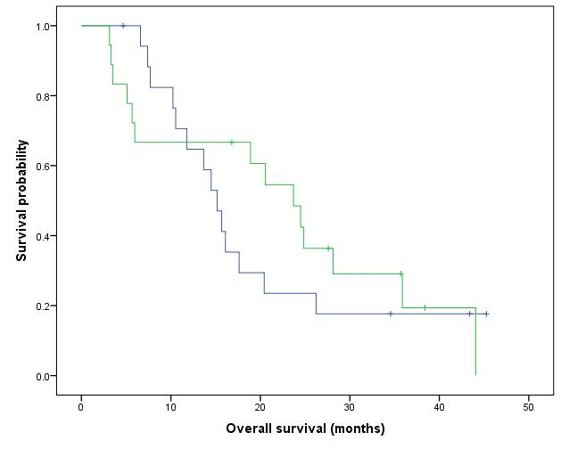
≤ Median

> Median

Medium and Median time of survival
RRM1 recodified by median | Mediumª |  |  |  | Median
 | Estimation | Standard error | Confidence intervall of 95% |  | Estimation | Standard error | Confidence intervall of 95%
 |  |  | Lower limit | Upper limit |  |  | Lower limit | Upper limit
<=Median | 22.313 | 2.193 | 18.014 | 26.612 | 20.567 | 3.214 | 14.268 | 26.865
>Median | 18.401 | 3.957 | 10.645 | 26.157 | 10.533 | 5.358 | .032 | 21.035
Global | 21.031 | 2.418 | 16.292 | 25.770 | 17.633 | 3.011 | 11.733 | 23.534
a. The estimation is limited to the longest time of survival for censored samples.

p-value (logrank/Mantel-Cox) = 0.425

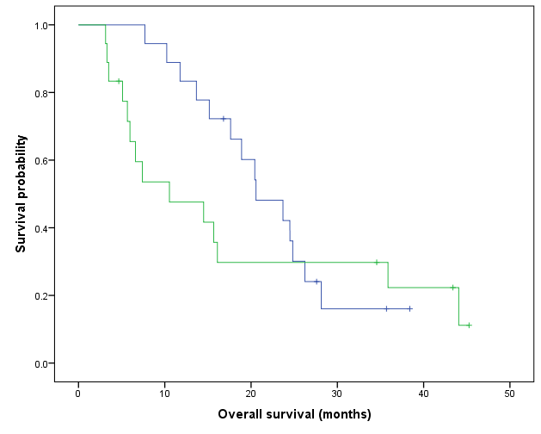
≤ Median

> Median

Medium and Median time of survival
RRM2 recodified by median | Mediumª |  |  |  | Median
 | Estimation | Standard error | Confidence intervall of 95% |  | Estimation | Standard error | Confidence intervall of 95%
 |  |  | Lower limit | Upper limit |  |  | Lower limit | Upper limit
<=Median | 24.471 | 3.085 | 18.425 | 30.517 | 23.700 | 3.749 | 16.351 | 31.049
>Median | 17.282 | 3.612 | 10.202 | 24.362 | 10.533 | 4.815 | 1.095 | 19.971
Global | 21.031 | 2.418 | 16.292 | 25.770 | 17.633 | 3.011 | 11.733 | 23.534
a. The estimation is limited to the longest time of survival for censored samples.

p-value (logrank/Mantel-Cox) = 0.231

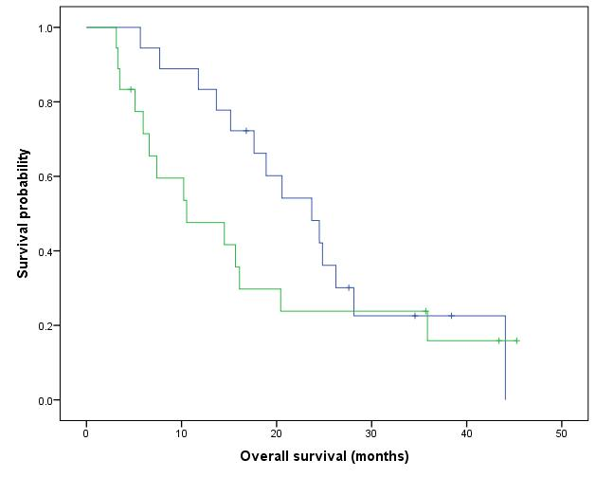
≤ Median

> Median

Medium and Median time of survival
RRP1 recodified by median | Mediumª |  |  |  | Median
 | Estimation | Standard error | Confidence intervall of 95% |  | Estimation | Standard error | Confidence intervall of 95%
 |  |  | Lower limit | Upper limit |  |  | Lower limit | Upper limit
<=Median | 21.671 | 3.348 | 15.108 | 28.233 | 15.667 | 2.149 | 11.454 | 19.880
>Median | 20.610 | 3.626 | 13.503 | 27.718 | 20.567 | 7.342 | 6.176 | 34.958
Global | 21.031 | 2.418 | 16.292 | 25.770 | 17.633 | 3.011 | 11.733 | 23.534
a. The estimation is limited to the longest time of survival for censored samples.

p-value (logrank/Mantel-Cox) = 0.835
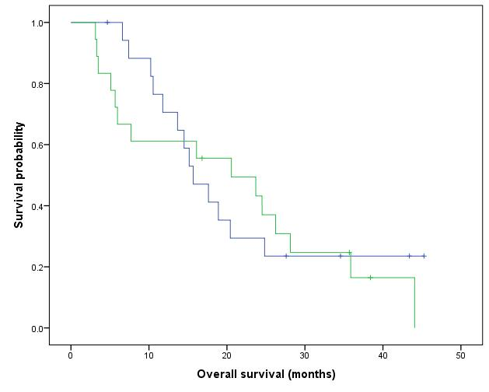
≤ Median

> Median

Medium and Median time of survival
RRP9 recodified by median | Mediumª |  |  |  | Median
 | Estimation | Standard error | Confidence intervall of 95% |  | Estimation | Standard error | Confidence intervall of 95%
 |  |  | Lower limit | Upper limit |  |  | Lower limit | Upper limit
<=Median | 23.326 | 3.183 | 17.088 | 29.564 | 17.633 | 3.429 | 10.912 | 24.355
>Median | 18.168 | 3.334 | 11.634 | 24.702 | 16.100 | 8.524 | .000 | 32.807
Global | 21.031 | 2.418 | 16.292 | 25.770 | 17.633 | 3.011 | 11.733 | 23.534
a. The estimation is limited to the longest time of survival for censored samples.

p-value (logrank/Mantel-Cox) = 0.315
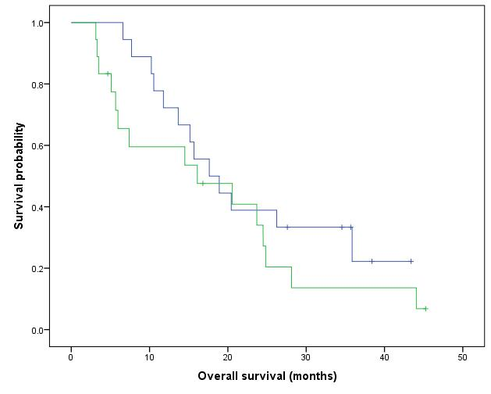
≤ Median

> Median

Medium and Median time of survival
SLC28A3 recodified by median | Mediumª |  |  |  | Median
 | Estimation | Standard error | Confidence intervall of 95% |  | Estimation | Standard error | Confidence intervall of 95%
 |  |  | Lower limit | Upper limit |  |  | Lower limit | Upper limit
<=Median | 25.367 | 3.406 | 18.691 | 32.042 | 23.700 | 4.776 | 14.340 | 33.060
>Median | 16.316 | 3.154 | 10.135 | 22.497 | 11.767 | 4.837 | 2.285 | 21.248
Global | 21.031 | 2.418 | 16.292 | 25.770 | 17.633 | 3.011 | 11.733 | 23.534
a. The estimation is limited to the longest time of survival for censored samples.

p-value (logrank/Mantel-Cox) = 0.102
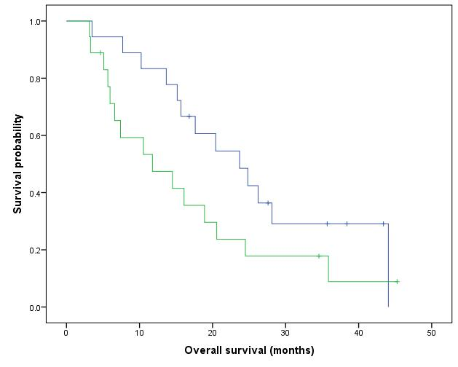
≤ Median

> Median

Medium and Median time of survival
SLC29A1 recodified by median | Mediumª |  |  |  | Median
 | Estimation | Standard error | Confidence intervall of 95% |  | Estimation | Standard error | Confidence intervall of 95%
 |  |  | Lower limit | Upper limit |  |  | Lower limit | Upper limit
<=Median | 21.108 | 3.111 | 15.010 | 27.205 | 18.900 | 2.883 | 13.250 | 24.550
>Median | 20.542 | 3.757 | 13.179 | 27.906 | 15.667 | 2.952 | 9.880 | 21.453
Global | 21.031 | 2.418 | 16.292 | 25.770 | 17.633 | 3.011 | 11.733 | 23.534
a. The estimation is limited to the longest time of survival for censored samples.

p-value (logrank/Mantel-Cox) = 0.926

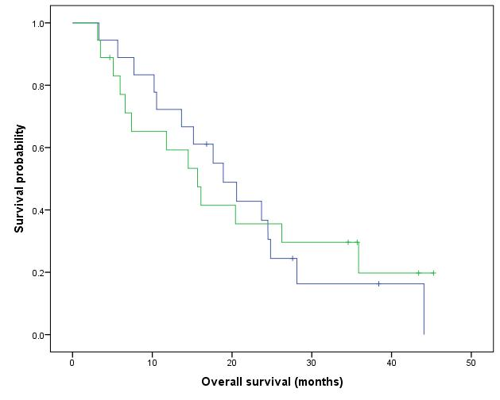
≤ Median

> Median

Medium and Median time of survival
SMARCA5 recodified by median | Mediumª |  |  |  | Median
 | Estimation | Standard error | Confidence intervall of 95% |  | Estimation | Standard error | Confidence intervall of 95%
 |  |  | Lower limit | Upper limit |  |  | Lower limit | Upper limit
<=Median | 20.441 | 3.336 | 13.902 | 26.980 | 15.167 | 1.237 | 12.741 | 17.592
>Median | 21.579 | 3.579 | 14.564 | 28.595 | 23.700 | 4.360 | 15.155 | 32.245
Global | 21.031 | 2.418 | 16.292 | 25.770 | 17.633 | 3.011 | 11.733 | 23.534
a. The estimation is limited to the longest time of survival for censored samples.

p-value (logrank/Mantel-Cox) = 0.647
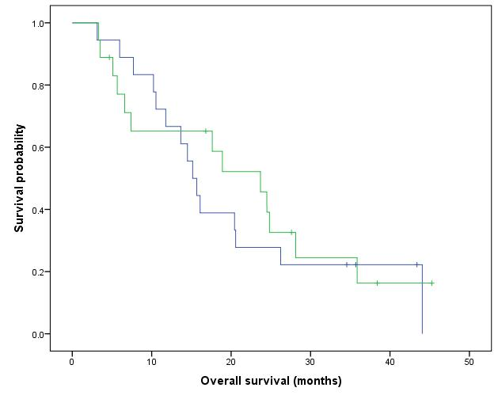
≤ Median

> Median

Medium and Median time of survival
TET2 recodified by median | Mediumª |  |  |  | Median
 | Estimation | Standard error | Confidence intervall of 95% |  | Estimation | Standard error | Confidence intervall of 95%
 |  |  | Lower limit | Upper limit |  |  | Lower limit | Upper limit
<=Median | 18.538 | 3.427 | 11.821 | 25.254 | 14.500 | 2.325 | 9.943 | 19.057
>Median | 23.363 | 3.430 | 16.640 | 30.086 | 20.433 | 4.024 | 12.546 | 28.320
Global | 21.031 | 2.418 | 16.292 | 25.770 | 17.633 | 3.011 | 11.733 | 23.534
a. The estimation is limited to the longest time of survival for censored samples.

p-value (logrank/Mantel-Cox) = 0.308
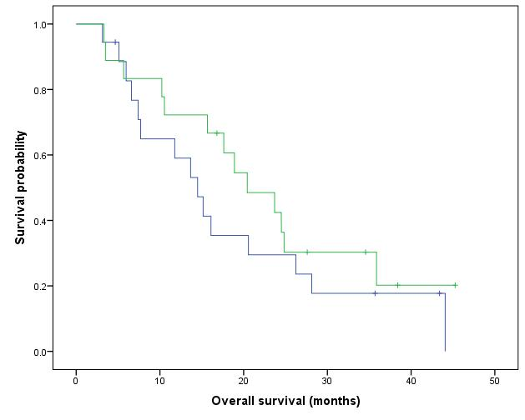
≤ Median

> Median

Medium and Median time of survival
TP53 recodified by median | Mediumª |  |  |  | Median
 | Estimation | Standard error | Confidence intervall of 95% |  | Estimation | Standard error | Confidence intervall of 95%
 |  |  | Lower limit | Upper limit |  |  | Lower limit | Upper limit
<=Median | 18.270 | 3.140 | 12.115 | 24.425 | 14.500 | 1.591 | 11.382 | 17.618
>Median | 23.944 | 3.651 | 16.789 | 31.099 | 24.500 | 2.709 | 19.190 | 29.810
Global | 21.031 | 2.418 | 16.292 | 25.770 | 17.633 | 3.011 | 11.733 | 23.534
a. The estimation is limited to the longest time of survival for censored samples.

p-value (logrank/Mantel-Cox) = 0.308

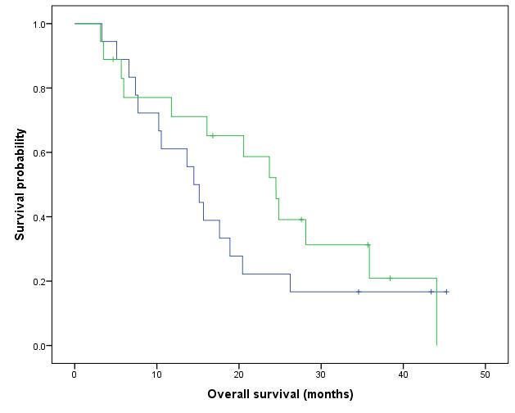
≤ Median

> Median

Medium and Median time of survival
UCK1 recodified by median | Mediumª |  |  |  | Median
 | Estimation | Standard error | Confidence intervall of 95% |  | Estimation | Standard error | Confidence intervall of 95%
 |  |  | Lower limit | Upper limit |  |  | Lower limit | Upper limit
<=Median | 19.071 | 3.337 | 12.531 | 25.611 | 15.167 | 2.667 | 9.939 | 20.394
>Median | 22.861 | 3.536 | 15.930 | 29.792 | 20.433 | 4.024 | 12.546 | 28.320
Global | 21.031 | 2.418 | 16.292 | 25.770 | 17.633 | 3.011 | 11.733 | 23.534
a. The estimation is limited to the longest time of survival for censored samples.

p-value (logrank/Mantel-Cox) = 0.381
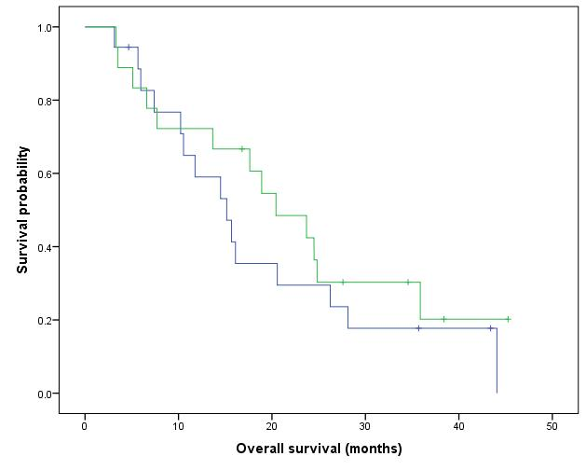
≤ Median

> Median

Medium and Median time of survival
UCK2 recodified by median | Mediumª |  |  |  | Median
 | Estimation | Standard error | Confidence intervall of 95% |  | Estimation | Standard error | Confidence intervall of 95%
 |  |  | Lower limit | Upper limit |  |  | Lower limit | Upper limit
<=Median | 23.947 | 3.669 | 16.755 | 31.139 | 18.900 | 4.605 | 9.874 | 27.926
>Median | 18.407 | 3.194 | 12.147 | 24.667 | 16.100 | 3.997 | 8.266 | 23.934
Global | 21.031 | 2.418 | 16.292 | 25.770 | 17.633 | 3.011 | 11.733 | 23.534
a. The estimation is limited to the longest time of survival for censored samples.

p-value (logrank/Mantel-Cox) = 0.241

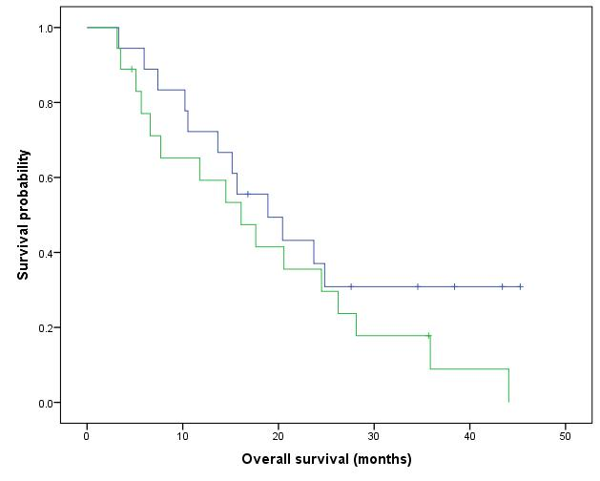
≤ Median

> Median

Medium and Median time of survival
EP300 recodified by median | Mediumª |  |  |  | Median
 | Estimation | Standard error | Confidence intervall of 95% |  | Estimation | Standard error | Confidence intervall of 95%
 |  |  | Lower limit | Upper limit |  |  | Lower limit | Upper limit
<=Median | 20.255 | 3.414 | 13.563 | 26.947 | 15.667 | 1.094 | 13.522 | 17.811
>Median | 21.950 | 3.575 | 14.943 | 28.958 | 18.900 | 2.751 | 13.507 | 24.293
Global | 21.031 | 2.418 | 16.292 | 25.770 | 17.633 | 3.011 | 11.733 | 23.534
a. The estimation is limited to the longest time of survival for censored samples.

p-value (logrank/Mantel-Cox) = 0.671
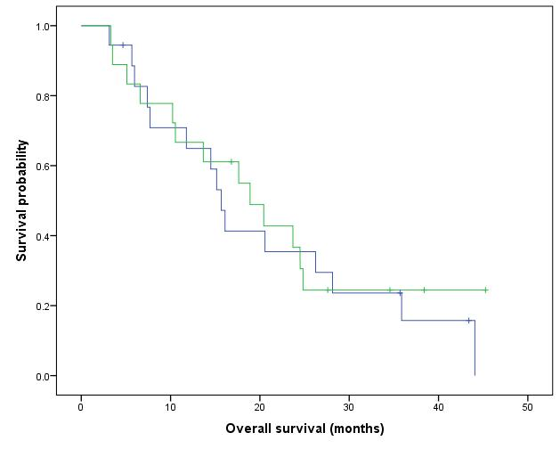
≤ Median

> Median

