Cardiac and hepatic siderosis in diverse causes of transfusion-dependent anemia and non-transfusion-dependent thalassemia: the TIMES study
SDC Table 1. True-positive and false-positive rates for detecting liver siderosis using serum ferritin threshold values in increments of 100 ng/mL, against the reference test of LIC ≥7 mg Fe/g dw
 | MDS  (siderosis positive n=38, negative n=32) |  | TM  (siderosis positive n=25, negative n=51) |  | Other  (siderosis positive n=37, negative n=28)
Serum ferritin cut-off (ng/mL) | True positive (%) | False positive (%) | True positive (%) | False positive (%) | True positive (%) | False positive (%)
0 | 100.0 | 100.0 | 100.0 | 100.0 | 100.0 | 100.0
100 | 100.0 | 96.9 | 100.0 | 100.0 | 100.0 | 100.0
200 | 100.0 | 96.9 | 100.0 | 100.0 | 100.0 | 100.0
300 | 100.0 | 96.9 | 100.0 | 100.0 | 100.0 | 100.0
400 | 100.0 | 96.9 | 100.0 | 100.0 | 100.0 | 100.0
500 | 100.0 | 93.8 | 100.0 | 100.0 | 100.0 | 100.0
600 | 97.4 | 84.4 | 100.0 | 86.3 | 97.3 | 89.3
700 | 97.4 | 84.4 | 96.0 | 78.4 | 97.3 | 78.6
800 | 97.4 | 78.1 | 88.0 | 70.6 | 94.6 | 75.0
900 | 97.4 | 62.5 | 84.0 | 62.7 | 94.6 | 71.4
1000 | 97.4 | 53.1 | 80.0 | 54.9 | 94.6 | 57.1
1100 | 97.4 | 53.1 | 76.0 | 49.0 | 91.9 | 57.1
1200 | 94.7 | 46.9 | 76.0 | 43.1 | 89.2 | 53.6
1300 | 92.1 | 43.8 | 76.0 | 39.2 | 83.8 | 39.3
1400 | 89.5 | 40.6 | 72.0 | 35.3 | 81.1 | 28.6
1500 | 84.2 | 40.6 | 68.0 | 25.5 | 75.7 | 28.6
1600 | 78.9 | 37.5 | 68.0 | 23.5 | 67.6 | 25.0
1700 | 65.8 | 34.4 | 60.0 | 17.6 | 62.2 | 25.0
1800 | 65.8 | 31.3 | 60.0 | 11.8 | 62.2 | 21.4
1900 | 65.8 | 21.9 | 56.0 | 9.8 | 62.2 | 21.4
2000 | 63.2 | 21.9 | 48.0 | 7.8 | 59.5 | 21.4
2100 | 63.2 | 21.9 | 48.0 | 7.8 | 56.8 | 21.4
2200 | 55.3 | 21.9 | 44.0 | 5.9 | 56.8 | 21.4
2300 | 52.6 | 18.8 | 40.0 | 5.9 | 56.8 | 21.4
2400 | 50.0 | 18.8 | 36.0 | 3.9 | 56.8 | 21.4
2500 | 47.4 | 18.8 | 36.0 | 3.9 | 54.1 | 10.7
2600 | 44.7 | 12.5 | 36.0 | 2.0 | 51.4 | 10.7
2700 | 42.1 | 12.5 | 36.0 | 2.0 | 48.6 | 7.1
2800 | 42.1 | 9.4 | 36.0 | 0.0 | 48.6 | 7.1
2900 | 39.5 | 9.4 | 32.0 | 0.0 | 48.6 | 7.1
3000 | 39.5 | 9.4 | 28.0 | 0.0 | 43.2 | 7.1
dw, dry weight; LIC, liver iron concentration; MDS, myelodysplastic syndromes; TM, thalassemia major.
SDC Table 2. Medical adherence questionnaire
- Do you ever forget to take your chelation therapy?
- Are you careless at times about taking your chelation therapy?
- When you feel better, do you sometimes stop taking your chelation therapy?
- Sometimes if you feel worse when you take your chelation therapy, do you stop taking it?
- I take my medication only when I am feeling sick
- By staying on medication, I can prevent getting sick
- In the past week, did you forget to take your chelation therapy on more than 1 day?
- In general, in the last 4 weeks, did you follow the chelation therapy regimen exactly as directed by your doctor?
- In general, in the last 4 weeks, did you think about stopping your chelation therapy?

SDC Table 3. Summary of MRI-based treatment decisions
Change to ICT | Overall | MDS |  | TM | NTDT |  | Other anemias
Any change, n (%) | n=229 | CN/MC n=27 | ICT n=42 | ICT n=77 | CN/MC n=11 | ICT n=7 | CN/MC n=37 | ICT n=28
Yes | 105 (45.9) | 17 (63.0) | 19 (45.2) | 26 (33.8) | 3 (27.3) | 7 (100.0) | 22 (59.5) | 11 (39.3)
No | 124 (54.1) | 10 (37.0) | 23 (54.8) | 51 (66.2) | 8 (72.7) | 0 (0.0) | 15 (40.5) | 17 (60.7)
Type of change, n (%) | n=75 | CN/MC n=13 | ICT n=16 | ICT n=23 | CN/MC n=2 | ICT n=7 | CN/MC n=8 | ICT n=6
Start ICT therapy | 27 (36.0) | 10 (76.9) | 4 (25.0)* | 0 (0.0) | 2 (100.0) | 3 (42.9)* | 8 (100.0) | 0 (0.0)
Stop ICT therapy | 0 (0.0) | 0 (0.0) | 0 (0.0) | 0 (0.0) | 0 (0.0) | 0 (0.0) | 0 (0.0) | 0 (0.0)
Increase ICT dose | 43 (57.3) | 3 (23.1) | 11 (68.8) | 20 (87.0) | 0 (0.0) | 4 (57.1) | 0 (0.0) | 5 (83.3)
Decrease ICT dose | 2 (2.7) | 0 (0.0) | 1 (6.3) | 1 (4.3) | 0 (0.0) | 0 (0.0) | 0 (0.0) | 0 (0.0)
Switch to other ICT | 2 (2.7) | 0 (0.0) | 0 (0.0) | 1 (4.3) | 0 (0.0) | 0 (0.0) | 0 (0.0) | 1 (16.7)
Change ICT delivery | 1 (1.3) | 0 (0.0) | 0 (0.0) | 1 (4.3) | 0 (0.0) | 0 (0.0) | 0 (0.0) | 0 (0.0)
Patient numbers based on evaluable patients; numbers for ‘type of change’ are lower than ‘any change – yes’ because some (n=30) specific responses were missing. *Patients with a history of receiving ICT restarted on therapy. CN, chelation naïve; ICT, iron chelation therapy; MC, minimally chelated; MDS, myelodysplastic syndromes; MRI, magnetic resonance imaging; NTDT, non-transfusion-dependent thalassemia; TM, thalassemia major.

SDC Figure 1. Proportion of investigators (95% confidence interval) ranking LIC, mT2*, serum ferritin or other as having most influence on treatment decisions concerning iron chelation
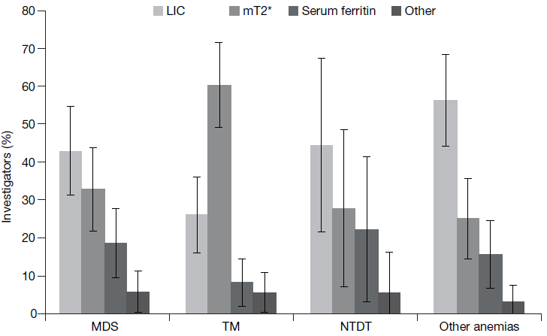
LIC, liver iron concentration; MDS, myelodysplastic syndromes; mT2*, myocardial T2*; NTDT, non­transfusion-dependent thalassemia; TM, thalassemia major.

