Supplementary Materials and Methods
Processing of human blood samples and isolation of T cells
Blood of CLL patients was drawn using ethylene diamine tetraacetic acid (EDTA)-coated tubes (Sarstedt, Nürnbrecht, Germany). Peripheral blood mononuclear cells (PBMCs) were isolated by Ficoll density gradient separation (Bio&Sell, Feucht, Germany; # L 6115) as previously described,^{1, 2} and if needed, EasySep™ Human Tcell Isolation Kit (Stemcell Technologies, Vancouver, Canada; #17951) was used to isolate T cells according to manufacturer’s instructions typically yielding a purity of 97.5%. PBMCs of CLL patients were viably frozen and when needed, frozen PBMCs were thawed and rested for 30 min until further processing.

Collection of murine tissue samples and preparation of cell suspensions
Mice were euthanized by increasing concentrations of carbon dioxide (CO₂). Single-cell suspensions were generated by mechanical disruption of spleens using gentleMACS (Miltenyi Biotech, Bergisch Gladbach, Germany; #130-093-237). Red blood cells were lysed using RBC Lysis Buffer (Biolegend, London, United Kingdom; #420301), filtered with a 70 µm cell strainer (Corning, USA; #352350) and counted using a Vi-Cell XR 2.03 cell counter (Beckman Coulter Inc.,Brea, USA). If necessary, T cells or CD8⁺ T cells were isolated from whole splenocytes using EasySep™ Mouse T cell Isolation Kit or Mouse CD8⁺ T cell Isolation Kit (Stemcell Technologies, Vancouver, Canada; #19851 and #19853) according to manufacturer’s instructions typically yielding a purity of 96%. Splenocytes of Eµ-TCL1 mice were viably frozen and when needed, frozen PBMCs were thawed and rested for 30 min until further processing.

Activation of T cells
To assess the activation of T-cells, cells were stimulated with anti-CD3 (1 µg/ml; murine: clone 145-2C11, ThermoFisher Scientific, Dreieich, Germany; #16-0031-86; human: clone: UCHT1, BioLegend, London, United Kingdom; #300438) or a combination of anti-CD3 (1 µg/ml) plus anti-CD28 (2 µg/ml; murine: clone 27.52, ThermoFisher Scientific, Dreieich, Germany; #16-0281-85; human: clone: 28.2, BioLegend, London, United Kingdom; #302934) antibodies in the presence of the different inhibitors or DMSO as vehicle control at 37°C, 5% CO₂. Isolated T cells were stimulated using Dynabeads T-Activator CD3/CD28 (ThermoFisher Scientific, Dreieich, Germany; #11456D and #11161D) at a cell:bead ratio of 1:1. For cytokine analysis, cells were stimulated for 6hrs in the presence of eBioscience™ Protein Transport Inhibitor Cocktail (ThermoFisher Scientific, Dreieich, Germany; # 00-4980-93) as previously described.²

Analyzing T-cell proliferation
Both, murine and human cells were labeled with Cell Proliferation Dye eFluorTM 670 (ThermoFisher Scientific, Dreieich, Germany) per manufacturer’s instructions to track cell divisions. Cells were stimulated with anti-CD3 (1 µg/ml) or a combination of anti-CD3 (1 µg/ml) plus anti-CD28 (2 µg/ml) antibodies in the presence of the different inhibitors or DMSO as vehicle control. Isolated T cells were stimulated using Dynabeads T-Activator CD3/CD28 (ThermoFisher Scientific, Dreieich, Germany) at a cell:bead ratio of 1:1.

Cytotoxic T-cell assay
CD8⁺ T cells recognizing an LCMV peptide were isolated from P14xCD4-Cre LCMV TCR-transgenic mice with a C57BL/6 background as detailed above. Purified T cells were treated with PI3K inhibitors or DMSO at 6 × 10⁶ cells/mL for 1h at 37°C, 5% CO₂. TCL1-355 tumor cells³ were labeled with eBioscience™ Cell Proliferation Dye eFluor 670 according to the manufacturer’s instructions using final concentrations of 5 × 10⁶ cells/mL and 1 µM cell dye for staining. After washing the T cells to remove inhibitors, labeled tumor cells were co-cultured with T cells at an effector:target (E:T) ratio of 1:1 in presence of 2 ng/mL gp33-41 peptide (RP20257, GenScript Biotech Corp, New Jersey, USA). For the analysis of effector cytokines and T cell degranulation, cells were incubated at 37°C, 5% CO₂ in the presence of eBioscience™ Protein Transport Inhibitor Cocktail and anti-CD107a antibody for 6hrs. To investigate tumor cell death, co-cultures were analyzed after 24hrs using the PE Annexin V Apoptosis Detection Kit with 7-AAD (Biolegend, BioLegend, London, United Kingdom; #640934) according to the manufacturer’s instructions.

Flow Cytometry
After incubation, cells were stained with fluorescently labelled antibodies (Supplementary Table 2) as previously described.^{1, 2} In brief, single cell suspensions were stained with fluorescently labelled antibodies in phosphate-buffered saline (PBS, Sigma-Aldrich, Taufkirchen, Germany; # D8537) with addition of eBioscienceTM Fixable Viability Dye eFluor® (ThermoFisher Scientific, Dreieich, Germany) at a concentration of 1:1000 for 30 min at 4°C. All Antibodies used for FACS stainings are listed in Supplementary Table 2. If possible, cells were fixed using eBioscienceTM Intracellular Fixation Buffer (ThermoFisher Scientific, Dreieich, Germany; #0-8222-49) for 30min at room temperature, washed and stored at 4°C in the dark until data acquisition. Cells of Nr4a1-GFP mice were stained, washed, and acquired immediately to get accurate readings of intracellular GFP levels.
For PhosphoFlow Cytometry, after incubation of surface markers, cells were fixed with 1% paraformaldehyde for 10min and permeabilized with ice-cold methanol. Staining with phospho-specific antibodies and total-protein controls was performed for 30min at room temperature and samples were acquired immediately at the flow cytometer.

References

1. Roessner PM, Llao Cid L, Lupar E, et al. EOMES and IL-10 regulate antitumor activity of T regulatory type 1 CD4(+) T cells in chronic lymphocytic leukemia. Leukemia. Aug 2021;35(8):2311-2324. doi:10.1038/s41375-021-01136-1
2. Roessner PM, Hanna BS, Ozturk S, et al. TBET-expressing Th1 CD4(+) T cells accumulate in chronic lymphocytic leukaemia without affecting disease progression in Emicro-TCL1 mice. British journal of haematology. Apr 2020;189(1):133-145. doi:10.1111/bjh.16316
3. Chakraborty S, Martines C, Porro F, et al. B-cell receptor signaling and genetic lesions in TP53 and CDKN2A/CDKN2B cooperate in Richter transformation. Blood. 2021;138(12):1053-1066. doi:10.1182/blood.2020008276

Clinical information CLL patients
Number of samples | 14
Sex | 28.6 % female (4/14)
Age (years) | mean: 63.3  median: 59.0
Binet stage at sampling | 64.3 % A (9/14)  7.1 % B (1/14)  28.6 % C (4/14)
Mutational state of IGHV | 92.9 % mutated (13/14)
Chromosomal aberration | 85.7 % del13q (12/14)  14.3 % normal karyotype (2/14)  7.14 % del14q (1/14)
TP53 mutation | 0.0 % (0/14)
Prior treatment | 0.0 % (0/14)

List of flow cytometry products
product | # | Supplier
AKT Pan (PKB) Antibody, anti-human/mouse/rat, PE, REAfinity™ | 130-126-096 | Miltenyi Biotech, Bergisch Gladbach
AKT pS473 Antibody, anti-human/mouse, APC, REAfinity™ | 130-119-570 | Miltenyi Biotech, Bergisch Gladbach
Annexin V Apoptosis Detection Kit with 7-AAD | 640937 | BioLegend, London, United Kingdom
anti-human CD19 FITC | 302206 | BioLegend, London, United Kingdom
anti-human CD197 (CCR7) Brilliant Violet 421™ | 353208 | BioLegend, London, United Kingdom
anti-human CD25 PE | 302606 | BioLegend, London, United Kingdom
anti-human CD3 APC | 317318 | BioLegend, London, United Kingdom
anti-human CD4 APC/Cy7 | 317418 | BioLegend, London, United Kingdom
anti-human CD4 Brilliant Violet 650™ | 317436 | BioLegend, London, United Kingdom
anti-human CD45RO APC/Cy7 | 304228 | BioLegend, London, United Kingdom
anti-human CD5 APC | 300612 | BioLegend, London, United Kingdom
anti-human CD5 Brilliant Violet 510™ | 364018 | BioLegend, London, United Kingdom
anti-human CD69 PE/Dazzle™ 594 | 310942 | BioLegend, London, United Kingdom
anti-human CD8a Brilliant Violet 605™ | 301040 | BioLegend, London, United Kingdom
anti-mouse CD107a PE | 12-1071-82 | ThermoFisher Scientific, Dreieich, Germany
anti-mouse CD127 (IL-7Ra) Brilliant Violet 605™ | 135041 | BioLegend, London, United Kingdom
anti-mouse CD19 FITC | 11-0193-86 | ThermoFisher Scientific, Dreieich, Germany
anti-mouse CD25 eFluor® 450 | 48-0251-82 | ThermoFisher Scientific, Dreieich, Germany
anti-mouse CD3ε Brilliant Violet 605™ | 100351 | BioLegend, London, United Kingdom
anti-mouse CD4 APC/Cy7 | 100526 | BioLegend, London, United Kingdom
anti-mouse CD44 Alexa Fluor® 700 | 103026 | BioLegend, London, United Kingdom
anti-mouse CD5 BD Horizon™ BV605 | 563194 | BD Biosciences, Heidelberg, Germany
anti-mouse CD5 PE | 100608 | BioLegend, London, United Kingdom
anti-mouse CD69 PE/Dazzle™ 594 | 104536 | BioLegend, London, United Kingdom
anti-mouse CD8a Brilliant Violet 605™ | 100744 | BioLegend, London, United Kingdom
anti-mouse CD8a PE | 100708 | BioLegend, London, United Kingdom
anti-mouse TCRβ PE/Cy7 | 25-5961-82 | BioLegend, London, United Kingdom
anti-mouse TNFa eFluor® 450 | 48-7321-82 | ThermoFisher Scientific, Dreieich, Germany
anti-mouse TNFa FITC | 11-7321-82 | ThermoFisher Scientific, Dreieich, Germany
BD Phosflow™ Alexa Fluor® 488 Mouse anti-NF-κB p65 (pS529) | 558421 | BD Biosciences, Heidelberg, Germany
BD Phosflow™ Alexa Fluor® 647 Mouse Anti-mTOR (pS2448) | 564242 | BD Biosciences, Heidelberg, Germany
eBioscience™ Cell Proliferation Dye eFluor® 670 | 65-0840-85 | ThermoFisher Scientific, Dreieich, Germany
eBioscience™ Fixable Viability Dye eFluor® 450 | 65-0863-18 | ThermoFisher Scientific, Dreieich, Germany
eBioscience™ Fixable Viability Dye eFluor® 506 | 65-0866-18 | ThermoFisher Scientific, Dreieich, Germany
mTOR (7C10) Rabbit mAb (PE Conjugate) | 15006S | Cell Signaling Technology, Leiden, Netherlands
NF-κB p65 (D14E12) XP® Rabbit mAb (Alexa Fluor® 647 Conjugate) | 8801S | Cell Signaling Technology, Leiden, Netherlands

IC₅₀ concentrations of murine T cells
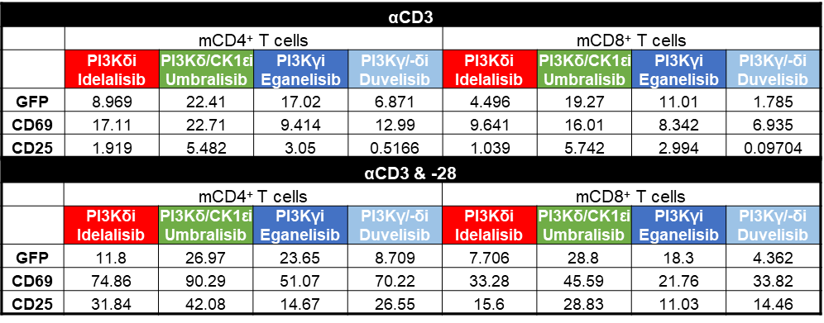
Splenocytes of Nr4a1-GFP mice were stimulated with αCD3 (1 µg/ml) or a combination of αCD3 (1 µg/ml) and αCD28 (2 µg/ml) in the presence of DMSO control or the indicated PI3K inhibitors (n = 3). MFI of Nr4a1-GFP and frequency of CD69⁺ or CD25⁺ cells were analyzed after 6hrs. IC₅₀ values are given as µM.

IC₅₀ concentrations of human T cells
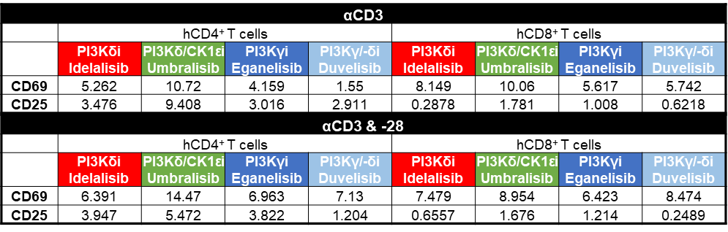
Human PBMCs were stimulated with αCD3 (1 µg/ml) or a combination of αCD3 (1 µg/ml) and αCD28 (2 µg/ml) in the presence of DMSO control or the indicated PI3K inhibitors (n = 4). Frequency of CD69⁺ or CD25⁺ cells were analyzed after 6hrs or 72hrs, respectively. IC₅₀ values are given as µM.

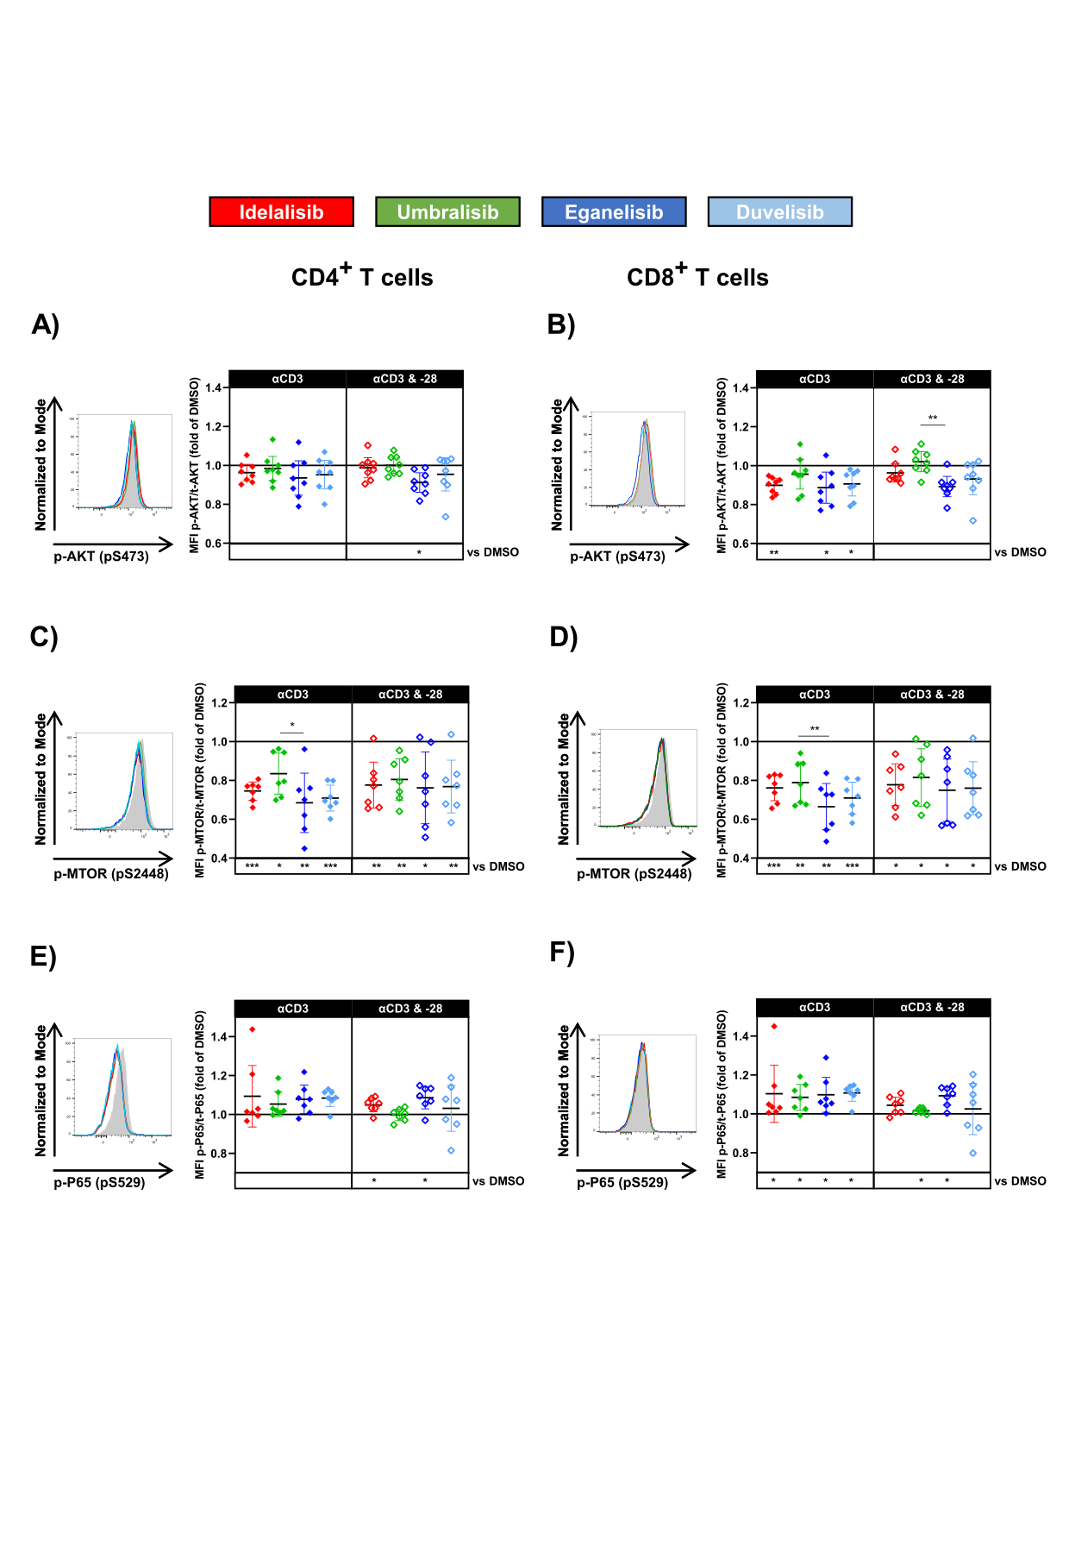

Suppl. Figure 1: PI3K inhibition reduces AKT/MTOR signaling after T-cell stimulation
A-F) Human PBMCs were incubated with DMSO control, idelalisib, umbralisib, eganelisib or duvelisib (all 1 µM) for 1h and subsequently, stimulated with αCD3 (1 µg/ml) or a combination of αCD3 (1 µg/ml) and αCD28 (2 µg/ml) for 1hr. Representative expression of phospho-proteins analyzed by phosphoFlow as well as Mean fluorescence intensity (MFI) of phospho- versus total-proteins are depicted. Expression of p-AKT of A) CD4⁺ and B) CD8⁺ T cells, p-MTOR of C) CD4⁺ and D) CD8⁺ T cells, as well as p-NF-kB P65 of E) CD4⁺ and F) CD8⁺ T cells were analyzed. Quantification was normalized to DMSO control (n = 7-8). All graphs show mean ± CI. * p <0.05; ** p < 0.01; *** p < 0.001.

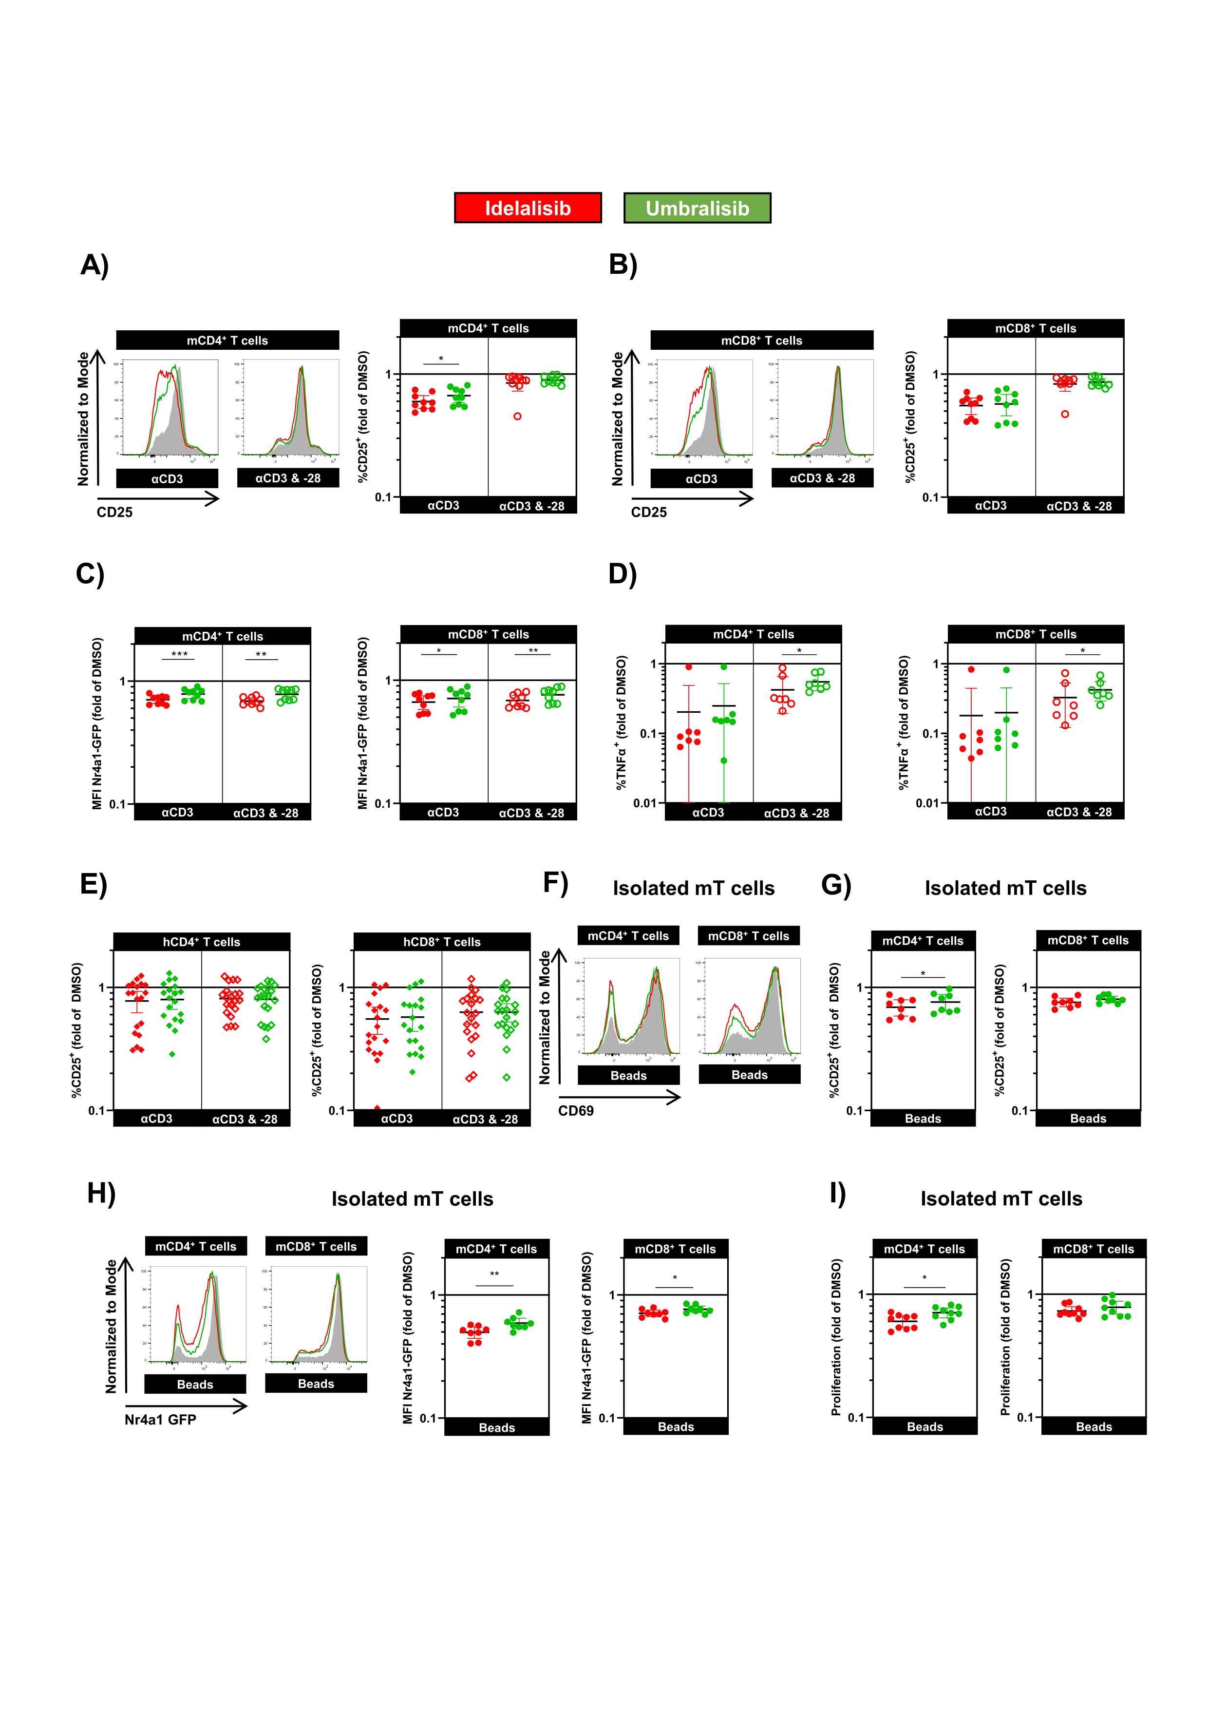
Suppl. Figure 2: Dual PI3Kδ and CK1ε inhibitor umbralisib reducing T-cell activity similarly to idelalisib
A-D) Murine splenocytes (m; circles) or E) human PBMCs (h; rhombi) were stimulated with αCD3 (1 µg/ml) or a combination of αCD3 (1 µg/ml) and αCD28 (2 µg/ml) in the presence of DMSO control, idelalisib or umbralisib (both 1 µM). A-B) Representative histogram and frequency of CD25⁺ cells (n = 9) of A) CD4⁺ and B) CD8⁺ T cells after 6hrs of stimulation relative to DMSO control. C) MFI of Nr4a1 GFP of CD4⁺ (left; n = 9) and CD8⁺ T cells (right; n = 9) relative to DMSO control. D) Frequency of TNFα-producing CD4⁺ (left; n = 7) and CD8⁺ T cells (right; n = 7) after 6hrs of stimulation normalized to DMSO control. E) Frequency of CD25⁺ cells out of human CD4⁺ (left) and CD8⁺ T cells (right) after 48 hrs of stimulation with αCD3 (n = 19) or a combination of αCD3 and αCD28 (n = 20) normalized to DMSO control. F-I) Murine T cells of were isolated using magnetic bead-based negative enrichment and stimulated with αCD3/αCD28 coated beads in the presence of the indicated inhibitors (all 1 µM) F) Representative histogram of CD69-expressing CD4⁺ (left) and CD8⁺ T cells (right). G) CD25 expression normalized to DMSO control (n = 8). H) MFI of Nr4a1-GFP depicted as representative histograms as well as quantification normalized to DMSO control (n = 8). I) Proliferation of T cells was analyzed by flow cytometry and normalized to DMSO control (n = 9).
All graphs show mean ± CI. * p <0.05; ** p < 0.01; *** p < 0.001.
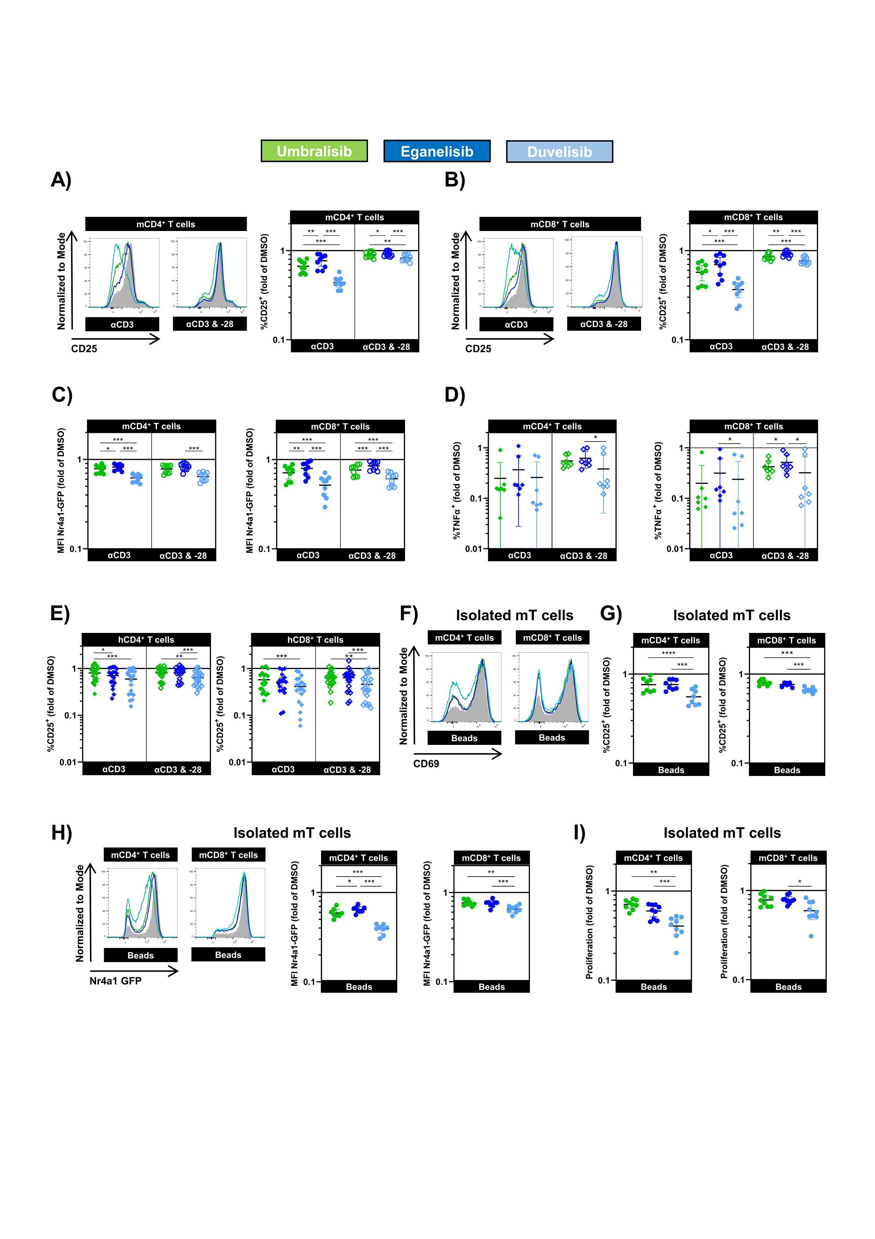
Suppl. Figure 3: Duvelisib, a dual PI3Kγ and -δ inhibitor, strongly reduces T-cell activity
A-D) Murine splenocytes (m; circles) or E) human PBMCs (h; rhombi) were stimulated with αCD3 (1 µg/ml) or a combination of αCD3 (1 µg/ml) and αCD28 (2 µg/ml) in the presence of DMSO control, umbralisib, eganelisib or duvelisib (all 1 µM). A-B) Representative histogram and frequency of CD25⁺ cells (n = 9) of A) CD4⁺ and B) CD8⁺ T cells after 6hrs of stimulation relative to DMSO control. C) MFI of Nr4a1 GFP of CD4⁺ (left; n = 9) and CD8⁺ T cells (right; n = 9) relative to DMSO control. D) Frequency of TNFα-producing CD4⁺ (left; n = 7) and CD8⁺ T cells (right; n = 7) after 6hrs of stimulation normalized to DMSO control. E) Frequency of CD25⁺ cells out of human CD4⁺ (left) and CD8⁺ T cells (right) after 48 hrs of stimulation with αCD3 (n = 19) or a combination of αCD3 and αCD28 (n = 20) normalized to DMSO control. F-I) Murine T cells of were isolated using magnetic bead-based negative enrichment and stimulated with αCD3/αCD28 coated beads in the presence of the indicated inhibitors (all 1µM) F) Representative histogram of CD69-expressing CD4⁺ (left) and CD8⁺ T cells (right). G) Relative CD25 expression normalized to DMSO control (n = 8). H) MFI of Nr4a1-GFP depicted as representative histograms as well as quantification normalized to DMSO control (n = 8). I) Proliferation of T cells was analyzed by flow cytometry and normalized to DMSO control (n = 9).
All graphs show mean ± CI. * p <0.05; ** p < 0.01; *** p < 0.001.

Suppl. Figure 4: Duvelisib reduces the activity of antigen-specific T cells
Splenic P14 CD8⁺ T cells were incubated for 1hr with respective PI3K inhibitors and co-cultured with cognate antigen-pulsed TCL1 leukemic cells (n = 9). A-B) Degranulation and cytokine production and T cells after 6 hrs and C-D) leukemia cell death after 24 hrs were analyzed. Mean fluorescence intensity (MFI) of A) CD107a and B) TNFα per marker-expressing cell. C) Frequency of early apoptotic (Annexin V⁺ 7AAD⁻), and all dead cells (Annexin V^{+/-} 7AAD⁺) of without (black) or with peptide pulsing of leukemic cells (grey).
All graphs show mean ± CI. *p <0.05; ** p < 0.01; *** p < 0.001.

Suppl. Figure 5: PI3Kγ and -δ additively control T-cell function
A) Human PBMCs (h; rhombi) were stimulated with αCD3 (1 µg/ml; n = 6) or a combination of αCD3 (1 µg/ml) and αCD28 (2 µg/ml; n = 7) in the presence of DMSO control, eganelisib, idelalisib, umbralisib or a combination of those (all 1 µM). Frequency of CD25⁺ cells out of human CD4⁺ (left) and CD8⁺ T cells (right) normalized to DMSO control.
All graphs show mean ± SEM. * p <0.05; ** p < 0.01; *** p < 0.001.

Suppl. Figure 6: T cells of Eµ-TCL1 mice show minor sensitivity to PI3K inhibition
A-F) Splenocytes of leukemic Eµ-TCL1 (m; circles; n = 12) were stimulated with αCD3 (1 µg/ml) or a combination of αCD3 (1 µg/ml) and αCD28 (2 µg/ml) in the presence of DMSO control, or the indicated PI3K inhibitors (all 1 µM). A) Frequency of CD69⁺ and B) CD25⁺ cells out of CD4⁺ (left) and CD8⁺ T cells (right) after 6 hrs of stimulation.
All graphs show mean ± CI. * p <0.05; ** p < 0.01; *** p < 0.001.

Suppl. Figure 7: Class I PI3K inhibition strongly reduces the function of T cells of CLL patients
PBMCs of CLL patients (n = 13) were stimulated with αCD3 (1 µg/ml) or a combination of αCD3 (1 µg/ml) and αCD28 (2 µg/ml) in the presence of DMSO control, or the indicated PI3K inhibitors (all 1 µM). A) Frequency of CD69⁺ cells out of CD4⁺ (left) and CD8⁺ T cells (right) was analyzed after 6 hrs of stimulation and normalized to DMSO control.
All graphs show mean ± CI. * p <0.05; ** p < 0.01; *** p < 0.001.

