Supplementary Data

SDC, Materials and Methods

Quantitative analysis: Multiple Reaction Monitoring (MRM) method development for determination of imatinib concentration in mouse livers. Quantitative analysis was performed by mass spectrometry in Multiple Reaction Monitoring (MRM) ion mode by using an AB SciexQTrap 4000 mass spectrometer, coupling with ExpressHT™-Ultra HPLC system (Eksigent). An aliquot of 6 µL of the extract was injected and separated on a Halo C18 1.0 mm x 50 mm, 2.7 µm column using a 40 μL/min flow rate at 40°C during 12 min gradient (0 min 70% A, 2min 50% A, 9min 5% A, 11 min 50% A, 12 min 70% A). The auto sampler was cooled at 4 °C. Solvent A composition: water acidified with 0,1% formic acid; solvent B composition: methanol acidified with 0.1% formic acid. The mass analysis was carried out in positive ion mode (ESI+). Precursor ion, product ions and optimal collision energies were established for each transition of Imatinib standard molecule were selected in according to published data and are summarized in Table 1S (http://dx.doi.org/10.1016/j.jpha.2017.07.009; https://doi.org/10.1093/chromsci/bmt037; DOI:10.1124/dmd.110.032326; DOI:10.1124/dmd.105.004283 ). The instrumental setting was: CUR 20, CAD 5, IS 4500, TEMP 380, GS1 25, GS2 24.
Table 1S. Compound-dependent parameters of Imatinib in HPLC-MRM/MS method.
Analyte | Precursor ion (m/z) | Product ions (m/z) | Dwell time (ms) | DP (V) | CE (V) | CXP (V)
Imatinib | 494.27 | 394.15 | 100
 |  | 379.15
 |  | 262.11
 |  | 222.09
 |  | 217.13
 |  | 276.15

The external standard method was used to quantify Imatinib in mice liver and kidney samples. To realize the calibration curve, a tablet of Imatinib drug corresponding to 100 mg of standard molecule was dissolved in 5 ml of DMSO/MeOH/ACN 1/1/1 solution and then serial dilution were prepared in the range of concentration 1-500 pg/μL by using MeOH/CAN 50:50 as solvent. To analyse the .wiff files Skyline software was used. The peak area recorded for all the monitored transitions was plotted as function of the standard concentration to realize the calibration curve for Imatinib (Figure 1Sa).
Imatinib distribution was determined in mouse kidney and liver tissue (25 mg) were weighed. 200 μL of lysis buffer containing 7M urea, 75mM NaCl and100mM AMBIC were added before homogenization by using a T10 basic Ultra-Turrax (IKA Dispersers). 500 μL of ACN/MeOH 50/50 solution were added to the homogenized tissue samples and centrifuged at 12000 rpm for 5 min. The supernatants were recovered, dried under vacuum and suspended in 200 μL of ACN/MeOH 50/50 solution to perform the MRM/MS analysis. An aliquot of 5 µL of the extracts was injected and the analysis of each sample was performed in triplicate (Figure 1Sb).
Analysis of phosphatidyl serine (PS) exposing erythrocytes. Briefly, blood from control and sickle mice was collected with heparinized capillary, centrifuged at 3000 rpm 5 min at 4°C, plasma and buffy coat were removed and red blood cells (RBCs) were washed once with PBS, BSA 1% (320 mOsm). 0.3 ul of washed RBCs underwent to the Annexin-V -PE Apoptosis Detection Kit (ThermoFisher Scientific, Waltham, United States), following the manufacturer’s instructions. Flow cytometric analysis was carried out with the FACSCanto II flow cytometer (BD Biosciences, Franklin Lakes, United States). The biparametric scatter plots were analyzed with FlowJo software version 10 (Tree Star Inc., Ashland, OR. ¹⁻⁴
Molecular analysis. For nucleic acid extraction, organs were homogenized in 10X volume of RNA lysis buffer (Norgen Biotek, Thorold, ON, 4Canada) using the GentleMACS tissue dissociator (Miltenyi Biotec, Calderara di Reno, Italy) and clear lysates were loaded onto silica spin columns for RNA/miRNA purification (Norgen) following manufacturer’s protocol. Gene and miRNA expression levels were quantified with real time PCR and expressed as relative expression (2-ΔCt) using GAPDH (for mRNA) or SNORD61 (for miRNA) as a control of equal cDNA inputs.
Immunoblot analysis. Packed red cells were lysed in ice-cold phosphate lysis buffer (5 mM Na₂HPO₄, pH 8.0, containing protease inhibitor cocktail tablets, 3 mM benzamidine final concentration, 1 mM Na₃VO₄ final concentration) and centrifuged 10 min at 4 °C at 12,000 g. Red cell membrane (ghost) and cytosol fractions were obtained as previously reported. ^{5,6} Frozen lung, kidney and aorta from each studied group were homogenized and lysed with iced lyses buffer (150 mM NaCl, 25 mM bicine, 0.1% SDS, 2% Triton X-100, 1 mM EDTA, protease inhibitor cocktail tablets (Roche), 1 mM Na3VO4 final concentration) then centrifuged 30 min at 4°C at 12,000 g. ⁷⁻⁹
Specific antibodies used are: anti Phospho-Tyrosine (clone PY99 from SCBT,Santa Cruz, CA (dilution 1:3000, 75 µgr/ul loaded) and clone 4G10 from Merck KGaA, Darmstadt, Germany (dilution 1:1600, 75µgr/ul loaded)); anti Band3 IVF12 (from Developmental Studies Hybridoma Bank, DSHB, University of Iowa, USA (1:1000 dilution, 20 µgr/ul loaded)); anti Phospho (Ser536) NF-kB p65 (dilution 1:1000, 75 µgr/ul loaded) and anti NF-kB p65 (clone C22B4) (dilution 1:1000, 75 µgr/ul loaded) from Cell Signaling Technology (Danvers, MA, USA); anti Endothelin-1 (ET-1) form AbCam, Cambridge, UK (dilution 1:1000, 75 µgr/ul loaded); anti VCAM-1 (R and D Systems, Minneapolis, MN, USA (dilution 1:1000, 40 µgr/ul loaded)); anti ICAM-1 (clone YN1.17) was kindly gifted by dr. Gabriella Costantin (dilution 1:1000, 75 µgr/ul loaded); anti PDGFBB (from AbCam, Cambridge, UK, (dilution 1:1000, 75 µgr/ul loaded)); anti Phospho (Tyr740) PDGF Receptor beta (PDGFR) (dilution 1:1000, 75 µgr/ul loaded), anti PDGF Receptor beta (PDGFR) (dilution 1:1000, 75 µgr/ul loaded), anti Phospho (Tyr653/654) FGF Receptor 1 (FGFR) (dilution 1:1000, 75 µgr/ul loaded), anti FGF Receptor 1 (FGFR) (dilution 1:1000, 75 µgr/ul loaded) from GeneTex, Inc, anti-heme oxygenase 1(HO-1) form SCBT (Santa Cruz, CA, USA (dilution 1:1000, 40 µgr/ul loaded); anti Phospho (Ser2448) mTOR (clone D9C2) (dilution 1:1000, 100 µgr/ul loaded) and anti mTOR (dilution 1:1000, 100 µgr/ul loaded) from Cell Signaling Technology (Danvers, MA, USA); anti LC3 I/II form Abcam Cambridge, UK, (dilution 1:1000, 75 µgr/ul loaded); anti SQSTM1/p62 form Abcam Cambridge, UK, (dilution 1:2000, 50 µgr/ul loaded); E-selectin (H-300) (dilution 1:1000, 75 µgr/ul loaded) and anti Ulk1 (H-240) from Santa Cruz Biotechnology, Inc, USA (dilution 1:1000, 100 µgr/ul loaded); anti GAPDH from SCBT (Santa Cruz, CA, USA (dilution 1:5000, 20 µgr/ul loaded)). Secondary donkey anti-rabbit IgG (dilution 1:10000) and anti-mouse IgG (dilution 1:5000) HRP conjugated were from GE Healthcare Life Sciences (Little Chalfont, UK); secondary donkey anti goat IgG (dilution 1:10000) HRP conjugated was from SCBT, secondary donkey anti rat IgG (dilution 1:5000) HRP conjugated was from AbCam. Blots were developed with Luminata Forte Chemiluminescent HRP Substrate from Merk Millipore (Burlington, MA, USA), and images were acquired with the Alliance Q9 Advanced imaging system (Uvitec, UK). Densitometric analyses were performed with the Nine Alliance software (Uvitec, UK).
Quantitative RT-PCR. mRNA was isolated and reverse transcribed into high-purity cDNA using lMACS One-step cDNA Kit according to the manufacturer’s instructions (Miltenyi Biotec). qRT-PCR was performed by SYBR Green PCR Master Mix (Applied Biosystems) by using the Applied Biosystems Model 7900HT Sequence Detection System. All PCR reactions were performed in triplicate. Relative gene expression was calculated by using the 2-DCt method, in which Ct indicates cycle threshold, the fractional cycle number where the fluorescent signal reaches the detection threshold. The DCt was computed by calculating the difference of the average Ct between the X-gene and the internal control glyceraldehyde 3-phosphate dehydrogenase (GAPDH). ^{7,10} Detailed primer sequences are shown in Supplementary Table 2S.
Supplemental Table 2S. List of primers used in quantitative real-time PCR.
Gene | Forward primer sequence  (5’ → 3’) | Reverse primer sequence  (5’ → 3’)
il-6 | GCCAGAGTCCTTCAGAGAGA | TGGAAATTGGGGTAGGAAGGA
il-1b | GCTGAAAGCTCTCCACCTCAA | TTGTCGTTGCTTGGTTCTCCT
e-selectin | GGACACTCAATGGATCTGCAG | GACTGGGGCTTCACAGGTAG

Magnetic Resonance Imaging (MRI). VCAM-1 targeted micelles were synthesized and characterized as previously reported. ^{11,12} The mice were anesthetized with a mixture of isoflurane/oxygen (5 % isoflurane for anesthesia induction, 1 % isoflurane for anesthesia maintenance) for the entire duration of the MRI experiment. T₂-weighted MR images were acquired on mouse abdomen with an axial geometry using a RARE sequence protocol (Repetition Time (TR)/ Echo Time (TE)/Rare Factor (RF)/ Number of Averages (NAV) = 2500/20/8/6, Field of View (FOV) = 3.50 cm, Matrix= 128x128, Slice Thickness = 1.50 mm) to precisely locate the aorta. T₁-weighted MRI images were acquired using a fast low angle shot (FLASH) sequence (TR/TE/NAV/Flip Angle = 50/5.45/2/50, FOV = 3.50 cm, Matrix= 128x128, Slice Thickness = 1.50 mm). A standard reference tube filled with the contrast agent gadoteridol (Gd concentration 0.5 mM) was placed next to the mice during the acquisitions and used to normalize the signal. Analysis of the images was performed with Bruker ParaVision software, version 5.1. More in details, specific Regions of Interest (ROIs) were manually drawn both on the aortic wall and on the reference tube in all the slices of T₂ weighted images, copied on T₁ weighted images and mean intensity values were calculated. The mean % T1 Signal Enhancement (SE) at 24 hours post injection was then determined as follows:
$$\% T1 SE= \frac{{{SI}_{aorta POST}}/{{SI}_{ref POST}}-{{SI}_{aorta PRE}}/{{SI}_{ref PRE}}}{{{SI}_{aorta PRE}}/{{SI}_{ref PRE}}}x 100$$
Where SI is the T1 signal intensity of aorta or reference tube, measured pre or 24 hours post injection of the VCAM-1 targeted micelles. Results are expressed as mean values ± SEM.
Aorta was dissected from some of the mouse that underwent MRI and vCAM1 expression was analysed by Immuno-blot analysis. Correlation graph was built plotting %T1 signal enhancement in relation to optical density (OD) acquired by densitometric analysis of VCAM1 western blot-expression.
Flow-cytometric analysis of kidney inflammatory infiltrates. Briefly, the right kidney was disaggregated with the gentle MACS dissociator (Miltenyi Biotec, Bergisch Gladbach, Germany) in 4 ml of PBS, BSA 1%, EDTA 2mM, filtered through a 70 µm cell strainer to obtain single cell suspension, centrifuged at 300 g 5 min at 4°C and resuspended in PBS, BSA 1%, EDTA 2mM. Mononuclear cells were isolated using the LymphoprepTM (STEMCELL Technologies, Germany) density gradient medium, centrifuging at 800 g for 20 minutes. The middle ring, containing white blood cells, was collected, washed twice with PBS and finally all the cells were resuspended in 100 µl of PBS, BSA 1%, EDTA 2mM added of anti CD45-V450, Ly6G APC-Cy7, B220 PE-Cy7, CD3 FITC, CD4 PE, CD8 PerCP-Cy5.5 (ThermoFisher Scientific, Waltham, United States). Anti CD16/CD32 monoclonal antibody (ThermoFisher Scientific) was used to block unspecific binding in the staining mixture. After 30 min at RT, cells were centrifuged at 300 g 5 min, resuspended in 200 µl of PBS, BSA 1%, EDTA 2mM and analysed with the FACSCanto II flow cytometer (BD Biosciences, Franklin Lakes, United States). The biparametric scatter plots were analysed with FlowJo software version 10 (Tree Star Inc., Ashland, OR). ¹³
Multiplex analysis of mouse plasmatic cytokines. Plasma was analysed using the Luminex Mouse Magnetic Assay (10-Plex) LXSAMSM-10 following the manufacturer instructions (R&D Systems, MI, United States) and the samples were read using the Bio-Plex® 200 System (Bio-Rad Laboratories, CA, United States).
Analysis of Efferocytosis and Macrophage Receptors. Spleen and lungs were gently dissociated into single cells using GentleMACS dissociator (Miltenyi Biotec, Germany) and stained with anti- CD45 PE-Cy5.5, F4/80 PE, CD11b FITC (Biolegend, CA, United States). Following staining cells were fixed, permeabilized, and counter-labeled with anti Ly6G BV421 and Ter-119 PE-Cy7 (Biolegend) to measure macrophage intracellular fluorescence associated with phagocytosed neutrophils and red cells respectively. Cells stained as above without permeabilization served as negative controls of intracellular staining, as previously reported. ¹
Anti-CD36 APC, Tim4 PE, CD68 FITC, and CD206 PerCP-Cy5.5 (Biolegend) were used to determine surface expression of phagocytic receptors on spleen and lungs macrophages identified using an anti-F4/80-APC-Cy7 antibody.
Flow cytometry was carried out on a BD FACS Canto II (BD Biosciences, NJ, United States) and results were analyzed with the FACS DIVA software (BD Biosciences).
Adhesion of human PMNs on activated HMEC-1. HMEC-1 (Human Microvascular Endothelial Cell line) monolayers were grown in Vena8 Endothelial+ Biochips (Cellix Ltd, Dublin, Ireland), as previously described ¹⁴ and activated by TNF-α (10 ng/ml, BioRad) and INF-γ (5 ng/mL, R&D systems) for 24 h prior to the adhesion assay. PMNs were stained by incubating 1 ml of freshly drawn whole blood with 1 μl of anti-CD16 alexa 488-conjugated mouse monoclonal antibody (Biolegend, USA) for 1 hour at 37°C, with or without imatinib (1.3 µM). Whole blood samples were perfused for 45 min at 1 dyn/cm² through the biochip channels containing TNF-α-activated HMEC-1 monolayers. PMN adhesion was monitored using AxioObserver Z1 microscope and ZEN software (Carl Zeiss, Le Pecq, France). Images were taken in 15 fields (5 representative consecutive fields are shown in the figures) at the centerline of each channel at 10 min intervals throughout the assay. ⁹
References
1. De Jong, K., et al. Short survival of phosphatidylserine-exposing red blood cells in murine sickle cell anemia. Blood 98, 1577–1584 (2001).
2. Noomuna P, R.M., Zhou S, et al. Inhibition of Band 3 tyrosine phosphorylation: a new mechanism for treatment of sickle cell disease. Br J Haematol 190(4), 599-609 (2020).
3. Kesely KR, P.A., Turrini FM, Olupot-Olupot P, Low PS. Inhibition of an Erythrocyte Tyrosine Kinase with Imatinib Prevents Plasmodium falciparum Egress and Terminates Parasitemia. PloS one (2016).
4. Pantaleo A, F.E., Pau MC, et al. . Band 3 Erythrocyte Membrane Protein Acts as Redox Stress Sensor Leading to Its Phosphorylation by p (72) Syk. Oxidative medicine and cellular longevity (2016).
5. Matté, A., et al. The novel role of peroxiredoxin-2 in red cell membrane protein homeostasis and senescence. Free Radic Biol Med 76, 80-88 (2014).
6. Matte, A., et al. Peroxiredoxin-2 expression is increased in beta-thalassemic mouse red cells but is displaced from the membrane as a marker of oxidative stress. Free radical biology & medicine 49, 457-466 (2010).
7. Federti, E., et al. Peroxiredoxin-2 plays a pivotal role as multimodal cytoprotector in the early phase of pulmonary hypertension. . Free Radical Biology and Medicine 112, 376-386 (2017).
8. Kalish, B.T., et al. Dietary ω-3 fatty acids protect against vasculopathy in a transgenic mouse model of sickle cell disease. Haematologica 100, 870-880 (2015).
9. Matte, A., et al. Resolution of sickle cell disease-associated inflammation and tissue damage with 17 R-resolvin D1 Blood 133, 252-265 (2019).
10. Matte, A., et al. Peroxiredoxin-2: A Novel Regulator of Iron Homeostasis in Ineffective Erythropoiesis. Antioxid Redox Signal 28, 1-14 (2018).
11. Garello, F., et al. MRI visualization of neuroinflammation using VCAM-1 targeted paramagnetic micelles. Nanomedicine: Nanotechnology, Biology and Medicine 14, 2341-2350 (2018).
12. Pagoto, A., et al. Paramagnetic Phospholipid-Based Micelles Targeting VCAM-1 Receptors for MRI Visualization of Inflammation. Bioconjugate Chem. 27, 1921–1930 (2016).
13. Schwarz, M., et al. Analysis of TNF-mediated recruitment and activation of glomerular dendritic cells in mouse kidneys by compartment-specific flow cytometry. Basic Research 84, 116-129 (2013).
14. Barbara Sandor , M.M., Claudine Lapoumeroulie, Miklos Rabaï, Sophie D Lefevre, Nathalie Lemonne, Wassim El Nemer, Anaïs Mozar, Olivier Français, Bruno Le Pioufle, Philippe Connes, Caroline Le Van Kim. Effects of Poloxamer 188 on red blood cell membrane properties in sickle cell anaemia British Journal of Haematology 173(1), 145-149 (2016).
Supplementary Figures

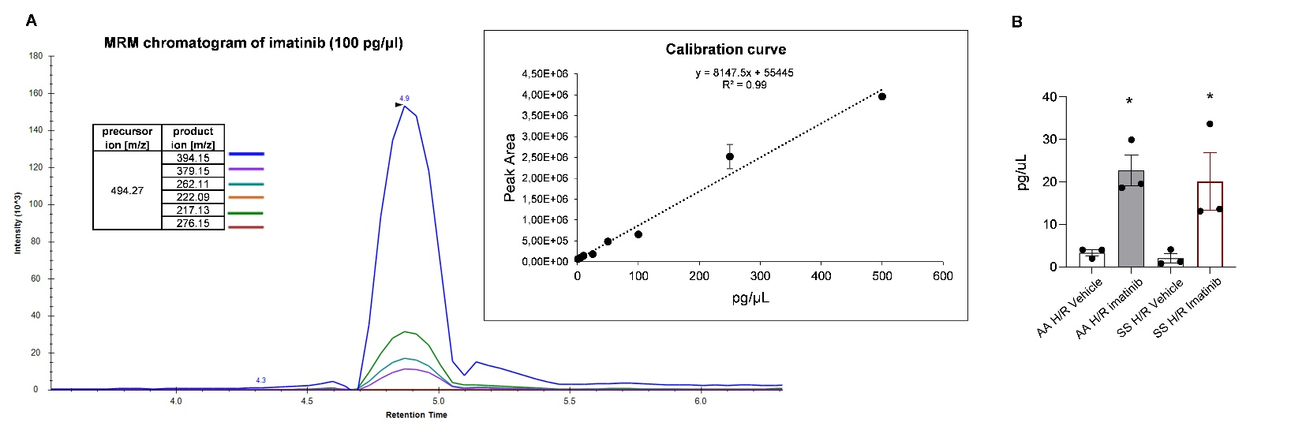
SDC, Figure 1

Figure 1S. A. MRM Chromatogram of 100 pg/μL Imatinib standard. The best six precursor ion-product ion transitions are reported. Right inset. Imatinib calibration curve in the range of concentration 1-500 pg/μL. The calculated RSD% was lower than 15% for each point of the calibration curve. B. Imatinib concentration in mouse kidney and liver from AA and SS mice treated with either vehicle or imatinib. Results are expressed in ng/mg of weighted tissue. Data are presented as means± SEM (n=3 mice; 2 male and 1 female in each group).

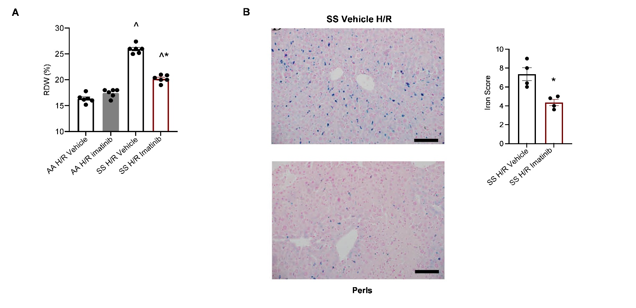
SDC, Figure 2

Figure 2S. A. Red cell distribution width (RDW) levels in AA (n = 6; 3 female and 3 male mice) and SS (n = 6; 3 female and 3 male mice) mice exposed to H/R: hypoxia (8% oxygen; 10 hours), followed by reoxygenation (21% oxygen; 3 hours) treated with vehicle or imatinib (50 mg/Kg/d for 3 weeks). Data are presented as mean ± SEM; *p < 0.05 when compared to vehicle treated animals; ^p<0.05 compared to AA mice. B. Left panel. Representative micropictures of Perls’-stained sections of liver at 400x magnification from SS mice exposed to H/R: hypoxia (8% oxygen; 10 hours), followed by reoxygenation (21% oxygen; 3 hours) treated with either vehicle or imatinib (50 mg/Kg/d for 3 weeks, n=4) (original magnification x200, scale bar 50um). Imatinib reduced iron accumulation in SS mice exposed to H/R. Right panel. Quantification of iron accumulation (n = 4; 2 female and 2 male mice). Data are shown as means ±SEM, *p<0.05 compared to vehicle treated animals.

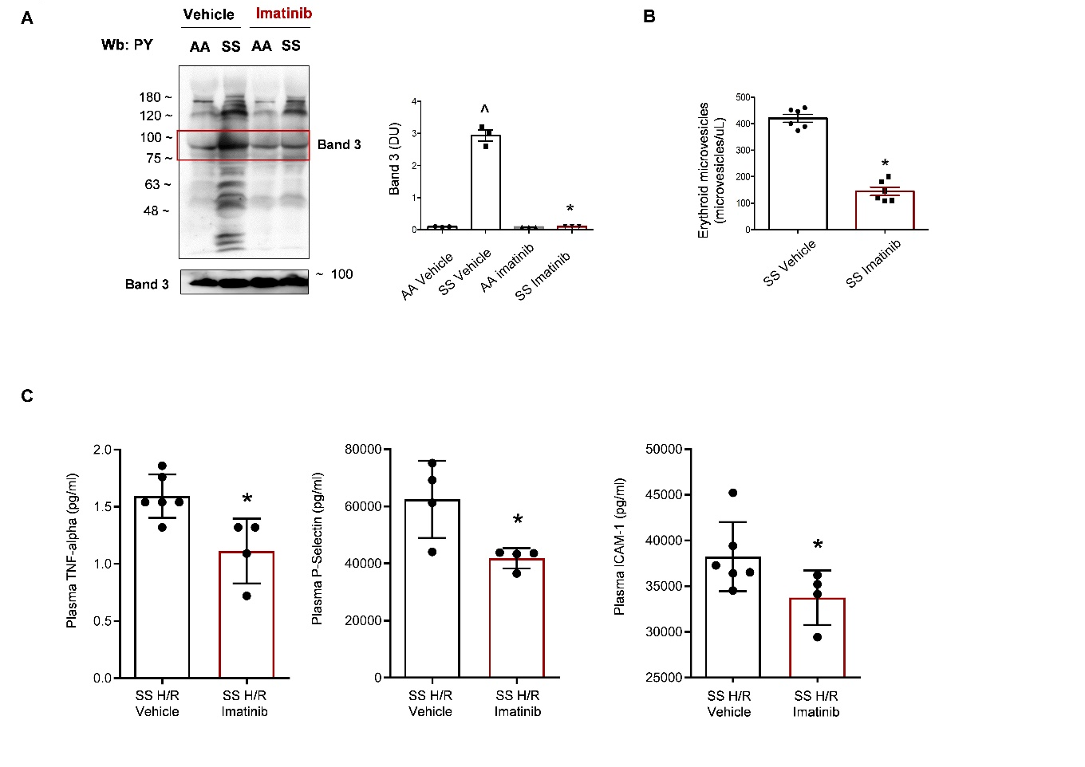
SDC, Figure 3

Figure 3S. A. Immunoblot analysis using specific antibodies against anti-phospho-tyrosine antibodies (PY) on RBC’s cytosol fraction from AA and SS mice treated as in a. The red box highlights band 3, which was identified in twin colloidal Coomassie stained gels by mass spectrometric analysis. One representative gel from 3 with similar results is shown. Densitometric analysis of immunoblots is shown on the right (DU: Densitometric Unit), data are shown as mean ± SEM (n=3); *p < 0.05 when compared to vehicle treated animals; ^p<0.05 compared to AA mice. B. Quantification of erythroid microvesicles in plasma from SS mice treated with either vehicle or imatinib. Data are shown as means ±SEM, *p < 0.05 when compared to vehicle (n=6). C. Bioplex analysis of plasmatic TNF-alpha, P-Selectin and ICAM-1 of SS mice exposed to H/R and treated with either vehicle or imatinib (50 mgr/Kg daily for 3 weeks). Data are presented as mean ± SEM (n= 4-6; 2-3 female and 2-3 male mice). * p <0.05 compared to vehicle.

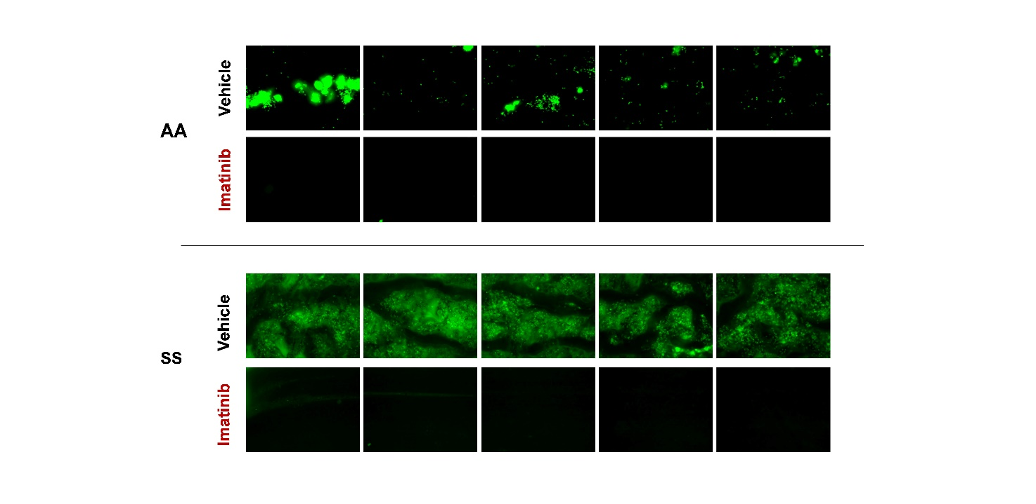
SDC, Figure 4

Figure 4S. Adhesion of human PMNs on activated HMEC-1. PMNs in whole blood samples from a healthy donor (AA) and an SCD patient (SS) were stained with an anti-CD16 alexa 488-conjugated mouse monoclonal antibody and incubated in the absence (Vehicle) or presence of Imatinib. Blood samples were perfused on HMEC-1 monolayers grown in microcapillaries and activated by TNF-α and INF-γ. Images show adherent PMNs (green fluorescence) in 5 consecutive fields of each capillary. Magnification of 100X, scale bar: 100 µm.

SDC, Figure 5
Figure 5S. Phagocytosis of erythrocytes and neutrophils by spleen MΦ derived from AA mice undergoing H/R and imatinib or vehicle treatment. Phagocytosis of erythrocytes and neutrophils were assessed respectively as the percentage of F4/80⁺/Ter-119⁺ and F4/80⁺/Ly6G⁺ double positive cells. Results are means ± SEM (n= 4-5 mice/group).

SDC, Figure 6
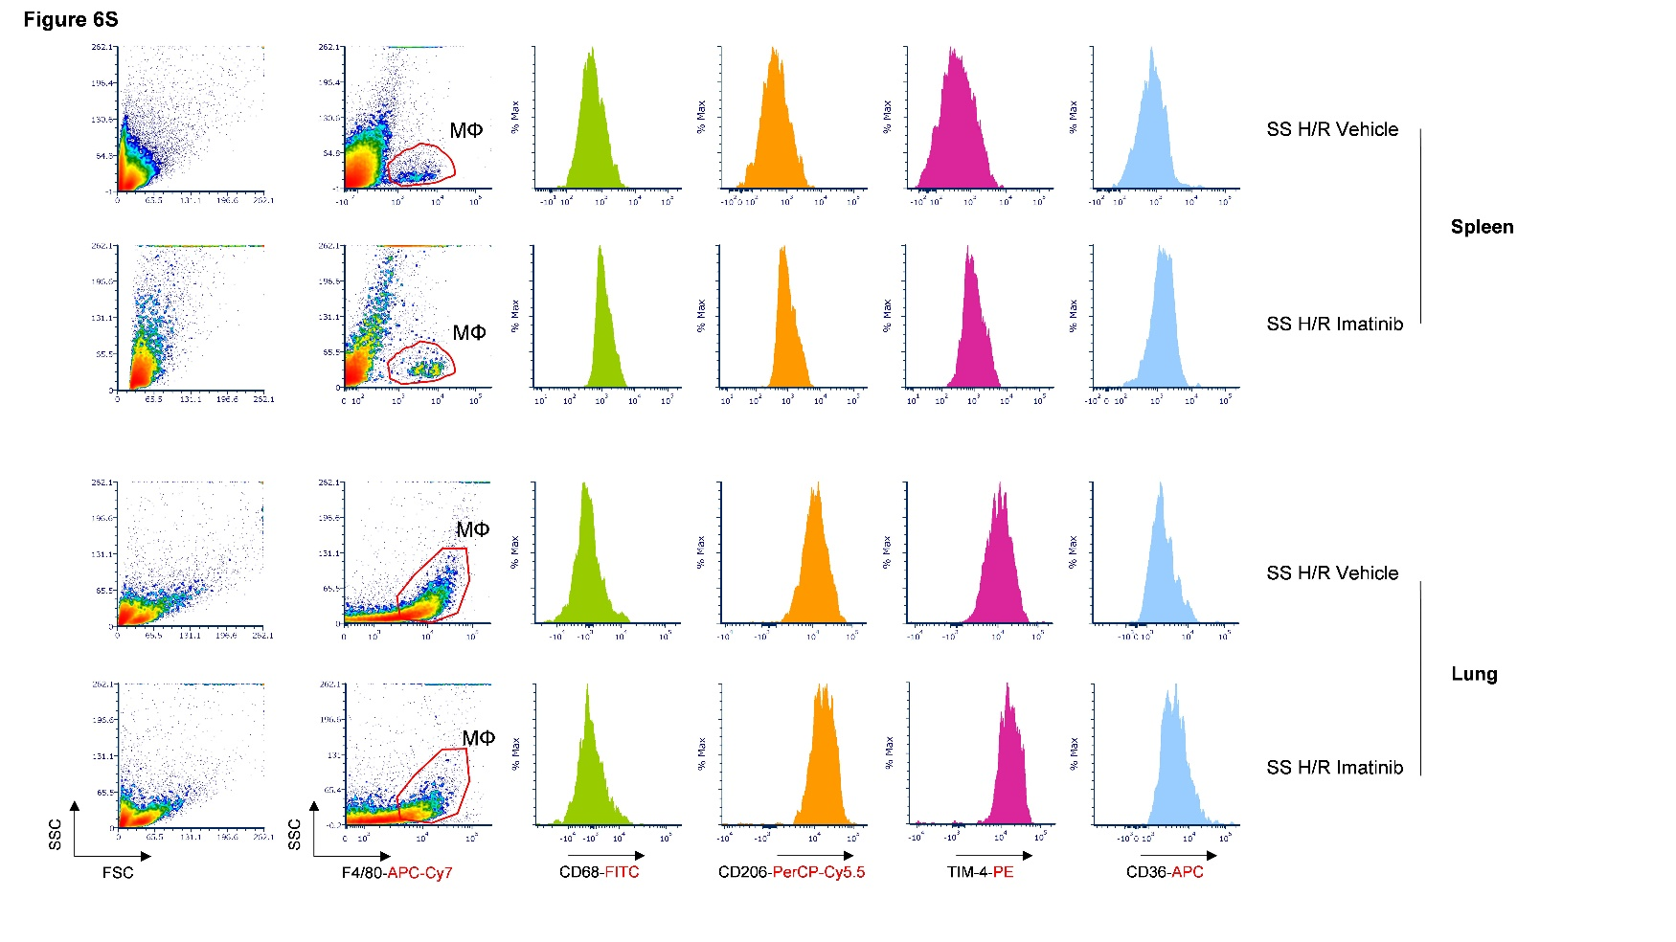

Figure 6S. Phagocytic receptor expression in spleen and lung macrophages from AA and SS mice undergoing H/R and treatment with Imatinib or vehicle. Representative flow cytometry plots show the gating strategy for identifying spleen and lung MΦ from forward/side scatter (FSC/SSC) plot based on expression of F4/80 and CD45/CD11b markers (not shown). Histogram plots show distribution of CD68, CD206, TIM-4, and CD36 mean fluorescence intensity.

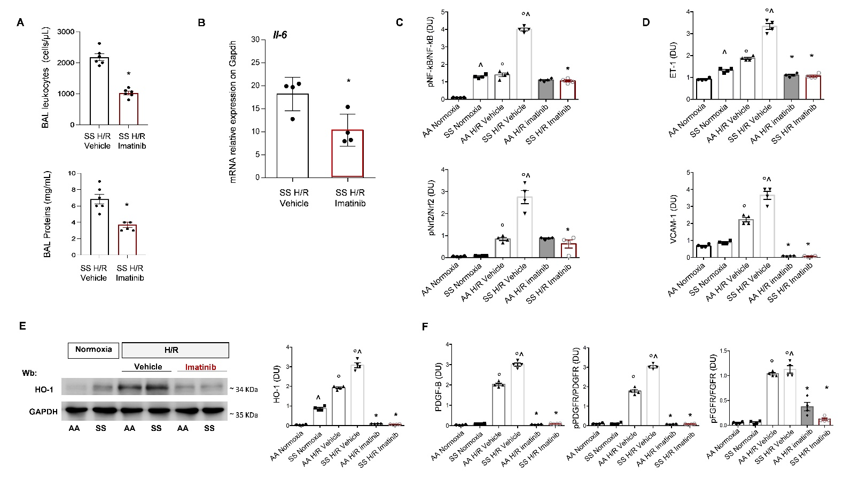
SDC, Figure 7

Figure 7S A. Leukocyte content (upper panel) and protein content (lower panel) in bronchoalveolar lavage (BAL) from SS mice under exposed to H/R: hypoxia (8% oxygen; 10 hours), followed by reoxygenation (21% oxygen; 3 hours) treated with either vehicle or Imatinib. Data are presented as mean ±SEM (n= 6, 3 age-matched male and 3 female animals). * p <0.001 compared to vehicle treated animals under hypoxia. P values were calculated using unpaired one-tailed t-test with Welch’s correction.B. Il-6 mRNA expression in lung tissues (normalized to GAPDH) from SS mice exposed to H/R: hypoxia (8% oxygen; 10 hours), followed by reoxygenation (21% oxygen; 3 hours) treated with either vehicle or imatinib (50 mg/Kg/d for 3 weeks). * p<0,05 compared to vehicle treated animals. Each sample is a pool from 3 mice (1 female and 2 male). Representative of three independent experiments. C. Densitometric analysis Figure 3b. Data are presented as means ±SEM (n=4); ^ p<0.05 compared to AA mice; * p<0.05 compared to vehicle; ° p<0.05 compared to normoxia (DU: Densitometric Unit). D. Densitometric analysis Figure 3b. Data are presented as means ±SEM (n=4); ^ p<0.05 compared to AA mice; * p<0.05 compared to vehicle; ° p<0.05 compared to normoxia (DU: Densitometric Unit). E. Immunoblot analysis using specific antibodies against HO-1 in lung from AA and SS mice exposed to H/R treated with either vehicle or imatinib (50 mg/Kg/d for 3 weeks). GAPDH serves as protein loading control. One representative gel from 4 with similar results is shown. Densitometric analysis of immunoblots is shown on the right. Data are presented as means ±SEM (n=4); ^ p<0.05 compared to AA mice; * p<0.05 compared to vehicle; ° p<0.05 compared to normoxia (DU: Densitometric Unit). F. Densitometric analysis Figure 3d. Data are presented as means ±SEM (n=4); ^ p<0.05 compared to AA mice; * p<0.05 compared to vehicle; ° p<0.05 compared to normoxia (DU: Densitometric Unit).

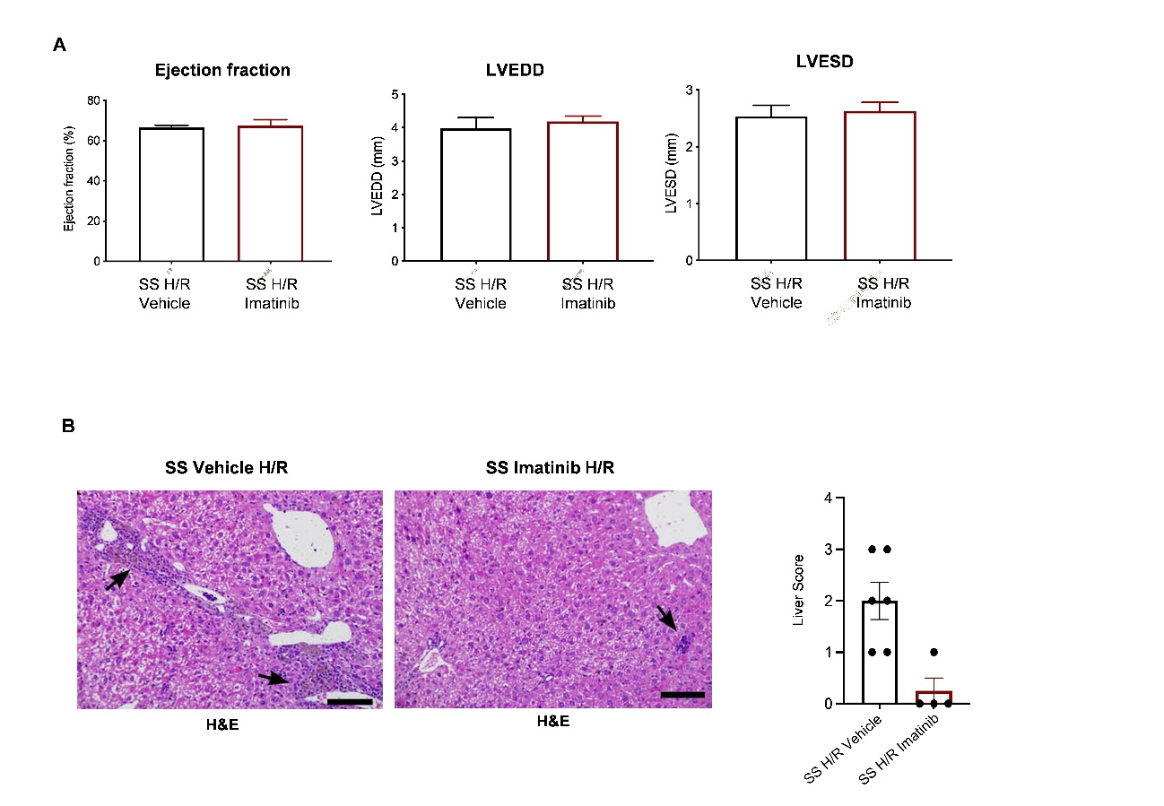
SDC, Figure 8

Figure 8S. A. Assessment of ejection-fraction, left ventricular end-​diastolic diameters (LVEDD) and left ventricular end-systolic diameters (LVESD) by echocardiography in SS mice (n=6 male mice) treated with vehicle or imatinib in normoxia conditions. B. Representative micropictures of Haematoxylin and eosin-stained (H&E) sections of liver at 400x magnification from SS mice exposed to H/R: hypoxia (8% oxygen; 10 hours), followed by reoxygenation (21% oxygen; 3 hours) treated with either vehicle or imatinib (50 mg/Kg/d for 3 weeks) (scale bar 50um). In vehicle treated SS mice, H&E stains shows a mild inflammatory infiltrate composed of lymphocytes and macrophages, located around biliary ducts within portal tracts with spill-over of some lymphocytes within hepatocyte trabeculae (arrows). In imatinib treated SS mice, the density of the inflammatory cell infiltrates is reduced to small focal areas (arrow). Right panel. Quantification of liver damage according to liver score determination. Liver score: 0: no hepatocellular damage; 1: mild injury characterized by cytoplasmic vacuolization and focal nuclear pyknosis; 2: moderate injury with dilated sinusoids, cytosolic vacuolization, and blurring of intercellular borders; 3: moderate to severe injury with con coagulative necrosis, abundant sinusoidal dilatation, red blood extravasation into hepatic chords, hypereosinophilia and migration of neutrophils; 4: severe necrosis with loss of hepatic architecture, disintegration of hepatic chords, haemorrhage and neutrophils infiltration. Data are shown as mean ±SEM (n=3); *p <0.05 compared to vehicle treated animals.

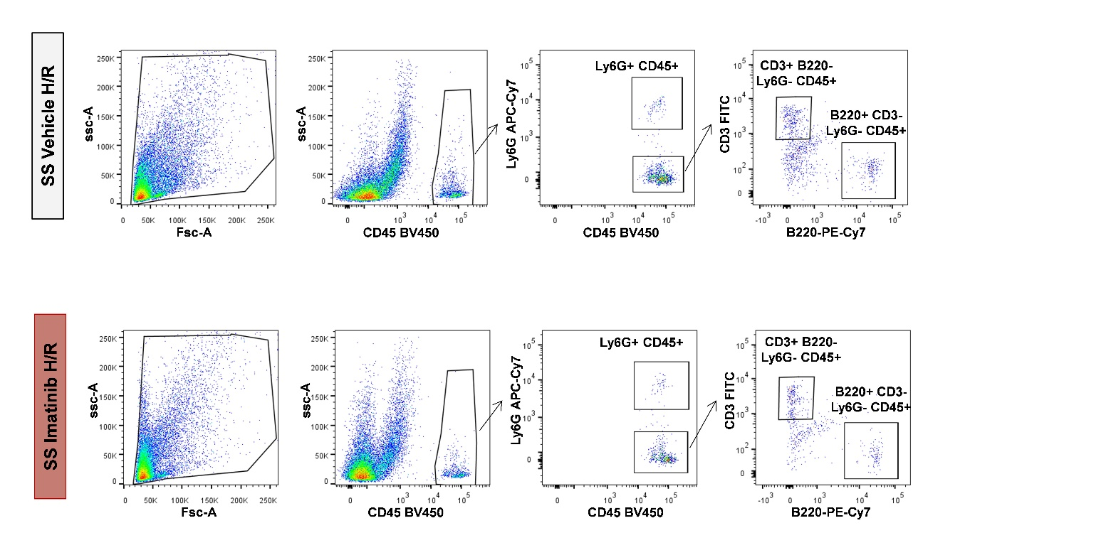
SDC, Figure 9

Figure 9S. Representative scatter plots and gating strategy to analyze inflammatory infiltrates in kidneys from SS mice exposed to H/R treated with either vehicle or imatinib (50 mg/Kg/d for 3 weeks). Neutrophils were identified as Ly6G+CD45+ population; T Lymphocytes were CD3+ B220- Ly6G- CD45+; B Lymphocytes were B220+ CD3- Ly6G- CD45+.

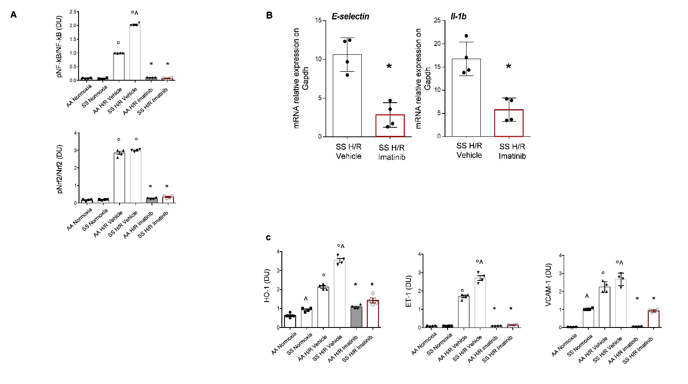
SDC, Figure 10

Figure 10S. A. Densitometric analysis Figure 4c. Data are presented as means ±SEM (n=4); ^ p<0.05 compared to AA mice; * p<0.05 compared to vehicle; ° p<0.05 compared to normoxia (DU: Densitometric Unit). B. E-selectin and Il-1b mRNA expression in kidney tissues (normalized to GAPDH) from SS mice exposed to H/R treated with either vehicle or imatinib (50 mg/Kg/d for 3 weeks). * p<0.05 compared to vehicle treated animals. Each sample is a pool from 3 mice (1 female and 2 male). Representative of three independent experiments. C. Densitometric analysis Figure 4d. Data are presented as means ±SEM (n=4); ^ p<0.05 compared to AA mice; * p<0.05 compared to vehicle; ° p<0.05 compared to normoxia (DU: Densitometric Unit).

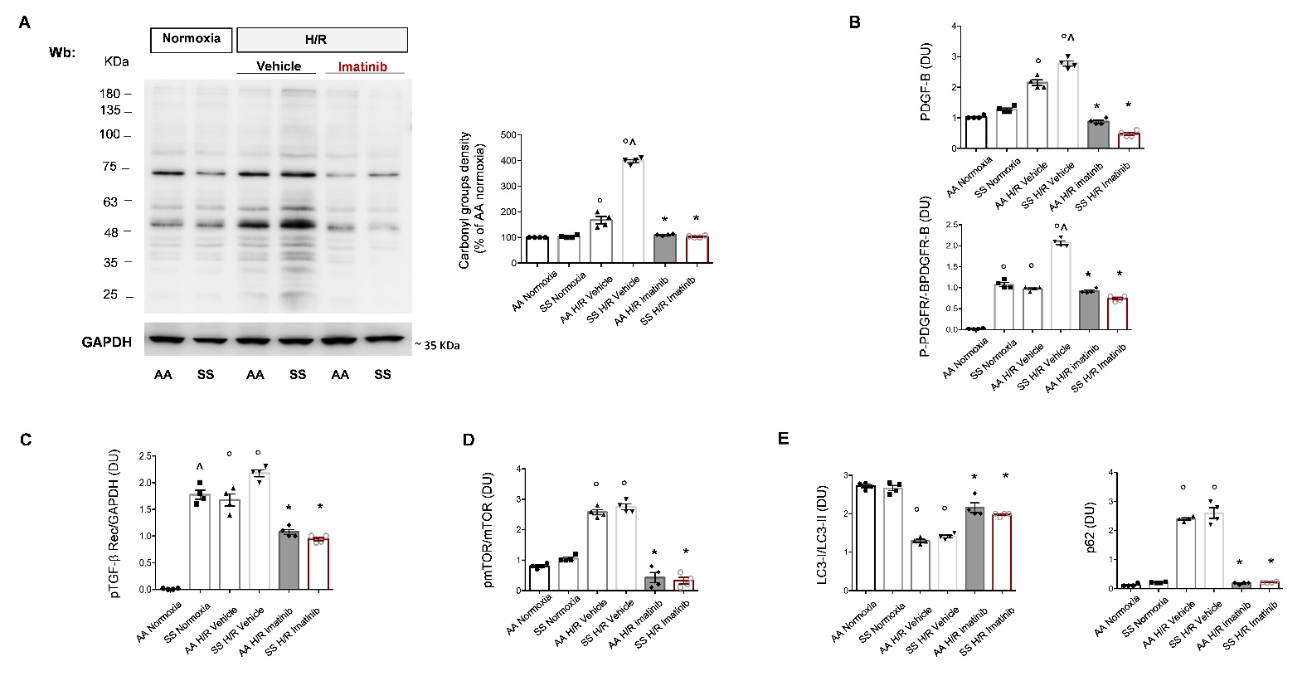
SDC, Figure 11

Figure 11S. A. Left panel. OxyBlot analysis of the soluble fractions of kidney from AA and SS mice exposed to H/R treated with either vehicle or imatinib (50 mg/Kg/d for 3 weeks). The carbonylated proteins (1 mg) were detected by treating with 2,4-dinitrophenylhydrazine and blotted with anti-DNP antibody. GAPDH serves as protein loading control. Right panel. Quantification of band area was performed. Data are presented as mean ±SEM (n = 4) (DU: Densitometric Unit). B. Densitometric analysis Figure 5a. Data are presented as means ±SEM (n=4); ^ p<0.05 compared to AA mice; * p<0.05 compared to vehicle; ° p<0.05 compared to normoxia (DU: Densitometric Unit). C. Densitometric analysis Figure 5c. Data are presented as means ±SEM (n=4); ^ p<0.05 compared to AA mice; * p<0.05 compared to vehicle; ° p<0.05 compared to normoxia (DU: Densitometric Unit). D. Densitometric analysis Figure 5d. Data are presented as means ±SEM (n=4); ^ p<0.05 compared to AA mice; * p<0.05 compared to vehicle; ° p<0.05 compared to normoxia (DU: Densitometric Unit). E. Densitometric analysis Figure 5e. Data are presented as means ±SEM (n=4); ^ p<0.05 compared to AA mice; * p<0.05 compared to vehicle; ° p<0.05 compared to normoxia (DU: Densitometric Unit).

SDC, Figure 12

Figure 12S. Western blot (Wb) analysis of ubiquitinated proteins (K48) in kidney from AA and SS mice exposed to H/R: hypoxia (8% oxygen; 10 hours), followed by reoxygenation (21% oxygen; 3 hours) treated with vehicle or imatinib (50 mg/Kg/d for 3 weeks). GAPDH is the protein loading control. Quantification of band area was performed by densitometry. Data are presented as means ±SEM (n=4); ^ p<0.05 compared to AA mice; * p< 0.05 compared to vehicle; ° p<0.05 compared to normoxia (DU: Densitometric Unit).

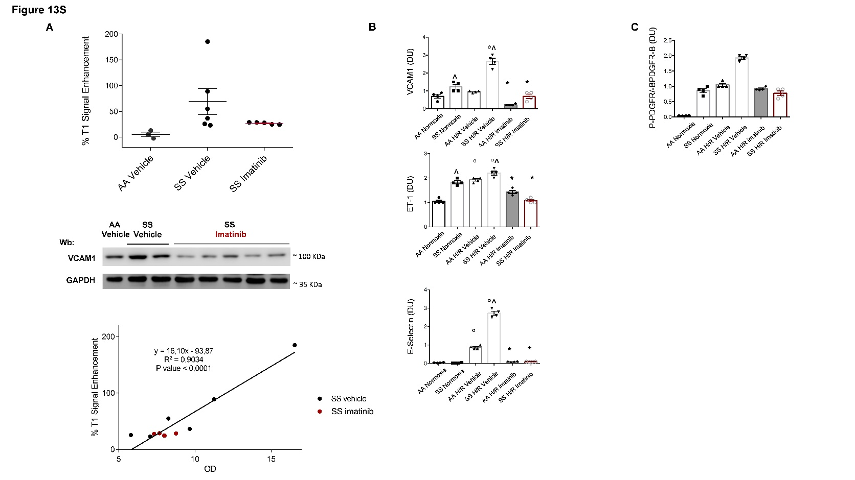
SDC, Figure 13

Figure 13S. A. % MRI T1 signal enhancement calculated over pre-images in the aortic wall 24 h post intravenous injection of VCAM-1 targeted micelles in AA and SS mice in normoxia condition treated with vehicle (n=1 female and 2 male AA mice; n=3 female and 3 male SS mice) or imatinib (n=5; 2 female and 3 male mice) (upper panel). Immunoblot analysis, using specific antibodies against VCAM-1, in isolated aorta from AA and SS mice in normoxia condition treated with vehicle or imatinib (50 mg/Kg daily for 3 weeks). Lane 1: AA vehicle-male, lane 2: SS vehicle male; lane 3: SS female; lane 4-6 SS imatinib treated females; lane 7-8, SS imatinib treated males (middle panel). One representative gel from 3 with similar results is shown. Lower panel. Correlation between %T1 signal enhancement and optical density (OD) acquired by densitometric analysis of VCAM1 as detected by Western blot-analyses in isolated aorta from the same mice. B. Densitometric analysis Figure 6c. Data are presented as means ±SEM (n=4); ^ p<0.05 compared to AA mice; * p<0.05 compared to vehicle; ° p<0.05 compared to normoxia (DU: Densitometric Unit). C. Densitometric analysis Figure 6c. Data are presented as means ±SEM (n=4); ^ p<0.05 compared to AA mice; * p<0.05 compared to vehicle; ° p<0.05 compared to normoxia (DU: Densitometric Unit).

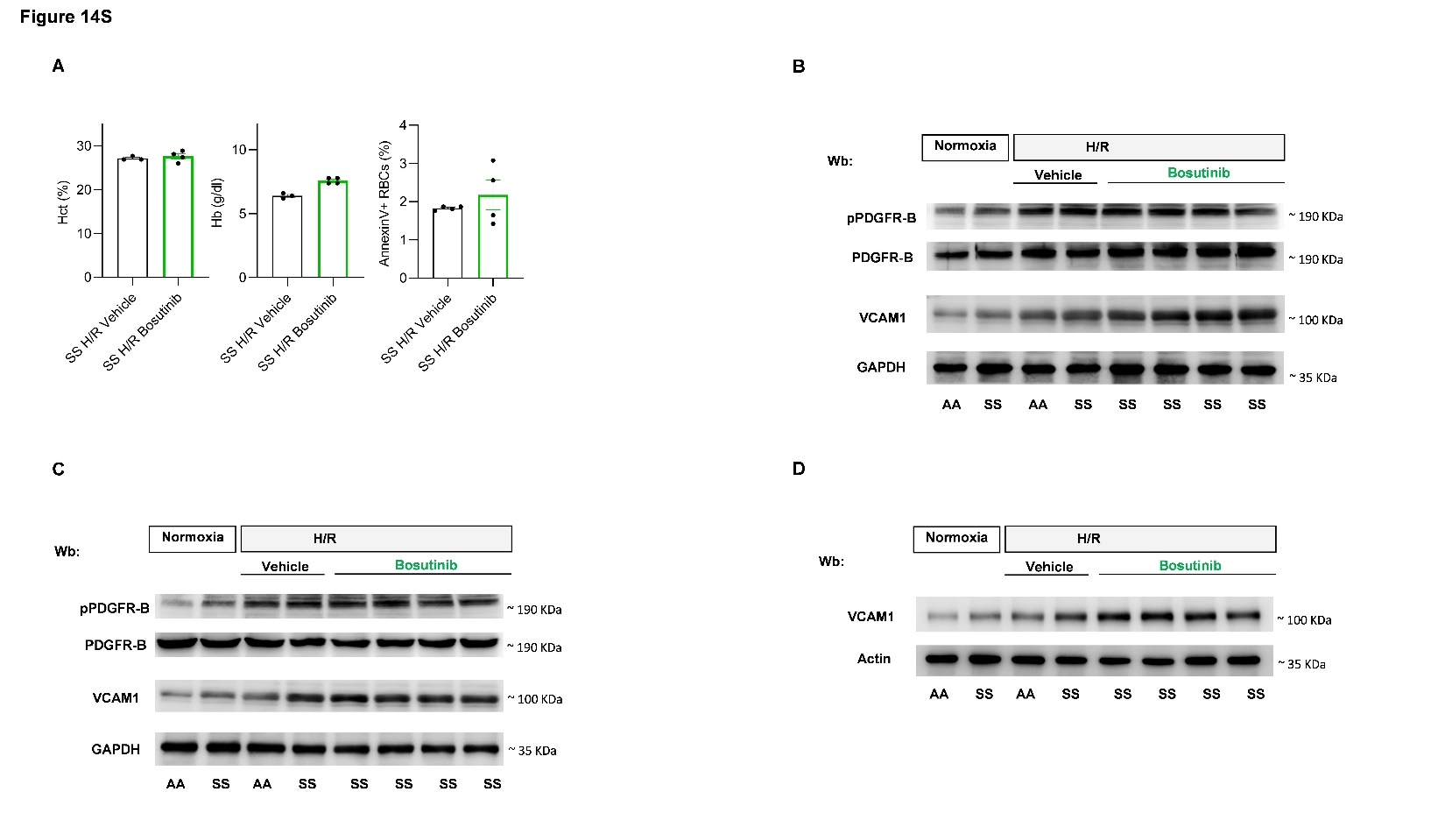
SDC, Figure 14

Figure 14S. A. Hematocrit (Hct), Hemoglobin (Hb) values and Annexin V+ red cells in SCD mice exposed to H/R: hypoxia (8% oxygen; 10 hours), followed by reoxygenation (21% oxygen; 3 hours) treated with either vehicle or bosutinib (150 mg/Kg/day for 11 days). Data are presented as mean ± SEM (n = 1 female and 2 male vehicle treated mice; n= 2 female and 2 male bosutinib treated mice). *p < 0.05 compared to vehicle. B-C. Immunoblot analysis, using specific antibodies against phospho(p) PDGFRB, PDGFRB and VCAM-1 in lung and kidney from AA and SCD mice treated as in a. GAPDH serves as protein loading control. One representative gel from 4 with similar results is shown. D. Immunoblot analysis, using specific antibodies against VCAM-1 in isolated aorta from AA and SCD mice treated as in a. GAPDH serves as protein loading control. One representative gel from 4 with similar results is shown.

