Supplementary Appendix
Supplement to: Rodier C, Kanagaratnam L, Morland D et al. Risk factors of progression in low-tumor burden follicular lymphoma initially managed by watch and wait in the era of PET and rituximab.
Table of Contents
Supplementary Table 1………………………………………………………………………….. 2
Supplementary Figure 1………………………………………………………………………..... 3
Supplementary Figure 2 ……….………………………………………………………………….. 4
Supplementary Table 2 ………………………………………………………………………….. 5
Supplementary Table 3 ………………………………………………………………………….. 6
Supplementary Table 4 ………………………………………………………………………….. 7

Supplemental Table 1. Type of extranodal involvement.

Extranodal site | Total (n=201) | PET-CT at diagnosis  (n= 113) | No PET-CT at diagnosis  (n=88)
≥ 1 extranodal site | 46 (23%) | 38 (34%) | 8 (9%)
Bone | 15 (7%) | 14 (12%) | 1 (1%)
Bone marrow | 14 (7%) | 11 (10%) | 3 (3%)
Digestive tract  Gastroduodenal  Small intestine  Colon  Rectum | 8 (4%)  3  1  2  2 | 7 (6%)  2  1  2  2 | 1 (1%)  1
Leukemic phase | 7 (3%) | 5 (4%) | 2 (2%)
Spleen | 4 (2%) | 4 (4%)
Skin | 4 (2%) | 4 (4%)
Tonsil | 3 (1%) | 3 (3%)
Parotid | 2 (1%) | 2 (2%)
Lung | 2 (1%) | 2 (2%)
Pleural | 2 (1%) | 2 (2%)
Kidney | 2 (1%) | 2 (2%)
Pancreas | 1 (0.5%) | 1 (1%)
Breast | 1 (0.5%) | 1 (1%)
Adrenal | 1 (0.5%) | 1 (1%)
Conjunctiva | 1 (0.5%) | 1 (1%)

Supplemental Figure 1. Overall survival (OS).
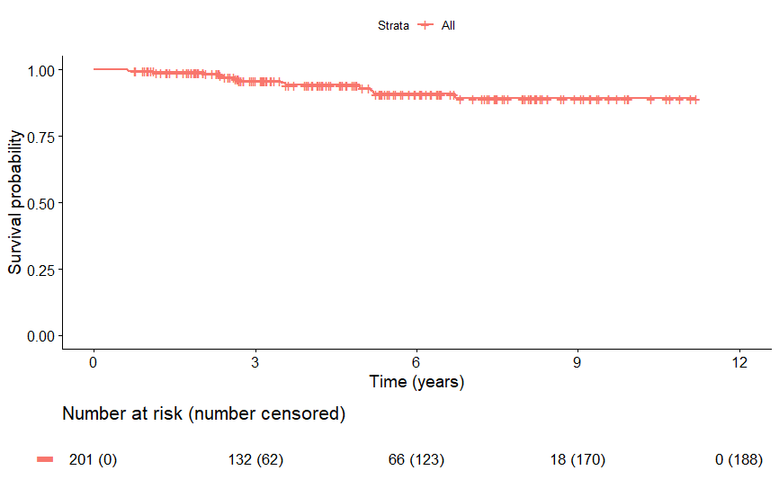

Supplemental Figure 2. (A) Progression-free survival after first-line treatment according to risk groups, (B) overall survival after treatment according to risk groups.
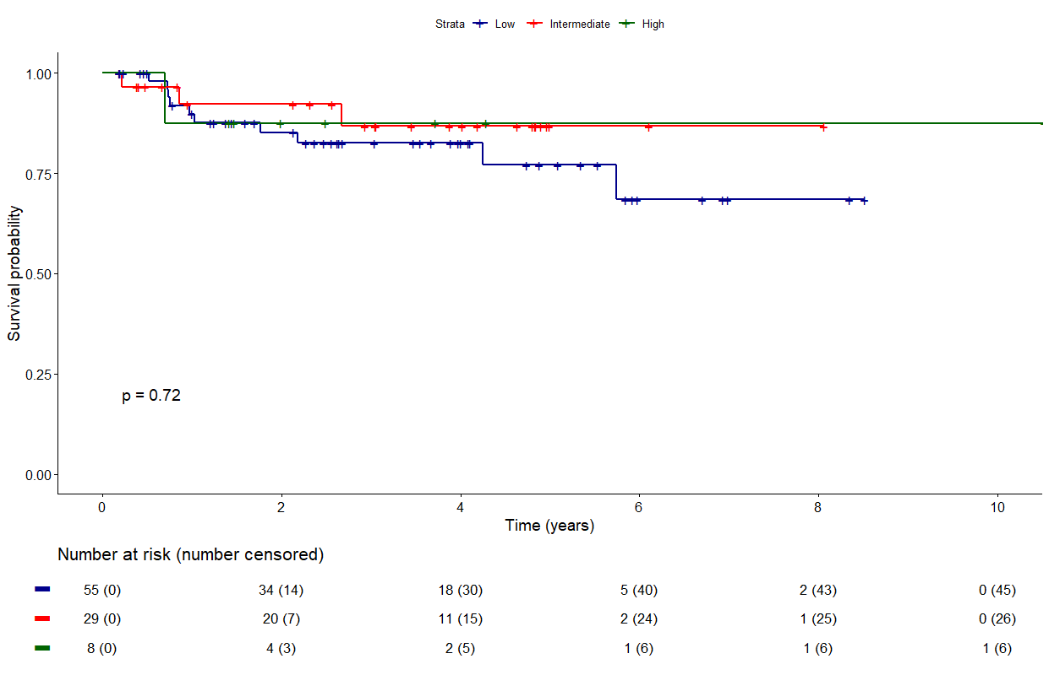
(A)

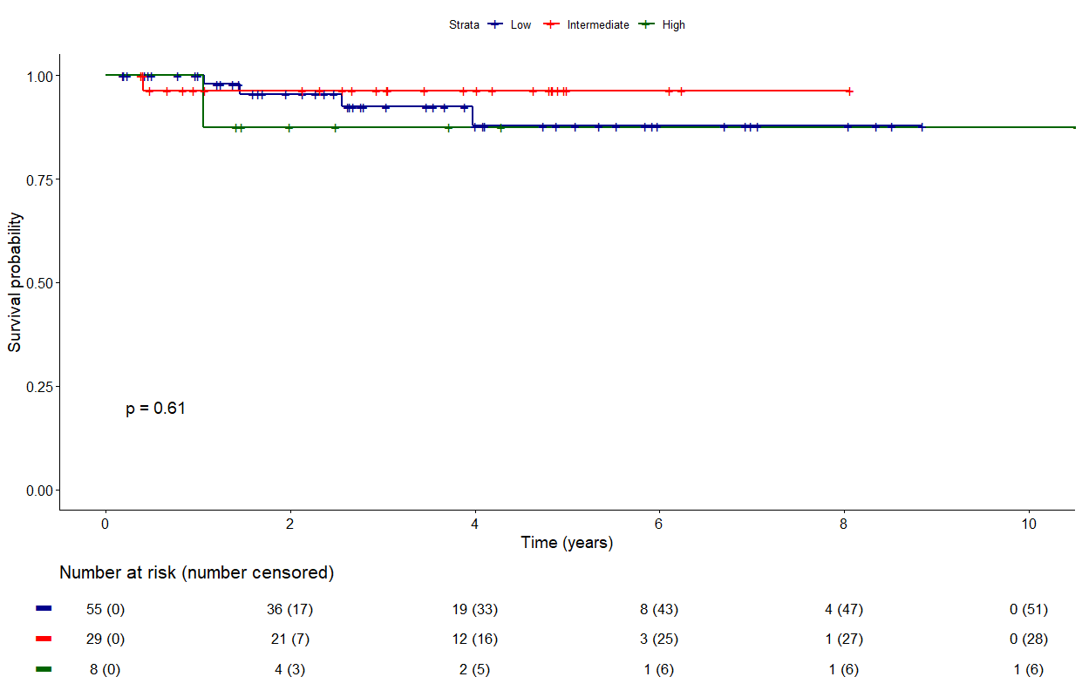
(B)

Supplemental Table 2. Patients’ characteristics according to TMTV.

Characteristic | TMTV ≥ 14 cm³  (n = 49) | TMTV < 14 cm³  (n = 26) | P-value
Age > 60 years | 34 (69%) | 17 (65%) | 0.72
ECOG performance status > 1 | 7 (14%) | 5 (21%) | 0.51
B symptoms | 2 (4%) | 0 (0%) | 1
Lymphopenia | 15 (31%) | 3 (12%) | 0.07
Circulating lymphoma cells | 5 (11%) | 0 (0%) | 0.16
Hemoglobin < 120 g/L | 0 (0%) | 0 (0%) | NA
Platelets < 150 10⁹/L | 4 (8%) | 1 (4%) | 0.66
Elevated LDH | 3 (6%) | 2 (8%) | 1
Elevated ß2m | 7 (15%) | 1 (5%) | 0.42
Albumin < 3.5 g/dl | 1 (3%) | 0 (0%) | 1
Number of nodal groups > 4 | 24 (51%) | 1 (4%) | < 0.0001
Extranodal involvement ≥ 2 | 9 (18%) | 0 (0%) | 0.02
Bone marrow involvement | 8 (73%) | 0 (0%) | 0.004
Ann Arbor stage III/IV | 46 (94%) | 6 (23%) | < 0.0001
FLIPI high-risk | 18 (37%) | 0 (0%) | < 0.0001

Supplemental Table 3. Patients’ characteristics according to SDmax.

Characteristic | SDmax ≥ 0.32 m⁻¹  (n = 23) | SDmax < 0.32 m⁻¹  (n = 52) | P-value
Age > 60 years | 15 (65%) | 36 (69%) | 0.73
ECOG performance status > 1 | 3 (13%) | 9 (18%) | 0.74
B symptoms | 1 (4%) | 1 (2%) | 0.53
Lymphopenia | 8 (35%) | 10 (20%) | 0.17
Circulating lymphoma cells | 3 (14%) | 2 (4%) | 0.32
Hemoglobin < 120 g/L | 0 (0%) | 0 (0%) | NA
Platelets < 150 10⁹/L | 1 (4%) | 4 (8%) | 1
Elevated LDH | 0 (0%) | 5 (10%) | 0.31
Elevated ß2m | 4 (18%) | 4 (9%) | 0.42
Albumin < 3.5 g/dl | 0 (0%) | 1 (3%) | 1
Number of nodal groups > 4 | 17 (81%) | 8 (15%) | < 0.0001
Extranodal involvement ≥ 2 | 7 (30%) | 2 (4%) | 0.003
Bone marrow involvement | 4 (57%) | 4 (36%) | 0.63
Ann Arbor stage III/IV | 23 (100%) | 29 (56%) | 0.0001
FLIPI high-risk | 11 (48%) | 7 (14%) | 0.0005

Supplemental Table 4. Multivariate analyses for time to lymphoma treatment (TLT) in 75 patients with baseline PET-CT available.

Parameter | Multivariate Cox proportional hazard
 | HR (95% CI) | P-value
Model 1
TMTV ≥ 14 cm³  SDmax ≥ 0.32 m⁻¹  Elevated LDH  Extranodal involvement ≥ 2  Number of nodal groups > 4 | 3.4 (1.2-9.6)  1.7 (0.7-4)  5.2 (1.6-16.8)  3.4 (1.1-10.1)  0.6 (0.3-1.5) | 0.02  0.24  0.006  0.03  0.26
Model 2
TMTV ≥ 14 cm³  SDmax ≥ 0.32 m⁻¹  Elevated LDH | 2.6 (1.0-6.7)  1.8 (0.9-3.9)  4.8 (1.5-15.0) | 0.04  0.11  0.007
Model 3
TMTV ≥ 14 cm³  SDmax ≥ 0.32 m⁻¹  Extranodal involvement ≥ 2 | 3.0 (1.2-7.7)  1.4 (0.6-2.9)  2.0 (0.8-5.0) | 0.02  0.41  0.15
Model 4
TMTV ≥ 14 cm³  SDmax ≥ 0.32 m⁻¹  Number of nodal groups > 4 | 3.2 (1.3-8.1)  1.8 (0.8-3.9)  0.7 (0.3-1.5) | 0.01  0.15  0.31
Model 5
TMTV ≥ 14 cm³  SDmax ≥ 0.32 m⁻¹  FLIPI high-risk | 2.8 (1.1-7.3)  1.5 (0.7-3.3)  1.1 (0.5-2.2) | 0.04  0.25  0.95

