SUPPLEMENTAL DATA
NK cell phenotype is associated with response and resistance to daratumumab in relapsed/refractory multiple myeloma

Supplemental material and methods

Flow cytometric analysis of bone marrow samples
Bone marrow (BM) aspirates were obtained at baseline prior to initiation of daratumumab treatment (Baseline; n=51). BM aspirates were also collected at the time of insufficient response to daratumumab monotherapy or at the time of disease progression, before initiation of ATRA treatment in part B (end of treatment part A, EOT-A; n=47).
Bone marrow mononuclear cells (BM-MNCs) were isolated by Ficoll-Hypaque density-gradient centrifugation, and cryopreserved until analysis. These BM samples were used to assess the frequency of NK cells, T-cells, and B cells, and to characterize the NK cell phenotype by staining 1x10⁶ nucleated cells with CD45 Krome Orange (Beckman Coulter), CD56 BUV737, CD3 BUV395, CD19 PE-CF594, and CD16 BV421 (all Becton Dickinson). Cells were also stained with Human Leukocyte Antigen-DR isotype (HLA-DR) APC-H7 to evaluate NK-cell activation, and with CD279 (PD-1) BV711, CD366 (T-cell immunoglobulin and mucin-domain containing-3 [TIM-3]) BV605 (all Becton Dickinson), and with CD223 (Lymphocyte-activation gene 3 [LAG3]) APC (Invitrogen) to assess the expression of immune checkpoints. The LIVE/DEAD Fixable Dead cell staining kit (Invitrogen) was used to determine sample viability. HuMax-003 FITC (Genmab/Janssen) was used to assess CD38 expression on NK cells. This antibody binds to a CD38 epitope distinct from the epitope recognized by daratumumab and binding is therefore unaffected by daratumumab treatment¹.
NK cells were defined as viable CD45^{high} lymphocytes with CD56⁺CD3⁻ expression.
Flow cytometry was performed using a LSRFORTESSA instrument (Becton Dickinson). Fluorescent labeled beads (CS&T beads, Becton Dickinson) were used daily to monitor the performance of the flow cytometer and verify optical path and stream flow. This procedure enables controlled standardized results and allows the determination of long-term drifts and incidental changes within the flow cytometer. No changes were observed which affected the results. Compensation beads were used to determine spectral overlap, compensation was automatically calculated using FACSDiva software (BD Biosciences). Flow cytometry data were analyzed using FCS express software, version 6 (DeNovo software).

Flow cytometric analysis of fresh peripheral blood samples
Peripheral blood (PB) samples were obtained from 61 patients at baseline prior to initiation of daratumumab treatment (baseline; n=53), after one cycle of daratumumab monotherapy (cycle 2 day 1, C2D1; n=51), and at the time of disease progression or insufficient response in part A, before initiation of ATRA treatment in part B (EOT-A; n=52).
These samples were analyzed within 24 hours after PB sampling, as described previously². Briefly, in these samples the frequency of NK cells was assessed by staining 1x10⁶ nucleated cells with CD45 Krome Orange, CD56 PE-Cy7 (both Beckman Coulter), CD3 V450 and CD16 PE (both Beckton Dickinson). Red blood cells were lysed with NH₄Cl directly before analysis. Flow cytometry was performed using a FACSCelesta instrument (Becton Dickinson).

Flow cytometric analysis of cryopreserved peripheral blood samples
In depth flow cytometric analysis was performed with longitudinal PB samples, obtained at baseline (n=20), at day 1 of the second treatment cycle (C2D1, n=20) and at EOT-A (n=20). PB-mononuclear cells (PB-MNCs) were isolated by Ficoll-Hypaque density-gradient centrifugation, and cryopreserved until analysis. In these samples, the frequency and phenotype of NK cells was characterized by staining 2x10⁶ nucleated cells (1x10⁶ per panel) with CD45 Krome Orange (Beckman Coulter), CD56 PE (Biolegend), CD14 BB700, CD3 BUV395, CD16 BUV737 (all Beckton Dickinson), and with the following antibodies in panel 1: CD57 FITC, Natural Killer Protein 30 [NKp30] BV421, DNAX Accessory Molecule-1 [DNAM-1] BV711, HLA-DR BV786 (all Beckton Dickinson), T-cell immunoreceptor with Ig and ITIM Domains [TIGIT] PE-Cy7, PD-1 BV605 (both Biolegend), and Killer Cell Lectin Like Receptor G1 [KLRG1] APC (ThermoFisher); and with the following antibodies in panel 2: NK Cell Group 2 isoform C [NKG2C] AF488 (R&D systems), CD160 PE-Cy7, NKG2A APC, NKG2D BV421, TIM-3 BV711 (all Biolegend), and Natural Killer Protein 46 [NKp46] BV786 (Beckton Dickinson). LIVE/DEADTM Fixable Near-IR Dead Cell fluorescent dye (Invitrogen) was used to determine viability. In order to prevent non-specific binding, human normal immunoglobulins (Nanogam, Sanquin Plasma Products B.V.) were added to the staining procedure as Fc-blocking reagent.
Flow cytometry was performed using a LSRFORTESSA instrument (Becton Dickinson). Fluorescent labeled beads (CS&T beads, Becton Dickinson) were used daily to monitor the performance of the flow cytometer and verify optical path and stream flow. Compensation beads were used to determine spectral overlap; compensation was automatically calculated using FACSDiva software (BD Biosciences). OneFlow Beads (Beckton Dickonson) and AlignflowTM Flow Cytometry Alignment Beads for UV (ThermoFisher) were used daily to maintain PMT values within 2% of the reference value. Flow cytometry data were analyzed using FCS express software, version 6 (DeNovo software).
In addition, manually gated NK cells were exported, and computational flow cytometry analyses were performed in RStudio and R version 4.0.3. To optimize the pre-gated flow cytometry data for computational flow cytometry analyses, several preprocessing steps were used. First, the peacoQC algorithm was used to select high quality cells based on timegating³. Second, hyperbolic arcsin transformation was used for all expression parameters with an optimized cofactor (either 50, 150, 300, 500 or 1000)⁴. Lastly, all expression parameters were scaled between 0 and 1 based on the lowest and upper 0.1% of all individual expression markers from 10 randomly selected files. A maximum of 20.000 cells per fcs file were aggregated, and FlowSOM was used to automatically identify cell populations using 225 clusters and 20 metaclusters for NK cell panels 1 and 2^{5,6}. The number of metaclusters was optimized based on visual inspection of the starplots and 2D scatterplots. Initially, FlowSOM was applied using 15 metaclusters, and the number of metaclusters was increased by 5 in case one metacluster contained both positive and negative cell populations of a certain marker. To calculate metacluster percentages and mean fluorescence intensities, all cells of the pre-gated NK cells were mapped over the optimized FlowSOM tree. UMAP was used for dimensionality reduction and visualization of the flow cytometry data in a 2D manner⁷.

Cytometry by time of flight (CyTOF) analysis on bone marrow samples
Patient PB and BM were collected and fixed in SmartTubes® (Smart Tube, Inc.) for 10 minutes at room temperature and stored at −80°C until analysis. CyTOF profiling was done in BM aspirates, obtained at baseline prior to initiation of daratumumab treatment (baseline), and in samples collected at the time of insufficient response to daratumumab monotherapy or at the time of disease progression, before initiation of ATRA treatment in part B (EOT-A).
Purified metal-conjugated antibodies from Fluidigm (Fluidigm Corp) or labeled in-house using the Maxpar® Antibody Labeling Kit (Fluidigm), according to the manufacturer’s protocol, were used for CyTOF staining and analysis. Prior to staining, samples were thawed and red blood cells were lysed with the addition of a hypotonic thaw-lyse buffer (SmartTube®), according to the manufacturer’s protocol. Samples still containing red blood cells after 3 lysis steps were further purified by CD235 depletion (MACSxpress Erythrocyte Depletion Kit; Miltenyi Biotec). To block surface Fc receptors, each sample received 10 µl of Human TruStain FcX (BioLegend). Cells were then incubated with a mixture of 36 surface marker metal-conjugated antibodies (not yet including antibodies for intracellular staining; Supplemental Table 3), and subsequently permeabilized with 1 mL of ice cold PermWash buffer (BD Biosciences). Next, intracellular staining was performed using anti-caspase-3, anti-granzyme B, and anti-CTLA4 antibodies. Cells were further permeabilized using PermIII buffer (BD Biosciences), stained with nucleic acid-intercalator (191Ir, 193Ir) (Fluidigm) and barcoded using Cell-IDTM 20-Plex Pd Barcoding Kit (Fluidigm). Labeled cells were then dissolved in ultrapure water with EQ™ Four Element Calibration Beads at a concentration of 3.3×10⁴ beads/mL (Fluidigm) for analysis with a CyTOF® C5 system (Fluidigm). Samples were run at an acquisition rate of 300 to 500 cells/min. Each experiment was run with a maximum of 20 samples per experiment, including an aliquot of PB from a healthy donor for quality control.
Data acquired on CyTOF® were obtained in FCS file format and normalized using CyTOF® Software 6.5.358 for Stand-Alone Processing Workstations (Fluidigm). Manual gating was performed using Cytobank software. Channel intensities were normalized with calibration beads. The arcsinh function with a cofactor of five was used to transform the channel intensities. Subsequent data analysis was performed using in house scripts and the R 4.0.3 and RStudio 1.1.442 software.
Sample quality was assessed by performing marker enrichment modelling to evaluate marker stability, and by relying on the Hilbert similarity and Earth Movers Distance methods to research sample similarity using clustering and dimensionality reduction⁸. BM samples from 11 patients were not included in the NK cell analysis, because of difficulties to adequately differentiate NK cells from CD56⁺ MM cells (analysis was performed with samples from 37 patients: 29 baseline and 23 EOT-A samples).
Manually gated NK cells were analyzed using a supervised learning approach to identify differences in composition driven by time, response to treatment and relapse. Briefly, cells were projected in the context of channels used for the analysis using the FreeViz method implemented in the Radviz package^{9,10}. The position of the channels was updated using a supervised algorithm to maximize the distance between cells from different categories. Shifts in composition were visualized using density plots and interpreted relative to the position of channels after optimization. To estimate the significance of those shifts, a Self-Organizing Map (SOM) was trained on down-sampled projected data and used to predict cluster assignments for all projected cells¹¹. The size of SOM clusters was computed for all conditions and transformed into a Centered Log Ratio (clr); the clr values were used as input to a Linear Mixed Model, where fold changes and P-values were computed for contrasts of interest.

Supplemental Table 1. Univariate analysis of clinical baseline characteristics for overall response rate part A (ORR(A)), progression-free survival part A+B (PFS-AB) and overall survival (OS).
 | ORR(A) | PFS-AB |  | OS
Characteristic | P | HR (95% CI) | P | HR (95% CI) | P
Age (years) | 0.872 | 0.998 (0.969 – 1.028) | 0.883 | 1.000 (0.967 – 1.034) | 0.995
WHO PS 1-2 | 0.040 | 1.912 (1.108 – 3.301) | 0.020 | 0.669 (0.366 – 1.223) | 0.192
Prior lines of treatment (n) | 0.533 | 1.095 (0.977 – 1.227) | 0.120 | 1.035 (0.916 – 1.170) | 0.582
Prior allogeneic stem cell transplantation | 0.707 | 0.432 (0.183 – 1.021) | 0.056 | 0.502 (0.179 – 1.408) | 0.191
Platelet count (x10⁹/L) | 0.562 | 1.000 (0.998 – 1.003) | 0.764 | 1.001 (0997 – 1.004) | 0.692
LDH (U/L) | 0.812 | 1.003 (1.001 – 1.006) | 0.016 | 1.002 (1.000 – 1.004) | 0.016
eGFR (ml/min) | 0.463 | 1.002 (0.988 – 1.016) | 0.769 | 0.997 (0.981 – 1.013) | 0.678
Beta2-microglobulin (mg/L) | 0.954 | 1.127 (1.033 – 1.230) | 0.007 | 1.107 (1.007 – 1.217) | 0.035
Albumin g/L | 0.737 | 1.000 (0.944 – 1.058) | 0.990 | 0.935 (0.884 – 0.988) | 0.018
ISS stadium II‡ | 0.777 | 0.629 (0.321 – 1232) | 0.177 | 0.691 (0.324 – 1.477) | 0.341
ISS stadium III‡ | 0.717 | 2.516 (1.193 – 5.304) | 0.015 | 2.934 (1.340 – 6.423) | 0.007
R-ISS stadium II‡ | 1.000 | 0.755 (0.347 – 1.642) | 0.478 | 0.604 (0.250 – 1.455) | 0.261
R-ISS stadium III‡ | 0.304 | 2.257 (0.804 – 6.335) | 0.122 | 3.683 (1.295 – 10.474) | 0.014
Extramedullary plasmacytomas | 0.122 | 3.773 (1.699 – 8.379) | 0.001 | 4.421 (1.998 – 9.785) | <0.0001
High risk cytogenetics* | 0.761 | 1.143 (0.597 – 2.190) | 0.687 | 1.094 (0.521 – 2.297) | 0.813
‡Referenced to (R-)ISS stadium I.
*According to the criteria proposed by Sonneveld et al. Blood 2016: high risk disease is defined by the presence of t(4;14), t(14;16), t(14;20), del(17/17p), and/or gain(1q).
Abbreviations: ORR(A), overall response rate part A; PFS-AB, progression free survival part A and B; OS, overall survival; HR, hazard ratio; CI, confidence interval; WHO PS, world health organization performance status; LDH, lactate dehydrogenase; eGFR, estimated glomerular filtration rate; ISS, International Staging System.

Supplemental Table 2. Univariate analysis of BM-resident NK cell characteristics on progression-free survival and overall survival.

 | ORR(A) | PFS-AB |  | OS
Characteristic | P | HR (95% CI) | P | HR (95% CI) | P
NK cells (%) | 0.150 | 0.970 (0.918 – 1.024) | 0.271 | 0.957 (0.896 – 1.021) | 0.185
NK cells expressing activating receptors  - CD16⁺ NK cells | 0.017 | 0.976 (0.957 – 0.997) | 0.023 | 0.978 (0.959 – 0.998) | 0.033
NK cells expressing activation markers (%)  - HLA-DR⁺ NK cells  - CD38⁺ NK cells | 0.043  0.794 | 1.048 (1.021 – 1.075)  0.982 (0.940 – 1.026) | <0.0001  0.409 | 1.071 (1.042 – 1.102)  1.023 (0.956 – 1.096) | <0.0001  0.511
NK cells expressing inhibitory receptors (%)  - LAG3⁺ NK cells  - TIM-3⁺ NK cells  - PD-1⁺ NK cells | 0.184  0.005  0.133 | 1.088 (0.781 – 1.516)  1.075 (1.018 – 1.135)  0.980 (0.937 – 1.024) | 0.617  0.009  0.361 | 1.385 (1.015 – 1.890)  1.078 (1.023 – 1.136)  1.006 (0.959 – 1.054) | 0.040  0.005  0.820
Abbreviations: PFS, progression-free survival part A and B; OS, overall survival part A and B; HR, hazard ratio; CI, confidence interval; NK cells, natural killer cells; LAG3, Lymphocyte-activation gene 3; TIM-3, T-cell immunoglobulin and mucin-domain containing-3; PD-1, programmed-death 1.

Supplemental Table 3. Antibody panel for CyTOF analysis

Specificity | Clone | Metal isotope | Purpose
CD45  CD34 | HI30  581 | 89Y  115In | Leukocytes  Hematopoietic progenitor cells
CD66b | 80H3 | 139La | Granulocytes
Caspase 3 | C92-605 | 141Pr | Apoptotic cells
CD20 | 2H7 | 142Nd | B lymphocytes
CD3 | UCHT1 | 143Nd | T lymphocytes
CD11b | ICRF44 | 144Nd | Monocytes, NK
CD4 | RPA-T4 | 145Nd | T-helper lymphocytes
CD8 | RPA-T8 | 146Nd | Cytotoxic T lymphocytes
CD24 | ML5 | 147Sm | Regulatory B cells
CD127 | eBioRDR5 | 148Nd | Activated and regulatory T cells
CD45RO | UCHL1 | 149Sm | Memory T lymphocytes
CD138 | MI15 | 150Nd | Plasma cells, multiple myeloma cells
CD33 | WM53 | 151Eu | Myeloid cells
CD55 | MEM118 | 152Sm | Complement inhibition
CD366 (TIM-3) | 344823 | 153Eu | Effector T cells, T-cell exhaustion
CD45RA | HI100 | 154Sm | Naive T lymphocytes
CD27 | L128 | 155Gd | Memory B lymphocytes, T lymphocytes
CD152 (CTLA4) | L3D10 | 156Gd | Regulatory T cells, T-cell activation
CD137 | 4B4-1 | 158Gd | Activated NK cells
CD123 | 9F5 | 159Tb | Plasmacytoid dendritic cells, basophils
CD69 | FN50 | 160Gd | T-cell early activation
CD28 | CD28.2 | 161Dy | T-cell costimulation
CD11c | Bu15 | 162Dy | Monocytes, myeloid dendritic cells
Granzyme B | GB11 | 163Dy | Activated T cells, NK cells
CD15 | W6D3 | 164Dy | Granulocytes
CD80 | MM0100-6N36 | 165Ho | Antigen presenting cells, CD28 and CTLA4 ligand
GPRC5D | 571961 | 166Er | Plasma cells
CD19 | HIB19 | 167Er | B lymphocytes
CD269 (BCMA) | Vicky | 168Er | Plasma cells
CD25 | M-A251 | 169Tm | Activated and regulatory T lymphocytes
CD279 (PD-1) | EH12-1 | 170Er | T-cell co-inhibitory receptor/exhaustion
CD14 | HCD14 | 171Yb | Monocytes, macrophages
CD38 | HuMax | 172Yb | Daratumumab target, activation, plasma cells
CD223 (LAG3) | 17B4 | 173Yb | T cell co-inhibitory receptor
HLA-DR | 646-6 | 174Yb | Dendritic cells, monocytes, B lymphocytes, T cell activation
CD274 (PD-L1) | 29E.2A3 | 175Lu | Activation PD-1
CD56 | R19-760 | 176Yb | NK and NKT cells
DNA Intercalator |  | 191Ir, 193 Ir | Nucleated cells
CD16 | 3G8 | 209Bi | Proinflammatory monocytes, NK subset, granulocytes
BCMA, B-cell maturation antigen; CTLA4, cytotoxic T-lymphocyte–associated protein 4; GPRC5D, G-protein coupled receptor family C group 5 member D; LAG3: Lymphocyte Activation Gene-3; NK, natural killer; NKT, natural killer T cell; PD-1, programmed death-1; PD-L1, programmed death ligand-1; TIM-3, T-cell immunoglobulin mucin-3; VISTA, V-domain immunoglobulin suppressor of T-cell activation.
Supplemental Figure 1. Low proportion of B cells in the BM-microenvironment of MM patients, compared to healthy controls.
Frequencies of T-cells and B cells, relative to total number of live cells, were assessed by flow cytometry in BM samples obtained from relapsed/refractory MM patients (n=51) and from healthy donors of comparable age (HD; n=10). Data are depicted as violin plots, indicating the distribution, including median and interquartile range. Groups were compared using Mann-Whitney test.
Abbreviations: ns, not significant; *P<0.05.

Supplemental Figure 2. BM-resident CD16⁺ NK cells have higher CD38 expression, compared to CD16^{neg} NK cells.
Median fluorescence intensity (MFI) expression of CD38 on CD16⁺ and CD16^{neg} NK cell subsets in BM samples at baseline (n=51), measured using flow cytometry. Data are depicted as violin plots, indicating the distribution, including median and interquartile range. Groups were compared using Wilcoxon Matched-pairs signed rank test.
****, P<0.0001.

Supplemental Figure 3. Impact of prior therapy on NK cell frequency and phenotype.
Flow cytometry was used to evaluate the frequency and phenotype of NK cells at baseline in bone marrow samples obtained from patients, who were treated with an IMiD-based regimen (n=38), a PI-based regimen (n=6), or a combined IMiD- and PI-based regimen (n=6) prior to study enrollment. Data are depicted as violin plots, indicating the distribution, including median and interquartile range. Groups were compared using Kruskal-Wallis test with Dunn’s multiple comparison post-test. One patient was treated with another type of therapy prior to study enrollment (melphalan and prednisone); this patient was excluded from the analysis depicted in this figure.

TIM-3
CD56
HLA-DR
CD16

Supplemental Figure 4. Computational analysis of BM samples obtained at baseline.
To assess co-expression of TIM-3, HLA-DR and CD16 in BM-residing NK cells at baseline, we performed a FlowSOM analysis. Per file 5.000 cells were grouped into 64 clusters, and subsequently in 10 metaclusters. The presented heatmap depicts the median expression of CD16, CD56, HLA-DR and TIM-3 per metacluster. Metacluster 1 consist of HLA-DR⁺ TIM-3⁺ CD16^{neg} NK cells, and is highlighted with the red box.

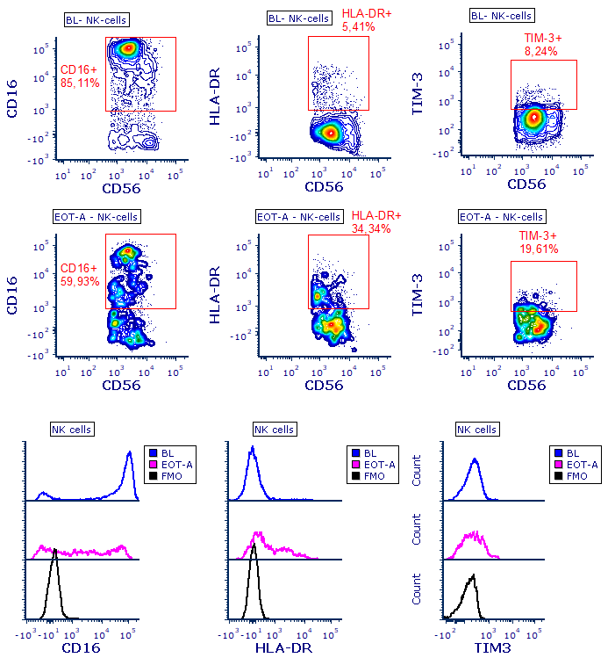

Supplemental Figure 5. Gating strategy of NK cell markers measured by flow cytometry in bone marrow samples.
Bone marrow-resident NK cells were defined as CD45⁺CD56⁺CD3⁻, whereby doublets and dead cells were excluded. Representative contour plots illustrate the gating strategy of NK cell markers. Samples from this representative patient were obtained at baseline (BL, upper plots) and at end of treatment (EOT-A, middle plots). Lower plots represent the expression of CD16, HLA-DR and TIM-3 on NK cells depicted in histogram plots, compared to FMO (fluorescence minus one) control.

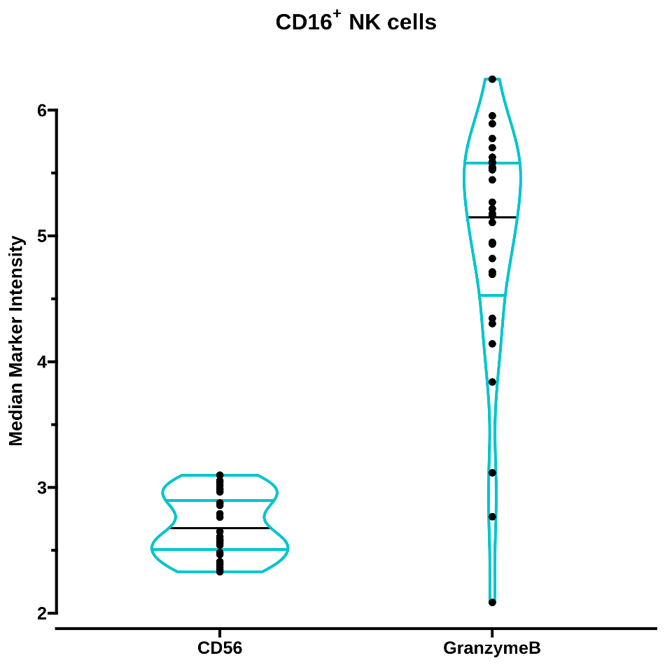

Supplemental Figure 6. BM-resident CD16⁺ NK cells are CD56^{dim} and granzyme B⁺.
Median intensity expression of CD56 and granzyme B in CD16⁺ NK cell subsets in BM samples at baseline (n=29), measured using CyTOF. Data are depicted as individual points and violin plots, indicating the distribution, including median and interquartile range.

Supplemental Figure 7. Two-dimensional bin analysis of Granzyme B (GrzB) and TIM-3 marker expression in patients with primary resistance (Prim-R) and acquired resistance (Acq-R).
To study coordinated changes in the expression of GrzB and TIM-3, the intensity distribution of each marker was divided into bins, and cells were assigned to each bin depending on the expression value of these markers. For each combination of the bins we counted the number of cells for each of the four groups under study (responders at baseline, non-responders at baseline, responders at end of treatment (patients with acquired resistance, Acq-R) and non-responders at end of treatment (patients with primary resistance, Prim-R) ).
Next we computed the fold change in bin size corresponding to Prim-R vs baseline (non-responders, left panel) and Acq-R vs baseline (responders, right panel). These log2 fold changes (log2FC) are plotted for each bin, with the X and Y axis showing the minimum expression level of TIM-3 and GrzB in each bin, respectively. The size of the squares represents the total number of cells in each bin at baseline and end of treatment.

Supplemental Figure 8. Gating strategy of NK cell phenotype measured by flow cytometry in peripheral blood samples.
Representative contour plots illustrate the gating strategy of circulating NK cells (defined as CD45⁺CD14⁻CD56⁺CD3⁻ cells, whereby doubles and dead cells were excluded), and NK cell surface proteins in peripheral blood samples from a representative patient at baseline and cycle 2 day 1 (C2D1).
Supplemental Figure 9. Early changes in peripheral blood-NK cell phenotype were comparable between responding and non-responding patients.
Peripheral blood samples from 20 patients (10 responding patients [partial response or better] who developed acquired daratumumab-resistance [Acq-R], and 10 patients with primary resistance, Prim-R [non-responders]) were subjected to in-depth immune profiling using flow cytometry.
Dots represent individual samples, with box and whiskers, representing median, 25th-75th percentile, and range. Groups were compared using Friedman test with Dunn’s multiple comparison post-test (when data did not follow a normal distribution), or using RM one-way ANOVA with Holm-Šídák’s multiple comparison post-test (when data followed a normal distribution). EOT-A values from Acq-R and Prim-R patients were compared using unpaired t-test or Mann-Whitney test.
Abbreviations: ns, not significant; *P<0.05; **P<0.01, ***P<0.001; ****P<0.0001.

Supplemental Figure 10. Daratumumab treatment results in enrichment of a cluster of circulating NK cells co-expressing TIM-3 and HLA-DR and with low CD16 expression.
A,B The two flow cytometry panels used for in-depth analysis of circulating NK cells (NK cell panel 1 and 2) were analyzed using FlowSOM, a method to computationally identify cell populations. A The heatmap in the left panel depicts the median expression of all cell surface proteins for the metaclusters identified by FlowSOM in NK cell panel 1. Metacluster 4 (MC4; highlighted with the red box) consists of NK cells that express high levels of HLA-DR and low levels of CD16, as visualized in more detail in the histograms in the middle panel. Percentage of MC4, relative to all NK cells, at baseline, C2D1 and EOT-A is visualized in the paired boxplots in the right panel. B The heatmap in the left panel depicts the median expression of all cell surface proteins for the metaclusters identified by FlowSOM in NK cell panel 2. Metacluster 1 (MC1; highlighted with the red box) consists of NK cells that express high levels of TIM-3 and low levels of CD16, as visualized in more detail in the histograms in the middle panel. Percentage of MC1, relative to all NK cells, at baseline, C2D1 and EOT-A is visualized in the paired boxplots in right panel. C To assess whether the TIM-3⁺ and HLA-DR⁺ cells represented the same NK cell subset, we performed a correlation analysis between percentage of panel 1-MC4 and panel 2-MC1 using Spearman’s correlation coefficient (r). The high correlation between the percentages of TIM-3⁺ and HLA-DR⁺ NK cell populations (r=0.98, P<0.0001) strongly suggests that NK cells expressing the highest levels of TIM-3 and HLA-DR belong to the same subset of NK cells. D A UMAP analysis was performed on 100.000 NK cells from panel 1. HLA-DR expression (left panel) and CD16 expression (right panel) in the UMAP analysis are visualized. The NK cells in FlowSOM MC4, as visualized in panel D, are encircled with the red line. E A UMAP analysis was performed on 100.000 NK cells from panel 2. TIM-3 expression (left panel) and CD16 expression (right panel) in the UMAP analysis are visualized. The NK cells in FlowSOM MC1, as visualized in panel E, are encircled with the red line.
Abbreviations: ns, not significant; *P<0.05; **P<0.01, ***P<0.001; ****P<0.0001.

Supplemental Figure 11. Daratumumab-induced NK cell activation does not result in upregulation of LAG3 in short-term assays.
UM9 cells were incubated with solvent control or 10 μg/mL daratumumab in the presence of PB-MNCs (ratio of 50:1) for 4 or 24 hours. A The proportion of LAG3⁺ NK cells was determined by flow cytometric analysis. B Frequency of CD107a-positive cells based on presence or absence of LAG3 expression on NK cells after the 4- or 24-hour incubation with daratumumab or solvent control. Data represent mean and standard error of mean (SEM) of 3 independent experiments, performed in triplicate. Paired Student t test was used to evaluate significance between both groups.
Abbreviations: PB-MNCs, peripheral blood mononuclear cells; ns, not significant; *P<0.05; ****P<0.0001.

References
1. Krejcik J, Frerichs KA, Nijhof IS, et al. Monocytes and Granulocytes Reduce CD38 Expression Levels on Myeloma Cells in Patients Treated with Daratumumab. Clin Cancer Res 2017;23(24):7498-7511. (In eng). DOI: 10.1158/1078-0432.Ccr-17-2027.
2. Frerichs KA, Minnema MC, Levin MD, et al. Efficacy and Safety of Daratumumab Combined With All-Trans Retinoic Acid in Relapsed/Refractory Multiple Myeloma. Blood Adv 2021. DOI: 10.1182/bloodadvances.2021005220.
3. Emmaneel A, Quintelier K, Sichien D, et al. PeacoQC: Peak-based selection of high quality cytometry data. Cytometry Part A;n/a(n/a). DOI: https://doi.org/10.1002/cyto.a.24501.
4. Liechti T, Weber LM, Ashhurst TM, et al. An updated guide for the perplexed: cytometry in the high-dimensional era. Nature Immunology 2021;22(10):1190-1197. DOI: 10.1038/s41590-021-01006-z.
5. Quintelier K, Couckuyt A, Emmaneel A, Aerts J, Saeys Y, Van Gassen S. Analyzing high-dimensional cytometry data using FlowSOM. Nature Protocols 2021;16(8):3775-3801. DOI: 10.1038/s41596-021-00550-0.
6. Van Gassen S, Callebaut B, Van Helden MJ, et al. FlowSOM: Using self-organizing maps for visualization and interpretation of cytometry data. Cytometry Part A : the journal of the International Society for Analytical Cytology 2015;87(7):636-45. (In eng). DOI: 10.1002/cyto.a.22625.
7. Becht E, McInnes L, Healy J, et al. Dimensionality reduction for visualizing single-cell data using UMAP. Nature biotechnology 2018 (In eng). DOI: 10.1038/nbt.4314.
8. Diggins KE, Greenplate AR, Leelatian N, Wogsland CE, Irish JM. Characterizing cell subsets using marker enrichment modeling. Nat Methods 2017;14(3):275-278. (In eng). DOI: 10.1038/nmeth.4149.
9. Demsar J, Leban G, Zupan B. FreeViz--an intelligent multivariate visualization approach to explorative analysis of biomedical data. J Biomed Inform 2007;40(6):661-71. (In eng). DOI: 10.1016/j.jbi.2007.03.010.
10. Abraham Y, Gerrits B, Ludwig MG, Rebhan M, Gubser Keller C. Exploring Glucocorticoid Receptor Agonists Mechanism of Action Through Mass Cytometry and Radial Visualizations. Cytometry B Clin Cytom 2017;92(1):42-56. (In eng). DOI: 10.1002/cyto.b.21499.
11. Wehrens R, Kruisselbrink J. Flexible Self-Organizing Maps in kohonen 3.0. Journal of Statistical Software 2018;87(7):1 - 18. DOI: 10.18637/jss.v087.i07.

