**Supplemental Material**

To

**Phospho-profiling linking biology and clinics in pediatric acute myeloid leukemia**

Angela Schumich,\*1 Michaela Prchal-Murphy,\*2 Margarita Maurer-Granofszky,\*1 Andrea Hoelbl-Kovacic,\*2 Nora Mühlegger,1 Ulrike Pötschger,1 Sabine Fajmann,2 Oskar A. Haas,1 Karin Nebral,1 Nils von Neuhoff,3 Martin Zimmermann,4 Heidrun Boztug,5 Mareike Rasche,3 Marlies Dolezal,6 Christiane Walter,3 Dirk Reinhardt,3 Veronika Sexl,#2 and Michael N. Dworzak#1

\*Angela Schumich, Michaela Prchal-Murphy, Margarita Maurer-Granofszky and Andrea Hoelbl-Kovacic contributed equally as first authors.

#Veronika Sexl and Michael N. Dworzak contributed equally as senior authors.

1CCRI, Children’s Cancer Research Institute, St. Anna Kinderkrebsforschung, Vienna, Austria

2Institute of Pharmacology and Toxicology, University of Veterinary Medicine, Vienna, Austria

3Pediatric Hematology and Oncology, Department for Pediatrics III, University Hospital of Essen, University of Duisburg-Essen, Essen, Germany

4Pediatric Hematology and Oncology, Hannover Medical School, Hannover, Germany

5Department of Pediatric Hematology and Oncology, St. Anna Children's Hospital; Medical University of Vienna, Vienna, Austria

6Bioinformatics and Biostatistics Platform, Department of Biomedical Sciences, University of Veterinary Medicine, Vienna, Austria

TABLE OF CONTENTS

***Supplemental Figures***

Supplemental Figure 1 Page 3

Supplemental Figure 2 Page 4-5

Supplemental Figure 3 Page 6-7

Supplemental Figure 4 Page 7

Supplemental Figure 5 Page 8

Supplemental Figure 6 Page 9

Supplemental Figure 7 Page 10

Supplemental Figure 8 Page 11

Supplemental Figure 9 Page 12

Supplemental Figure 10 Page 13

***Supplemental Tables***

Supplemental Table 1 Patient Characteristics Page 14

Supplemental Table 2 List of antibodies used for phospho-flow analysis Page 15

Supplemental Table 3 List of signaling inhibitors used for the study Page 15

***References*** Page 16-17

**Supplemental Figures**

**Supplemental Figure 1**

**A**

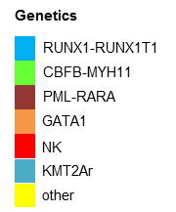**\\chubaka\home\margarita.maurer\settings\desktop\Phospho Paper\Hemasphere\Revision\Figure2C_pheatmap_NEU4_MEDIAN_horizontal_ORDEREDperPatient_orderBy.Genetik.TreatmentAll.INCL_UNSTIM.tif**

**B**

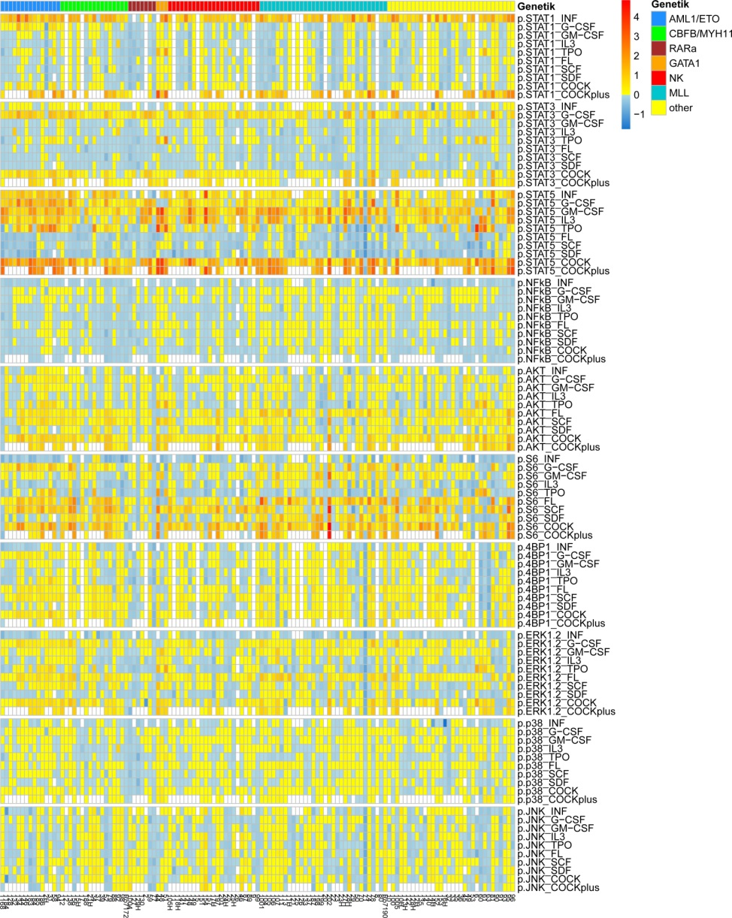

**Supplemental Figure 1. (A)** Heat map of unstimulated (basal) phospho-signal levels in AML blasts according to different genetic AML subtypes: *RUNX1-RUNX1T1* (n=15); *CBFB-MYH11* (n=17); *PML-RARA* (n=7); *GATA-1* (n=3) gene mutations, patients with normal karyotype (NK; n=23), with *KMT2A* rearrangements (*KMT2Ar*; n=32), and a cohort termed “other” - all other genetic abnormalities (n=32). Basal phospho-signal levels were calculated as log2 of MFIon-target/geoMFIcontrol. **(B)** Heat map of phospho-signal levels stimulated either with individual cytokines or with a cytokine-“cocktail” or “cocktail plus” (containing additional IFNy). Stimulated phospho-signal levels were calculated as log2 (geoMFIstimulated/geoMFIunstimulated).

**Supplemental Figure 2**

**A**

|  |  |  |
| --- | --- | --- |
| **Subtype** | **№ of patients** | **№ of relapses** |
| KMT2Ar | 33 | 15 |
| NK | 23 | 12 |
| other | 34 | 14 |
| RUNX1-RUNX1T1 | 15 | 2 |
| CBFB-MYH11 | 17 | 0 |
| PML-RARA | 7 | 2 |
| GATA1 | 3 | 0 |

**B**

|  |  |  |
| --- | --- | --- |
| **Rearrangement** | **№ of patients** | **№ of relapses** |
| KMT2A-AF9 | 15 | 4 |
| KMT2A-AF10 | 6 | 5 |
| KMT2A-AF6 | 3 | 3 |
| KMT2A-ELL | 2 | 1 |
| KMT2A-ABl1 | 1 | 0 |
| KMT2A-AF1 | 1 | 0 |
| KMT2A-LASP1 | 1 | 0 |
| KMT2A-FBP17 | 1 | 0 |
| KMT2A-ACACA | 1 | 1 |
| KMT2A-ENL | 1 | 1 |
| KMT2A other | 1 | 0 |
| **total** | **33** | **15** |

**C**

**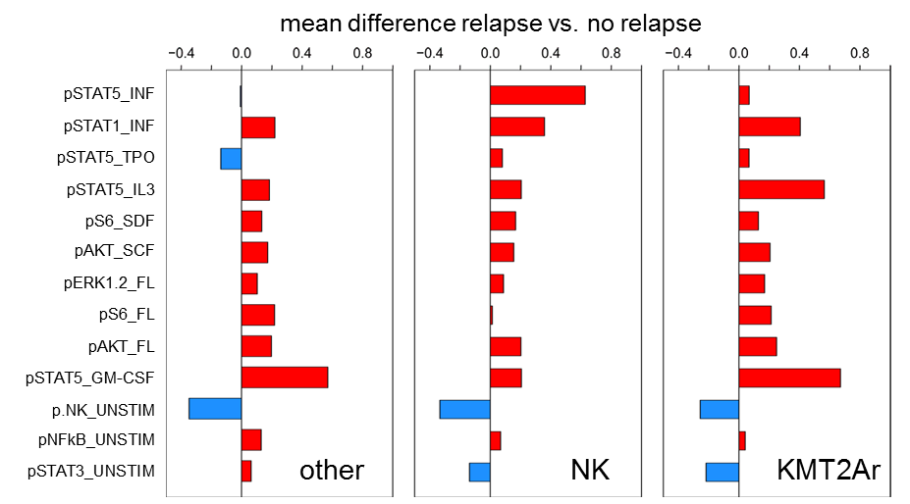**

**D**

|  |  |  |  |  |
| --- | --- | --- | --- | --- |
|  | **Hazard-Ratio** | | **p-value** | |
|  | **Estimate** | **95% CI** | **unadjusted** | **adjusted** |
| pSTAT3\_UNSTIM | 0.73 | 0.39-1.37 | 0.331 | **0.991** |
| pNFkB\_UNSTIM | 2.22 | 1.18-4.17 | 0.013 | **0.147** |
| pJNK\_UNSTIM | 0.29 | 0.15-0.56 | 0.0003 | **0.002** |
| pSTAT5\_GM-CSF | 3.30 | 1.68-6.49 | 0.001 | **0.007** |
| pAKT\_FL | 1.82 | 0.97-3.4 | 0.063 | **0.527** |
| pS6\_FL | 1.61 | 0.87-2.99 | 0.129 | **0.775** |
| pERK1/2\_FL | 1.85 | 0.98-3.47 | 0.057 | **0.490** |
| pAKT\_SCF | 2.18 | 1.13-4.21 | 0.021 | **0.230** |
| pS6\_SDF | 2.13 | 1.13-4.02 | 0.020 | **0.218** |
| pSTAT5\_IL3 | 2.23 | 1.16-4.27 | 0.016 | **0.188** |
| pSTAT5\_TPO | 1.18 | 0.63-2.21 | 0.607 | **1.000** |
| pSTAT1\_INF | 2.32 | 1.17-4.6 | 0.017 | **0.190** |
| pSTAT5\_INF | 1.47 | 0.77-2.8 | 0.243 | **0.954** |

**E**

|  |  |  |  |
| --- | --- | --- | --- |
| **Parameter** |  | **p-value** | **Hazard ratio**  **(95% CI)** |
| **Genetics** | **other** |  | 1.00 |
|  | **KMT2Ar** | 0.524 | 1.27 (0.60-2.68) |
|  | **NK** | 0.829 | 1.09 (0.49-2.42) |
| pJNK\_UNSTIM |  | 0.0013 | 0.31 (0.16-0.63) |
| pSTAT5\_GM-CSF |  | 0.0023 | 3.00 (1.48-6.09) |

**Supplemental Figure 2**. **(A)** Table summarizing patient cohort characteristics with respect to genetic subtype and risk category (low (LR), intermediate (IR) / high risk (HR)). Due to low number of relapses among LR cases, we focused on IR and HR patients for relapse risk correlations. **(B)** Table summarizing *KMT2A* rearrangements of the patient cohort. **(C)** Bar plot of log2-fold differences between group means of signal activation nodes measured in leukemic cells of relapsed vs non-relapsed patients. Bars marked red relate to higher phospho-signals in relapsed cases, and blue bars to higher activation in non-relapsed cases. **(D)** pJNK\_UNSTIM and pSTAT5\_GM-CSF significantly correlate with relapse risk. Univariate Cox regression analysis was performed to obtain hazard ratios (HR) and 95% (confidence interval) CI for 13 signal nodes with differential phospho-signal activation between samples from relapsed/non-relapsed patients. Permutation test was used to adjust for multiple testing. Data correspond to Figure 3A. **(E)** Multivariate Cox regression analysis was restricted to 11 signal nodes, as data from pSTAT1\_INF and pSTAT5\_INF were missing in 12/90 patients. Analysis included genetic subtypes *KMT2Ar* (*KMT2A* rearrangement) and NK (normal karyotype) with the risk of “other” karyotypes set to 1.0 HR**.** Stepwise selection was used to identify significant activated phospho-signal nodes, where genetic subtype was forced into the model. Bootstrapping was used to estimate the amount of required shrinkage to account for overfitting. The estimated shrinkage factor was 0.73, which corresponds to estimated shrinked HRs of 0.44 and 2.43 for JNK\_UNSTIM and STAT5\_GM-CSF, respectively.

**Supplemental Figure 3**

**A**

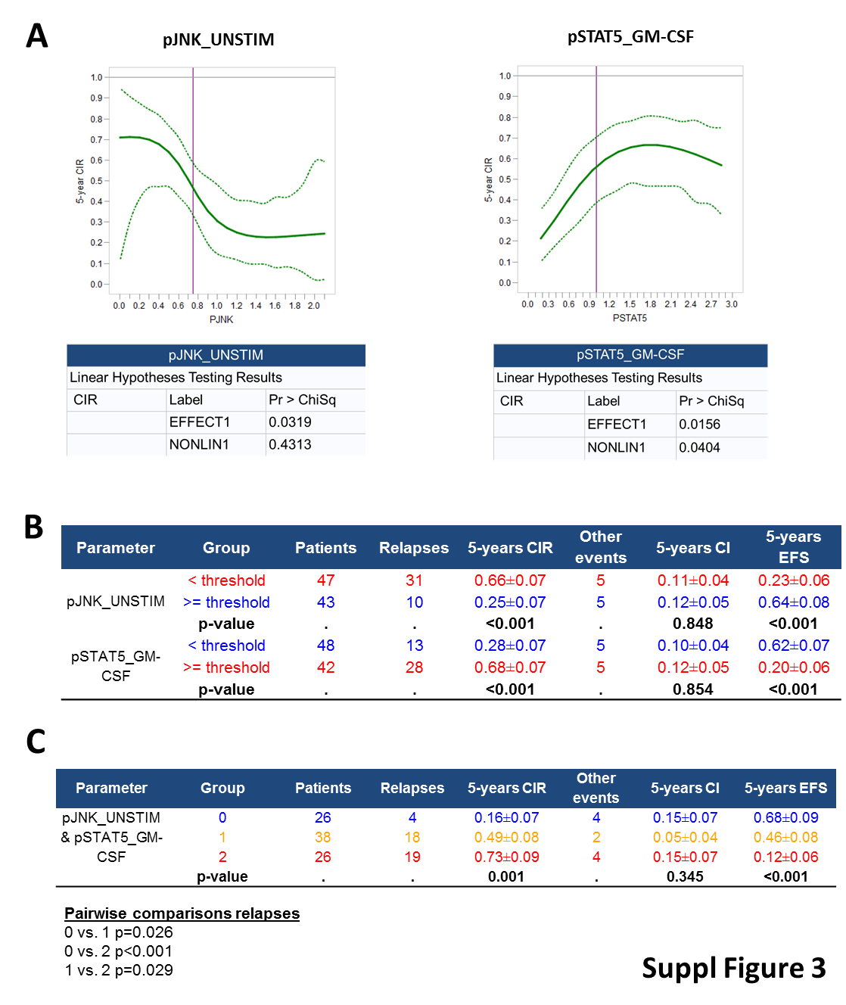

**B**

**pSTAT5\_GM-CSF KMT2Ar**

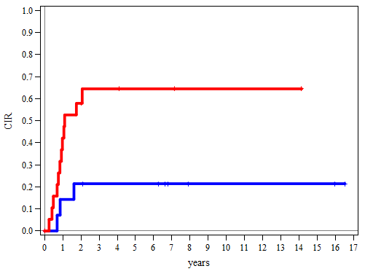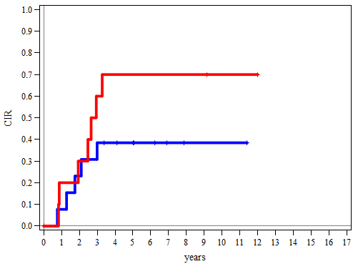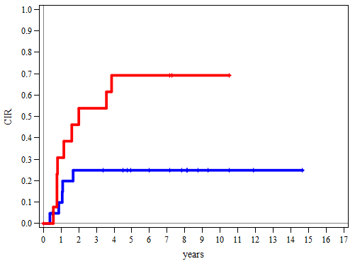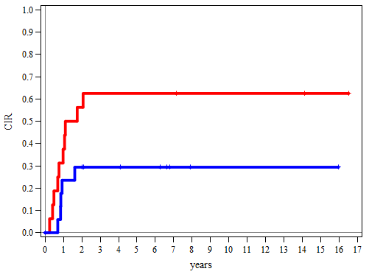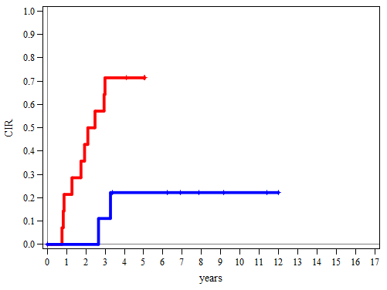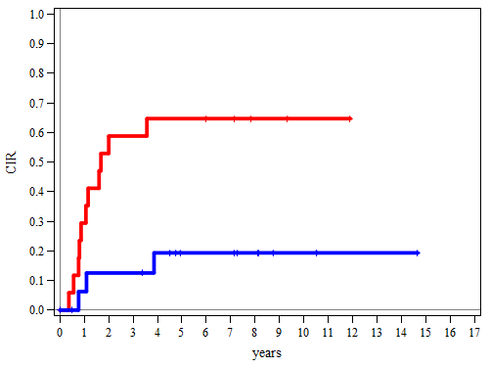

**pSTAT5\_GM-CSF NK**

**pSTAT5\_GM-CSF other**

**pJNK\_UNSTIM KMT2Ar**

**pJNK\_UNSTIM NK**

**pJNK\_UNSTIM other**

\*

\*

\*

\*

**Supplemental Figure 3**. **(A)** Restricted Cubic Splines (RCS) functions in univariate Cox model to define cut-off levels for “high” and “low” expressers of pSTAT5\_GM-CSF and pJNK\_UNSTIM. **(B)** IR/HR patients with low basal pJNK and high pSTAT5\_GM-CSF expression showed a significantly higher 5-years CIR than patients with reciprocal expression when the three genetic groups (*KMT2Ar*, NK, other) were analysed separately. Plots with significant differences (*p*<0.05) between subgroups are marked by asterisks.

**Supplemental Figure 4**

**A**



**B**



**C**

**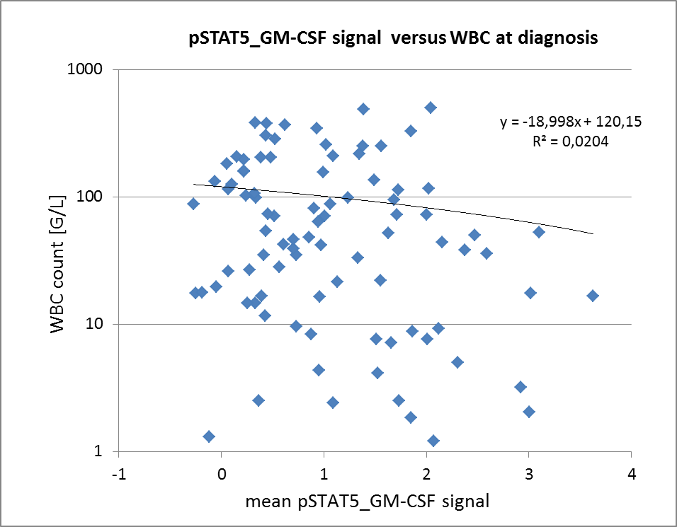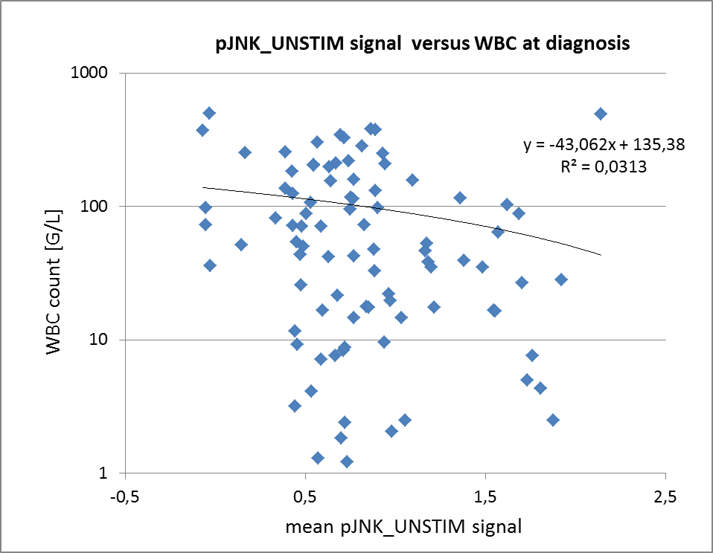Supplemental Figure 4. (A)** *FLT3-*ITD status significantly correlated with the number of relapses in ‘other’ or ‘all’ AML subtypes but not in ‘*KMT2Ar*’ or ’NK’ subtypes. Ten patients were excluded due to other events. **(B)** *FLT3-*ITD status does not correlate with signal expression levels of pSTAT5\_GM-CSF and pJNK\_UNSTIM measured at diagnosis. **(C)** White blood cell counts tested as continuous variable did not correlate with pSTAT5\_GM-CSF (left panel) or basal pJNK (right panel) signal levels at diagnosis.

**Supplemental Figure 5**

**A**

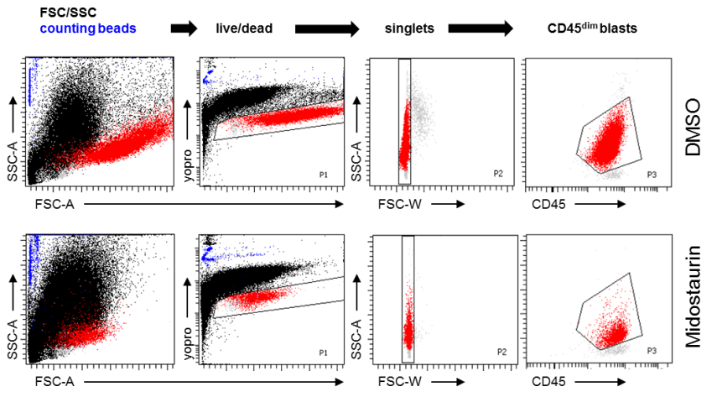

**B**



**C**

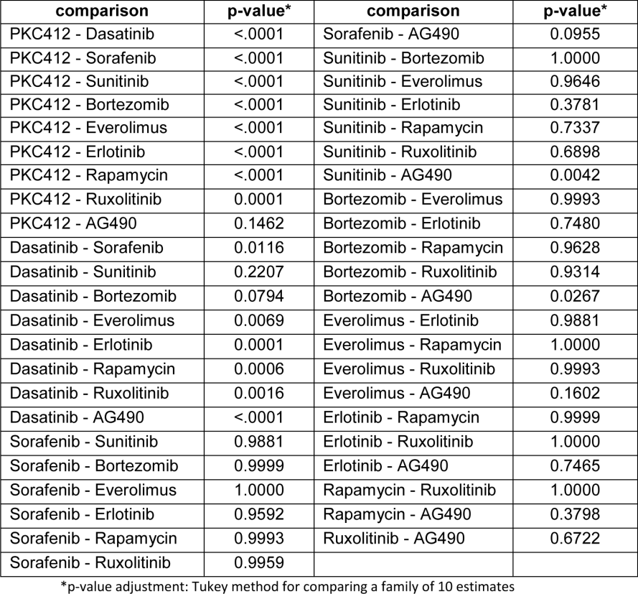

**Supplemental Figure 5. (A)** Gating strategy used to determine the number of living AML blasts after treatment with signaling inhibitors in relation to DMSO control. **(B)** Forty-four primary pedAML samples were used for testing inhibitor sensitivity along with signal expression. Table depicts details on genetics as well as on FAB nomenclature of the patient cohort. **(C)** Pairwise comparisons of signal inhibitor efficiency with respect to reduction of viable AML blasts. Midostaurin was more active than most other drugs except for AG490.

**Supplemental Figure 6**

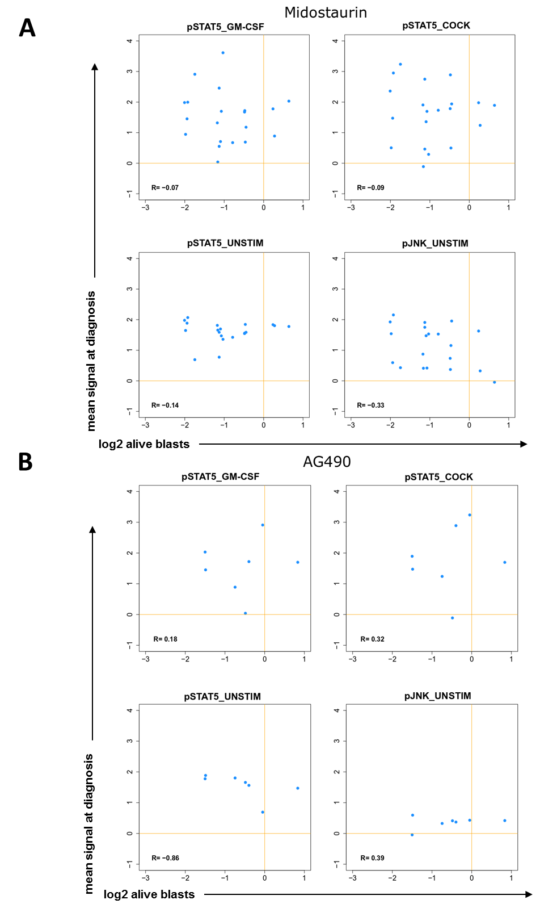

**Supplemental Figure 6.** Meanphospho-signal levels of STAT5 (basal or stimulated with GM-CSF or cocktail) and JNK (basal levels) at the time of diagnosis did not predict inhibitor sensitivity in the cell survival assay. The magnitude of reduction of pSTAT5 and pAKT (y-axis) following treatment with midostaurin **(A)** or AG490 **(B)** – the two most active inhibitors - and the association with the number of alive blasts (x-axis) is depicted. No significant association was found for any correlation. Similar non-significant results were obtained with all other signal node/inhibitor combinations (data not shown).

**Supplemental Figure 7**

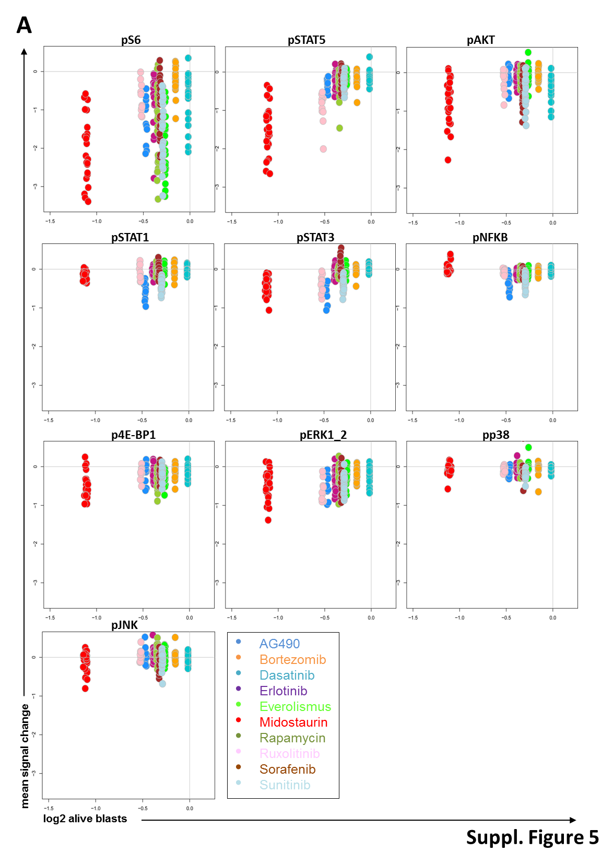

**Supplemental Figure 7.** Mean signal change of pS6, pSTAT5, pAKT, pSTAT1, pSTAT3, pNFƘB, p4E-BP1, pERK1\_2, pp38 and pJNK (y-axis) following treatment with different signaling inhibitors and the association with the number of alive blasts upon treatment (x-axis) is depicted. Note that for visualization purposes, all samples per incubation group are represented on the x-axis by the group-derived mean of log2 values of the numbers of alive blasts.

**Supplemental Figure 8**

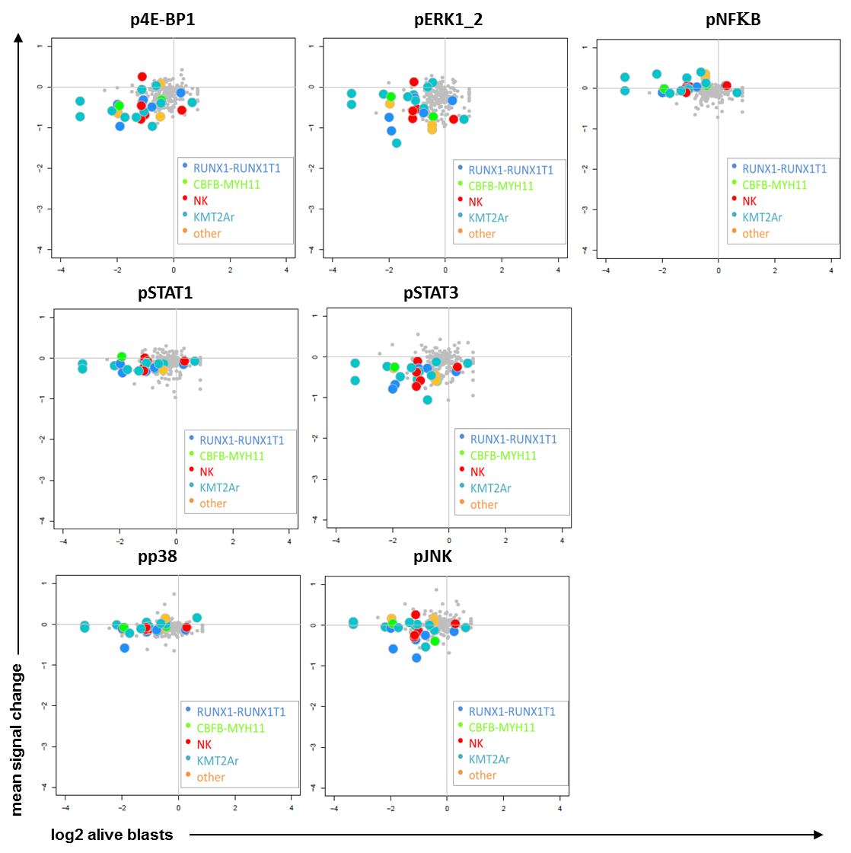

**Supplemental Figure 8.** Mean signal change of p4E-BP1, pERK1\_2, pNFƘB, pSTAT1, pSTAT3, pp38 and pJNK (y-axis) following treatment with midostaurin (color) or other signaling inhibitors (grey) and the association with the number of alive blasts (log2) upon treatment (x-axis) is depicted for the different genetic AML subtypes.

**Supplemental Figure 9**

**A**

|  |  |  |  |
| --- | --- | --- | --- |
| **Patient** | **Subtype** | **FAB** | **Karyotype** |
| P1 | KMT2A-MLLT10 | M5a | 46,XX,t(10;11)(p15;q23)[20] |
| P2 | KMT2A-MLLT4 | M5a | 47,XY,+6[15]/46,XY[5] |
| P3 | KMT2A-MLLT10 | M5 | 46,XX,?del(9)(p2?4),t(10;11)(p12;q23),add(20)(q13),?del(22)(q13)[11]/46,XX[19] |
| P4 | KMT2A-MLLT3 | M5 | 46,XY,del(11)(q23)[5]  (PB) |
| P5 | KMT2A-split | M5 | n.a. |

**B**



**C**



**D**

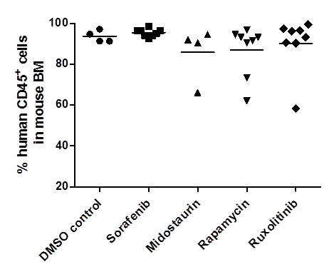

**Supplemental Figure 9.** **(A)** Table depicts genetics of AML blasts used for xenotransplantation into NSG mice**. (B)** Validation of drug sensitivity of leukemic cells of three patients with complete time-courses (P1, P2, P3) before and after xenotransplantation**. (C)** Presence of human CD45+ (hCD45+) cells in the peripheral blood over time **(D)** as well as in the bone marrow in case of terminal disease was assessed by flow cytometry.

**Supplemental Figure 10**

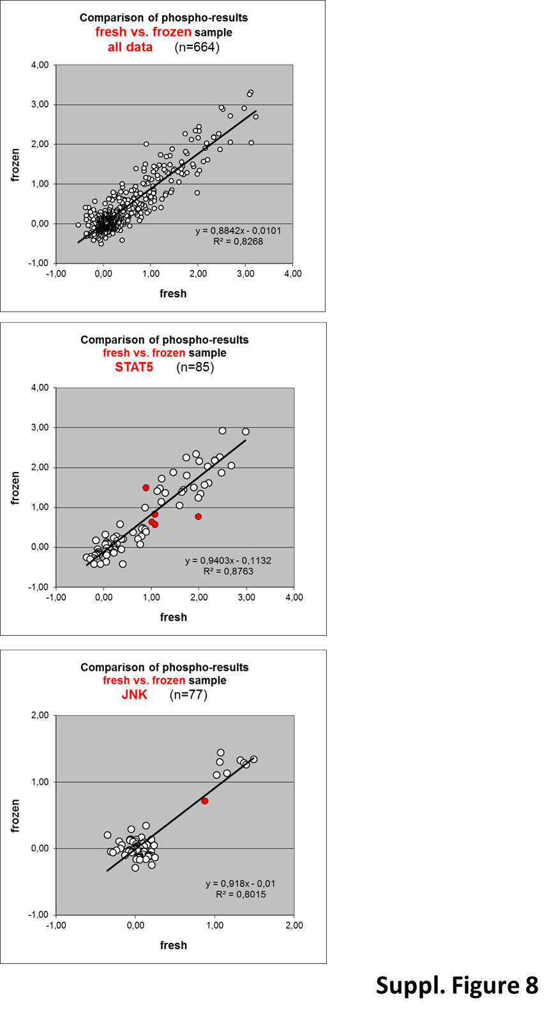

**Supplemental Figure 10.** Comparison of flow cytometric phospho-signal assessments on fresh versus cryopreserved AML blasts. R2 values were calculated by comparing phospho-signal expression data from the fresh and the frozen cells for all phospho-signals (upper panel), for pSTAT5 levels (middle panel) and for pJNK levels (bottom panel). Data points in red represent single outlier cases when a cut-off 1.0 is used to separate low from high expression among pSTAT5 as well as pJNK levels – such theoretical outliers were mostly borderline cases.

**Supplemental Tables**

**Supplemental Table 1. Patients Characteristics**



**Supplemental Table 2.** List of antibodies used for phospho-flow analysis.



**Supplemental Table 3.**  List of signaling inhibitors used for the study.

|  |  |  |  |  |
| --- | --- | --- | --- | --- |
| **Compound** | **Solvent** | **Concentration [ng/ml]\*** | **Reference** | **Source** |
| Midostaurin | DMSO | 4000 | 11 | LC Laboratories |
| Sunitinib | DMSO | 100 | 12 | LC Laboratories |
| Sorafenib | DMSO | 4000 | 13 | LC Laboratories |
| Dasatinib | DMSO | 15 | 14 | LC Laboratories |
| Everolimus | DMSO | 15 | 15 | LC Laboratories |
| Rapamycin | DMSO | 15 | 16 | LC Laboratories |
| Bortezomib | DMSO | 2 | 17 | LC Laboratories |
| Ruxolitinib | DMSO | 40 | 18 | LC Laboratories |
| Erlotinib | DMSO | 1000 | 19 | LC Laboratories |
| AG490 | DMSO | 30000 | n.a. | Calbiochem |
| \*Concentrations of signaling inhibitors used in the study were chosen based on human pharmacokinetic data (see references) with the exception of AG490 were no such *in vivo* data are available. | | | | |

**References**

1. Boztug H. et al: Development of treatment and clinical results in childhood AML in Austria (1993–2013). 2014; Memo 7:63-74

2. Rasche M. et al: Successes and challenges in the treatment of pediatric acute myeloid leukemia: a retrospective analysis of the AML-BFM trials from 1987 to 2012. Leukemia 2018; 32:2167-2177

3. Quotti Tubi L. et al.: Protein kinase CK2 regulates AKT, NF-kappaB and STAT3 activation, stem cell viability and proliferation in acute myeloid leukemia. Leukemia 2017 Feb; **31**(2)**:** 292-300.

4. Levy D.E. et al.: Stats: transcriptional control and biological impact. Nat Rev Mol Cell Biol 2002 Sep; **3**(9)**:** 651-662.

5. Liu F. et al: Targeting ERK, an Achilles' Heel of the MAPK pathway, in cancer therapy. Acta Pharm Sin B 2018 Jul; **8**(4)**:** 552-562.

6. Cuadrado A. et al: Mechanisms and functions of p38 MAPK signalling. Biochem J 2010 Aug 1; **429**(3)**:** 403-417.

7. Ruvolo P.P. et al: Phosphorylation of GSK3alpha/beta correlates with activation of AKT and is prognostic for poor overall survival in acute myeloid leukemia patients. BBA Clin 2015 Dec; **4:** 59-68.

8. Perl A.E. et al: Single-cell pharmacodynamic monitoring of S6 ribosomal protein phosphorylation in AML blasts during a clinical trial combining the mTOR inhibitor sirolimus and intensive chemotherapy. Clinical cancer research : an official journal of the American Association for Cancer Research 2012 Mar 15; **18**(6)**:** 1716-1725.

9. Bubici C. et al: JNK signalling in cancer: in need of new, smarter therapeutic targets. Br J Pharmacol 2014 Jan; **171**(1)**:** 24-37.

10. Qin X. et al: Jiang B, Zhang Y. 4E-BP1, a multifactor regulated multifunctional protein. Cell Cycle 2016; **15**(6)**:** 781-786.

11. Stone, R.M.et al: Patients with acute myeloid leukemia and an activating mutation in FLT3 respond to a small-molecule FLT3 tyrosine kinase inhibitor, PKC412. Blood, 2005; 105: 54-60.

12. Fiedler, W., H. Serve, H. Dohner, M. Schwittay, O.G. Ottmann, A.M. O'Farrell, C.L. Bello, R. Allred, W.C. Manning, J.M. Cherrington, S.G. Louie, W. Hong, N.M. Brega, G. Massimini, P. Scigalla, W.E. Berdel, and D.K. Hossfeld: A phase 1 study of SU11248 in the treatment of patients with refractory or resistant acute myeloid leukemia (AML) or not amenable to conventional therapy for the disease. Blood, 2005; 105: 986-993.

13. Strumberg, D., H. Richly, R.A. Hilger, N. Schleucher, S. Korfee, M. Tewes, M. Faghih, E. Brendel, D. Voliotis, C.G. Haase, B. Schwartz, A. Awada, R. Voigtmann, M.E. Scheulen, and S. Seeber: Phase I clinical and pharmacokinetic study of the Novel Raf kinase and vascular endothelial growth factor receptor inhibitor BAY 43-9006 in patients with advanced refractory solid tumors. J Clin Oncol, 2005; 23: 965-972.

14. Talpaz, M., N.P. Shah, H. Kantarjian, N. Donato, J. Nicoll, R. Paquette, J. Cortes, S. O'Brien, C. Nicaise, E. Bleickardt, M.A. Blackwood-Chirchir, V. Iyer, T.T. Chen, F. Huang, A.P. Decillis, and C.L. Sawyers: Dasatinib in imatinib-resistant Philadelphia chromosome-positive leukemias. N Engl J Med, 2006; 354: 2531-2541.

15. Kirchner, G., L. Mueller, M. Winkler, M. Loss, F. Roechte, M. Deters, U. Christians, V. Kaever, J. Klempnauer, K. Sewing, and M. Manns: Long-term pharmacokinetics of the metabolites of everolimus and cyclosporine in renal transplant recipients. Transplant Proc, 2002; 34: 2233-2234.

16. Schachter, A.D., K.E. Meyers, L.D. Spaneas, J.A. Palmer, M. Salmanullah, J. Baluarte, K.L. Brayman, and W.E. Harmon: Short sirolimus half-life in pediatric renal transplant recipients on a calcineurin inhibitor-free protocol. Pediatr Transplant, 2004; 8: 171-177.

17. Attar, E.C., D.J. De Angelo, J.G. Supko, F. D'Amato, D. Zahrieh, A. Sirulnik, M. Wadleigh, K.K. Ballen, S. McAfee, K.B. Miller, J. Levine, I. Galinsky, E.G. Trehu, D. Schenkein, D. Neuberg, R.M. Stone, and P.C. Amrein: Phase I and pharmacokinetic study of bortezomib in combination with idarubicin and cytarabine in patients with acute myelogenous leukemia. Clin Cancer Res, 2008; 14: 1446-1454.

18. Shi, J.G., X. Chen, R.F. McGee, R.R. Landman, T. Emm, Y. Lo, P.A. Scherle, N.G. Punwani, W.V. Williams, and S. Yeleswaram: The pharmacokinetics, pharmacodynamics, and safety of orally dosed INCB018424 phosphate in healthy volunteers. J Clin Pharmacol, 2011; 51: 1644-1654.

19. Broniscer, A., J.C. Panetta, M. O'Shaughnessy, C. Fraga, F. Bai, M.J. Krasin, A. Gajjar, and C.F. Stewart: Plasma and cerebrospinal fluid pharmacokinetics of erlotinib and its active metabolite OSI-420. Clin Cancer Res, 2007; 13: 1511-1515.