HemaSphere-2019-0071R1

Hegemann et al., May 15, 2020

MEMSID: Results from a Phase 2 Pilot Study on Memantine Treatment for Sickle Cell Disease

Supplementary Data

Trial permission and oversight
In 2015, a clinical trial to study the safety and tolerability of Memantin Mepha® in Sickle Cell Disease Patients (MemSID, NCT02615847) was approved by the local Kanton Zurich ethics committee (KEK-ZH 2015-0297). This phase 2, open-label, single center study was conducted at the Department of Medical Oncology and Haematology at the Zurich University Hospital (USZ) in accordance with the local ethics committee guidelines and Declaration of Helsinki. All participants gave written informed consent. For original deidentified data please contact: Inga.Hegemann@usz.ch and Jeroen.Goede@ksw.ch.

Patient eligibility and study flow chart
Patients aged 18 or older, with a confirmed diagnosis of symptomatic SCD (homozygous hemoglobin S or hemoglobin S/β0) were eligible for the trial. Concomitant treatment with hydroxyurea was permitted and the individual dosing was not changed during the trial unless mentioned below. Patients were included if the last blood transfusion occurred at least three months before the screening period. Main exclusion criteria were active infection requiring systemic treatment, infection with HIV or HTLV-1, impaired renal or liver function, history of malignancy, known epileptic disease and pregnancy. The originally screened participant cohort was comprised of two male and seven female subjects, aged 19 - 48, six of which had a family background from Central Africa, one from Afghanistan and two from the Caribbean. Details including sex, age, weight, demographics and premedication with hydroxyurea of the six participants who entered the study are summarized in Fig. 1A.

The study flow chart is explained in the text and visualized in Fig. S1:
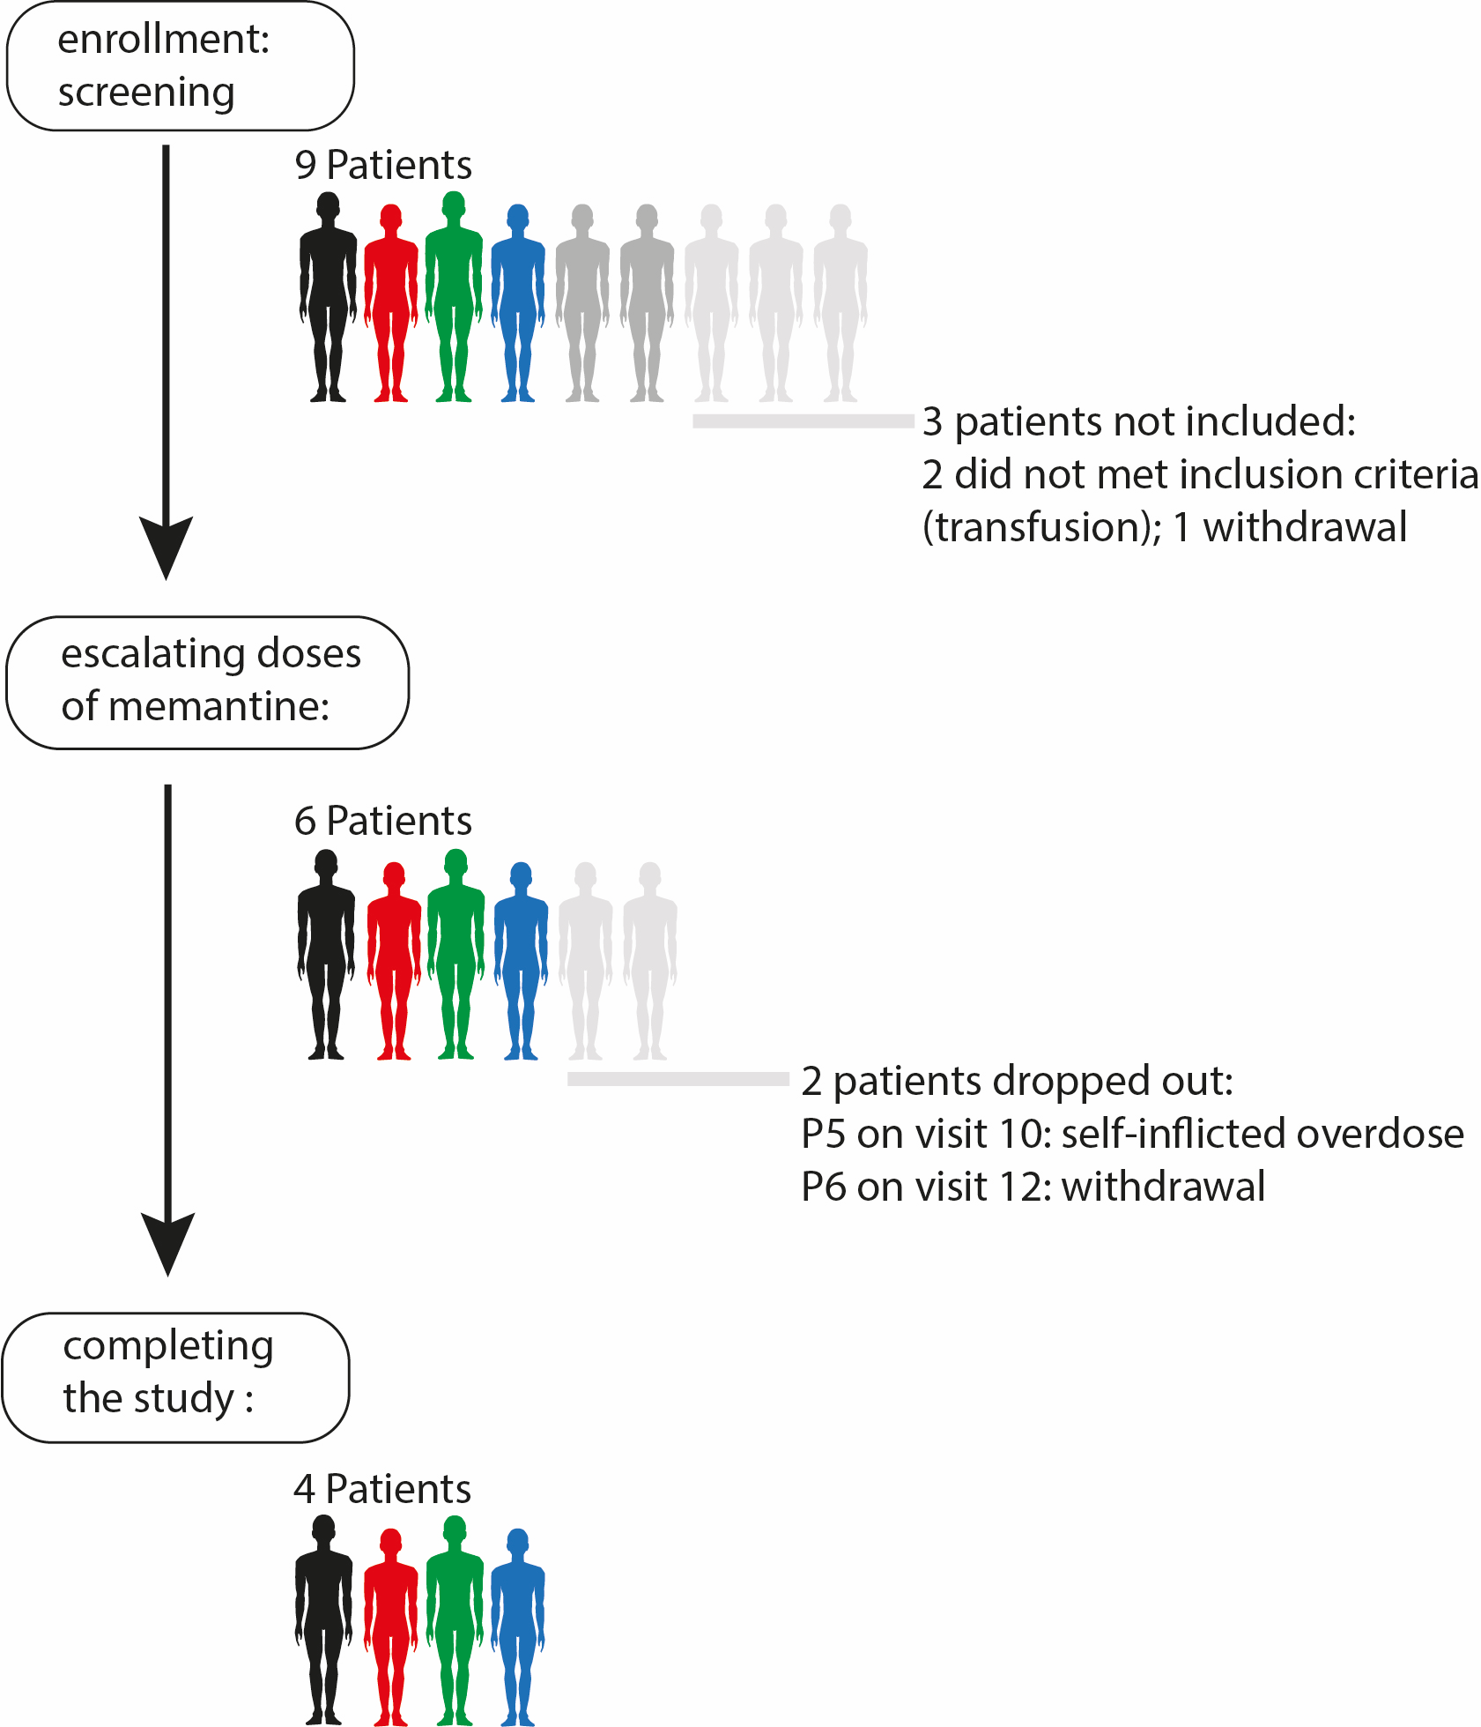
Fig. S1: study flow chart

Study design
Eligibility assessment of the patients during the screening period lasted up to 4 weeks. Records included demographics, social situation, medical history, QoL as well as previous and concomitant medication. Throughout the screening period, baseline examinations were performed that were comprised of 12-lead electrocardiography (ECG), abdominal ultrasound, ophthalmological tests, lung function test and transcranial Doppler velocity testing. All examinations were repeated at the end of trial and the results revealed that these parameters remained stable throughout the trail and were not influenced by memantine.
The study was divided into five periods (Fig. 1C, in weeks) and consisted of screening (up to 4 w), up-titration (4w), treatment with 20 mg memantine (41-44w), down-titration (3w) and follow-up period (8 w), the planned total duration of the study being 56-59 weeks (Fig. 1C). The up-titration protocol and the daily dose of memantine were defined following the guidelines developed for patients with Alzheimer’s disease in Switzerland and are described in the medical compendium for Memantin Mepha® (https://compendium.ch/mpro/mnr/25327/html/de). Treatment with memantine was accompanied by clinical visits and started with a dose of 5 mg per day in the first week followed by 10 mg in the second week and 15 mg in the third week, reaching 20 mg at week 4 and this dose was continued for 41 weeks. Only patient 1 took memantine (20mg) for 44 weeks because the visit had to be postponed. After this treatment period the dose was down-titrated by 5mg weekly. Patients’ visits schedules varied from several times per week in the up-titrating period, once monthly in the treatment period to once weekly in down-titration. Adjustments of memantine dose for a few days were required and are mentioned later in the text. Four weekly follow-up visits were performed within the first post-medication period. A final end-of-study visit occurred eight weeks after discontinuation of memantine (week 56 with the exception of patient 1: week 59). The study medication adherence was evaluated by direct questioning at each visit and based on pill count. As the later was not very accurate, plasma samples were collected at each visit and plasma memantine concentration at every visit was determined in these samples at the end of the study (Fig. 1B).

Endpoints
The primary endpoints were safety and tolerability of memantine by SCD patients. The incidence and severity of memantine treatment-related adverse events (AE) were assessed according the criteria issued by the National Cancer Institute (NCI). These criteria defines grade 1-5 as mild, moderate, severe, life threatening or deathly, respectively. Serious adverse events (SAE) were defined according to Federal Drug Agency (FDA) regulations (code 21CFR312.32, www.accessdata.fda.gov). In brief, either in-patient hospitalization or prolongation of existing hospitalization is considered a SAE. The long-term secondary endpoints included the monitoring of the following laboratory parameters: RBC count, Hb concentration and hemolytic activity (LDH, total bilirubin and reticulocyte count) as well as of iron status (ferritin). Detailed medical history including hospitalization, infections and transfusion requirements were taken for each patient.

QoL-questionnaire and safety assessment
QoL assessment was rated by a 10 cm linear visual analog scale (1 cm = 1 point, absent 0, maximum 10) concerning current pain, maximum pain since the last visit and influence of SCD on daily activity, mood, work, free time, social relations, sleep and pleasure of life. All parameters were assessed at each clinical visit by the patient marking the scale with a cross. To define QoL, all single values were added.

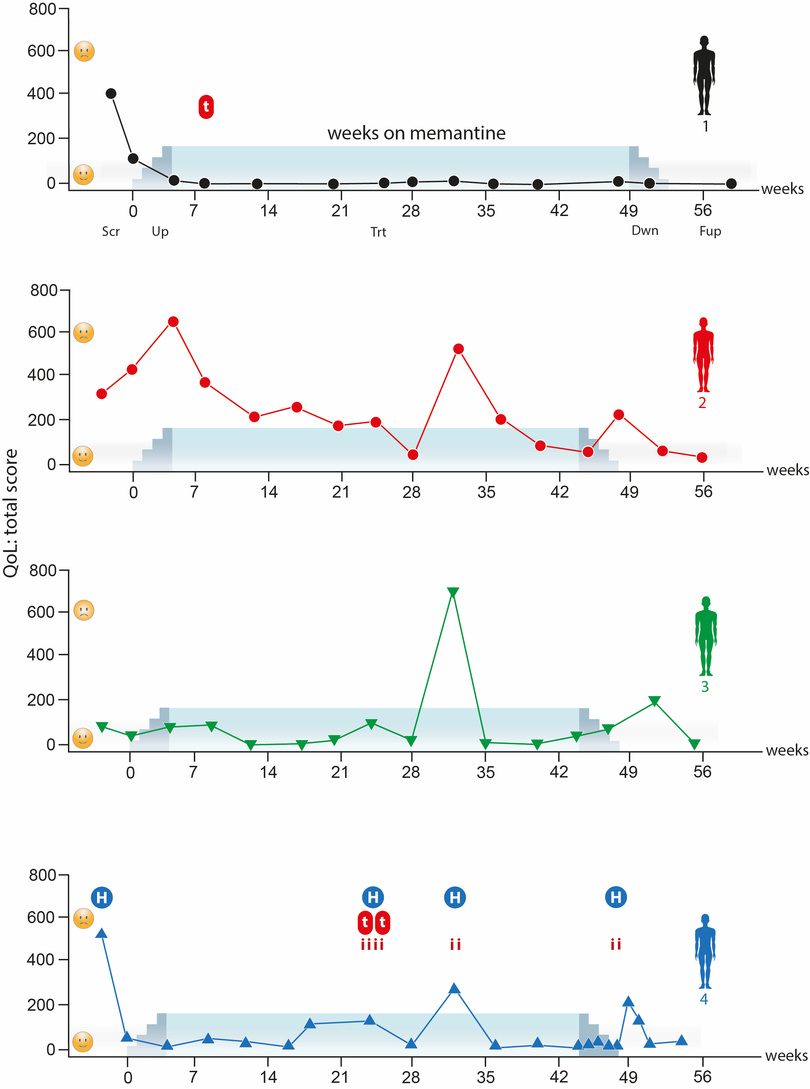

Fig. S2: Total quality of life (QoL) scores. The total score of QoL is the composite outcome of several parameters including maximal pain since last visit, actual pain at visit as well as influence of SCD on daily activity, mood, work, leisure, social interactions, sleep behavior and pleasure of life. A low score reflects a pleasant QoL (as shown by the emoji).
t: transfusion, H: hospitalisation, i: infection

influenced by their disease, including activity, mood and working capacity as well as leisure activities, sleep and social life. Fig. S2 shows the total rate of the QoL questionnaire. Further safety assessments were done throughout the study by clinical investigation and laboratory testing in order to monitor for AE and SAE (Fig. 1D).

Laboratory measurements
Whole blood count, RBC count, percentage of hypochromic or hyperchromic RBCs as well as reticulocyte counts were assessed by ADVIA® 2100. Lactate dehydrogenase (LDH) activity in plasma were detected using lactate/pyruvate conversion assay, and HbS and HbF were quantified by HPLC. Quantitation of plasma memantine concentration was performed using a combination of HPLC and MS/MS mass spectrometry (Nevitt SJ et al., Cochrane Database Syst Rev 2017;4 CD002202 doi: 10.1002/14651858.CD002202.pub2 and Brugnara C., J Pediatr Hematol Oncol 2003;25(12):927-33). Urine analysis was performed by standard laboratory procedure to screen for infection, hemolysis and proteinuria.

Blood parameters and statistical approaches
To explore graphically the course of blood parameters during the five periods of the study we computed mean and 95% Wald confidence interval (95%-CI) for each period, including a pre-study period that includes measurements until two years back from screening start date. Symbols (dot, *,**,***, meaning p<0.1, p<0.05, p<0.01, p<0.001, respectively) were added to visualize the evidence for a difference compared to screening period. The p-values to define the symbols were Welch’s t-test and not adjusted for multiple comparison. Since blood transfusions and infections affects blood parameters we also performed a regression. We used a mixed model with patient as random variable, hospitalization, blood transfusion and infection as control variables and periods (pre-study, screening, upload, treatment, download and follow-up) as variable of interest. Screening was used as reference for computing p-values. Since screening had only one observation point, we included also pre-study observations as additional information (Tab S1). Since the residuals of the regression for bilirubin, reticulocytes, ferritin as well as hyperchrome and hypochrome RBC had a skewed distribution, these outcomes were logarithmized to get reasonable p-values and 95%-CI. In these cases the results are communicated as fraction in % or factor from screening phase as reference. All data preparation and analysis were done with R (version 3.6.1) (R Core Team, 2019, R: A language and environment for statistical computing. R Foundation for Statistical Computing, Vienna, Austria. URL https://www.R-project.org/). Additionally we created a table with descriptive statistics on patient and phase level for each parameter measured (Tab. S2).

Tab. S1: Multivariale Regression. Estimates and 95%-CIs of a linear regression with patients as random variable. Regression contains infection and transfusion as control variables and trial phase as variables of interest. Level pre-study in phase was added to give additional information of the patient status. Bilirubin, ferritin, reticulocytes, hyperchrome and hypochrome RBC values were logarithmized to get reasonable 95%-CI and P-values. Regression with logarithmized outcomes has to be read as follow: intercept is the value at screen with no infection and transfusion. All other estimates represent proportions of these estimates. For example: Reticulocytes: at screen phase (=100%) is estimated with 229*10¹²/l (intercept). The value at treatment phase is fraction of 97.5% of the intercept value with a 95% CI of 75.3-126%. Regression of outcome ferritin was performed only with 3 patients (P1-P3) with similar ferritin levels.

Tab. S2: Descriptive statistics of blood parameters. These tables display number of measurements, number of hospitalizations, number of blood transfusions, number of infections, mean, standard deviation, median, interquartile range, minimum and maximum value and 95%-CI.

