Supplemental digital file 2
EFFICACY AND SAFETY OF INTRAVITREAL AFLIBERCEPT USING A TREAT-AND-EXTEND REGIMEN FOR NEOVASCULAR AGE-RELATED MACULAR DEGENERATION: THE ARIES STUDY
A Randomized Clinical Trial

Paul Mitchell, MD PhD,¹ Frank G Holz, FEBO, FARVO,² Philip Hykin, FRCS, FRCOphth,³ Edoardo Midena, MD PhD,⁴ Eric Souied, MD PhD,⁵ Helmut Allmeier, PhD,⁶ George Lambrou, MD PhD,⁶ Thomas Schmelter, PhD,⁷ Sebastian Wolf, MD PhD,⁸ on behalf of the ARIES study investigators

¹University of Sydney (Westmead Institute for Medical Research), Sydney, NSW, Australia;
²Department of Ophthalmology, University of Bonn, Bonn, Germany;
³Moorfields Eye Hospital, London, United Kingdom;
⁴Department of Ophthalmology, University of Padova, Padova, Italy;
⁵Department d’Ophtalmologie, Hôpital Intercommunal de Creteil, Creteil, France;
⁶Bayer Consumer Care, AG, Pharmaceuticals, Switzerland;
⁷Bayer AG, Berlin, Germany;
⁸Department for Ophthalmology, Inselspital, University Hospital, University of Bern, Bern, Switzerland

Contents
Methods 2
Patients 2
Randomization 2
Safety 2
Statistical analysis 2
eFigure 1. BCVA gains and losses from baseline to Week 52 and Week 104 (PPS) 4
eFigure 2. Boxplot of change in BCVA from baseline to Weeks 16, 52 and 104 (PPS) 5
eFigure 3. Mean change in CRT from baseline to Week 104 (PPS) 6

Methods

Patients
Patients aged ≥50 years with active choroidal neovascularization (CNV) lesions secondary to neovascular age-related macular degeneration (nAMD) with foveal involvement in the study eye were included. The area of CNV had to occupy at least 50% of the total lesion. Patients were required to have best-corrected visual acuity (BCVA) Early Treatment Diabetic Retinopathy Study (ETDRS) of 73–25 letters (approximately 20/40–20/320 Snellen equivalent) in the study eye. Patients could withdraw from the study at any time or could be withdrawn at any time at the discretion of the investigator or sponsor for safety, behavioral, or administrative reasons. Patients were excluded if they had prior or current use of anti-vascular endothelial growth factor therapy or had received prior ocular or systemic treatment or surgery for nAMD in the study eye. Patients with active infection or intraocular inflammation in either eye, intraocular pressure ≥25 mmHg in the study eye, or any other ocular condition in the study eye that might impact vision were excluded.

Randomization
Patients were randomly assigned in a 1:1 ratio by a randomization list generated by the ‘Randomization Management’ department of Bayer using the Bayer standard randomization tool ‘RANDOM’. This randomization list was uploaded into the interactive voice/web response system (IxRS) of the IxRS supplier to control the correct treatment assignment of each patient.

Safety
All adverse events were coded using Medical Dictionary for Regulatory Activities version 22.0.

Statistical analysis
A sample size of 108 evaluable patients per treatment arm was planned. Assuming an ETDRS letter score standard deviation of 13 in mean BCVA change from Week 16 to Week 104 and an equal mean BCVA change from Week 16 to Week 104 in the two treatment arms, this sample size provided a power of 80% for the one-sided non-inferiority test with non-inferiority margin of five letters using an alpha of 2.5%. The expected drop-out rate from Week 16 to Week 104 was 15%; thus, a total of 254 patients (127 per treatment arm) was calculated for randomization. With an additional expected drop-out rate of 5% until Week 16, approximately 268 patients had to be treated at baseline. The safety analysis set included all patients who received at least one injection of intravitreal aflibercept. The full analysis set (FAS) included all randomized patients who received any study treatment and had a BCVA assessment at Week 16 and at least one additional BCVA assessment after Week 16. The per-protocol analysis set (PPS) included all patients in the FAS without any major protocol deviation, i.e. any violation of inclusion or exclusion criteria, a treatment duration shorter than 52 weeks, or no BCVA assessment at Week 52 or later. Additionally, patients who received injections at shorter intervals than every 8 weeks between Week 16 and Week 52 were excluded from the PPS (but included in the FAS). All variables were summarized by descriptive statistics and frequency tables were generated for categorical variables The methodologic approach for the primary efficacy variable was the calculation of two-sided 95% confidence interval (CI) for the difference in the least squares means (early-start treat-and-extend [T&E] regimen minus late-start T&E regimen) of the change in ETDRS letter score from Week 16 to Week 104, based on a two-way analysis of covariance with the BCVA measure at Week 16 as a covariate, and treatment arm and the stratification variable “visual outcomes” (actual values) as fixed factors. The primary statistical analysis was performed on the PPS. The early-start T&E regimen was considered non-inferior to the late-start T&E regimen if this analysis was statistically significant; i.e. if the CI of the difference lay entirely above −5, where a positive difference favored the early-start T&E regimen. A sensitivity analysis was performed on the FAS. Last observation carried forward was used for the main analysis, with observed cases and multiple imputation as supportive. If the early-start T&E regimen was statistically non-inferior to the late-start T&E regimen in the primary efficacy analysis, confirmatory testing was to be continued on the PPS to assess the non-inferiority of the early-start T&E regimen to the late-start T&E regimen with regard to the key secondary efficacy variable. The key secondary endpoint was analyzed using a Cochran-Mantel-Haenszel test stratifying for “visual outcome”. The early-start T&E regimen was considered non-inferior to the late-start T&E regimen if the CI of the difference lay entirely above −7%, where a positive difference favored the early-start T&E regimen. The other secondary visual acuity endpoints were summarized descriptively. The statistical evaluation was performed using SAS release 9.4 (SAS Institute Inc., Cary, NC, USA).

eFigure 1. BCVA gains and losses from baseline to Week 52 and Week 104 (PPS)
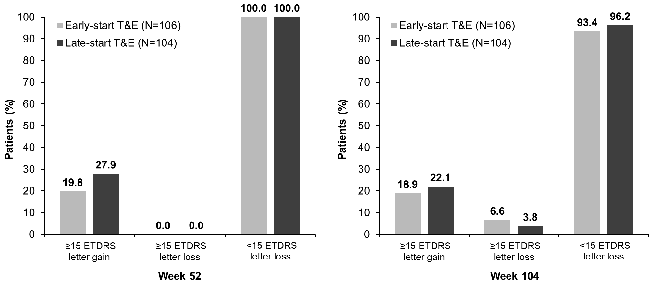
BCVA, best-corrected visual acuity; ETDRS, Early Treatment Diabetic Retinopathy Study; PPS, per-protocol set; T&E, treat-and-extend.

eFigure 2. Boxplot of change in BCVA from baseline to Weeks 16, 52 and 104 (PPS)
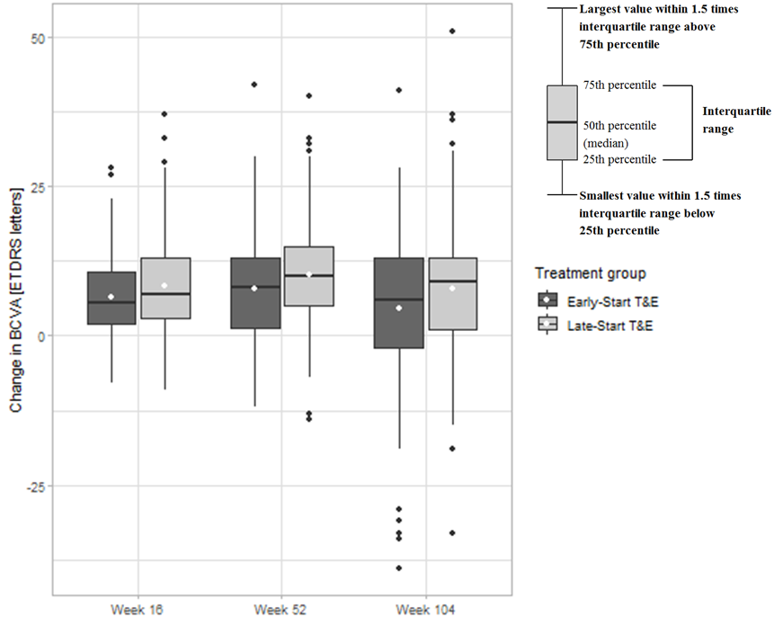
The outliers (black markers) signify values that are >1.5 times and <3 times the interquartile range beyond either end of the box; mean values are represented by the white markers. BCVA, best-corrected visual acuity; ETDRS, Early Treatment Diabetic Retinopathy Study; PPS, per-protocol set; T&E, treat-and-extend.

eFigure 3. Mean change in CRT from baseline to Week 104 (PPS)
CRT, central retinal thickness; PPS, per-protocol set; T&E, treat-and-extend.

