SDC2: Supplementary Figures for Detection of plasmid-mediated tigecycline resistance gene tet(X4) in a Salmonella enterica serovar Llandoff isolate

Yanan Wang^{1,2,#}, Fei Liu^{2,#}, Xuebin Xu^{3,#}, Hua Huang⁴, Na Lyu², Sufang Ma², Luping Chen², Mengyu Mao^{2,5}, Yongfei Hu⁶, Xiaofeng Song⁷, Jing Li², Yuanlong Pan², Aiping Wang⁸, Gaiping Zhang^{1,8}, Baoli Zhu^{2,9,10,11}, George F. Gao^{2,9,12,*}

¹College of Veterinary Medicine, Henan Agricultural University, Zhengzhou, Henan, China;
²CAS Key Laboratory of Pathogen Microbiology and Immunology, Institute of Microbiology, Chinese Academy of Sciences (CAS), Beijing, China;
³Department of Microbiology, Shanghai Municipal Center for Disease Control and Prevention, Shanghai, China;
⁴Beijing Products Quality Supervision and Inspection Institute, Beijing, China;
⁵Institutes of Physical Science and Information Technology, Anhui University, Hefei, Anhui, China;
⁶State Key Laboratory of Animal Nutrition, College of Animal Science and Technology, China Agricultural University, Beijing, China;
⁷National Institute for Communicable Disease Control and Prevention, Chinese Center for Disease Control and Prevention, Beijing, China;
⁸School of Life Sciences, Zhengzhou University, Zhengzhou, Henan, China;
⁹Savaid Medical School, University of Chinese Academy of Sciences, Beijing, China;
¹⁰Beijing Key Laboratory of Antimicrobial Resistance and Pathogen Genomics, Beijing, China;
¹¹Department of Pathogenic Biology, School of Basic Medical Sciences, Southwest Medical University, Luzhou, Sichuan, China;
¹²Chinese Center for Disease Control and Prevention (China CDC), Beijing, China.
#These authors contributed equally to this work.

*Corresponding author: George F. Gao, CAS Key Laboratory of Pathogen Microbiology and Immunology, Institute of Microbiology, Chinese Academy of Sciences (CAS), NO.1 Beichen West Road, Chaoyang District, Beijing 100101, China. E-mail: gaof@im.ac.cn

# YW, FL and XX contributed equally to this work.

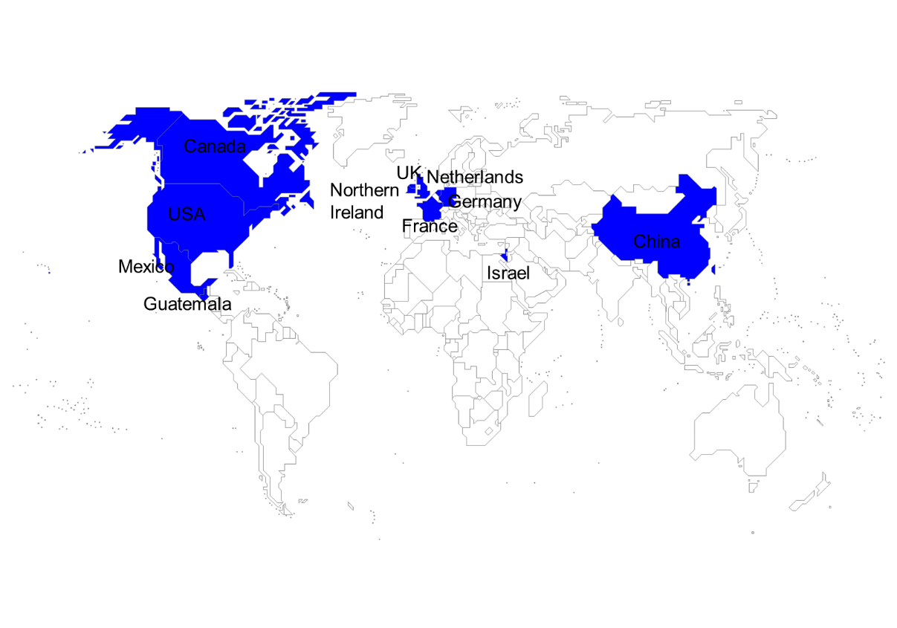

Figure S1. Source location of Salmonella enterica serovar Llandoff strain genomes used in this study. The blue color indicates the presence of this serovar.

Figure S2. The phylogenomic relationship among 20 Salmonella enterica serovar Llandoff strains. The 20 S. Llandoff isolates were distributed in 11 countries on four continents and grouped into different sublineages. SH16G3606 was closer to the S. Llandoff strains in Guatemala, the USA, and Mexico in the evolutionary tree. “100” represent bootstrap value and “0.05” represents distance scale.
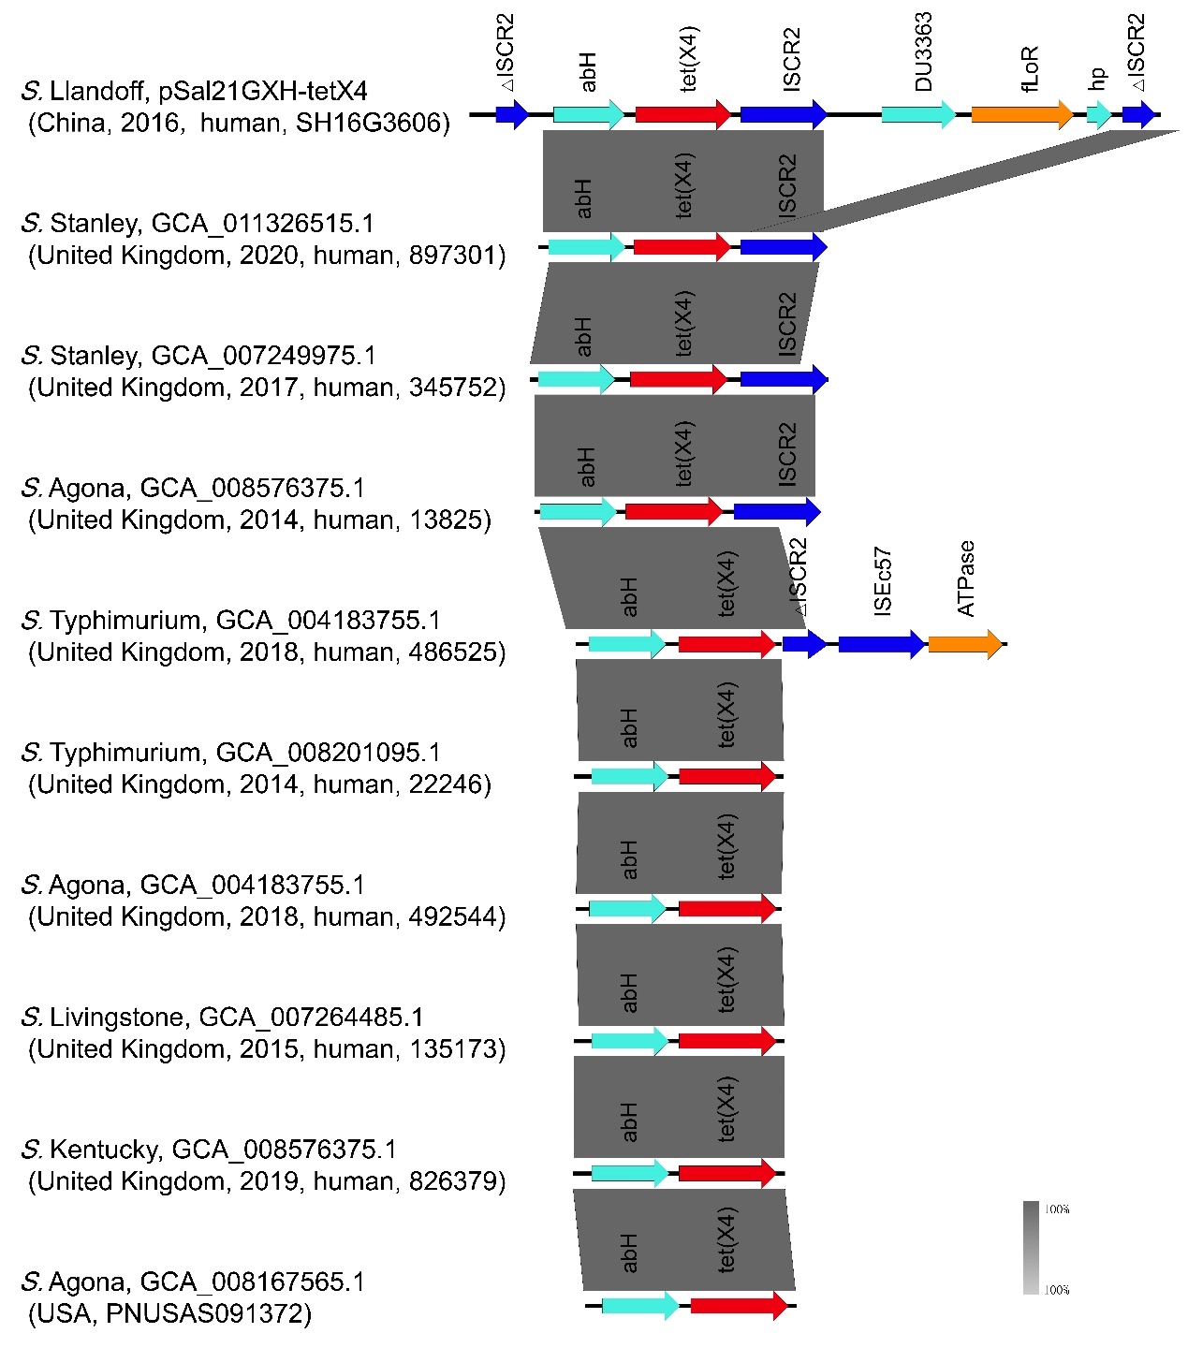

Figure S3. Comparison analysis of tet(X4)-positive Salmonella enterica contigs.

