Supplemental Digital Content 2. Global distribution of included children with Down syndrome and RSV-related death
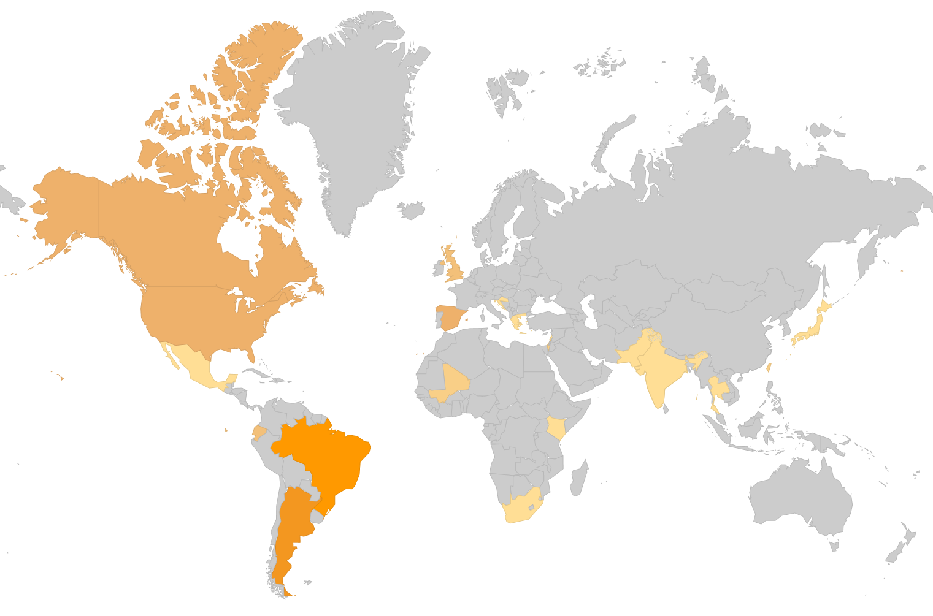
1 ..
1 ..
2 ..
1 ..
1 ..
2 ..
1 ..
1 ..
4 ..
1 ..
2 ..
2 ..
11 ..
9 ..
3 ..
1 ..
1 ..
1 ..
4 ..
4 ..

